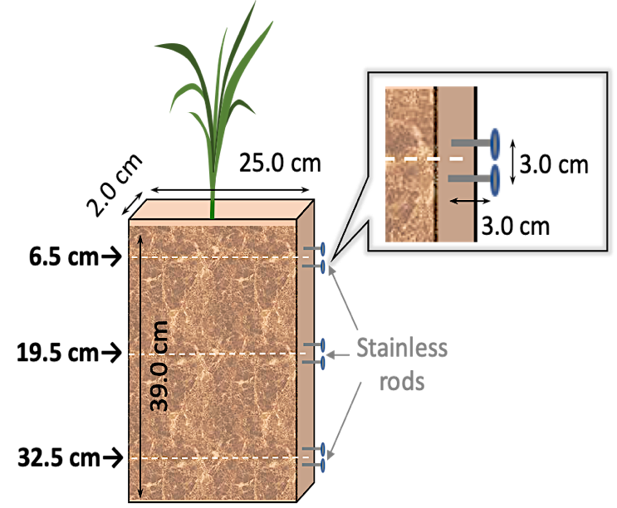
(a) (b)

Figure S1. Root box setup (a), and irrigation method of TI-SMF and BI-SMF (b).
The two stainless steel rods were equally inserted into the side wall of the root box. The soil moisture contents (v/v %) were measured by attaching the Time Domain Reflectometry (TDR; Tektronix Inc., Wilsonville, OR, USA) soil moisture meter to the pre-inserted rods. Water was supplied from the top of the soil surface by using cup in TI-SMF, while BI-SMF, water was supplied from slit of the bottom of root box by using a syringe.

