Table S1. Partitions and models of sequence evolution used in the Maximum Likelihood (ML) and Bayesian Analysis (BI).

Partitions Sites (#) ML BI
P1 CYTB 1st, 16s (866) GTR+I+G GTR+G
P2 CYTB 2nd (370) GTR+G HKY+I+G
P3 CYTB 3rd (370) GTR+G GTR+G
P4 RAG1 1st, RAG1 2nd, RAG1 3rd (884) GTR+G HKY+G

Table S2. Uncorrected p-distances of sequences used in this study for cytb gene
S.no. | Species | 1 | 2 | 3 | 4 | 5 | 6 | 7 | 8 | 9 | 10 | 11 | 12 | 13 | 14 | 15 | 16 | 17 | 18 | 19 | 20 | 21 | 22 | 23 | 24
1 | Ahaetulla nasuta cf. isabellina
2 | Ahaetulla anomala | 0
3 | Ahaetulla fasciolata | 0.15 | 0.1
4 | Ahaetulla fronticincta | 0.12 | 0.12 | 0.2
5 | Ahaetulla fronticincta | 0.12 | 0.12 | 0.16 | 0
6 | Ahaetulla laudankia sp. nov. | 0.09 | 0.09 | 0.16 | 0.11 | 0.1
7 | Ahaetulla mycterizans | 0.13 | 0.13 | 0.10 | 0.14 | 0.14 | 0.1
8 | Ahaetulla nasuta (Sri Lanka) | 0.09 | 0.10 | 0.14 | 0.11 | 0.12 | 0.09 | 0.1
9 | Ahaetulla nasuta (Lao) | 0.11 | 0.11 | 0.15 | 0.12 | 0.12 | 0.08 | 0.14 | 0.1
10 | Ahaetulla prasina | 0.15 | 0.15 | 0.09 | 0.16 | 0.16 | 0.15 | 0.09 | 0.15 | 0.1
11 | Ahaetulla prasina (Philippines) | 0.15 | 0.14 | 0.11 | 0.15 | 0.15 | 0.15 | 0.08 | 0.14 | 0.16 | 0.1
12 | Ahaetulla pulverulenta (Sri Lanka) | 0.05 | 0.05 | 0.14 | 0.12 | 0.11 | 0.09 | 0.13 | 0.09 | 0.10 | 0.15 | 0.1
13 | Chrysopelea ornata | 0.19 | 0.19 | 0.18 | 0.17 | 0.17 | 0.18 | 0.19 | 0.20 | 0.19 | 0.18 | 0.18 | 0.2
14 | Chrysopelea paradisi | 0.18 | 0.18 | 0.17 | 0.19 | 0.19 | 0.20 | 0.17 | 0.18 | 0.18 | 0.18 | 0.17 | 0.16 | 0.1
15 | Chrysopelea pelias | 0.18 | 0.18 | 0.19 | 0.18 | 0.18 | 0.18 | 0.18 | 0.18 | 0.18 | 0.19 | 0.18 | 0.17 | 0.16 | 0.1
16 | Chrysopelea taprobanica | 0.15 | 0.15 | 0.17 | 0.16 | 0.16 | 0.16 | 0.17 | 0.17 | 0.17 | 0.17 | 0.17 | 0.15 | 0.17 | 0.18 | 0.2
17 | Dendrelaphis cyanochloris | 0.17 | 0.17 | 0.18 | 0.17 | 0.17 | 0.16 | 0.16 | 0.17 | 0.17 | 0.18 | 0.17 | 0.17 | 0.18 | 0.17 | 0.18 | 0.2
18 | Dendrelaphis formosus | 0.19 | 0.19 | 0.20 | 0.19 | 0.19 | 0.20 | 0.19 | 0.19 | 0.19 | 0.20 | 0.19 | 0.19 | 0.19 | 0.19 | 0.19 | 0.19 | 0.2
19 | Dendrelaphis fuliginosus | 0.19 | 0.19 | 0.20 | 0.19 | 0.19 | 0.19 | 0.19 | 0.20 | 0.19 | 0.19 | 0.20 | 0.19 | 0.20 | 0.19 | 0.19 | 0.18 | 0.17 | 0.2
20 | Dendrelaphis haasi | 0.17 | 0.17 | 0.18 | 0.16 | 0.16 | 0.16 | 0.16 | 0.16 | 0.16 | 0.18 | 0.17 | 0.16 | 0.18 | 0.16 | 0.16 | 0.16 | 0.14 | 0.15 | 0.2
21 | Dendrelaphis marenae | 0.17 | 0.17 | 0.18 | 0.17 | 0.17 | 0.16 | 0.16 | 0.17 | 0.17 | 0.18 | 0.16 | 0.16 | 0.18 | 0.18 | 0.17 | 0.16 | 0.14 | 0.15 | 0.18 | 0.1
22 | Dendrelaphis pictus | 0.16 | 0.16 | 0.17 | 0.16 | 0.16 | 0.15 | 0.16 | 0.16 | 0.16 | 0.16 | 0.16 | 0.15 | 0.19 | 0.17 | 0.17 | 0.17 | 0.13 | 0.17 | 0.17 | 0.13 | 0.1
23 | Dendrelaphis striatus | 0.16 | 0.16 | 0.20 | 0.15 | 0.16 | 0.17 | 0.17 | 0.18 | 0.16 | 0.18 | 0.19 | 0.16 | 0.17 | 0.17 | 0.16 | 0.16 | 0.12 | 0.17 | 0.18 | 0.16 | 0.2 | 0.16
24 | Dendrelaphis subocularis | 0.18 | 0.17 | 0.19 | 0.17 | 0.17 | 0.19 | 0.18 | 0.19 | 0.20 | 0.20 | 0.21 | 0.18 | 0.20 | 0.21 | 0.19 | 0.17 | 0.18 | 0.16 | 0.18 | 0.17 | 0.2 | 0.17 | 0.17
25 | Dryophiops philippina | 0.18 | 0.18 | 0.19 | 0.19 | 0.19 | 0.19 | 0.18 | 0.19 | 0.20 | 0.20 | 0.19 | 0.17 | 0.19 | 0.19 | 0.18 | 0.19 | 0.18 | 0.19 | 0.20 | 0.18 | 0.18 | 0.18 | 0.19 | 0.18
Table S3. Uncorrected p-distances of sequences used in this study for 16s gene
S.no. | Species | 1 | 2 | 3 | 4 | 5 | 6 | 7 | 8 | 9 | 10 | 11 | 12 | 13 | 14 | 15 | 16 | 17 | 18 | 19 | 20 | 21
1 | Ahaetulla nasuta cf. isabellina
2 | Ahaetulla anomala | 0.01
3 | Ahaetulla fasciolata | 0.05 | 0.05
4 | Ahaetulla fronticincta | 0.03 | 0.03 | 0.04
5 | Ahaetulla laudankia sp. nov. | 0.04 | 0.03 | 0.05 | 0.03
6 | Ahaetulla mycterizans | 0.04 | 0.04 | 0.02 | 0.04 | 0.06
7 | Ahaetulla nasuta (Lao) | 0.03 | 0.03 | 0.04 | 0.03 | 0.03 | 0.05
8 | Ahaetulla prasina (Philippines) | 0.04 | 0.04 | 0.04 | 0.04 | 0.05 | 0.01 | 0.04
9 | Ahaetulla pulverulenta (Sri Lanka) | 0.03 | 0.02 | 0.04 | 0.03 | 0.04 | 0.04 | 0.03 | 0.04
10 | Chrysopelea ornata | 0.07 | 0.07 | 0.07 | 0.07 | 0.07 | 0.06 | 0.07 | 0.07 | 0.07
11 | Chrysopelea pelias | 0.08 | 0.07 | 0.06 | 0.07 | 0.07 | 0.07 | 0.06 | 0.07 | 0.07 | 0.04
12 | Chrysopelea taprobanica | 0.07 | 0.07 | 0.06 | 0.07 | 0.07 | 0.07 | 0.06 | 0.07 | 0.08 | 0.04 | 0.05
13 | Dendrelaphis cyanochloris | 0.07 | 0.07 | 0.06 | 0.06 | 0.07 | 0.07 | 0.06 | 0.07 | 0.07 | 0.07 | 0.07 | 0.06
14 | Dendrelaphis formosus | 0.07 | 0.07 | 0.07 | 0.07 | 0.07 | 0.07 | 0.07 | 0.08 | 0.08 | 0.07 | 0.08 | 0.07 | 0.06
15 | Dendrelaphis fuliginosus | 0.07 | 0.07 | 0.06 | 0.07 | 0.07 | 0.07 | 0.06 | 0.07 | 0.07 | 0.07 | 0.08 | 0.07 | 0.05 | 0.05
16 | Dendrelaphis haasi | 0.07 | 0.07 | 0.07 | 0.06 | 0.07 | 0.07 | 0.06 | 0.07 | 0.07 | 0.07 | 0.08 | 0.07 | 0.06 | 0.06 | 0.05
17 | Dendrelaphis marenae | 0.08 | 0.08 | 0.07 | 0.07 | 0.07 | 0.07 | 0.06 | 0.07 | 0.08 | 0.07 | 0.08 | 0.07 | 0.05 | 0.06 | 0.05 | 0.03
18 | Dendrelaphis ngansonensis | 0.07 | 0.07 | 0.06 | 0.07 | 0.06 | 0.07 | 0.06 | 0.07 | 0.07 | 0.07 | 0.07 | 0.06 | 0.01 | 0.05 | 0.05 | 0.06 | 0.05
19 | Dendrelaphis pictus | 0.08 | 0.08 | 0.07 | 0.07 | 0.08 | 0.06 | 0.07 | 0.07 | 0.08 | 0.08 | 0.09 | 0.07 | 0.06 | 0.06 | 0.06 | 0.06 | 0.05 | 0.05
20 | Dendrelaphis striatus | 0.07 | 0.07 | 0.07 | 0.07 | 0.07 | 0.06 | 0.06 | 0.07 | 0.07 | 0.07 | 0.08 | 0.07 | 0.04 | 0.06 | 0.06 | 0.06 | 0.05 | 0.04 | 0.05
21 | Dendrelaphis subocularis | 0.10 | 0.10 | 0.08 | 0.09 | 0.09 | 0.09 | 0.08 | 0.09 | 0.10 | 0.09 | 0.08 | 0.08 | 0.06 | 0.07 | 0.08 | 0.09 | 0.08 | 0.06 | 0.07 | 0.06
22 | Dryophiops philippina | 0.07 | 0.07 | 0.06 | 0.07 | 0.06 | 0.06 | 0.05 | 0.06 | 0.07 | 0.06 | 0.07 | 0.07 | 0.07 | 0.08 | 0.06 | 0.08 | 0.07 | 0.06 | 0.07 | 0.06 | 0.07

Table S4. Scalation data for Ahaetulla nasuta sensu lato. NA=data not available. * Tail damaged
s.no | Country | voucher | Sex | Ventrals | Subcaudals | body colour in preservation | Source
1 | Myanmar | CAS- 208442 | M | 194 | 161 | green | current study
2 | Myanmar | CAS-215752 | M | 210 | 173 | green | current study
3 | Myanmar | CAS-246998 | M | 192 | * | green | current study
4 | Myanmar | CAS- 204856 | M | 196 | 163 | green | current study
5 | Myanmar | BMNH 91.11.26.42 | M | 200 | 158 | green | current study
6 | Myanmar | CAS- 214102 | F | 207 | 161 | green | current study
7 | Thailand | BMNH 1956.1.12.99 | M | 194 | 153 | brown | current study
8 | Thailand | NA | NA | 202 | 163 | NA | Taylor & Elbel 1958.
9 | Thailand | BMNH 1977.1997 | F | 197 | 142 | green | current study
10 | Thailand | IRSNB 16995 | ? | 188 | 152 | NA | Pauwels et al. 2009
11 | Vietnam | BMNH 1920.1.20.2655 | M | 192 | 163 | green | current study
12 | Sri Lanka | CAS- 12771 | F | 180 | 155 | green | current study
13 | Sri Lanka | CAS 16909 | M | 181 | 169 | green | current study
14 | Sri Lanka | BMNH 1933.12.6.18 | M | 176 | 175 | green | current study
15 | Sri Lanka | BMNH 1912-2171 | F | 172 | 124* | brown | current study
16 | Sri Lanka | BMNH 1912-2173 | F | 168 | 138 | brown | current study
17 | Sri Lanka | BMNH 1920.5.6.5 | F | 184 | 166 | green | current study
18 | Sri Lanka | NA | NA | 182 | 154 | NA | Taylor, E H (1953)
19 | Sri Lanka | BMNH 97.20.20.5 | F | 177 | 149 | green | current study
20 | India | ZSI-CZRC-6548 | F | 181 | 146 | green | current study
21 | India | BNHS 3028 | F | 176 | 152 | brown | current study
22 | India | ZSI-WGRS- 8394 | ? | 176 | 139 | green | current study
23 | India | ZSI-WGRC-IR/V/22 | ? | 178 | 142 | green | current study
24 | India | ZSI-WGRC-IR/V/43 | F | 171 | 149 | brown | current study
25 | India | SNT-16 | M | 175 | 159 | brown | current study
26 | India | BMNH OE-LS-2018-11 | F | 180 | 148 | green | current study
27 | India | FMNH 217689-93 | ? | 179-185 | 147-168 | NA | Inger et al. 1984
28 | India | NA | NA | 185 | 177 | NA | Constable, J D(1949)
29 | India | BMNH 69.8.28.85 | F | 181 | 152 | green | current study

References
Constable, J D (1949). Reptiles from the Indian Peninsula in the Museum of Comparative Zoology. Bulletin of the Museum of Comparative Zoology at Harvard College. 103, 59–160.
Inger, R. F., Shaffer, H. B., Koshy, M., & Bakde, R (1984). A report on a collection of amphibians and reptiles from the ponmudi kerala south India . The journal of the Bombay Natural History Society. 81(2), 406–427.
Pauwels, O. S., Chan-ard, T., Wanchai, P., Kheowyoo, B., & Bauer, A. M.(2009). Reptile diversity of Phetchaburi Province, western Thailand: an update. Hamadryad. 34, 9–21.
Taylor, E H (1953). Report on a collection of Ceylonese serpents. The University of Kansas science bulletin. 35, 1615-1624.
Taylor, E.H. & Elbel, R.E. (1958). Contribution to the herpetology of Thailand. The University of Kansas science bulletin. 38 , 1033-1189.

Supp. Figure 1. Ahaetulla laudankia sp.nov. (ZSI 8425) from near Mount Abu, Rajasthan state, India. A. lateral, B. dorsal and C. ventral coloration and pattern.Image not to scale.

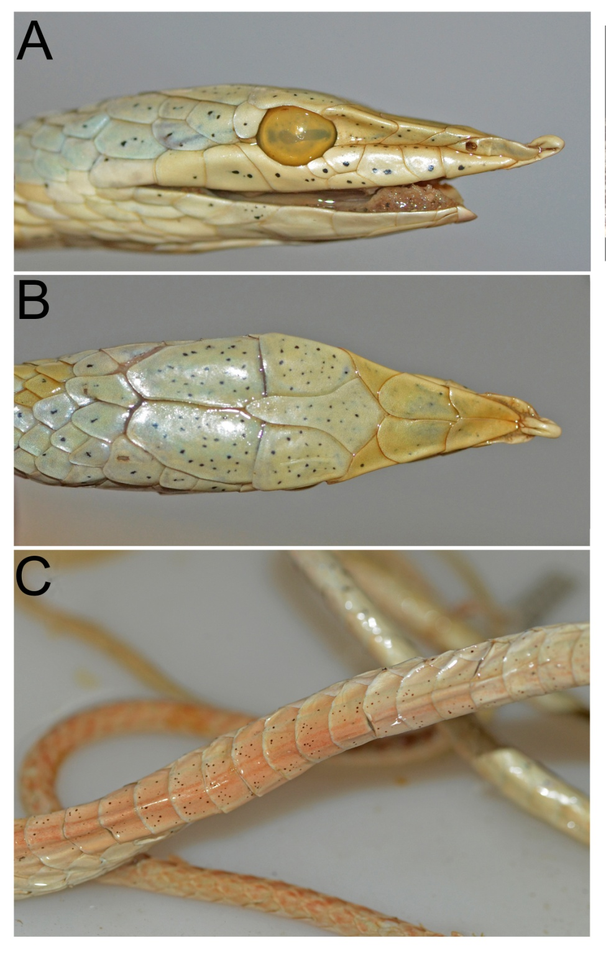

Supp. Figure 2. Supp. Figure 2. Ahaetulla cf. isabellina from low land Tamil Nadu state, Tirunelveli District. A. Male (ZSI-CZRC-6405) showing typical coloration (inset image showing keels on the dorsum). B. female (ZSI-CZRC-6576) from the same locality showing bands in threat display
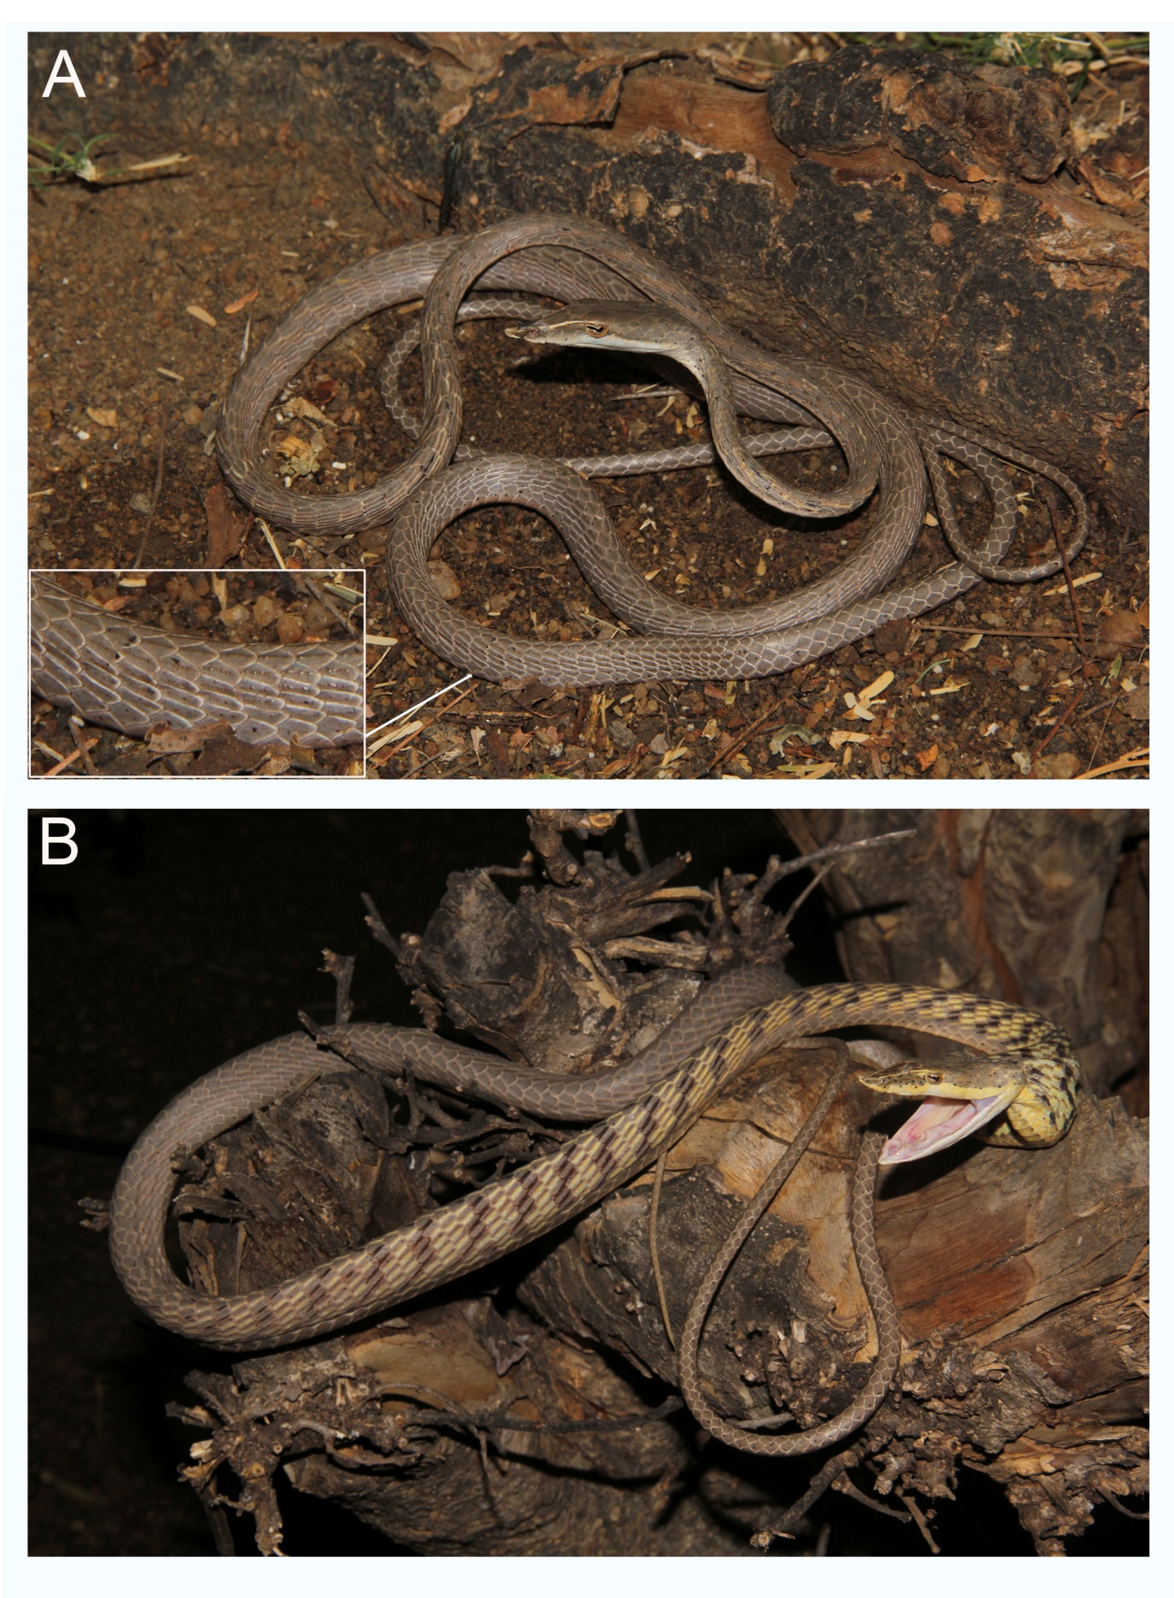

Supp. Figure 3. Ahaetulla nasuta (FMNH 255023) collected from Mounlapamok District, Laos.

Supp. Figure 4. Dorsal head coloration of Ahaetulla nasuta sensu lato from South Asia and SE Asia. Note majority of the SE Asian individuals are green in color.
