A Regression Analysis with Laboratory Validation for the use of Reverse Micelles to Achieve Desired Nano-Sized Catalytically Active Sites

Karishma Piler, Ashik Mahmud, and Tracy J Benson*
Dan F. Smith Department of Chemical Engineering, Lamar University, P.O. Box 10053, Beaumont, TX 77710
*Author to whom correspondence should be addressed, Phone: 1-409-880-7536; Email: tracy.benson@lamar.edu

Supplementary Material

Table 1
Range of the values for the dependent and independent variables taken for the regression analysis
Variables | Range
Particle Size, nm | 1.6 - 500
Water/Surfactant Molar Ratio (W) | 0.33 - 40
Reaction Time, h | 0.5 - 15
Surfactant Concentration, M | 0.03 – 0.9

Table 2
Types of surfactants used in the regression analysis
Surfactant Name | Structure | Properties
Triton X -100 | 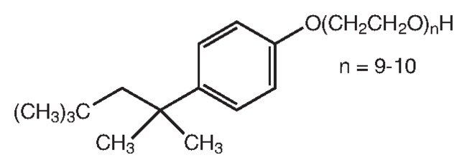 | Non-ionic  Molar mass: 647 g/mol
Cetrimonium bromide (CTAB)  (C₁₉H₄₂BrN) | 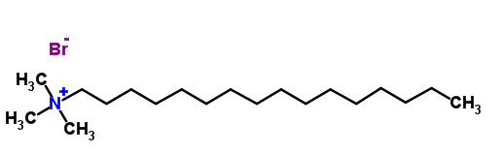 | Cationic  Molar mass: 364 g/mol
Bis(2-ethylhexyl)-sulfosuccinate sodium salt (AOT) |  | Anionic  Molar mass: 445 g/mol
Brij 30 | 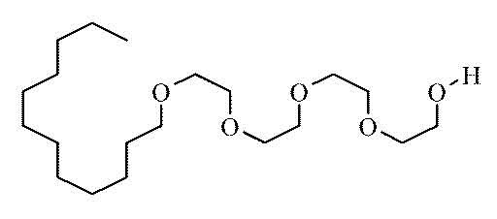 | Non-ionic  Molar mass: 362 g/mol
Igepal CO-520 | 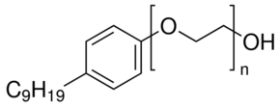 | Non-ionic  Molar mass: 441 g/mol
Cetylpyridinium bromide (CPB) | 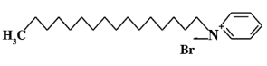 | Cationic  Molar mass: 340 g/mol

Table 3
Types of solvents used in the regression analysis
Solvent Name | Structure | Properties
Cyclohexane | 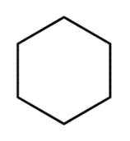 | Molar mass: 84 g/mol  Density: 779 kg/m³
Isooctane | 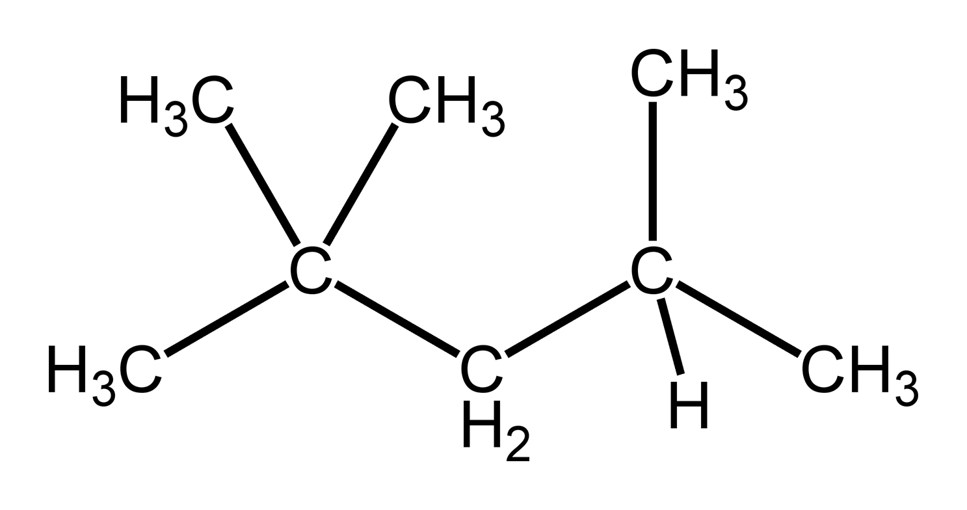 | Molar mass: 114 g/mol  Density: 690 kg/m³
n-hexanol | 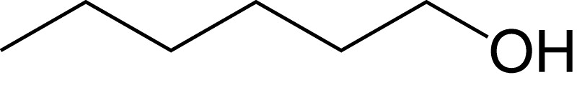 | Molar mass: 102 g/mol  Density: 820 kg/m³ at 20˚C
n-hexane | 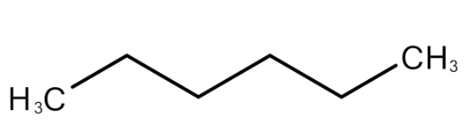 | Molar mass: 86 g/mol  Density: 655 kg/m³
n-heptane | 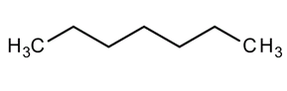 | Molar mass: 100 g/mol  Density: 684 kg/m³
n-octane |  | Molar mass: 114 g/mol  Density: 703 kg/m³

Multiple Linear Regression – Least Squares Method Results
Regression Statistics
Multiple R | 0.9562
R Square | 0.9144
Adjusted R Square | 0.8918
Standard Error | 40.9707
Observations | 68
ANOVA
 | df | SS | MS | F | Significance F
Regression | 14 | 950428.32 | 67887.7 | 40.443 | 3.07E-23
Residual | 53 | 88965.79 | 1678.6
Total | 67 | 1039394.11
 | Coefficients | Std Error | t Stat | P-value | Lower 95% | Upper 95% | Lower 95.0% | Upper 95.0%
Intercept | 258.345 | 80.858 | 3.195 | 0.0024 | 96.164 | 420.525 | 96.164 | 420.525
X1, Water/ surfactant ratio, (W) | 5.923 | 2.192 | 2.703 | 0.0092 | 1.528 | 10.319 | 1.528 | 10.319
X2, W*(Reaction Time) | -1.436 | 0.596 | -2.411 | 0.0194 | -2.631 | -0.242 | -2.631 | -0.242
X2^2, (W*(Reaction Time))^2 | 0.009 | 0.002 | 3.623 | 0.0007 | 0.004 | 0.014 | 0.004 | 0.014
X3, Surfactant Conc, (M) | -198.315 | 65.682 | -3.019 | 0.0039 | -330.056 | -66.574 | -330.056 | -66.574
X4, Triton X-100 | -471.651 | 95.663 | -4.930 | 8.48E-06 | -663.526 | -279.776 | -663.526 | -279.776
X5, CTAB | -240.674 | 56.641 | -4.249 | 0.0001 | -354.281 | -127.067 | -354.281 | -127.067
X6, AOT | -441.186 | 74.000 | -5.962 | 2.08E-07 | -589.611 | -292.761 | -589.611 | -292.761
X7, OP-4 | -254.830 | 60.071 | -4.242 | 0.0001 | -375.318 | -134.342 | -375.318 | -134.342
X8, Brij 30 | -220.734 | 75.043 | -2.941 | 0.0048 | -371.252 | -70.217 | -371.252 | -70.217
X9, Igepal CO-520 | -454.844 | 105.017 | -4.331 | 0.0001 | -665.481 | -244.207 | -665.481 | -244.207
X10, Cyclohexane | 244.982 | 84.402 | 2.903 | 0.0054 | 75.694 | 414.271 | 75.694 | 414.271
X11, Isooctane | 233.497 | 44.743 | 5.219 | 3.06E-06 | 143.755 | 323.240 | 143.755 | 323.240
X12, n-Hexanol | 102.816 | 87.025 | 1.181 | 0.2427 | -71.733 | 277.365 | -71.733 | 277.365
X13, (x)ane,(x=C6,C7,C8) | 59.326 | 56.641 | 1.047 | 0.2997 | -54.281 | 172.933 | -54.281 | 172.933
Data used in regression analysis
Metal | Y, Particle Diameter, (nm) | X1, water/ surfactant ratio, (W) | X2, W*(Reaction Time) | X2^2, (W*(Reaction Time))^2 | X3, Surfactant Conc, (M) | X4, Triton X-100 | X5, CTAB | X6, AOT | X7, OP-4 | X8, Brij 30 | X9, Igepal CO-520 | X10, Cyclohexane | X12, n-Hexanol | X11, Isooctane | X13, n-hexane | Surfactant Name | Solvent | Ref
Ni | 8 | 1 | 3 | 9 | 0.1 | 1 | 0 | 0 | 0 | 0 | 0 | 1 | 0 | 0 | 0 | Triton X-100 | Cyclohexane | Kumar et al., 2013
Ni | 16 | 3 | 9 | 81 | 0.1 | 1 | 0 | 0 | 0 | 0 | 0 | 1 | 0 | 0 | 0 | Triton X-100 | Cyclohexane | Kumar et al., 2013
Ni | 29 | 5 | 15 | 225 | 0.1 | 1 | 0 | 0 | 0 | 0 | 0 | 1 | 0 | 0 | 0 | Triton X-100 | Cyclohexane | Kumar et al., 2013
Ni | 59 | 7 | 21 | 441 | 0.1 | 1 | 0 | 0 | 0 | 0 | 0 | 1 | 0 | 0 | 0 | Triton X-100 | Cyclohexane | Kumar et al., 2013
Ni | 68 | 9 | 27 | 729 | 0.1 | 1 | 0 | 0 | 0 | 0 | 0 | 1 | 0 | 0 | 0 | Triton X-100 | Cyclohexane | Kumar et al., 2013
Ni | 81 | 11 | 33 | 1089 | 0.1 | 1 | 0 | 0 | 0 | 0 | 0 | 1 | 0 | 0 | 0 | Triton X-100 | Cyclohexane | Kumar et al., 2013
Ni | 6 | 5 | 15 | 225 | 0.1 | 1 | 0 | 0 | 0 | 0 | 0 | 1 | 0 | 0 | 0 | Triton X-100 | Cyclohexane | Kumar et al., 2013
Ni | 6 | 5 | 15 | 225 | 0.1 | 1 | 0 | 0 | 0 | 0 | 0 | 1 | 0 | 0 | 0 | Triton X-100 | Cyclohexane | Kumar et al., 2013
Ni | 30 | 5 | 15 | 225 | 0.1 | 1 | 0 | 0 | 0 | 0 | 0 | 1 | 0 | 0 | 0 | Triton X-100 | Cyclohexane | Kumar et al., 2013
Ni | 32 | 5 | 15 | 225 | 0.1 | 1 | 0 | 0 | 0 | 0 | 0 | 1 | 0 | 0 | 0 | Triton X-100 | Cyclohexane | Kumar et al., 2013
Ni | 33 | 5 | 15 | 225 | 0.1 | 1 | 0 | 0 | 0 | 0 | 0 | 1 | 0 | 0 | 0 | Triton X-100 | Cyclohexane | Kumar et al., 2013
Ni | 8.2 | 11 | 11 | 121 | 0.9 | 0 | 1 | 0 | 0 | 0 | 0 | 0 | 1 | 0 | 0 | CTAB | n-hexanol | Chen et al., 2000
Ni | 5.8 | 11 | 11 | 121 | 0.8 | 0 | 1 | 0 | 0 | 0 | 0 | 0 | 1 | 0 | 0 | CTAB | n-hexanol | Chen et al., 2000
Ni | 14.3 | 13.8 | 13.8 | 190.44 | 0.9 | 0 | 1 | 0 | 0 | 0 | 0 | 0 | 1 | 0 | 0 | CTAB | n-hexanol | Chen et al., 2000
Ni | 4.6 | 13.8 | 13.8 | 190.44 | 0.8 | 0 | 1 | 0 | 0 | 0 | 0 | 0 | 1 | 0 | 0 | CTAB | n-hexanol | Chen et al., 2000
NiO | 9 | 1 | 3 | 9 | 0.1 | 1 | 0 | 0 | 0 | 0 | 0 | 1 | 0 | 0 | 0 | Triton X-100 | Cyclohexane | Kumar et al., 2013
NiO | 13 | 3 | 9 | 81 | 0.1 | 1 | 0 | 0 | 0 | 0 | 0 | 1 | 0 | 0 | 0 | Triton X-100 | Cyclohexane | Kumar et al., 2013
NiO | 20 | 5 | 15 | 225 | 0.1 | 1 | 0 | 0 | 0 | 0 | 0 | 1 | 0 | 0 | 0 | Triton X-100 | Cyclohexane | Kumar et al., 2013
NiO | 39 | 7 | 21 | 441 | 0.1 | 1 | 0 | 0 | 0 | 0 | 0 | 1 | 0 | 0 | 0 | Triton X-100 | Cyclohexane | Kumar et al., 2013
NiO | 86 | 9 | 27 | 729 | 0.1 | 1 | 0 | 0 | 0 | 0 | 0 | 1 | 0 | 0 | 0 | Triton X-100 | Cyclohexane | Kumar et al., 2013
NiO | 110 | 11 | 33 | 1089 | 0.1 | 1 | 0 | 0 | 0 | 0 | 0 | 1 | 0 | 0 | 0 | Triton X-100 | Cyclohexane | Kumar et al., 2013
NiO | 8 | 5 | 15 | 225 | 0.1 | 1 | 0 | 0 | 0 | 0 | 0 | 1 | 0 | 0 | 0 | Triton X-100 | Cyclohexane | Kumar et al., 2013
NiO | 7 | 5 | 15 | 225 | 0.1 | 1 | 0 | 0 | 0 | 0 | 0 | 1 | 0 | 0 | 0 | Triton X-100 | Cyclohexane | Kumar et al., 2013
NiO | 27 | 5 | 15 | 225 | 0.1 | 1 | 0 | 0 | 0 | 0 | 0 | 1 | 0 | 0 | 0 | Triton X-100 | Cyclohexane | Kumar et al., 2013
NiO | 33 | 5 | 15 | 225 | 0.1 | 1 | 0 | 0 | 0 | 0 | 0 | 1 | 0 | 0 | 0 | Triton X-100 | Cyclohexane | Kumar et al., 2013
NiO | 36 | 5 | 15 | 225 | 0.1 | 1 | 0 | 0 | 0 | 0 | 0 | 1 | 0 | 0 | 0 | Triton X-100 | Cyclohexane | Kumar et al., 2013
Ni(OH)2 | 15 | 5 | 2.5 | 6.25 | 0.1 | 1 | 0 | 0 | 0 | 0 | 0 | 1 | 0 | 0 | 0 | Triton X-100 | Cyclohexane | Harish et a., 2011
Ni(OH)2 | 12 | 10 | 5 | 25 | 0.1 | 1 | 0 | 0 | 0 | 0 | 0 | 1 | 0 | 0 | 0 | Triton X-100 | Cyclohexane | Harish et a., 2011
Ni(OH)2 | 22 | 15 | 7.5 | 56.25 | 0.1 | 1 | 0 | 0 | 0 | 0 | 0 | 1 | 0 | 0 | 0 | Triton X-100 | Cyclohexane | Harish et a., 2011
Ni(OH)2 | 400 | 40 | 120 | 14400 | 0.03 | 0 | 1 | 0 | 0 | 0 | 0 | 1 | 0 | 0 | 0 | CTAB | Cyclohexane | Cao et al., 2007
Ni(OH)2 | 500 | 40 | 120 | 14400 | 0.03 | 0 | 1 | 0 | 0 | 0 | 0 | 1 | 0 | 0 | 0 | CTAB | Cyclohexane | Cao et al., 2007
C2NiO4 | 30 | 12 | 180 | 32400 | 0.1 | 1 | 0 | 0 | 0 | 0 | 0 | 1 | 0 | 0 | 0 | Triton X-100 | Cyclohexane | Sharma et al., 2015
C2NiO4 | 300 | 12 | 180 | 32400 | 0.1 | 0 | 1 | 0 | 0 | 0 | 0 | 0 | 0 | 1 | 0 | CTAB | isooctane | Sharma et al., 2015
C2NiO4 | 100 | 4 | 60 | 3600 | 0.1 | 0 | 1 | 0 | 0 | 0 | 0 | 0 | 0 | 1 | 0 | CTAB | isooctane | Sharma et al., 2015
C2NiO4 | 200 | 8 | 120 | 14400 | 0.1 | 0 | 1 | 0 | 0 | 0 | 0 | 0 | 0 | 1 | 0 | CTAB | isooctane | Sharma et al., 2015
C2NiO4 | 500 | 12 | 180 | 32400 | 0.1 | 0 | 1 | 0 | 0 | 0 | 0 | 0 | 0 | 1 | 0 | CTAB | isooctane | Sharma et al., 2015
C2NiO4 | 500 | 16 | 240 | 57600 | 0.1 | 0 | 1 | 0 | 0 | 0 | 0 | 0 | 0 | 1 | 0 | CTAB | isooctane | Sharma et al., 2015
C2NiO4 | 100 | 12 | 180 | 32400 | 0.1 | 0 | 1 | 0 | 0 | 0 | 0 | 0 | 0 | 0 | 0 | CTAB | n-heptane | Sharma et al., 2015
ZnS:Ni2+ | 2.51 | 7 | 7 | 49 | 0.1 | 0 | 0 | 1 | 0 | 0 | 0 | 0 | 0 | 1 | 0 | AOT | isooctane | Ibrahim et al., 2017
Ni | 100 | 2 | 2 | 4 | 0.15 | 0 | 0 | 1 | 0 | 0 | 0 | 0 | 0 | 1 | 0 | AOT | isooctane | Gornostaeva et al., 2008
NiO | 20 | 2 | 2 | 4 | 0.15 | 0 | 0 | 1 | 0 | 0 | 0 | 0 | 0 | 1 | 0 | AOT | isooctane | Gornostaeva et al., 2008
C2NiO6 | 400 | 12 | 180 | 32400 | 0.1 | 0 | 0 | 0 | 0 | 0 | 0 | 0 | 0 | 0 | 1 | CPB | n-hexane | Sharma et al., 2015
Ni oxalte | 225 | 12 | 180 | 32400 | 0.5 | 0 | 1 | 0 | 0 | 0 | 0 | 0 | 0 | 1 | 0 | CTAB | isooctane | Vidya et al., 2008
Ni oxalte | 110 | 12 | 180 | 32400 | 0.5 | 0 | 1 | 0 | 0 | 0 | 0 | 0 | 0 | 0 | 1 | CTAB | n-hexane | Vidya et al., 2008
Ni oxalte | 5 | 12 | 180 | 32400 | 0.6 | 1 | 0 | 0 | 0 | 0 | 0 | 1 | 0 | 0 | 0 | Triton X-100 | Cyclohexane | Vidya et al., 2008
NiO | 50 | 12 | 180 | 32400 | 0.5 | 0 | 1 | 0 | 0 | 0 | 0 | 0 | 0 | 0 | 1 | CTAB | n-hexane | Vidya et al., 2008
NiO | 20 | 12 | 180 | 32400 | 0.6 | 1 | 0 | 0 | 0 | 0 | 0 | 1 | 0 | 0 | 0 | Triton X-100 | Cyclohexane | Vidya et al., 2008
Ag-Ni | 50 | 3 | 3 | 9 | 0.1 | 0 | 0 | 0 | 1 | 0 | 0 | 0 | 0 | 0 | 1 | OP-4 | n-hexane | Xia et al., 2010
Ag-Ni | 100 | 11 | 11 | 121 | 0.1 | 0 | 0 | 0 | 1 | 0 | 0 | 0 | 0 | 0 | 1 | OP-4 | n-hexane | Xia et al., 2010
Ni | 1.9 | 1 | 12 | 144 | 0.1 | 1 | 0 | 0 | 0 | 0 | 0 | 1 | 0 | 0 | 0 | Triton X-100 | Cyclohexane | Cheney et al., 2010
Pt-Ni | 1.6 | 1 | 12 | 144 | 0.1 | 1 | 0 | 0 | 0 | 0 | 0 | 1 | 0 | 0 | 0 | Triton X-100 | Cyclohexane | Cheney et al., 2010
Ni oxalte H | 250 | 12 | 144 | 20736 | 0.4 | 0 | 1 | 0 | 0 | 0 | 0 | 0 | 0 | 1 | 0 | CTAB | isooctane | Ahmad et al., 2011
Ni-Zn Ferrite | 2 | 8.7 | 8.7 | 75.69 | 0.8 | 0 | 1 | 0 | 0 | 0 | 0 | 0 | 1 | 0 | 0 | CTAB | n-hexanol | Uskokovic et al., 2004
Ni-Zn Ferrite | 4 | 8.7 | 8.7 | 75.69 | 0.8 | 0 | 1 | 0 | 0 | 0 | 0 | 0 | 1 | 0 | 0 | CTAB | n-hexanol | Uskokovic et al., 2004
Ni | 8.5 | 3 | 36 | 1296 | 0.1 | 0 | 0 | 0 | 0 | 1 | 0 | 0 | 0 | 0 | 0 | Brij 30 | n-octane | Chen et al., 2008
Ni | 10 | 5 | 60 | 3600 | 0.1 | 0 | 0 | 0 | 0 | 1 | 0 | 0 | 0 | 0 | 0 | Brij 30 | n-octane | Chen et al., 2008
Ni | 15 | 7 | 84 | 7056 | 0.1 | 0 | 0 | 0 | 0 | 1 | 0 | 0 | 0 | 0 | 0 | Brij 30 | n-octane | Chen et al., 2008
Ni | 23 | 9 | 108 | 11664 | 0.1 | 0 | 0 | 0 | 0 | 1 | 0 | 0 | 0 | 0 | 0 | Brij 30 | n-octane | Chen et al., 2008
Ni | 31 | 11 | 132 | 17424 | 0.1 | 0 | 0 | 0 | 0 | 1 | 0 | 0 | 0 | 0 | 0 | Brij 30 | n-octane | Chen et al., 2008
Ni-Au | 12.9 | 9 | 108 | 11664 | 0.1 | 0 | 0 | 0 | 0 | 1 | 0 | 0 | 0 | 0 | 0 | Brij 30 | n-octane | Chen et al., 2008
Ni-Au | 21.6 | 11 | 132 | 17424 | 0.1 | 0 | 0 | 0 | 0 | 1 | 0 | 0 | 0 | 0 | 0 | Brij 30 | n-octane | Chen et al., 2008
Ni-Au | 8.8 | 7 | 84 | 7056 | 0.1 | 0 | 0 | 0 | 0 | 1 | 0 | 0 | 0 | 0 | 0 | Brij 30 | n-octane | Chen et al., 2008
NiO | 39.09 | 0.66 | 1.32 | 1.7424 | 0.1 | 0 | 0 | 0 | 0 | 0 | 1 | 1 | 0 | 0 | 0 | Igepal CO-520 | Cyclohexane | Usman et al., 2016
NiO | 27.58 | 0.66 | 1.32 | 1.7424 | 0.1 | 0 | 0 | 0 | 0 | 0 | 1 | 1 | 0 | 0 | 0 | Igepal CO-520 | Cyclohexane | Usman et al., 2016
NiO | 32.08 | 0.5 | 1 | 1 | 0.1 | 0 | 0 | 0 | 0 | 0 | 1 | 1 | 0 | 0 | 0 | Igepal CO-520 | Cyclohexane | Usman et al., 2016
NiO | 26.4 | 0.5 | 1 | 1 | 0.1 | 0 | 0 | 0 | 0 | 0 | 1 | 1 | 0 | 0 | 0 | Igepal CO-520 | Cyclohexane | Usman et al., 2016
NiO | 31.36 | 0.33 | 0.66 | 0.4356 | 0.1 | 0 | 0 | 0 | 0 | 0 | 1 | 1 | 0 | 0 | 0 | Igepal CO-520 | Cyclohexane | Usman et al., 2016
NiO | 24.55 | 0.33 | 0.66 | 0.4356 | 0.1 | 0 | 0 | 0 | 0 | 0 | 1 | 1 | 0 | 0 | 0 | Igepal CO-520 | Cyclohexane | Usman et al., 2016

