Supplementary Data
TABLE 1
Gas oil Proprieties before and after MESD Treatment
Properties of gas oil | Method | Before MEDS treatment | After MEDS treatment
Density at 15 °C | ASTM D1298 | 0.8226 | 0.8207
Flash point, °C | ASTM D93 | 68 | 69
Pour point, °C | ASTM D97 | -15 | -15
Colour test | ASTM D1500 | < 1 | < 1
Total sulphur content, wt. ppm | ASTM D2622 | 548 | 5
Viscosity at 50 °C, cSt | ASTM D445 | 2.7 | 2.6
Cetane index | ASTM D976 | 54 | 54.9
Refractive index, n_{D}²⁰ | ASTM D1218 | 1.4655 | 1.4601
Distillation,
Initial boiling point, °C | ASTM D86 | 180 | 184
10 % Distillation, °C | ASTM D86 | 207 | 210
20 % Distillation, °C | ASTM D86 | 220 | 223
50 % Distillation, °C | ASTM D86 | 265 | 267
90 % Distillation, °C | ASTM D86 | 329 | 328
95 % Distillation, °C | ASTM D86 | 353 | 355
Final boiling point, °C | ASTM D86 | 360 | 364
Residue, vol. % | ASTM D86 | 1 | 1
Loss, vol. % | ASTM D86 | 1 | 1
Recovery, vol. % | ASTM D86 | 98 | 99
Conditions: Vgasoil= 20 mL, T= 30 °C, NMP/DMF/EG= 2:1:1, Extraction Stage Number= 3, Stirring Speed = 200 rpm for 5 min at 500 W.

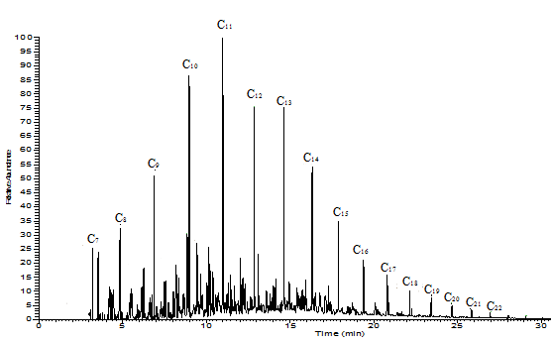
- Before MEDS treatment (138 ppm)
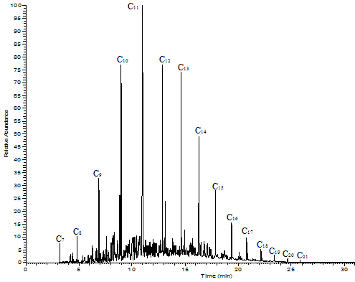
(B) After MEDS treatment (1 ppm)
FIGURE 1 CG-MS Chromatogram of Gas Oil Fraction Boiling in the Temperature Range of 190–250
°C (conditions: Vgasoil= 20 mL, T= 30 °C, NMP/DMF/EG= 2:1:1, Extraction Stage Number= 3, Stirring Speed = 200 rpm for 5 min at 500 W)

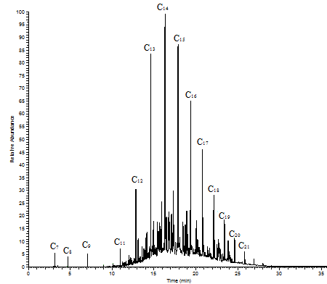
(A) Before MEDS treatment (607 ppm)
(B) After MEDS treatment (5 ppm)

FIGURE 2 CG-MS Chromatogram of Gas Oil Fraction Boiling in the Temperature Range of 250-300 °C (Conditions: Vgasoil= 20 mL, T= 30 °C, NMP/DMF/EG= 2:1:1, Extraction Stage Number= 3, Stirring Speed = 200 rpm for 5 min at 500 W)
(A) Before MEDS treatment (1409 ppm)
(B) After MEDS treatment (9 ppm)

FIGURE 3 CG-MS Chromatogram of Gas Oil Fraction Boiling in the Temperature Range of 300- 360 °C (Conditions: Vgasoil= 20 mL, T= 30 °C, NMP/DMF/EG= 2:1:1, Extraction Stage Number= 3, Stirring Speed = 200 rpm for 5 min at 500 W)

