SUPPORTING INFORMATION

Figure 1S. The TGA data from as-prepared BHAP (a), CA/BHAP (b), and 3,4-DHBA/BHAP (c) powders obtained in the temperature range 25–1000 °C at a heating rate of 10 °C/ min, in the dynamic air atmosphere (flow rate 20 cm³/min)

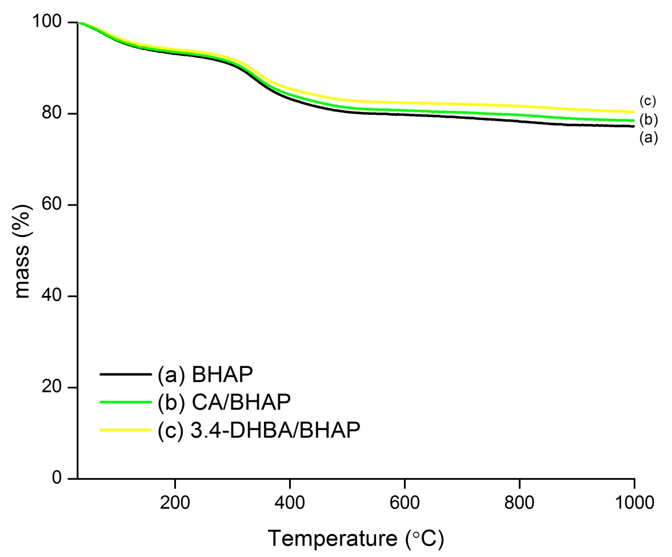

Table S1. Zeta potential of as-prepared BHAP, CA/BHAP, and 3,4-DHBA/BHAP powders dispersed in the inert electrolyte (10⁻² mol/L KNO₃, solid-to-solution ratio 1/200).

Sample | Equilibrium pH | Zeta potential (meV)
BHAP | 7.5±0.1 | -10.3 ± 0.6
CA/BHAP | 7.2±0.1 | -10.5 ± 1.4
3,4-DHBA/BHAP | 7.3±0.1 | -12.3 ± 1.0

Figure S2. Linear fits of Pb equilibrium sorption from five-component equimolar mixtures by BHAP, CA/BHAP, and 3,4-DHBA/BHAP using Langmuir (A) and Freundlich (B) isotherm models

