Supplementary Materials

S1
For simplicity, we assume no competing censorings and that the entry time is 0 for all individuals. Assume random effect variable $Z\sim U(a, b)$. From the simulation method described in section 3, we know that $t|z\sim Exp(λ)$ when $S\left(t\right)=e^{-λt^{ }}$. Treat the number of events $m$ as a random variable, and it can be shown that $m|z\sim Poisson\left(\frac{λT_{tot}}{z}\right)$, where $T_{tot}$ is the total follow-up time. It follows that
$$E\left(m\right)=E\left[E\left(m | z\right)\right]=\int_{a}^{b}{\frac{λT_{tot}}{z}}dz=\left(log⁡(b)-log⁡(a)\right)λT_{tot}$$
$$V\left(m\right)=E\left[V\left(m | z\right)\right]+V\left[E\left(m | z\right)\right]=E\left[V\left(m | z\right)\right]+{\left(λT_{tot}\right)}^{2}\left(E\left(\frac{1}{z^{2}}\right)-E{\left(\frac{1}{z}\right)}^{2}\right)=\int_{a}^{b}{\frac{λT_{tot}}{z}}dz+{\left(λT_{tot}\right)}^{2}\left(\int_{a}^{b}{\frac{1}{z^{2}}}dz-{\left(\int_{a}^{b}{\frac{1}{z}dz}\right)}^{2}\right)=\left(log⁡(b)-log⁡(a)\right)λT_{tot}+{\left(λT_{tot}\right)}^{2}\left(\frac{1}{a}-\frac{1}{b}-{\left(log⁡(b)-log⁡(a)\right)}^{2}\right)$$
By plugging in numbers, $E\left(m\right)$ and $V\left(m\right)$ can be calculated and are shown in Table S1.
Table S1. Expectation and variance of number of events
 | $$λ$$ | $$E\left(m\right)$$ | $$V\left(m\right)$$
U(0.5, 1.5) | $$exp(-4.5)$$ | 2.2 | 2.7
 | $$exp(-4.25)$$ | 2.8 | 3.7
 | $$exp(-4)$$ | 3.6 | 5.0
U(0.1, 1.9) | $$exp(-4.5)$$ | 5.9 | 9.1
 | $$exp(-4.25)$$ | 7.5 | 12.9
 | $$exp(-4)$$ | 9.7 | 18.4
U(0.01, 1.99) | $$exp(-4.5)$$ | 10.6 | 296.4
 | $$exp(-4.25)$$ | 13.6 | 484.8
 | $$exp(-4)$$ | 17.5 | 794.3

S2
We simulated data 5,000 times for each Z distribution and parameter setup using the method described in section 3. For each simulated dataset, we record the largest number of events ($\max_{i}{m_{i}^{*}}$) and calculated the average of this number over 5,000 simulations.

Table S2. Average largest number of events
Z distribution | Parameters: treatment vs placebo | Average $\max_{i}{m_{i}^{*}}$
U(0.5, 1.5) | $$-logλ: 4.25 vs 4$$ | 7.3
 | $$-logλ: 4.5 vs 4$$ | 7.0
U(0.1, 1.9) | $$-logλ: 4.25 vs 4$$ | 15.9
 | $$-logλ: 4.5 vs 4$$ | 15.2
U(0.01, 1.99) | $$-logλ: 4.25 vs 4$$ | 59.4
 | $$-logλ: 4.5 vs 4$$ | 54.8

S3
To show differences in the residual distribution using Jung and Jeong’s method and using our new method, we simulated one dataset for each Z distribution using the method described in Part 3 and show the corresponding residuals using two different methods in Figure S1. Baseline survival distributions for treatment and control groups are $S\left(t\right)=e^{-e^{-4.5}t}$ and $S\left(t\right)=e^{-e^{-4}t}$ respectively. It can be seen that tail part of individual-level residual distribution based on Jung and Jeong’s method is heavier than that based on our new method.

Z distribution | Boxplots of individual-level residuals
U(0.5, 1.5) | 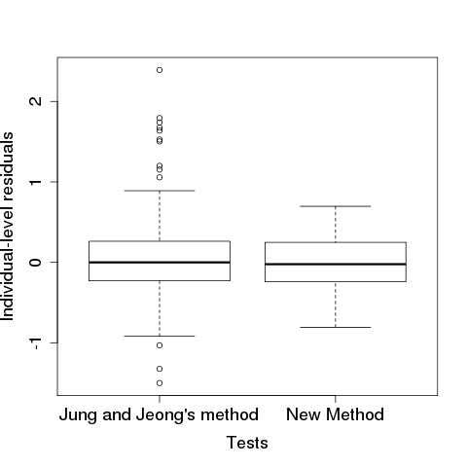
U(0.1, 1.9) | 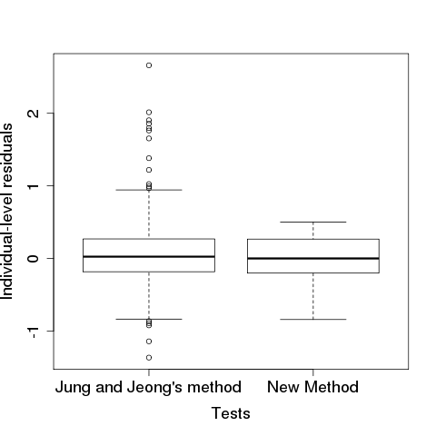
U(0.01, 1.99) | 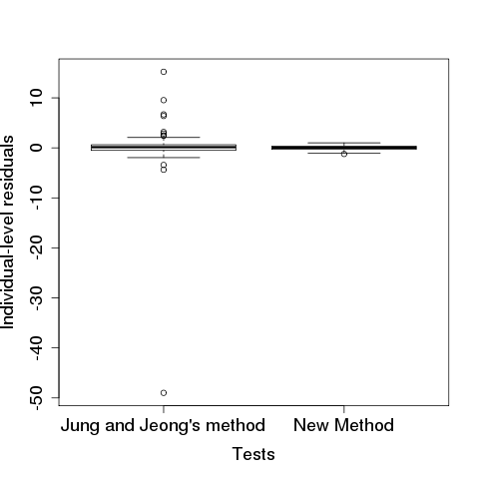
Figure S1 Boxplots of individual-level residuals based on two different methods, given different Z distributions

S4
To further confirm that residuals calculated using Jung and Jeong’s method have a heavy-tailed distribution, we calculated average kurtosis values from 5,000 simulated datasets.

Table S3. Average kurtosis of residual distribution
 |  | Jung and Jeong’s method | New method
Z distribution | Parameters: treatment vs placebo | Average kurtosis ${\hat{ε}}_{i}$ distribution | Average kurtosis of ${{\hat{ε}}_{i}}^{*}$ distribution
U(0.5, 1.5) | $$-logλ: 4.25 vs 4$$ | 7.7 | 2.7
 | $$-logλ: 4.5 vs 4$$ | 8.5 | 2.7
U(0.1, 1.9) | $$-logλ: 4.25 vs 4$$ | 22.5 | 2.5
 | $$-logλ: 4.5 vs 4$$ | 22.9 | 2.5
U(0.01, 1.99) | $$-logλ: 4.25 vs 4$$ | 71.0 | 2.4
 | $$-logλ: 4.5 vs 4$$ | 69.3 | 2.4

