Supplementary Materials
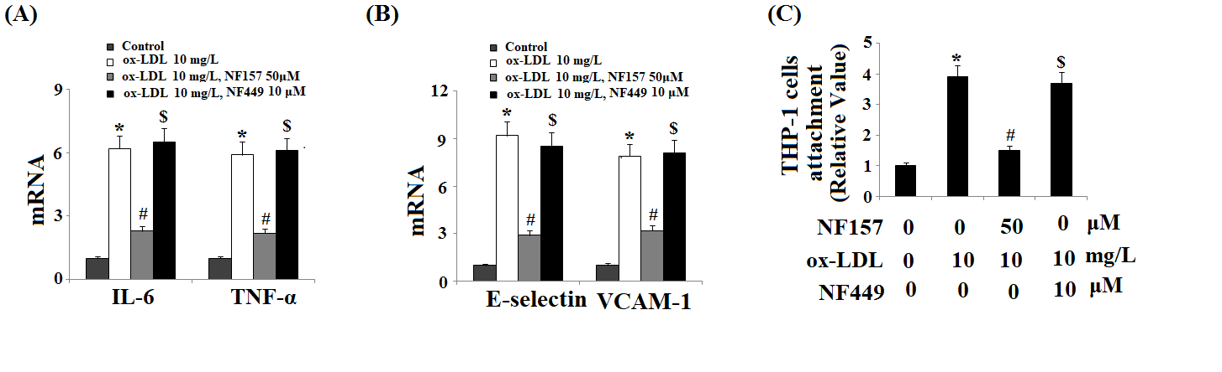
Supplementary Figure 1. The selective P2X1 antagonist NF449 didn’t have a protective effect against ox-LDL- induced endothelial insults. HAECs were treated with 10 mg/L ox-LDL with or without 50 μM NF157 or 10 μM NF449 for 24 h. (A). The expression of IL-6 and TNF-α at the mRNA levels as determined by real time PCR analysis; (B). The expression of E-selectin, and VCAM-1 at the mRNA levels as determined by real time PCR analysis; (C). Quantification of adhesive THP-1 cells to HAECs (*, #, $, P < 0.01 vs. previous column group).

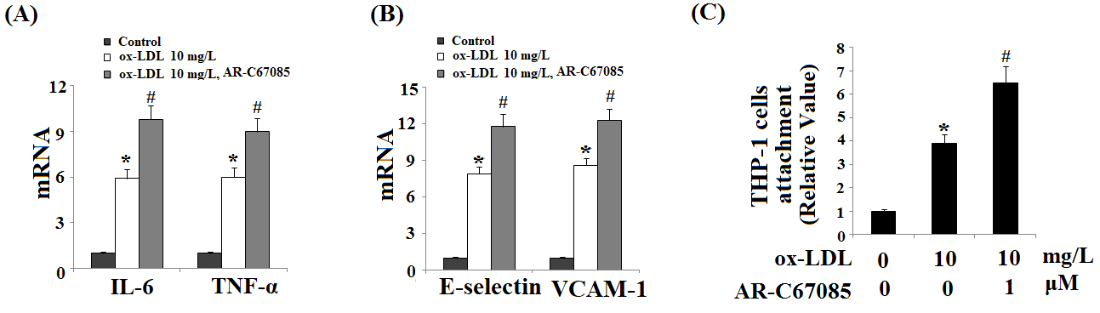
Supplementary Figure 2. The specific P2Y11R agonist AR-C67085 exacerbated the ox-LDL- induced endothelial insults. HAECs were treated with 10 mg/L ox-LDL with or without 1 μM AR-C67085for 24 h. (A). The expression of IL-6 and TNF-α at the mRNA levels as determined by real time PCR analysis; (B). The expression of E-selectin and VCAM-1 at the mRNA levels as determined by real time PCR analysis; (C). Quantification of adhesive THP-1 cells to HAECs (*, #, P < 0.01 vs. previous column group).

