Supplementary Information
for
The removal of Pb (II) and Cd (II) with hydrous manganese dioxide: Mechanism on zeta potential and adsorption behavior

Shanshan Wuª, Fencun Xie ^{a*}

School of Chemistry and Chemical Engineering, South China University of Technology, Guangzhou, 510641, P. R. China

Corresponding author:
Fencun Xie^{a*}
School of Chemistry and Chemical Engineering, South China University of Technology, Guangzhou, 510641, P. R. China
E-mail: acfchxie@scut.edu.cn

Table 1. The number of HMO with different ZP values
 | 1 | 2 | 3 | 4 | 5 | 6 | 7 | 8 | 9 | 10 | 11
MnO₄⁻/Mn²⁺ | 1:1 | 1:1.1 | 1:1.2 | 1:1.3 | 1:1.4 | 1:1.5 | 1:1.6 | 1:1.7 | 1:1.8 | 1:1.9 | 1:2
ZP value(mV) | -51.7 | -49.0 | -44.6 | -42.2 | -40.8 | -38.6 | -35.4 | -32.6 | -29.6 | -26.3 | -21.8

Table 2. The BET analysis of HMOs
 | 1-HMO | 3-HMO | 5-HMO | 7-HMO | 9-HMO | 11-HMO
Zeta potential(mV) | -51.7 | -44.6 | -40.8 | -35.4 | -29.6 | -21.8
Surface area(m²/g) | 66.88 | 64.80 | 62.00 | 60.00 | 59.00 | 58.21
Average pore size(nm) | 5.39 | 7.20 | 7.55 | 8.28 | 12.10 | 15.53

Table 3 The parameter of linear function for Pb (II) and Cd (II)
 | Slope | Intercept | R²
Pb (II) | -7.68 | 75.12 | 0.99
Cd (II) | -2.65 | 0.29 | 0.99

Table 4 The parameters of Langmuir and Freundlich isotherm model
heavy metal | Temperature/K | Langmuir |  |  |  | Freundlich
 |  | Q_{m} (mg/g) | K_{L} | R² |  | K_{F} | 1/n | R²
Pb | 293.15 | 469.1 | 4.3 | 0.99 |  | 365.6 | 0.06 | 0.90
 | 303.15 | 475.4 | 131.1 | 0.97 |  | 416.4 | 0.05 | 0.66
 | 313.15 | 487.0 | 118.7 | 0.99 |  | 435.7 | 0.04 | 0.64
Cd | 293.15 | 128.2 | 20.5 | 0.99 |  | 115.1 | 0.05 | 0.79
 | 303.15 | 140.3 | 6.2 | 0.98 |  | 117.0 | 0.06 | 0.92
 | 313.15 | 154.6 | 3.9 | 0.99 |  | 120.2 | 0.06 | 0.94

Table 5 The comparison of the Langmuir maximum adsorption capacity onto various adsorbents for Pb (II) and Cd (II)
Heavy metal ion | Adsorbents | q_{m} (mg/g) | Refs.
Pb (II) | chitosan functionalized magnetic nanoparticles | 498.6 | [1]
 | HMO | 475.4 | This study
 | sulphuric acid-treated cashew nut shell | 408.6 | [2]
 | surface modified Strychnos potatorum seeds | 166.7 | [3]
 | β-MnO₂ | 13.6 | [4]
Cd (II) | MnO2 nanosheet | 348 | [5]
 | freshly synthesized hydrous manganese dioxide | 168.4 | [6]
 | HMO | 140.3 | This study
 | polying alcohol/polyacrylic acid double network gel | 115.9 | [7]
 | Surface modified Eucalyptus seeds | 71.2 | [8]

Table 6 Thermodynamic parameters for the adsorption of Pb (II) and Cd (II)
 | Initial con. (mg/L) | ΔH (kJ/mol) | ΔS (J/mol/K) | ΔG (kJ/mol)
 |  |  |  | 293.15 | 303.15 | 313.15
Pb | 90 | 164.4 | 596.2 | -10.6 | -16.6 | -22.5
 | 100 | 61.3 | 239.8 | -9.3 | -11.7 | -14.1
 | 110 | 24.2 | 107.9 | -7.6 | -8.7 | -9.8
Cd | 20 | 28.8 | 149.7 | -15.1 | -16.6 | -18.1
 | 30 | 9.5 | 60.7 | -8.3 | -8.9 | -9.5
 | 40 | 5.0 | 35.8 | -5.5 | -5.8 | -6.2

Table 7 The kinetic model constants and correlation coefficients for Pb (II)
 |  | pseudo-first order model |  |  | pseudo-second order model |  |  | intraparticle diffusion model
 |  | q_{e}(mg/g) | k₁(s⁻¹) | R² | q_{e}(mg/g) | k₂(g/mg*s) | R² | k_{p}(mg/g min^{1/2}) | C | R²
Pb | 1-HMO | 465.7 | 0.22 | 0.83 | 467.3 | 0.0069 | 0.99 | 12.06 | 405.7 | 0.95
 | 3-HMO | 419.7 | 0.39 | 0.82 | 421.9 | 0.0056 | 0.99 | 21.19 | 321.1 | 0.74
Cd | 1-HMO | 135.3 | 0.12 | 0.90 | 135.9 | 0.0201 | 0.99 | 2.02 | 122.4 | 0.85
 | 3-HMO | 123.7 | 0.20 | 0.73 | 124.5 | 0.0135 | 0.99 | 3.86 | 100.1 | 0.58

Fig. 1 The relationship between ZP value and ratio of KMnO₄ and MnSO₄
Fig. 2 The XRD spectrum of HMOs with different Zeta potential

Fig. 3 The SEM images of 1-HMO (a), 6-HMO (b) and 11-HMO (c) and TEM images of 1-HMO (d) and 11-HMO (e)
Fig. 4 The correlation between zeta potential and adsorption capacity (a) and removal rate (b)

Fig. 5 Effect of pH on Pb (II) and Cd (II) removal by 1-HMO
Fig. 6 Isotherm adsorption of Pb (II) and Cd (II) on 1-HMO in (a-d)

Fig. 7 Thermodynamic study
Fig. 8 The kinetic study of Pb (II) and Cd (II) on 1 and 3-HMO

Fig. 9 Intraparticle diffusion model

Fig. 10 SEM-EDS spectra of HMO nanoparticles before and after adsorbing Pb (II) and Cd (II)
Fig. 11 The FT-IR spectrum of 1-HMO adsorbent before and after adsorbing Pb (II) and Cd (II)

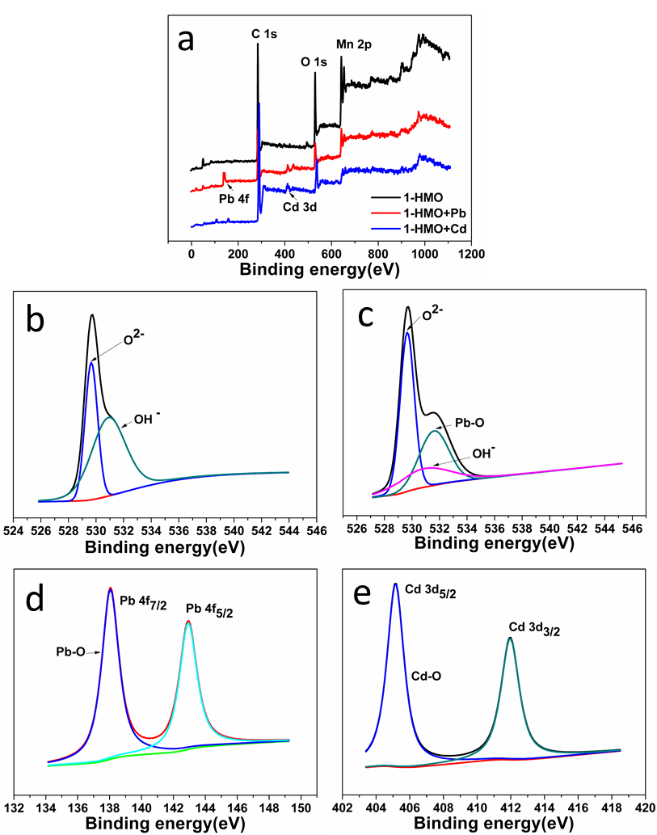
Fig. 12 The XPS full spectrum of 1-HMO before and after adsorption of Pb (II) and Cd (II) (a); O (1s) spectra before adsorption (b) and after adsorption of Pb (II) (c); Pb (4f) spectra (d) and Cd (3d) spectra of 1-HMO after adsorption
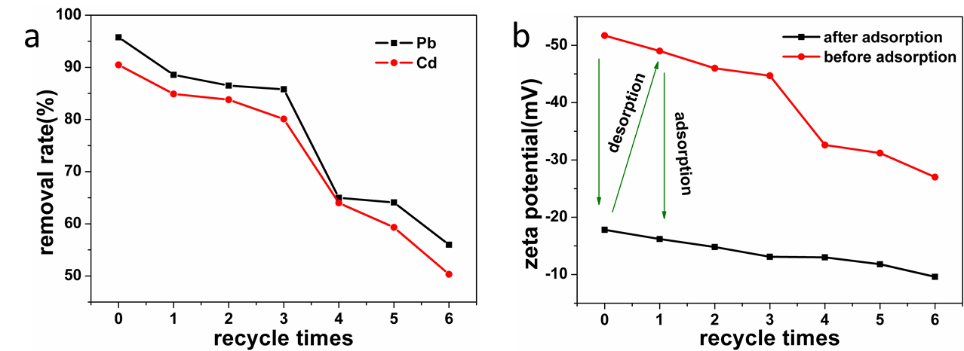
Fig. 13 the removal efficiency of heavy metal ion and ZP value versus recycle times of HMO

References
1. Christopher FC, Anbalagan S, Kumar PS, Pannerselvam SR, Vaidyanathan VK: Surface adsorption of poisonous Pb(II) ions from water using chitosan functionalised magnetic nanoparticles. Iet Nanobiotechnol 2017, 11(4):433-442.
2. Kumar PS, Ramalingam S, Abhinaya RV, Thiruvengadaravi KV, Baskaralingam P, Sivanesan S: Lead(II) Adsorption onto Sulphuric Acid Treated Cashew Nut Shell. Sep. Sci. Technol.2011, 46(15):2436-2449.
3. Senthil Kumar P, Senthamarai C, Sai Deepthi ASL, Bharani R: Adsorption isotherms, kinetics and mechanism of Pb(II) ions removal from aqueous solution using chemically modified agricultural waste. Canadian J. Chem. Eng. 2013, 91(12):1950-1956.
4. Zhao D, Yang X, Zhang H, Chen C, Wang X: Effect of environmental conditions on Pb(II) adsorption on β-MnO2. Chem. Eng. J. 2010, 164(1):49-55.
5. Peng L, Zeng Q, Tie B, Lei M, Yang J, Luo S, Song Z: Manganese Dioxide nanosheet suspension: A novel absorbent for Cadmium(II) contamination in waterbody. J. Colloid. Interf. Sci. 2015, 456:108-115.
6. Zhai Y, Wang H: Kinetics and mechanism study on adsorption of cadmium by freshly synthesized hydrous manganese dioxide. Desalin. Water Treat 2015, 57(15):6981-6990.
7. Chu L, Liu C, Zhou G, Xu R, Tang Y, Zeng Z, Luo S: A double network gel as low cost and easy recycle adsorbent: Highly efficient removal of Cd(II) and Pb(II) pollutants from wastewater. J. Hazard. Mate. 2015, 300:153-160.
8. Kiruba UP, Kumar PS, Prabhakaran C, Aditya V: Characteristics of thermodynamic, isotherm, kinetic, mechanism and design equations for the analysis of adsorption in Cd(II) ions-surface modified Eucalyptus seeds system. J. Taiwan Institute. Chem. Eng. 2014, 45(6):2957-2968.

