|  |  |  |  |  |  |  |  |  |  |  |
| --- | --- | --- | --- | --- | --- | --- | --- | --- | --- | --- |
| **Supplementary Table 1:** Observations for the different environmental samples grown in various mediums and results pertaining to growth and terminal electron acceptor reduction. | | | | | | | | | | |
| **Sample** | **Enrichment media** | **Aerobic Growth Observed** | | | **Anaerobic Growth Observed** | | | **Gram stain Results** | **Live/Dead Stain results** | **Reduction of electron acceptor** |
| **25 °C** | **37 °C** | **50 °C** | **25 °C** | **37 °C** | **50 °C** |
| Free State Groundworks | Mineral salts-BTEX medium | Yes | Yes | No | Yes | No | No | Gram negative rods | > 90 % Live Cells | Nitrate reduction; no sulphate reduction |
| Bushnell Hass Broth | Yes | Yes | No | Yes | No | No | Gram negative rods | > 90 % Live Cells | Nitrate reduction; no sulphate reduction |
| Mineral salts medium | Yes | Yes | No | Yes | No | No | Gram negative rods | > 90 % Live Cells | Nitrate reduction; no sulphate reduction |
| Methanogenic medium | No | No | No | No | No | No | Not Tested | Not Tested | Not tested |
| Sulphate reducing media | No | No | No | No | No | No | Gram negative rods | < 10 % Live Cells | No sulphate reduction |
| Nitrate reducing media | Yes | Yes | No | Yes | No | No | Gram negative rods | > 90 % Live Cells | Nitrate reduction |
|  |  |  |  |  |  |  |  |  |  |  |
| Star Diamonds | Mineral salts-BTEX medium | Yes | Yes | Yes | Yes | Yes | No | Gram negative rods | > 90 % Live Cells | Nitrate reduction; no sulphate reduction |
| Bushnell Haas Broth | Yes | Yes | Yes | Yes | Yes | No | Gram negative rods | > 90 % Live Cells | Nitrate reduction; no sulphate reduction |
| Mineral salts medium | Yes | Yes | Yes | Yes | Yes | No | Gram negative rods | > 90 % Live Cells | Nitrate reduction; no sulphate reduction |
| Methanogenic medium | No | No | No | No | No | No |  | < 10 % Live Cells | Not tested |
| Sulphate reducing media | Yes | Yes | Yes | Yes | Yes | No | Gram negative rods | > 90 % Live Cells | Low sulphate reduction |
| Nitrate reducing media | Yes | Yes | Yes | Yes | Yes | No | Gram negative rods | > 90 % Live Cells | Nitrate reduction |

**Supplementary Table 2:** Closest GenBank reference obtained for DGGE band sequences from different sampling sites.

|  |  |  |  |  |
| --- | --- | --- | --- | --- |
| **Consortium** | **Phylotype** | **Phylogenetic Affiliation** | **Closest Relative** | **Identity** |
| **Star Diamonds** | B1 | Deinococci | *Meiothermus ruber* strain 21 | 89 % |
|  | B2 | γ-Proteobacteria | *Thioalkalivibrio sulfidophilus* strain HL-EbGR7 | 89 % |
|  | B3 | γ-Proteobacteria | Uncultured low G+C Gram-positive bacterium clone ML623J-26 | 75 %\* |
|  |  |  |  |  |
| **Free State Groundworks** | A1 | Flavobacteria | *Epilithonimonas xixisoli* strain S31 | 94 % |
|  | A2 |  | Uncultured bacterium clone 3N21hH100 | 79 %\* |
|  | A3 |  | *Citrobacter* *amalonaticus* strain CECT 863 | 100 % |
|  | A4 | γ-Proteobacteria | *Dokdonella koreensis* strain DS-123 | 83 % |
|  | A5 | γ-Proteobacteria | *Pseudomonas balearica* strain SP1402 | 87 % |
|  | A6 | γ-Proteobacteria | *Pseudoxanthomonas spadix* strain IMMIB AFH-5 | 99 % |
|  | A7 | γ-Proteobacteria | *Hydrocarboniphaga daqingensis* strain NBRC | 81 % |
|  | A8 |  | *Citrobacter amalonaticus* strain CECT 863 | 99 % |
|  | A9 |  | *Citrobacter* *amalonaticus* strain CECT 863 | 100 % |
|  | A10 |  | *Citrobacter* *amalonaticus* strain CECT 863 | 99 % |

\*Sequences omitted from GenBank submission due to low identity.

|  |  |  |  |  |
| --- | --- | --- | --- | --- |
| **Supplementary Table 3:** Closest GenBank reference obtained for DGGE band sequences from different enrichment samples. | | | | |
| **Consortium** | **Phylotype** | **Phylogenetic Affiliation** | **Closest Relative** | **Identity** |
|  |  |  |  |  |
| **Star Diamonds Soil 25 °C Aerobic Enrichment** | A1 | γ-Proteobacteria | *Pseudomonas knackmussii* strain B13 | 99 % |
| A2 | β-Proteobacteria | *Luteibacter jiangsuensis* strain JW-64-1 | 99 % |
| A3 | β-Proteobacteria | *Pseudomonas denitrificans* ATCC 13867 | 99 % |
| A4 | γ-Proteobacteria | *Acinetobacter baumannii* ATCC 17978 | 91 % |
| A5 | γ-Proteobacteria | *Comamonas odontotermitis* strain Dant 3-8 | 99 % |
| A6 | γ-Proteobacteria | *Achromobacter xylosoxidans* strain LMG 1863 | 99 % |
|  |  |  |  |  |
| **Star Diamonds Soil 37 °C Aerobic Enrichment** | B1 | α-Proteobacteria | *Dyella jiangningensis* strain SBZ3-12 | 97 % |
| B2 | Bacilli | *Ochrobactrum intermedium* strain NBRC 15820 | 100 % |
|  |  |  |  |  |
| **Star Diamonds Soil 50 °C Aerobic Enrichment** | C1 | Bacilli | *Anoxybacillus rupiensis* strain R270 | 99 % |
|  |  |  |  |  |
| **Star Diamonds Soil 25 °C Anaerobic Enrichment** | D1 | γ-Proteobacteria | *Pseudomonas denitrificans* ATCC 13867 | 91 % |
| D2 | γ-Proteobacteria | *Enterobacter ludwigii* strain EN-119 | 99 % |
|  |  |  |  |  |
| **Star Diamonds Soil 37 °C Anaerobic Enrichment** | E1 | γ-Proteobacteria | *Pseudomonas stutzeri* A1501 | 99 % |
| E2 | γ-Proteobacteria | *Pseudomonas stutzeri* strain KJ-W22 | 99 % |
|  |  |  |  |  |
| **Free State Groundworks 25 °C Aerobic Enrichment** | F1 | β-Proteobacteria | *Massilia varians* strain CCUG 35299 | 98 % |
| F2 | β-Proteobacteria | *Massilia niastensis* strain 5516S-1 | 99 % |
| F3 | γ-Proteobacteria | *Pseudomonas taeanensis* strain MS-3 | 92 % |
| F4 | γ-Proteobacteria | *Pseudomonas luteola* strain NBRC 103146 | 98 % |
| F5 | γ-Proteobacteria | *Citrobacter amalonaticus* strain CECT 863 | 100 % |
|  |  |  |  |  |
| **Supplementary Table 3: (Continued):** Closest GenBank reference obtained for DGGE band sequences from different enrichment samples. | | | | |
| **Consortium** | **Phylotype** | **Phylogenetic Affiliation** | **Closest Relative** | **Identity** |
| **Free State Groundworks 37 °C Aerobic Enrichment** | G1 | γ-Proteobacteria | *Escherichia vulneris* strain NBRC 102420 | 99 % |
| G2 | γ-Proteobacteria | *Pseudomonas aeruginosa* strain SNP0614 | 99 % |
| G3 | γ-Proteobacteria | *Dyella jiangningensis* strain SBZ3-12 | 94 % |
|  |  |  |  |  |
| **Free State Groundworks 25 °C Anaerobic Enrichment** | H1 | γ-Proteobacteria | *Salmonella enterica subsp. indica* strain DSM 14848 | 99 % |
| H2 | γ-Proteobacteria | *Citrobacter amalonaticus* strain CECT 863 | 98 % |
| H3 | γ-Proteobacteria | *Citrobacter amalonaticus* strain CECT 863 | 98 % |
| H4 | γ-Proteobacteria | *Citrobacter amalonaticus* strain CECT 863 | 98 % |
|  | H5 | γ-Proteobacteria | *Citrobacter amalonaticus* strain CECT 863 | 99 % |
| H6 | γ-Proteobacteria | *Citrobacter amalonaticus* strain CECT 863 | 99 % |
| H7 | γ-Proteobacteria | *Pseudomonas aeruginosa* strain SNP0614 | 100 % |
| H8 | γ-Proteobacteria | *Pseudomonas aeruginosa* strain SNP0614 | 99 % |

C:\Users\iateh_000\AppData\Local\Microsoft\Windows\INetCache\Content.Word\Figure 1- new.tif

**(B)**

**Fig. 1**

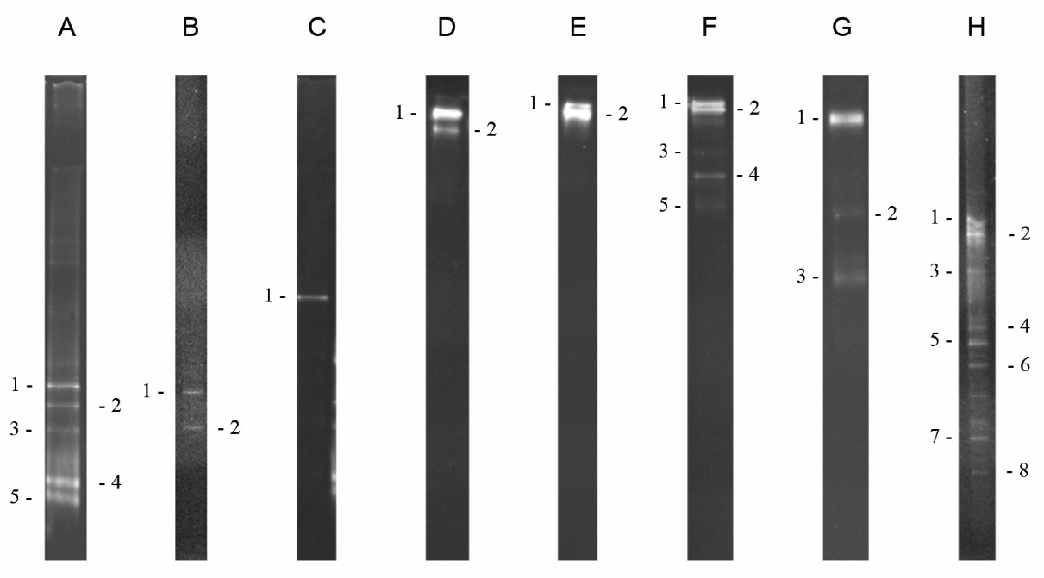

**Fig. 2**



**Fig. 3**



**Fig. 4**

**M 1 2 3 4 5 6 7 8 9 10 11 M**

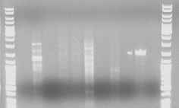

**Supplementary Fig. 1**

|  |  |  |  |
| --- | --- | --- | --- |
| **Primer set/Lane Number:** | **Forward and Reverse sequences** | **Amplicon size (bp)** | **Reference** |
| 1. (targets *ass*A and *bss*A) | ass/bssF: 5’-TTTGAGTGCATCCGCCAYGGICT-3’  ass/bssR: 5’-TCGTCRTTGCCCCATTTIGGIGC-3’ | *ass*A: 661  *bss*A: 682 | [20] |
| 2. (targets *bss*A) | 7772F: 5’-GAC ATG ACC GAC GCS ATY CT-3’  8546R: 5’-TCG TCG TCR TTG CCC CAY TT-3’ | 793 | [61] |
| 3. (targets *ass*A) | 1294F: 5’-TTSGARTGCATCCGNCACGGN-3’  1936R: 5’-TCRTCATTNCCCCAYTTNGG-3’ | 661 | [20] |
| 4. (targets *ass*A) | 1294F: 5’-TTSGARTGCATCCGNCACGGN-3’  2457R: 5’-TTGTCCTGNGTYTTGCGG-3’ | 1180 | [20] |
| 5. (targets *ass*A) | 1294dF: 5’-TTYGAGTGYATNCGCCASGGC-3’  1936R: 5’-TCRTCATTNCCCCAYTTNGG-3’ | 661 | [20] |
| 6. (targets *ass*A) | 1294dF: 5’-TTYGAGTGYATNCGCCASGGC-3’  2457R: 5’-TTGTCCTGNGTYTTGCGG-3’ | 1180 | [20] |
| 7. (targets *ass*A) | 1432F: 5’-CCNACCACNAAGCAYGG-3’  1936R: 5’-TCRTCATTNCCCCAYTTNGG-3’ | 523 | [20] |
| 8. (targets *ass*A) | 1432F: 5’-CCNACCACNAAGCAYGG-3’  2457R: 5’-TTGTCCTGNGTYTTGCGG-3’ | 1042 | [20] |
| 9. (targets *ass*A) | 1432F: 5’-CCNACCACNAAGCAYGG-3’  ass/bssR: 5’-TCGTCRTTGCCCCATTTIGGIGC-3’ | 523 | [20] |
| 10. Positive Control (Targets 16S) | 27F: 5' - AGA GTT TGA TCM TGG CTC AG - 3'  1492R: 5' - GGT TAC CTT GTT ACG ACT T-3' | 1500 | [62] |