Supplementary Material
Oxidation-precipitation of magnetic Fe₃O₄/AC nanocomposite as a heterogeneous catalyst for electro-Fenton treatment

Pegah Nazariª, Neda Askariª, Shahrbanoo Rahman Setayeshª*
ªDepartment of Chemistry, Sharif University of Technology, Azadi Avenue, Tehran, PO Box 11155-3516, Iran

*Corresponding author Telephone: +98-21-66165338, E-mail: setayesh@sharif.edu

Synthesis of Fe₃O₄ NPs
4.000 g of iron (II) sulfate heptahydrate and 1.800 g of sodium nitrate were dissolved in 200 ml of double distilled water and the solution was deoxygenated using Ar gas. After 20 min, the resulted solution was heated to 333 K and 20 ml ammonium hydroxide (28%) was added dropwise, under vigorous stirring. The temperature was kept at 333 K for 1 h. The mixture was cooled to room temperature and the solid was collected by a magnetic bar. The precipitate was washed with double distilled water until reaching pH=7 and dried in vacuum oven at 353 K for 12 h.

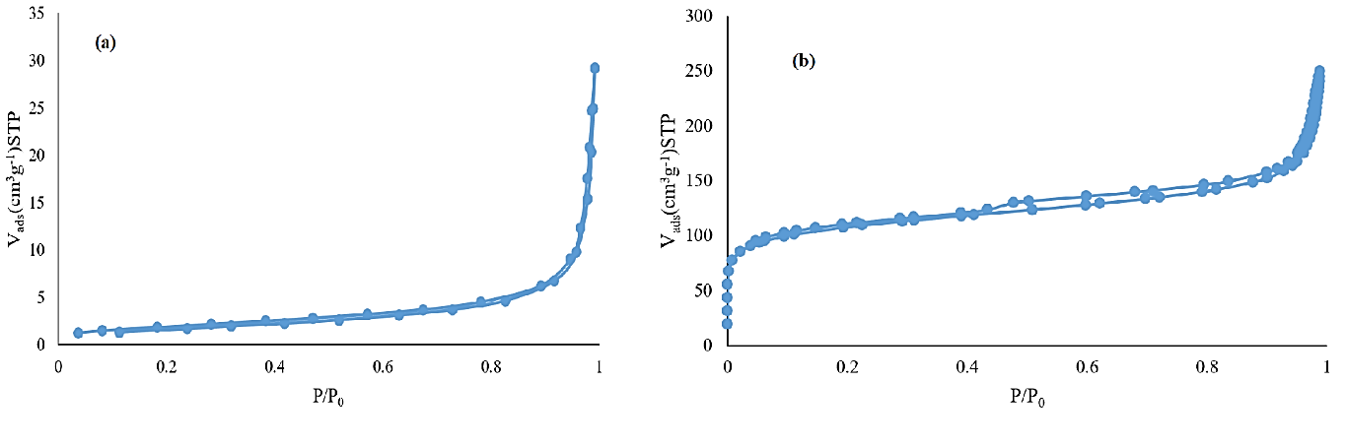
Figure S1. Nitrogen adsorption/desorption isotherms for (a) Fe₃O₄ and (b) Fe₃O₄/AC

Figure S2. The magnetization hysteresis loops of (a) Fe₃O₄ and (b) Fe₃O₄/AC
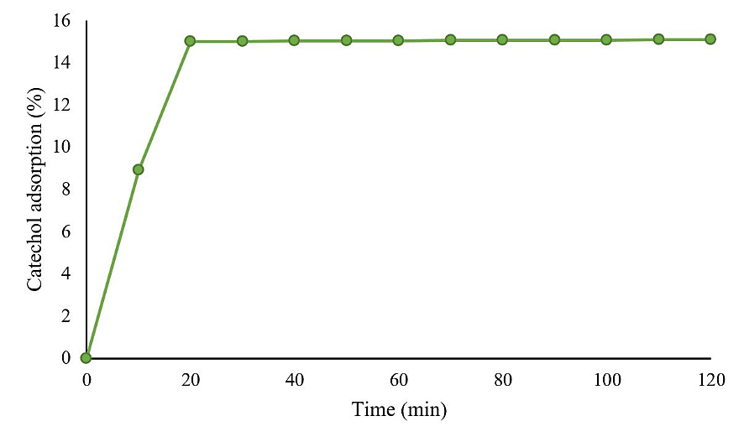
Figure S3. Catechol adsorption on the surface of catalyst before EF reaction (pH 3, Fe₃O₄/AC: 1.2 g L⁻¹, Catechol: 1.0 × 10⁻³ mol L⁻¹)

Figure S4. Catechol removal by various processes at the optimum conditions (pH 3, Fe₃O₄/AC: 0.9 g L⁻¹, Na₂SO₄: 0.05 mol L⁻¹, Catechol: 8.0×10⁻⁴ mol L⁻¹ at I: 120 mA)

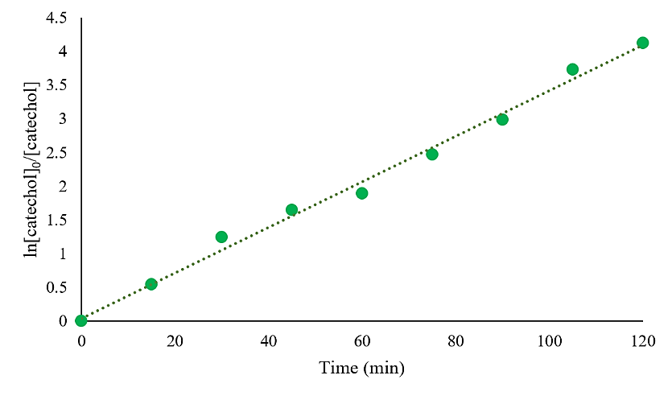
Figure S5. Plot of ln ([catechol]₀/[catechol]) versus time for catechol removal at the optimized condition (pH 3, Fe₃O₄/AC : 0.9 g L⁻¹, Na₂SO₄: 0.05 mol L⁻¹, Catechol: 8.0×10⁻⁴ mol L⁻¹ at 120 mA)

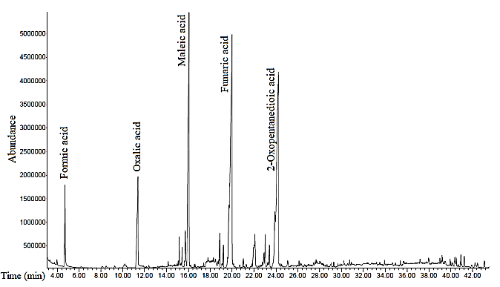
Figure S6. GC-MS chromatogram of sample after 90 min EF degradation of catechol (pH 3, Fe₃O₄/AC: 0.9 g L⁻¹, Na₂SO₄: 0.05 mol L⁻¹, Catechol: 8.0×10⁻⁴ mol L⁻¹ at 120 mA)

