**Supplementary file**

**Effects of cerium oxide nanoparticles on biochemical and oxidative parameters in marigold leaves**

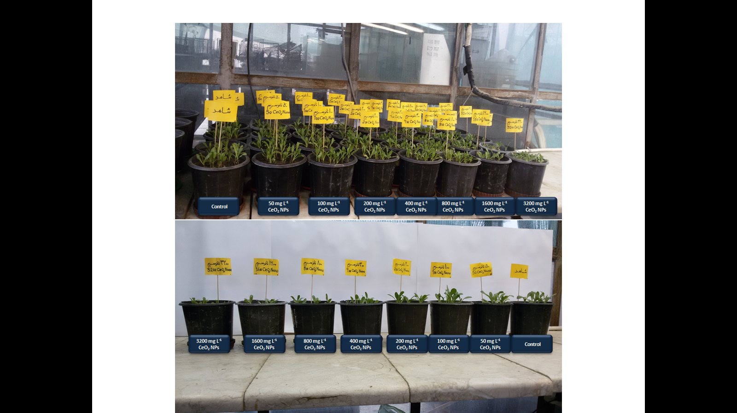

**Fig. S1.** Effects of foliar application of CeO2 NPs (50-3200 mg L-1) on marigold grown in a greenhouse.

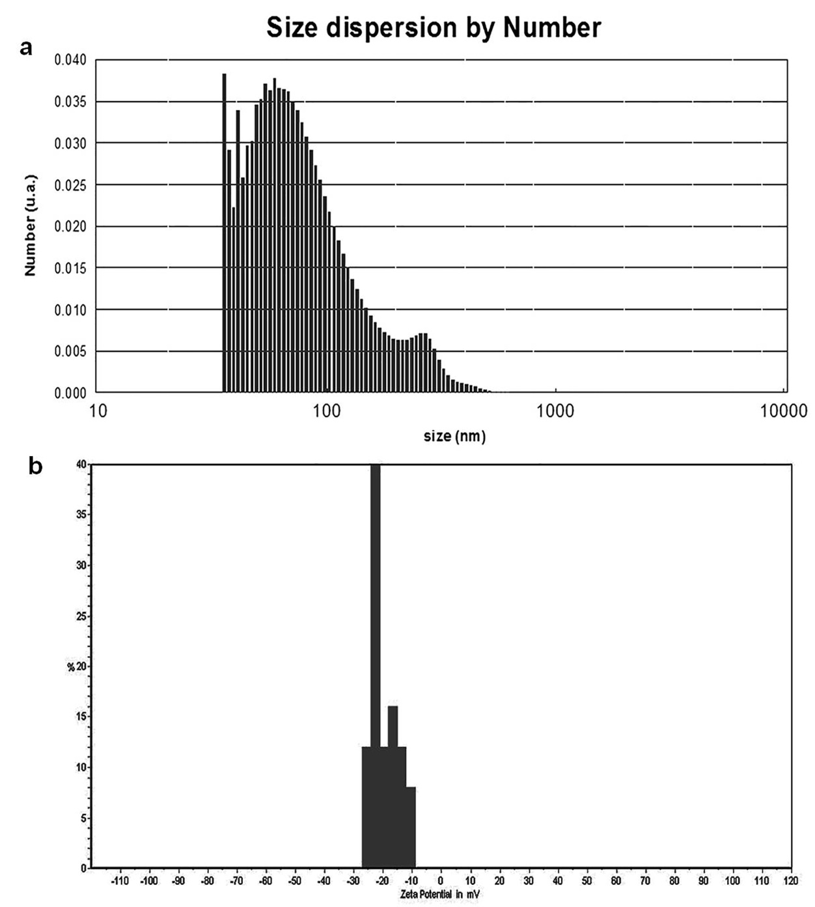

**Fig. S2.** Hydrodynamic diameter (a) and zeta potential (b) of CeO2 NPs.

**Abbreviations**:

**AFM,** atomic force microscopy; **AsA,** ascorbate; **CeO2 NPs,** cerium oxide nanoparticles; **DHA,** dehydroascorbate; **DPPH,** 2,2-diphenyl-1-picrilhydrazil; **DW,** dry weight; **FW,** fresh weight; **GSH,** reduced glutathione; **LOX,** lipoxygenase; **MDA,** malondialdehyde; **MSI,** membrane stability index; **PAL,** phenylalanine ammonia lyase; **ROS,** reactive oxygen species; **RWC,** relative water content; **TAL,** tyrosine ammonia lyase; **TEM,** transmission electron microscopy; **XRD,** X-ray diffractometer.

