Supplementary Materials
Materials
STUDY 1

The following is an approximate English-language translation of the original Japanese. Variations for the material condition are in square brackets.

**Instruction**: Please think of an event that you recently planned, that was meant to be an experience (e.g., going to a concert, going to a trip, going on a date), but was canceled or ruined because of someone else. [an object that you used to possess (e.g., a laptop, a book, a glass), but no longer possess or use because someone lost, broke, or damaged it.] This could be anything, from a potentially life changing experience (e.g., participating in an audition) to a mundane experience (e.g., studying with a friend). [from an object of great value (e.g., a car) to an object of little monetary value (e.g., a pencil).]

What was this intended “experience” [“object”]?
When did the situation occur? Year(s) / Month(s) / Day(s) ago
Approximately how much time did you spend planning [was the object worth]?
Year(s) / Month(s) / Day(s) / Hour(s) [JPY]
*Material condition only
[Did you have any strong feelings or a special connection to the object? Yes / No]

**Instruction**: In this section, we will ask about the person who ruined your experience. [who lost, broke, or damage the object.]

Who was the person?
(a) Family (b) Romantic partner (c) Friend (d) Acquaintance
(e) Other (for example, customer service, a stranger, etc.): please specify

What did the person do after the episode? Please read through the following list of behaviors, and place a check by all that apply. **Transgression Appeasement and Reconciliation Checklist (Tabak et al., 2012)**
1. Started physical contact |  | 11. Showed concern for your condition (e.g., was responsive to your needs)
2. Started communication |  | 12. Showed concern for the relationship
3. Expressed shame |  | 13. Tried to repair the harm or damage
4. Admitted regret |  | 14. Asked for forgiveness
5. Showed remorse |  | 15. Explained or expressed that the harm or hurt was unintentional
6. Showed submissiveness or inhibited speech |  | 16. Showed embarrassment

(cont.)
7. Showed modesty or humility |  | 17. Assured you that he/she is trustworthy
8. Admitted or explained his/her responsibility |  | 18. Showed politeness
9. Apologized |  | 19. Made fun of themselves or put themselves down about it
10. Offered you a gift or favor (e.g., food or help with something) |  | 20. Did not do anything described above

To what extent did you forgive the person?
1…………..2…………..3…………..4…………..5…………..6
(not at all) (totally)

**Instruction**: In the following section, we will ask about whether the person offered any compensation regardless of whether you accepted it or not. Here, compensation means any action which tried to repair the loss, such as rescheduling the experience [providing a replacement object] or reimbursing money.

Did the person offer any compensation? Yes/No

### If “Yes”, please answer the following questions:

a) What was the compensation?
b) Did you accept it? Yes/No
c) To what extent did you feel your loss was (or would be, if you did not accept it) recovered by the compensation?
1…………..2…………..3…………..4…………..5…………..6
(not at all recovered) (fully recovered)

Did you think your loss was replaceable?

1…………..2…………..3…………..4…………..5…………..6
(not at all replaceable) (completely replaceable)

STUDY 2
The following is an approximate English-language translation of the original Japanese. Variations for the irreplaceable condition are in square brackets. The order of the scenarios was counterbalanced. The instructions were the same between scenarios. Some questions irrelevant to the present purpose were also included in the questionnaire. Although we do not report those questions here (because we are preparing a separate manuscript reporting on those variables), the full questionnaire is available from the corresponding author upon request.

**Instruction**: Please read the following story and imagine the situation as clearly as possible.
Book scenario:
One of your friends borrowed your prized book. The book, which was written by a well-known novelist, was in a like-new condition. [a signed first edition of the book; you will never get the same one again.] However, while reading the book, your friend accidentally tripped and spilled his/her coffee on the book. Although he/she wiped it off immediately, the book is now visibly stained with coffee. After reading the book, your friend told you that he/she stained your book with coffee.

**Instruction:** Please read the rest of the scenario and answer the following questions.
Compensation: Your friend did not apologize at all for staining the book, but bought a new copy of the same book and returned it to you.

or

Apology: Your friend apologized for staining the book, saying, “I’m sorry I stained the book.” Then, he/she returned the stained book to you.

**Instruction**: Please imagine that the series of events described above actually happened to you. Then, please imagine as clearly as possible how you would feel in this situation, and answer the following questions.

To what extent would you forgive this friend?
1…………..2…………..3…………..4…………..5…………..6
(not forgive at all) (forgive completely)

To what extent was the loss recovered by this your friend’s behavior?
1…………..2…………..3…………..4…………..5…………..6
(not recovered at all) (completely recovered)

Baseball Game Scenario
You and one of your friends heard there was a baseball game in the local stadium, and bought a pair of tickets, which were a good deal. Both of you looked forward to watching the game because it was the first of three consecutive games of your favorite team to be played in the stadium. [the last game of your favorite team to be played in the stadium.] On the day of the game, you waited and waited, but the friend did not show up. Also, you could not contact him/her. Because your friend had both tickets, you could not enter the stadium. Your friend ended up arriving two hours late, so you and your friend missed the baseball game.

**Instruction:** Please read the rest of the scenario and answer the following questions.

Compensation: Your friend did not apologize at all for being late, but bought you a new ticket for the next game (where your favorite team would be playing [where your favorite team would not be playing]) in the stadium.

or

Apology: Your friend apologized for being late, saying, “I’m really sorry I’m late.”

The Order Effect in Study 2

When a 2 (order: Book first or Baseball Game first) × 2 (replaceability: irreplaceable loss or replaceable loss) × 2 (type of loss: material loss or experiential loss) × 2 (type of conciliatory act: compensation or apology) mixed design ANOVA was conducted on forgiveness, the order × type of conciliatory act × type of loss interaction effect was significant, F(1, 177) = 5.51, p = .020, η² = .03, as well as the order × type of loss interaction effect, F(1, 177) = 22.34, p < .001, η² = .11. The main effect and other interaction effects including the order effect were not significant, Fs < 3.27, p > .072. Also, when another ANOVA was conducted with the same factors, but with perceived recovery as the dependent variable, the order × type of loss and order × type of conciliatory act interaction effects were significant, F(1, 177) = 12.60, p < .001, η² = .07 and F(1, 177) = 3.98, p = .048, η² = .02, respectively. The main effect and other interaction effects including the order effect were not significant, Fs < 2.15, p > .14. Admittedly, we do not have good explanations for these interaction effects involving scenario order. However, as can be seen in Table 4 and Figure 2, the replaceable-book-compensation combination evoked a particularly high level of perceived recovery and forgiveness. Those who were exposed to this combination might have negatively responded to the next scenario due to a contrast effect. Thus, the unexpected interactions involving scenario order might have been caused by the exceptionally high endorsement for compensating an irreplaceable book. It is noteworthy that, at the same time, as expected, ANOVA tests revealed replaceability × type of conciliatory act × type of loss interaction effects, F(1, 177) = 6.85, p = .010, η² = .04 for forgiveness and F(1, 177) = 14.67, p < .001, η² = .08 for perceived recovery; the patterns of the results were not different between the Book first and the Baseball Game first conditions.
To address the order effect, we also conducted analyses using only the data related to the scenario participants first read. The data would provide the cleanest and most sensitive reactions to the manipulation. We conducted a type of loss × irreplaceability × type of conciliatory act ANOVA on the perceived recovery and on forgiveness, and a series of mediation analysis (i.e., irreplaceability -> the perceived recovery -> forgiveness), and tested whether the main findings could be replicated or not when considering the order effect.
Perceived Recovery. First, to examine whether perceived recovery was influenced by replaceability and type of conciliatory act, we conducted a type of loss × irreplaceability × type of conciliatory act ANOVA on the perceived recovery of the loss (Table S1). The means and standard errors of the perceived recovery for each type of loss are shown in Figure S1. As expected, there was an interaction effect of irreplaceability × type of conciliatory act (Table S1). Regardless of scenarios, compensation was more likely to lead to a perceived recovery of the replaceable loss than the irreplaceable loss, F(1, 88) = 37.31, p < .001, whereas there was no difference in the case of apology, F(1, 89) = 3.02, p = .086. As shown in Table S1, the 3-way interaction effect did not reach conventional significance level; this interaction effect was not qualified by type of loss.
Forgiveness. We also conducted a type of loss × replaceability × type of conciliatory act between-subject factor ANOVA on forgiveness (Table S1). The means and standard errors are shown in Figure S2. Most importantly, as expected, there was an interaction effect of replaceability × type of conciliatory act (Table S1). Regardless of type of loss (i.e., experiential loss vs. material loss), individuals who received compensation were more likely to forgive their perpetrator in the replaceable loss condition than in the irreplaceable loss condition, F(1, 88) = 17.09, p < .001, whereas there was no difference in the case of apology, F(1, 89) = 0.67, p = .41. Any other interaction effects did not reach the conventional significance level (Table S1).
Mediation by perceived recovery. Finally, we conducted mediation analyses to test whether the effect of replaceability on forgiveness was mediated by perceived recovery, using a SPSS macro, PROCESS (Hayes, 2013). The mediation analyses were conducted separately for the Book and Baseball Game scenarios. We first confirmed that forgiveness was predicted by the replaceability manipulation (A dummy-coded variable, 0 = replaceable loss, 1 = irreplaceable loss; b = -1.21, SE = 0.41, 95%CI = [-2.04, -0.38], t(41) = -2.94, p = .005 for the Book scenario and b = -0.94, SE = 0.33, 95%CI = [-1.60, -0.28], t(47) = -2.87, p = .006 for the Baseball Game scenario). As predicted, when perceived recovery was entered into the model, the effect of the replaceability manipulation became non-significant, b = 0.22, SE= 0.54, 95%CI = [-0.88, 1.31], t(40) = 0.40, p = .69 for the Book Scenario and b = -0.44, SE = 0.25, 95%CI = [-0.95, 0.08], t(46) = -1.72, p = .093 for the Baseball Game scenario. Tests of the indirect effect showed that the effect of the replaceability on forgiveness was explained by a feeling of perceived recovery (see Figure S3).

Table S1. ANOVA (Study 2)
Variables | F | p | partial η²
Perceived Recovery
Irreplaceability | 9.93 | .002 | .053
Type of conciliatory act | 0.09 | .767 | .000
Type of loss | 4.41 | .037 | .024
Irreplaceability x type of conciliatory act | 31.16 | .000 | .150
Irreplaceability x Type of loss | 8.41 | .004 | .045
Type of conciliatory acts x Type of loss | 0.49 | .485 | .003
Irreplaceability x Type of conciliatory acts x Type of loss | 0.87 | .352 | .005
Forgiveness
Irreplaceability | 7.06 | .009 | .038
Type of conciliatory acts | 48.89 | .000 | .216
Type of loss | 0.42 | .518 | .002
Irreplaceability x Type of conciliatory acts | 13.74 | .000 | .072
Irreplaceability x Type of loss | 0.17 | .677 | .001
Type of conciliatory acts x Type of loss | 0.85 | .358 | .005
Irreplaceability x Type of conciliatory acts x Type of loss | 0.13 | .715 | .001
Note. df1 = 1, df2 = 177. Bold numbers indicate statistical significance at p < .05.

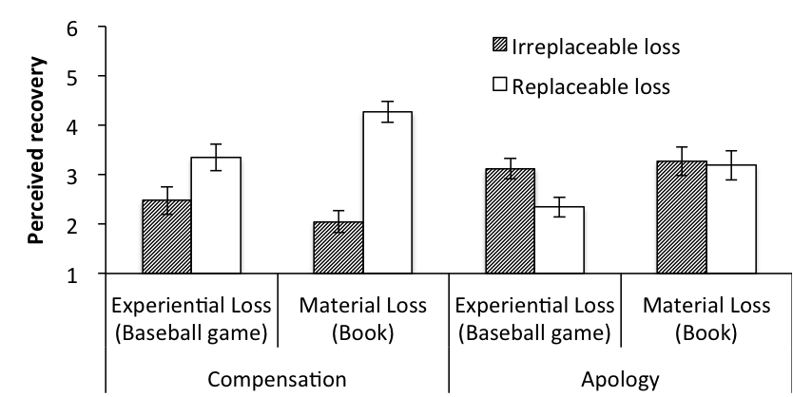

Figure S1. The means and standard errors of perceived recovery (Study 2)

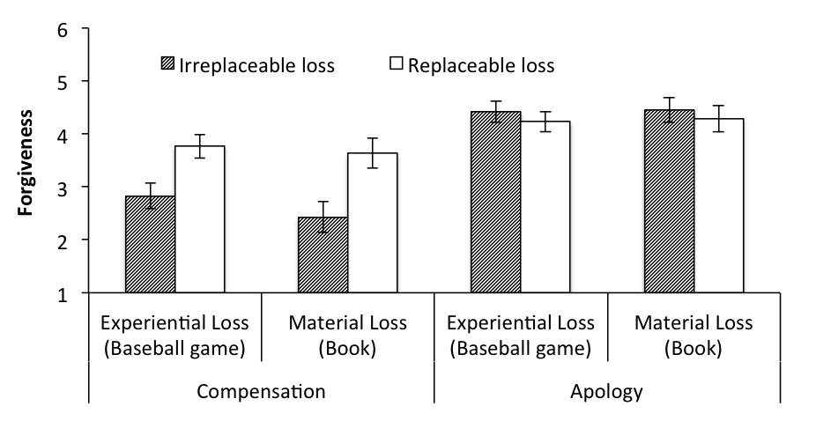

Figure S2. The means and standard errors of forgiveness (Study 2)

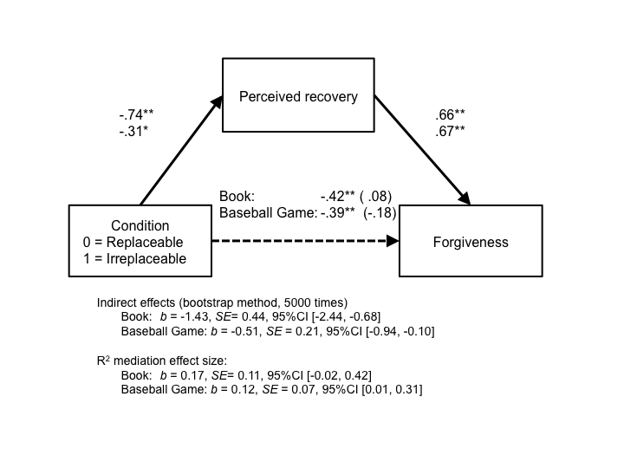
Figure S3. A mediation model (Study 2). The standardized regression coefficients between replaceable/irreplaceable condition and forgiveness controlling for the extent of perceived recovery are in parentheses.
**p < .01, *p < .05.

