Table S1: Surface area, pore volume and pore size of CoAl and Bent-CoAl
 | CoAl | B-CoAl
BET surface area (m²/g) | 44.2 | 119.1
Pore volume (at p/p_{o}=0.3014) (cm³/g) | 0.02 | 0.06
Pore size (based on BJH) (A) | 34.6 | 19.5

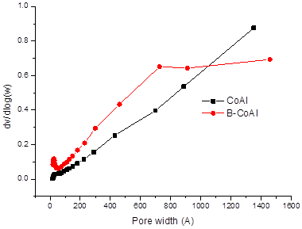
Fig S1: (Pore size distribution for CoAl and Bent-CoAl

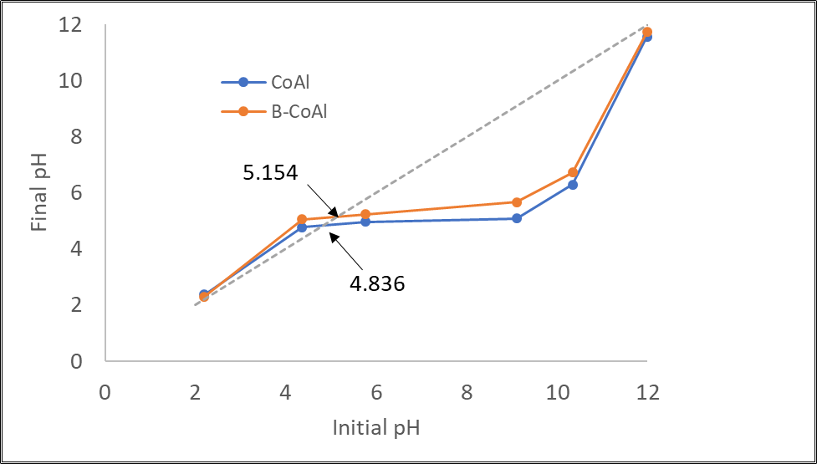
Fig S2: point of zero charge for CoAl and Bent-CoAl

Figure S3. Linear plot between LnK_{d} and 1/T for CoAl and Bent-CoAl

