SUPPLEMENTARY MATERIAL

Analysis and modelling of flame speed in autoignitive mixtures of n-heptane and methane

Bruno S. Soriano1 and Edward S. Richardson1

1Faculty of Engineering and the Environment, University of Southampton,

Southampton, SO17 1BJ, United Kingdom

The supplementary material section contains:

1. Additional data for validation and comparison of chemical kinetic models
2. Flame speed data used in order to obtain the flame speed models
3. Additional data comparing alternative mixing-rules.

## Additional data for validation and comparison of chemical kinetic models

The 106 species Polimi-106 skeletal mechanism is selected for this study based on comparison against experimental ignition delay time and flame speed data for combustion of pure methane and pure n-heptane. Since ignition delay and flame speed measurements for combustion of methane/n-heptane blends are not generally available, the Polimi-106 model predictions for methane/n-heptane blends are also compared with predictions of more detailed chemical mechanisms. Data are presented for the chemical models summarised in Table 1.

Table 1. Summary of chemical models.

|  |  |  |  |  |
| --- | --- | --- | --- | --- |
| **Mechanism name** | **Reference** | **Main fuel** | **Number of species** | **Type** |
| **Polimi-451** | [‎1] | n-heptane | 451 | detailed |
| **Mehl *et al.*** | [‎2] | n-heptane | 658 | detailed |
| **Polimi-106** | [‎3] | n-heptane | 106 | reduced |
| **Liu *et al.*** | [‎4] | n-heptane | 44 | reduced |
| **Lu *et al.*** | [‎5] | n-heptane | 52 | reduced |
| **Chalmers** | [‎6] | n-heptane | 42 | reduced |
| **GRI3.0** | [‎7] | methane | 53 | detailed |
| **San Diego** | [‎8] | methane | 50 | detailed |

The Polimi-106 skeletal scheme [‎3] is a sub-set of the Polimi-451 scheme [‎1]. The 44-species reduced mechanism by Liu *et al.* [‎4] is considered because it gives an adequate compromise between predictive accuracy and computational expense for engine calculations, and the 42-species Chalmers mechanism is considered because it performed best out of the mechanisms compared in a previous study of methane/n-heptane dual fuel combustion [‎6]. The 52-species reduced mechanism developed by Lu *et al.* [‎5] employs dynamic stiffness removal in order to achieve low computational cost, and it has been validated against its parent detailed mechanism in a perfectly-stirred reactor at ambient temperatures and for homogeneous autoignition at engine-relevant temperatures.

### Ignition delay

Constant volume ignition delay predictions are presented for pure methane and n-heptane in Figs. Figure S1 and Figure S2, in comparison with shock-tube measurements for stoichiometric methane-air at 30 atm [‎9], n-heptane–air at 55 atm [‎10] and n-heptane–air at 42 atm [‎11]. Ignition delay time predictions for the reduced n-heptane mechanisms are compared with the detailed n-heptane mechanisms for ignition of methane/n-heptane blends in Figure S3.

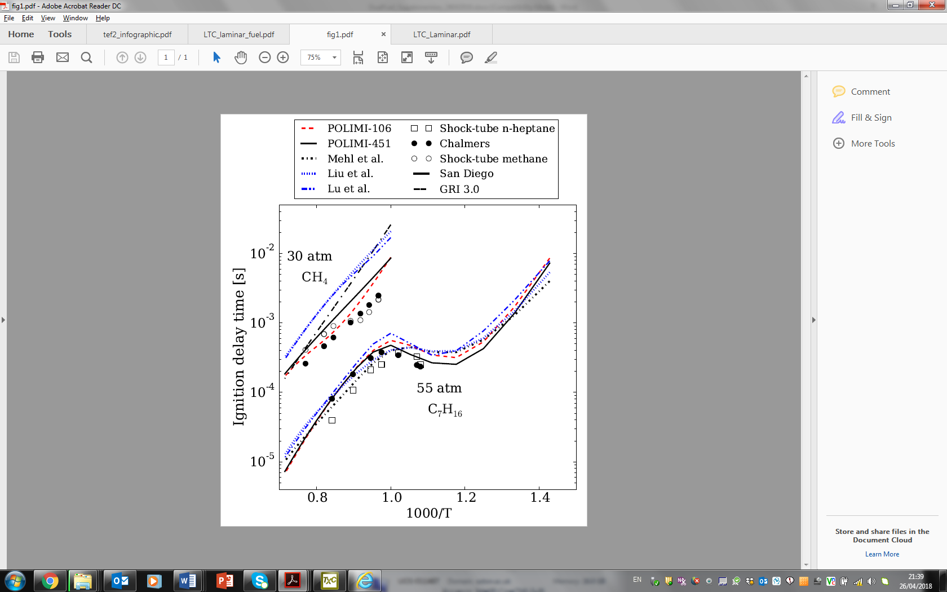

Figure S1. Constant-volume ignition delay times for stoichiometric methane–air at 30 atm and n-heptane/air at 55 atm. Shock-tube data: ○ [‎9], □ [‎10].

#### Figures/fig_S1.pdf

Figure S2. Constant-volume ignition delay times for stoichiometric n-heptane-air at 42atm for Polimi-451, Mehl *et al.,* Polimi-106, Liu *et al.* and Lu *et al.* (refer to Figure S1 for legend). Shock-tube data ▲[‎11].

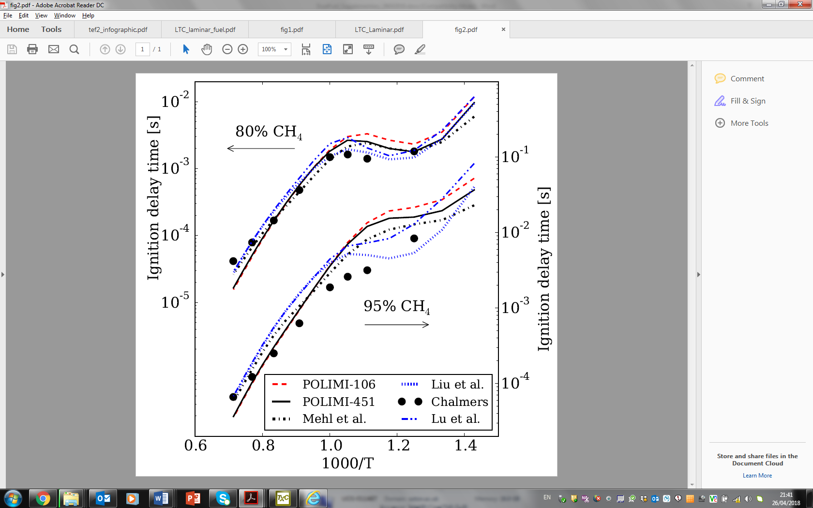

Figure S3. Constant-volume ignition delay times for stoichiometric methane/n-heptane–air mixtures at 30 bar with 80%vol CH4 (left axis) and 95%vol CH4 (right axis) in the fuel blend.

### Flame speed

Figure S4 presents stoichiometric methane–air flame speeds at 10 bar for equivalence ratios spanning 0.7 to 1.2 at 360 and 400 K, comparing experimental measurements [‎12] and numerical predictions of methane-air flame speeds for the detailed methane mechanisms and the reduced n-heptane mechanisms. Similar data for ambient pressure are presented in Figure S5.

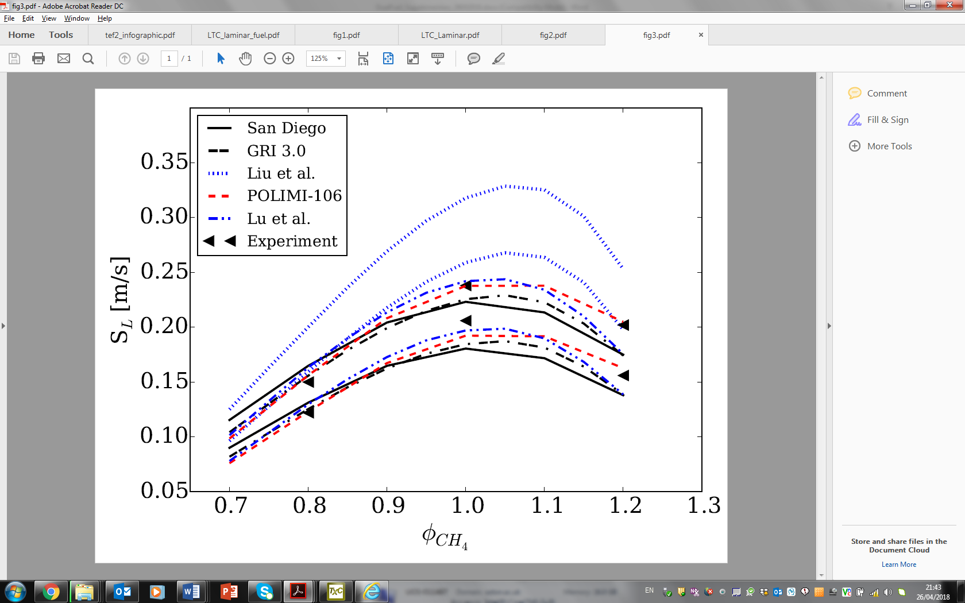

Figure S4. Laminar flame speed of methane–air flames versus equivalence ratio for 360 K (lower speeds) and 400 K (higher speeds) at 10 bar. ◄◄ experimental data [‎12].

#### Figures/fig3_NTP.pdf

Figure S5. Laminar flame of methane-air flames versus equivalence ratio at 300K, 1.01bar. Refer to Figure S4 for legend.

## Flame speed data used in order to fit the flame speed models

Flame speeds (cm.s-1) and adiabatic flame temperatures (K) for equivalence ratio $φ_{tot}=\left\{0.8, 1, 1.2\right\}$, unburnt temperature $T_{u}=\left\{700,775,850,925,1000\right\}$, pressure $p=\left\{20,40,60\right\}$ bar for (a) pure methane fuel; (b) pure n-heptane fuel; (c) a methane/n-heptane blend with $φ_{CH4}/φ_{tot}=0.5$; and (d) additional diluted flames with burned product mass fraction of $ξ=\{0.00, 0.05, 0.10, 0.15\}$ at $φ_{tot}=1.0$, $T_{u}=850$ K and $p=40$ bar. The burned products are assumed to consist of CO2, H2O and N2 only.

(a)

|  |  |  |  |  |  |  |  |
| --- | --- | --- | --- | --- | --- | --- | --- |
| CH4 | Tu [K] | $φ$ = 0.8 | | $φ$ = 1.0 | | $φ$ = 1.2 |  |
| 20bar |  | ***SL*** | ***Tb*** | ***SL*** | ***Tb*** | ***SL*** | ***Tb*** |
| 700 | 44.7 | 2295.6 | 60.7 | 2515.7 | 56.8 | 2435.0 |
| 775 | 60.6 | 2350.9 | 79.9 | 2559.6 | 76.0 | 2491.1 |
| 850 | 80.9 | 2405.9 | 103.8 | 2603.0 | 100.2 | 2547.1 |
| 925 | 106.6 | 2460.2 | 133.2 | 2645.9 | 130.3 | 2602.5 |
| 1000 | 138.7 | 2513.7 | 169.5 | 2688.3 | 167.4 | 2656.8 |
| 40bar | 700 | 32.5 | 2300.3 | 45. 6 | 2532.6 | 43.1 | 2438.3 |
| 775 | 44.5 | 2356.9 | 60.4 | 2578.5 | 57.8 | 2495.9 |
| 850 | 60.0 | 2413.4 | 79.0 | 2624.2 | 76.5 | 2553.6 |
| 925 | 79.7 | 2469.6 | 102.2 | 2669.4 | 100.0 | 2611.2 |
| 1000 | 104.3 | 2525.0 | 130.8 | 2714.1 | 129.3 | 2668.2 |
| 60bar | 700 | 27.6 | 2302.6 | 39.2 | 2541.5 | 37.7 | 2439.9 |
| 775 | 37.9 | 2359.8 | 52.1 | 2588.6 | 50.5 | 2498.0 |
| 850 | 51.2 | 2417.1 | 68.3 | 2635.5 | 66.7 | 2556.5 |
| 925 | 68.1 | 2474.1 | 88.6 | 2682.0 | 87.3 | 2615.1 |
| 1000 | 89.5 | 2530.7 | 113.6 | 2728.0 | 113.0 | 2673.5 |

(b)

|  |  |  |  |  |  |  |  |
| --- | --- | --- | --- | --- | --- | --- | --- |
| C7H16 | Tu [K] | $φ$ = 0.8 | | $φ$ = 1.0 | | $φ$ = 1.2 | |
| 20bar |  | ***SL*** | ***Tb*** | ***SL*** | ***Tb*** | ***SL*** | ***Tb*** |
| 700 | 70.9 | 2359.7 | 88.8 | 2576.3 | 85.1 | 2518.2 |
| 775 | 92.8 | 2413.6 | 113.9 | 2618.3 | 110.4 | 2574.2 |
| 850 | 121.2 | 2470.9 | 144.8 | 2660.3 | 141.6 | 2629.1 |
| 925 | 155.5 | 2524.0 | 182.5 | 2702.3 | 179.6 | 2682.2 |
| 1000 | 197.2 | 2575.4 | 228.2 | 2743.8 | 225.6 | 2734.0 |
| 40bar | 700 | 56.6 | 2366.7 | 72.9 | 2596.8 | 69.3 | 2523.4 |
| 775 | 74.5 | 2421.7 | 93.9 | 2641.2 | 90.5 | 2581.8 |
| 850 | 103.9 | 2479.3 | 121.5 | 2685.0 | 119.4 | 2640.2 |
| 925 | 128.0 | 2535.9 | 153.6 | 2730.0 | 151.4 | 2695.4 |
| 1000 | 161.0 | 2590.0 | 189.9 | 2773.0 | 187.7 | 2750.5 |
| 60bar | 700 | 49.5 | 2369.4 | 65.1 | 2607.5 | 62.0 | 2526.1 |
| 775 | 65.5 | 2425.1 | 84.0 | 2653.5 | 81.0 | 2584.4 |
| 850 | 86.1 | 2690.0 | 107.6 | 2690.0 | 104.8 | 2690.0 |
| 925 | 117.6 | 2541.3 | 143.9 | 2744.7 | 142.5 | 2701.1 |
| 1000 | 143.4 | 2597.4 | 171.2 | 2788.9 | 169.5 | 2758.5 |

(c)

|  |  |  |  |  |  |  |  |
| --- | --- | --- | --- | --- | --- | --- | --- |
| $$φ_{CH4}/φ_{tot}=0.5$$ | Tu [K] | $φ$ = 0.8 | | $φ$ = 1.0 | | $φ$ = 1.2 | |
| 20bar |  | ***SL*** | ***Tb*** | ***SL*** | ***Tb*** | ***SL*** | ***Tb*** |
| 700 | 59.2 | 2328.8 | 76.6 | 2546.4 | 72.3 | 2477.8 |
| 775 | 78.6 | 2383.7 | 99.2 | 2589.5 | 95.1 | 2533.9 |
| 850 | 102.9 | 2437.8 | 127.0 | 2632.2 | 123.3 | 2589.5 |
| 925 | 133.1 | 2491.2 | 161.2 | 2674.4 | 157.9 | 2643.9 |
| 1000 | 170.6 | 2543.7 | 202.7 | 2716.0 | 199.6 | 2696.5 |
| 40bar | 700 | 45.3 | 2334.7 | 60.0 | 2564.7 | 56.6 | 2482.1 |
| 775 | 60.7 | 2391.0 | 78.6 | 2610.5 | 75.1 | 2539.1 |
| 850 | 80.1 | 2446.7 | 101.1 | 2655.1 | 97.7 | 2596.6 |
| 925 | 104.3 | 2502.1 | 129.2 | 2700.0 | 126.2 | 2653.9 |
| 1000 | 134.6 | 2556.9 | 163.2 | 2743.8 | 160.8 | 2710.2 |
| 60bar | 700 | 38.6 | 2335.2 | 52.7 | 2574.5 | 50.0 | 2483.7 |
| 775 | 52.5 | 2394.4 | 68.8 | 2620.7 | 66.1 | 2542.1 |
| 850 | 69.6 | 2449.7 | 89.6 | 2667.6 | 86.7 | 2600.3 |
| 925 | 91.0 | 2507.5 | 114.1 | 2713.5 | 111.8 | 2658.3 |
| 1000 | 117.7 | 2563.5 | 144.5 | 2759.1 | 142.6 | 2716.1 |

d)

|  |  |  |  |  |  |  |
| --- | --- | --- | --- | --- | --- | --- |
| $$ξ$$ | C7H16 | | CH4 | | $$φ_{CH4}/φ_{tot}=0.5$$ | |
|  | ***SL*** | ***Tb*** | ***SL*** | ***Tb*** | ***SL*** | ***Tb*** |
| 0.05 | 103.7 | 2620.2 | 64.8 | 2557.8 | 86.0 | 2289.3 |
| 0.1 | 89.0 | 2549.9 | 52.7 | 2488.6 | 72.2 | 2520.2 |
| 0.15 | 75.4 | 2475.2 | 42.0 | 2415.8 | 59.7 | 2447.3 |

## Additional data comparing alternative mixing-rules.

Figure S6 presents the performance of the linear [‎13] and Hirasawa *et al.* [‎14] flame speed mixing rules for the case of $φ_{CH4}/φ_{tot}$ = 0.8, showing that both models are satisfactory also for this condition. The burned temperature mixing rule given by Hirasawa *et al.* [‎14] is evaluated in Figure S7, again showing that this model is satisfactory for modelling the burnt temperatures of methane/n-heptane mixtures.

#### 

Figure S6. Variation of flame speed with equivalence ratio for methane/n-heptane fuel blends at 850K and 40bar: Polimi-106 simulations for $φ_{CH4}/φ_{tot}$ = 0 (●), 0.8 (♦) and 1.0 (★ ); Fitted flame speeds from Eq. 5 (C:\Users\Bruno\Desktop\44species.png); and linear [‎13] (C:\Users\Bruno\Desktop\ranzi skeletal.png) and Hirasawa *et al.* [‎14] (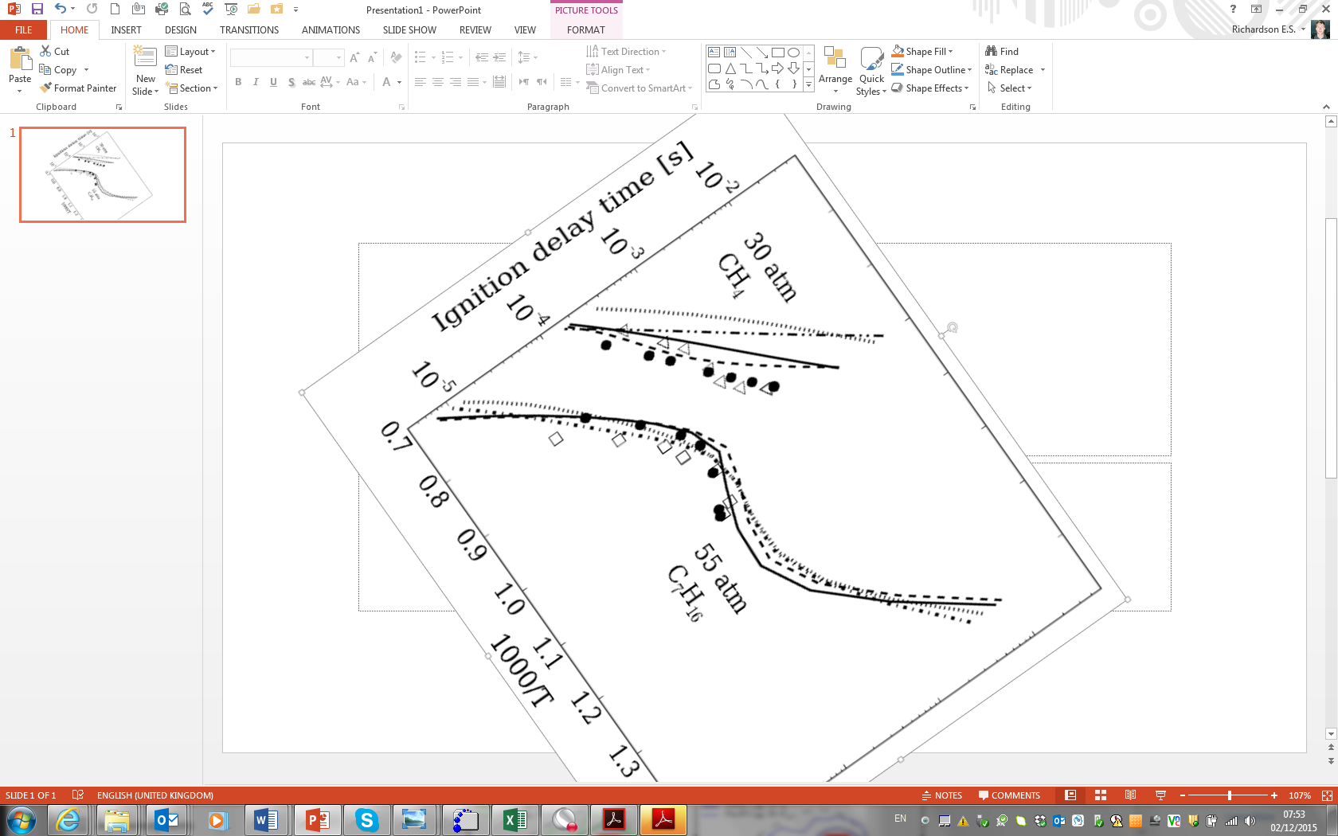)mixing-rules.

#### 

Figure S7. Variation of flame temperature with equivalence ratio for methane/n-heptane fuel blends at 850K and 40bar: Hirasawa *et al.* [‎14] mixing-rule (C:\Users\Bruno\Desktop\ranzi skeletal.png) for = 0.5 (left) and 0.8 (right); Polimi-106 simulations for $φ_{CH4}/φ_{tot}$ = 0 (●), 0.5 or 0.8 (★ ), and 1.0 (♦).

## References

1. E. Ranzi, A. Frassoldati, R. Grana, A. Cuoci, T. Faravelli, A.P. Kelley, C.K. Law, Hierarchical and comparative kinetic modeling of laminar flame speeds of hydrocarbon and oxygenated fuels, Prog. Energy Combust. Sci. 38 (2012) 468–501. doi:10.1016/j.pecs.2012.03.004.
2. M. Mehl, W.J. Pitz, C.K. Westbrook, H.J. Curran, Kinetic modeling of gasoline surrogate components and mixtures under engine conditions, Proc. Combust. Inst. 33 (2011) 193–200. doi:10.1016/j.proci.2010.05.027.
3. E. Ranzi, A. Frassoldati, A. Stagni, M. Pelucchi, A. Cuoci, T. Faravelli, Reduced kinetic schemes of complex reaction systems: Fossil and biomass-derived transportation fuels, 2014. doi:10.1002/kin.20867.
4. S. Liu, J.C. Hewson, J.H. Chen, H. Pitsch, Effects of strain rate on high-pressure nonpremixed n-heptane autoignition in counterflow, Combust. Flame. 137 (2004) 320–339. doi:10.1016/j.combustflame.2004.01.011.
5. T. Lu, C.K. Law, C.S. Yoo, J.H. Chen, Dynamic stiffness removal for direct numerical simulations, Combust. Flame. 156 (2009) 1542–1551. doi:10.1016/j.combustflame.2009.02.013.
6. S.K. Aggarwal, O. Awomolo, K. Akber, Ignition characteristics of heptane-hydrogen and heptane-methane fuel blends at elevated pressures, Int. J. Hydrogen Energy. 36 (2011) 15392–15402. doi:10.1016/j.ijhydene.2011.08.065.
7. V.V.L. and Z.Q. G. P. Smith, D. M. Golden, M. Frenklach, N. W. Moriarty, B. Eiteneer, M. Goldenberg, C. T. Bowman, R. K. Hanson, S. Song, J. W. C. Gardiner, GRI-Mech, (n.d.). http://www.me.berkeley.edu/gri\_mech/ (accessed September 1, 2015).
8. Mechanical and Aerospace Engineering (Combustion Research), Chemical-Kinetic Mechanisms for Combustion Applications, Univ. Calif. San Diego. (n.d.). http://web.eng.ucsd.edu/mae/groups/combustion/mechanism.html (accessed September 1, 2015).
9. J. Huang, W.K. Bushe, P.G. Hill, S.R. Munshi, Experimental and kinetic study of shock initiated ignition in homogeneous methane-hydrogen-air mixtures at engine-relevant conditions, Int. J. Chem. Kinet. 38 (2006) 221–233. doi:10.1002/kin.20157.
10. B.M. Gauthier, D.F. Davidson, R.K. Hanson, Shock tube determination of ignition delay times in full-blend and surrogate fuel mixtures, Combust. Flame. 139 (2004) 300–311. doi:10.1016/j.combustflame.2004.08.015.
11. H.K. Ciezki and G. Adomeit, Shock-tube investigation of self-ignition of n-heptane-air mixtures under engine relevant conditions, Combust. Flame 93 (1993) 421–433. doi:10.1016/0010-2180(93)90142-P.
12. X.J. Gu, M.Z. Haq, M. Lawes, R. Woolley, Laminar burning velocity and Markstein lengths of methane-air mixtures, Combust. Flame. 121 (2000) 41–58. doi:10.1016/S0010-2180(99)00142-X.
13. S. Yang, R.D. Reitz, Integration of a Continuous Multi-Component Fuel Evaporation Model with an Improved G-Equation Combustion and Detailed Chemical Kinetics Model with Application to GDI Engines, SAE Tech. Pap. (2009). doi:10.4271/2009-01-0722.
14. T. Hirasawa, C.J. Sung, a. Joshi, Z. Yang, H. Wang, C.K. Law, Determination of laminar flame speeds using digital particle image velocimetry: Binary Fuel blends of ethylene, n-Butane, and toluene, Proc. Combust. Inst. 29 (2002) 1427–1434. doi:10.1016/S1540-7489(02)80175-4.