SUPPLEMENTARY MATERIAL

Effects of long-term chlorpyrifos exposure on mortality and reproductive tissues of Banded Gourami (Trichogaster fasciata)

Kizar Ahmed Sumon^{a,b}, Most. Farzana Yesmin^{b}, Paul J. Van den Brink^{a,c}, Roel H. Bosma^{d}, Edwin T.H.M. Peetersª, Harunur Rashid^{b,*}

ªAquatic Ecology and Water Quality Management Group, Wageningen University, P.O. Box 47, 6700 AA Wageningen, The Netherlands
^{b}Department of Fisheries Management, Bangladesh Agricultural University, Mymensingh-2202, Bangladesh
^{c}Wageningen Environmental Research (Alterra), P.O. Box 47, 6700 AA Wageningen, The Netherlands
^{d}Aquaculture and Fisheries Group, Wageningen University, P.O. Box 338, 6700 AH Wageningen, The Netherlands

*Corresponding author:
Harunur Rashid
Email: rashid@bau.edu.bd
Phone: +8801924429971

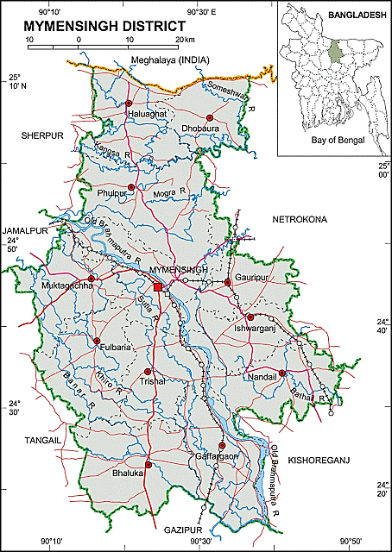

Fig. S1. Mymensingh District map (Gauripur) showing the banded gourami fish collection area.

Histology of gonads
Table S1. Dehydration process of gonad tissue before clearing with benzene.

Step | Reagent | Temperature (ºC) | Programme  (min)
1 | 80% Ethanol | Ambient | 720
2 | 95% Ethanol | Ambient | 60
3 | 95% Ethanol | Ambient | 60
4 | 100% Ethanol | Ambient | 60
5 | 100% Ethanol | Ambient | 60
6 | 100% Ethanol | Ambient | 60

Table S2. Clearing process of gonad tissue before infiltration with paraffin.

Step | Reagent | Temperature (ºC) | Programme  (min)
1 | 100% Benzene | Ambient | 60
2 | 100% Benzene | Ambient | 60

Table S3: Infiltration process of gonad tissue with paraffin to enable slicing.

Step | Reagent | Temperature (ºC) | Programme  (min)
1 | Paraffin | 60 | 40
2 | Paraffin | 60 | 40

Table S4: Staining process of gonad tissue before mounting.
Step | Reagent | Temperature  (ºC) | Programme  (min) | Process
1 | Xylene | Ambient | 10 minutes | Clearing
2 | Xylene | Ambient | 10 minutes
3 | Xylene | Ambient | 10 minutes
4 | 100% alcohol | Ambient | 5 minutes | Dehydration
5 | 100% alcohol | Ambient | 5 minutes
6 | 90% alcohol | Ambient | 3 minutes
7 | 80% alcohol | Ambient | 3 minutes
8 | 70% alcohol | Ambient | 3 minutes
9 | 50% Ethyl alcohol | Ambient | 2 minutes | Staining
10 | Distilled water | Ambient | 15 dips
11 | Haematoxylene (Mayer’s) | Ambient | 3 minutes
12 | Wash in tap water | Ambient | 15 minutes
13 | 50% Ethyl alcohol | Ambient | 10-15 dips
14 | 95% Ethyl alcohol | Ambient | 30 seconds
15 | Eosin Y | Ambient | 1 minute
16 | 95% Ethyl alcohol | Ambient | 2 minutes | Rehydration
17 | 100% Ethyl alcohol | Ambient | 1 minute
18 | 100% Ethyl alcohol | Ambient | 3 minutes
19 | 100% Ethyl alcohol | Ambient | 1 minutes
20 | Xylene | Ambient | 20 minutes | Clearing
21 | Xylene | Ambient | 20 minutes
22 | Drying | Ambient | Over night
23 | D.P.X. | Ambient | Over night | Mounting

Table S5: Acute toxicity (96-h LC50) of chlorpyrifos for Banded Gourami (Trichogaster fasciata) according to OECD (mean ± SD; n = 3).

Chlorpyrifos concentration (µg/L) | Total number of individuals | Number of dead individuals at 96 h
0 | 7 ± 0 | 0
150 | 7 ± 0 | 0
250 | 7 ± 0 | 1 ± 1
350 | 7 ± 0 | 1.3 ± 0.6
450 | 7 ± 0 | 1.7 ± 0.6
550 | 7 ± 0 | 2 ± 1
650 | 7 ± 0 | 2.7 ± 0.6
LC10 value with 95% confidence limits |  | 258 (158-421)
LC50 value with 95% confidence limits |  | 833 (506-1371)
LC90 value with 95% confidence limits |  | 2689 (727-9942)

Table S6: Mortality (%) of male and female Banded Gourami (mean ± SD; n = 3) exposed to different chlorpyrifos concentrations during the experimental period.
Chlorpyrifos concentrations  (µg/L) | Male mortality (%) |  |  |  |  | Female mortality (%)
 | Day 15 | Day 30 | Day 45 | Day 60 | Day 75 | Day 15 | Day 30 | Day 45 | Day 60 | Day 75
0 | 0 | 3.7±6.4 | 4.2±7.2 | 9.5±8.3 | 11±9.5 | 0 | 3.7±6.4 | 4.2±7.2 | 9.5±8.3 | 16.7±16.6
15 | 0 | 0 | 16.7±7.2 | 33.4±8.3 | 100±0 | 3.3±5.8 | 3.7±6.4 | 16.7±7.2 | 28.6±0 | 33.3±0
50 | 3.3±5.8 | 11±11 | 33.3±7.2 | 52.4±8.2 | 100±0 | 6.7±5.8 | 22.2±0 | 13.3±14.4 | 42.8±14.3 | 61±9.5
150 | 20±0 | 48±6.5 | 100±0 | 100±0 | 100±0 | 10±10 | 33.3±22.2 | 62.5±12.5 | 100±0 | 100±0
500 | 100±0 | 100±0 | 100±0 | 100±0 | 100±0 | 100±0 | 100±0 | 100±0 | 100±0 | 100±0

Table S7: No observed effect concentrations (NOECs) in µg/L of male and female mortality, GSI and histopathological alterations of ovary and testes during the experimental period.
Days of exposure | Mortality |  | GSI |  | Ovary alterations |  |  |  |  |  |  |  | Testes alterations
 | Male | Female | Male | Female | CC | CR | AF | DPNO | AD | DOL | IFS | NE | ISST | BST | DICL | DSC | TO | EL
15 | 50 | 50 | <15 | 50 | 50 | 50 | 50 | ≥ 150 | ≥ 150 | ≥ 150 | ≥ 150 | ≥ 150 | 50 | 50 | 50 | 50 | ≥ 150 | ≥ 150
30 | 50 | 50 | <15 | ≥ 150 | ≥ 150 | ≥ 150 | ≥ 150 | ≥ 150 | ≥ 150 | ≥ 150 | ≥ 150 | ≥ 150 | ≥ 150 | ≥ 150 | 50 | 50 | ≥ 150 | ≥ 150
45 | <15 | 15 | ≥ 50 | ≥ 150 | 50 | 50 | 15 | 15 | 15 | ≥ 150 | ≥ 150 | ≥ 150 | ≥ 50 | ≥ 50 | ≥ 50 | ≥ 50 | 15 | 15
60 | <15 | <15 | ≥ 50 | ≥ 50 | ≥ 50 | ≥ 50 | 15 | ≥ 50 | ≥ 50 | <15 | ≥ 50 | 15 | ≥ 50 | 15 | <15 | ≥ 50 | ≥ 50 | 15
75 | <15 | <15 | NC | ≥ 50 | ≥ 50 | ≥ 50 | 15 | ≥ 50 | 15 | 15 | ≥ 50 | 15 | NC | NC | NC | NC | NC | NC

NC= Not calculated due to 100% mortality
Table S8: Chronic NOECs for mortality of different fishes exposed to chlorpyrifos.
Species name | Days of exposure | NOEC values (µg/L) | Reference
Clarias batrachus | 30 | 0.21 | ECOTOX Database (http://cfpub.epa.gov/ecotox/quick_query.htm)
Pimephales promelas | 32 | *1.88 (n = 2)
Cyprinus carpio | 40 | *2.33 (n = 75)
Tilapia zillii | 90 | *2.67 (n = 5)
Oreochromis niloticus | 28 | *8.6 (n = 5)
Oncorhynchus tshawytscha | 60 | *3.7 (n = 2)
Fundulus heteroclitus | 28 | *7.65 (n = 5)
*when more than 1 value was available for a species, the geometric mean was calculated

