Supplementary Material

Supplementary Figure 1. Initial study to bind, extract and detect SDS including the minimisation of experimental variance by pooling steps for the SDS recovery. SDS was not detected in the negative controls with or without pNP (pNP no SDS; no SDS no pNP; water), nor in the positive (washing) controls (SDS no pNP). SDS was only bound to NH₂-pNPs (SDS+pNP) and was recovered but with an unacceptably high coefficient of variation of >50% that required protocol optimisation (as described in the main text) to overcome. Data represent mean ± SD (n=3) of peak areas derived from LC-MS/MS.

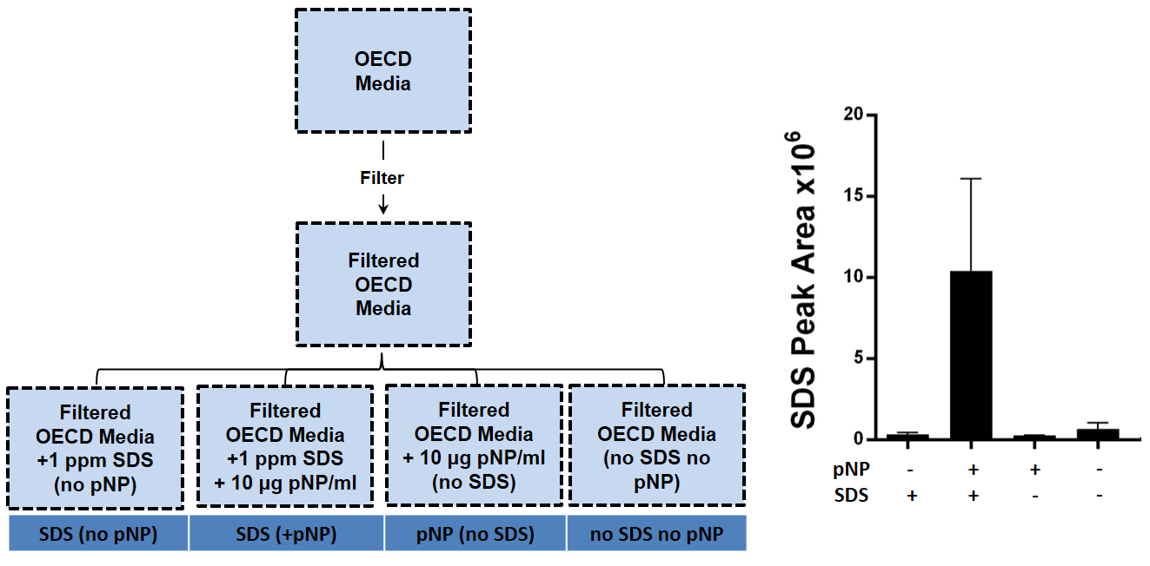

Supplementary Figure 2. Optimization of SDS recovery method included performing an assessment of the greatest sources of variation within the whole incubation and extraction workflow. We discovered that the incubation step caused the major variation, which we addressed by introducing a pooling step after the NP incubations in all subsequent studies. Independent replicates of NH₂-pNPs incubated with 1 ppm SDS were treated as n=6 independent technical replicates, which (1) were kept separate throughout the workflow from the initial step of the incubation onwards, or (2) combined the replicates immediately after the incubation step, or (3) combined the replicates after the extraction step. Data represent mean ± SD (n=6) of peak areas.

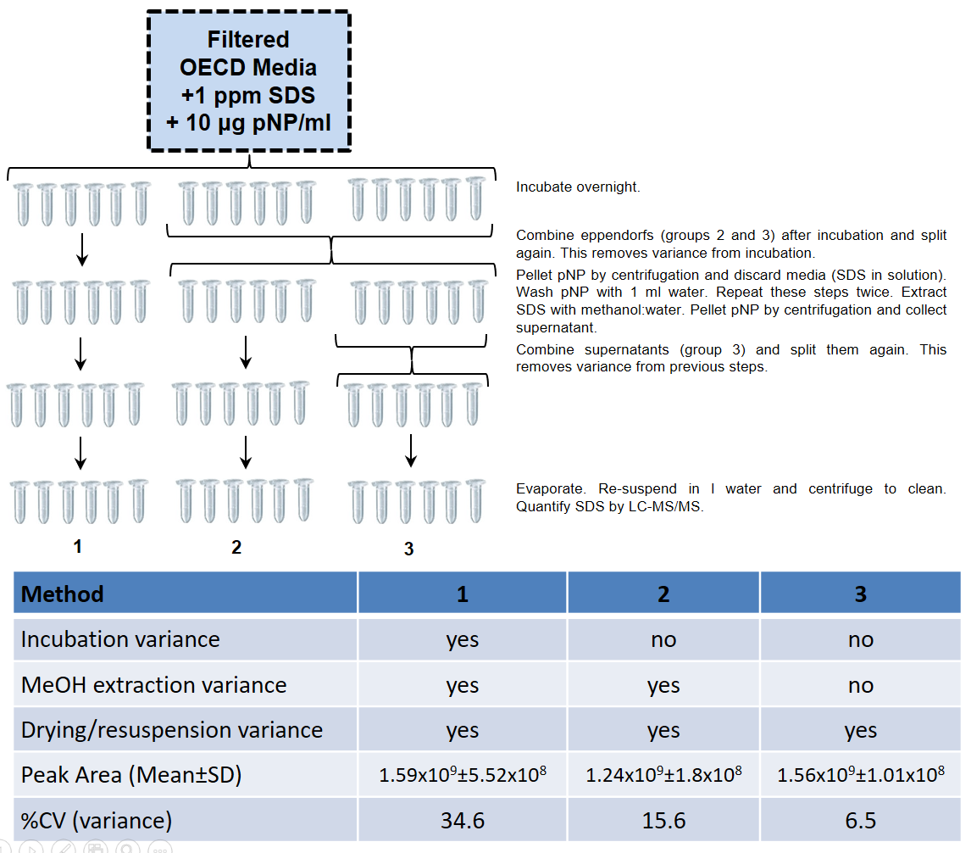

Supplementary Figure 3. Dynamic Light Scattering characterisation of the NH2-pNPs in OECD medium over 24 hours, and a comparison to the size in the relatively widely used HH COMBO medium.
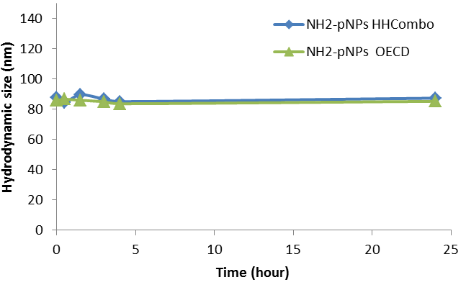

Supplementary Table 1a List of m/z values of features and putative molecular formulae used for van Krevelen diagrams for positive ion mode.

m/z | Intensity | Putative  Molecular  formula  (MI-Pack) | Ion form (MI-Pack) | Mass error (MI-Pack) | Putative Molecular formula (Kujawinski) | Ion form (Kujawinski) | Mass error (Kujawinski)
89.1074 | 251374 | NA | NA | NA | NA | NA | NA
105.1022 | 98094 | C4H12N2O | [M+H]+ | 0.02 | C4H12N2O | [M+H]+ | 0.02
154.9416 | 29634 | NA | NA | NA | NA | NA | NA
311.1368 | 128455 | C13H24N2O4 | [M+K]+ | 0.05 | C11H23N2O6P | [M+H]+ | 0.33
342.1024 | 62116 | C12H24N3OP3 | [M+Na]+ | 0.06 | C8H21N7O2SP2 | [M+H]+ | 0.34
343.1103 | 58857 | C14H20N6S | [M+K]+ | 0.24 | C10H22N4O5S2 | [M+H]+ | 0.52
344.1181 | 84188 | C12H26N3OP3 | [M+Na]+ | 0.04 | C8H23N7O2SP2 | [M+H]+ | 0.24
346.7420 | 40423 | NA | NA | NA | NA | NA | NA
354.1026 | 56449 | C9H21N7O2P2S | [M+H]+ | 0.03 | C25H11N3 | [M+H]+ | 0.04
355.1104 | 58685 | C15H25O4PS | [M+Na]+ | 0.06 | C11H22N4O5S2 | [M+H]+ | 0.21
356.1057 | 53589 | C10H21N5O5S2 | [M+H]+ | 0.06 | C10H21N5O5S2 | [M+H]+ | 0.07
357.1134 | 78709 | C12H25N4OP3 | [M+Na]+ | 0.14 | C8H22N8O2SP2 | [M+H]+ | 0.13
357.1260 | 62768 | C15H27O4PS | [M+Na]+ | 0.05 | C11H24N4O5S2 | [M+H]+ | 0.21
358.1213 | 80697 | C10H23N5O5S2 | [M+H]+ | 0.02 | C10H23N5O5S2 | [M+H]+ | 0.04
358.1339 | 90182 | C11H26N7PS | [M+K]+ | 0.12 | C10H19N11S2 | [M+H]+ | 0.04
359.1291 | 83592 | C8H24N8O2P2S | [M+H]+ | 0.03 | C24H14N4 | [M+H]+ | 0.04
360.1496 | 71106 | C11H28N7PS | [M+K]+ | 0.07 | C10H21N11S2 | [M+H]+ | 0.23
361.1448 | 51067 | C10H27N8PS | [M+K]+ | 0.04 | C24H16N4 | [M+H]+ | 0.20
364.7305 | 236708 | NA | NA | NA | NA | NA | NA
368.1182 | 67859 | C10H23N7O2P2S | [M+H]+ | 0.03 | C26H13N3 | [M+H]+ | 0.04
372.1328 | 64847 | C16H26N3OPS2 | [M+H]+ | 0.03 | C16H26N3OS2P | [M+H]+ | 0.01
372.1496 | 73852 | C26H17N3 | [M+H]+ | 0.11 | C11H21N11S2 | [M+H]+ | 0.03
374.1483 | 82655 | C8H24N9O4PS | [M+H]+ | 0.04 | C8H24N9O4SP | [M+H]+ | 0.06
374.1526 | 116123 | C15H23N7O2 | [M+(41K)]+ | 0.01 | C11H27N5O5S2 | [M+H]+ | 0.11
375.2682 | 52603 | C27H34O | [M+H]+ | 0.21 | C27H34O | [M+H]+ | 0.21
377.7384 | 229783 | NA | NA | NA | NA | NA | NA
378.2401 | 97279 | C21H27N7 | [M+H]+ | 0.10 | C21H27N7 | [M+H]+ | 0.10
382.1214 | 80556 | C10H29N5OP4 | [M+Na]+ | 0.09 | C12H23N5O5S2 | [M+H]+ | 0.30
382.1340 | 64082 | C13H26N7PS | [M+K]+ | 0.12 | C27H15N3 | [M+H]+ | 0.35
384.1497 | 81975 | C13H28N7PS | [M+K]+ | 0.13 | C12H21N11S2 | [M+H]+ | 0.28
397.1446 | 56608 | C13H33N4OPS2 | [M+(41K)]+ | 0.06 | C11H26N8O2SP2 | [M+H]+ | 0.37
398.1527 | 52970 | C13H27N5O5S2 | [M+H]+ | 0.13 | C13H27N5O5S2 | [M+H]+ | 0.15
398.1649 | 99237 | C16H32N3OP3 | [M+Na]+ | 0.27 | C12H29N7O2SP2 | [M+H]+ | 0.52
398.7732 | 70614 | C8H2OP4S5 | [M+H]+ | 0.17 | NA | NA | NA
399.2794 | 248797 | C28H34N2 | [M+H]+ | 0.18 | C28H34N2 | [M+H]+ | 0.18
400.1682 | 88976 | C17H25N7O2 | [M+(41K)]+ | 0.01 | C13H29N5O5S2 | [M+H]+ | 0.09
400.2830 | 63799 | C16H39N7OS | [M+Na]+ | 0.14 | NA | NA | NA
401.1397 | 46481 | C17H28O8 | [M+(41K)]+ | 0.01 | C26H16N4O | [M+H]+ | 0.04
404.1953 | 105863 | C12H31N9O2S | [M+K]+ | 0.07 | C18H34N3OS2P | [M+H]+ | 0.22
414.1838 | 71553 | C18H34NO4PS | [M+Na]+ | 0.02 | C14H31N5O5S2 | [M+H]+ | 0.21
415.3570 | 66378 | C28H46O2 | [M+H]+ | 0.12 | C28H46O2 | [M+H]+ | 0.12
416.1588 | 39173 | C10H26N9O5PS | [M+H]+ | 0.03 | C10H26N9O5SP | [M+H]+ | 0.02
425.6992 | 78608 | C3H2NOPS9 | [M+K]+ | 0.03 | NA | NA | NA
427.1549 | 49248 | C13H30N8S4 | [M+H]+ | 0.03 | C13H30N8S4 | [M+H]+ | 0.01
427.1913 | 68918 | C12H32N6O8 | [M+K]+ | 0.13 | C18H35O7SP | [M+H]+ | 0.28
428.1995 | 45378 | C19H29N7O2 | [M+(41K)]+ | 0.07 | C15H33N5O5S2 | [M+H]+ | 0.16
430.1744 | 57411 | C15H31N5O4P2 | [M+Na]+ | 0.05 | C11H28N9O5SP | [M+H]+ | 0.17
430.2151 | 107970 | C19H38NO4PS | [M+Na]+ | 0.09 | C15H35N5O5S2 | [M+H]+ | 0.31
432.1943 | 82059 | C24H34NPS2 | [M+H]+ | 0.04 | C24H34NS2P | [M+H]+ | 0.03
432.2264 | 57575 | C16H37N5O3P2 | [M+Na]+ | 0.07 | C12H34N9O4SP | [M+H]+ | 0.29
432.2306 | 61464 | C19H35N7S | [M+K]+ | 0.01 | C17H34N7O2SP | [M+H]+ | 0.28
433.2020 | 90084 | C19H38O6S | [M+K]+ | 0.05 | C17H37O8SP | [M+H]+ | 0.22
437.3390 | 56581 | C28H46O2 | [M+Na]+ | 0.03 | C23H49O5P | [M+H]+ | 0.06
444.2308 | 101363 | C20H40NO4PS | [M+Na]+ | 0.05 | C16H37N5O5S2 | [M+H]+ | 0.16
452.2771 | 138713 | C26H39NO4 | [M+Na]+ | 0.14 | C21H42NO7P | [M+H]+ | 0.21
457.2024 | 57210 | C16H35N8OPS | [M+K]+ | 0.02 | C30H24N4O | [M+H]+ | 0.18
458.2102 | 31789 | C16H35N5O6S2 | [M+H]+ | 0.05 | C16H35N5O6S2 | [M+H]+ | 0.06
459.2544 | 61467 | C17H41N8PS | [M+K]+ | 0.05 | C31H30N4 | [M+H]+ | 0.24
463.2404 | 31514 | C23H42N2OP2 | [M+K]+ | 0.03 | C22H35N6OSP | [M+H]+ | 0.15
472.2259 | 39967 | C29H37NS | [M+(41K)]+ | 0.15 | C17H37N5O6S2 | [M+H]+ | 0.17
474.2051 | 23782 | C16H35N5O7S2 | [M+H]+ | 0.09 | C16H35N5O7S2 | [M+H]+ | 0.10
475.2803 | 1686607 | C22H48N2O2P2 | [M+(41K)]+ | 0.11 | C26H38N2O6 | [M+H]+ | 0.14
476.2185 | 31171 | C24H32N5O2P | [M+Na]+ | 0.08 | C12H25N15O6 | [M+H]+ | 0.09
476.2836 | 444979 | C21H48N3O2PS | [M+K]+ | 0.05 | C20H41N7O2S2 | [M+H]+ | 0.07
486.2050 | 29832 | C21H31N7O4 | [M+(41K)]+ | 0.02 | C20H45NP6 | [M+H]+ | 0.02
486.2371 | 30922 | C15H36N9O5PS | [M+H]+ | 0.02 | C15H36N9O5SP | [M+H]+ | 0.03
488.2207 | 32908 | C21H33N7O4 | [M+(41K)]+ | 0.01 | C17H37N5O7S2 | [M+H]+ | 0.08
492.2519 | 59845 | C21H44NO6PS | [M+Na]+ | 0.02 | C27H42NOS2P | [M+H]+ | 0.19
493.2556 | 29595 | C20H43N6P3S | [M+H]+ | 0.01 | C26H32N6O4 | [M+H]+ | 0.46
499.2127 | 31423 | C18H43N4O3PS2 | [M+(41K)]+ | 0.05 | C25H43P5 | [M+H]+ | 0.23
595.2824 | 888565 | NA | NA | NA | NA | NA | NA
611.2777 | 84274 | NA | NA | NA | NA | NA | NA
615.4405 | 87809 | NA | NA | NA | NA | NA | NA
623.2500 | 104502 | NA | NA | NA | NA | NA | NA
623.4070 | 157427 | NA | NA | NA | NA | NA | NA
626.2689 | 160986 | NA | NA | NA | NA | NA | NA
639.2451 | 60348 | NA | NA | NA | NA | NA | NA
653.2968 | 126960 | NA | NA | NA | NA | NA | NA
655.4333 | 86758 | NA | NA | NA | NA | NA | NA
674.5047 | 37166 | NA | NA | NA | NA | NA | NA
676.3212 | 33413 | NA | NA | NA | NA | NA | NA
690.5068 | 644983 | NA | NA | NA | NA | NA | NA
701.4749 | 40060 | NA | NA | NA | NA | NA | NA
713.4918 | 120145 | NA | NA | NA | NA | NA | NA
731.4859 | 22153 | NA | NA | NA | NA | NA | NA
759.5731 | 25961 | NA | NA | NA | NA | NA | NA
760.5854 | 34725 | NA | NA | NA | NA | NA | NA
812.4444 | 27258 | NA | NA | NA | NA | NA | NA
820.4375 | 23388 | NA | NA | NA | NA | NA | NA
820.4469 | 33881 | NA | NA | NA | NA | NA | NA
821.4504 | 18322 | NA | NA | NA | NA | NA | NA
834.3964 | 19483 | NA | NA | NA | NA | NA | NA
834.4056 | 26811 | NA | NA | NA | NA | NA | NA
836.4420 | 23867 | NA | NA | NA | NA | NA | NA
860.6403 | 31620 | NA | NA | NA | NA | NA | NA
861.6437 | 18412 | NA | NA | NA | NA | NA | NA
866.4549 | 16437 | NA | NA | NA | NA | NA | NA
941.5404 | 18923 | NA | NA | NA | NA | NA | NA
943.5231 | 8730 | NA | NA | NA | NA | NA | NA
950.5736 | 10890 | NA | NA | NA | NA | NA | NA
963.5491 | 13657 | NA | NA | NA | NA | NA | NA
965.5644 | 9860 | NA | NA | NA | NA | NA | NA
Footnotes:
- Please note that the molecular formulae annotations are only putative and interpretation should be taken with caution
- Molecular formulae not reported for m/z values > 500 due to the high number of potential candidates.
- Where multiple molecular formulae were assigned to a single m/z value the formula with the lowest absolute mass error was chosen as the putative annotation.

Supplementary Table 1b List of m/z values of features and putative molecular formulae used for van Krevelen diagrams for negative ion mode.

m/z | Intensity | Molecular formula  (MI-Pack) | Ion form  (MI-Pack) | Mass error (MI-Pack) | Molecular formula (Kujawinski) | Ion form (Kujawinski) | Mass error (Kujawinski)
174.8289 | 8504 | NA | NA | NA | NA | NA | NA
204.0265 | 388 | C7H14NP3 | [M-H]- | 0.59 | NA | NA | NA
269.1299 | 627 | C6H20N4P2 | [M+Hac-H]- | 0.94 | C8H24N4O2P2 | [M-H]- | 0.93
273.1248 | 870 | C12H21N4P | [M+Na-2H]- | 1 | NA | NA | NA
277.1845 | 1323 | C12H26OS | [M+Hac-H]- | 0.75 | C14H30O3S | [M-H]- | 0.75
283.0689 | 70421 | C12H19N2P3 | [M-H]- | 0.28 | C12H19N2P3 | [M-H]- | 0.28
283.5698 | 12404 | NA | NA | NA | NA | NA | NA
284.0666 | 11902 | C6H8N7OP | [M+Hac-H]- | 0.02 | C8H12N7O3P | [M-H]- | 0.01
284.0714 | 895 | C6H17N7P2 | [M+Cl]- | 0.15 | C19H11NO2 | [M-H]- | 0.96
284.5681 | 2087 | NA | NA | NA | NA | NA | NA
289.0776 | 7537 | C6H14O9 | [M+Hac-H]- | 0.02 | C13H16N4P2 | [M-H]- | 0.35
289.5793 | 1663 | NA | NA | NA | NA | NA | NA
290.0762 | 5172 | C8H19N3O4S | [M+(37Cl)]- | 0.32 | NA | NA | NA
290.5778 | 1138 | NA | NA | NA | NA | NA | NA
291.0746 | 911 | C13H21OPS | [M+Cl]- | 0.41 | C13H16N4S2 | [M-H]- | 0.80
297.0842 | 5554 | C12H21O4P | [M+(37Cl)]- | 0.14 | C11H14N4O6 | [M-H]- | 0.34
300.0581 | 562 | C7H15NO4S2 | [M+Hac-H]- | 0.08 | C9H19NO6S2 | [M-H]- | 0.06
333.2101 | 1016 | C19H31N2OP | [M-H]- | 0.08 | C19H31N2OP | [M-H]- | 0.08
351.1448 | 285 | C7H26N10S2 | [M+(37Cl)]- | 0.03 | C13H29N4OS2P | [M-H]- | 0.10
365.1606 | 257 | C17H22O5 | [M+Hac-H]- | 0.06 | C19H26O7 | [M-H]- | 0.05
365.3786 | 513 | C25H50O | [M-H]- | 0.72 | C25H50O | [M-H]- | 0.72
407.2282 | 276 | C16H38N6P2S | [M-H]- | 0.14 | NA | NA | NA
445.3677 | 793 | C21H47N4P | [M+Hac-H]- | 0.13 | C23H51N4O2P | [M-H]- | 0.13
452.2775 | 731 | C24H43N3OS2 | [M-H]- | 0.12 | C24H43N3OS2 | [M-H]- | 0.12
459.2185 | 351 | C22H37N2O4P | [M+Cl]- | 0.01 | C30H36S2 | [M-H]- | 0.15
471.2188 | 407 | C22H42O6S | [M+K-2H]- | 0.05 | C20H41O8SP | [M-H]- | 0.21
472.2264 | 357 | C16H38N3O3P3 | [M+Hac-H]- | 0.03 | C18H42N3O5P3 | [M-H]- | 0.02
474.2059 | 223 | C20H35N7O2S | [M+K-2H]- | 0.02 | C26H38NOS2P | [M-H]- | 0.16
478.3535 | 495 | C26H45NO3 | [M+Hac-H]- | 0.61 | C28H49NO5 | [M-H]- | 0.61
481.2569 | 840 | C23H30N6O2 | [M+Hac-H]- | 0.02 | C25H34N6O4 | [M-H]- | 0.02
482.2109 | 617 | C18H30N7OPS | [M+Hac-H]- | 0.04 | C20H34N7O3SP | [M-H]- | 0.03
483.2559 | 478 | C18H36N2O9 | [M+Hac-H]- | 0.07 | C18H28N16O | [M-H]- | 0.04
490.3533 | 318 | C25H51N5S | [M+(37Cl)]- | 0.61 | NA | NA | NA
491.2927 | 319 | C19H49N6OP3 | [M+Na-2H]- | 0.09 | C31H36N6 | [M-H]- | 0.35
496.2634 | 602 | C18H39N5O3S2 | [M+Hac-H]- | 0.27 | C30H36N5P | [M-H]- | 0.27
496.7653 | 271 | C3HN10OP5S4 | [M+Na-2H]- | 0.04 | NA | NA | NA
497.2342 | 899 | C26H41N2OPS | [M+(37Cl)]- | 0 | C33H38S2 | [M-H]- | 0.08
498.2376 | 243 | C25H39N3O5 | [M+K-2H]- | 0.04 | C23H38N3O7P | [M-H]- | 0.28
499.2133 | 657 | C25H39N2O4P | [M+K-2H]- | 0.05 | C24H32N6O4S | [M-H]- | 0.06
515.2453 | 4844 | NA | NA | NA | NA | NA | NA
555.2244 | 209 | NA | NA | NA | NA | NA | NA
559.2346 | 234 | NA | NA | NA | NA | NA | NA
565.1462 | 1014 | NA | NA | NA | NA | NA | NA
567.1432 | 707 | NA | NA | NA | NA | NA | NA
587.1281 | 1308 | NA | NA | NA | NA | NA | NA
589.1250 | 942 | NA | NA | NA | NA | NA | NA
589.2449 | 786 | NA | NA | NA | NA | NA | NA
590.2484 | 269 | NA | NA | NA | NA | NA | NA
593.2673 | 935 | NA | NA | NA | NA | NA | NA
597.8236 | 326 | NA | NA | NA | NA | NA | NA
606.4398 | 273 | NA | NA | NA | NA | NA | NA
608.2585 | 533 | NA | NA | NA | NA | NA | NA
609.5203 | 300 | NA | NA | NA | NA | NA | NA
614.2461 | 324 | NA | NA | NA | NA | NA | NA
617.2254 | 659 | NA | NA | NA | NA | NA | NA
620.3649 | 212 | NA | NA | NA | NA | NA | NA
620.4563 | 266 | NA | NA | NA | NA | NA | NA
620.4727 | 218 | NA | NA | NA | NA | NA | NA
621.2352 | 780 | NA | NA | NA | NA | NA | NA
622.2385 | 280 | NA | NA | NA | NA | NA | NA
623.2509 | 585 | NA | NA | NA | NA | NA | NA
624.8794 | 326 | NA | NA | NA | NA | NA | NA
634.4523 | 289 | NA | NA | NA | NA | NA | NA
636.4678 | 353 | NA | NA | NA | NA | NA | NA
637.2300 | 446 | NA | NA | NA | NA | NA | NA
639.8712 | 294 | NA | NA | NA | NA | NA | NA
641.4170 | 503 | NA | NA | NA | NA | NA | NA
643.4365 | 294 | NA | NA | NA | NA | NA | NA
646.5080 | 218 | NA | NA | NA | NA | NA | NA
647.8821 | 362 | NA | NA | NA | NA | NA | NA
654.8216 | 340 | NA | NA | NA | NA | NA | NA
655.3233 | 220 | NA | NA | NA | NA | NA | NA
660.4345 | 573 | NA | NA | NA | NA | NA | NA
660.4605 | 720 | NA | NA | NA | NA | NA | NA
660.8944 | 676 | NA | NA | NA | NA | NA | NA
662.1013 | 2191 | NA | NA | NA | NA | NA | NA
674.4761 | 452 | NA | NA | NA | NA | NA | NA
675.4261 | 361 | NA | NA | NA | NA | NA | NA
678.1388 | 598 | NA | NA | NA | NA | NA | NA
678.4582 | 242 | NA | NA | NA | NA | NA | NA
681.3751 | 289 | NA | NA | NA | NA | NA | NA
684.1646 | 447 | NA | NA | NA | NA | NA | NA
684.4874 | 257 | NA | NA | NA | NA | NA | NA
690.4985 | 2212 | NA | NA | NA | NA | NA | NA
694.4400 | 276 | NA | NA | NA | NA | NA | NA
698.4094 | 285 | NA | NA | NA | NA | NA | NA
702.4709 | 476 | NA | NA | NA | NA | NA | NA
702.5074 | 1473 | NA | NA | NA | NA | NA | NA
703.5106 | 557 | NA | NA | NA | NA | NA | NA
704.4865 | 956 | NA | NA | NA | NA | NA | NA
715.3883 | 270 | NA | NA | NA | NA | NA | NA
716.1540 | 343 | NA | NA | NA | NA | NA | NA
717.5261 | 1366 | NA | NA | NA | NA | NA | NA
718.4736 | 845 | NA | NA | NA | NA | NA | NA
719.4862 | 10566 | NA | NA | NA | NA | NA | NA
720.4902 | 4480 | NA | NA | NA | NA | NA | NA
724.5001 | 193 | NA | NA | NA | NA | NA | NA
728.4870 | 450 | NA | NA | NA | NA | NA | NA
729.5268 | 406 | NA | NA | NA | NA | NA | NA
733.5021 | 402 | NA | NA | NA | NA | NA | NA
740.5231 | 486 | NA | NA | NA | NA | NA | NA
742.5107 | 155 | NA | NA | NA | NA | NA | NA
744.5263 | 162 | NA | NA | NA | NA | NA | NA
747.5085 | 530 | NA | NA | NA | NA | NA | NA
750.5129 | 149 | NA | NA | NA | NA | NA | NA
756.5535 | 134 | NA | NA | NA | NA | NA | NA
759.4810 | 193 | NA | NA | NA | NA | NA | NA
761.4964 | 219 | NA | NA | NA | NA | NA | NA
768.4791 | 464 | NA | NA | NA | NA | NA | NA
773.5330 | 311 | NA | NA | NA | NA | NA | NA
780.4184 | 103 | NA | NA | NA | NA | NA | NA
782.5784 | 111 | NA | NA | NA | NA | NA | NA
784.3197 | 295 | NA | NA | NA | NA | NA | NA
785.3234 | 109 | NA | NA | NA | NA | NA | NA
786.2809 | 704 | NA | NA | NA | NA | NA | NA
786.6154 | 729 | NA | NA | NA | NA | NA | NA
790.5603 | 273 | NA | NA | NA | NA | NA | NA
792.4174 | 95 | NA | NA | NA | NA | NA | NA
795.5202 | 292 | NA | NA | NA | NA | NA | NA
797.5137 | 503 | NA | NA | NA | NA | NA | NA
801.4891 | 480 | NA | NA | NA | NA | NA | NA
814.4513 | 224 | NA | NA | NA | NA | NA | NA
815.5630 | 697 | NA | NA | NA | NA | NA | NA
817.5785 | 336 | NA | NA | NA | NA | NA | NA
827.5044 | 310 | NA | NA | NA | NA | NA | NA
828.9747 | 367 | NA | NA | NA | NA | NA | NA
829.3092 | 404 | NA | NA | NA | NA | NA | NA
829.4425 | 267 | NA | NA | NA | NA | NA | NA
829.6435 | 277 | NA | NA | NA | NA | NA | NA
832.4752 | 155 | NA | NA | NA | NA | NA | NA
834.9847 | 1189 | NA | NA | NA | NA | NA | NA
835.3189 | 398 | NA | NA | NA | NA | NA | NA
836.6594 | 322 | NA | NA | NA | NA | NA | NA
836.9938 | 348 | NA | NA | NA | NA | NA | NA
837.3285 | 193 | NA | NA | NA | NA | NA | NA
838.5598 | 752 | NA | NA | NA | NA | NA | NA
839.5631 | 371 | NA | NA | NA | NA | NA | NA
840.4031 | 335 | NA | NA | NA | NA | NA | NA
841.4066 | 155 | NA | NA | NA | NA | NA | NA
841.5788 | 392 | NA | NA | NA | NA | NA | NA
841.9776 | 406 | NA | NA | NA | NA | NA | NA
842.3120 | 154 | NA | NA | NA | NA | NA | NA
845.4381 | 125 | NA | NA | NA | NA | NA | NA
846.2963 | 791 | NA | NA | NA | NA | NA | NA
846.4810 | 526 | NA | NA | NA | NA | NA | NA
846.9649 | 609 | NA | NA | NA | NA | NA | NA
847.2993 | 315 | NA | NA | NA | NA | NA | NA
847.4845 | 283 | NA | NA | NA | NA | NA | NA
848.3289 | 152 | NA | NA | NA | NA | NA | NA
856.3979 | 158 | NA | NA | NA | NA | NA | NA
859.5342 | 237 | NA | NA | NA | NA | NA | NA
860.4292 | 183 | NA | NA | NA | NA | NA | NA
868.5104 | 243 | NA | NA | NA | NA | NA | NA
872.4396 | 245 | NA | NA | NA | NA | NA | NA
874.6497 | 684 | NA | NA | NA | NA | NA | NA
875.6527 | 271 | NA | NA | NA | NA | NA | NA
879.9479 | 284 | NA | NA | NA | NA | NA | NA
888.0390 | 140 | NA | NA | NA | NA | NA | NA
890.0295 | 771 | NA | NA | NA | NA | NA | NA
890.2829 | 571 | NA | NA | NA | NA | NA | NA
890.3640 | 985 | NA | NA | NA | NA | NA | NA
890.6983 | 700 | NA | NA | NA | NA | NA | NA
891.0326 | 371 | NA | NA | NA | NA | NA | NA
891.3670 | 145 | NA | NA | NA | NA | NA | NA
892.4023 | 145 | NA | NA | NA | NA | NA | NA
903.4911 | 154 | NA | NA | NA | NA | NA | NA
914.4410 | 250 | NA | NA | NA | NA | NA | NA
917.6874 | 964 | NA | NA | NA | NA | NA | NA
918.0216 | 382 | NA | NA | NA | NA | NA | NA
921.5380 | 159 | NA | NA | NA | NA | NA | NA
924.3461 | 404 | NA | NA | NA | NA | NA | NA
948.9798 | 304 | NA | NA | NA | NA | NA | NA
951.5491 | 196 | NA | NA | NA | NA | NA | NA
953.6904 | 244 | NA | NA | NA | NA | NA | NA
957.6878 | 404 | NA | NA | NA | NA | NA | NA
958.0222 | 504 | NA | NA | NA | NA | NA | NA
958.3566 | 390 | NA | NA | NA | NA | NA | NA
958.6909 | 204 | NA | NA | NA | NA | NA | NA
975.5850 | 201 | NA | NA | NA | NA | NA | NA
979.7058 | 175 | NA | NA | NA | NA | NA | NA
981.5229 | 192 | NA | NA | NA | NA | NA | NA
982.5264 | 135 | NA | NA | NA | NA | NA | NA
Footnotes:
- Please note that the molecular formulae annotations are only putative and interpretation should be taken with caution
- Molecular formulae not reported for m/z values > 500 due to the high number of potential candidates.
- Where multiple molecular formulae were assigned to a single m/z value the formula with the lowest absolute mass error was chosen as the putative annotation.

