Supplemental Data

Multiple Linear Regression Applied to Predicting Droplet Size of Complex Perfluorocarbon Nanoemulsions from Composition

Eric Lamberta and Jelena M. Janjic*,a,b

a Graduate School of Pharmaceutical Sciences, Duquesne University, 600 Forbes Avenue, Pittsburgh, PA 15282, USA; b Chronic Pain Research Consortium, Duquesne University, 600 Forbes Avenue, Pittsburgh, PA 15282, USA

**Supp. Table 1.** PFPE-tyramide solubility results by visual analysis. Scale bar reads 100 µm. Transcutol was selected as the carrier for PFPE-tyramide on the basis of appearance of each sample to the naked eye and appearance under 40x magnification.

|  |  |  |  |
| --- | --- | --- | --- |
| Excipient | No magnification | 40x magnification | Comment |
| Miglyol 812 |  |  | Large solid chunk visible at 1x; clear; very small amount visible under 40x; very low solubility |
| Olive oil |  |  | Large solid chunk visible at 1x; clear; small amount visible under 40x; low solubility |
| PFPE-oxide |  |  | Moderate solid chunk visible at 1x; translucent; considerable amount visible under 40x; low solubility |
| PCE |  |  | Small solid chunk visible at 1x; opaque; considerable amount visible under 40x; low solubility |
| CrEL |  |  | Large solid chunk visible at 1x; clear; small amount visible under 40x; low solubility |
| Transcutol |  |  | No solid chunk visible at 1x; clear to translucent; moderate amount visible under 40x; good solubility. Evidence of self-assembly |

Inclusion of process variables among mixture variables in multiple linear regression analysis introduces certain limitations in which a process main effect cannot be analyzed in the presence of mixture main effects; therefore a preliminary analysis of the data was conducted on: 1) the main effect of PFPE-tyramide in simple linear regression and 2) the PFPE-tyramide interactions in the presence of mixture main effects and interaction effects. Supp. Table 2 and Supp. Table 3 show that none of the PFPE-tyramide regression coefficients are statistically significant in these analyses, so they were omitted from the subsequent regression analysis.

**Supp. Table 2.** Regression coefficients for PFPE-tyramide in simple linear regression.

|  |  |  |  |  |
| --- | --- | --- | --- | --- |
| Term | Estimate | Std Error | t Ratio | P-value |
| Intercept | 144.17 | 2.94 | 49.12 | <.0001 |
| T | 1.58 | 5.08 | 0.31 | 0.759 |

**Supp. Table 3**. Regression coefficients for special cubic model.

|  |  |  |  |  |
| --- | --- | --- | --- | --- |
| Term | Estimate | Std Error | t Ratio | P-value |
| Intercept | 126.17 | 4.66 | 27.09 | <.0001 |
| A | 6.42 | 6.04 | 1.06 | 0.3233 |
| B | 29.95 | 6.04 | 4.96 | 0.0016 |
| C | 21.49 | 6.04 | 3.56 | 0.0093 |
| D | 49.05 | 6.04 | 8.11 | <.0001 |
| AC | -41.43 | 14.03 | -2.95 | 0.0214 |
| AD | -72.13 | 14.03 | -5.14 | 0.0013 |
| AT | 4.04 | 5.40 | 0.75 | 0.4782 |
| BC | -19.42 | 14.03 | -1.38 | 0.2089 |
| BD | -69.88 | 14.03 | -4.98 | 0.0016 |
| BT | -1.25 | 5.40 | -0.23 | 0.8234 |
| CT | 12.55 | 5.40 | 2.33 | 0.053 |
| DT | 3.61 | 5.40 | 0.67 | 0.5253 |
| ACT | 26.32 | 34.93 | 0.75 | 0.4757 |
| ADT | -51.68 | 34.93 | -1.48 | 0.1826 |
| BCT | 26.50 | 34.93 | 0.76 | 0.4729 |
| BDT | 41.72 | 34.93 | 1.19 | 0.2713 |

Z-average droplet size and zeta potential for all nanoemulsions were examined periodically using dynamic light scattering. Multiple representations of the measurements are included to demonstrate long-term stability in Supp. Figure 1, 2, 3, 4, 5, 6, and 7.

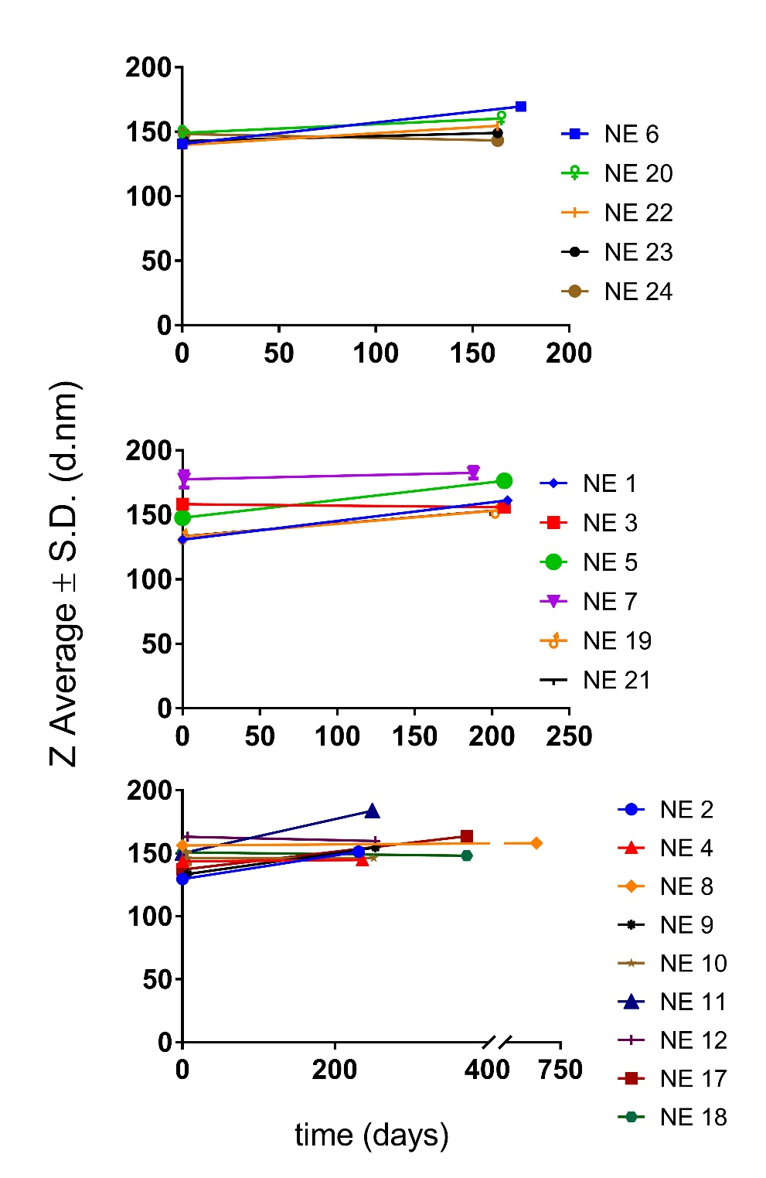

*A*

*B*

*C*

**Supp. Figure 1.** Nanoemulsions were stored at 4 °C and monitored for change in size over time to demonstrate shelf-life. Lines are put in place only to aid the reader.

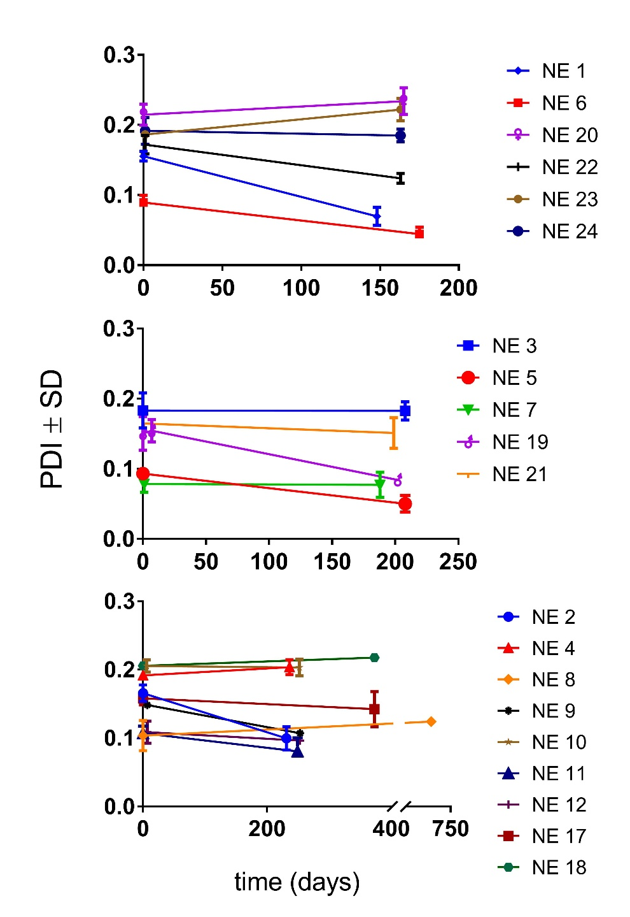

*A*

*B*

*C*

**Supp. Figure 2.** Nanoemulsions were stored at 4 °C and monitored for change in PDI over time to demonstrate shelf-life. Lines are put in place only to aid the reader.

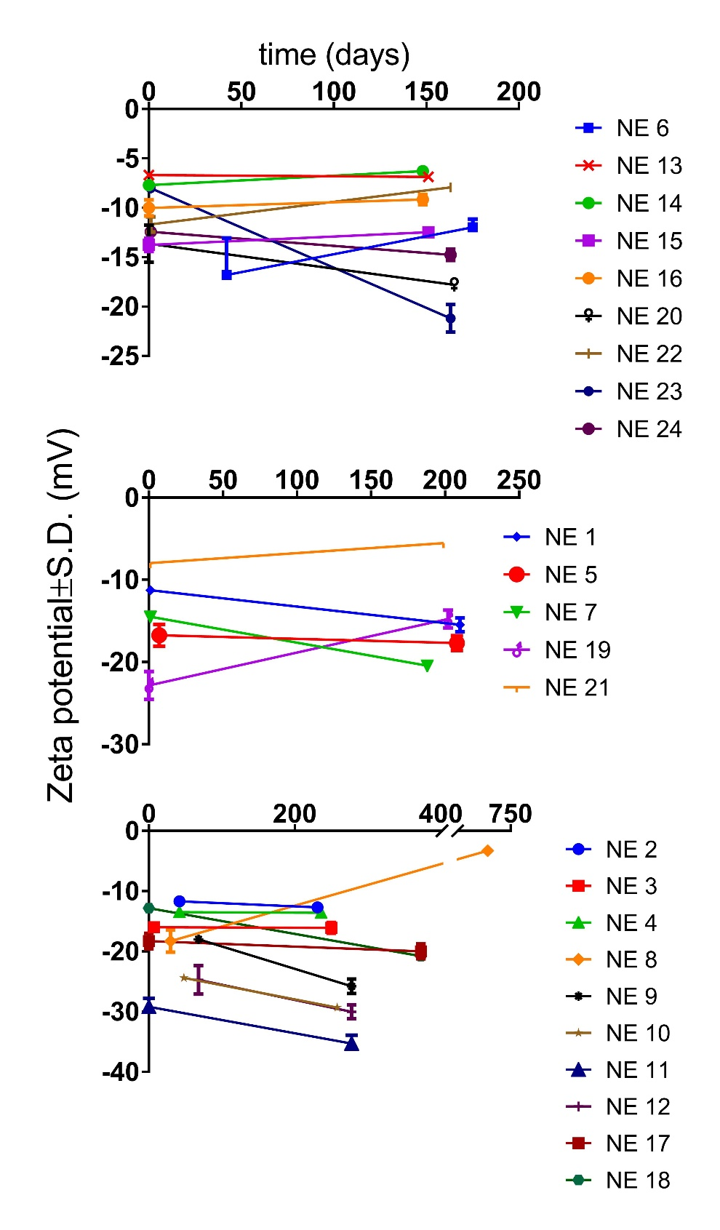

*A*

*B*

*C*

**Supp. Figure 3.** Nanoemulsions were stored at 4 °C and monitored for change in zeta potential over time to demonstrate shelf-life. Lines are put in place only to aid the reader.



**Supp. Figure 4.** Size distribution overlays for selected nanoemulsions. Solid lines represent measurements made within the first week of production. Dashed lines represent measurements made at a later follow up time (23 weeks post-production).



**Supp. Figure 5.** Zeta potential distribution overlays for selected nanoemulsions. Solid lines represent measurements made within the first week of production. Dashed lines represent measurements made at a later follow up time (23 weeks post-production).



**Supp. Figure 6.** Size distribution overlays for selected nanoemulsions. Solid lines represent measurements made within the first week of production. Dashed lines represent measurements made at a later follow up time (37, 53, and 53 weeks post-production for NEs 3, 17, and 18, respectively).



**Supp. Figure 7.** Zeta potential distribution overlays for selected nanoemulsions. Solid lines represent measurements made within the first week of production. Dashed lines represent measurements made at a later follow up time (37, 53, and 53 weeks post-production for NEs 3, 17, and 18, respectively).

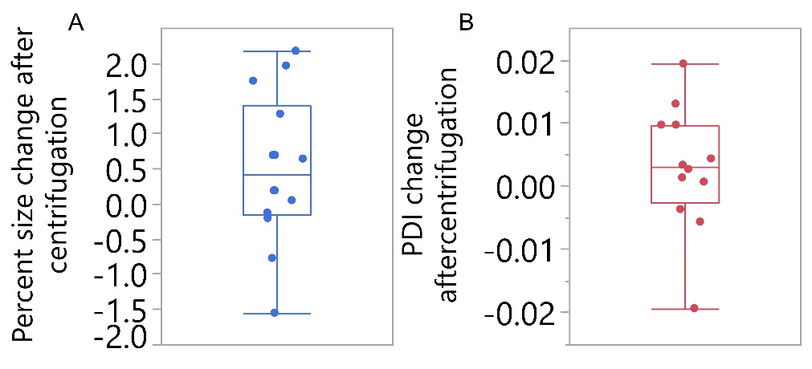

**Supp. Figure 8.** Centrifugation conditions elicited very small responses for all two-phase nanoemulsions and consequently the test was abandoned for remainder of emulsions.