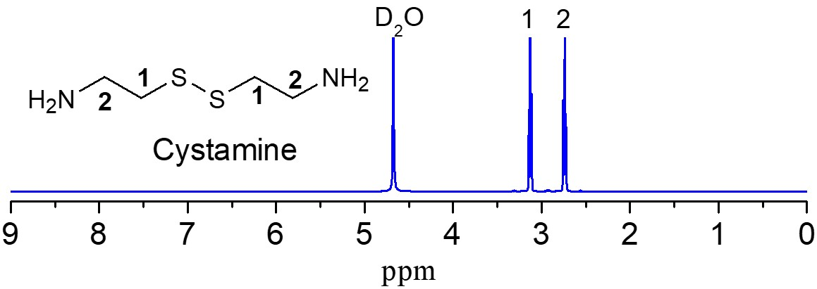
Figure 1S. ¹H NMR spectra of cystamine. D₂O was used as the solvent.

Graphical Abstracts
