Supplementary Information

1. Quantification of PHC-degrading genes and 16S rDNA

1.1 DNA extraction and general PCR

DNA was extracted from the soil microbes by use of E.Z.N.A. Soil DNA Soil Kit (OMEGA, USA) following the procedures recommended by the the manufacturer’s manual. General PCR was constructed in 25 µL reaction volumes containing 12.5 µL of 2× Master Mix (Promega, USA), 0.2 µM of each primer and 1µL of template DNA. The PCR amplification was carried out in an S1000 Thermal Cycler (Bio-Rad, USA) with the following protocols: initial denaturation at 95 ℃ for 5 min, followed by 35cycles of denaturing (95℃ for 30 s and 30 s at the annealing temperature specified in S1), and ended with an extension at 72 °C for 7 min. PCR products were detected using 1.5% (w/v) agarose gel electrophoresis and examined by comparison with DNA Mark I (TransGen, China).

1.2 Plasmid preparation and construction of standard curves

Agarose gel was recovered using Gel Extraction Kit (Omega) to obtain the target DNA. Then the DNA fragment was combined with pEASY®-T1 Cloning Vector (TransGen, China) and transformed into Phage Resistant Chemically Competent Cell (TransGen, China) following the manufacturer’s instructions. Blue-white selection based on plate culture was conducted to acquire the positive clones. Plasmid carrying target genes were extracted and verified by use of Plasmid Kit (OMEGA, USA) and agarose gel electrophoresis. Concentration and quality of the plasmids was determined using a biophotometers analyzer (Ependorf, Germany). Gene copy number per microliter of plasmid solution could be calculated directly according to lengths of the vector and the target genes. Then the ten-fold-serial plasmids dilutions for every set of primers were amplified through q-PCR to construct the standard curves of gene copy number-Ct value.

1.3 Real-time q-PCR

Real-time q-PCR was performed in iCycler Thermal Cycler (Bio-Rad, USA) with 25 µL reaction volumes containing 12.5 µL of SYBR Premix Ex Taq II (Takara, Japan), 0.2 µM of each primer and 1µL of template DNA (ten-fold-serial plasmids dilutions used for construction of standard curves, soil DNA for quantification of target genes and sterile water for negative control, respectively). Real-time qPCR protocols were set as follows: initial denaturation at 95 ℃ for 5 min, followed by 40 cycles of 3 steps including 95℃ for 30 s, 30 s at the annealing temperature for each set of primers specified in S1 and an extension at 72 °C for 30 s, when the fluorescence signal was first read. The final step lasted for 7 min at 72 °C. Quality of the q-PCR procedure was measured by read of the SYBR Green I signal by a melt curve analysis after the final step with temperature ramping from 55℃ to 95℃ at the speed of 0.5 °C/10 s.

1.4 Quantification of genes from sample soil microbes

Real-time q-PCR was carried out to quantify 16S rDNA, alkane and PAH degrading genes. Reaction volumes and temperature protocols for q-PCR were the same as that for the standard curves, except that DNA extracted from sample soil microbes were added as template DNA.

Data were analyzed using the CF Manager Software (Bio-Rad, US). Ct values were compared with the standard curves to calculate the gene copy number of 16S rDNA, alkane and PAH degrading genes. Each DNA sample from experimental soil microbes was run in triplicate. Quality of the q-PCR procedure was measured by read of the SYBR Green I signal by a melt curve analysis.

Table S1 Soil physicochemical parameters

|  |  |  |  |  |  |  |  |
| --- | --- | --- | --- | --- | --- | --- | --- |
|  | TPH  (mg/kg) | Salinity  (mg/kg) | pH | Total N  (mg/kg) | Total P  (mg/kg) | Total K  (mg/kg) | CEC  (mmol/kg) |
| Clean soils | 0 | 326 | 7.65 | 1467 | 0.1119 | 10862 | 146.5 |
| Contaminated soils | 65986 | 8981 | 8.37 | 445 | 0.0948 | 24607 | 95.4 |

Table S2 Characteristics of PCR primer sets used in this study

|  |  |  |  |  |  |
| --- | --- | --- | --- | --- | --- |
| Primer | Target gene | Sequence (5'→3') | Amplicon  Size | Annealing  Temperature | Reference |
| 1369F | 16S rDNA | CGGTGAATACGTTCYCGG | 123bp | 56°C | [1] |
| 1492R | GGWTACCTTGTTACGACTT |
| AlkBF | Alkane mono-oxygenase | AACTACMTCGARCAYTACGG | 100bp | 50°C | [2] |
| AlkBR | TGAMGATGTGGTYRCTGTTCC |
| PAH-RHDα-GNF | Gram negative PAH-RHDα | GAGATGCATACCACGTKGGTTGGA | 306bp | 57°C | [3] |
| PAH-RHDα-GNR | AGCTGTTGTTCGGGAAGAYWGTGCMGTT |
| PAH-RHDα-GPF | Gram negative PAH-RHDα | CGG CGC CGA CAA YTT YGT NGG | 292bp | 54°C | [3] |
| PAH-RHDα-GPR | GGG GAA CAC GGT GCC RTG DAT RAA |

Table S3 Gene copy numbers of AlkB and PAH-RHDα genes (normalized to 16S rDNA)

|  |  |  |  |  |  |  |  |  |
| --- | --- | --- | --- | --- | --- | --- | --- | --- |
|  | (%)AlkB-H | (%)AlkB-C | (%)PAH-GN-H | (%)PAH-GN-C | (%)PAH-GP-H | (%)PAH-GP-C | (%)PAH-H | (%)PAH-C |
| T0 | 1.99E-06 | 1.92E-06 | 4.78E-07 | 2.99E-07 | 5.11E-07 | 9.11E-07 | 9.89E-07 | 1.21E-06 |
| T1 | 3.96E-05 | 8.39E-06 | 7.26E-06 | 5.03E-07 | 2.30E-06 | 1.57E-06 | 9.56E-06 | 2.08E-06 |
| T2 | 7.03E-05 | 1.29E-05 | 1.25E-05 | 1.92E-06 | 6.84E-06 | 2.81E-06 | 1.93E-05 | 4.74E-06 |
| T3 | 1.51E-04 | 3.43E-05 | 2.86E-05 | 5.64E-06 | 9.83E-06 | 5.32E-06 | 3.85E-05 | 6.96E-06 |
| T4 | 1.56E-04 | 2.28E-05 | 7.83E-05 | 7.08E-06 | 1.43E-05 | 7.78E-06 | 9.26E-05 | 1.49E-05 |

-H, phytoremediation treatments planted with *H. spectabile*; -C, control treatments; %, (degrading gene copy numbers) / (16S rDNA copy numbers).

Table S4 Pearson correlation matrix between TPH concentration and degrading gene numbers

|  |  |  |  |  |  |
| --- | --- | --- | --- | --- | --- |
| Index | Alkb | PAH-RHDα-GN | PAH-RHDα-GP | PAH-RHDα | TPH |
| AlkB | 1 |  |  |  |  |
|  |  |  |  |
| PAH-RHDα-GN | 0.975* | 1 |  |  |  |
| 0.025 |  |  |  |
| PAH-RHDα-GP | 0.969* | 0.918 | 1 |  |  |
| 0.031 | 0.082 |  |  |
| PAH-RHDα | 0.984* | 0.999** | 0.938 | 1 |  |
| 0.016 | 0.001 | 0.062 |  |
| TPH | 0.998** | 0.979* | 0.977* | 0.988* | 1 |
| 0.001 | 0.021 | 0.023 | 0.012 |  |

*Correlation is significant at the 0.05 level (2-tailed); **Correlation is significant at the 0.01 level (2-tailed).

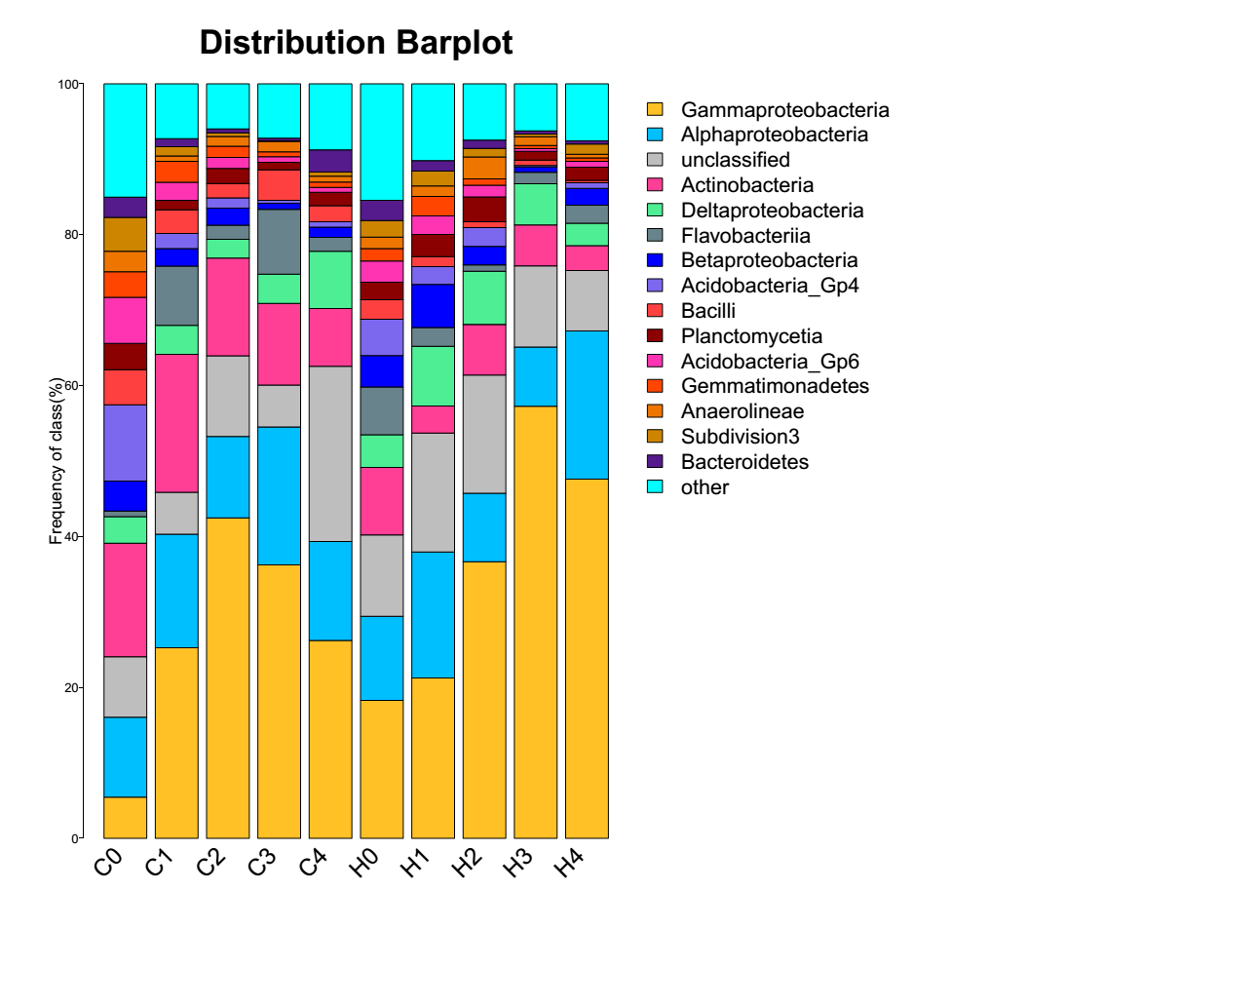

Figure S1 Distribution bar plot of bacterial communities among different treatments at class level. Taxonomic composition out of the top 14 classes were grouped as “other”; Sequences that could not be classified into any known group were assigned as “unclassified”.

../../../../../Desktop/new%20paper/figures/16s%20standard%20curve.p ../../../../../Desktop/new%20paper/figures/alkB.pdf

../../../../../Desktop/new%20paper/figures/pah-gn1.pdf../../../../../Desktop/new%20paper/figures/pah-gp1.pdf

Figure S2 Standard curves of 16S rDNA (a), AlkB (b), PAH-RHDα-GN (c) and PAH-RHDα-GP (d)