Supplementary files

Supplementary file 1: Overview of TTS clips

Clip | Quick Clip Pro | Quick Clip 2  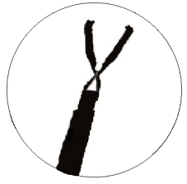 | Resolution clip  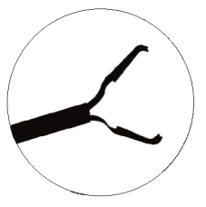 | Instinct clip | Hemoclip  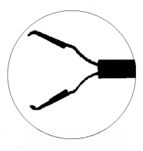 | Chinese hemoclip | DuraClip | SureClip  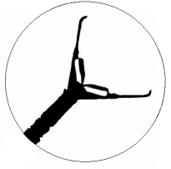
Brand | Olympus, Tokyo Japan | Olympus, Tokyo Japan | Boston Scientific, Natick MA | Cook Medical, N USA | Life Partners Europe, Bagnelot, France | Zhuji Pengtian Medical Instrument Co., Zhejiang, China | Conmed, NY, USA | Micro-Tech Endoscopy, MI, USA
Release year | 2002 | 2005 | 2003 | 2011 | 2017 ? | 2016 | 2016 | 2018
Opening span | 11 mm | 9 mm (long: 11 mm) | 11 mm | 16 mm | 9/11/13/16 mm | 8/11/16mm | 11 mm or 16 mm | 11 mm or 16 mm
360ᵒ rotatable | ✓ | ✓ | -/ ✓  (new version Resolution 360 is fully rotatable) | ✓ | ✓ | ✓ | ✓ | ✓
Repositionable | ✓ (up to 5 times) | - | ✓ (up to 5 times) | - | ✓ (Also offers the ‘One drop’clip’ which is not repositionable) | ✓ | ✓ (unlimited) | -
Average duration of retention | ? | Average 9.4 days on normal mucosa.  1-3 weeks on ulcerative mucosa | 4 weeks - 180 days  4.2% retention at first FU (3-6 months) | 8.6% retention at first FU (3-6 months) | ? | ? | ? | ?
- All clips, except for the QuickClip2, are compatible with standard MRI with a static magnetic field of 3.0 Tesla or less and a maximum spatial magnetic gradient of 1600 Gauss/cm or less.
- All clips in the table are ready-to-use. In addition, Olympus also offers the EZ clip, which is not ready to use. The clip applier costs €40 and can be used to place multiple clips within one person before throwing it away. EZ clips cost €10, so the more clips are needed in one session, the cheaper the price per placement.
- Prices are approximations and may not reflect the exact prices due to price variations.
- Excreted clips are disposed of via the sewage system, where it gets filtered out of the water together with other metal remnants.

