**Supplementary material**

**Loss of suitable climatic areas for *Araucaria* forests over time**

Rodrigo S. Bergamin, Vanderlei Debastiani, Daiany C. Joner, Priscila Lemes, Taís Guimarães, Rafael D. Loyola, Sandra C. Müller

Table S1a: Comparison between the model predictions and pollen studies for the LGM (21 000 years before the present). Codes refer to the localities presented in Fig. 4a.



Table S1b: Comparison between the model predictions and pollen studies for the mid-Holocene (6 000 years before the present). Codes refer to the localities presented in Fig. 4b.



References

Behling H. 1995. A high resolution Holocene pollen record from Lago do Pires, SE Brazil: vegetation, climate and fire history. Journal of Paleolimnology 14: 253–268.

Behling H. 1997. Late quaternary vegetation, climate and fire history of the Araucaria forest and campos region from Serra Campos Gerais, Paraná State (South Brazil). – Review of Palaeobotany and Palynology 97:109–121.

Behling H. 1997. Late Quaternary vegetation, climate and fire history from the tropical mountain region of Morro de Itapeva, SE Brazil. Palaeogeography, Palaeoclimatology, Palaeoecology 129: 407–422.

Behling H and Lichte M. 1997. Evidence of Dry and Cold Climatic Conditions at Glacial Times in Tropical Southeastern Brazil. Quaternary Research 48: 348–358.

Behling H and Negrelle RRB. 2001. Late Quaternary tropical rain forest and climate dynamics from the Atlantic lowland in southern Brazil. – Quaternary Research 56: 383–389.

Behling H. 2003. Late Quaternary vegetation, climate and fire history inferred from Lagoa Nova in the southeastern Brazilian lowland. Vegetation History and Archaeobotany 12: 263–270.

Behling H, Pillar VD, Orlóci L, Bauermann, S.G. 2004. Late Quaternary Araucaria forest, grassland (Campos), fire and climate dynamics, studied by high-resolution pollen, charcoal and multivariate analysis of the Cambará do Sul core in southern Brazil. Palaeogeography, Palaeoclimatology, Palaeoecology 203: 277–297.

Behling, H. et al. 2005. Late Quaternary grassland (Campos), gallery forest, fire and climate dynamics, studied by pollen, charcoal and multivariate analysis of the São Francisco de Assis core in western Rio Grande do Sul (southern Brazil). – Rev. Palaeobot. Palynol.133: 235–248.

Behling H, Dupont L, Safford H, Wefer G. 2007. Late Quaternary vegetation and climate dynamics in the Serra da Bocaina, southeastern Brazil. Quaternary Intermational 161: 22–31.

Jeske-Pieruschka V and Behling H. 2011. Palaeoenvironmental history of the São Francisco de Paula region in southern Brazil during the late Quaternary inferred from the Rincão das Cabritas core. Holocene 22:1251–1262.

Jeske-Pieruschka, V. et al. 2012. New insights into vegetation, climate and fire history of southern Brazil revealed by a 40,000 year environmental record from the State Park Serra do Tabuleiro. – Veg. Hist. Archaeobot. 22: 299–314.

Ledru MP. 1993. Late Quaternary Environmental and Climate Changes in Central Brazil. Quaternary Research 39: 90-98.

Leonhardt A and Lorscheitter ML. 2010. The last 25,000 years in the Eastern Plateau of Southern Brazil according to Alpes de São Francisco record. Journal of South American Earth Science 29:454–463.

Macedo, R.B. et al. 2010. Palynological analysis of a late Holocene coer from Santo Antônio da Patrulha, Rio Grande do Sul, Southern Brazil. – An. Acad. Bras. Cienc. 82:731–745.

Pessenda, L.C.R.et al. 2009. The evolution of a tropical rainorest/grassland mosaic in southeastern Brazil since 28,000 14C yr BP based on carbon isotopes and pollen records. – Quat. Res. 71: 437-452.

Pessenda, L.C.R. et al. 2012. Late Quaternary vegetation and coastal environmental changes at Ilha do Cardoso mangrove, southeastern Brazil. – Palaeogeogr. Palaeoclimatol. Palaeoecol. 363-364: 57-68.

Figure S1. Individual occurrence points of the indicator species: a) *Annona rugulosa*; b) *Araucaria angustifolia*; c) *Cinnnamodendron dinisii*; d) *Cinnamomum amoenum*; e) *Cryptocaria aschersoniana*; f) *Mimosa scabrella*; g) *Myrceugenia cucculate*; h) *Ocotea porosa*; i) *Piptocarpha angustifolia*; j) *Solanum compressum*; k) *Solanum corymbiflorum*, and; l) *Zanthoxyluma kleinii*.

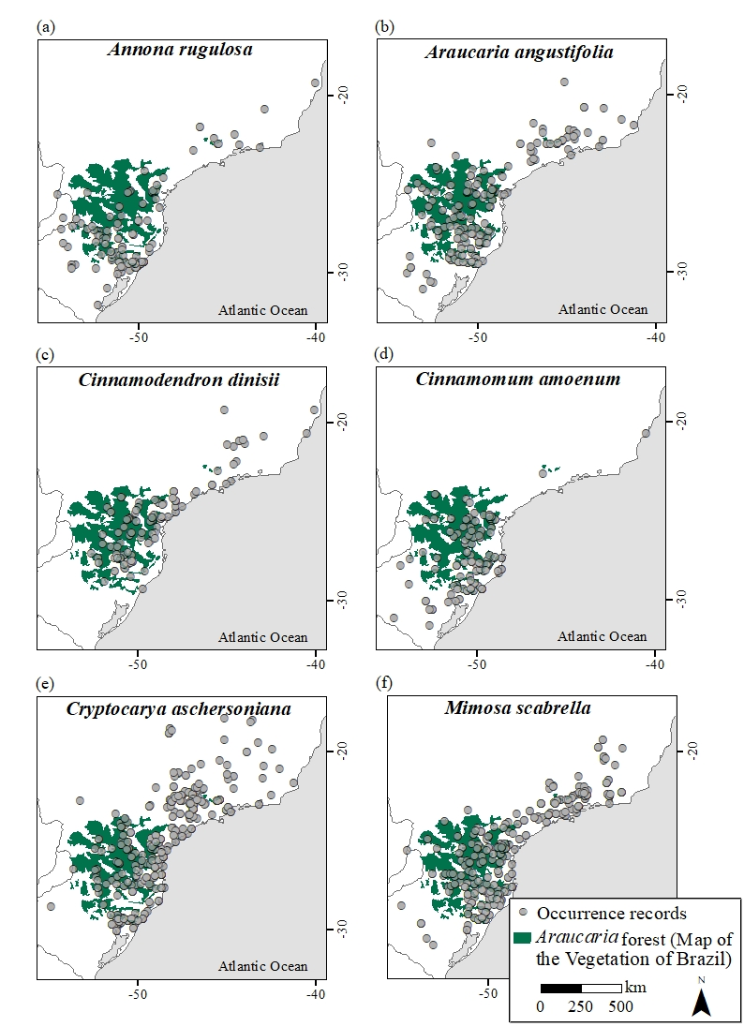

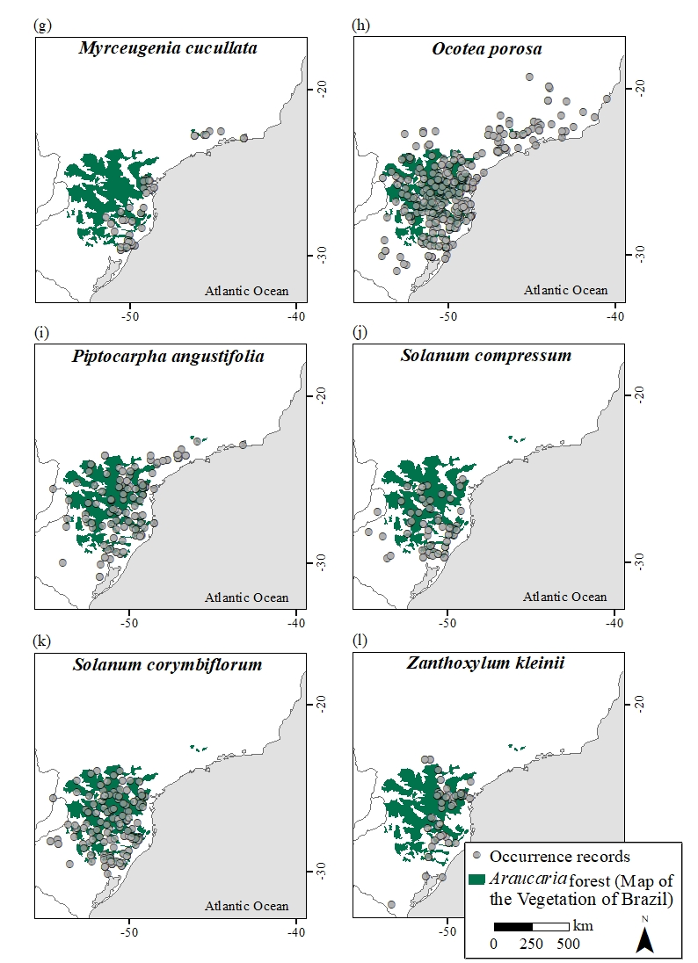

Figure S2: Modelled climatic suitability of *Annona rugulosa*. A, the Last Glacial Maximum (21,000 years before present); B, the mid-Holocene (6,000 years before present); C, current distribution; D, projected distribution in 2070 under a low greenhouse gas emission scenario (RCP 2.6); E, projected distribution in 2070 under a high greenhouse gas emission scenario (RCP 8.5); F, core area (areas that overlap across all scenarios).

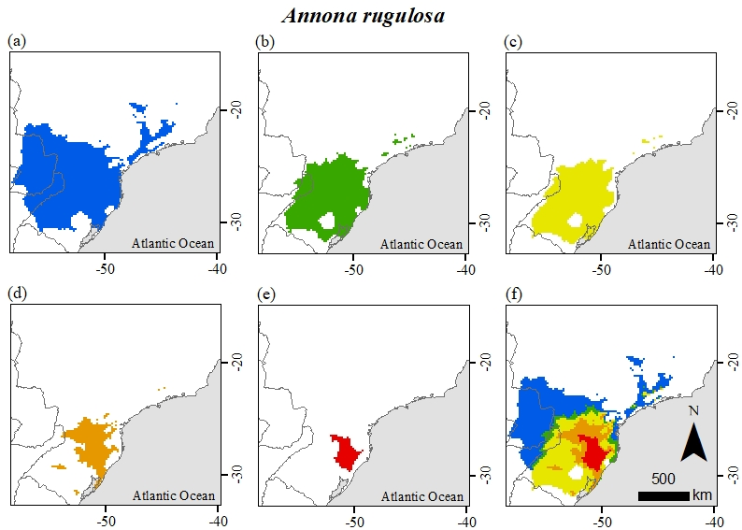

Figure S3: Modelled climatic suitability of *Araucaria angustifolia*. A, the Last Glacial Maximum (21,000 years before present); B, the mid-Holocene (6,000 years before present); C, current distribution; D, projected distribution in 2070 under a low greenhouse gas emission scenario (RCP 2.6); E, projected distribution in 2070 under a high greenhouse gas emission scenario (RCP 8.5); F, core area (areas that overlap across all scenarios).

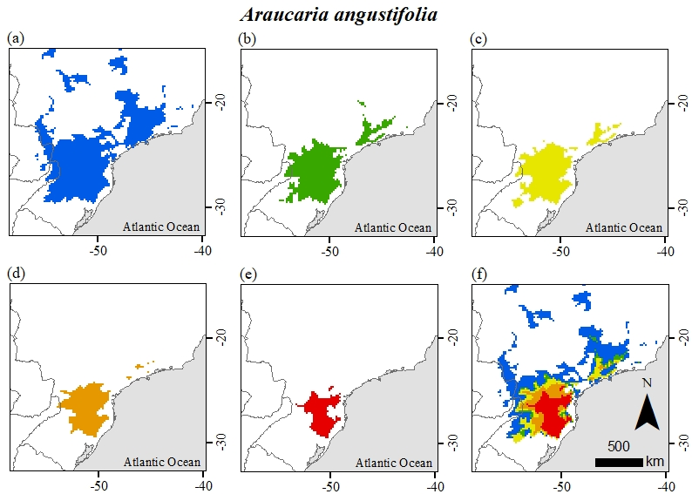

Figure S4: Modelled climatic suitability of *Cinnamodendron dinisii*. A, the Last Glacial Maximum (21,000 years before present); B, the mid-Holocene (6,000 years before present); C, current distribution; D, projected distribution in 2070 under a low greenhouse gas emission scenario (RCP 2.6); E, projected distribution in 2070 under a high greenhouse gas emission scenario (RCP 8.5); F, core area (areas that overlap across all scenarios).

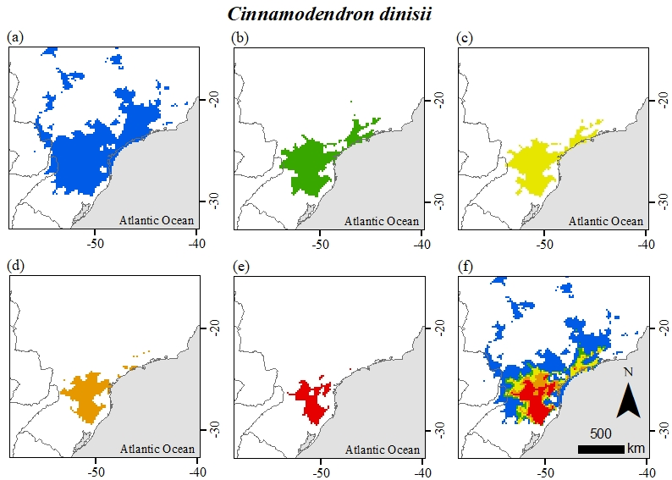

Figure S5: Modelled climatic suitability of *Cinnamomum amoenum*. A, the Last Glacial Maximum (21,000 years before present); B, the mid-Holocene (6,000 years before present); C, current distribution; D, projected distribution in 2070 under a low greenhouse gas emission scenario (RCP 2.6); E, projected distribution in 2070 under a high greenhouse gas emission scenario (RCP 8.5); F, core area (areas that overlap across all scenarios).

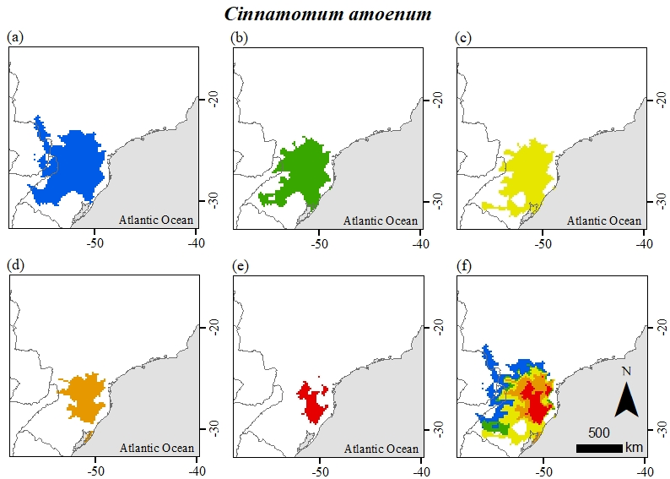

Figure S6: Modelled climatic suitability of *Cryptocaria aschersoniana*. A, the Last Glacial Maximum (21,000 years before present); B, the mid-Holocene (6,000 years before present); C, current distribution; D, projected distribution in 2070 under a low greenhouse gas emission scenario (RCP 2.6); E, projected distribution in 2070 under a high greenhouse gas emission scenario (RCP 8.5); F, core area (areas that overlap across all scenarios).

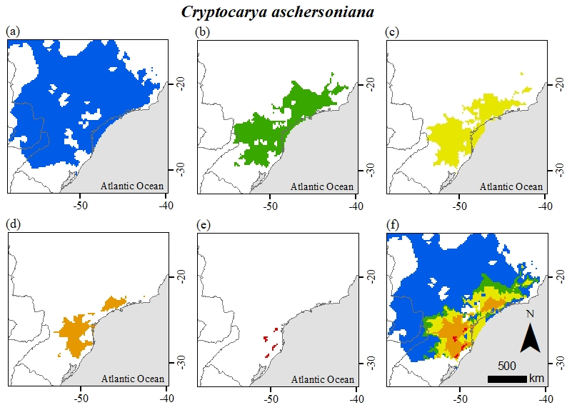

Figure S7: Modelled climatic suitability of *Mimosa scabrella*. A, the Last Glacial Maximum (21,000 years before present); B, the mid-Holocene (6,000 years before present); C, current distribution; D, projected distribution in 2070 under a low greenhouse gas emission scenario (RCP 2.6); E, projected distribution in 2070 under a high greenhouse gas emission scenario (RCP 8.5); F, core area (areas that overlap across all scenarios).

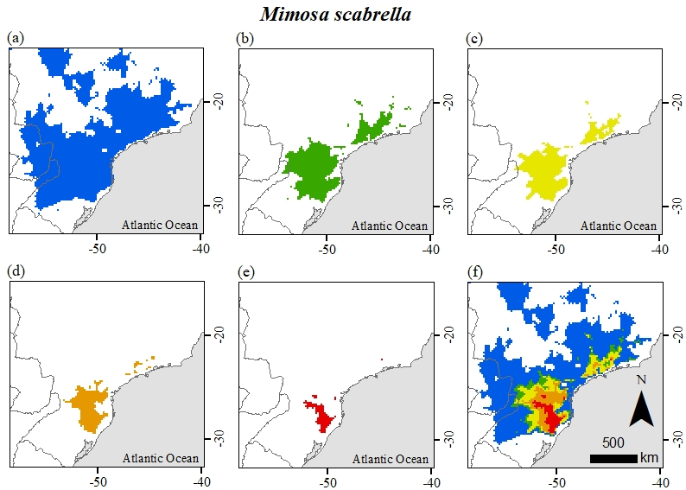

Figure S8: Modelled climatic suitability of *Myrceugenia cucullata*. A, the Last Glacial Maximum (21,000 years before present); B, the mid-Holocene (6,000 years before present); C, current distribution; D, projected distribution in 2070 under a low greenhouse gas emission scenario (RCP 2.6); E, projected distribution in 2070 under a high greenhouse gas emission scenario (RCP 8.5); F, core area (areas that overlap across all scenarios).

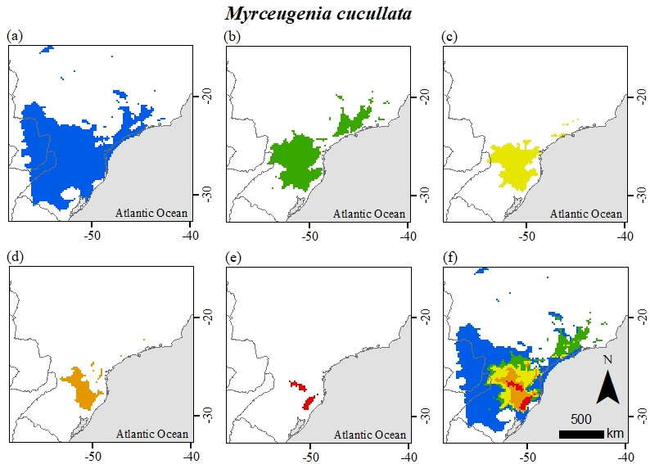

Figure S9: Modelled climatic suitability of *Ocotea porosa*. A, the Last Glacial Maximum (21,000 years before present); B, the mid-Holocene (6,000 years before present); C, current distribution; D, projected distribution in 2070 under a low greenhouse gas emission scenario (RCP 2.6); E, projected distribution in 2070 under a high greenhouse gas emission scenario (RCP 8.5); F, core area (areas that overlap across all scenarios).

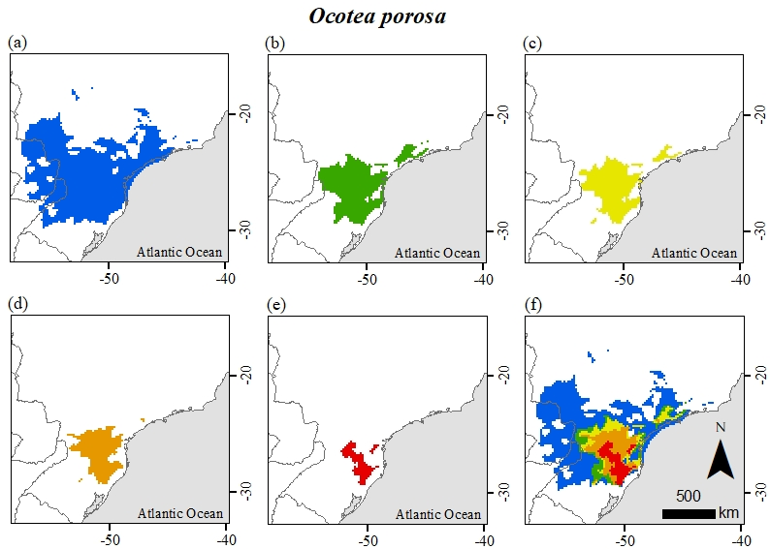

Figure S10: Modelled climatic suitability of *Piptocarpha angustifolia*. A, the Last Glacial Maximum (21,000 years before present); B, the mid-Holocene (6,000 years before present); C, current distribution; D, projected distribution in 2070 under a low greenhouse gas emission scenario (RCP 2.6); E, projected distribution in 2070 under a high greenhouse gas emission scenario (RCP 8.5); F, core area (areas that overlap across all scenarios).

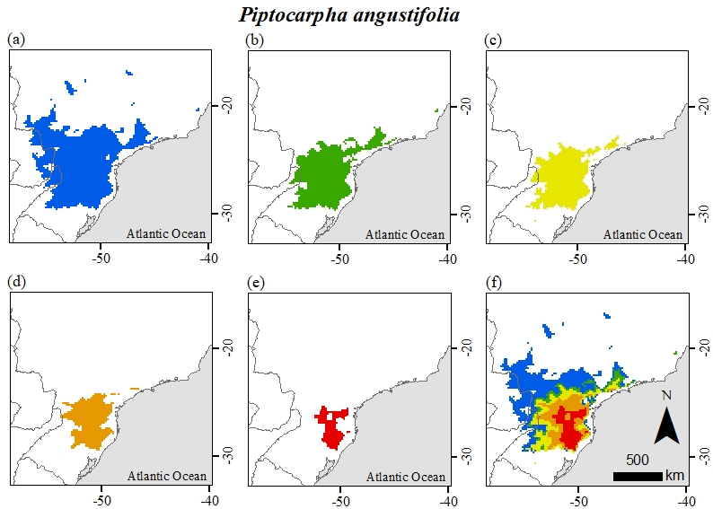

Figure S11: Modelled climatic suitability of *Solanum compressum*. A, the Last Glacial Maximum (21,000 years before present); B, the mid-Holocene (6,000 years before present); C, current distribution; D, projected distribution in 2070 under a low greenhouse gas emission scenario (RCP 2.6); E, projected distribution in 2070 under a high greenhouse gas emission scenario (RCP 8.5); F, core area (areas that overlap across all scenarios).

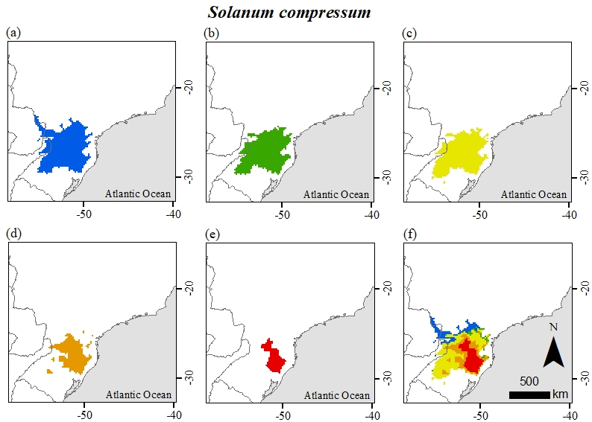

Figure S12: Modelled climatic suitability of *Solanum corymbiflorum*. A, the Last Glacial Maximum (21,000 years before present); B, the mid-Holocene (6,000 years before present); C, current distribution; D, projected distribution in 2070 under a low greenhouse gas emission scenario (RCP 2.6); E, projected distribution in 2070 under a high greenhouse gas emission scenario (RCP 8.5); F, core area (areas that overlap across all scenarios).

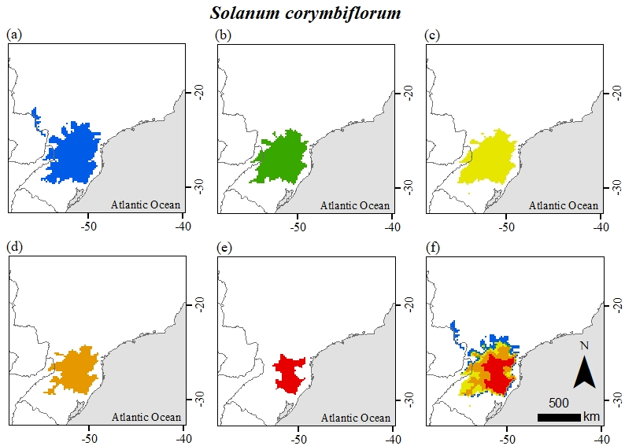

Figure S13: Modelled climatic suitability of *Zanthoxylum kleinii*. A, the Last Glacial Maximum (21,000 years before present); B, the mid-Holocene (6,000 years before present); C, current distribution; D, projected distribution in 2070 under a low greenhouse gas emission scenario (RCP 2.6); E, projected distribution in 2070 under a high greenhouse gas emission scenario (RCP 8.5); F, core area (areas that overlap across all scenarios).

