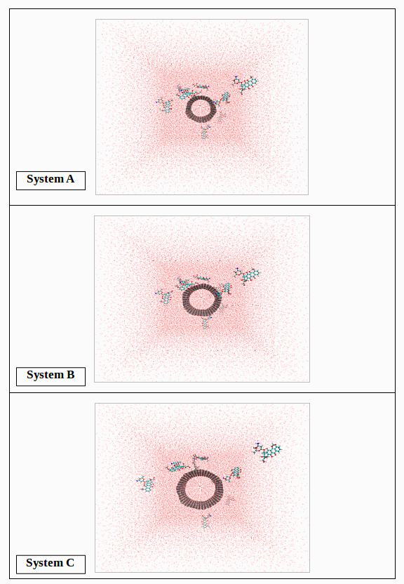
Figure SF1. Initial snapshots of different simulation systems (i.e. A-C systems).

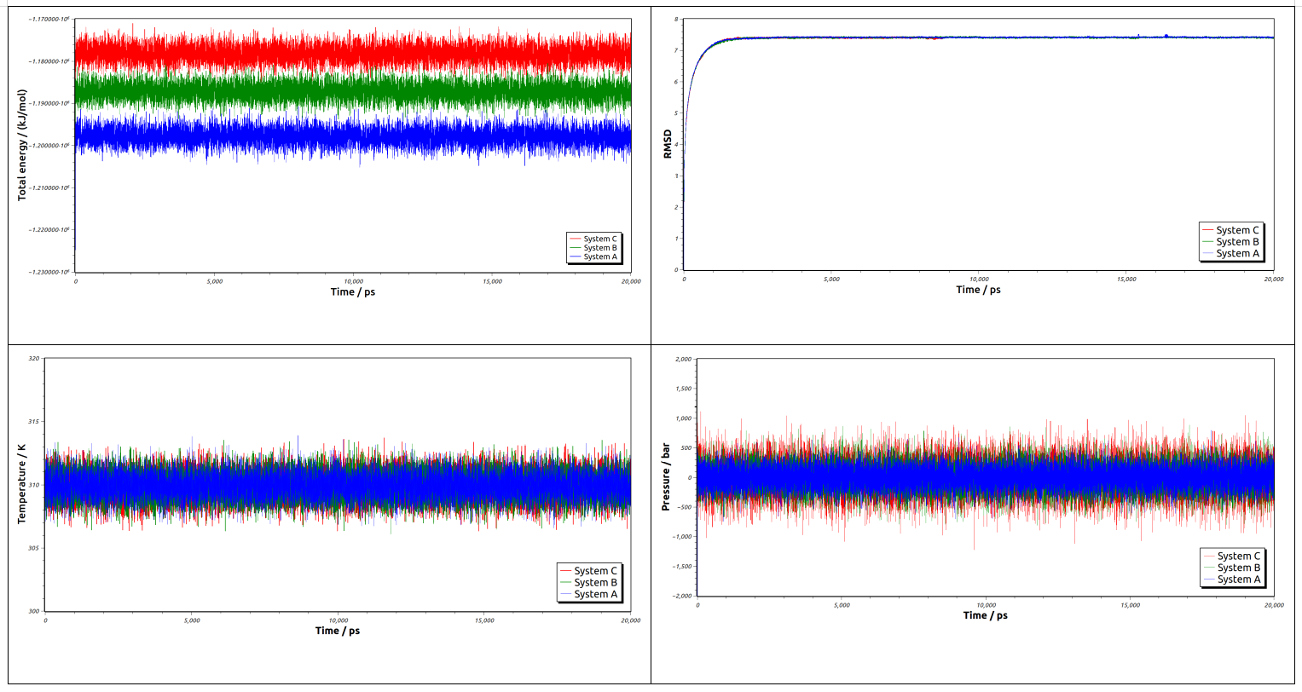
Figure SF2. Total energy, RMSD, Temperature and Pressure curves for all MD simulation systems (i.e. A-C systems).

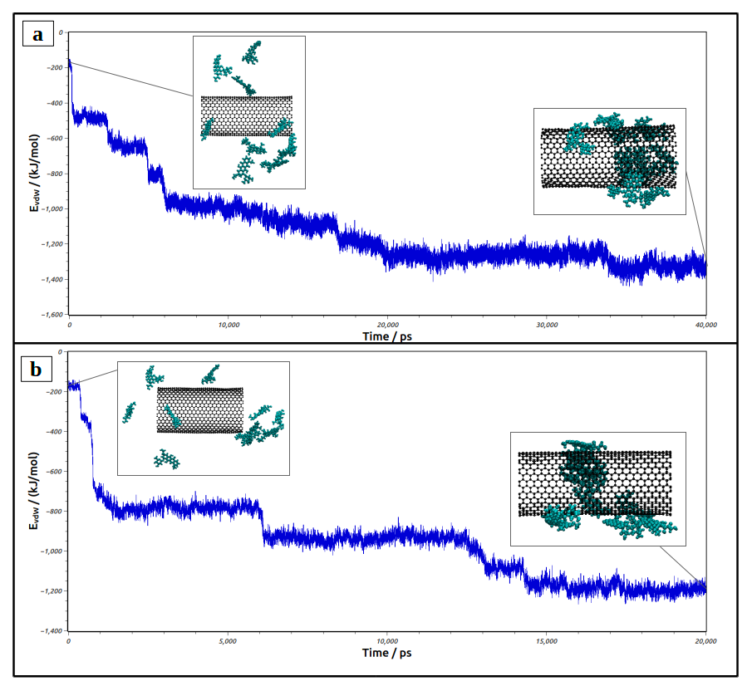
Figure SF3. The vdW interaction energies between DOX molecules and SWCNT with a. increasing the simulation time to 40 ns, and b. different initial configuration.

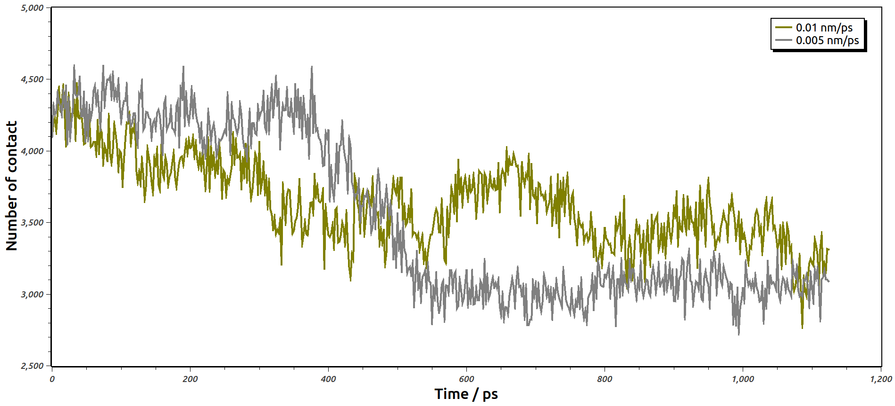
Figure SF4. Number of contacts between DOX and water molecules in E system at different velocities.

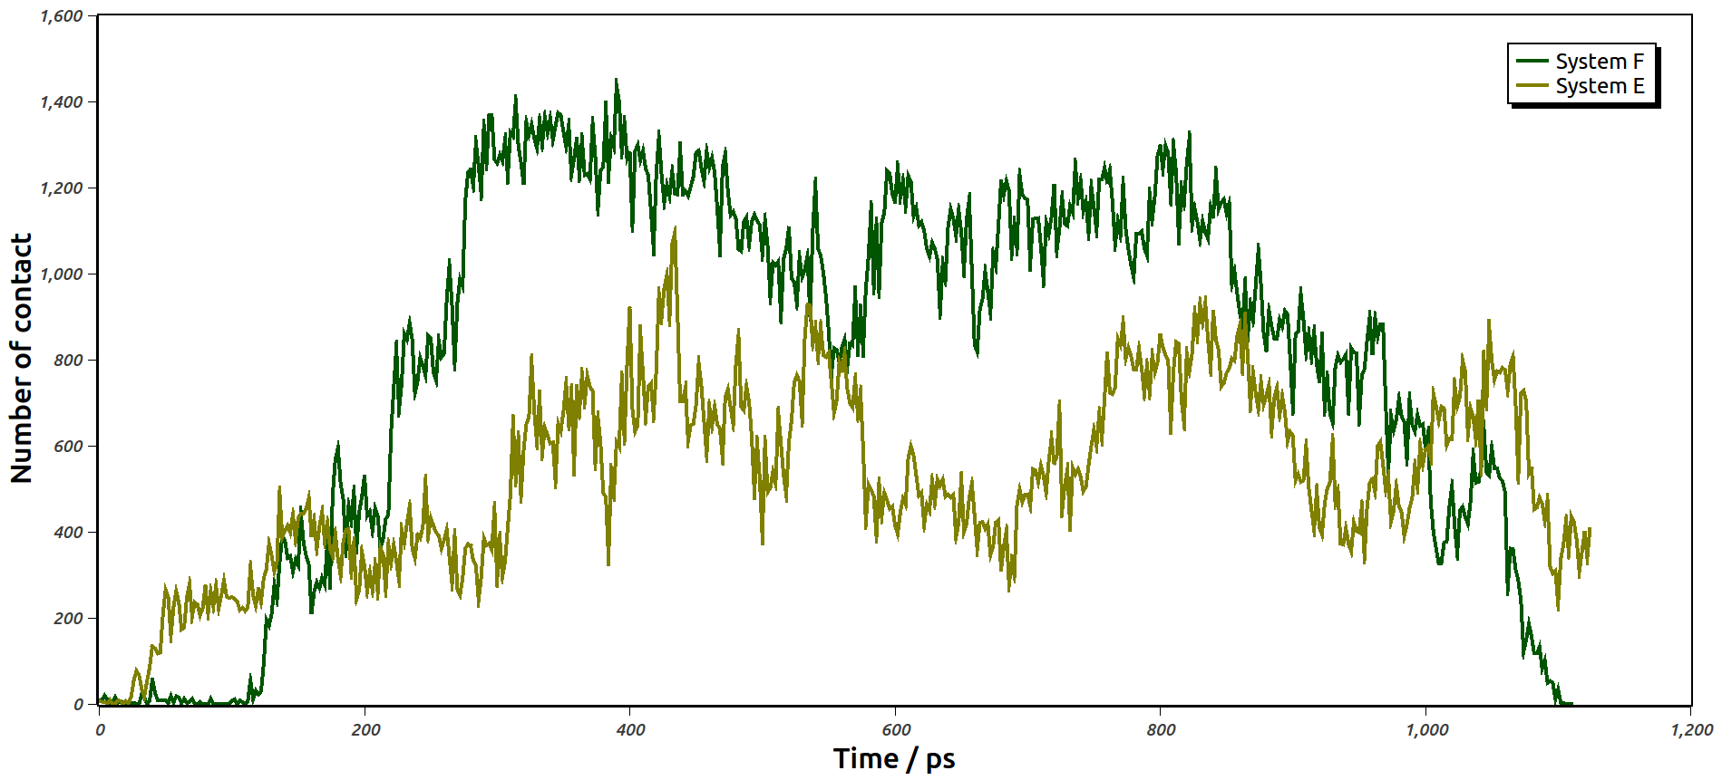
Figure SF5. Number of contacts between DOX molecules and SWCNT wall in E and F systems at the constant velocity of 0.01 nm/ps.

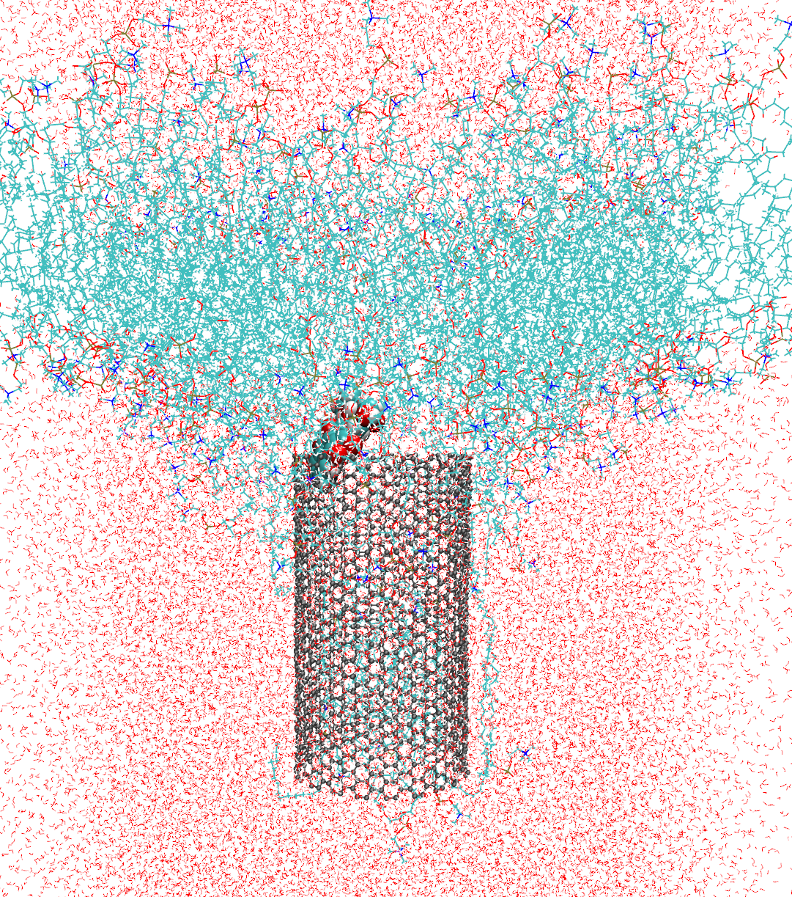
Figure SF6. Final snapshot of the encapsulated DOX- SWCNT (20, 20) exiting the lipid bilayer in the absence of Nicotine molecules (system E).

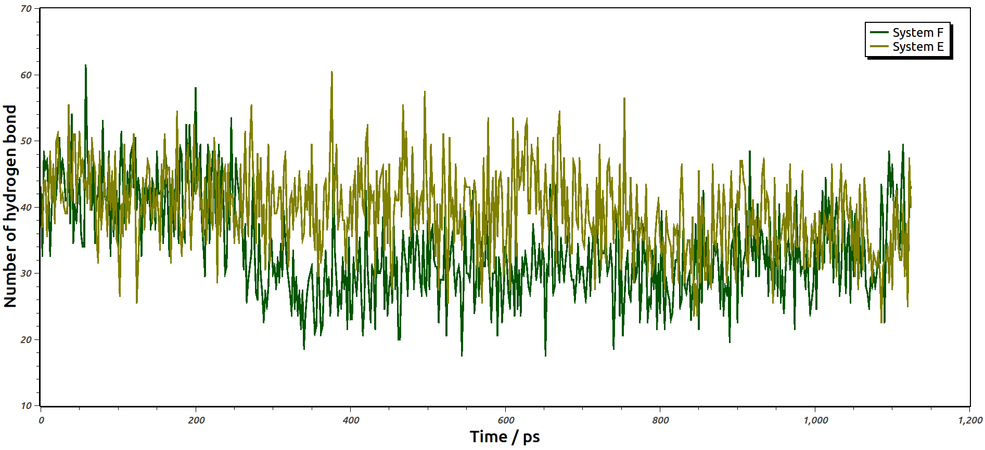
Figure SF7. The number of hydrogen bonds between DOX drug and water molecules in E and F systems at velocity of 0.01 nm/ps.

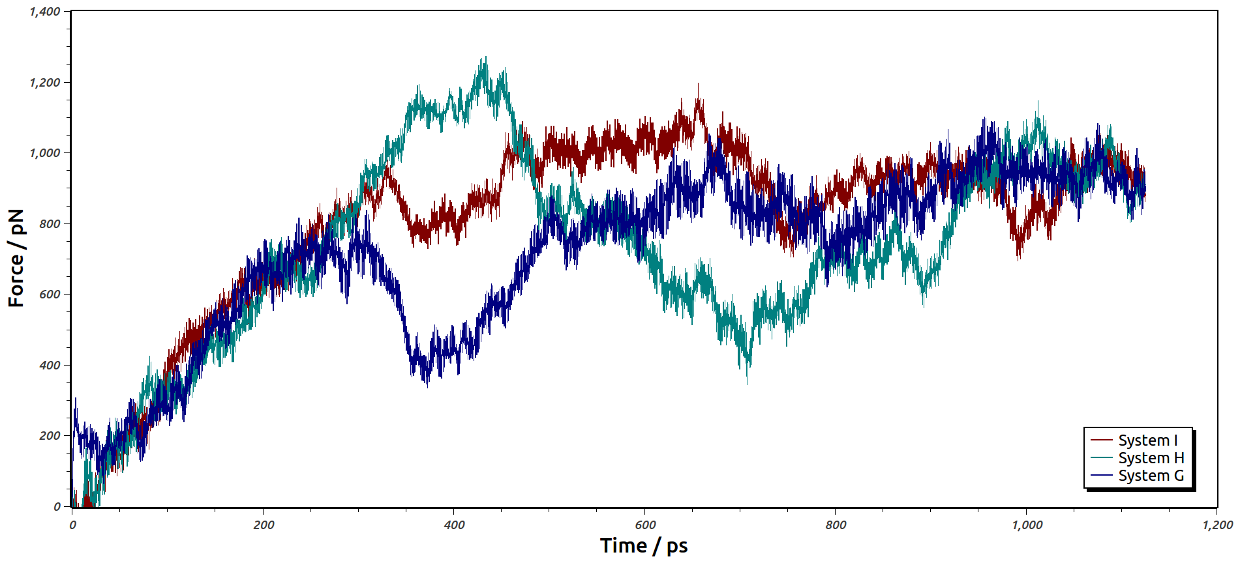
Figure SF8. The force-time curves of the encapsulated DOX-SWCNT system under different concentrations of Nicotine.

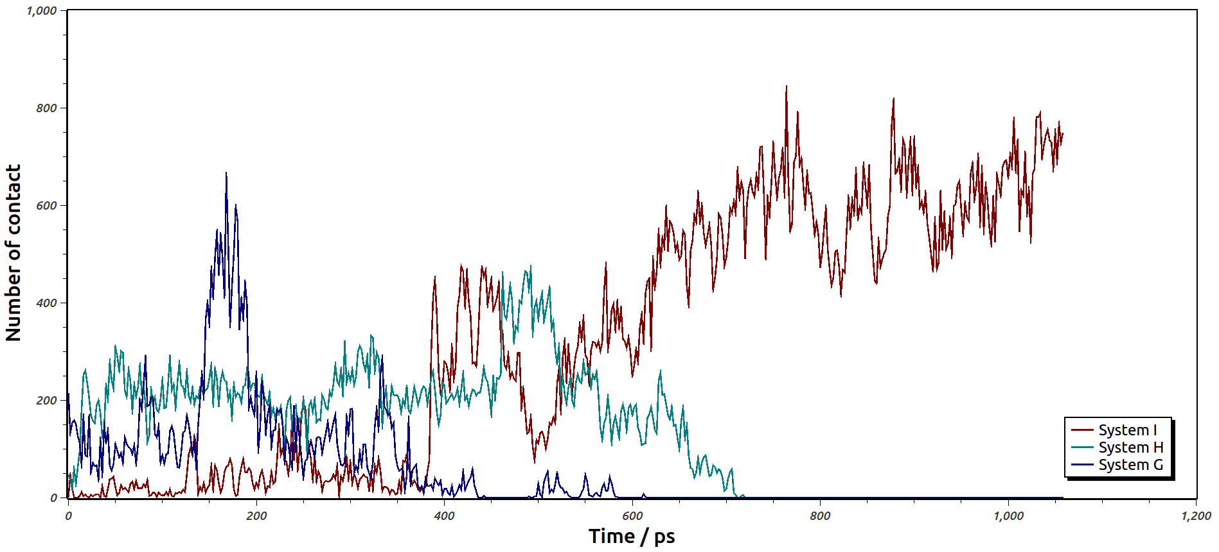
Figure SF9. Number of contacts between DOX molecules and SWCNT wall under different concentrations of Nicotine.

