Supporting Information

Corrosion behavior investigation of 460 low alloy steels exposed in the natural deep-sea environment
Tigang Duan, Likun Xu *, Kangkang Ding, Wenshan Peng, Jian Hou, Weimin Guo, Wenhua Cheng
State Key Laboratory for Marine Corrosion and Protection, Luoyang Ship Material Research Institute(LSMRI), Qingdao 266237, China
*Corresponding author.
Likun Xu: Tel.: +86-13583228231; E-mail address: xulk@sunrui.net

(b)
(a)
(c)
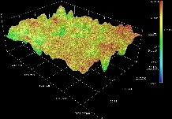  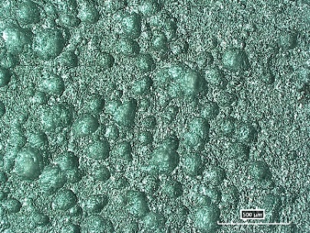  (d) | 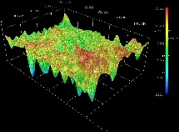  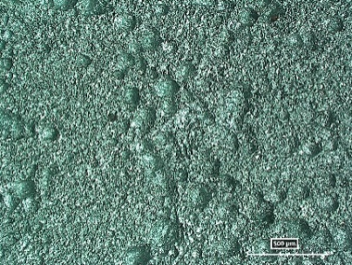  (e) | 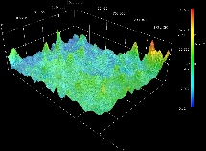  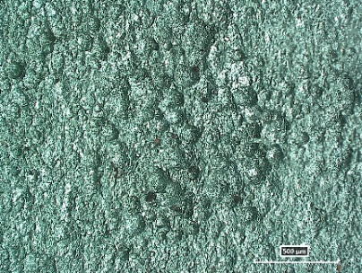  (f)
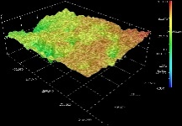  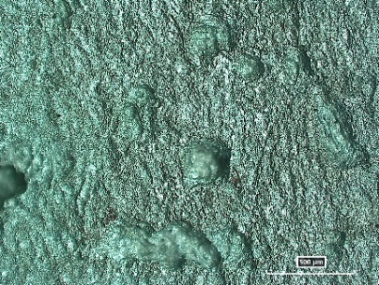  (g) | 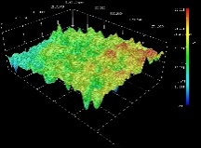  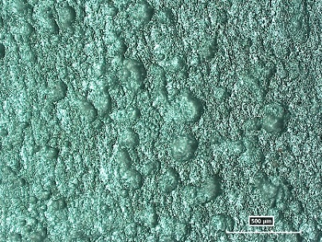  (h) | 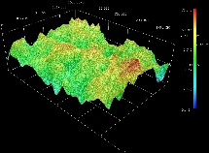  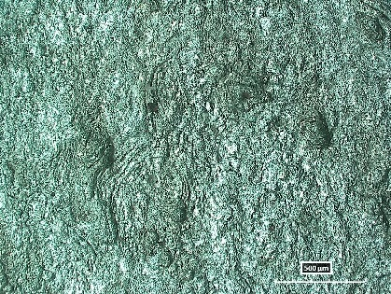  (i)
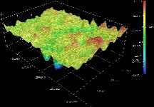  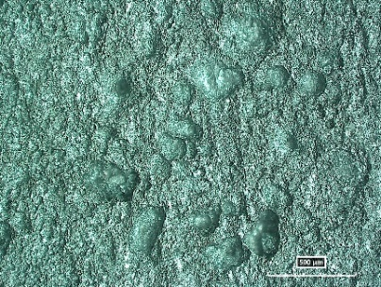 | 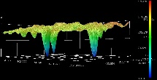  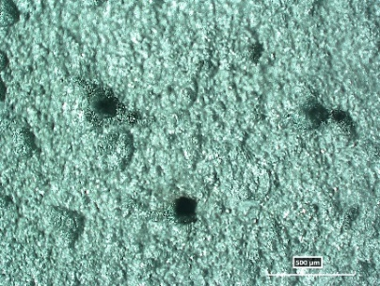 | 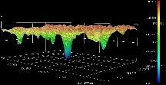  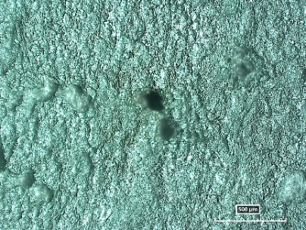  500 μm
Figure S1 Corrosion micro-morphologies of 460 steel after rust removal: (a-c) 0.5a period, (d-f) 1a period, (g-i) 2a period; (a, d, g) 1200 m, (b, e, h) 2000 m, (c, f, i) 3000 m. Insets are the corresponding 3D structure images.

