**Supporting information**

**Lead removal via biochars obtained from slow pyrolysis of dry and soaked pecan shell biomass**

Glenn B. Crisler II¥, Griffin A. Burk¥, Patrice Simmons¥, Mitchell Quigley¥, and Todd Mlsna¥.

¥Department of Chemistry, Mississippi State University, Starkville, Mississippi 39762, United States

Contents

Figure S1 TGA decomposition curves for NPSB and WPSB Page S3

Figure S2 FTIR spectra of NPSB and WPSB Page S4

Figure S3 EDX spectra of NPSB and WPSB before and after Pb2+ adsorption Page S5

Figure S4 First order kinetics linearized plot log(qe-qt) vs t Page S6

Table S1 Ash Content Page S5

Table S2 1st order kinetic parameters Page S6

Figure S1. TGA decomposition curves for NPSB and WPSB



Figure S2. FTIR spectra for NPSB and WPSB



Table S1. Ash content of NPSB and WPSB, masses are given in grams.

|  |  |  |  |  |  |  |  |  |  |  |
| --- | --- | --- | --- | --- | --- | --- | --- | --- | --- | --- |
| Biochar | Repetition 1 | | | Repetition 2 | | | Repetition 3 | | | Average Ash % |
| Initial Mass | Final Mass | Ash % | Initial Mass | Final Mass | Ash % | Initial Mass | Final Mass | Ash % |
| NPSB | 1.15 | 0.056 | 4.91 | 1.01 | 0.054 | 5.09 | 1.13 | 0.058 | 5.07 | 5.02 |
| WPSB | 1.09 | 0.048 | 4.36 | 1.04 | 0.047 | 3.33 | 1.04 | 0.044 | 4.20 | 3.96 |

Figure S3. EDX spectra of NPSB and WPSB before and after Pb2+ adsorption

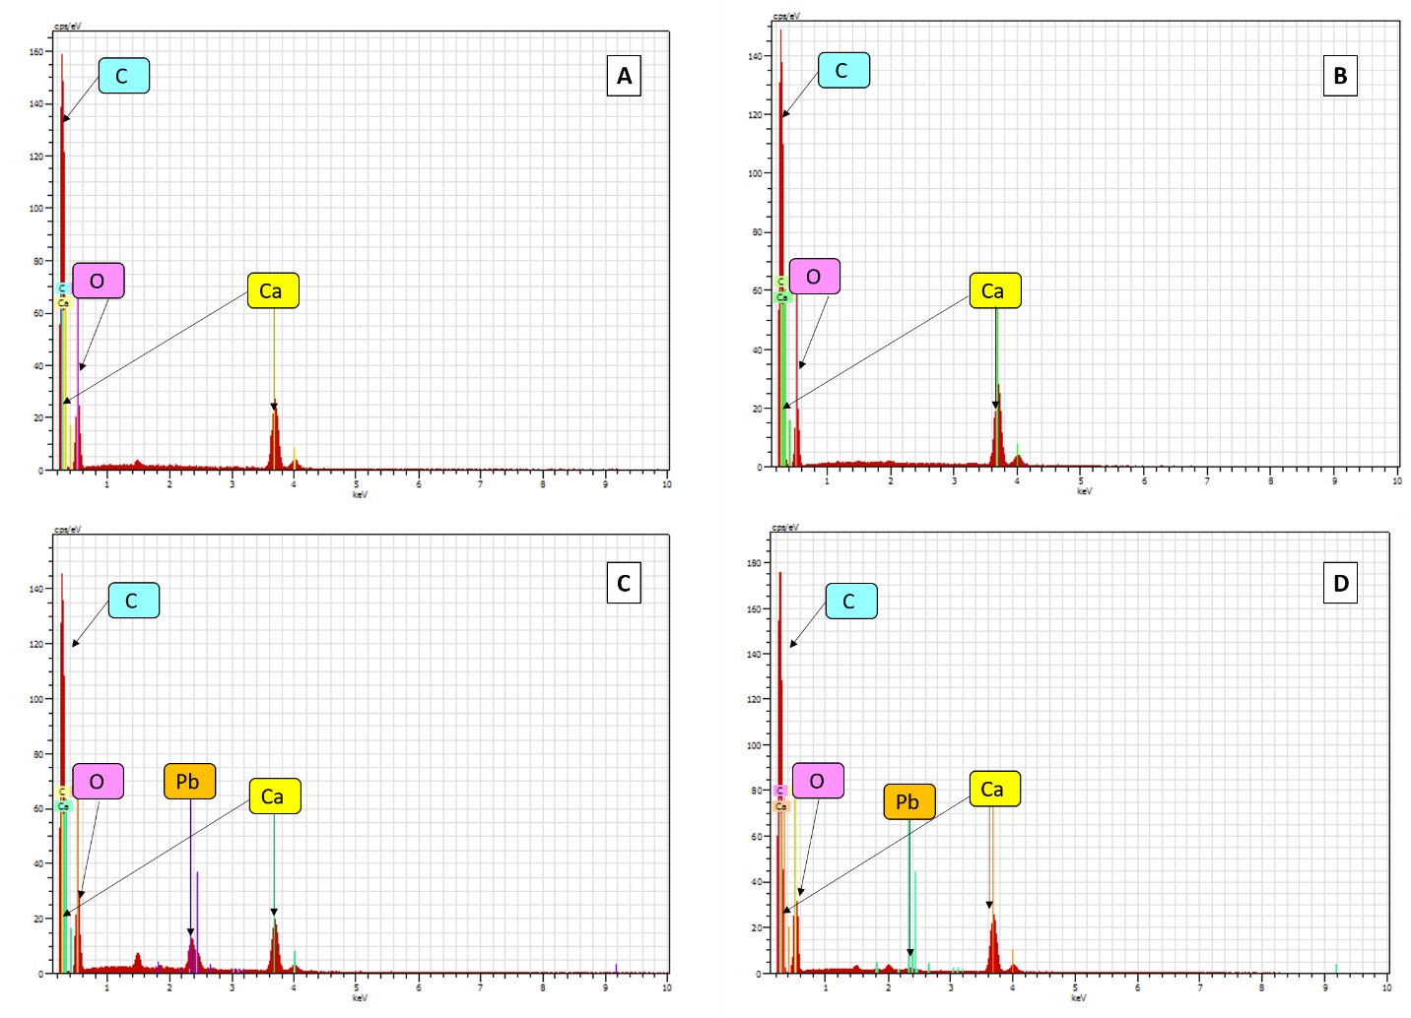

A) EDX spectra for NPSC before Pb2+ adsorption, B) EDX spectra for WPSC before Pb2+ adsorption, C) EDX spectra for NPSC after Pb2+ adsorption, and D) EDX spectra for WPSC after Pb2+ adsorption

Figure S4. First order kinetics linearized plot log(qe-qt) vs t



Table S2. Pseudo-First order plots for lead adsorption at pH 5 and 150 ppm.

|  |  |  |  |  |  |
| --- | --- | --- | --- | --- | --- |
| Pseudo-second order parameters on NPSB and WPSB | | | | | |
| Char | Initial conc. (ppm) | Q exp. (mg/g) | Q calc. (mg/g) | K1  (g mg-1 h-1) | R2 |
| NPSB | 150 | 61.9 | 60.8 | 0.0676 | 0.912 |
| WPSB | 150 | 71.5 | 71.3 | 0.0678 | 0.768 |