SUPPORTING MATERIALS

Occurrence of Fipronil in residential house dust in presence and absence of pets: a hint for a comprehensive toxicological assessment

Cecilia Testa¹, Severyn Salis¹, Nicola Rubattu¹, Paola Roncada², Roberto Miniero^{3a}, and Gianfranco Brambilla^{3b}

¹ Istituto Zooprofilattico Sperimentale della Sardegna, Department of Food Security, Sassari, Italy

² Department of Veterinary Medical Sciences, University of Bologna, via Tolara di Sopra 50, 40064 Ozzano Emilia (BO), Italy

³ Istituto Superiore di Sanità, ª Environment and Health Dept.; ^{b} Veterinary Public Health, Food Safety, and Nutrition Dept. Viale Regina Elena, 299 I-00161 Rome, Italy
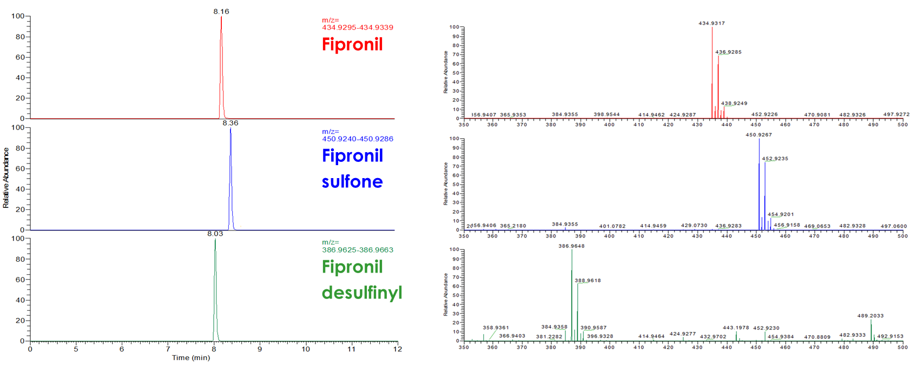
Figure 1S. Chromatograms and High-resolution mass spectra for Fipronil, Sulfone, and Desulfinyl.

Table 1S. Molecular, retention time, accurate mass, mass errors of Fipronil and its products.
Compound Molecular formula RT (min) Precursor ion Mass error
Theoretical Experimental (ppm)
Fipronil C₁₂H₄Cl₂F₆N₄OS 8.16 434.9314 434.9317 0.3
Fipronil-sulfone C₁₂H₄Cl₂F₆N₄O₂S 8.36 450.9263 450.9267 0.4
Fipronil desulfinyl C₁₂H₄Cl₂F₆N₄ 8.03 386.9639 386.9648 0.9

Table 2S. Computed use of Fipronil as veterinary drug per year in cats and dogs.
Population  dogs (N) | Treated  % | Treated  (N) | kg bw  mean | Posology  mg/kg per month | Treatments  per year  (N) | F use  mg per year
10,717,479 | 62 | 6,612,685 | 17.07 | 6.7 | 8  8  8  8 | 6,273,586,080
 | 82 | 8,756,180 |  |  |  | 8,307,163,415
Population
cats (N)
6,967,000 | 62 | 4,298,639 | 4.42 | 6.7 |  | 1,018,399,163
 | 82 | 5,692,039 |  |  |  | 1,348,512,344

Table 3S. Descriptors of total Fipronil presence in house dust in the presence of pets (pets+), accounting for the availability or not (g+/g-) of a private garden in the household. Test statistic = 0.430356; P value = 0.511814.

 | Count | Average |  | Median | Standard deviation |  | MAD |  | Minimum | Maximum | Lower quartile
pet+ g- | 22 | 3298.77 |  | 832.61 | 5756.04 |  | 772.96 |  | 15.0 | 22605.9 | 155.91
pet+ g+ | 38 | 7499.18 |  | 442.48 | 15672.6 |  | 424.7 |  | 15.0 | 67798.6 | 54.48
Total | 60 | 6032.37 |  | 466.7 | 13182.1 |  | 448.92 |  | 15.0 | 67798.6 | 75.68
 | Upper quartile |  | Stnd. skewness |  |  | Stnd. kurtosis
pet+ g- | 3775.49 |  | 4.92505 |  |  | 6.21046
pet+ g+ | 6090.57 |  | 6.7734 |  |  | 8.26557
Total | 4284.5 |  | 10.0411 |  |  | 16.1735

