Supplementary information

Alkyl-capped copper oxide nanospheres and nanoprolates for sustainability: water treatment and improved lubricating performance

Christian Chimeno Trinchet, Alfonso Fernández-González, Josefa Ángela García Calzón, Marta Elena Díaz García, Rosana Badía-Laíño

Faculty of Chemistry, Department of Physical and Analytical Chemistry,
University of Oviedo. Av. Julián Clavería, 8 33006-Oviedo, Spain
rbadia@uniovi.es, medg@uniovi.es

Figure S1. Main compounds used in the surface nanoparticle modification synthesis and Congo Red structure

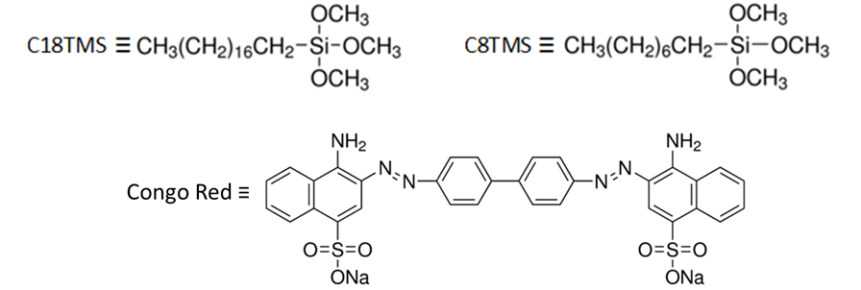

Figure S2. Linear and quadratic Williamson-Hall diagrams and Langford plot corresponding to the CuO-np sample

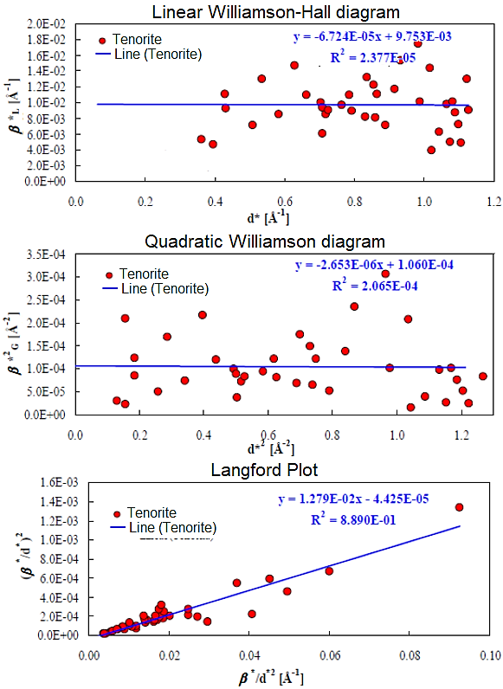

Figure S3. ATR-FTIR spectra for CuO nanospheroids (prolates) and silane coupling agents for surface nanoparticles modification.

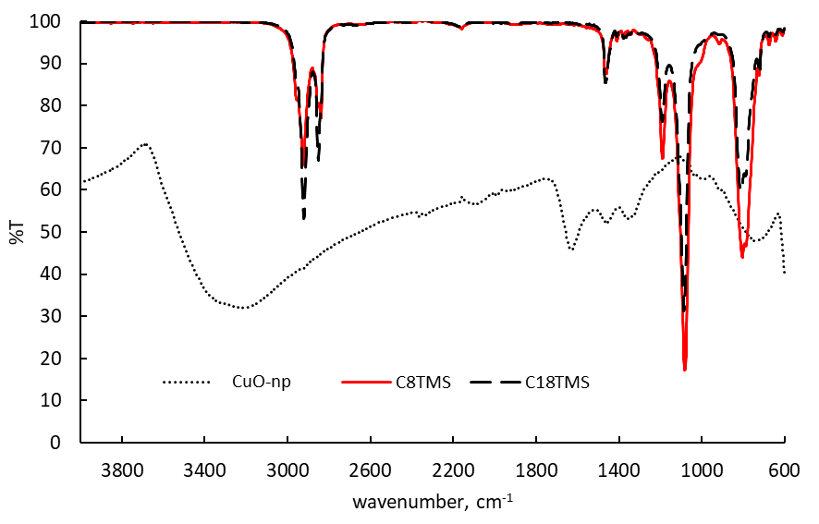

Figure S4. Deconvolution of SDTA bands (⋅⋅⋅⋅⋅) of synthetized nanomaterials assigned to: fitted band (⎯) condensation of surface hydroxyl groups (⎯), decomposition of chemically bonded alkyl chains (⎯) and acetate loss (⎯).
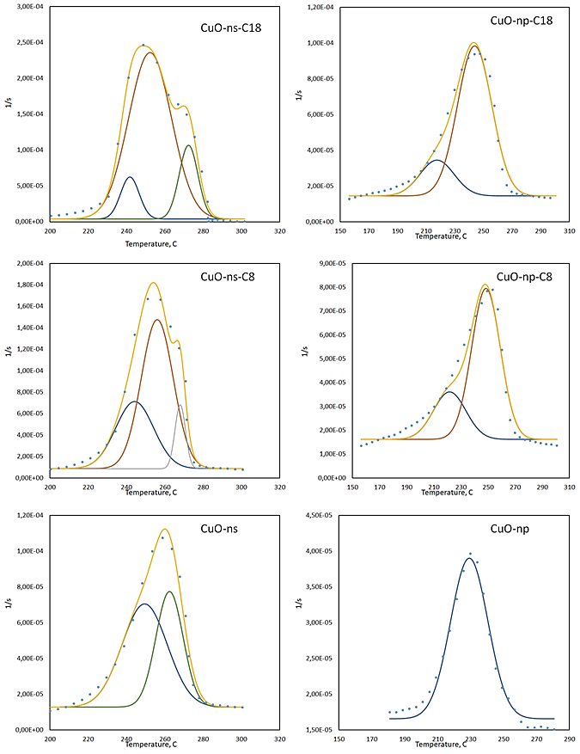

Table S1. Structural parameters derived from Rietveld analysis of XRD patterns for CuO-ns and CuO-np samples.

Sample | Microstructural Analysis
 | Rietveld refinement |  | Debye-Scherrer | TEM
 | R_{hkl} [nm]  s [nm] | R [nm]  σ [nm] | D_{v} [nm]  σ [nm] | D (nm)  σ [nm]
CuO-ns | 8.4  ±0.7 | 8.3  ±0.31 | 12.71  ±0.05 | 10.00  ±2.00
CuO-np | 10.21  ±1.66 | 10.71  ±0.04 | 15.30  ±0.03 | Rod shaped  L = 22  D = 6

Table S2. Hydrophobic grafting introduced by alkylation
 |  |  |  |  | Alkyls |  | Nanoparticles
 | started weight, mg | mg CuO at 800 C | mg lossed | % alkyl by fitting SDTA bands | mg | mmols | number | μmols | mmol alkyl/µmol CuO-NP
CuO-ns | 79,6120 | 75,7277 | 1,7506 | 0 | 0,0000 | 0,000 | 2,295E+16 | 0,0381 | 0,00
CuO-ns-C₈ | 75,5990 | 71,5931 | 2,1318 | 43 | 0,9167 | 8,112E-03 | 2,169E+16 | 0,0360 | 0,23
CuO-ns-C₁₈ | 85,2379 | 80,3122 | 3,2378 | 66 | 2,1370 | 8,447E-03 | 2,434E+16 | 0,0404 | 0,21
CuO-np | 34,3187 | 32,5980 | 0,6094 | 0 | 0,0000 | 0,000 | 9,88E+15 | 0,0164 | 0,00
CuO-np-C₈ | 33,5368 | 31,7765 | 0,9384 | 74 | 0,6944 | 6,145E-03 | 8,11E+15 | 0,0135 | 0,46
CuO-np-C₁₈ | 39,2183 | 37,0351 | 1,3306 | 81 | 1,0778 | 4,260E-03 | 9,45E+15 | 0,0157 | 0,27

