Supporting Information to Accompany:

Liquid CO₂ extraction of dyes contained in glow sticks
Bruce W. Baldwin, Kasey R. Bunker and Thomas S. Kuntzleman*

Department of Chemistry, Spring Arbor University, Spring Arbor, Michigan 49283 United States
bbaldwin@arbor.edu

Table of Contents:
Emission spectra of red glow stick material…………….……………………………………...2

Emission spectra of yellow glow stick material…………….…………………………………..3

Emission spectra of green glow stick material…………….…………………………………...4

Emission spectra of blue glow stick material…………….………………...…………………..5

Emission spectra of purple glow stick material…………….………………..………………...6

Emission spectra of white glow stick material…………….………………….………………..7

Student Lab Sheet: Liquid carbon dioxide extraction of dyes in glow stick fluid……...8 – 11

Emission spectra of red glow stick material:
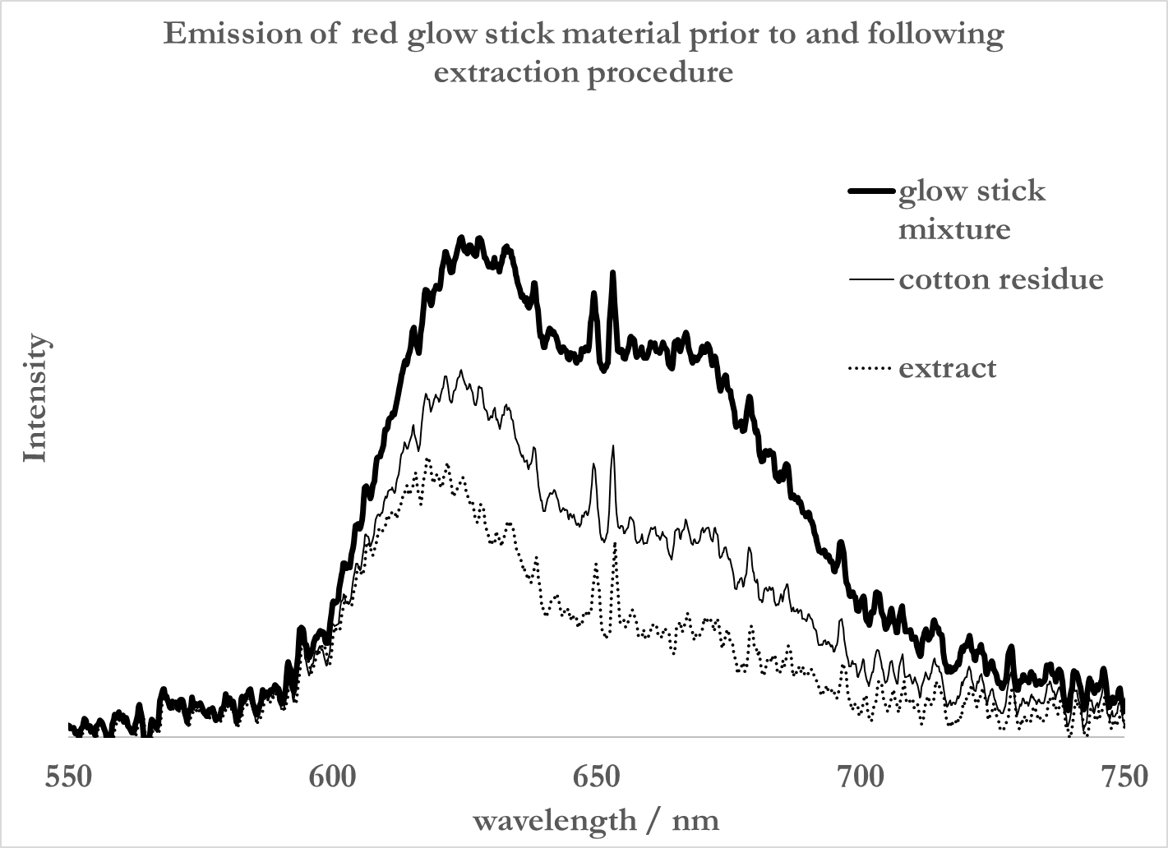

Emission spectra of yellow glow stick material:

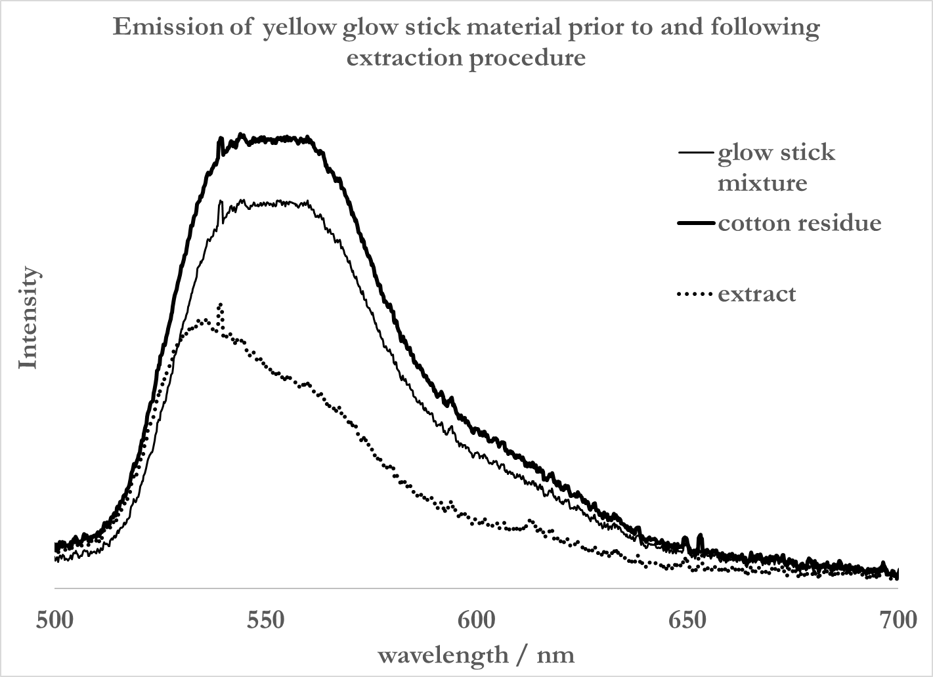

Emission spectra of green glow stick material:

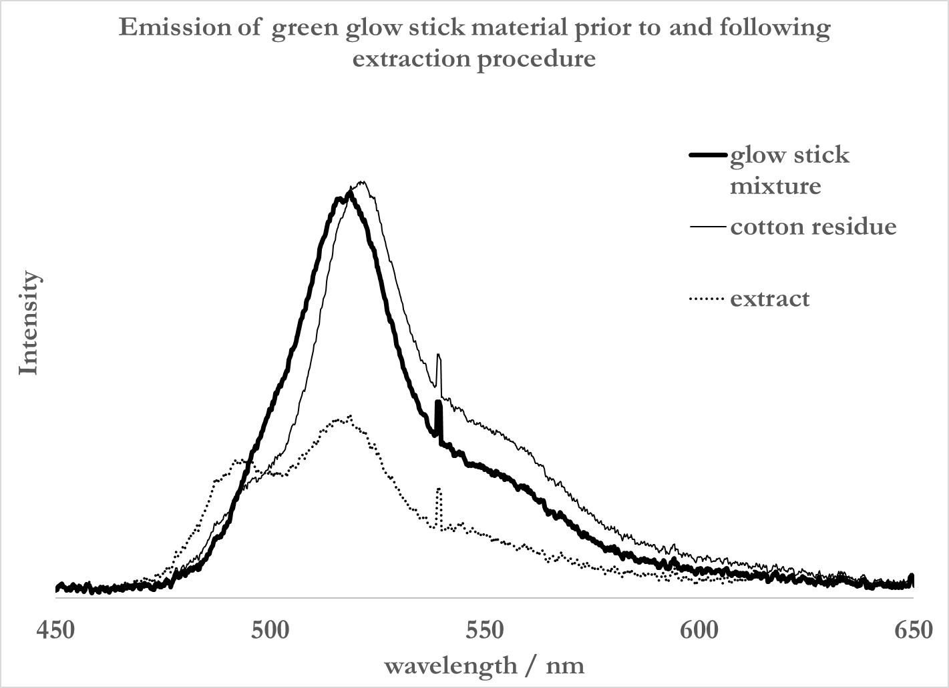

Emission spectra of blue glow stick material:

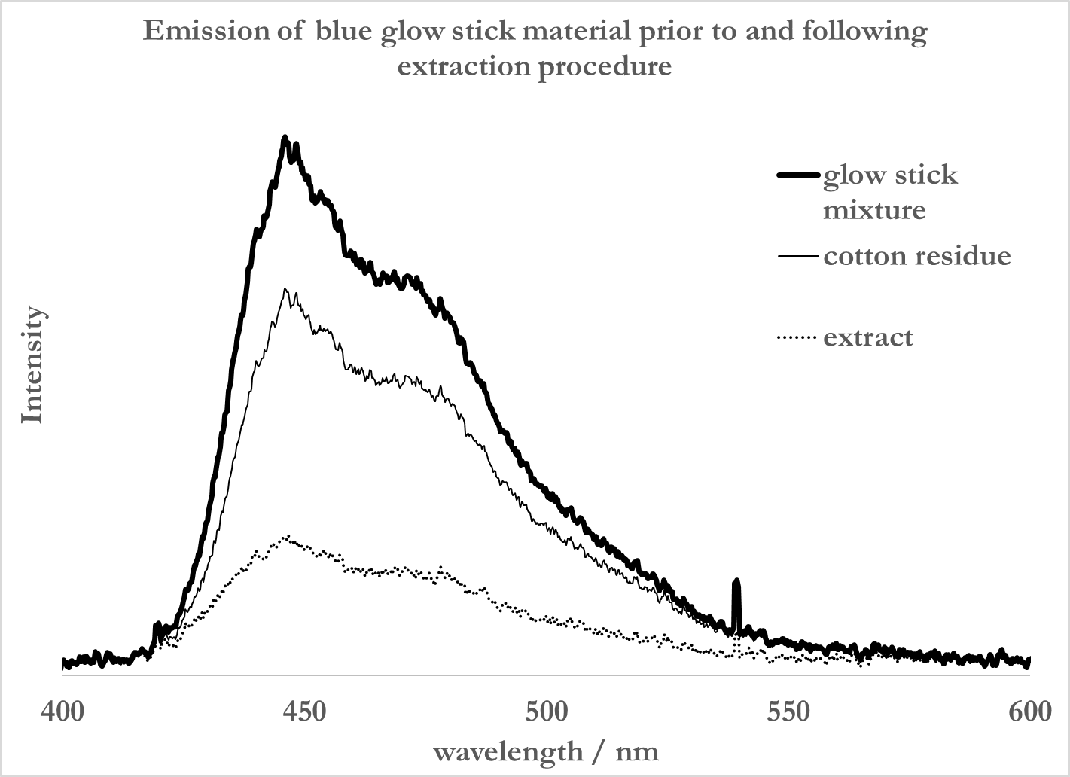

Emission spectra of purple glow stick material:

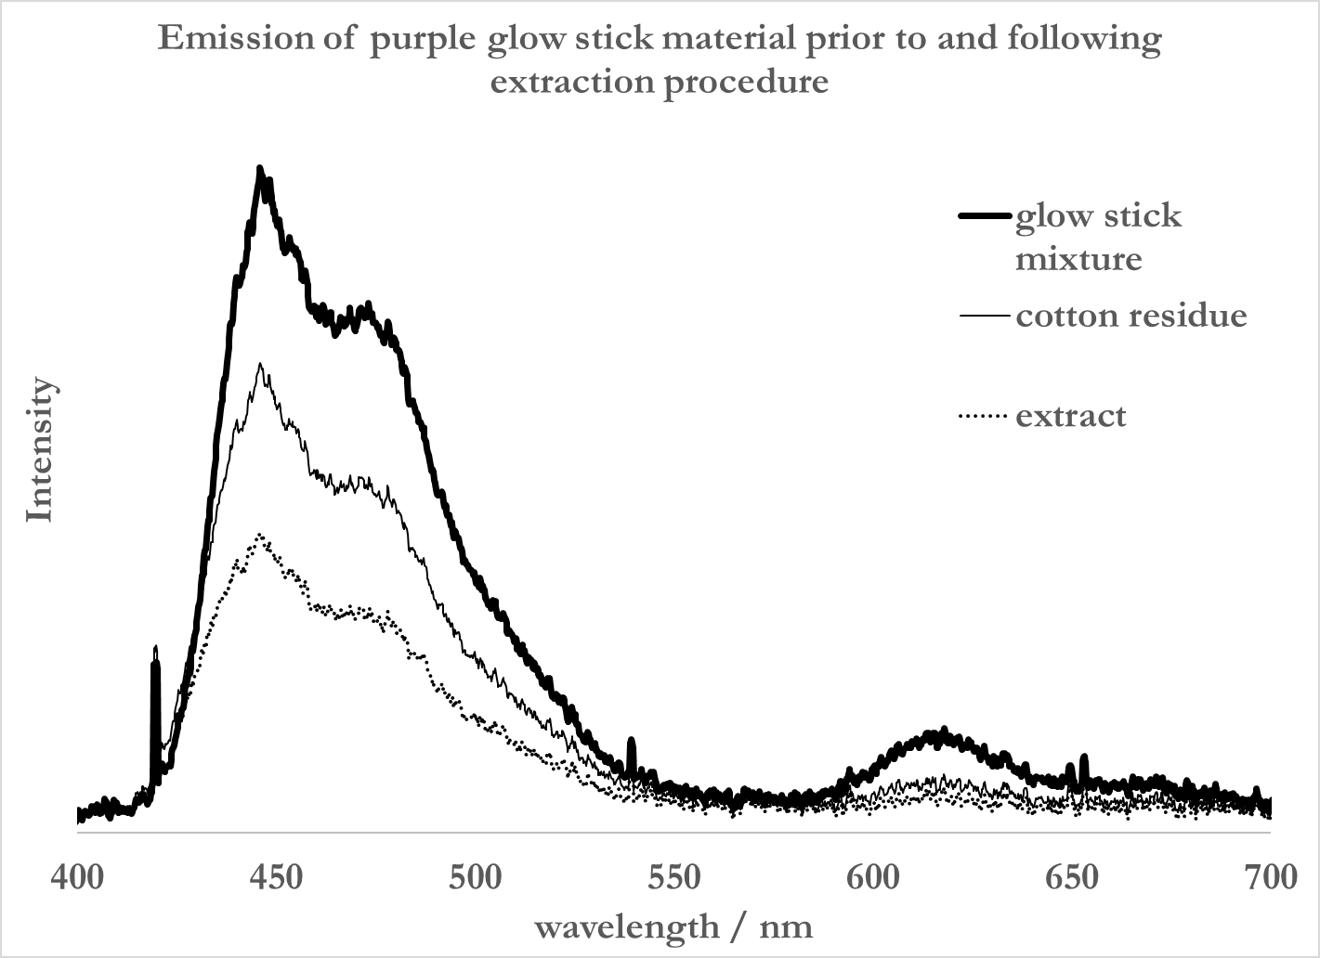

Emission spectra of white glow stick material:

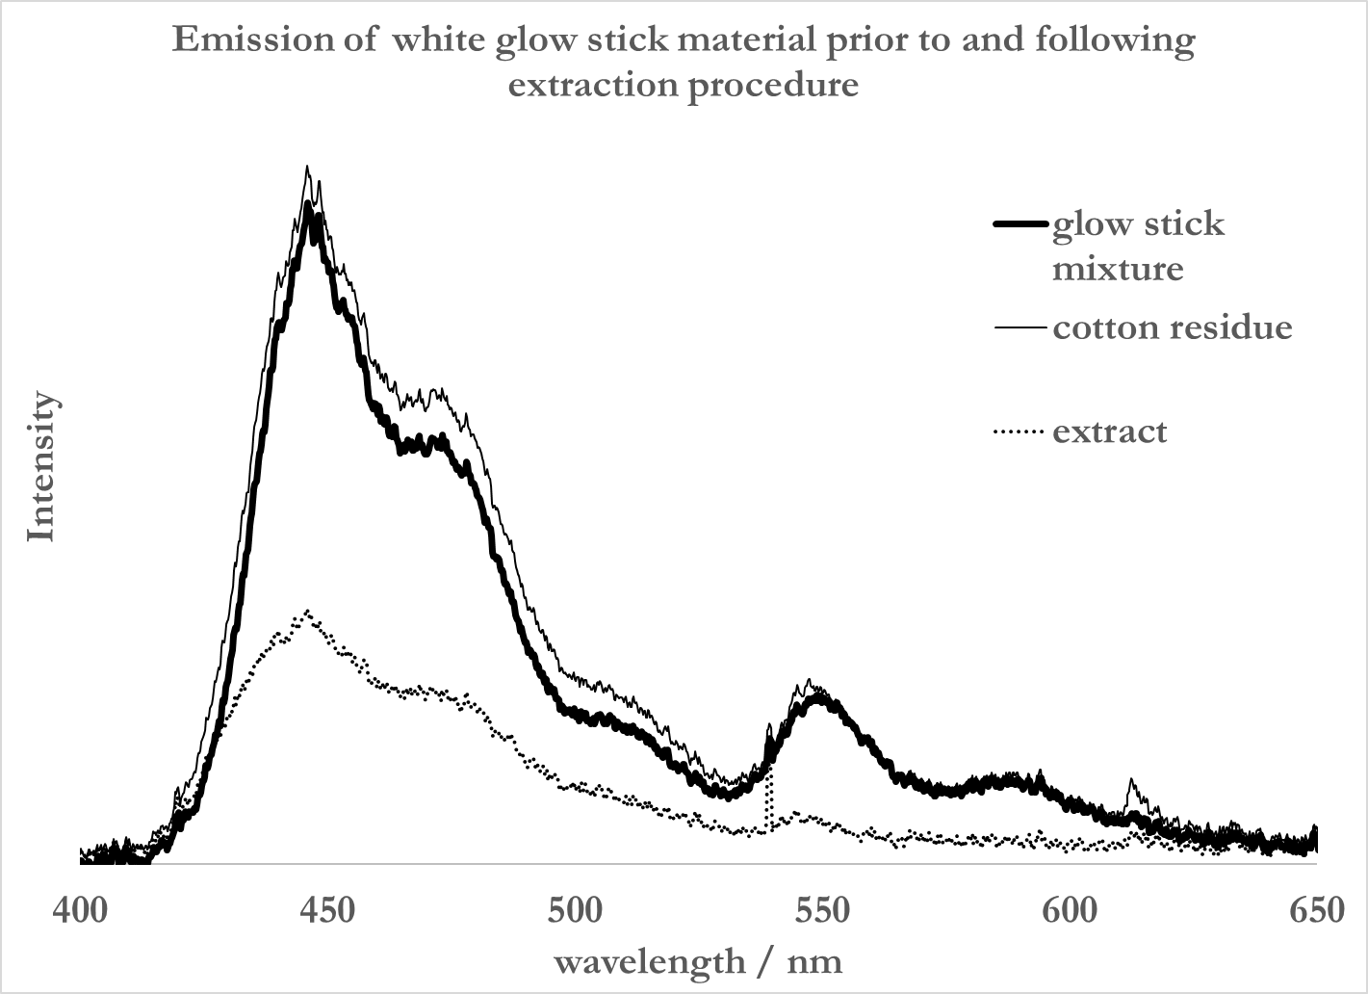

Student Lab Sheet: Liquid carbon dioxide extraction of dyes in glow stick fluid

Introduction: Glow sticks are powered by chemical reactions. In particular, a glow stick uses the following chemical reaction to produce light:

C₁₄H₄Cl₆O₄ + H₂O₂ 2 C₆H₃Cl₃O + 2 CO₂ + energy

In this reaction, bis(2,4,5-trichlorophenyl)oxalate (C₁₄H₄Cl₆O₄, or TCPO) reacts with hydrogen peroxide to form trichlorophenol, carbon dioxide, and a lot of energy. The energy released in this reaction is gained by dyes contained within the glow sticks. The dyes release this energy as light. Just like different colored markers have different inks, the different colors emitted by glow sticks come from different dyes in the glow sticks.

The chemical structure of a particular dye determines the color of light given off by that dye. Consider for example 9,10-bis(phenylethnyl)anthracene (BPEA), which emits yellow-green light and rhodamine 6g (R6G), which emits red-orange light, (Figure 1). BPEA is a non-polar compound, while R6G is relatively polar. Because of this difference in polarity, one would expect BPEA, but not R6G, to dissolve well in a non-polar fluid. The difference in polarity between these two molecules allows for a way to extract one of these from a mixture of the two dyes. Thus, if a mixture of BPEA and R6G is rinsed with a non-polar fluid, we would only expect BPEA to dissolve in the non-polar fluid.

Figure 1: Chemical structures of BPEA (top) and R6G (bottom). BPA is non-polar while R6G is polar.
In this experiment, we will attempt to separate dyes from actively glowing fluid from a glow stick. Dry ice will be used as a source of liquid carbon dioxide. Liquid carbon dioxide is a non-polar fluid which can be used to extract non-polar dyes from various colors of glow stick mixtures.

How can dry ice be used as a source of liquid carbon dioxide? After all, dry ice sublimes, or goes directly from a solid to a gas at atmospheric pressure and room temperature:

CO₂(s) CO₂(g)

However, if subjected to pressures over 5.1 atm, dry ice liquefies:

CO₂(s) CO₂(l)

Thus, by pressurizing dry ice above 5.1 atm, it melts to form a liquid. Pressures of 5.1 atm are easily achieved by enclosing dry ice in a sealed container. As it sublimes, the pressure in the container builds up. Once the pressure reaches 5.1 atm, then the dry ice can melt, forming non-polar liquid CO₂, which can be used to extract non-polar dyes from a glow stick mixture.

If you wish, you may watch a video at the following link that describes the changes in temperature, pressure, and phase when dry ice is sealed in a closed container and warmed: https://www.youtube.com/watch?v=n2QWyJyehus

The use of CO₂ as a solvent provides many advantages to the environment. For example, CO₂ can be extracted from and returned to the air, which means CO₂ is a renewable resource. Furthermore, because the liquid CO₂ that is used as a solvent returns to the air upon use, no solvent waste is generated. The use of CO₂ also has potential to eliminate the need for many organic based solvents that can introduce other environmental problems.

Materials: dry ice, centrifuge tubes, empty 12-ounce soda bottle, scissors, clamp, ring stand, Al wire, Q-tips water, hot plate, glow sticks of various colors, cotton, droppers, thermometer.

Hazards: Eye protection is required for this experiment. Dry ice is extremely cold: use insulating gloves during handling. The pressurized centrifuge tubes present projectile and tube-rupture hazards. Exposure of the polypropylene centrifuge tube to low temperature can cause crazing, which can potentially result in explosion. It is very important that the centrifuge tube be charged with dry ice only after the water bath, contained in a 12 oz clear PETE soda bottle, is pre-warmed to ~60 °C and immediately ready to receive the charged and sealed centrifuge tube. This precaution minimizes excessive cooling of the centrifuge tube, which can result in rupture.

Procedure:.
Part A. Observation of the melting of dry ice under pressure.
1. Cut the top off of a small plastic soda bottle.
2. Crush some dry ice into a powder with a hammer.
3. Heat some water to 60-70ºC.
3. Once the water reaches this temperature, pour it into the cut soda bottle.
4. Arrange a ring stand with a test tube clamp close to the soda bottle for the purpose of holding the centrifuge tube almost fully submerged in the water.
5. Pour the powdered dry ice into the centrifuge tube and secure the cap tightly.
6. Immediately place the full centrifuge tube in the water. Quickly use the test tube clamp and ring stand to secure the tube so that it is almost fully submerged in the water. It is not necessary to clamp the tube to the test tube clamp. Rather, simply use the clamp to secure the tube in place.
7. Observe the contents of the centrifuge tube. Look carefully for evidence that the dry ice is subliming and/or melting. Do you hear any hissing? What does this hissing sound indicate? Record your observations.
8. When you are satisfied that you can repeatedly get the dry ice to melt using this method, move on to Part B of this procedure.

Part B. Using liquid carbon dioxide to extract dyes from activated glow stick mixtures
1. Heat some water to 60-70ºC.
2. Cut one of the ends off of a Q-tip
3. Activate a pink glow stick.
4. Use PVC cutters to cut open the activated glow stick.
5. Dip the cotton end of the Q-tip into the glowing fluid. Gently dab the end of the Q-tip to remove excess fluid.
6. Insert the Q-tip, cotton side up, into a centrifuge tube.
7. Pour the hot water into the cut soda bottle.
8. Arrange a ring stand with a test tube clamp close to the soda bottle for the purpose of holding the centrifuge tube almost fully submerged in the water.
10. Crush some dry ice with a hammer.
11. Pour the powdered dry ice into the centrifuge tube and secure the cap tightly.
12. Immediately place the full centrifuge tube in the water. Quickly use the test tube clamp and ring stand to secure the tube so that it is almost fully submerged in the water. It is not necessary to clamp the tube to the test tube clamp. Rather, simply use the clamp to secure the tube in place.
13. Observe the contents of the centrifuge tube. As the dry ice melts, the melted CO₂ travels through the cotton on the Q-tip. Do you notice any color developing in the liquid CO₂ due to dissolved dyes?
14. When the process is complete, immediately remove the Q-tip from the centrifuge tube, being careful not to contaminate it with extracted residue adhered to the sides of the centrifuge tube.
15. Allow the material on the Q-tip and the extracted material in the centrifuge tube to warm to room temperature.
16. Take the centrifuge tube and Q-tip to a darkened room. Do you notice any difference in color between the Q-tip and the material in the centrifuge tube? Quickly move on to Part C.

Part C. Emission spectra
1. Collect the emission spectrum of the material in the centrifuge tube.
2. Collect the emission spectrum of the material left on the Q-tip.
3. Collect the emission spectrum of fresh, activated, and unextracted pink glow stick material adsorbed onto a Q-tip.

Part D. Other colors
Repeat parts B – C using a glow sticks of other colors (at least 2).

Data Analysis:
1. Prepare an overlay plot that includes: 1) the emission spectrum of the unextracted pink glow stick material, 2) the emission spectrum of the Q-tip residue from the pink glow stick, and 3) the emission spectrum of the material extracted by the liquid CO₂.

2. Repeat Step 1 of the Data Analysis for the glow sticks of other color that you tested.

3. Compare your results with those of your classmates. Can you draw any conclusions about the polarity of the dyes that tended to be extracted by the liquid CO₂ as compared to those that were not?

