Supplementary Figure S3. Among injured older adults transported by EMS and dying within one year, the location of death plotted over time by POLST status (n = 1,600).
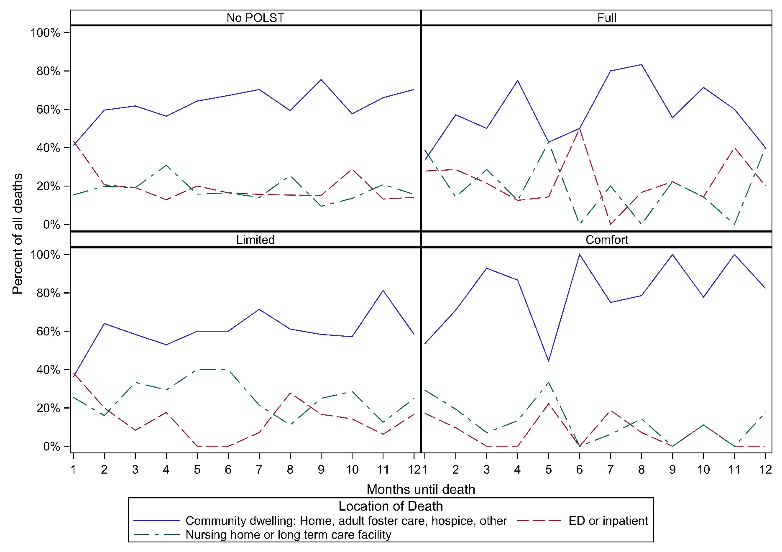
Supplementary Figure S4. Among injured older adults transported by EMS and dying within one year, the top 5 causes of death plotted over time by POLST status (n = 1,600).
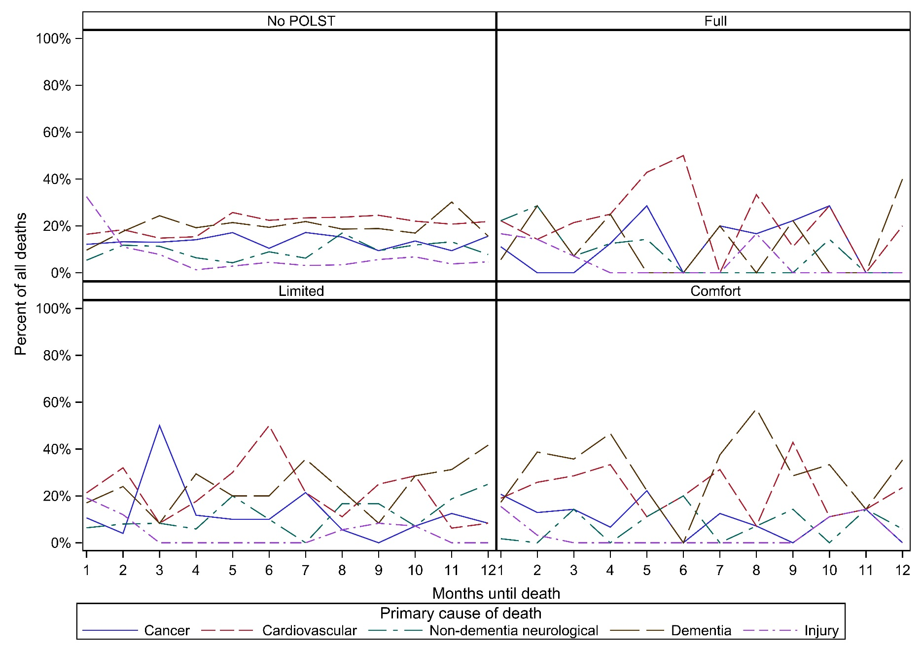

Supplementary Figure S5. Oregon POLST form.

