Supplementary Materials

1. Materials and methods
1.1 Dry weights (DWs) test method
After striping biofilms, the cleaned emitter samples were weighted after dried in the oven at the constant temperature of 60℃ for 1 h. Thus, the DWs of biofilms attached inside the emitter were the differences between two batches of weights measured above.
1.2 Phospholipid fatty acids (PLFAs) test method
Totally 15 mL mixture after striping biofilms was collected for PLFAs test according to previously reported method (Pennanen et al. 1999). The chemicals used in the experiment were manufactured by Beijing Chemical Analysis Company and the deionized water was provided by Beijing KEBANZHENGYE company. The detail testing steps were as follows:
(a) Collect PLFAs of microorganisms: The collected liquid was mixed with chloroform, methanol, and phosphate-buffered solution at a volume ratio of 1:2:0.8. The mixture was subjected to oscillating extraction in darkness for 2–4 h and centrifugation at 7,000 r/min for 15 min. The supernatant was transported to a separation funnel. Then, 10 mL phosphate buffer and 10 mL chloroform were added to perform separation at room temperature in the darkness for 2–4 h. Finally, the samples were dried in nitrogen.
(b) Purification: The silica gel was activated in oven under 100 ℃ for 1 h. The samples loaded on activated silica gel column were eluted with 15 mL chloroform, 30 mL acetone and 15 mL methanol. The collected methanol samples were then dried in nitrogen.
(c) Methyl esterification: Totally 1 mL methanol:toluene mixture (v:v = 1:1) and 1 mL 0.56 % (w/v) KOH were added in the samples and then incubated at 35 ℃ for 30 min. After cooling down at room temperature, the samples were treated with acetic acid. Then, the samples were incubated with 2 mL chloroform:hexane mixture (v:v = 1:4) and ultrapure water. The hexane supernatant was collected for nitrogen drying and stored at -20 ℃ for later use.
(d) Mass spectrometry (GC–MS): The extraction was dissolved in the solution containing 33 lg/mL nonadecanoic acid methyl ester and internal standard of chloroform:n-hexane mixture (v:v = 1:4). The HP6890 gas chromatography–HP5973 mass spectrometer (GC–MS) was used for the test at the temperature of 280 ℃. Highly pure helium (1 mL/min) was used as the carrier gas, and the electron ionization (EI) mode was used as the electron energy of 70 eV.

(e) Biomass evaluation: The PLFAs as the specific microorganisms’ biomarkers were referred to Zhou et al.(2013).

1.3 Extracellular polymers (EPS) test method
The EPS of attached biofilms inside the labyrinth channels mainly included extracellular polysaccharide (EPO) and extracellular protein (EPR). The EPO was tested through the phenol-sulfuric acid method, and the EPR was determined by Lowry method (Lowry et al. 1951; Nocker et al. 2007). As for the chemicals used in the experiment, NaOH and Na₂CO₃ were manufactured by Beijing Chemical Analysis Company, CuSO₄ and Na-tartrate were manufactured by Sinopharm Chemical Regent Co. Ltd, standard BSA liquid was offered by Beijing Tiandz Inc, and forint-phenol reagent was manufactured by Beijing Solarbio Inc. The specific testing procedures were as follows:
(a) Totally 15 mL mixture after striping biofilms was subjected to centrifugation at the speed of 12,000 r/min for 15 min. Collecting the suspended solids into 1.5 mL tube, and re-suspended the suspended solids with sterile water.
(b) Preparation of the standard polysaccharides curve: 1 mL 6 % phenol and 5 mL concentrated sulfuric acid solution were added in 0.1 mL suspended solution and then kept at room temperature for 30 min. The optical density of suspended solution at 490 nm was determined using spectrophotometer (UV-1100), and the standard curve of glucose was confirmed using standard BSA liquid.
(c) Preparation of standard protein curve: Reagent A (mixture of 143 mmol/L NaOH and 270 mmol/L Na₂CO₃) and Reagent B (mix Reagent A with 57 mmol/L CuSO₄ solution and 124 mmol/L Na-tartrate at the volume ratio of 100:1:1). Then, 0.7 ml Reagent B and 0.1 mL phenylephrine solution (diluted with sterile water at the volume ratio of 5:6) were added in 0.5 mL samples. The samples were oscillated at room temperature for 45 min. The optical density of the samples at 750 nm was determined using spectrophotometer (UV-1100), and the standard curve of protein was confirmed using standard bovine serum album.
(d) Numerical calculation: According to the standard curve, the regression equation and correlation coefficient were calculated. The content of the sample can be determined when the correlation coefficient is greater than 0.99 on the basis of optical density.

1.4 Flow evaluation method
① Dra
The relative discharge of drip irrigation emitters (Dra) was calculated using Eq. (1):
(1)
Where indicated the initial discharge of the new emitter under 20℃
② CU
The outflow uniformity of the drip irrigation emitters could be represented by uniformity coefficient CU (Eq. 3), which reflected the irrigation quality
（2）
（3）
Where indicated the mean correctional emitter outflow when the system running to the time of .

2. Results and analysis
The bacterial genera represented by the DNA sequence was determined based on 97% similarity. It can be seen from the rarefaction curve of the libraries that the curves tend to be gentle (Fig. S1), and the number of sequences obtained could have been more robust but it appears that sampling was adequate.
By analyzing the classification tree of specific taxa in each sample (Fig. S3), it was found that the top 9 bacterial classifications at the genus level were Thermomonas, Acinetobacter, Massilia, Curvibacter, Candidatus_Microthrix, Bacillus, Anoxybacillus, Brevibacillus, Flavobacterium. They belong to phyla Proteobacteria, Actinomycetes, Bacteroides and Firmicutes. The dominant genus with the highest relative abundance was Thermomonas.
There was a significant linear positive correlation between DW (dry weight of biofilm) and EPS (extracellular polymeric substances) (Fig. S4). With the increase of viscous EPS content, the biofilm DW in the labyrinth channel gradually increased. The three samples (320h, 640h, 960h) showed the same pattern. There is a significant linear negative correlation between the DW and Dra. As the dry weight of biofilm increases, the discharge of the labyrinth channel gradually decreases. There is also a significant linear negative correlation between EPS and Dra.
Both Acinetobacter and Thermomonas showed a significant linear negative correlation with viscous EPS (Fig. S6). Acinetobacter showed a linear positive correlation with the duration of chlorination, and the relative abundance gradually increased with increased duration of chlorination. Thermomonas was significantly positively correlated to chlorine concentration, that is, as the concentration of chlorination increased, the relative abundance of Thermomonas gradually increased. The same variation was observed under three sampling times (320h, 640h, 960h), indicating both genera were chlorine resistant.
The chlorination combined with the lateral flushing treatment significantly reduced the emitter clogging and slowed down the decline tendency of emitter discharge. The three types of emitters in each treatment group showed significantly higher Dra (discharge ratio variation) and CU (coefficient of uniformity) than the non-chlorination treatment group (Tables S9 and S10). At the system running to the end (960h), the Dra of the emitter E1 in the three chlorination modes should be higher than the control 88.0% - 117.9%, and the Dr of the emitter E2 should be higher than the control 75.4% - 89.5%; the emitter E3 Dra is 84.4% - 108.6% higher than the control. The CU of the emitter E1 was higher than the control group by 45.8%, 42.6% and 33.2% respectively in the three chlorination modes; the CU of the E2 emitter was higher than the control group by 52.9%, 38.4% and 39.0%, respectively; the CU of E3 emitter was higher than the control group by 51.1%, 57.6% and 48.4%, respectively. The three types of emitter’s DRA and CU did not show continuous changes with the concentration or duration of chlorination. The E1 and E2 emitters in the C0.83T3 treatment group had the highest Dra and the best anti-clogging effect, while the highest Dra of the E3 emitter was in the C2.50T2 treatment group, but there were no significant differences from the C0.83T3 treatment group.

Reference:
Lowry OH, Rosebrough NJ, Farr AL, Randall RJ. 1951. Protein measurement with the Folin phenol reagent. J Biol Chem. 193(1): 265-275.
Pennanen T, Liski J, Baath E, Kitunen V, Uotila J, Westman CJ, Fritze H. 1999. Structure of the microbial communities in coniferous forest soils in relation to site fertility and stand development stage. Microb Ecol. 38: 168-179.
Nocker A, Lepo JE, Martin LL, Snyder RA. 2007. Response of estuarine biofilm microbial community development to changes in dissolved oxygen and nutrient concentrations. Microb Ecol. 54(3): 532-542.
Zhou B, Li Y, Pei Y, Liu Y, Zhang Z, Jiang Y. 2013. Quantitative relationship between biofilms components and emitter clogging under reclaimed water drip irrigation. Irrigation Sci. 31(6):1251-1263.

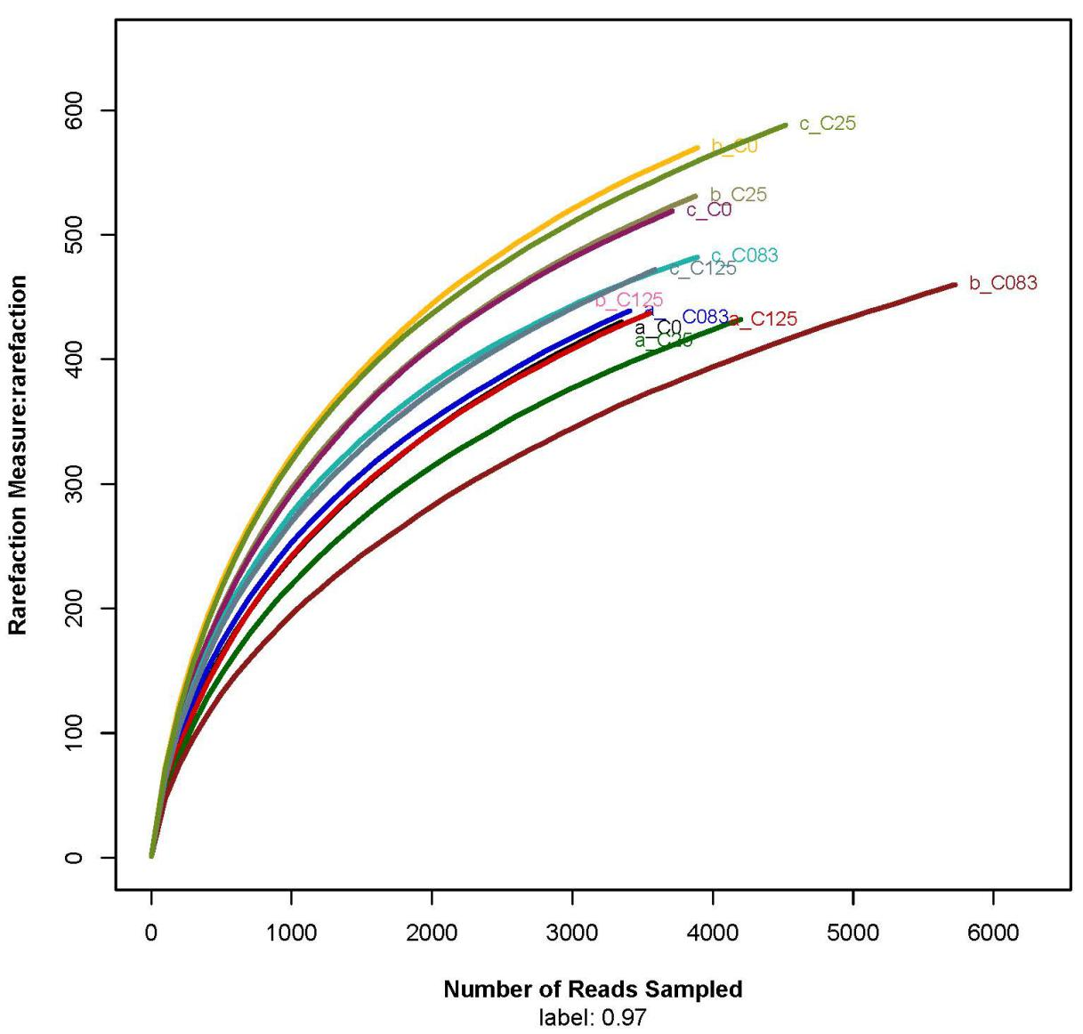
Note：“a” represents 320 h，“b” represents 640 h，“c” represents 960 h; Number of Reads Sampled label: 0.97

Supplementary Fig. 1 Rarefaction curve.

Supplementary Fig. 2 The correlation between Shannon and clogging degree (a), chlorination duration(b).

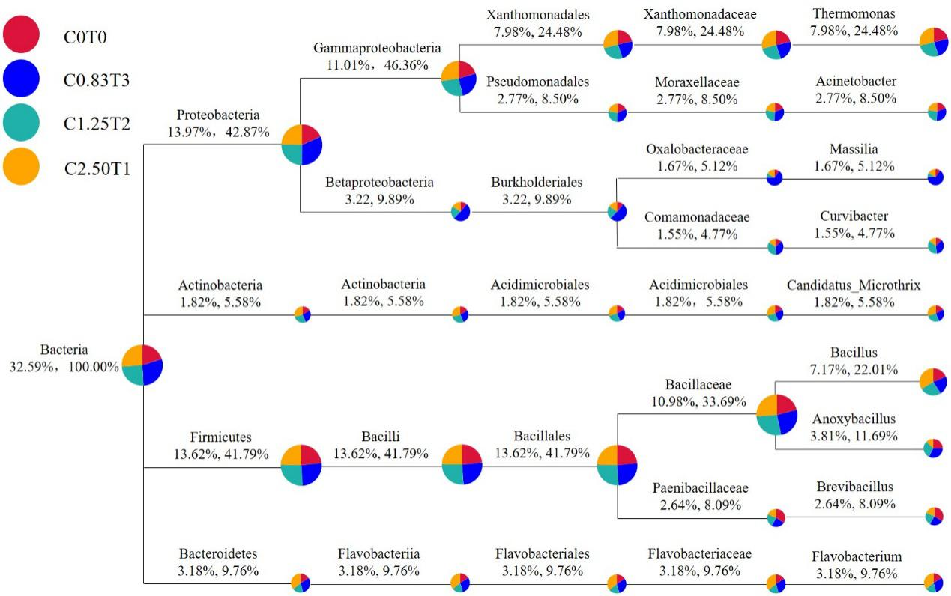
Note: The circles of different colors represent different samples; the size of the sector represents the proportion of the sample's relative abundance in the classification. The two values below the category name indicate the average relative abundances of all the samples in the classification; the former represents the percentage of all the species, and the latter represents the percentage of the selected species along the vertical axis.

Supplementary Fig. 3 Classification tree of specific species in each sample.

Supplementary Fig. 4 Changes in DW and EPS content.

Supplementary Fig. 5 Relationship among EPS, DW, and DRA.

Note: (a) represents the correlation between the relative abundance of Acinetobacter and EPS content, (b) represents the correlation between the relative abundance of Acinetobacter and chlorination duration, (c) represents the correlation between the relative abundance of Thermomonas and EPS content, (d) represents the correlation between the relative abundance of Thermomonas and chlorination duration.

Supplementary Fig. 6 Correlation between chlorine-resistant bacteria and different chlorination treatments and EPS content.

Supplementary Fig. 7 The changes in Dra and CU under different chlorination modes.

Supplementary Table 1 The relationship between PLFA content and Dra; PLFA content and chlorine duration
Treatment | The relationship between PLFA content and Dra
C0T0 | PLFA = -0.13 Dra + 17.43 R² = 0.81 (F=29.97**)
C0.83T3 | PLFA = -0.13 Dra + 15.57 R² = 0.70 (F=16.37**)
C1.25T2 | PLFA = -0.13 Dra + 16.47 R² = 0.65 (F=12.81**)
C2.50T1 | PLFA = -0.13 Dra + 16.83 R² = 0.65 (F=13.14**)
Sample time | The relationship between PLFA content and chlorine duration
320h | PLFA = -0.67 T + 6.65 R² = 0.95 (F=40.99*)
640h | PLFA = -1.35 T + 9.19 R² = 0.93 (F=26.80*)
960h | PLFA = -1.86 T + 11.29 R² = 0.92 (F=22.40*)

Supplementary Table 2 High-throughput sequencing of the biofilm and ecological parameters.
Sampling Time | Treatment | Reads | OTU | ACE | Chao | Shannon | Simpson
320 h | C0T0 | 3417 | 446 | 804 | 631 | 4.71 | 0.0356
 | C0.83T3 | 4237 | 437 | 643 | 618 | 4.13 | 0.0797
 | C1.25T2 | 3577 | 441 | 638 | 585 | 4.41 | 0.0588
 | C2.50T1 | 3357 | 429 | 777 | 608 | 4.62 | 0.0297
640 h | C0T0 | 3903 | 569 | 754 | 732 | 5.42 | 0.0099
 | C0.83T3 | 5711 | 452 | 709 | 691 | 4.31 | 0.0323
 | C1.25T2 | 3088 | 445 | 636 | 625 | 4.93 | 0.0214
 | C2.50T1 | 3838 | 534 | 712 | 725 | 5.06 | 0.0214
960 h | C0T0 | 4546 | 597 | 780 | 815 | 5.37 | 0.0112
 | C0.83T3 | 3943 | 493 | 631 | 627 | 4.92 | 0.0282
 | C1.25T2 | 3589 | 477 | 681 | 667 | 4.98 | 0.0188
 | C2.50T1 | 3776 | 523 | 695 | 667 | 5.16 | 0.0136

Supplementary Table 3 The relationship between MA content and Dra; MA and chlorination duration
Treatment | The relationship between MA and Dra
C0T0 | MA = -0.004 Dra + 0.82 R² = 0.43 (F=5.17*)
C0.83T3 | MA = -0.002 Dra + 0.63 R² = 0.65 (F=12.90**)
C1.25T2 | MA = -0.006 Dra + 1.02 R² = 0.710 (F=17.12**)
C2.50T1 | MA = -0.005 Dra + 0.91 R² = 0.76 (F=22.26**)
Sample time | The relationship between MA and chlorination concentration
320h | MA = 0.02 C + 0.44 R² = 0.99 (F=261.03**)
640h | MA = 0.02 C + 0.51 R² = 0.99 (F=270.27**)
960h | MA = 0.03 C + 0.55 R² = 0.94 (F=30.93*)

Supplementary Table 4 The correlation between the abundances of chlorine-resistant bacteria and chlorination duration or concentration
Level | Bacteria | Fit Curve
Phylum | Nitrospirae | P_{320h} = -0.01 T_{320h} + 0.05 R² = 0.97 (F=57.19*)
 |  | P_{640h} = -0.32 T_{640h} + 1.04 R² = 0.93 (F=25.92*)
 |  | P_{960h} = -0.40 T_{960h} + 1.39 R² = 0.92 (F=22.55*)
 | Actinobacteria | P₃₂₀ = 0.91 T₃₂₀ + 3.81 R² = 0.93 (F=26.54*)
 |  | P₆₄₀ = 0.61 T₆₄₀ + 1.77 R² = 0.94 (F=34.07*)
 |  | P₉₆₀ = 1.54 T₉₆₀ + 3.86 R² = 0.92 (F=23.00*)
Class | Bacilli | P_{320h} = 0.85 C_{320h} + 3.01 R² = 0.95 (F=40.54*)
 |  | P_{640h} = 1.22 C_{640h} + 6.33 R² = 0.99 (F=158.47**)
 |  | P_{960h} = 3.33 C_{960h} + 27.59 R² = 0.92 (F=24.19*)
 | Actinobacteria | P_{320h} = 0.60 T_{320h} + 2.08 R² = 0.91 (F=19.57*)
 |  | P_{640h} = 0.32 T_{640h} + 0.37 R² = 0.95 (F=39.76*)
 |  | P_{960h} = 0.29 T_{960h} + 1.02 R² = 0.99 (F=180.80**)
 | Sphingobacteriia | P_{320h} = -1.93 T_{320h} + 18.76 R² = 0.95 (F=34.45*)
 |  | P_{640h} = -3.45 T_{640h} + 18.36 R² = 0.95 (F=38.19*)
 |  | P_{960h} = -1.98 T_{960h} + 14.73 R² = 0.94 (F=25.56*)
Order | Xanthomonadales | P_{320h} = 5.25 T_{320h} + 16.20 R² = 0.97 (F=67.87*)
 |  | P_{640h} = 1.98 T_{640h} + 10.46 R² = 0.97 (F=56.99*)
 |  | P_{960h} = 3.19 T_{960h} + 8.35 R² = 0.94 (F=30.77*)
 | Pseudomonadales | P_{320h} = 0.11 T_{320h} + 1.65 R² = 0.98 (F=97.50**)
 |  | P_{640h}= 0.33 T_{640h} + 0.26 R² = 0.98 (F=101.57**)
 |  | P_{960h} = 2.72 T_{960h} + 2.17 R² = 0.96 (F=51.45*)
Family | Xanthomonadaceae | P_{320h} = 5.38 C_{320h} + 15.83 R² = 0.95 (F=36.71*)
 |  | P_{640h} = 2.25 C_{640h} + 9.04 R² = 0.93 (F=27.89*)
 |  | P_{960h} = 2.75 C_{960h} + 8.02 R² = 0.92 (F=22.16*)
 | Anaerolineaceae | P_{320h} = -0.19 C_{320h} + 1.17 R² = 0.93 (F=25.23*)
 |  | P_{640h} = -1.33 C_{640h} + 4.57 R² = 0.91 (F=20.75*)
 |  | P_{960h} = -0.41 C_{960h} + 1.66 R² = 0.92 (F=23.95*)

Supplementary Table 5 The correlation between the abundances of chlorine-resistant bacteria and chlorination duration or concentration
Level | Bacteria | Fit Curve
Phylum | Nitrospirae | P = -0.03 DRA + 2.69 R² = 0.92 (F=113.89**)
 | Proteobacteria | P = 0.34 DRA + 12.80 R² = 0.40 (F=6.73*)
Class | Bacilli | P = 123.31 e^{(0.04)DRA} R² = 0.34 (F=5.133*)
 | Gammaproteobacteria | P = 0.39 DRA - 6.94 R² = 0.69 (F=21.99**)
 | Deltaproteobacteria | P = -0.02 DRA + 1.81 R² = 0.45 (F=8.25*)
Order | Xanthomonadales | P = 0.30 DRA - 5.64 R² = 0.55 (F=12.34*)
Family | Xanthomonadaceae | P = 0.30 DRA - 6.94 R² = 0.53 (F=11.13**)
 | Moraxellaceae | P = 0.01 e^{0.06 DRA} R² = 0.39 (F=6.364*)

Supplementary Table 6 The correlation between Shannon and Dra
Treatment | Fit curve between Shannon and Dra
 | D_{Shannon} = -0.02 Dra + 6.47 R² = 0.71 (F=24.26**)
Sample time | Fit curve between Shannon and chlorination duration
320h | D_{320h} = -0.20 T_{320h} + 4.76R² = 0.95 (F=41.56*)
640h | D_{640h} = -0.35 T_{640h} + 5.45 R² = 0.93 (F=27.96*)
960h | D_{960h} = -0.15 T_{960h} + 5.34 R² = 0.95 (F=38.82*)

Supplementary Table 7 The correlation among DW EPS and Dra
Sample time | Fit curve between DW and EPS
320h | SD_{320h} = 0.28 EPS_{320h} + 0.09 R² = 0.76 (F=31.18**)
640h | SD_{640h} = 0.23 EPS_{640h} + 0.12 R² = 0.85 (F=57.25**)
960h | SD_{960h} = 0.33 EPS_{960h} + 0.08 R² = 0.92 (F=116.35**)
 | Fit curve between Dra and DW
320h | Dra_{320h} = -200.65 SD_{320h} + 140.10 R² = 0.92 (F=120.36**)
640h | Dra_{640h} = -224.40 SD_{640h} + 148.56 R² = 0.88 (F=74.55**)
960h | Dra_{960h} = -167.89 SD_{960h} + 130.75 R² = 0.84 (F=51.68**)
 | Fit curve between Dra and EPS
320h | Dra_{320h} = -58.87 EPS_{320h} + 124.76 R² = 0.75 (F=30.29**)
640h | Dra_{640h} = -50.53 EPS_{640h} + 120.66 R² = 0.75 (F=29.49**)
960h | Dra_{960h} = -54.42 EPS_{960h} + 116.50 R² = 0.73 (F=26.49**)

Supplementary Table 8 The correlation between chlorine-resistant bacteria and different chlorination treatments
Bacteria | Simple time | Fit curve
Acinetobacter |  | EPS = -0.29P +1.70 R²=0.81 (F=41.35**)
 | 320h | P_{320h} = 0.49 T_{320h} + 2.50 R² = 0.97 (F=55.41*)
 | 640h | P_{640h} = 0.55 T_{640h} + 1.88 R² = 0.96 (F=54.14*)
 | 960h | P_{960h} = 0.55 T_{960h} + 1.55 R² = 0.97 (F=69.34*)
Thermomonas |  | P = -0.07 EPS + 1.43 R² = 0.45 (F=8.31*)
 | 320h | P_{320h} = 1.44 C_{320h} + 8.32 R² = 0.95 (F=36.34*)
 | 640h | P_{640h} = 0.96 C_{640h} + 7.67 R² = 0.93 (F=25.60*)
 | 960h | P_{960h} = 0.66 C_{960h} + 4.46 R² = 0.98 (F=96.06**)

Supplementary Table 9 t-test analysis of Dra.
Treatment | E1 |  |  | E2 |  |  | E3
 | t value | r | RMSE | t value | r | RMSE | t value | r | RMSE
C0T0&C0.83T3 | -3.381** | 0.922 | 4.225 | -3.457** | 0.944 | 4.034 | -3.853** | 0.977 | 3.592
C0T0&C1.25T2 | -3.407** | 0.966 | 3.956 | -3.490** | 0.941 | 3.872 | -3.902** | 0.971 | 3.590
C0T0&C2.50T1 | -3.700** | 0.996 | 3.488 | -3.307* | 0.959 | 3.777 | -3.542** | 0.983 | 3.408
C0.83T3&C1.25T2 | 2.077N | 0.955 | 1.839 | 2.021N | 0.988 | 1.395 | -0.236N | 0.982 | 1.578
C0.83T3&C2.50T1 | 2.520* | 0.940 | 2.467 | 4.143** | 0.995 | 1.481 | 2.499* | 0.973 | 1.854
C1.25T3&C2.50T1 | 2.134N | 0.978 | 1.974 | 4.037** | 0.992 | 1.130 | 2.300* | 0.961 | 1.998
Note: In the table, N indicates not significant, * indicates significant (p<0.05), **indicates extremely significant (p<0.01), r indicates the correlation coefficient, and RMSE indicates the root-mean square error.

Supplementary Table 10 t-test analysis of CU.
Treatment | E1 |  |  | E2 |  |  | E3
 | t value | r | RMSE | t value | r | RMSE | t value | r | RMSE
C0T0&C0.83T3 | -4.710** | 0.970 | 3.352 | -3.802** | 0.890 | 3.591 | -3.978** | 0.940 | 3.360
C0T0&C1.25T2 | -4.149** | 0.944 | 3.330 | -4.052** | 0.829 | 3.408 | -4.265** | 0.967 | 3.514
C0T0&C2.50T1 | -4.527** | 0.962 | 3.028 | -3.713** | 0.888 | 3.305 | -4.025** | 0.978 | 2.956
C0.83T3&C1.25T2 | 6.137** | 0.974 | 1.062 | 0.576N | 0.821 | 1.840 | -2.853* | 0.947 | 1.650
C0.83T3&C2.50T1 | 4.661** | 0.991 | 1.564 | 2.750* | 0.920 | 1.754 | 2.735* | 0.951 | 1.888
C1.25T3&C2.50T1 | 1.748N | 0.961 | 1.602 | 2.573* | 0.904 | 1.590 | 3.828** | 0.947 | 2.139
Note: In the table, N indicates not significant, * indicates significant (p< 0.05), **indicates extremely significant (p<0.01), r indicates the correlation coefficient, and RMSE indicates the root-mean square error.

