Could we Expect New Praziquantel Derivatives? A Meta Pharmacometrics/Pharmacoinformatics Analysis of all Antischistosomal Praziquantel Derivatives Found in the Literature

SUPPORTING INFORMATION

Vinícius Barros Ribeiro da Silva^{a,b*}, Benjamin Boucherleª, Brice Hoffman^{c}, Jonathan El Methni^{d}, Anekécia Lauro da Silva^{e}, Antoine Fortuneª, Maria Carmo Alves de Lima^{b}, Aline Thomasª

Table. S1 Structure of all derivatives used in the article; original reference; original name and name used on our paper. Biological activities were measured according to different protocols. Original value of biological activity (ª = Killing 25 mM 72h by Wang et al., 2013a, ^{b} = Killing 25 mM 72h by Wang et al., 2013b; ^{c} = Killing 100 μM 24 h by Zheng et al., 2014; ^{d} = EC₅₀ [μM] by Sharma et al., 2014; ^{e} = EC50 [μM] by Liu et al., 2012; ^{f} = 90% Lethal conc [µM] by Sadhu et al., 2012; ^{g} = EC₅₀ [μM] and EC₁₀₀ [μM] by Kamel et al., 2012; ^{h} = Mortality single 500 mg/kg dose by Dong et al., 2010; ^{i} = EC₁₀₀ [μM] by Ronketti et al., 2007; ^{j} = Mortality single 500 mg/kg dose by Abo-Ghalia and Soliman, 2001; ^{k} = Mortality single 500 mg/kg dose Abo-Ghalia and Soliman, 2000); class of activity used in our study; specie of the parasite used to test the molecules (J = Schistosoma japonicum, M = Schistoma mansoni). *Repeated molecules; ** Two times repeated. ^{ts1} = molecules from training set model 1; ^{ts2} = molecules from training set model 2.

Structure | Reference | Original Name |  | Name on the Article | Biological Activity | Class of Activity | Specie
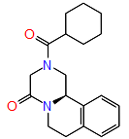 |  | PZQ |  | PZQ | 62.5 % ª; 100 % ^{b}; 100 % ^{c}; 0.5 µM ^{d}; 0.37 μM ^{e}; 3 μM ^{f}; 0.5< and 10 μM ^{g}; 98 % ^{h}; 3 µM ^{i}; 90 % ^{j. k} | 2 | J and M
 | Wang et al.. 2013a | 1 |  | 1 | 0 % ª | 0 | J
 | Wang et al.. 2013a | 2 |  | 2* | 0 % ª | 0 | J
 | Wang et al.. 2013a | 3 |  | 3 | 10 % ª | 1 | J
 | Wang et al.. 2013a | 4 |  | 4* ^{ts2} | 50 % ª | 1 | J
 | Wang et al.. 2013a | 5 |  | 5* | 0 % ª | 0 | J
 | Wang et al.. 2013a | 6 |  | 6 | 0 % ª | 0 | J
 | Wang et al.. 2013a | 7 |  | 7 | 100 % ª | 2 | J
 | Wang et al.. 2013a | 8 |  | 8 | 0 % ª | 0 | J
 | Wang et al.. 2013a | 9 |  | 9** | 87.5 % ª | 1 | J
 | Wang et al.. 2013a | 10 |  | 10 | 0 % ª | 0 | J
 | Wang et al.. 2013a | 11 |  | 11 | 62.5 % ª | 1 | J
 | Wang et al.. 2013a | 12 |  | 12 | 0 % ª | 0 | J
 | Wang et al.. 2013a | 13 |  | 13 | 0 % ª | 0 | J
 | Wang et al.. 2013a | 14 |  | 14 | 0 % ª | 0 | J
 | Wang et al.. 2013a | 15 |  | 15 | 0 % ª | 0 | J
 | Wang et al.. 2013a | 16 |  | 16 | 0 % ª | 0 | J
 | Wang et al.. 2013a | 17 |  | 17 | 0 % ª | 0 | J
 | Wang et al.. 2013a | 18 |  | 18 ^{ts2} | 18.2 % ª | 1 | J
 | Wang et al.. 2013a | 19 |  | 19 | 57.1 % ª | 1 | J
 | Wang et al.. 2013a | 20 |  | 20 | 0 % ª | 0 | J
 | Wang et al.. 2013a | 21 |  | 21 | 0 % ª | 0 | J
 | Wang et al.. 2013a | 22 |  | 22 | 100 % ª | 2 | J
 | Wang et al.. 2013a | 23 |  | 23^{ts1} | 87.5 % ª | 2 | J
 | Wang et al.. 2013a | 24 |  | 24 | 0 % ª | 0 | J
 | Wang et al.. 2013a | 25 |  | 25 | 0 % ª | 0 | J
 | Wang et al.. 2013a | 26 |  | 26 | 0 % ª | 0 | J
 | Wang et al.. 2013a | 27 |  | 27 | 0 % ª | 0 | J
 | Wang et al.. 2013a | 28 |  | 28 | 0 % ª | 0 | J
 | Wang et al.. 2013a | 29 |  | 29 | 0 % ª | 0 | J
 | Wang et al.. 2013a | 30 |  | 30 | 0 % ª | 0 | J
 | Wang et al.. 2013a | 31 |  | 31 | 0 % ª | 0 | J
 | Wang et al.. 2013a | 32 |  | 32 | 0 % ª | 0 | J
 | Wang et al.. 2013a | 33 |  | 33 ^{ts2} | 100 % ª | 2 | J
 | Wang et al.. 2013b | 6a | 34 |  | 87.2 % ^{b} | 2 | J
 | Wang et al.. 2013b | 6b | 35 |  | 55 % ^{b} | 1 | J
 | Wang et al.. 2013b | 6c | 36 ^{ts1} |  | 50 % ^{b} | 2 | J
 | Wang et al.. 2013b | 6d | 37* |  | 25 % ^{b} | 1 | J
 | Wang et al.. 2013b | 6e | 38 |  | 50 % ^{b} | 1 | J
 | Wang et al.. 2013b | 6f | 39 ^{ts2} |  | 54 % ^{b} | 1 | J
 | Wang et al.. 2013b | 6g | 40 |  | 33.5 % ^{b} | 1 | J
 | Wang et al.. 2013b | 6h | 41 ^{ts1} |  | 37.5 % ^{b} | 1 | J
 | Wang et al.. 2013b | 6i | 42* |  | 75 % ^{b} | 2 | J
 | Wang et al.. 2013b | 6j | 43 |  | 100 % ^{b} | 2 | J
 | Zheng et al.. 2014 | R-1 | 44 |  | 0 % ^{c} | 0 | J
 | Zheng et al.. 2014 | R-2 | 45 |  | 0% ^{c} | 0 | J
 | Zheng et al.. 2014 | R-3 | 46 |  | 60 % ^{c} | 2 | J
 | Sharma et al.. 2014 | (R)-3 | 47 ^{ts1, ts2} |  | 53.3 µM ^{d} | 1 | M
 | Sharma et al.. 2014 | 4 | 48 ^{ts1} |  | 132.1 µM ^{d} | 0 | M
 | Sharma et al.. 2014 | 5 | 49 |  | >300.0 µM ^{d} | 0 | M
 | Liu et al.. 2012 | 8b | 50 |  | 0 µM e | 0 | M
 | Liu et al.. 2012 | 8c | 51 |  | 0.9 µM e | 2 | M
 | Liu et al.. 2012 | 8d | 52 |  | 1000 µM e | 0 | M
 | Liu et al.. 2012 | 8e | 53 |  | 1000 µM e | 0 | M
 | Liu et al.. 2012 | 9a | 54 |  | 1.3 µM e | 2 | M
 | Liu et al.. 2012 | 9b | 55 |  | 1000 µM e | 0 | M
 | Liu et al.. 2012 | 9c | 56 ^{ts1} |  | 0 µM e | 0 | M
 | Liu et al.. 2012 | 9d | 57 |  | 43.7 µM e | 1 | M
 | Liu et al.. 2012 | 9e | 58 ^{ts1} |  | 1000 µM e | 0 | M
 | Liu et al.. 2012 | 9f | 59 |  | 1000 µM e | 0 | M
 | Liu et al.. 2012 | 10c | 60 |  | 46.8 µM e | 1 | M
 | Liu et al.. 2012 | 10d | 61 |  | 9.9 µM e | 1 | M
 | Liu et al.. 2012 | 10e | 62 |  | 1000 µM e | 0 | M
 | Liu et al.. 2012 | 10f | 63 |  | 1000 µM e | 0 | M
 | Liu et al.. 2012 | 10g | 64 |  | 0 µM e | 0 | M
 | Liu et al.. 2012 | 10h | 65 ^{ts1} |  | 0 µM e | 0 | M
 | Liu et al.. 2012 | 11a | 66 |  | 0 µM e | 0 | M
 | Liu et al.. 2012 | 11b | 67 |  | 0 µM e | 0 | M
 | Liu et al.. 2012 | 11c | 68 |  | 0 µM e | 0 | M
 | Liu et al.. 2012 | 11d | 69 |  | 0 µM e | 0 | M
 | Liu et al.. 2012 | 11e | 70 ^{ts1} |  | 0 µM e | 0 | M
 | Liu et al.. 2012 | 11f | 71 ^{ts1} |  | 0 µM e | 0 | M
 | Liu et al.. 2012 | 11g | 72 |  | 0 µM e | 0 | M
 | Sadhu et al.. 2012 | 28 | 73 |  | >10 µM ^{f} | 1 | M
 | Sadhu et al.. 2012 | 30 | 74 |  | 25 µM ^{f} | 1 | M
 | Sadhu et al.. 2012 | 31 | 75 |  | >100 µM ^{f} | 0 | M
 | Sadhu et al.. 2012 | 32 | 76 |  | 1000 µM ^{f} | 0 | M
 | Sadhu et al.. 2012 | 33 | 77 |  | 1000 µM ^{f} | 0 | M
 | Sadhu et al.. 2012 | 34 | 78 |  | 1000 µM ^{f} | 0 | M
 | Sadhu et al.. 2012 | 35 | 79 |  | >100 µM ^{f} | 0 | M
 | Sadhu et al.. 2012 | 36 | 80 |  | 1000 µM ^{f} | 0 | M
 | Sadhu et al.. 2012 | 37 | 81 |  | 1000 µM ^{f} | 0 | M
 | Sadhu et al.. 2012 | 47 | 82 |  | 25 µM ^{f} | 1 | M
 | Sadhu et al.. 2012 | 48 | 83 ^{ts2} |  | 50 µM ^{f} | 1 | M
 | Sadhu et al.. 2012 | 49 | 84 |  | 25 µM ^{f} | 1 | M
 | Sadhu et al.. 2012 | 50 | 85 |  | 1000 µM ^{f} | 0 | M
 | Sadhu et al.. 2012 | 59 | 86 |  | 1000 µM ^{f} | 0 | M
 | Sadhu et al.. 2012 | 60 | 87 |  | 1000 µM ^{f} | 0 | M
 | Sadhu et al.. 2012 | 61 | 88 |  | 1000 µM ^{f} | 0 | M
 | Sadhu et al.. 2012 | 62 | 89 |  | 1000 µM ^{f} | 0 | M
 | Kamel et al.. 2012 | 1a | 90 |  | 40 and 70 μM ^{g} | 0 | M
 | Kamel et al.. 2012 | 1b | 91 |  | 40 and 70 μM ^{g} | 0 | M
 | Kamel et al.. 2012 | 1c | 92 |  | 20 and 60 μM ^{g} | 1 | M
 | Kamel et al.. 2012 | 2a | 93 |  | 20 and 50 μM ^{g} | 1 | M
 | Kamel et al.. 2012 | 2b | 94 |  | 20 and 50 μM ^{g} | 1 | M
 | Kamel et al.. 2012 | 2c | 95 |  | 10 and 40 μM ^{g} | 1 | M
 | Kamel et al.. 2012 | 2d | 96 ^{ts1} |  | 5 and 30 μM ^{g} | 1 | M
 | Dong et al.. 2010 | 2 | 97 ^{ts1} |  | 39 % ^{h} | 1 | M
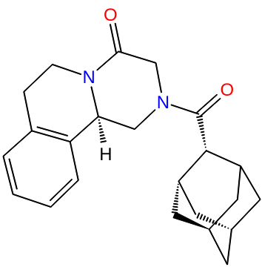 | Dong et al.. 2010 | 3 | 98 |  | 2 % ^{h} | 0 | M
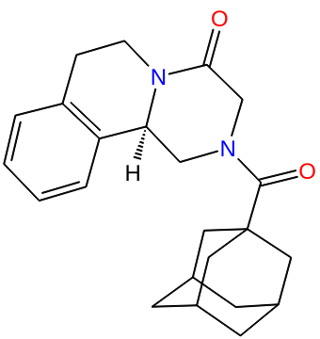 | Dong et al.. 2010 | 4 | 99 |  | 0 % ^{h} | 0 | M
 | Dong et al.. 2010 | 5 | 100 |  | 9 % ^{h} | 0 | M
 | Dong et al.. 2010 | 6 | 101 ^{ts1} |  | 0 % ^{h} | 0 | M
 | Dong et al.. 2010 | 7 | 102 |  | 0 % ^{h} | 0 | M
 | Dong et al.. 2010 | 8 | 103 ^{ts2} |  | 0 % ^{h} | 1 | M
 | Dong et al.. 2010 | 9 | 104 |  | 0 % ^{h} | 0 | M
 | Ronketti et al.. 2007 | 3 | 105 |  | 400 μM ^{i} | 0 | M
 | Ronketti et al.. 2007 | 4 | 106 |  | 28 μM ^{i} | 1 | M
 | Ronketti et al.. 2007 | 5 | 107 |  | 400 μM ^{i} | 0 | M
 | Ronketti et al.. 2007 | 6 | 108 |  | >80 μM ^{i} | 0 | M
 | Ronketti et al.. 2007 | 7 | 109 ^{ts2} |  | 18 μM ^{i} | 1 | M
 | Ronketti et al.. 2007 | 8 | 110 ^{ts1} |  | 200 μM ^{i} | 0 | M
 | Ronketti et al.. 2007 | 9 | 111 |  | 12 μM ^{i} | 1 | M
 | Abo-Ghalia and Soliman. 2001 | b | 112 ^{ts1} |  | 23 % ^{j} | 1 | M
 | Abo-Ghalia and Soliman. 2001 | c | 113 |  | 12 % ^{j} | 0 | M
 | Abo-Ghalia and Soliman. 2001 | d | 114 |  | 10 % ^{j} | 0 | M
 | Abo-Ghalia and Soliman. 2001 | e | 115 ^{ts2} |  | 70 % ^{j} | 1 | M
 | Abo-Ghalia and Soliman. 2001 | g | 116 |  | 52 % ^{j} | 1 | M
 | Abo-Ghalia and Soliman. 2001 | h | 117 |  | 55 % ^{j} | 1 | M
 | Abo-Ghalia and Soliman. 2001 | i | 118 |  | 60 % ^{j} | 1 | M
 | Abo-Ghalia and Soliman. 2001 | j | 119* |  | 75 % ^{j} | 1 | M
 | Abo-Ghalia and Soliman. 2001 | k | 120 ^{ts1} |  | 68 % ^{j} | 1 | M
 | Abo-Ghalia and Soliman. 2001 | II | 121 ^{ts1, ts2} |  | 63 % ^{j} | 1 | M

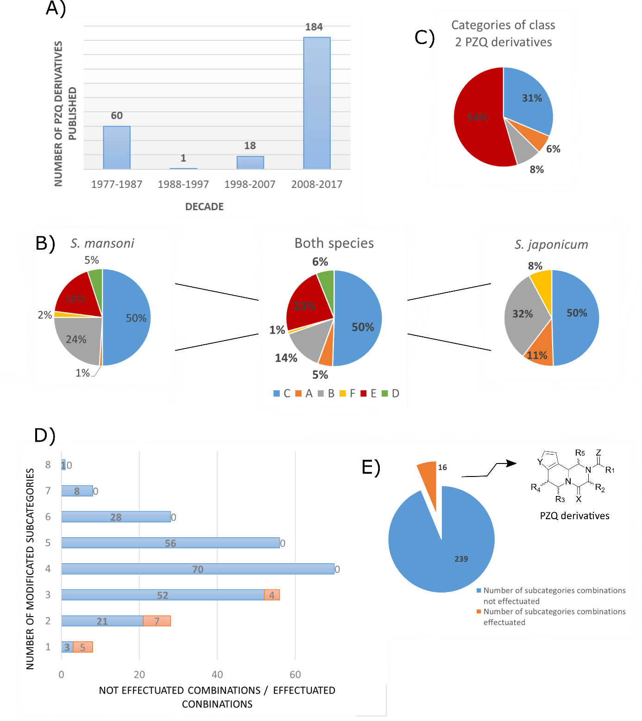

Figure S1 A) Number of PZQ derivatives used in our study versus the decades (1977 till 2017); B) Proportion of derivatives subcategory according to the worm species in which they were tested; C) Subcategories proportion of class 2 compounds. D) Histogram of number of modified subcategories vs not effectuated combinations (orange)/ effectuated combinations (blue); E) Sector graph of the total number of modifications, not performed modifications (blue) and performed modifications (orange);

Table. S2 Phase scores of the derivatives. * = Derivatives that do not match the model.
Name | Vector Score | Volume Score | Num. Sites Matched | Matched Ligand Site | Fitness | Align Score
PZQ | 0.991302 | 0.913960 | 4 | A(1) H(3) H(4) R(6) | 2.817619 | 0.105171
1 | * | * | * | * | * | *
2 | 0.995679748 | 0.854227255 | 4 | A(1) H(5) H(4) R(6) | 2.785305396 | 0.077521928
3 | 0.992072696 | 0.870822384 | 4 | A(1) H(5) H(4) R(6) | 2.779185426 | 0.100451585
4 | 0.991903321 | 0.897502474 | 4 | A(1) H(5) H(4) R(6) | 2.805726097 | 0.100415638
5 | 0.992161391 | 0.776488745 | 4 | A(1) H(3) H(4) R(5) | 2.685102406 | 0.100257276
6 | 0.993691872 | 0.763930116 | 4 | A(1) H(3) H(4) R(5) | 2.682633388 | 0.089986321
7 | 0.994258807 | 0.788029777 | 4 | A(2) H(4) H(5) R(6) | 2.707508191 | 0.089736472
8 | 0.994141392 | 0.753222038 | 4 | A(2) H(4) H(5) R(6) | 2.671871037 | 0.090590872
9 | 0.993342266 | 0.767584016 | 4 | A(1) H(3) H(4) R(5) | 2.684993689 | 0.091119111
10 | 0.993184882 | 0.767067361 | 4 | A(2) H(4) H(5) R(6) | 2.682822752 | 0.092915389
11 | 0.994629497 | 0.698686686 | 4 | A(2) H(3) H(4) R(6) | 2.621301016 | 0.086418201
12 | 0.99465519 | 0.818379644 | 4 | A(1) H(5) H(4) R(7) | 2.742894035 | 0.08416896
13 | * | * | * | * | * | *
14 | * | * | * | * | * | *
15 | * | * | * | * | * | *
16 | * | * | * | * | * | *
17 | 0.793695956 | 0.459670387 | 4 | A(1) H(3) H(4) R(5) | 1.347643657 | 1.086867224
18 | 0.838905816 | 0.428571808 | 4 | A(1) H(3) H(4) R(5) | 1.298287185 | 1.163028527
19 | 0.797472603 | 0.413913933 | 4 | A(1) H(2) H(4) R(5) | 1.240942612 | 1.164532709
20 | 0.847309355 | 0.409850985 | 4 | A(1) H(2) H(3) R(5) | 1.288195222 | 1.162758142
21 | 0.8441528 | 0.421562997 | 4 | A(1) H(2) H(3) R(5) | 1.304520011 | 1.153434944
22 | 0.992430237 | 0.873513785 | 4 | A(2) H(5) H(6) R(8) | 2.784898899 | 0.925479075
23 | 0.997194793 | 0.737346214 | 4 | A(1) H(4) H(3) R(6) | 2.643717083 | 0.108988709
24 | * | * | * | * | * | *
25 | 0.997166343 | 0.722976413 | 4 | A(1) H(4) H(5) R(6) | 2.628975524 | 0.109400678
26 | 0.997010043 | 0.729170128 | 4 | A(1) H(4) H(5) R(6) | 2.634283242 | 0.110276314
27 | 0.997388912 | 0.749683236 | 4 | A(1) H(4) H(5) R(6) | 2.656868418 | 0.108244475
28 | 0.997780779 | 0.825090374 | 4 | A(1) H(4) H(3) R(5) | 2.73413329 | 0.106485435
29 | 0.996428339 | 0.739391881 | 4 | A(1) H(4) H(3) R(5) | 2.641756002 | 0.112877062
30 | 0.997027419 | 0.655315858 | 4 | A(1) H(4) H(3) R(5) | 2.560902307 | 0.109729165
31 | 0.998177729 | 0.679658181 | 4 | A(2) H(4) H(3) R(6) | 2.59155274 | 0.103539803
32 | 0.998121011 | 0.67814052 | 4 | A(1) H(4) H(5) R(6) | 2.590415238 | 0.103015551
33 | 0.997848832 | 0.769511235 | 4 | A(2) H(5) H(4) R(6) | 2.678443053 | 0.106700417
34 | 0.99080235 | 0.86823273 | 4 | A(2) H(5) H(6) R(8) | 2.7682049 | 0.10899622
35 | 0.93784188 | 0.79221637 | 4 | A(1) H(5) H(4) R(7) | 2.71032862 | 0.02367555
36 | 0.93474144 | 0.72960607 | 4 | A(1) H(5) H(4) R(7) | 2.64286109 | 0.02578371
37 | 0.99197893 | 0.87346442 | 4 | A(2) H(5) H(6) R(8) | 2.78160133 | 0.10061043
38 | 0.99353304 | 0.72846801 | 4 | A(1) H(5) H(4) R(7) | 2.64740339 | 0.0895172
39 | 0.99185822 | 0.89973239 | 4 | A(1) H(4) H(5) R(7) | 2.80778215 | 0.10057015
40 | 0.99163511 | 0.90073972 | 4 | A(1) H(4) H(5) R(7) | 2.80738034 | 0.10199338
41 | 0.99107932 | 0.89817031 | 4 | A(1) H(4) H(5) R(7) | 2.80121524 | 0.10564127
42 | 0.99243044 | 0.87351636 | 4 | A(2) H(5) H(6) R(8) | 2.7848989 | 0.09725748
43 | 0.99289574 | 0.81043423 | 4 | A(2) H(5) H(6) R(8) | 2.72567865 | 0.09318158
44 | 0.99165545 | 0.83745316 | 4 | A(1) H(5) H(4) R(6) | 2.74400652 | 0.1021225
45 | 0.99115206 | 0.8791445 | 4 | A(1) H(5) H(4) R(6) | 2.78234364 | 0.1055435
46 | 0.99122912 | 0.89822233 | 4 | A(1) H(4) H(5) R(7) | 2.80174691 | 0.10524546
47 | 0.99580915 | 0.53041765 | 4 | A(2) H(9) H(10) R(13) | 2.49083404 | 0.04247131
48 | 0.9974709 | 0.39478094 | 4 | A(3) H(6) H(7) R(12) | 2.3413913 | 0.06103265
49 | 0.81138981 | 0.28171286 | 4 | A(3) H(12) H(11) R(15) | 1.59171477 | 0.60166549
50 | 0.99257338 | 0.82963332 | 4 | A(3) H(7) H(8) R(10) | 2.73959477 | 0.09913432
51 | 0.99725041 | 0.73735659 | 4 | A(1) H(4) H(3) R(6) | 2.64383545 | 0.10892586
52 | 0.99872743 | 0.64983988 | 4 | A(2) H(5) H(6) R(8) | 2.60940635 | 0.04699314
53 | 0.99981923 | 0.59073892 | 4 | A(2) H(7) H(6) R(9) | 2.48757625 | 0.12357829
54 | 0.99897444 | 0.88245725 | 4 | A(1) H(4) H(5) R(7) | 2.8461441 | 0.04234511
55 | 0.99859265 | 0.67915644 | 4 | A(1) H(5) H(4) R(7) | 2.63719996 | 0.04865895
56 | 0.99981938 | 0.67795739 | 4 | A(1) H(3) H(4) R(7) | 2.66524257 | 0.01504104
57 | 0.99918171 | 0.81434706 | 4 | A(1) H(3) H(4) R(7) | 2.79162222 | 0.02628787
58 | 0.99963406 | 0.78600815 | 4 | A(1) H(3) H(4) R(7) | 2.77487526 | 0.01292035
59 | 0.99968009 | 0.54725676 | 4 | A(1) H(4) H(5) R(8) | 2.52834965 | 0.02230464
60 | 0.9927379 | 0.73248446 | 4 | A(1) H(5) H(6) R(7) | 2.64470566 | 0.09662004
61 | 0.99438805 | 0.58436014 | 4 | A(2) H(4) H(5) R(7) | 2.50492124 | 0.08859233
62 | 0.99390764 | 0.62875651 | 4 | A(3) H(6) H(7) R(8) | 2.55016877 | 0.08699446
63 | 0.99426994 | 0.53464649 | 4 | A(3) H(4) H(5) R(9) | 2.4541889 | 0.08967304
64 | 0.99470259 | 0.6575604 | 4 | A(3) H(4) H(5) R(8) | 2.60948408 | 0.0513347
65 | 0.9919963 | 0.70213353 | 4 | A(1) H(4) H(5) R(6) | 2.61086455 | 0.09991834
66 | 0.9957749 | 0.85422725 | 4 | A(1) H(5) H(4) R(6) | 2.7853054 | 0.07752193
67 | 0.99931375 | 0.78195025 | 4 | A(2) H(6) H(7) R(9) | 2.7538099 | 0.03294492
68 | 0.9974709 | 0.39478094 | 4 | A(3) H(6) H(7) R(12) | 2.3413913 | 0.06103265
69 | 0.94343647 | 0.71475413 | 4 | A(1) H(2) H(4) R(5) | 2.64103137 | 0.02059108
70 | 0.98274913 | 0.73898233 | 4 | A(1) H(4) H(5) R(7) | 2.81740076 | 0.01837455
71 | 0.9925537 | 0.80928676 | 4 | A(1) H(5) H(6) R(8) | 2.8573649 | 0.09627551
72 | 0.99660046 | 0.40731533 | 4 | A(3) H(10) H(11) R(12) | 2.36485383 | 0.04687435
73 | 0.97442913 | 0.76498233 | 4 | A(1) H(2) H(4) R(5) | 2.64103137 | 0.10252193
74 | 0.99398082 | 0.77718301 | 4 | A(3) H(9) H(8) R(10) | 2.696864 | 0.08915979
75 | 0.9925537 | 0.80928676 | 4 | A(2) H(5) H(6) R(8) | 2.7138989 | 0.60166549
76 | 0.99509723 | 0.54192815 | 4 | A(4) H(8) H(9) R(11) | 2.46784335 | 0.08301843
77 | 0.99745376 | 0.62656567 | 4 | A(2) H(4) H(5) R(7) | 2.58620876 | 0.0453728
78 | 0.99772056 | 0.62891551 | 4 | A(2) H(6) H(5) R(7) | 2.59080865 | 0.0429929
79 | 0.92746207 | 0.6823847 | 4 | A(1) H(3) H(4) R(7) | 2.47264226 | 0.06837458
80 | 0.99787199 | 0.53243824 | 4 | A(3) H(5) H(6) R(8) | 2.49522162 | 0.04210634
81 | 0.99957118 | 0.78025537 | 4 | A(2) H(4) H(5) R(7) | 2.76342468 | 0.01968224
82 | 0.87288725 | 0.57084155 | 4 | A(1) H(5) H(4) R(7) | 2.32363356 | 0.14411428
83 | 0.87185618 | 0.55762016 | 4 | A(2) H(5) H(6) R(7) | 2.31375636 | 0.13886397
84 | 0.84420582 | 0.47920976 | 4 | A(1) H(4) H(3) R(6) | 2.20593827 | 0.14097277
85 | 0.83537959 | 0.47535008 | 4 | A(2) H(4) H(5) R(6) | 2.20884106 | 0.12226633
86 | 0.8326067 | 0.44117705 | 4 | A(2) H(6) H(4) R(7) | 2.1721827 | 0.12192125
87 | 0.84770362 | 0.42600477 | 4 | A(2) H(5) H(6) R(7) | 2.16934337 | 0.12523802
88 | 0.85202792 | 0.48621099 | 4 | A(3) H(5) H(6) R(7) | 2.23737566 | 0.12103589
89 | 0.92359361 | 0.50838094 | 4 | A(2) H(6) H(4) R(7) | 2.33917239 | 0.11136258
90 | 0.9941965 | 0.63792451 | 4 | A(1) H(3) H(4) R(6) | 2.55393923 | 0.09381814
91 | 0.99851825 | 0.62000475 | 4 | A(2) H(5) H(6) R(8) | 2.58834319 | 0.03621576
92 | 0.99670689 | 0.58272327 | 4 | A(1) H(3) H(4) R(7) | 2.52256608 | 0.06823689
93 | 0.99942719 | 0.6946888 | 4 | A(1) H(4) H(5) R(8) | 2.67012524 | 0.02878889
94 | 0.99983372 | 0.69267161 | 4 | A(1) H(4) H(5) R(8) | 2.67925718 | 0.01589778
95 | 0.99955574 | 0.59472296 | 4 | A(1) H(3) H(4) R(8) | 2.57452342 | 0.02370634
96 | 0.99931375 | 0.78195025 | 4 | A(2) H(6) H(7) R(9) | 2.7538099 | 0.03294492
97 | 0.99514897 | 0.68706955 | 4 | A(2) H(6) H(7) R(8) | 2.61252964 | 0.08362665
98 | 0.99111327 | 0.80665062 | 4 | A(1) H(3) H(4) R(8) | 2.71042267 | 0.10480946
99 | 0.9906532 | 0.66647503 | 4 | A(1) H(3) H(4) R(8) | 2.56889146 | 0.10588412
100 | 0.99403123 | 0.81421571 | 4 | A(1) H(3) H(4) R(6) | 2.73488682 | 0.08803214
101 | 0.99418415 | 0.81376407 | 4 | A(2) H(4) H(5) R(7) | 2.7362518 | 0.08603571
102 | 0.99432714 | 0.89077737 | 4 | A(1) H(4) H(5) R(6) | 2.81440786 | 0.08483598
103 | 0.99439812 | 0.69508422 | 4 | A(2) H(6) H(7) R(8) | 2.61582231 | 0.08839204
104 | 0.99150066 | 0.59580335 | 4 | A(4) H(8) H(6) R(12) | 2.50171197 | 0.10271045
105 | 0.99131594 | 0.83382812 | 4 | A(1) H(4) H(3) R(6) | 2.7401802 | 0.10195663
106 | 0.99236609 | 0.90094882 | 4 | A(1) H(5) H(6) R(8) | 2.81154627 | 0.09812237
107 | 0.9925537 | 0.80928676 | 4 | A(1) H(5) H(6) R(8) | 2.72161086 | 0.09627551
108 | 0.99280578 | 0.38811519 | 4 | A(1) H(6) H(7) R(12) | 2.29964841 | 0.09752708
109 | 0.9931434 | 0.73847555 | 4 | A(1) H(5) H(6) R(7) | 2.65502212 | 0.09191619
110 | 0.99131888 | 0.89505022 | 4 | A(2) H(5) H(6) R(8) | 2.79938861 | 0.10437658
111 | 0.99389096 | 0.74209202 | 4 | A(1) H(5) H(6) R(7) | 2.66213469 | 0.08861795
112 | 0.99123764 | 0.80531328 | 4 | A(1) H(3) H(4) R(5) | 2.71129097 | 0.10231195
113 | 0.99334827 | 0.61365242 | 4 | A(2) H(8) H(9) R(11) | 2.52963654 | 0.09283698
114 | 0.9936078 | 0.6429614 | 4 | A(1) H(7) H(8) R(10) | 2.56085114 | 0.09086167
115 | 0.99417833 | 0.66568373 | 4 | A(2) H(4) H(5) R(6) | 2.58592032 | 0.08873009
116 | 0.99373865 | 0.63799089 | 4 | A(1) H(5) H(6) R(7) | 2.55795291 | 0.08853195
117 | 0.99430294 | 0.55842529 | 4 | A(1) H(5) H(6) R(7) | 2.47929738 | 0.08811702
118 | 0.99253863 | 0.52382452 | 4 | A(2) H(8) H(9) R(10) | 2.43583197 | 0.09663741
119 | 0.99406678 | 0.77047214 | 4 | A(2) H(4) H(5) R(6) | 2.69201684 | 0.08702649
120 | 0.9941281 | 0.6647981 | 4 | A(1) H(2) H(3) R(5) | 2.58230362 | 0.09194711
121 | 0.9970197 | 0.57971653 | 4 | A(1) H(3) H(4) R(9) | 2.54610229 | 0.03676074

Table. S3 Physico-chemical parameters calculated to the derivatives matching with the pharmacophore using the software QikProp from Schrodinger. * = Derivatives that do not match the pharmacophore model.
Name | Category | WPSA | EA(eV) | PISA | LogS | IP
PZQ |  | 0 | 0.125 | 152.95 | -2.555 | 9.515
1 | C. D | * | * | * | * | *
2 | C | 0 | 0.021 | 149.33 | -0.622 | 9.686
3 | C | 0 | 0.035 | 154.739 | -0.776 | 9.51
4 | C | 0 | 0.033 | 85.001 | -2.099 | 9.545
5 | C | 0 | 0.14 | 83.453 | -0.603 | 9.732
6 | C | 0 | 0.289 | 105.508 | -2.17 | 9.326
7 | C | 72.2 | 0.296 | 112.372 | -2.589 | 9.569
8 | C | 97.667 | 0.302 | 99.203 | -2.076 | 9.298
9 | C | 0 | 0.284 | 94.884 | -2.094 | 9.606
10 | C | 0 | 0.678 | 154.256 | -0.954 | 9.647
11 | C | 45.596 | 0.951 | 48.156 | -0.934 | 9.573
12 | C | 0 | 0.414 | 129.985 | -2.298 | 9.561
13 | D | * | * | * | * | *
14 | C | * | * | * | * | *
15 | C. D | * | * | * | * | *
16 | A. C. D | * | * | * | * | *
17 | A. C | 0 | -0.263 | 154.261 | -1.895 | 9.535
18 | A. C | 0 | -0.279 | 152.753 | -1.329 | 9.511
19 | A | 0 | -0.293 | 152.765 | -1.818 | 9.51
20 | A. C | 0 | 0.127 | 339.985 | -2.443 | 9.481
21 | A. C | 44.225 | 0.881 | 277.045 | -2.429 | 9.56
22 | A. C | 73.239 | 0.145 | 155.821 | -2.139 | 9.192
23 | F | 49.984 | 0.861 | 154.838 | -2.391 | 9.178
24 | C. D. F | * | * | * | * | *
25 | C. F | 49.983 | 0.863 | 104.876 | -2.957 | 9.608
26 | C. F | 49.785 | 0.792 | 152.753 | -1.329 | 9.511
27 | C. F | 49.981 | 0.859 | 72.576 | -1.851 | 9.579
28 | C. F | 49.99 | 0.754 | 98.33 | -2.513 | 9.507
29 | C. F | 49.755 | 0.774 | 98.321 | -2.519 | 9.471
30 | C. F | 49.745 | 0.75 | 113.715 | -2.388 | 9.499
31 | C. F | 95.567 | 0.967 | 122.522 | -5.735 | 9.524
32 | C. F | 49.989 | 0.866 | 156.048 | -3.664 | 9.598
33 | C. F | 121.965 | 0.873 | 229.721 | -3.482 | 9.524
34 | F | 0 | 0.152 | 258.595 | -2.88 | 9.841
35 | F | 77.373 | 0.488 | 263.524 | -1.961 | 9.165
36 | F | 68.16 | 0.579 | 45.101 | -2.111 | 8.844
37 | F | 0 | 0.035 | 183.86 | -3.423 | 8.523
38 | F | 70.955 | 0.51 | 302.295 | -5.335 | 8.454
39 | F | 0 | 0.089 | 302.22 | -4.216 | 8.493
40 | F | 0 | 0.109 | 281.418 | -6.235 | 8.763
41 | F | 0 | 0.08 | 156.094 | 0.251 | 9.266
42 | F | 0 | 0.145 | 131.397 | -2.735 | 9.098
43 | F | 0 | 0.374 | 155.768 | -3.139 | 8.881
44 | C | 0 | 0.13 | 153.186 | -1.428 | 9.381
45 | C | 0 | 0.114 | 152.994 | -2.602 | 9.677
46 | C | 0 | 0.205 | 149.708 | -2.942 | 9.588
47 | C | 0 | -0.134 | 108.473 | -2.345 | 8.335
48 | C | 102.637 | 1.791 | 294.242 | -2.913 | 8.383
49 | C | 0 | 0.565 | 293.6 | -2.882 | 8.331
50 | F | 0 | 0.052 | 140.893 | -1.496 | 9.363
51 | F | 47.238 | 0.716 | 360.187 | -3.16 | 9.593
52 | B | 0 | 0.253 | 350.603 | -2.577 | 9.646
53 | B. F | 0 | 0.343 | 498.176 | -4.187 | 9.47
54 | B | 0 | -0.007 | 512.964 | -3.87 | 9.675
55 | B | 0 | 0.241 | 304.441 | -1.488 | 9.563
56 | B | 0 | 0.247 | 146.225 | -5.778 | 8.575
57 | B | 0 | 0.129 | 153.144 | -6.415 | 9.533
58 | B | 0 | 0.13 | 152.75 | -0.936 | 9.492
59 | B | 46.822 | 0.293 | 154.027 | 0.253 | 9.548
60 | C | 0 | 0.188 | 154.8 | -1.041 | 9.519
61 | C | 38.656 | 1.492 | 146.755 | -0.38 | 9.775
62 | C | 0 | 1.095 | 304.672 | -1.515 | 9.59
63 | C | 0 | 0.608 | 297.64 | -1.508 | 9.472
64 | C | 38.056 | 0.982 | 136.287 | -1.543 | 9.241
65 | C | 0 | 0.803 | 339.866 | -2.827 | 9.186
66 | C. H | 0 | 0.388 | 277.955 | -2.584 | 9.185
67 | C. H | 0 | 0.394 | 84.855 | -1.783 | 9.532
68 | C | 0 | 1.929 | 82.013 | -1.065 | 9.589
69 | C | 0 | 1.95 | 84.834 | -0.933 | 9.545
70 | C | 0 | 2.028 | 85.745 | -0.823 | 9.575
71 | C | 0 | 2.091 | 77.126 | -0.918 | 9.547
72 | C | 0 | 2.052 | 256.977 | -2.093 | 9.59
73 | C. D | 0 | 0.9 | 207.332 | -2.309 | 9.589
74 | C. F | 0 | -0.001 | 221.003 | -1.478 | 9.555
75 | C. D. F | 0 | 0.904 | 152.69 | -0.355 | 9.649
76 | C. F | 117.659 | 0.887 | 152.672 | -0.863 | 9.634
77 | B | 0 | 0.403 | 321.099 | -5.455 | 9.676
78 | B. C | 0 | 0.405 | 247.963 | -3.955 | 9.59
79 | B. C. D | 0.576 | 1.178 | 46.893 | -2.326 | 8.899
80 | B. C | 117.917 | 1.176 | 151.017 | -2.636 | 9.693
81 | B. C | 0 | 0.517 | 157.321 | -3.961 | 8.638
82 | F | 0 | 0.305 | 152.314 | -3.749 | 9.52
83 | C. F | 117.169 | 0.978 | 154.501 | -3.59 | 9.506
84 | C. F | 0 | 0.299 | 155.575 | -3.823 | 9.571
85 | C. F | 117.166 | 0.986 | 273.029 | -4.612 | 9.489
86 | B. C. F | 0 | 0.441 | 351.151 | -3.459 | 8.908
87 | B. C. F | 0 | 0.441 | 312.841 | -3.142 | 8.727
88 | B. C. F | 117.704 | 1.027 | 249.15 | 0.008 | 9.375
89 | B. C. F | 0 | 0.507 | 339.994 | -1.866 | 9.703
90 | B | 0 | 0.567 | 149.866 | -1.475 | 9.462
91 | B | 0 | 0.51 | 146.972 | -0.599 | 9.453
92 | B | 47.352 | 0.656 | 211.741 | -4.587 | 9.297
93 | B | 0 | 0.146 | 211.741 | -4.068 | 9.353
94 | B | 0 | -0.064 | 199.546 | -2.425 | 9.744
95 | B | 0 | 0.258 | 295.867 | -4.602 | 8.475
96 | B | 0 | 0.059 | 189.243 | -2.128 | 9.361
97 | C | 70.512 | 0.369 | 205.394 | -2.011 | 9.058
98 | C | 0 | 0.12 | 166.962 | -4.351 | 9.134
99 | C | 0 | -0.217 | 147.206 | -3.97 | 9.835
100 | C | 0 | -0.034 | 146.295 | -3.522 | 9.836
101 | C | 0 | 0.016 | 269.338 | -3.361 | 9.76
102 | C | 0 | -0.012 | 269.564 | -5.23 | 9.94
103 | C | 71.186 | 0.195 | 134.374 | -4.081 | 9.9
104 | C | 0 | 0.142 | 432.218 | -6.417 | 8.404
105 | F | 0 | 1.453 | 321.944 | -6.63 | 8.592
106 | F | 0 | -0.081 | 318.391 | -6.267 | 8.595
107 | F | 0 | 0.281 | 431.069 | -7.958 | 8.586
108 | F | 0 | 1.102 | 286.772 | -6.408 | 8.53
109 | C | 0 | -0.043 | 334.363 | -5.722 | 9.062
110 | C | 0 | 0.146 | 279.286 | -5.888 | 8.864
111 | C | 0 | 0.113 | 154.09 | -2.782 | 9.516
112 | C | 0 | -0.216 | 142.647 | -3.238 | 9.363
113 | C | 0 | 0.27 | 152.77 | -2.515 | 9.282
114 | C | 0 | 0.117 | 152.775 | -1.28 | 9.406
115 | C | 0 | 0.239 | 152.618 | -1.297 | 9.257
116 | C | 0 | 0.281 | 154.22 | -4.564 | 9.568
117 | C | 0 | 0.394 | 93.647 | -1.99 | 9.918
118 | C | 0 | 0.395 | 94.004 | -3.062 | 9.026
119 | C | 0 | 0.645 | 316.595 | -8.635 | 8.091
120 | A. D | 118.871 | 1.225 | 154.258 | -1.949 | 9.559
121 | C | 0 | 0.043 | 149.866 | -2.87 | 9.426

Table. S4 Matrix correlation to model 1 calculated using the software R.
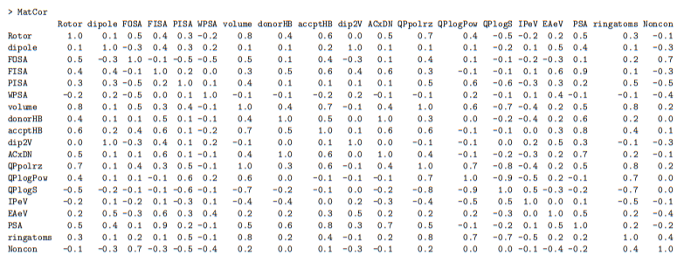

Table. S5 Matrix correlation to model 2 calculated using the software R.

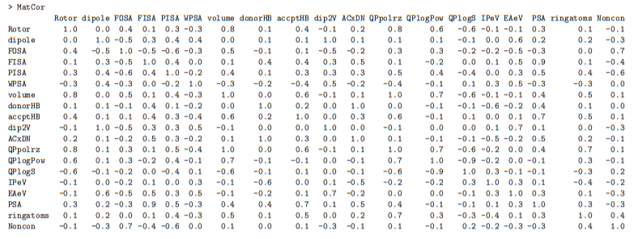
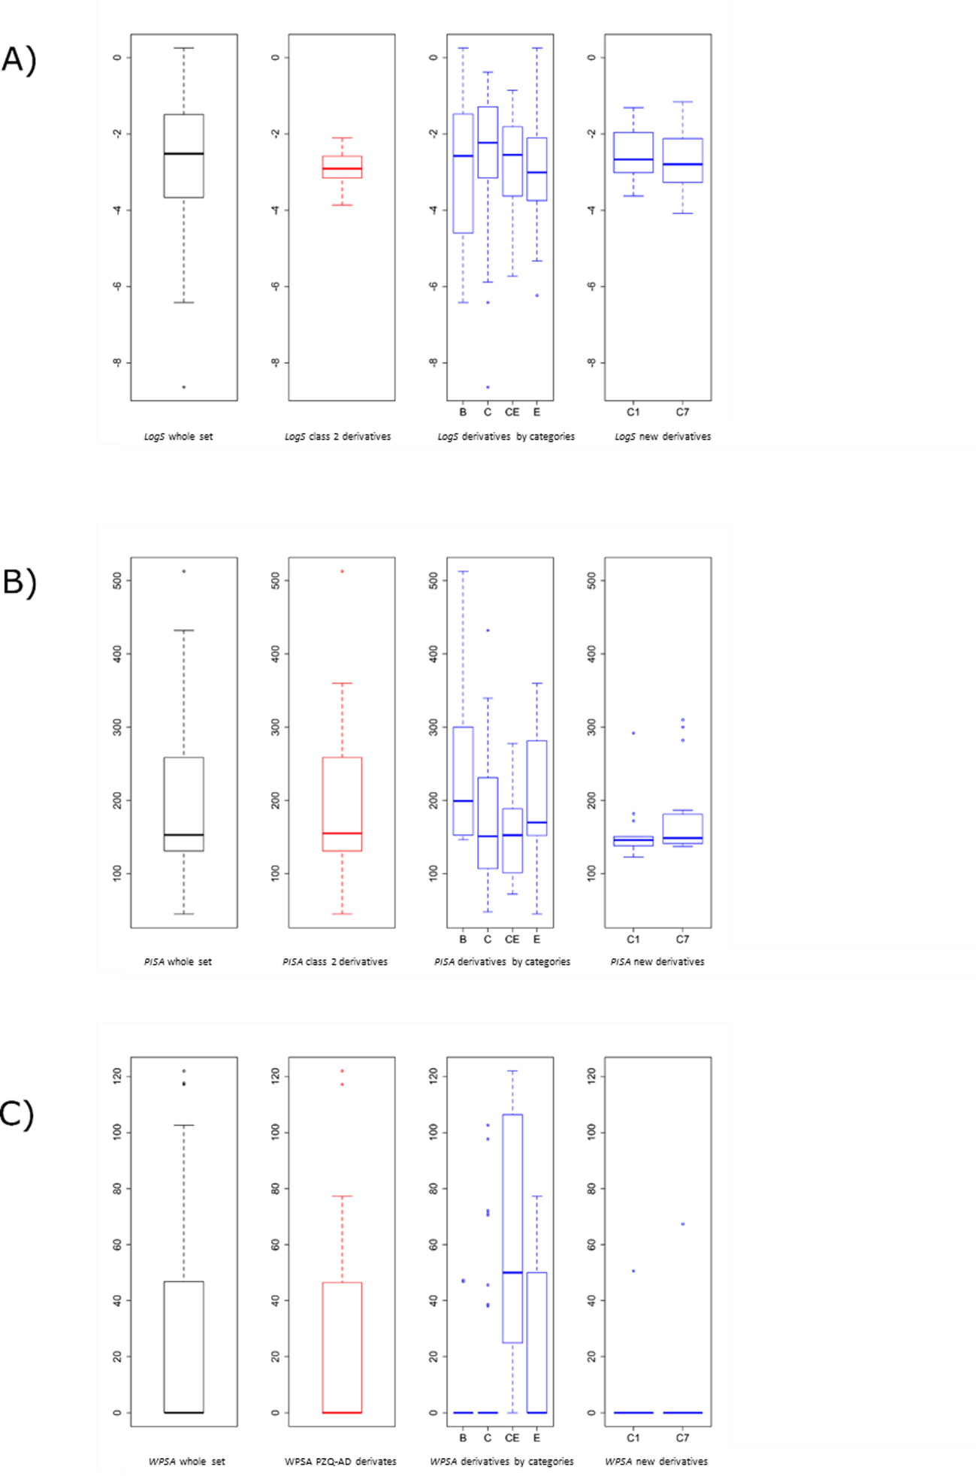
Figure S2. Boxplots representing the variability of physico-chemical properties. In black the whole set; in red only the active derivatives (PZQ-AD or Class 2), in blue the already synthetized derivatives divided by categories and the new proposed derivatives from categories C₁ and C₇.; A) LogS (Min. = -2.59; 1st Qu. =-2.12; Median = -1.99; Mean = -1.6; 3rd Qu. = -0.9; Max. = -0.6; var = 0.56; sd = 0.75); B) PISA (Min. = 48.16; 1st Qu. =92.41; Median = 108.94; Mean = 114.26; 3rd Qu. = 150.56; Max. = 154.74; var = 1197.52; sd = 34.61); C) WPSA (Min. = 0.00; 1st Qu. =0.00; Median = 23.62; Mean = 36.07; 3rd Qu. = 69.17; Max. = 121.97; var = 1747.2; sd = 41.8).
Tab. S6. Physico-chemical parameters and their interval values to distinguish the active molecules from the inactive ones. * Description of the physico-chemical parameter and algorithms used to generate the values were extracted from Schrödinger QikProp manual (Schrödinger. 2017c).
Parameters | Description* | Coefficient
EA (eV) | PM3 calculated electron affinity | - 2.44
WPSA | Weakly polar component of the total solvent accessible surface area (SASA) in square angstroms using a probe with a 1.4 Å radius (halogens. P. and S). | + 0.015
PISA | π (carbon and attached hydrogen) component of the SASA | - 0.03
LogS | Predicted aqueous solubility. log S. S in mol dm–3 is the concentration of the solute in a saturated solution that is in equilibrium with the crystalline solid | + 1.01
IP (eV) | PM3 calculated ionization potential | + 6.1

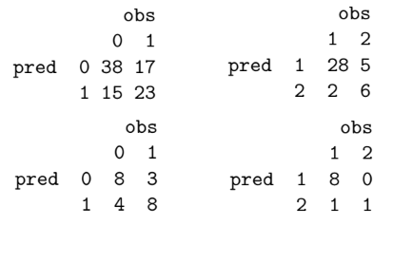
C)
A)

D)
B)

Figure S3. A) Confusion matrix for model 1 training set, class PZQ-AD vs Class 0; B) Confusion matrix for model 1 test set, PZQ-AD vs Class 0. C) Confusion matrix for model 1 training set, class PZQ-AD vs Class 0; B Confusion matrix for model 1 test set, class 1 vs Class 2.

Figure S4. Structure of all new active derivatives proposed by our work.

Table. S7. Names, categories, calculated physico-chemical parameters and the probability to belong to class PZQ-AD and 2 to the new proposed derivatives. When the probability is bigger or equal to 50% the derivative is classified on Class PZQ-AD or 2.
Name | Category | WPSA | EA(eV) | PISA | LogS | IP | Prob. Class PZQ-AD | Prob. Class 2
C₁ 1 | C₁ | 0 | 0.078 | 148.145 | -2.117 | 9.551 | 56% | 27%
C₁ 2 | C₁ | 0 | 0.082 | 147.944 | -2.709 | 9.538 | 56% | 14%
C₁ 3 | C₁ | 0 | 0.106 | 143.261 | -3.169 | 9.493 | 55% | 8%
C₁ 4 | C₁ | 0 | 0.07 | 146.061 | -1.668 | 9.433 | 57% | 24%
C₁ 5 | C₁ | 0 | 0.074 | 137.217 | -2.672 | 9.515 | 56% | 17%
C₁ 6 | C₁ | 0 | 0.144 | 122.782 | -1.963 | 9.617 | 52% | 59%
C₁ 7 | C₁ | 0 | 0.125 | 292.110 | -3.628 | 9.441 | 54% | 0%
C₁ 8 | C₁ | 0 | 0.094 | 282.326 | -3.693 | 9.484 | 55% | 0%
C₁ 9 | C₁ | 0 | 0.144 | 148.864 | -2.429 | 9.374 | 52% | 7%
C₁ 10 | C₁ | 0 | 0.21 | 150.980 | -3.301 | 9.783 | 49% | 26%
C₁ 11 | C₁ | 50.632 | 1.903 | 138.216 | -3.014 | 9.318 | 4% | 4%
C₁ 12 | C₁ | 0 | 0.004 | 172.128 | -2.577 | 9.623 | 60% | 14%
C₁ 13 | C₁ | 0 | 0.061 | 138.163 | -1.313 | 9.633 | 57% | 68%
C₁ 14 | C₇ | 0 | 0.079 | 136.957 | -1.459 | 9.679 | 56% | 72%
C₁ 15 | C₇ | 0 | 0.045 | 182.136 | -2.973 | 9.668 | 58% | 9%
C₇ 1 | C₇ | 0 | 0.265 | 138.438 | -2.435 | 9.525 | 45% | 22%
C₇ 2 | C₇ | 0 | 0.266 | 137.944 | -2.800 | 9.521 | 45% | 15%
C₇ 3 | C₇ | 0 | 0.265 | 138.476 | -3.403 | 9.502 | 45% | 7%
C₇ 4 | C₇ | 0 | 0.116 | 137.217 | -3.141 | 9.495 | 54% | 9%
C₇ 5 | C₇ | 0 | 0.116 | 300.256 | -4.030 | 9.525 | 54% | 0%
C₇ 6 | C₇ | 0 | 0.263 | 310.183 | -4.084 | 9.532 | 45% | 0%
C₇ 7 | C₇ | 0 | 0.557 | 175.719 | -2.215 | 9.511 | 29% | 10%
C₇ 8 | C₇ | 0 | 0.801 | 151.027 | -1.164 | 9.785 | 19% | 82%
C₇ 9 | C₇ | 67.359 | 2.116 | 147.046 | -2.028 | 9.146 | 3% | 3%
C₇ 10 | C₇ | 0 | 0.273 | 171.955 | -2.884 | 9.508 | 45% | 5%
C₇ 11 | C₇ | 0 | 0.42 | 144.486 | -1.197 | 9.559 | 37% | 56%
C₇ 12 | C₇ | 0 | 0.403 | 145.513 | -2.044 | 9.597 | 37% | 37%
C₇ 13 | C₇ | 0 | 0.324 | 186.726 | -3.087 | 9.561 | 42% | 4%

