Synthesis, Antibacterial Activity and Docking Studies of Substituted Quinolone Thiosemicarbazones
Hogantharanni Govender1, Chunderika Mocktar2, Hezekiel M. Kumalo3 and Neil A. Koorbanally1*
1School of Chemistry and Physics, University of KwaZulu-Natal, Private Bag X54001, Durban, 4000, South Africa
2School of Health Sciences, University of KwaZulu-Natal, Private Bag X54001, Durban, 4000, South Africa
3Nelson R. Mandela School of Medicine, University of KwaZulu-Natal, Private Bag X54001, Durban, 4000, South Africa

Email: Koorbanally@ukzn.ac.za

Supplemental Materials

Docking studies with the assistance of ligplot

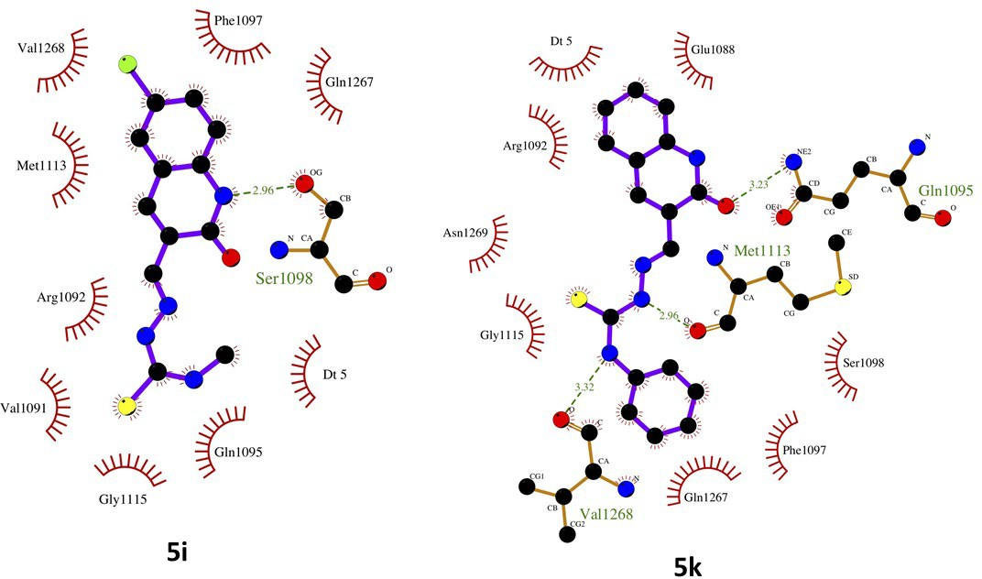

Figure S 1: 3D Ligand residue interactions for 5i and 5k against DNA Gyrase. Oxygen = red spheres, nitrogen = blue spheres, carbon = black spheres, sulfur = yellow spheres, chlorine = green sphere, red arcs = hydrophobic interactions and green dashed lines = hydrogen bonds.

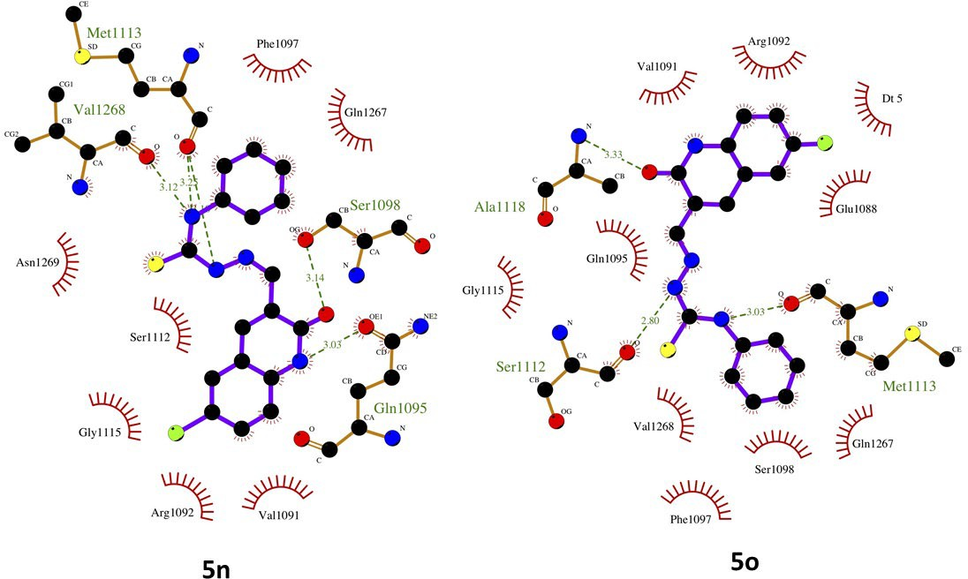

Figure S 2: 3D Ligand residue interactions for 5n and 5o against DNA Gyrase. Oxygen = red spheres, nitrogen = blue spheres, carbon = black spheres, sulfur = yellow spheres, chlorine = green sphere in 5n and fluorine = green sphere in 5o, red arcs = hydrophobic interactions and green dashed lines = hydrogen bonds.

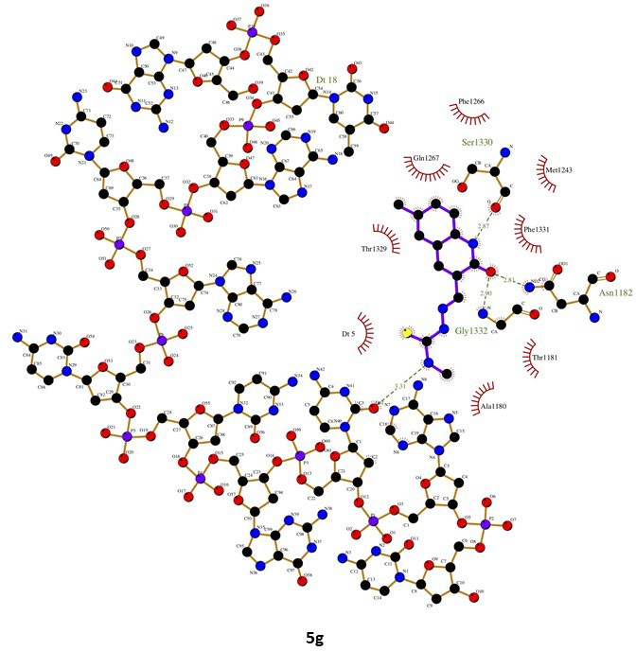

Figure S 3 3D Ligand residue interactions for 5g against DNA Gyrase. Oxygen = red spheres, nitrogen = blue spheres, carbon = black spheres, sulfur = yellow spheres, red arcs = hydrophobic interactions and green dashed lines = hydrogen bonds.

NMR spectra

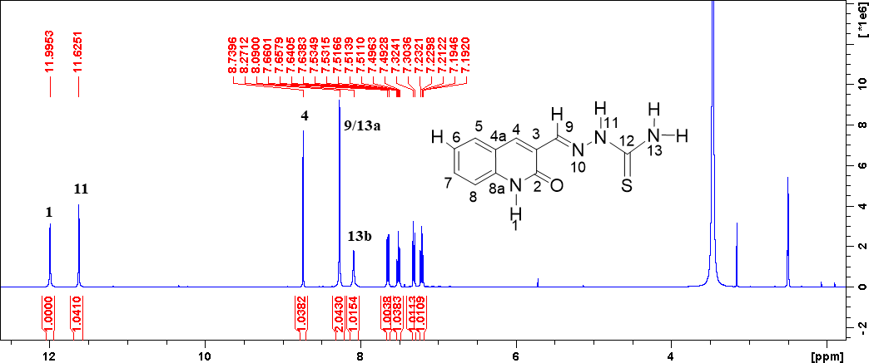

Figure S 3 1H NMR spectrum of 5a

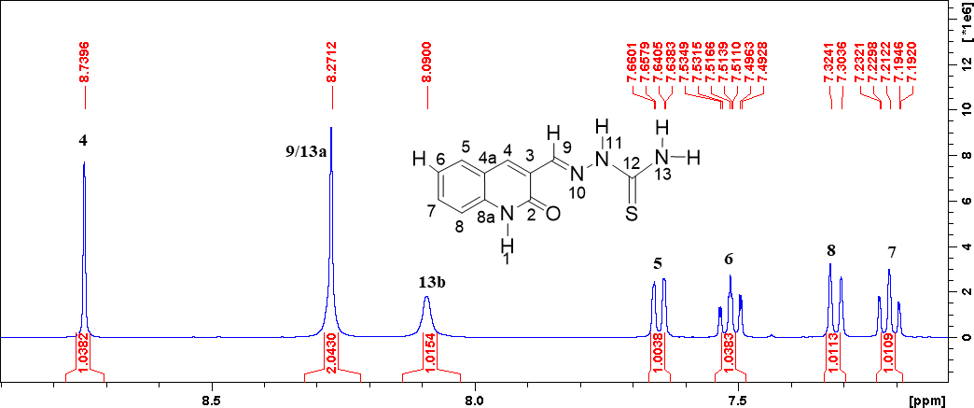

Figure S 4 Expanded 1H NMR spectrum of 5a

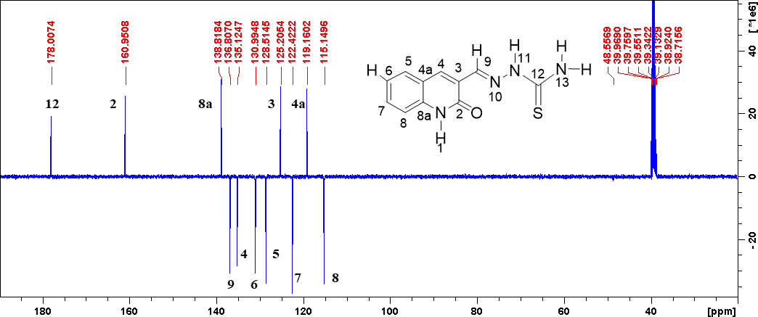

Figure S 5 13C NMR spectrum of 5a

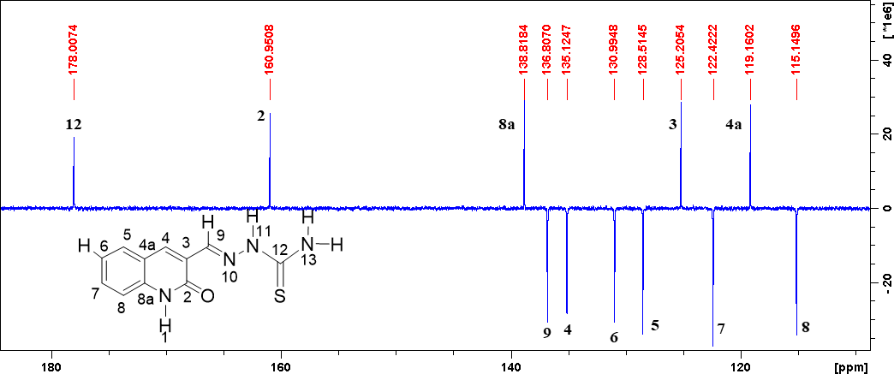

Figure S 6 Expanded 13C NMR spectrum of 5a

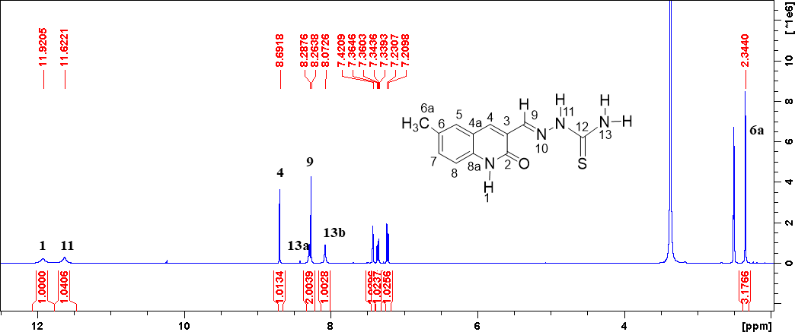

Figure S 7 1H NMR spectrum of 5b

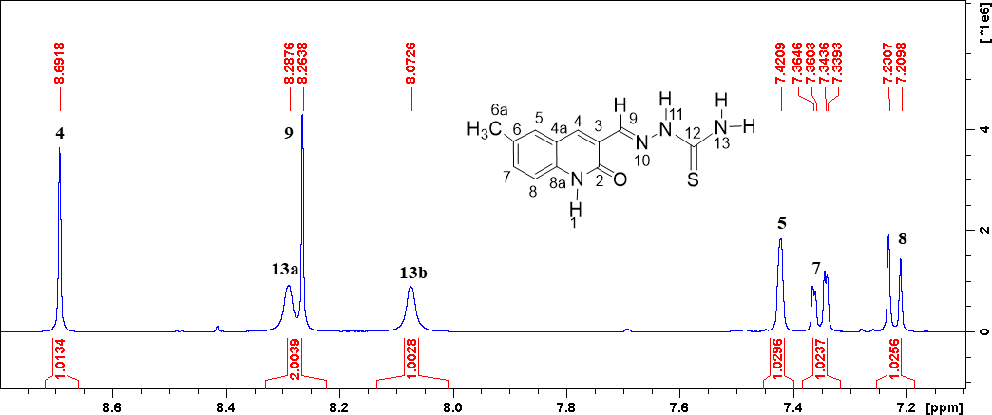

Figure S 8 Expanded 1H NMR spectrum of 5b

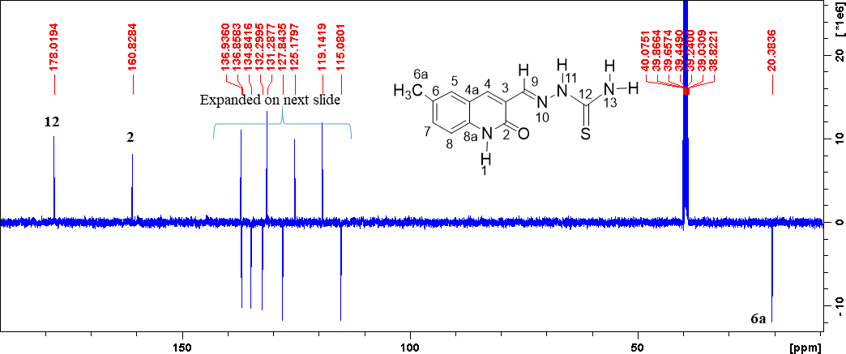

Figure S 9 13C NMR spectrum of 5b

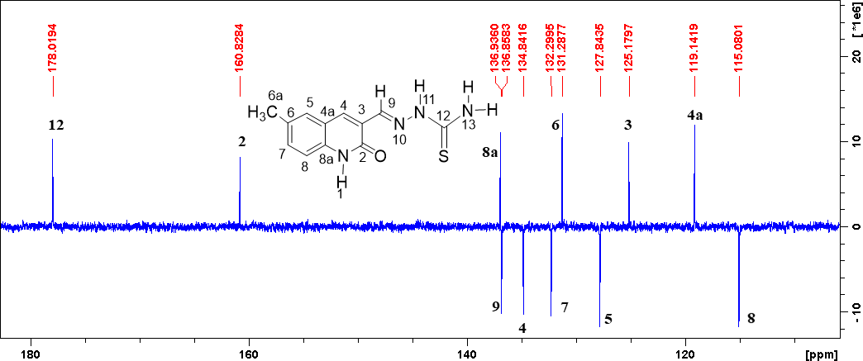

Figure S 10 Expanded 13C NMR spectrum of 5b

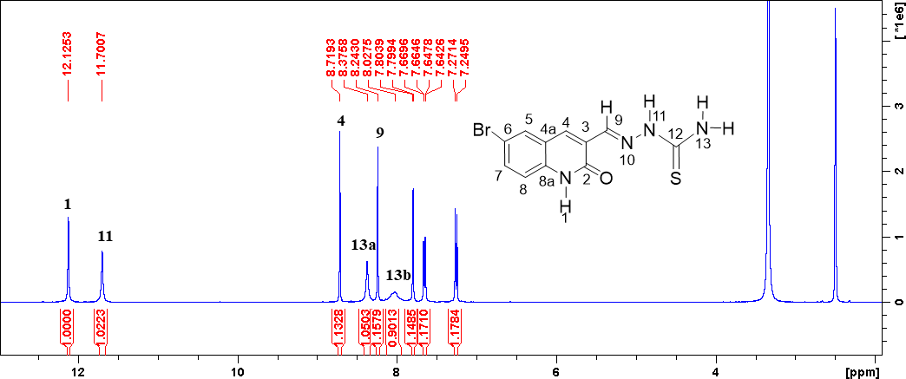

Figure S 11 1H NMR spectrum of 5c

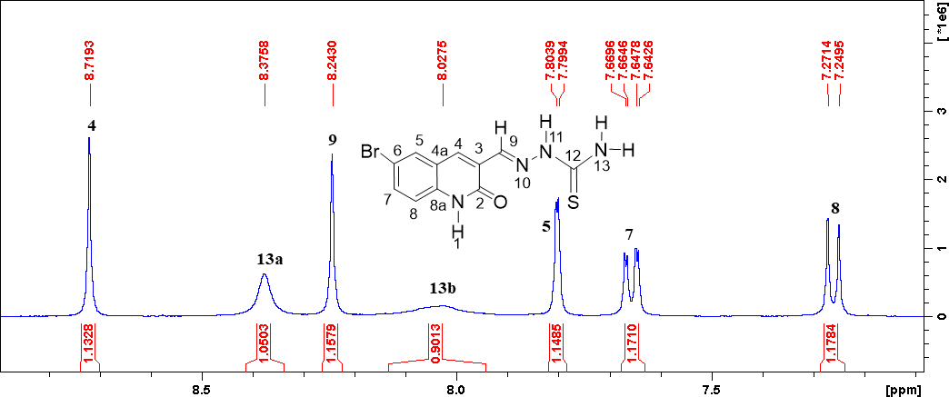

Figure S 12 Expanded 1H NMR spectrum of 5c

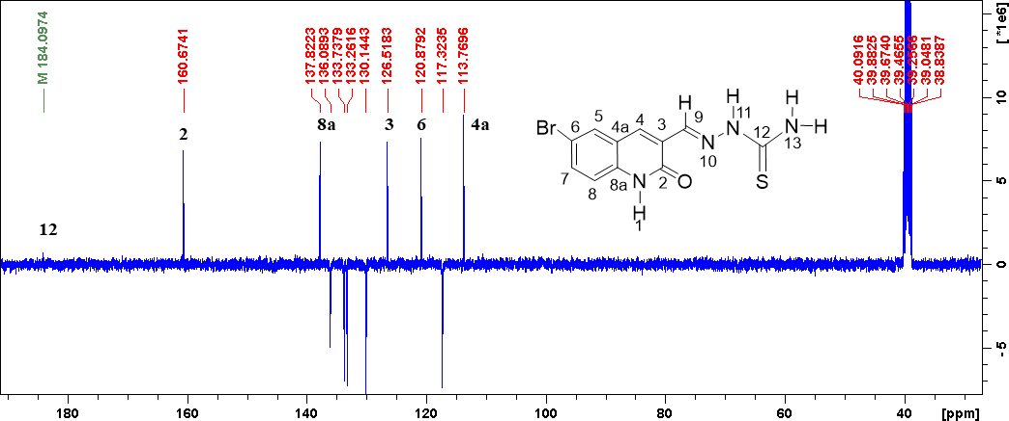

Figure S 13 13C NMR spectrum of 5c

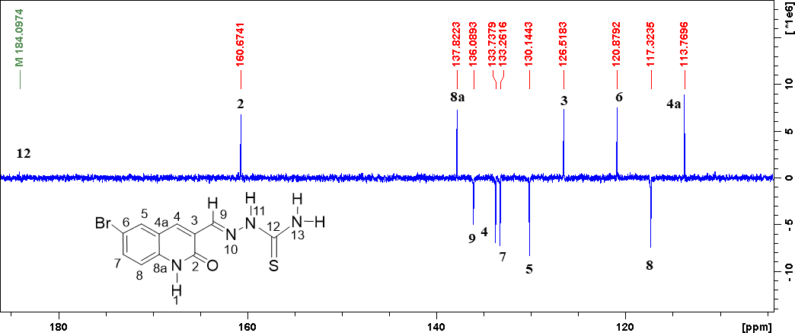
Figure S 14 Expanded 13C NMR spectrum of 5c

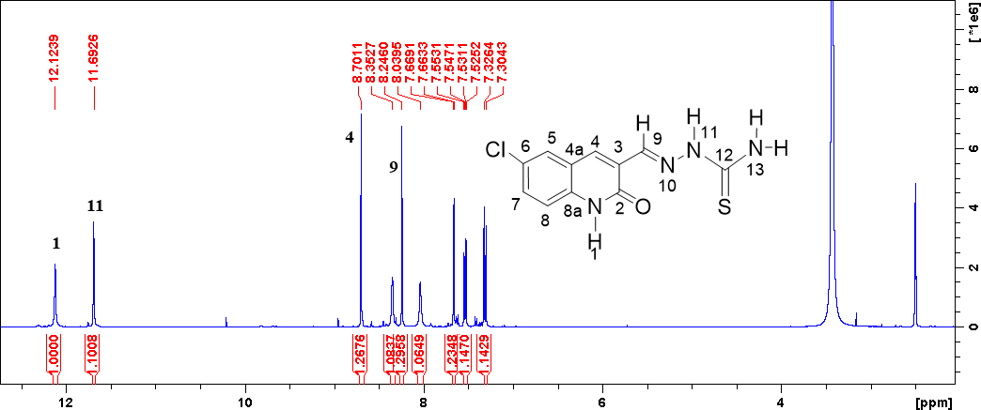

Figure S 15 1H NMR spectrum of 5d

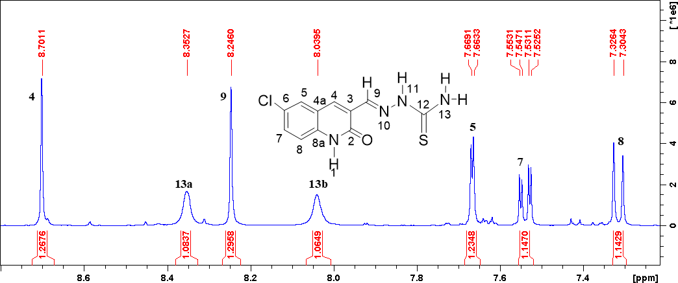
Figure S 16 Expanded 1H NMR spectrum of 5d

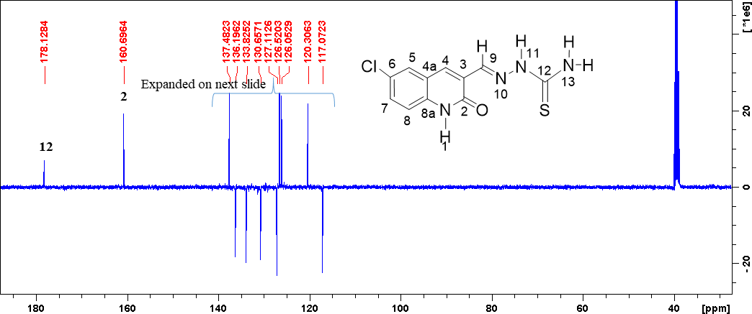

Figure S 17 13C NMR spectrum of 5d

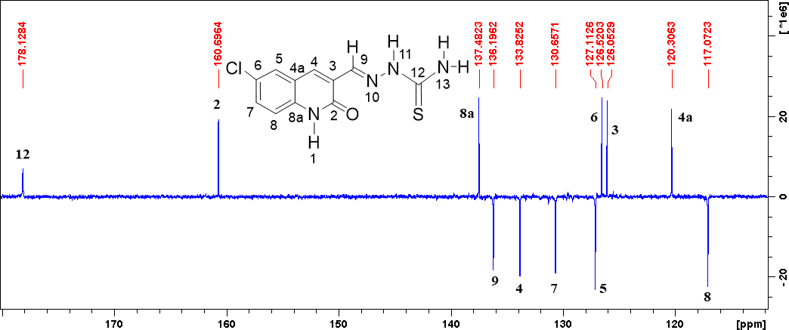
Figure S 18 Expanded 13C NMR spectrum of 5d

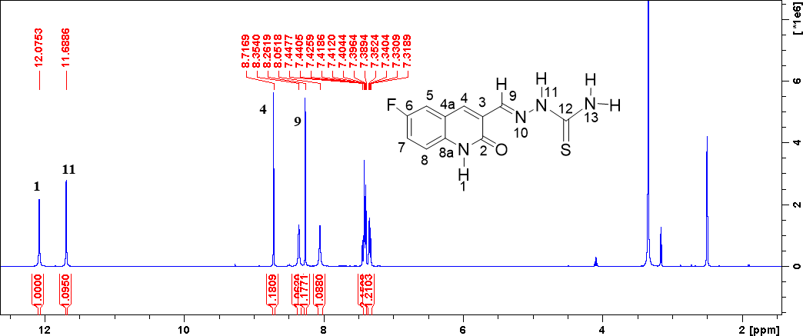

Figure S 19 1H NMR spectrum of 5e

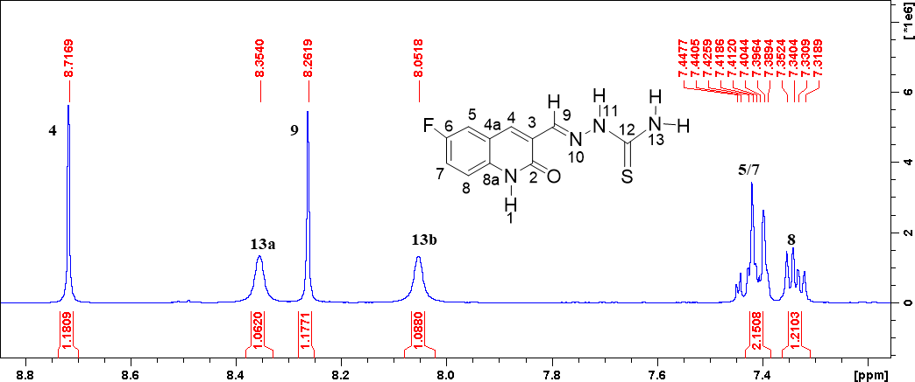

Figure S 20 Expanded 1H NMR spectrum of 5e

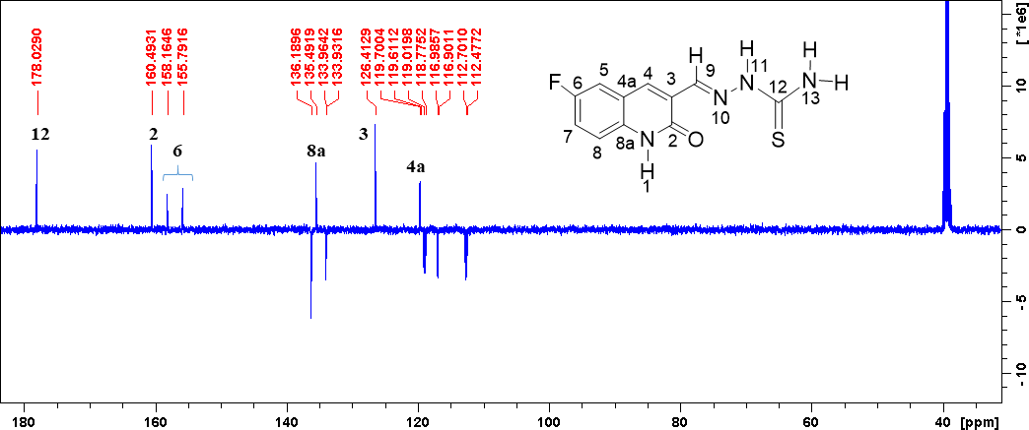

Figure S 21 13C NMR spectrum of 5e

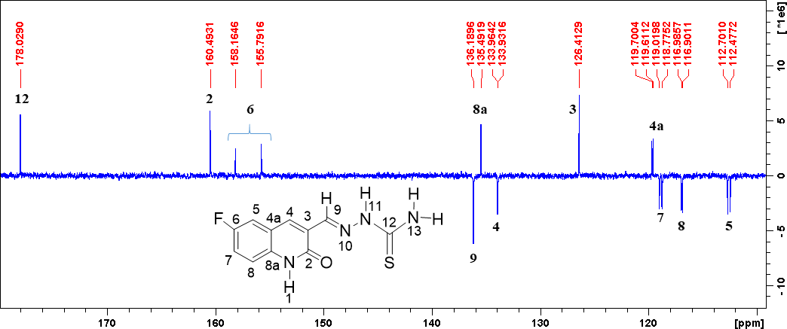
Figure S 22 Expanded 13C NMR spectrum of 5e

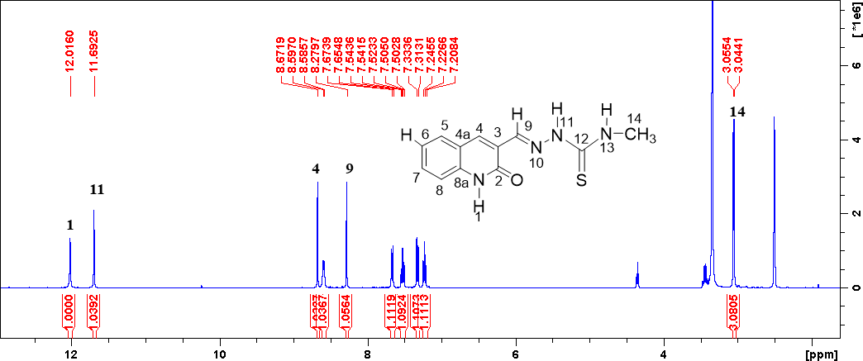

Figure S 23 1H NMR spectrum of 5f

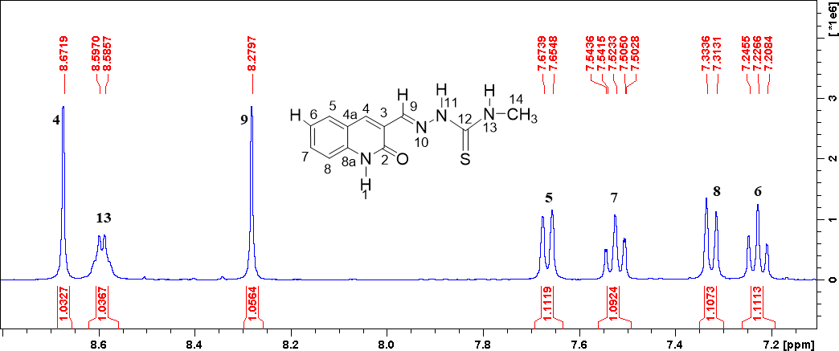
Figure S 24 Expanded 1H NMR spectrum of 5f

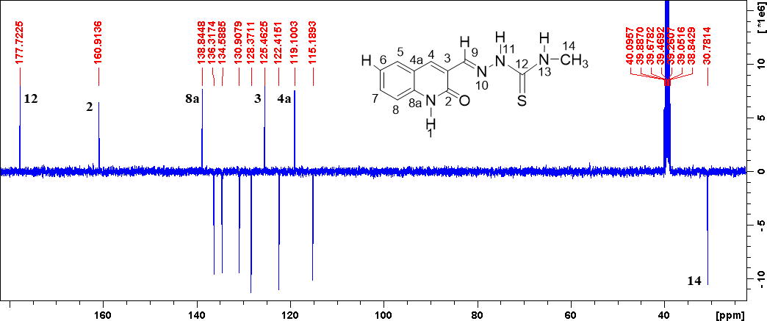

Figure S 25 13C NMR spectrum of 5f

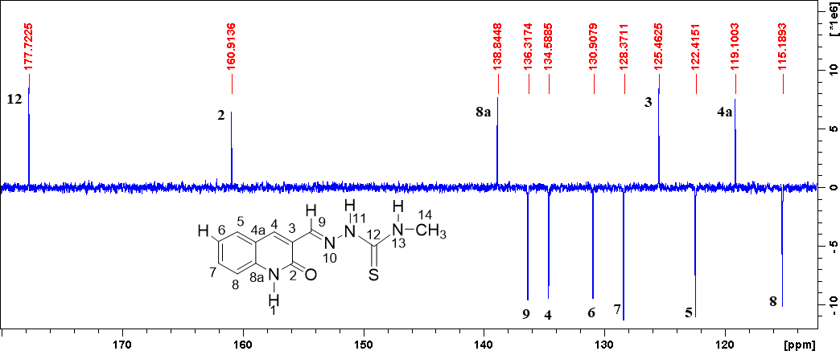
Figure S 26 Expanded 13C NMR spectrum of 5f

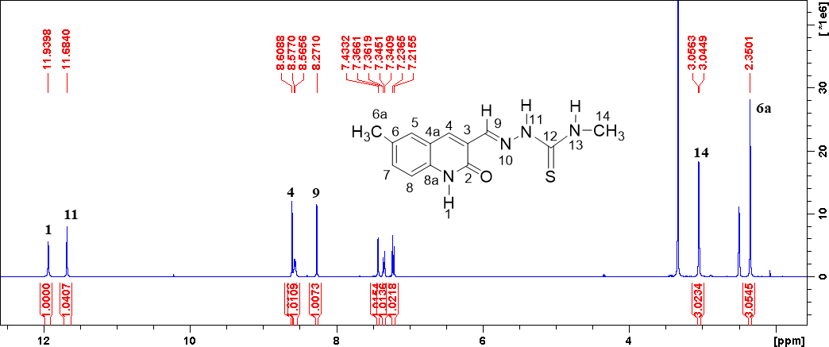

Figure S 27 1H NMR spectrum of 5g

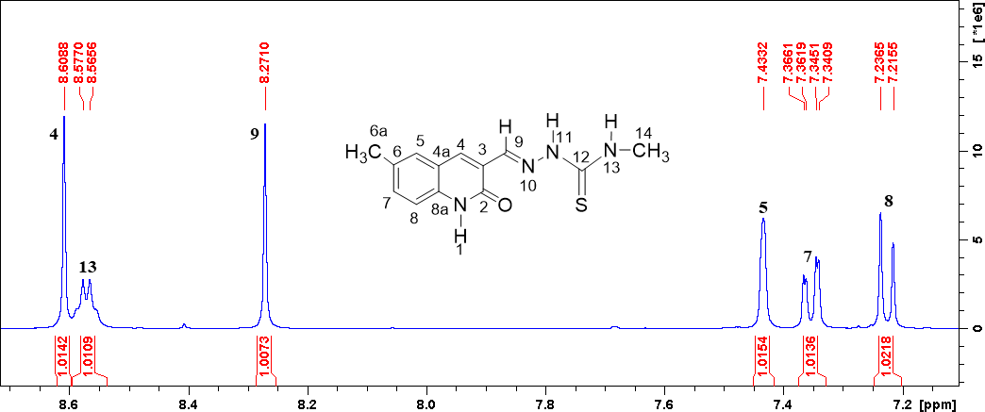

Figure S 28 Expanded 1H NMR spectrum of 5g

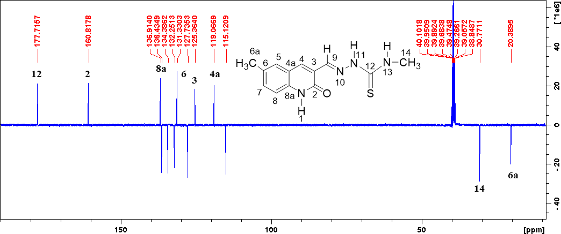

Figure S 29 13C NMR spectrum of 5g

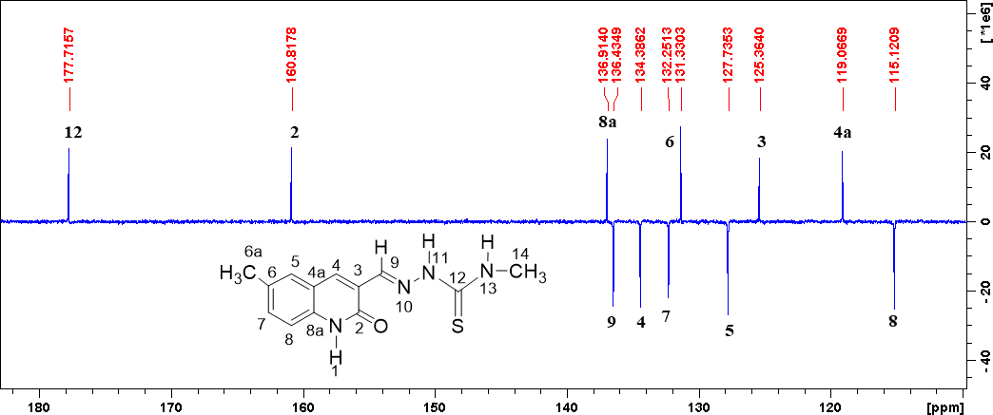
Figure S 30 Expanded 13C NMR spectrum of 5g

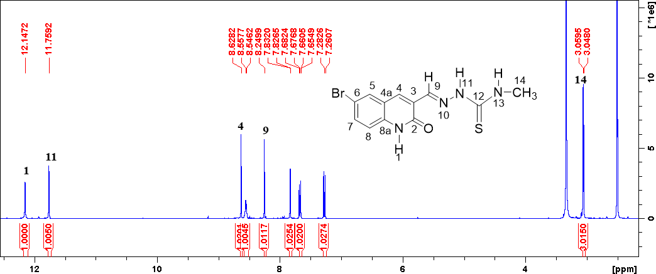

Figure S 31 1H NMR spectrum of 5h

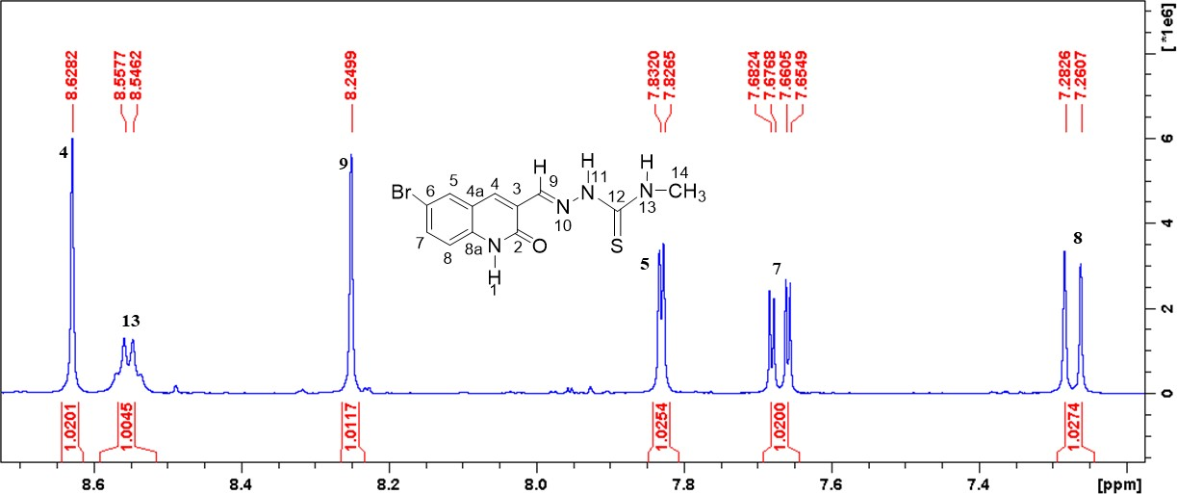
Figure S 32 Expanded 1H NMR spectrum of 5h

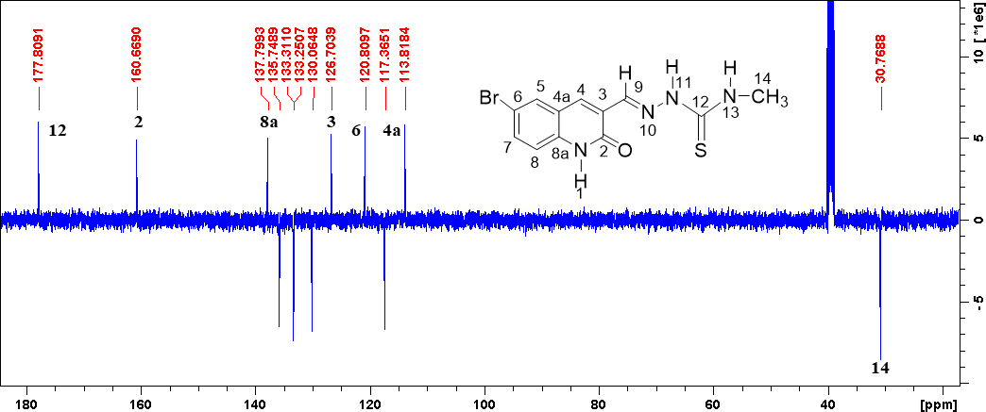

Figure S 33 13C NMR spectrum of 5h

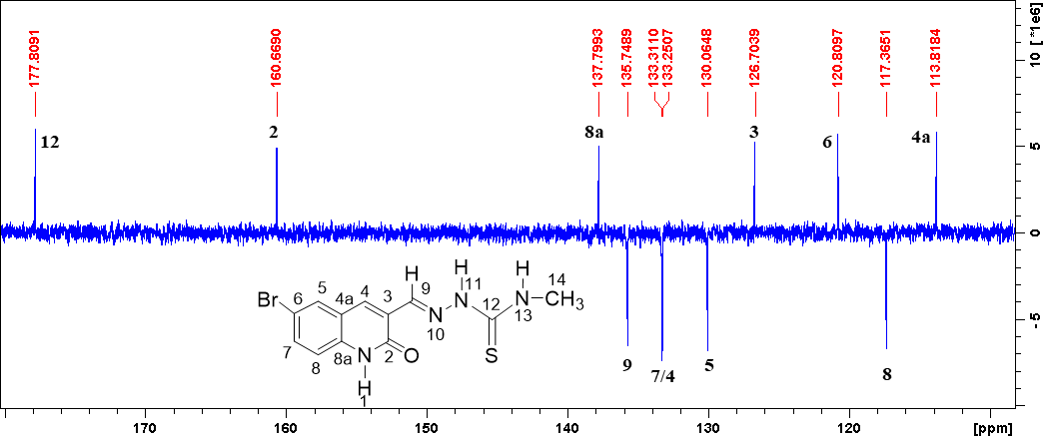
Figure S 34 Expanded 13C NMR spectrum of 5h

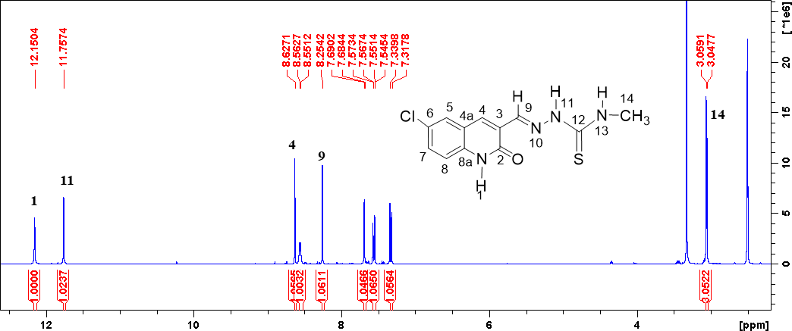

Figure S 35 1H NMR spectrum of 5i

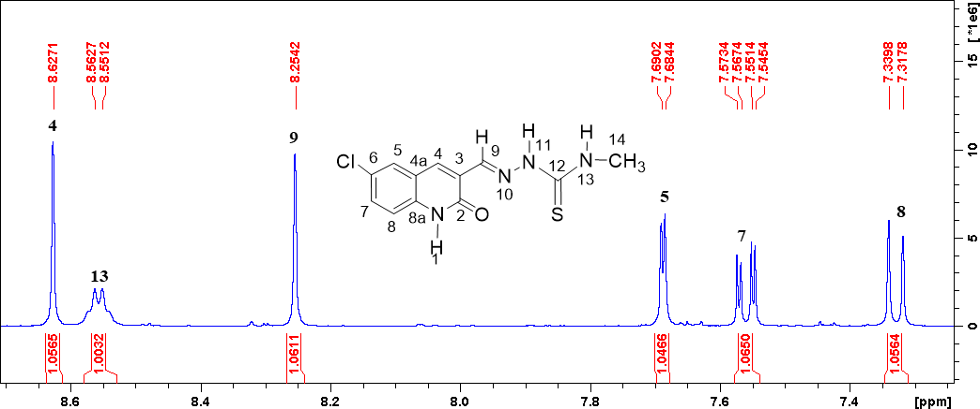
Figure S 36 Expanded 1H NMR spectrum of 5i

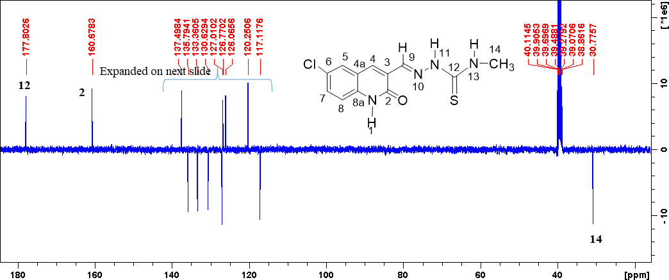

Figure S 37 13C NMR spectrum of 5i

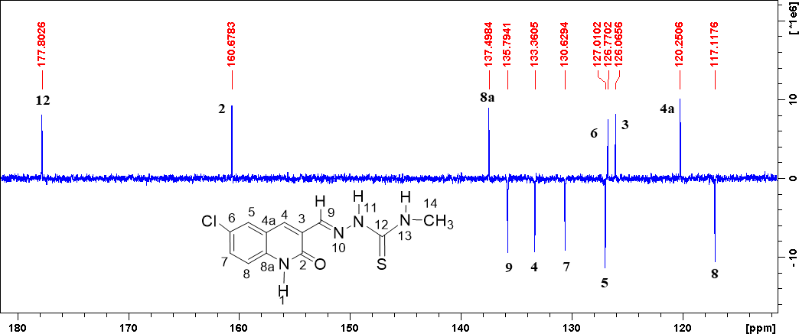

Figure S 38 Expanded 13C NMR spectrum of 5i

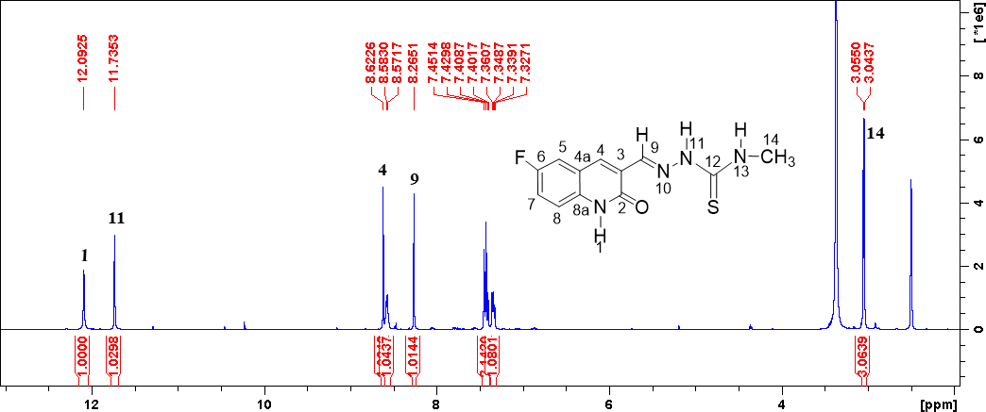

Figure S 39 1H NMR spectrum of 5j

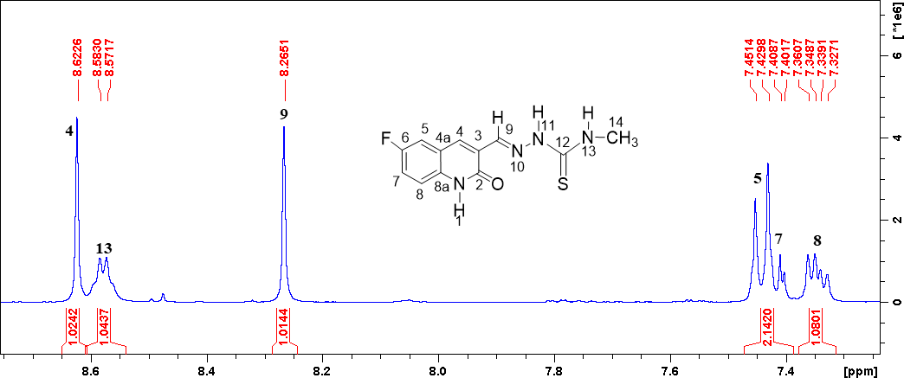
Figure S 40 Expanded 1H NMR spectrum of 5j

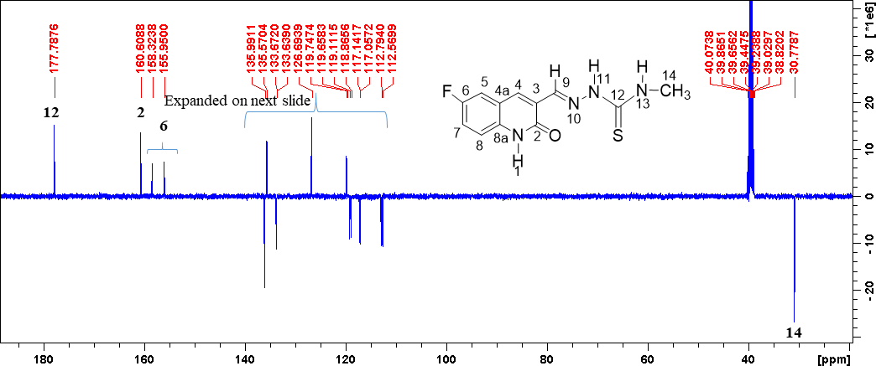

Figure S 41 13C NMR spectrum of 5j

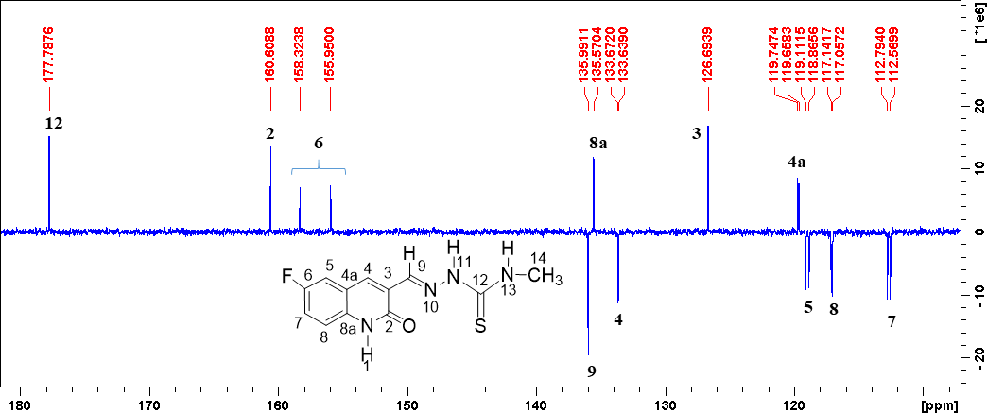

Figure S 42 Expanded 13C NMR spectrum of 5j

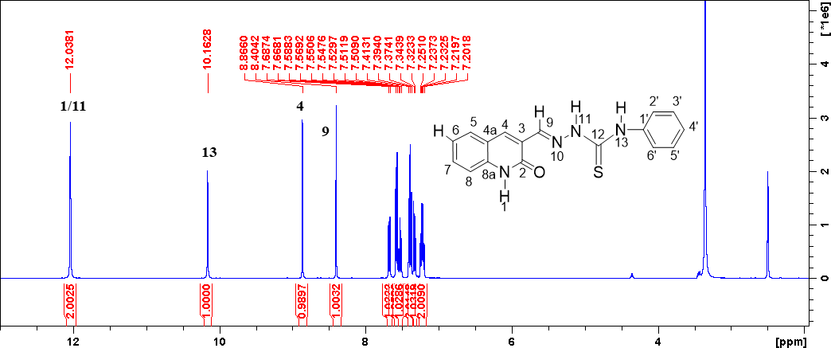

Figure S 43 1H NMR spectrum of 5k

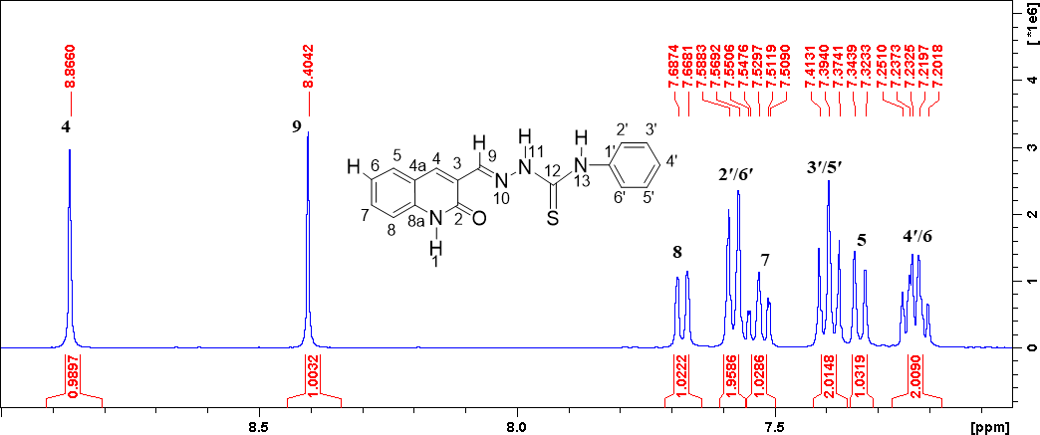
Figure S 44 Expanded 1H NMR spectrum of 5k

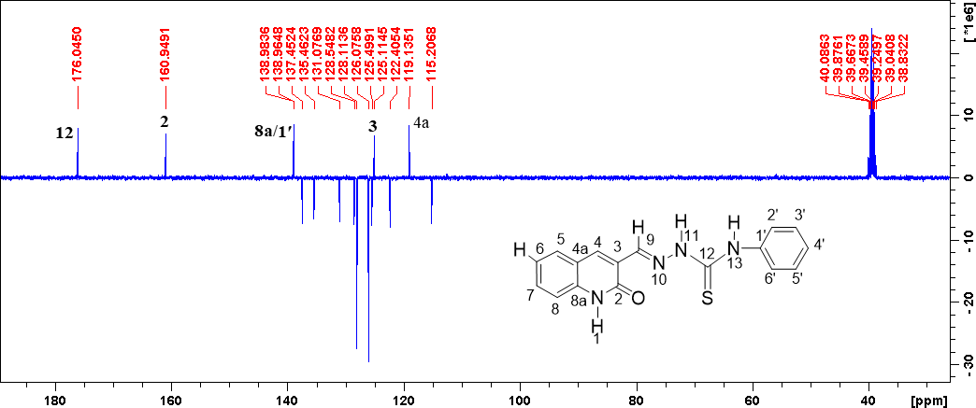

Figure S 45 13C NMR spectrum of 5k

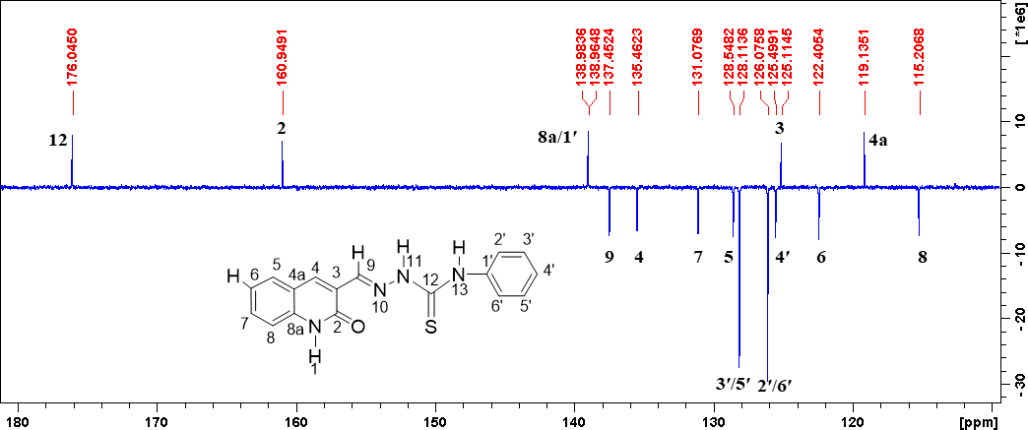

Figure S 46 Expanded 13C NMR spectrum of 5k

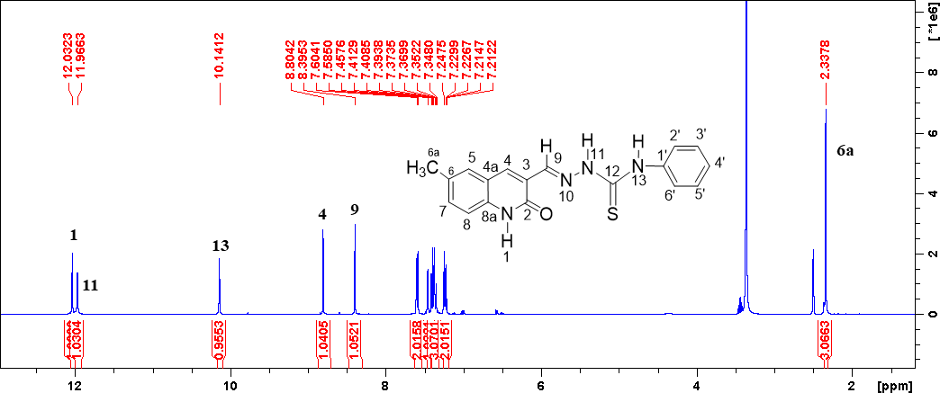

Figure S 47 1H NMR spectrum of 5l

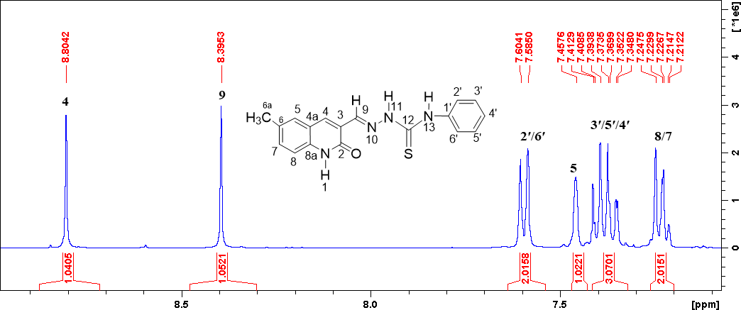
Figure S 48 Expanded 1H NMR spectrum of 5l

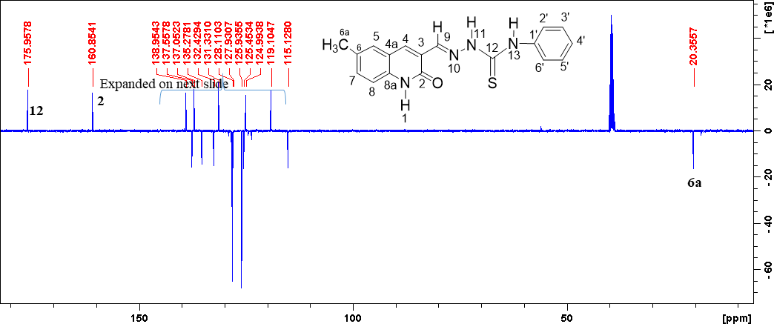

Figure S 49 13C NMR spectrum of 5l

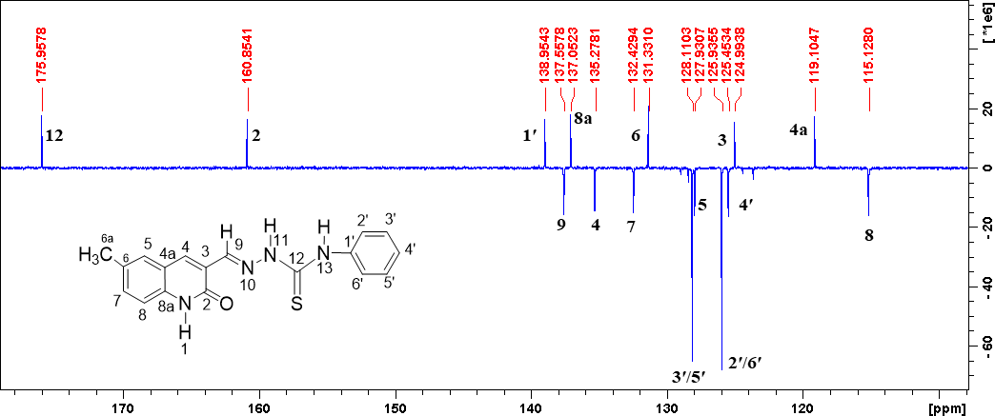
Figure S 50 Expanded 13C NMR spectrum of 5l

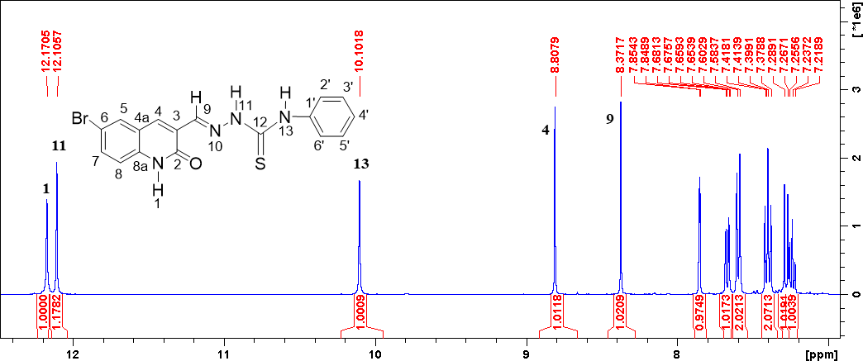

Figure S 51 1H NMR spectrum of 5m

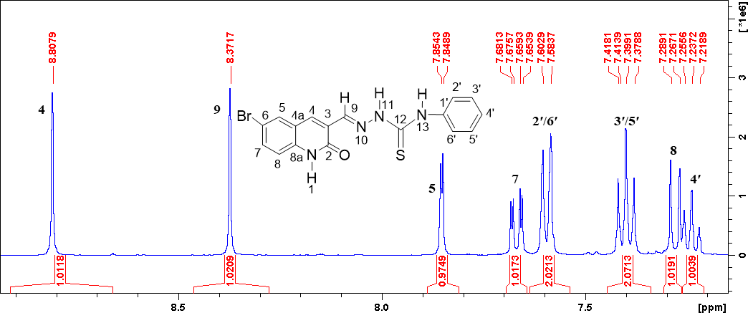
Figure S 52 Expanded 1H NMR spectrum of 5m

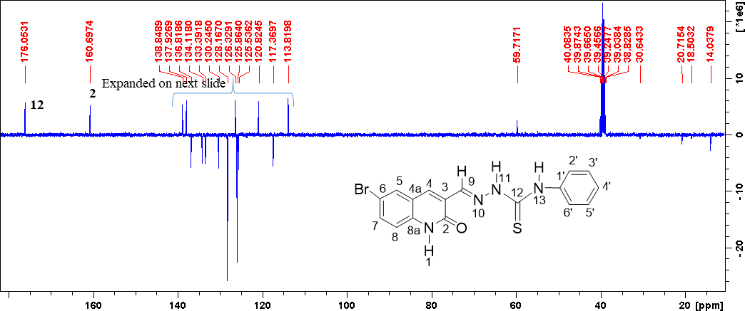

Figure S 53 13C NMR spectrum of 5m

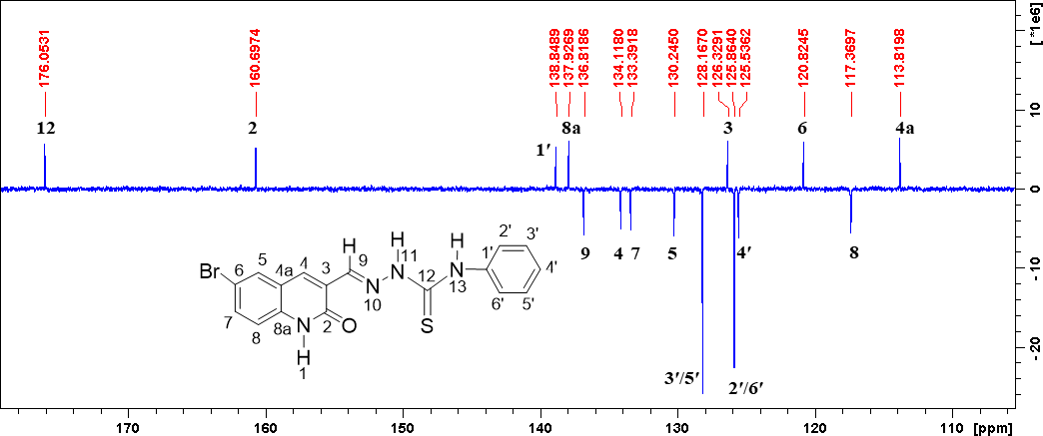
Figure S 54 Expanded 13C NMR spectrum of 5m

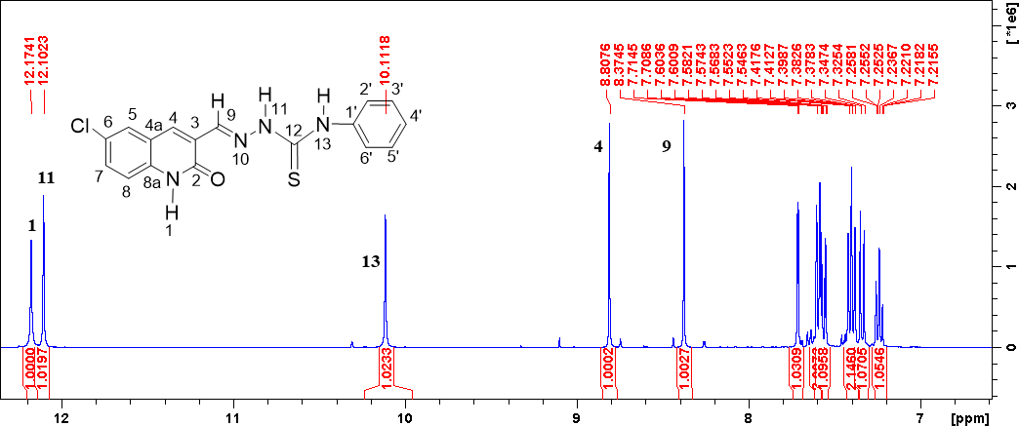

Figure S 55 1H NMR spectrum of 5n

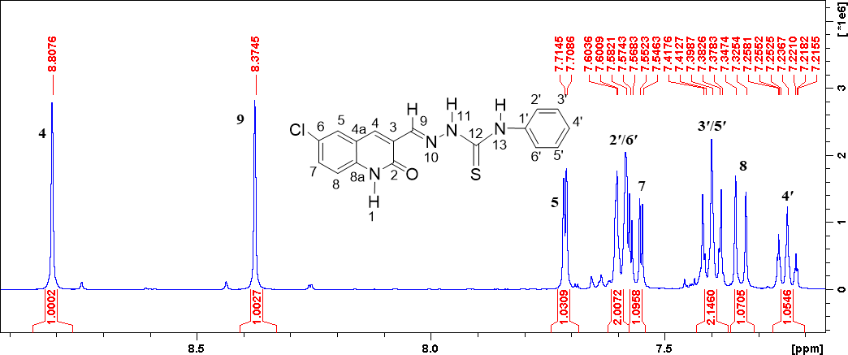
Figure S 56 Expanded 1H NMR spectrum of 5n

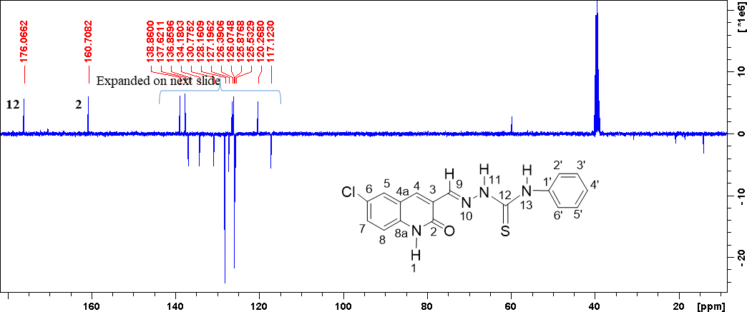
Figure S 57 13C NMR spectrum of 5n

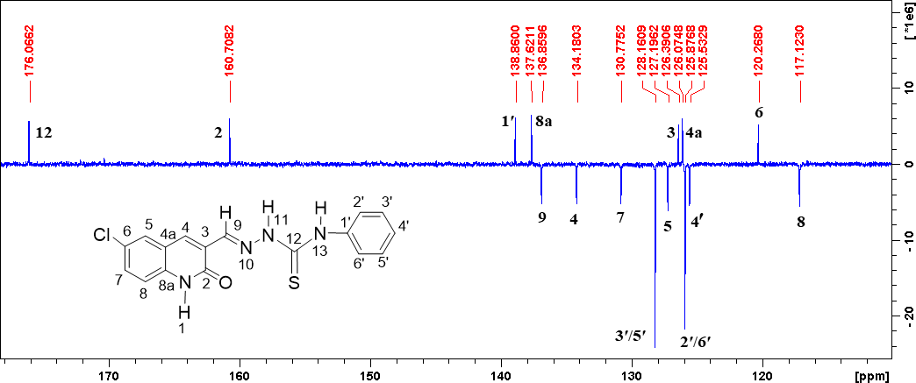
Figure S 58 Expanded 13C NMR spectrum of 5n

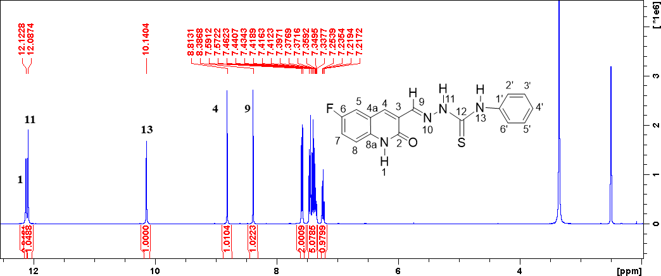

Figure S 59 1H NMR spectrum of 5o

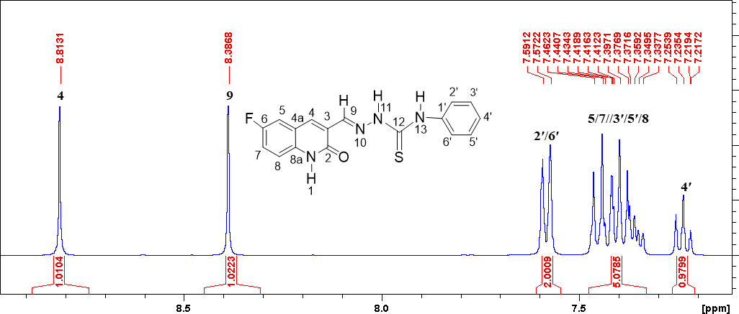
Figure S 60 Expanded 1H NMR spectrum of 5o

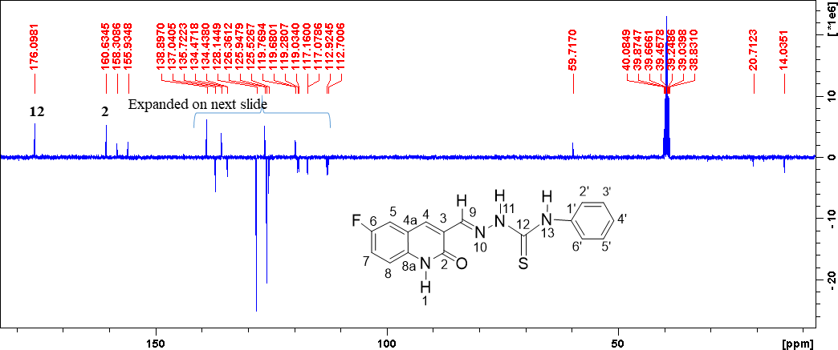

Figure S 61 13C NMR spectrum of 5o

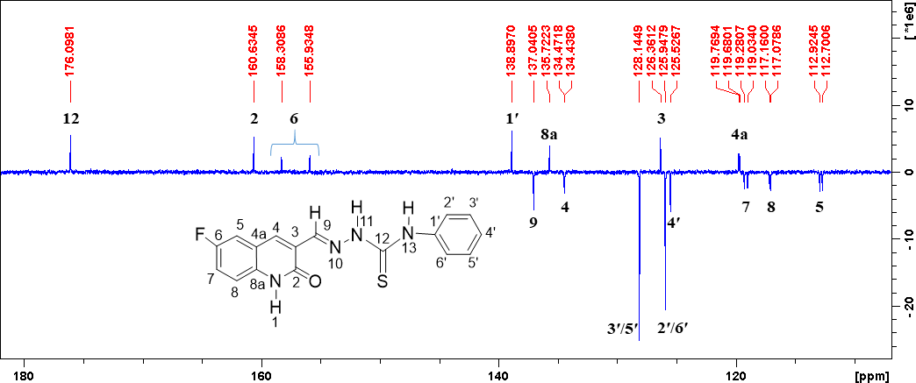
Figure S 62 Expanded 13C NMR spectrum of 5o

