**Appendix S1**

|  |  |  |  |  |  |  |  |  |  |  |  |  |  |  |  |  |  |  |  |  |  |  |  |  |  |  |  |  |  |  |  |  |  |  |  |  |  |  |  |  |  |  |  |  |  |  |
| --- | --- | --- | --- | --- | --- | --- | --- | --- | --- | --- | --- | --- | --- | --- | --- | --- | --- | --- | --- | --- | --- | --- | --- | --- | --- | --- | --- | --- | --- | --- | --- | --- | --- | --- | --- | --- | --- | --- | --- | --- | --- | --- | --- | --- | --- | --- |
| **Table S1**: Environmental variables used to build the models (highlighted ones were removed, after applying Variance Inflation Factor (VIF) to reduce the collinearity).   |  |  | | --- | --- | | BIO1 | Annual Mean Temperature | | BIO2 | Mean Diurnal Range (Mean of monthly (max temp - min temp)) | | BIO3 | Isothermality (BIO2/BIO7) (* 100) | | BIO4 | Temperature Seasonality (standard deviation *100) | | BIO5 | Max Temperature of Warmest Month | | BIO6 | Min Temperature of Coldest Month | | BIO7 | Temperature Annual Range (BIO5-BIO6) | | BIO8 | Mean Temperature of Wettest Quarter | | BIO9 | Mean Temperature of Driest Quarter | | BIO10 | Mean Temperature of Warmest Quarter | | BIO11 | Mean Temperature of Coldest Quarter | | BIO12 | Annual Precipitation | | BIO13 | Precipitation of Wettest Month | | BIO14 | Precipitation of Driest Month | | BIO15 | Precipitation Seasonality (Coefficient of Variation) | | BIO16 | Precipitation of Wettest Quarter | | BIO17 | Precipitation of Driest Quarter | | BIO18 | Precipitation of Warmest Quarter | | BIO19 | Precipitation of Coldest Quarter | | Altitude | Altitude | | Habitat | Habitat | | NDVI_Max | NDVI maximum value | | NDVI_Difference | Absolute difference between the highest and lowest NDVI values | |

**Table S2**: Species weighting based on different kind of scoring.

|  |  |
| --- | --- |
| **Species world distribution** | **Score** |
| Widespread | 1 |
| Narrow | 2 |
| Restricted | 3 |
| Endemic/ Near Endemic | 4 |

|  |  |
| --- | --- |
| **Species distribution within Egypt** | **Score** |
| Widespread | 1 |
| Narrow | 2 |
| Localized | 3 |
| Endemic/ Near Endemic | 4 |

|  |  |
| --- | --- |
| **National IUCN status (based on model)** | **Score** |
| Least Concern | 1 |
| Near Threatened | 2 |
| Vulnerable | 3 |
| Endangered | 4 |
| Critically Endangered | 5 |

Current



2020 2050 2080

2020 2050 2080

A2a

B2a

**Fig. S1**: Conservation prioritization ranked values using ‘Additive Benefit Function’ removal rule for current and future scenarios assuming no dispersal without using a cost layer. The colour run from red (high) to blue (low) conservation value.

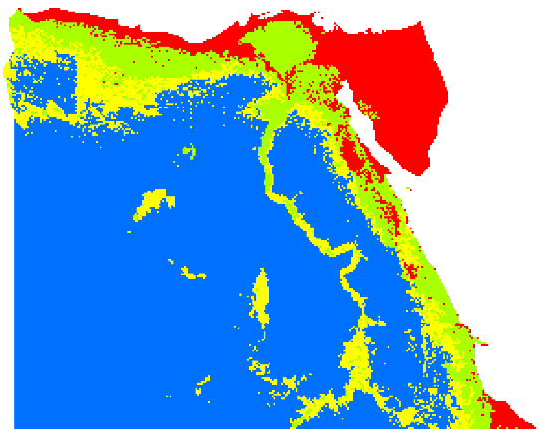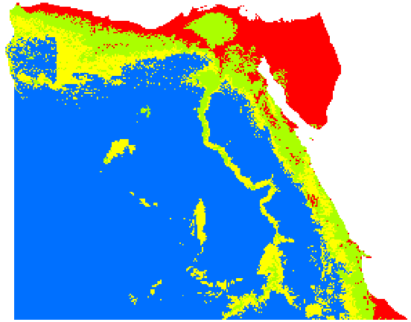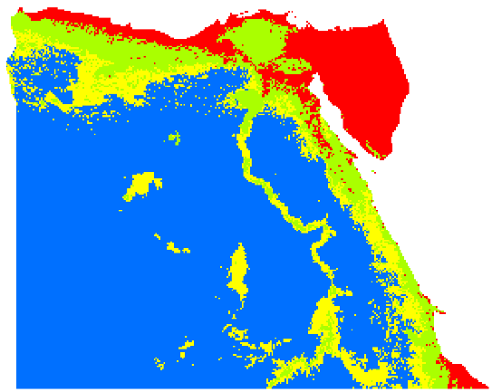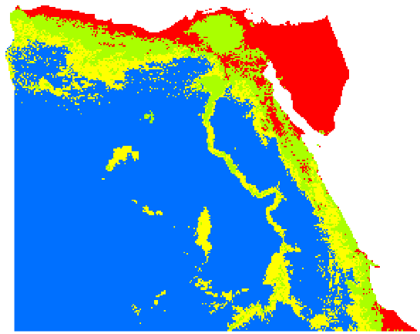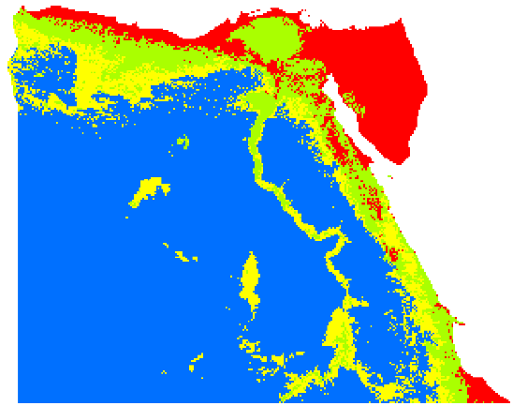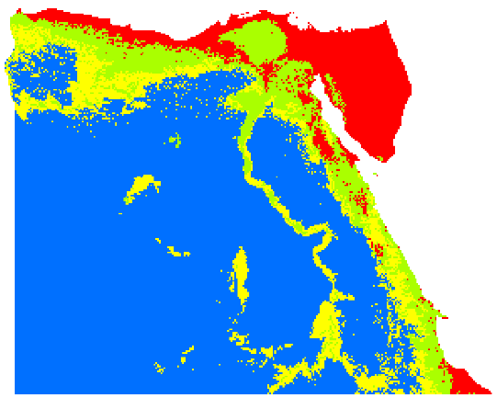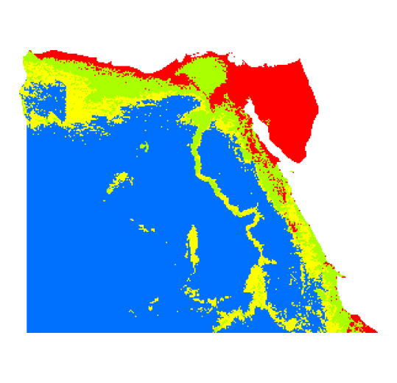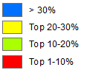

**Fig. S2**: Conservation prioritization ranked values using ‘Core – Area Zonation’ removal rule for current and future scenarios assuming no dispersal without using a cost layer. The colour run from red (high) to blue (low) conservation value.

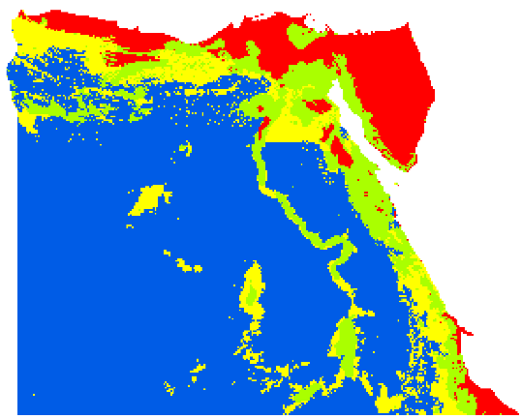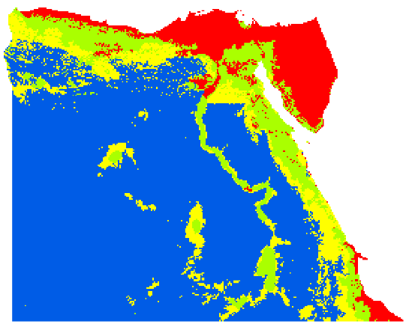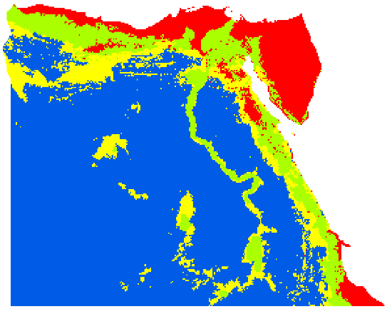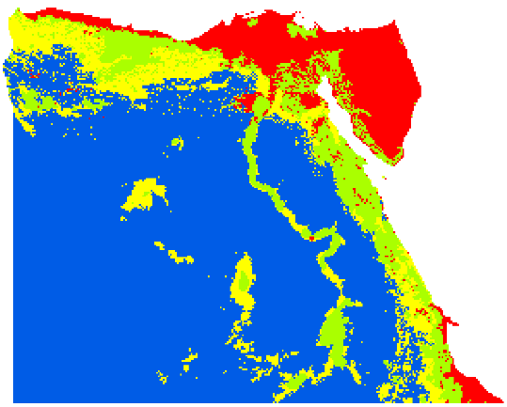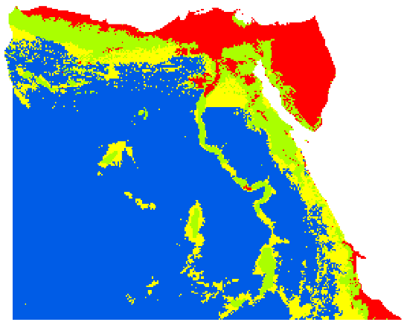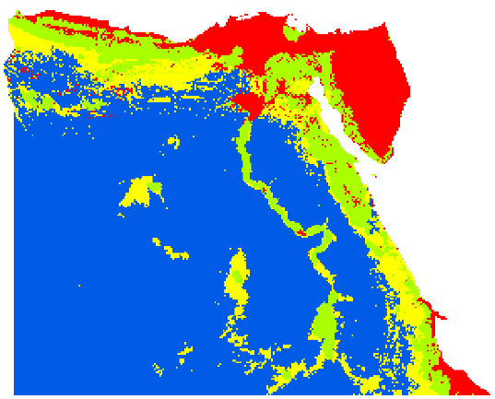

2020 2050 2080

2020 2050 2080

Current

A2a

B2a

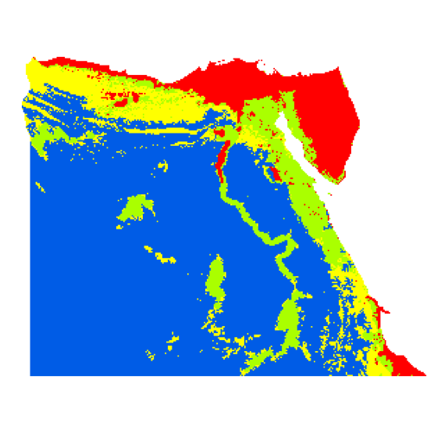

2020 2050 2080

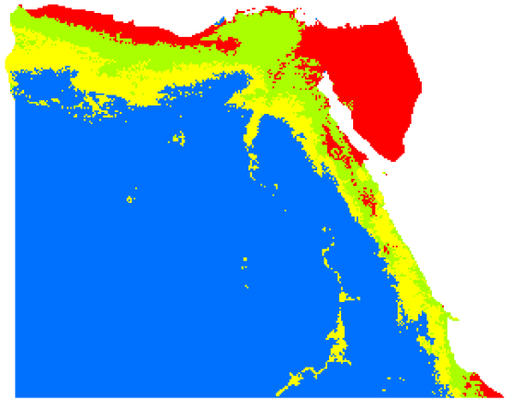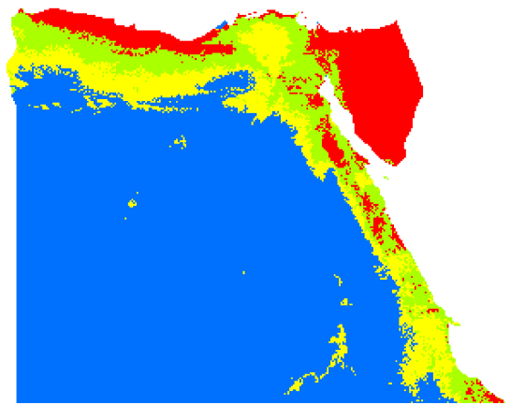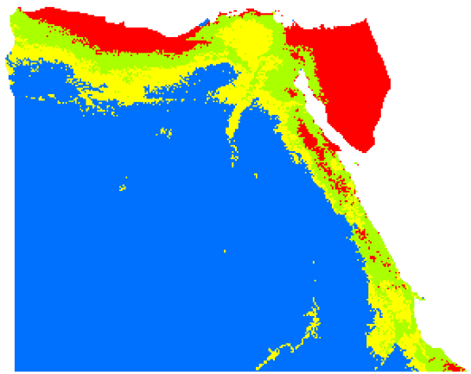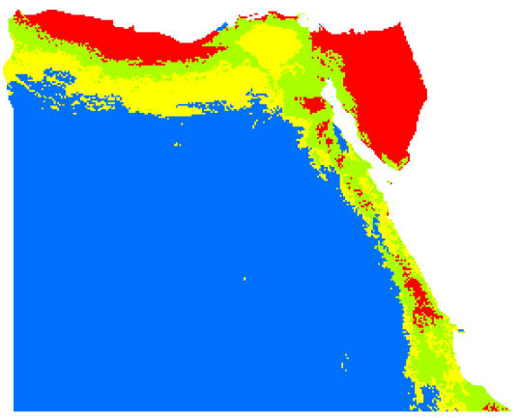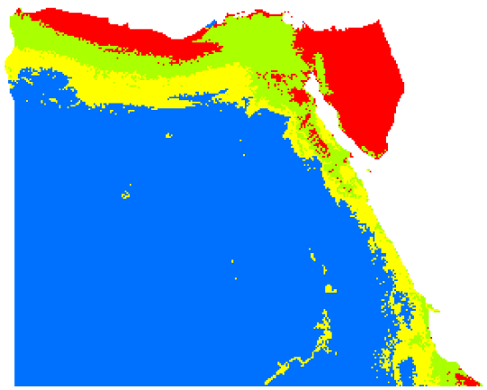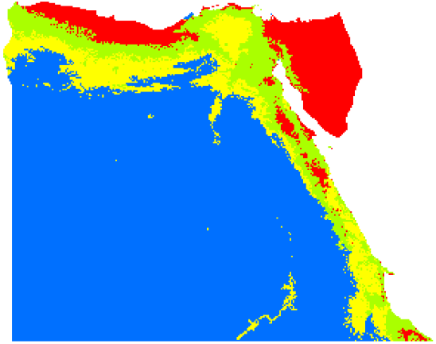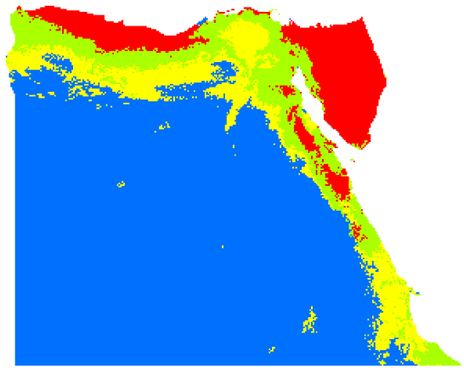

**Fig. S3**: Conservation prioritization ranked values using ‘Additive Benefit Function’ removal rule for current and future scenarios assuming unlimited dispersal using population density as a cost layer. The colour run from red (high) to blue (low) conservation value.

2020 2050 2080

Current

A2a

B2a



2020 2050 2080

2020 2050 2080

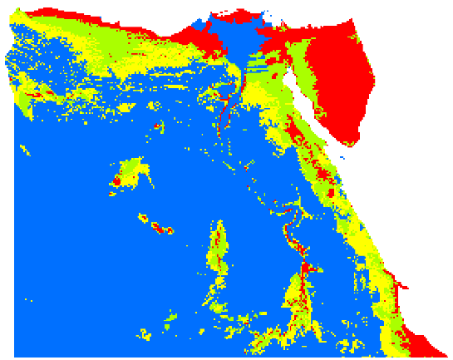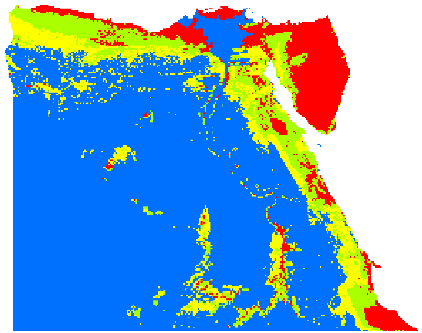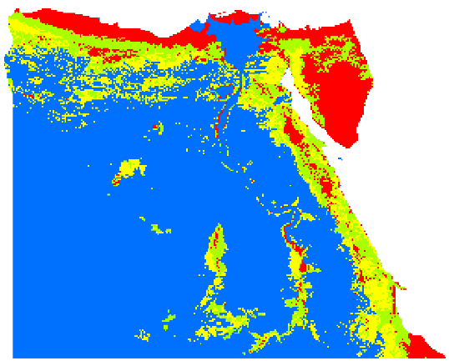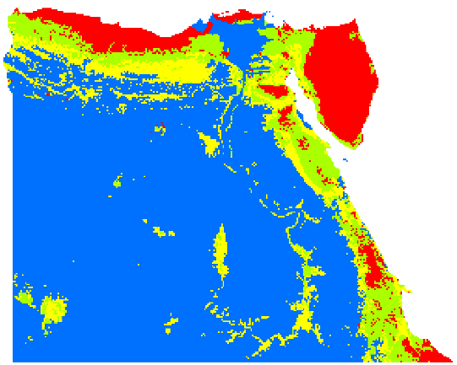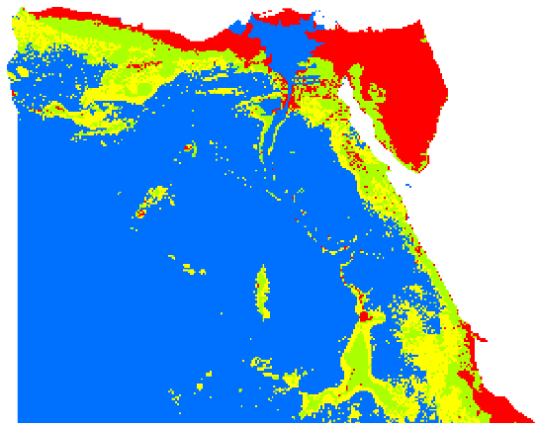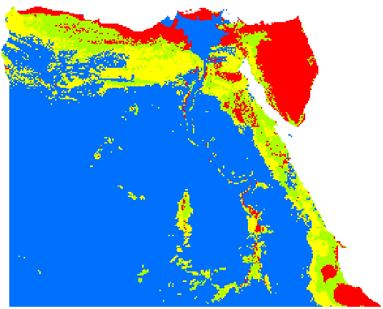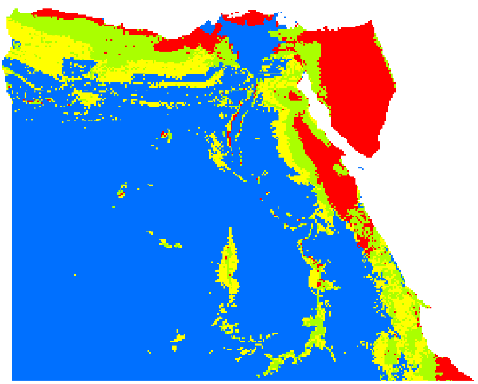

**Fig. S4**: Conservation prioritization ranked values using ‘Core – Area Zonation’ removal rule for current and future scenarios assuming unlimited dispersal using population density as a cost layer. The colour run from red (high) to blue (low) conservation value.

Current

A2a

B2a



**Fig. S5**: Conservation prioritization ranked values using ‘Additive Benefit Function’ removal rule for current and future scenarios assuming no dispersal using HII as a cost layer. The colour ramp goes from red (high) to blue (low) conservation value.

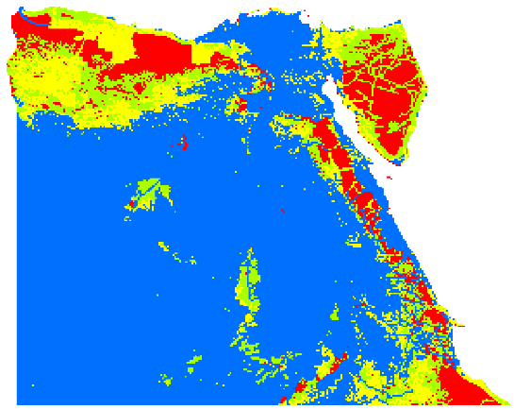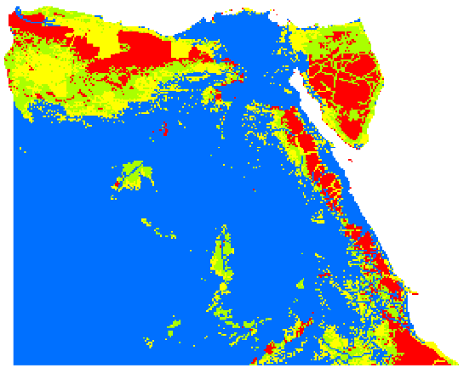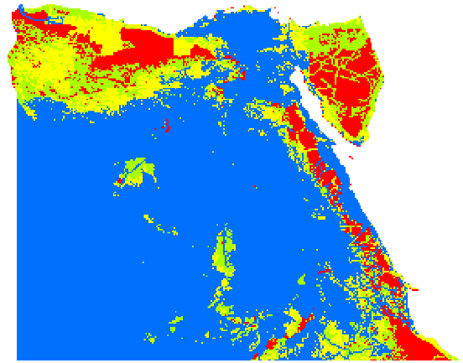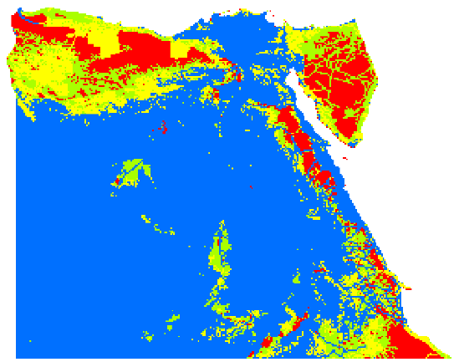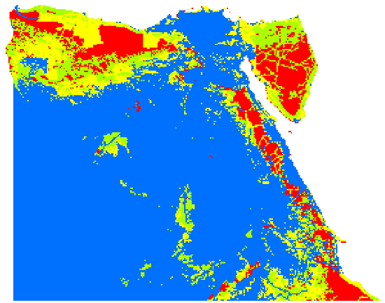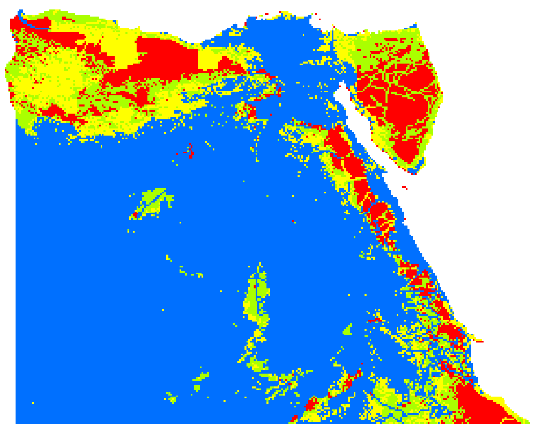

2020 2050 2080

2020 2050 2080

Current

A2a

B2a

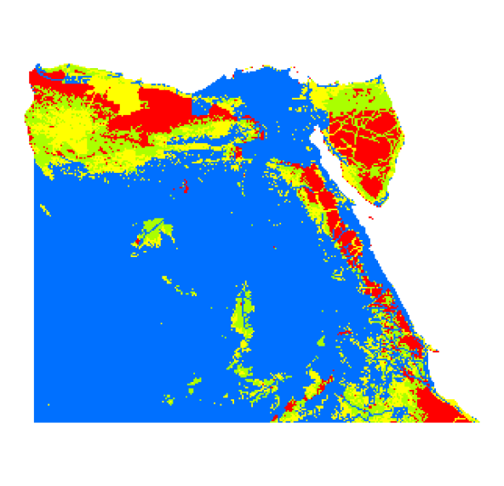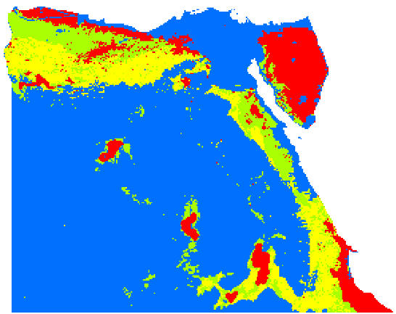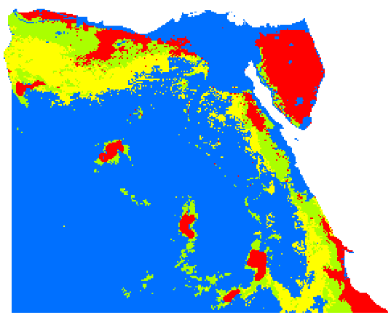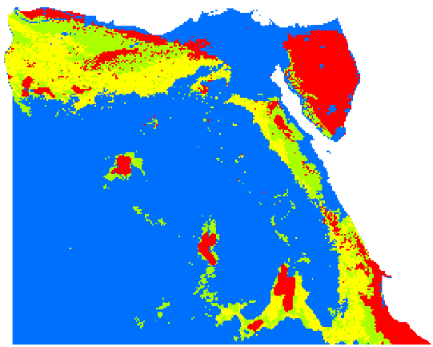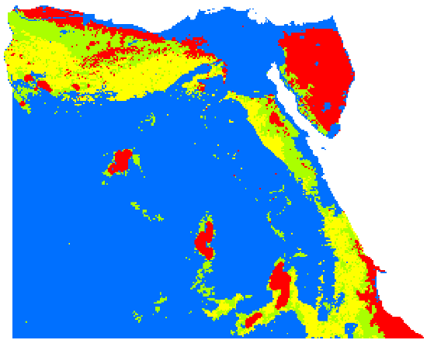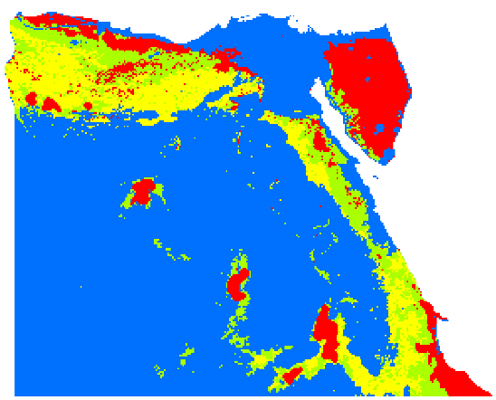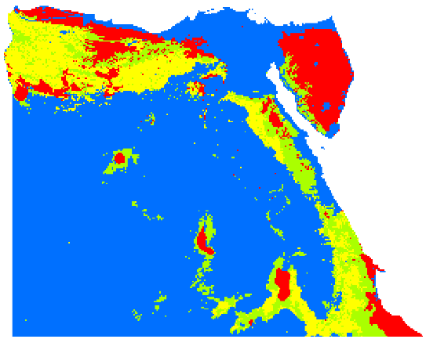

2020 2050 2080

2020 2050 2080

**Fig. S6**: Conservation prioritization ranked values using ‘Core – Area Zonation’ removal rule for current and future scenarios assuming no dispersal using HII as a cost layer. The colour run from red (high) to blue (low) conservation value.

Current

A2a

B2a

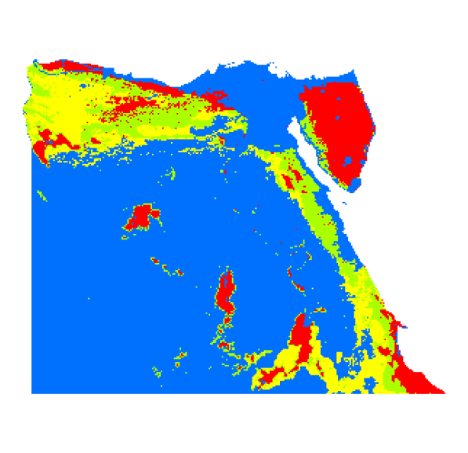

**Fig. S7**: Conservation prioritization ranked values using ‘Additive Benefit Function’ removal rule for current and future scenarios assuming no dispersal using population density as a cost layer. The colour run from red (high) to blue (low) conservation value.

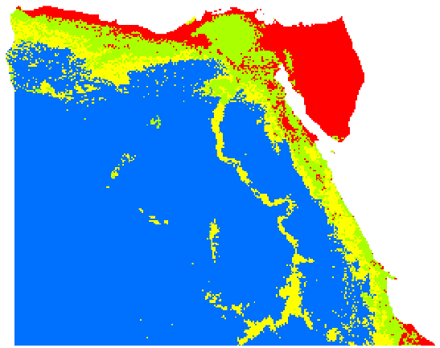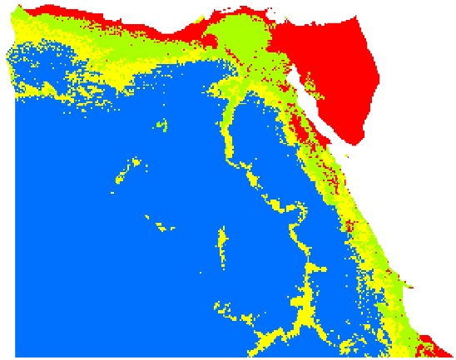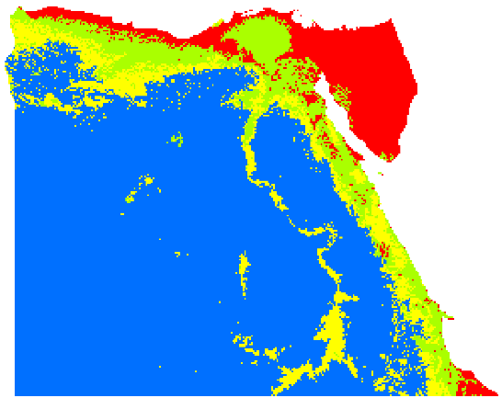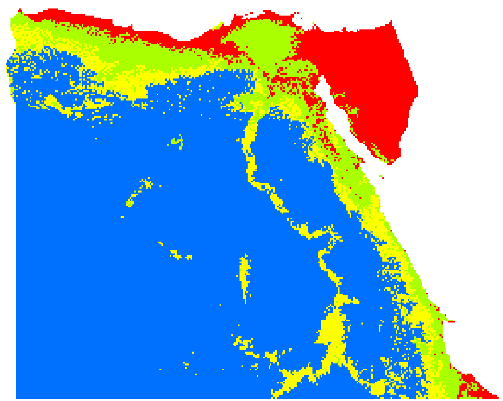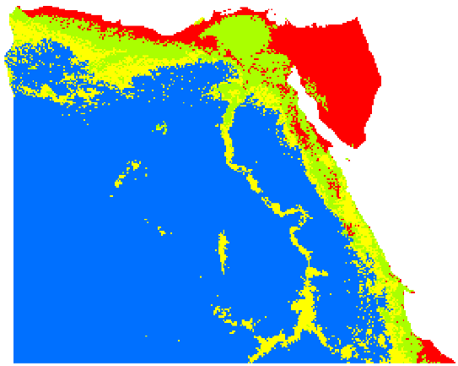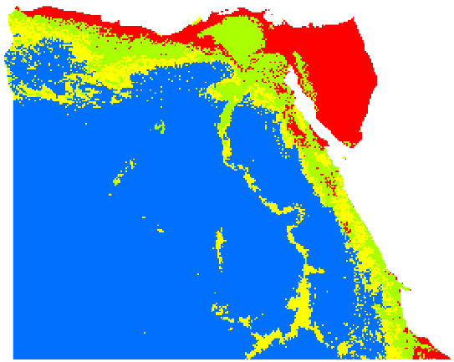

Current

A2a

B2a

2020 2050 2080

2020 2050 2080

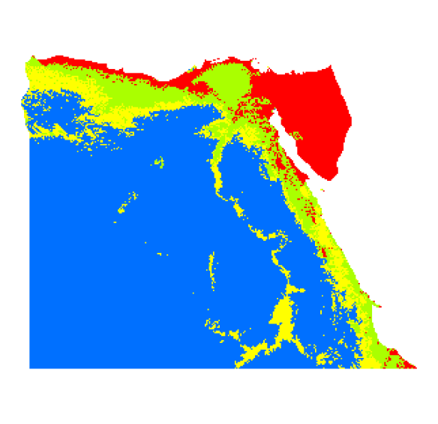

2020 2050 2080

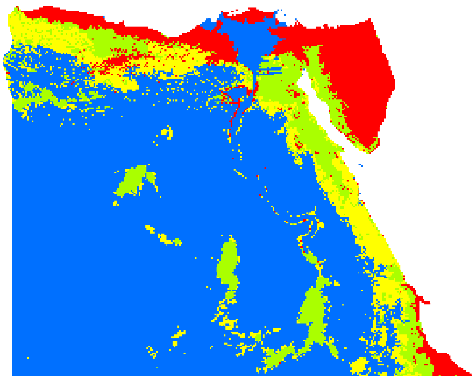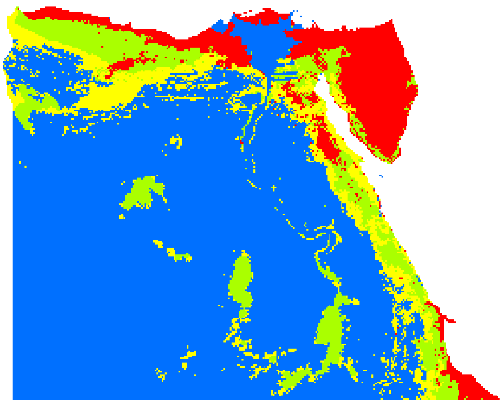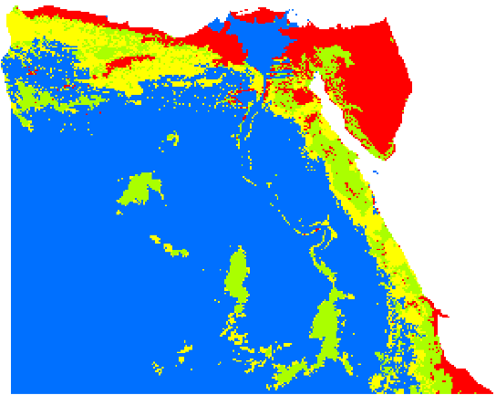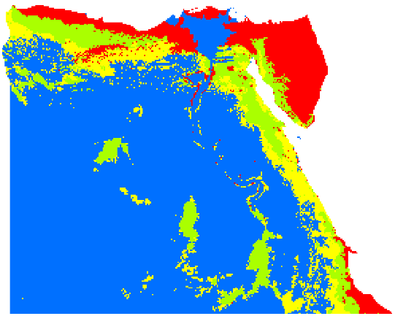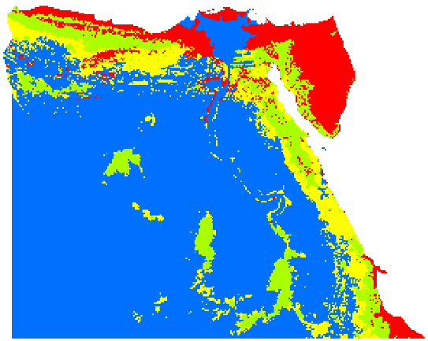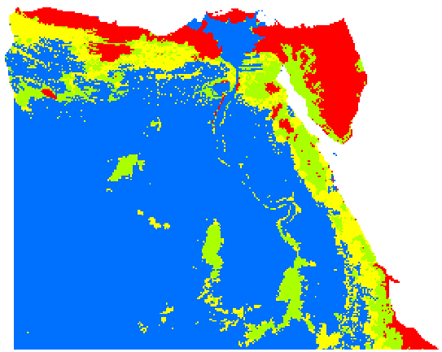

2020 2050 2080

Current

A2a

B2a



**Fig. S8**: Conservation prioritization ranked values using ‘Core – Area Zonation’ removal rule for current and future scenarios assuming no dispersal using population density as a cost layer. The colour run from red (high) to blue (low) conservation value.

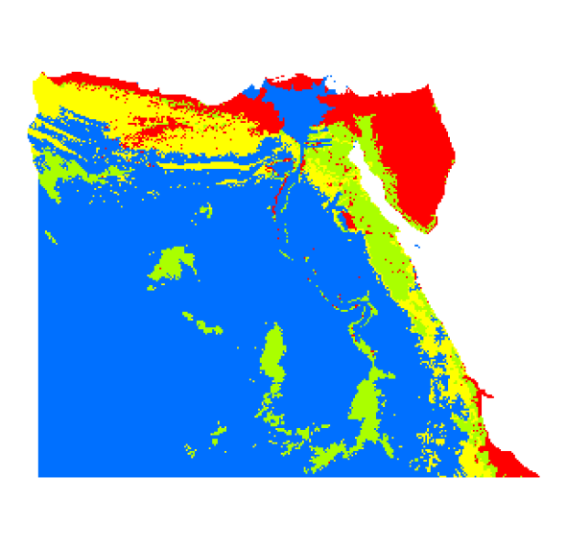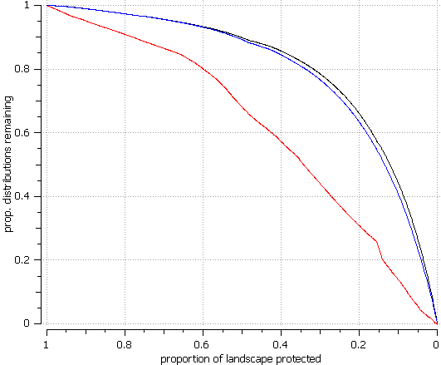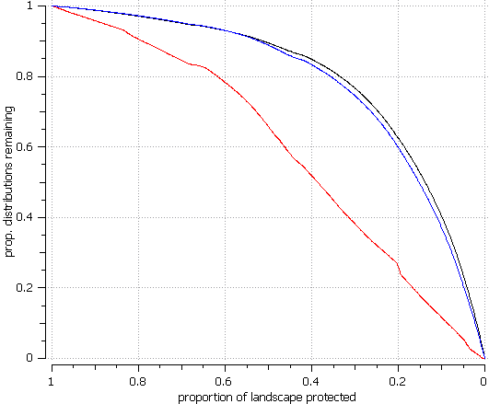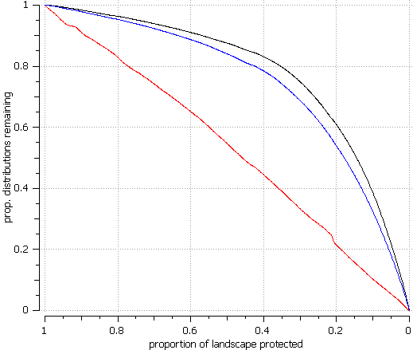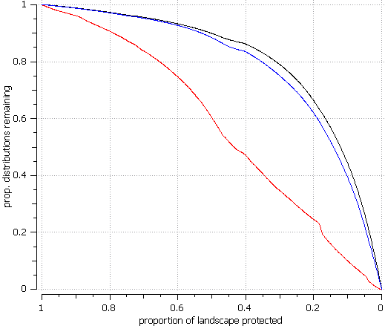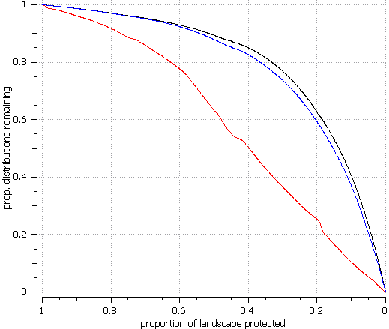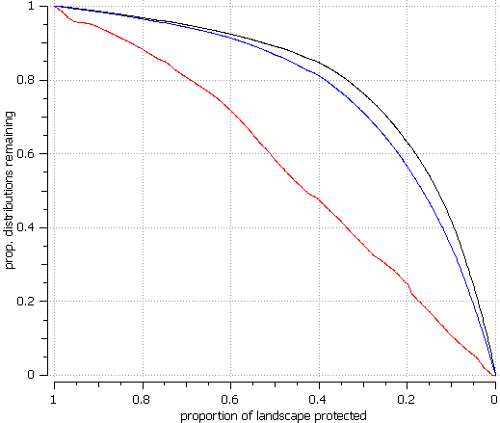

2020 2050 2080

2020 2050 2080

Current

A2a

B2a

**Fig. S9**: The curve performance showing the proportion of species distribution preserved for ‘Additive Benefit Function’ removal rule, comparing current and future times assuming unlimited dispersal.

Average of species retained when weighted

Average of species retained when not weighted

Average of minimum proportion retained

Current

A2a

2020 2050 2080

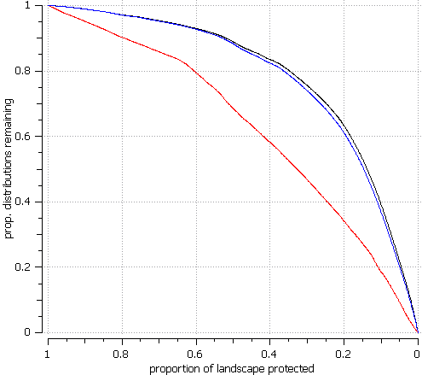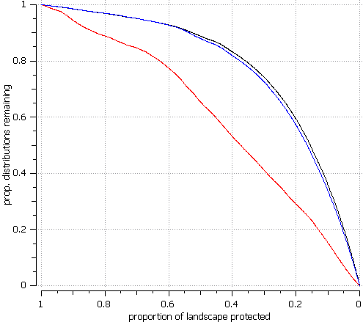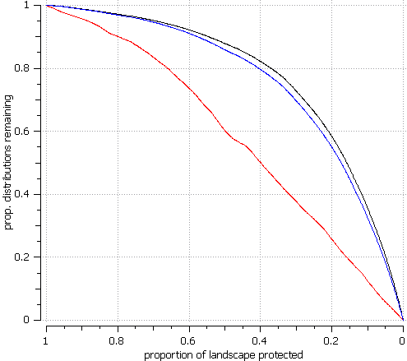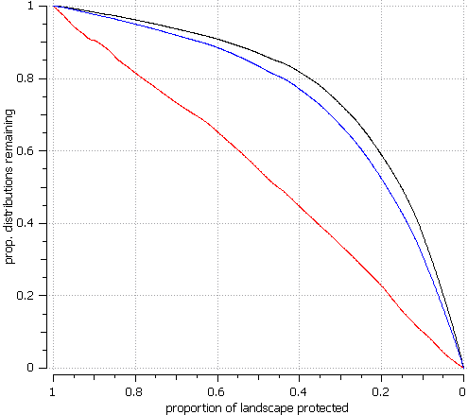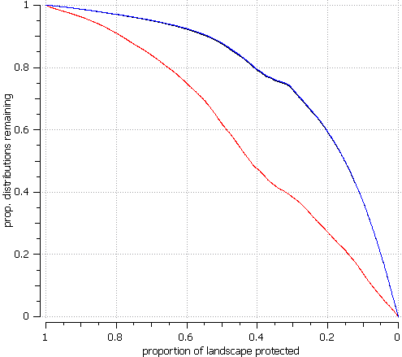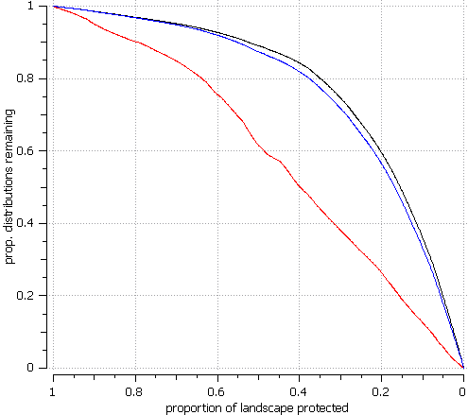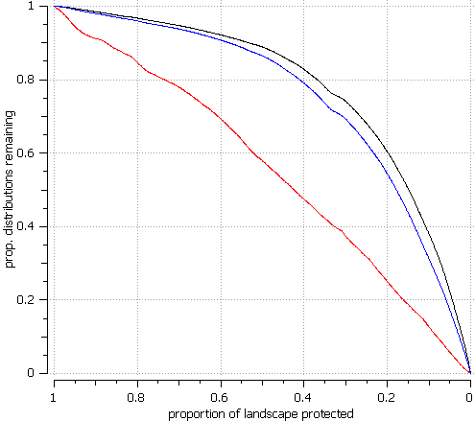

2020 2050 2080

B2a

**Fig. S10**: The curve performance showing the proportion of species distribution preserved for ‘Core – Area Zonation’ removal rule, comparing current and future times assuming unlimited dispersal.

Average of species retained when weighted

Average of species retained when not weighted

Average of minimum proportion retained

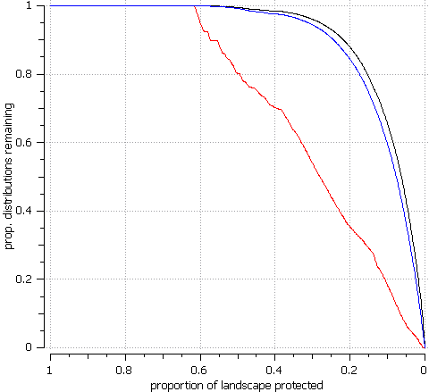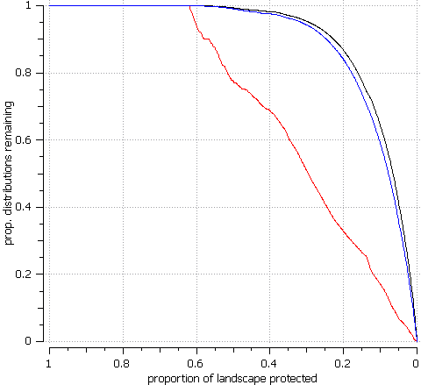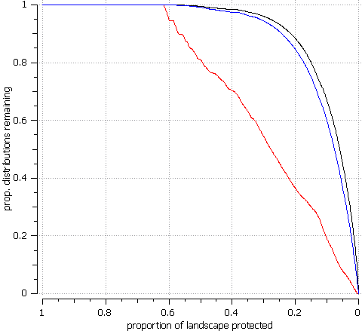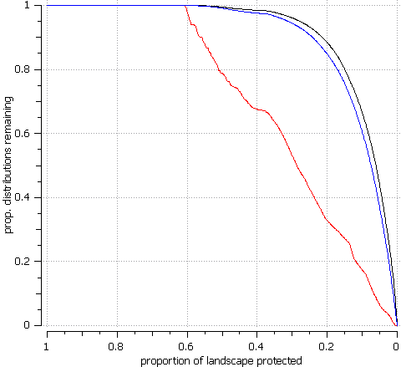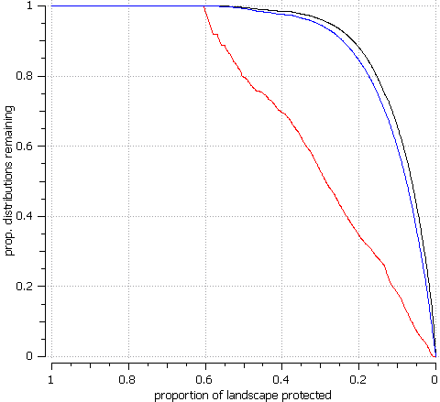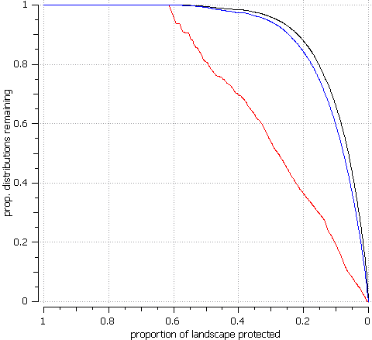

2020 2050 2080

2020 2050 2080

**Fig. S11**: The curve performance showing the proportion of species distribution preserved for ‘Additive Benefit Function’ removal rule, comparing current and future times assuming no dispersal.

Average of species retained when weighted

Average of species retained when not weighted

Average of minimum proportion retained

Current

A2a

B2a

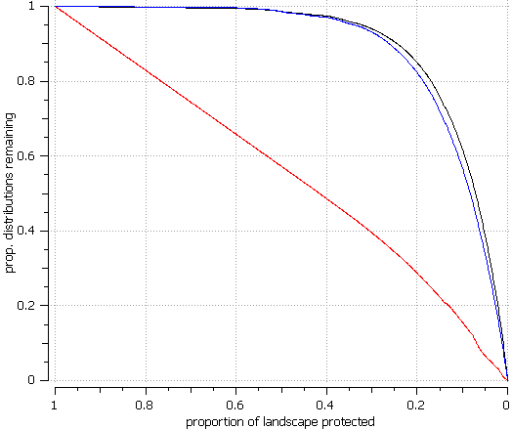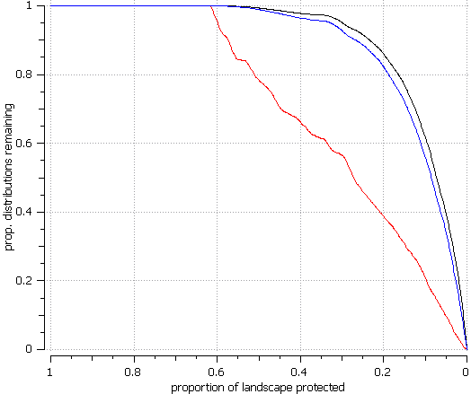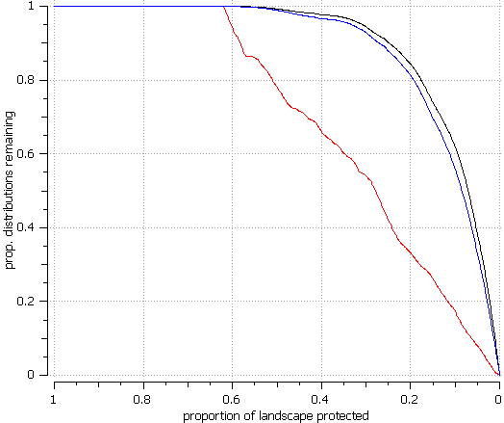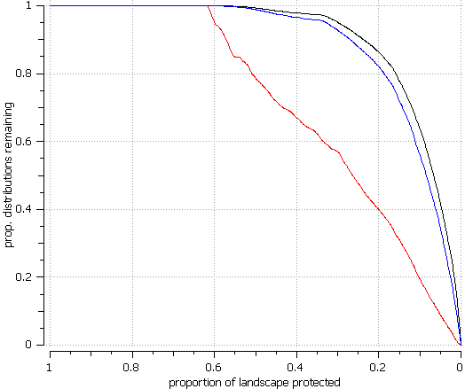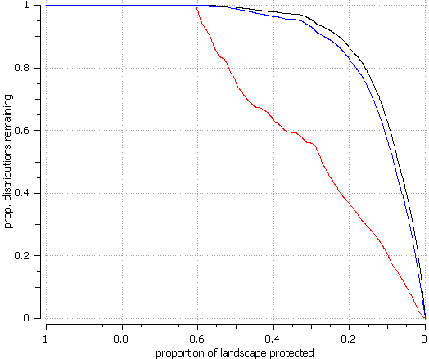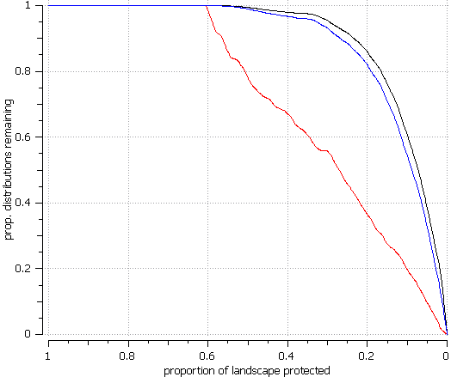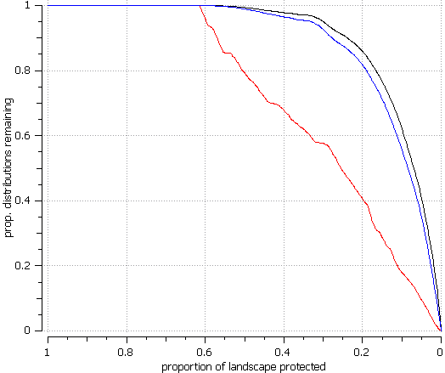

2020 2050 2080

2020 2050 2080

**Fig. S12**: The curve performance showing the proportion of species distribution preserved for ‘Core – Area Zonation’ removal rule, comparing current and future times assuming no dispersal.

Average of species retained when weighted

Average of species retained when not weighted

Average of minimum proportion retained

Current

A2a

B2a

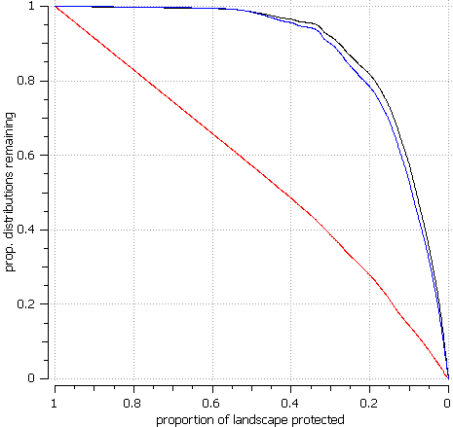

2020 2050 2080

2020 2050 2080

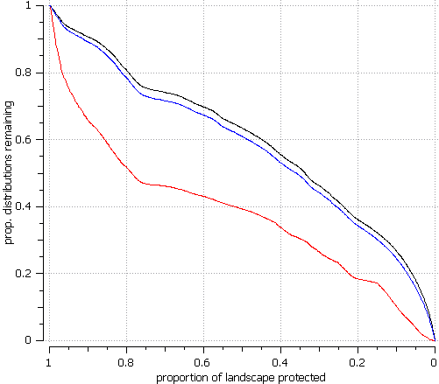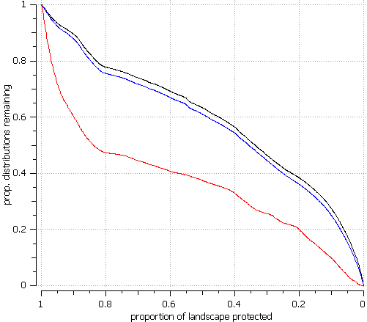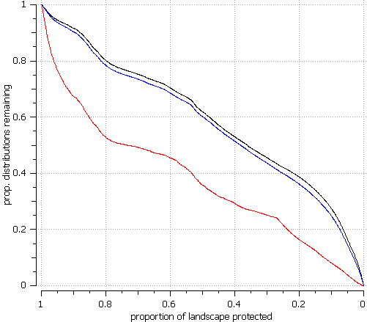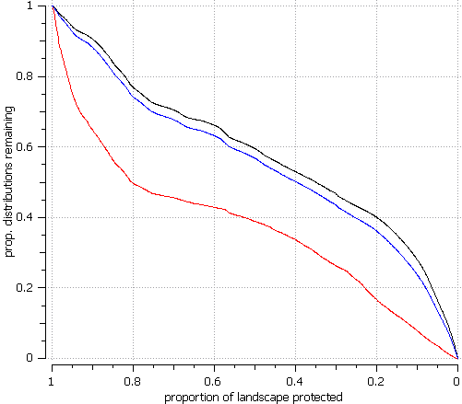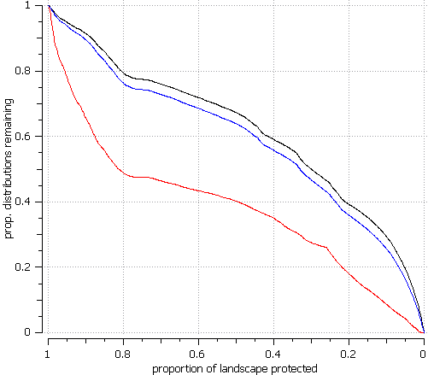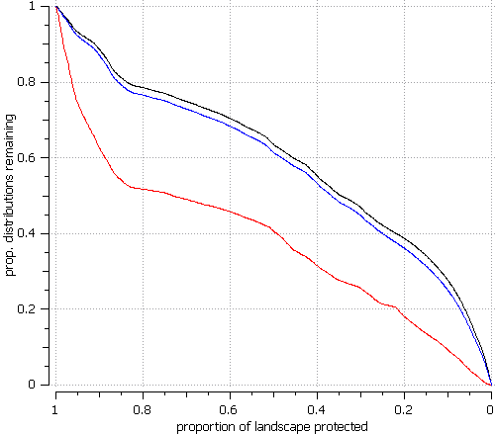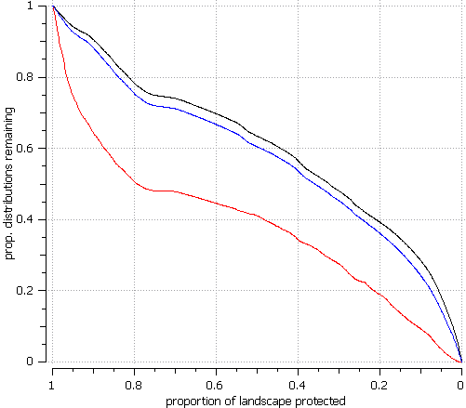

**Fig. S13**: The curve performance showing the proportion of species distribution preserved for ‘Additive Benefit Function’ removal rule, comparing current and future times assuming unlimited dispersal using HII as a cost layer.

Average of species retained when weighted

Average of species retained when not weighted

Average of minimum proportion retained

Current

A2a

B2a

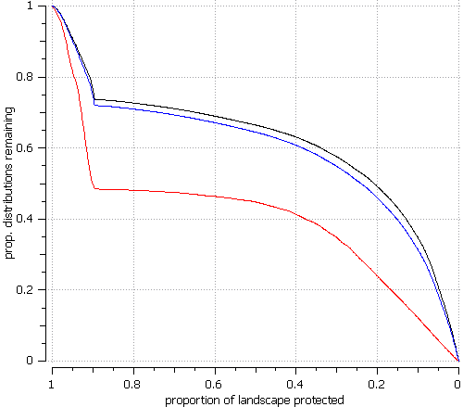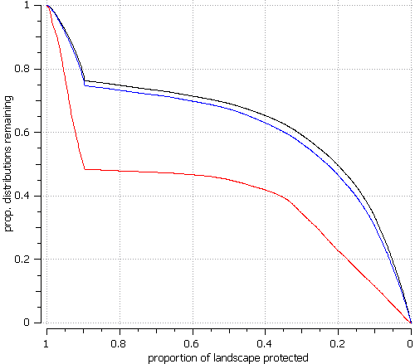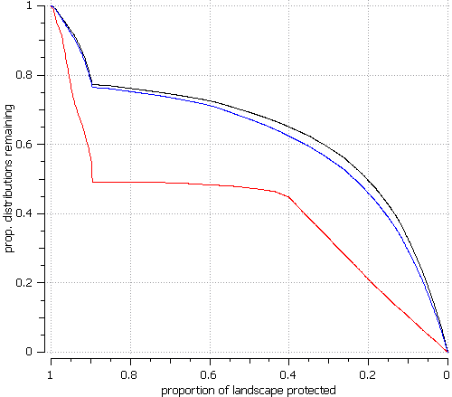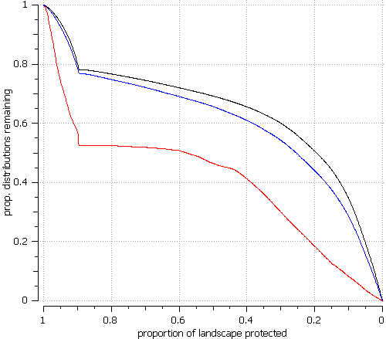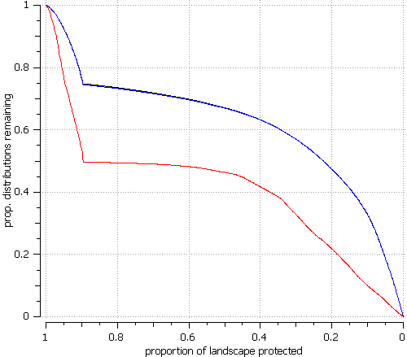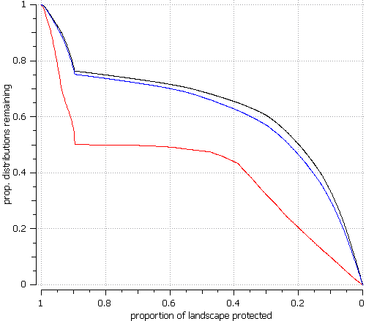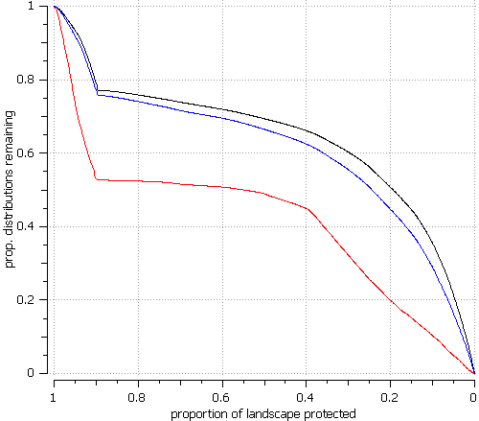

2020 2050 2080

2020 2050 2080

**Fig. S14**: The curve performance showing the proportion of species distribution preserved for ‘Core – Area Zonation’ removal rule, comparing current and future times assuming unlimited dispersal using HII as a cost layer.

Average of species retained when weighted

Average of species retained when not weighted

Average of minimum proportion retained

Current

A2a

B2a

Average of species retained when weighted weighted

Average of species retained when not weighted

Average of minimum proportion retained

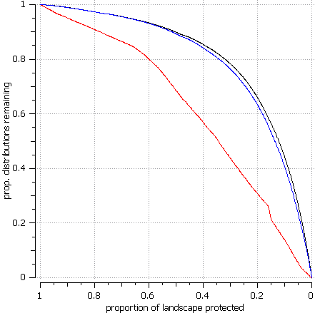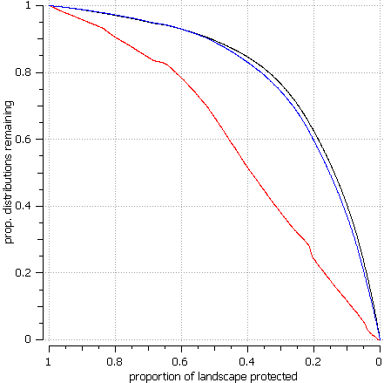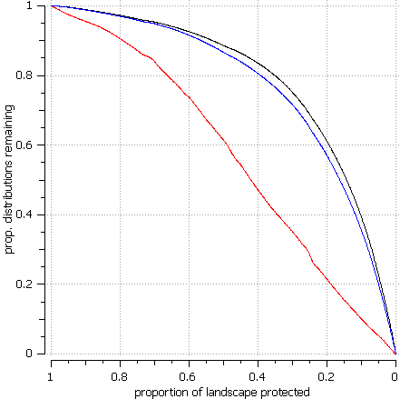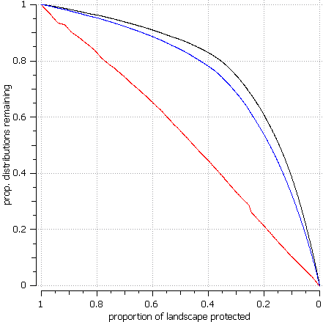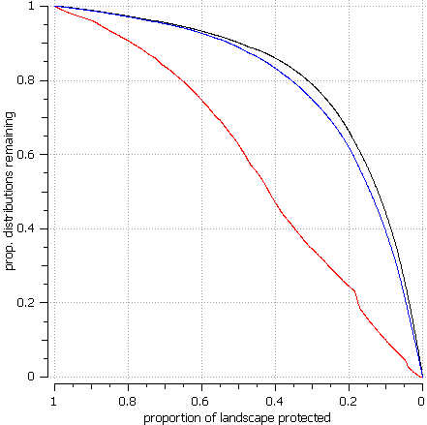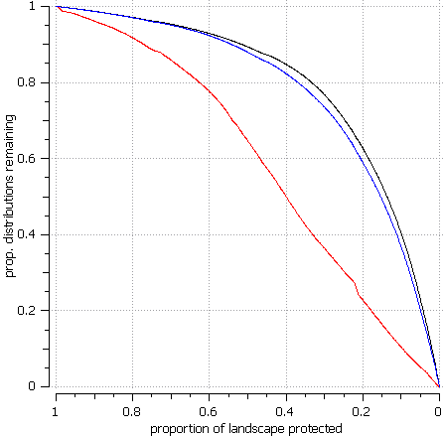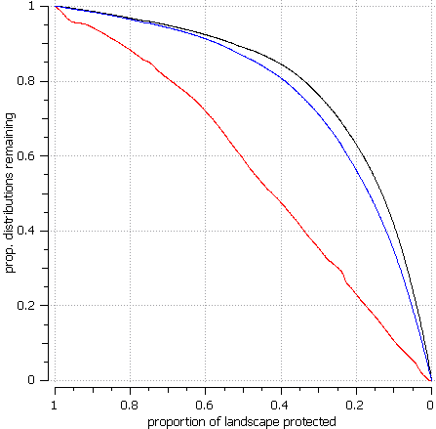

2020 2050 2080

2020 2050 2080

**Fig. S15**: The curve performance showing the proportion of species distribution preserved for ‘Additive Benefit Function’ removal rule, comparing current and future times assuming unlimited dispersal using population density as a cost layer.

Current

A2a

B2a

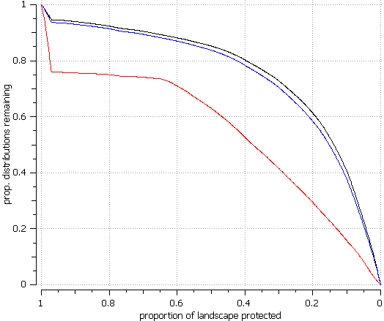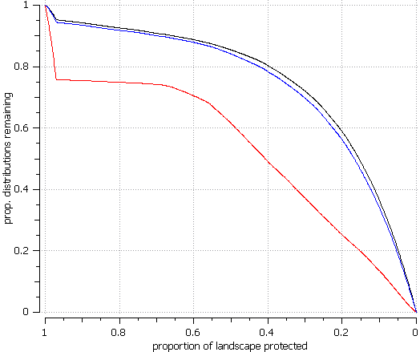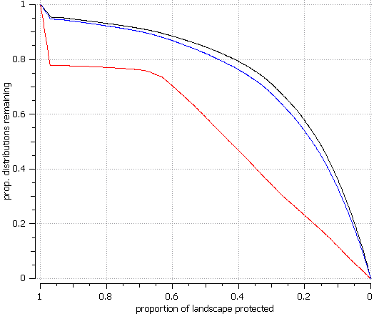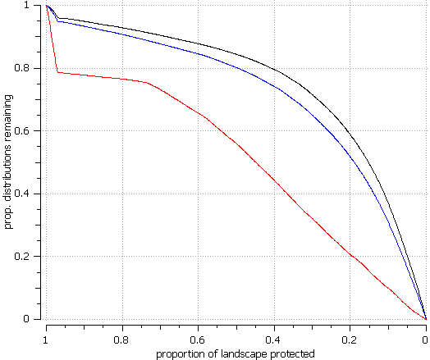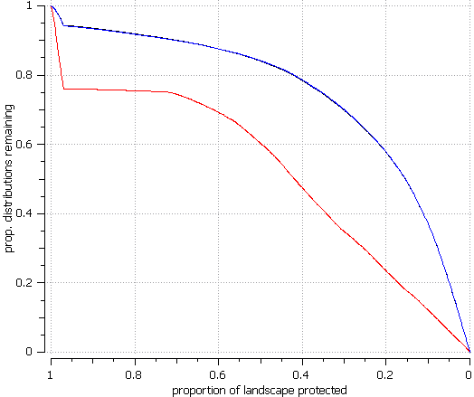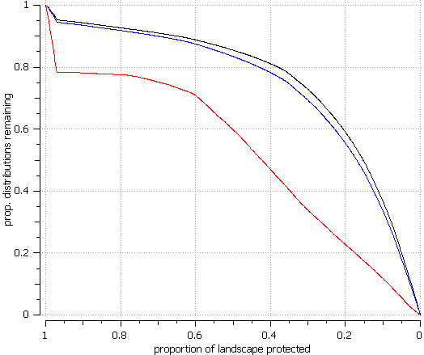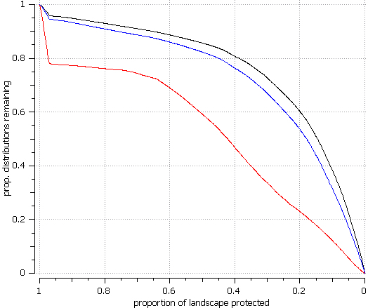

**Fig. S16**: The curve performance showing the proportion of species distribution preserved for ‘Core – Area Zonation’ removal rule, comparing current and future times assuming unlimited dispersal using population density as a cost layer.

2020 2050 2080

2020 2050 2080

Average of species retained when weighted

Average of species retained when not weighted

Average of minimum proportion retained

Current

A2a

B2a

A2a

2020 2050 2080

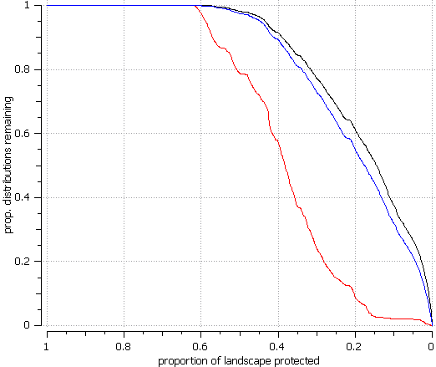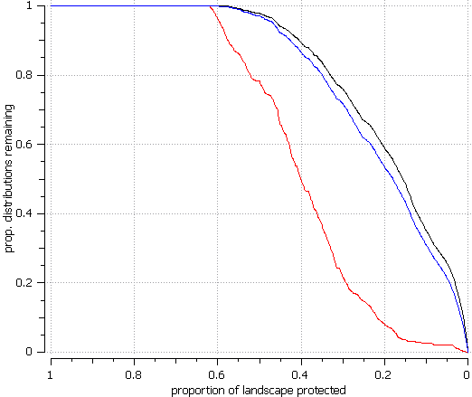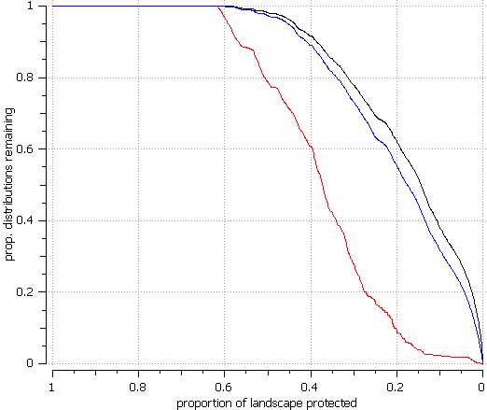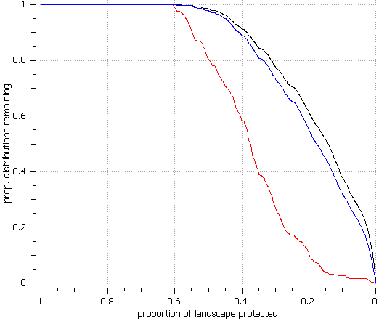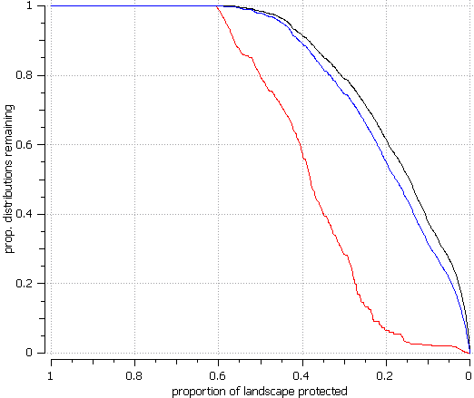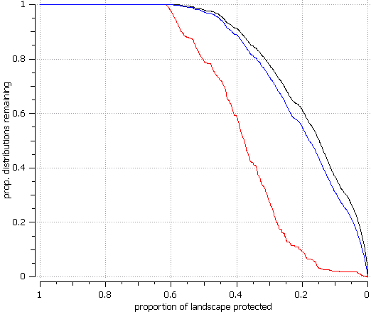

2020 2050 2080

**Fig. S17**: The curve performance showing the proportion of species distribution preserved for ‘Additive Benefit Function’ removal rule, comparing current and future times assuming no dispersal using HII as a cost layer.

Average of species retained when weighted

Average of species retained when not weighted

Average of minimum proportion retained

Current

B2a

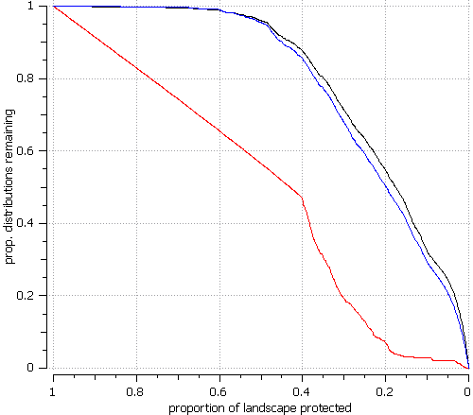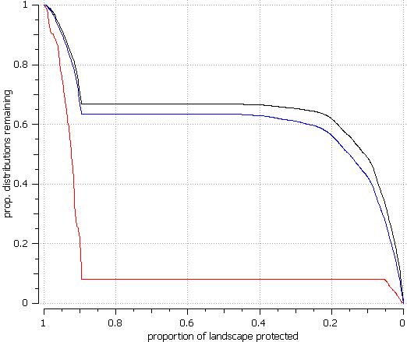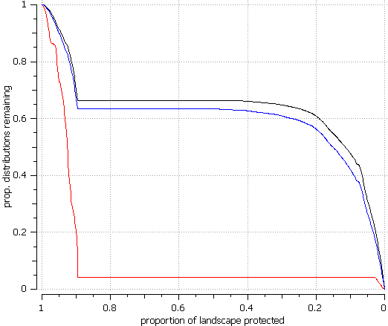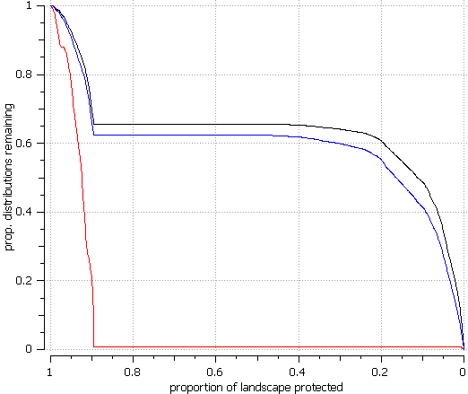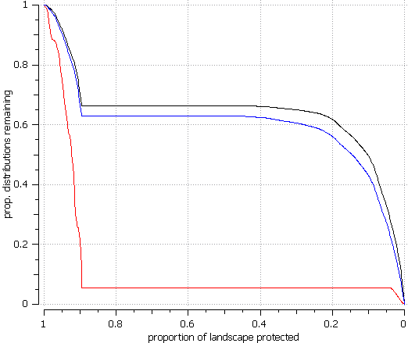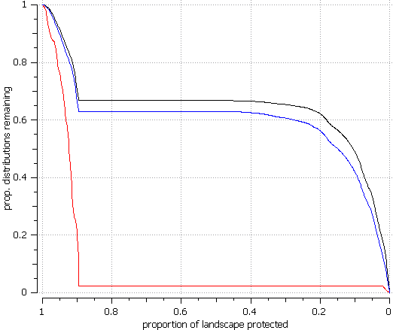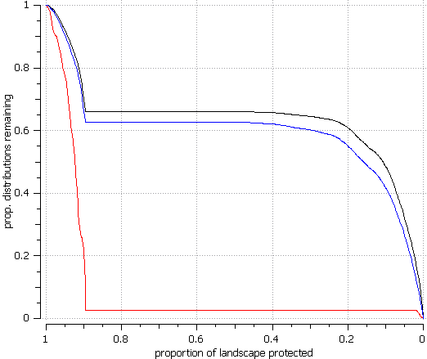

**Fig. S18**: The curve performance showing the proportion of species distribution preserved for ‘Core – Area Zonation’ removal rule, comparing current and future times assuming no dispersal using HII as a cost layer.

2020 2050 2080

2020 2050 2080

Current

A2a

B2a

Average of species retained when weighted

Average of species retained when not weighted

Average of minimum proportion retained

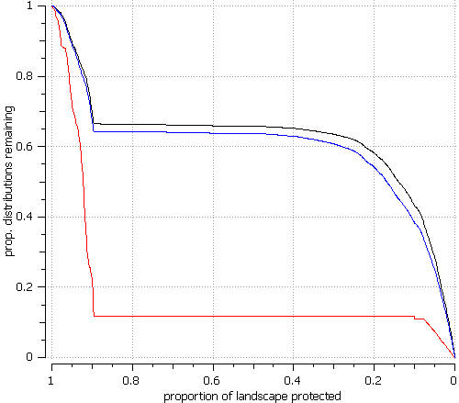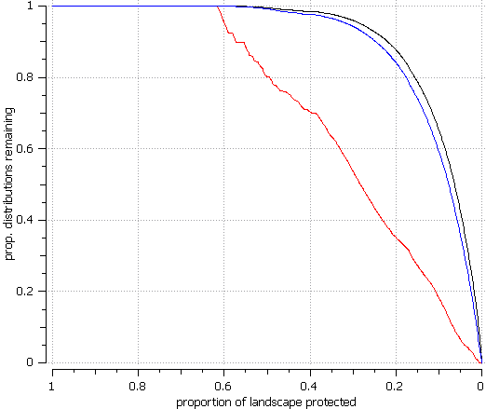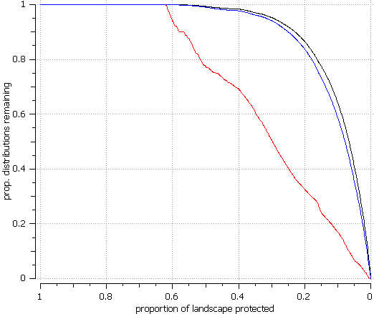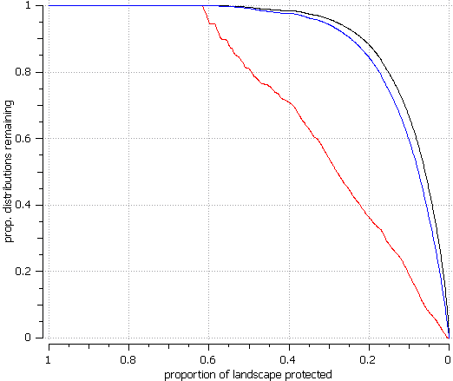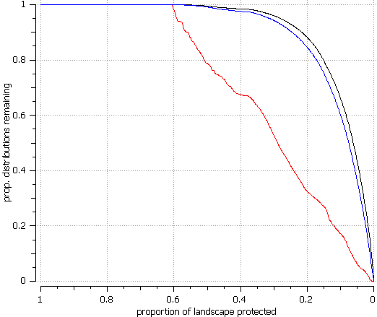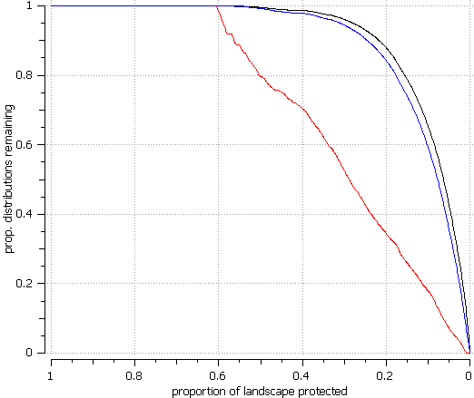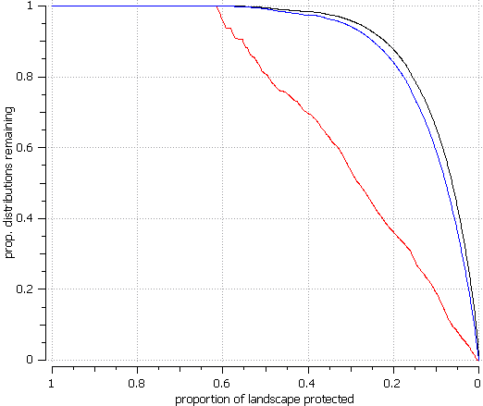

2020 2050 2080

2020 2050 2080

**Fig. S19**: The curve performance showing the proportion of species distribution preserved for ‘Additive Benefit Function’ removal rule, comparing current and future times assuming no dispersal using population density as a cost layer.

Average of species retained when weighted

Average of species retained when not weighted

Average of minimum proportion retained

Current

A2a

B2a

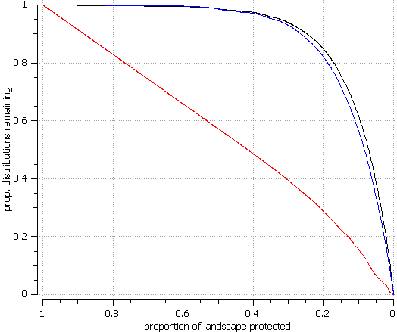

A2a

Current

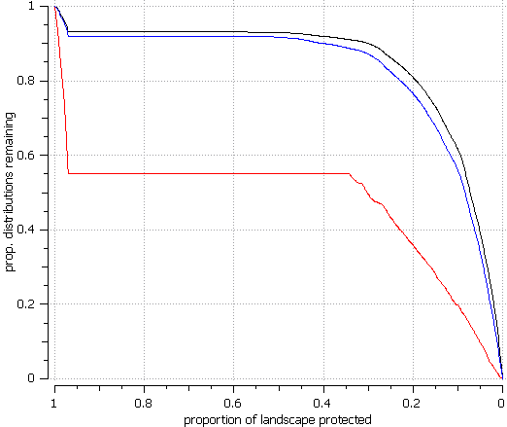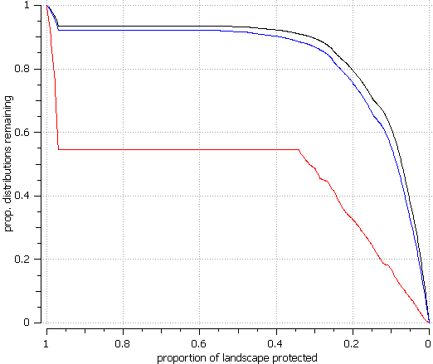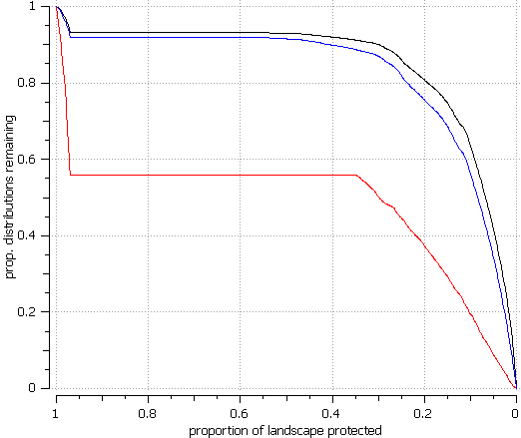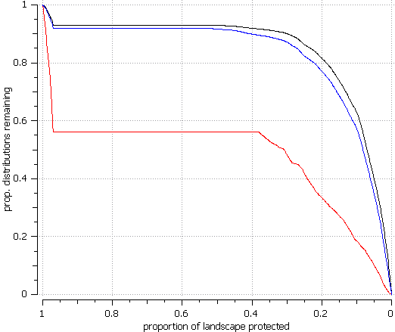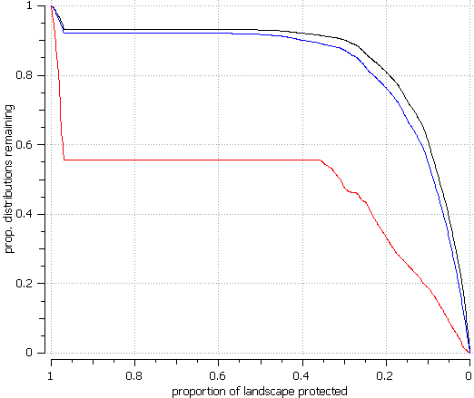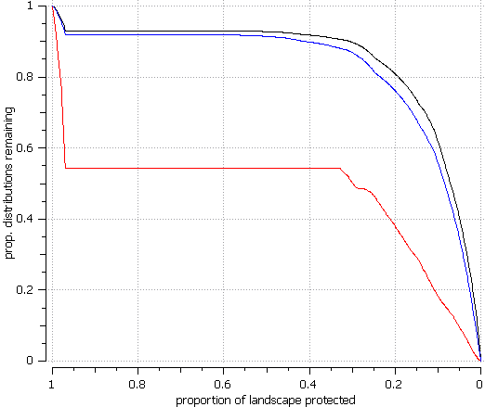

**Fig. S20**: The curve performance showing the proportion of species distribution preserved for ‘Core – Area Zonation’ removal rule, comparing current and future times assuming no dispersal using population density as a cost layer.

2020 2050 2080

2020 2050 2080

Average of species retained when weighted

Average of species retained when not weighted

Average of minimum proportion retained

B2a

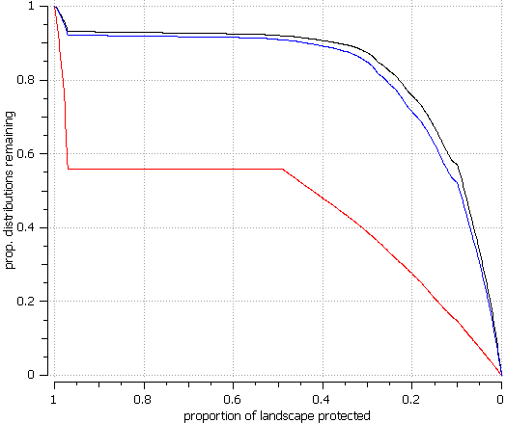

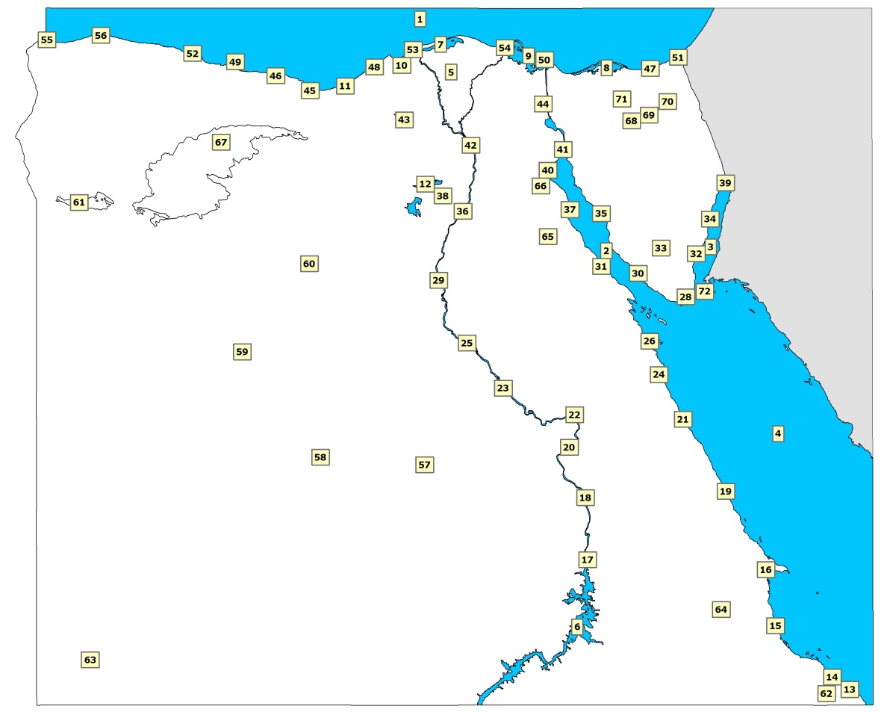

|  |  |  |  |  |  |  |  |
| --- | --- | --- | --- | --- | --- | --- | --- |
| **1** | The Mediterranean Sea |  | **25** | Assiut |  | **49** | Ras El-Hekma |
| **2** | The Suez Gulf |  | **26** | Hurghada |  | **50** | Port-Said |
| **3** | The Aqaba Gulf |  | **27** | Ras Mohamed |  | **51** | Rafah |
| **4** | The Red Sea |  | **28** | Sharm El-Sheikh |  | **52** | Mersa Matruh |
| **5** | The Nile Delta |  | **29** | El-Minia |  | **53** | Rosetta |
| **6** | Lake Nasser |  | **30** | El-Tur |  | **54** | Damietta |
| **7** | Lake Brullus |  | **31** | Ras Gharib |  | **55** | Sallum |
| **8** | Lake Bardawil |  | **32** | Dahab |  | **56** | Sidi Barrani |
| **9** | Lake Manzala |  | **33** | Saint-Katherine |  | **57** | Kharga oasis |
| **10** | Lake Idku |  | **34** | Nuweiba |  | **58** | Dakhla oasis |
| **11** | Lake Mariut |  | **35** | Abu Zneima |  | **59** | Farafra oasis |
| **12** | Lake Qarun |  | **36** | Beni Suef |  | **60** | Bahariya oasis |
| **13** | Halayeb |  | **37** | Ras Zaafarana |  | **61** | Siwa oasis |
| **14** | Abu Ramad |  | **38** | Fayoum |  | **62** | Gebel Elba area |
| **15** | Al-Shalatein |  | **39** | Taba |  | **63** | El-Gilf El-Kebir |
| **16** | Berenice |  | **40** | Ain Sukhna |  | **64** | Gebel Abraq area |
| **17** | Aswan |  | **41** | Suez |  | **65** | Gebel El-Gallala El-Qibliya |
| **18** | Edfu |  | **42** | The greater Cairo |  | **66** | Gebel El-Gallala El-Bahariya |
| **19** | Mersa Alam |  | **43** | Wadi El-Natrun |  | **67** | Qattara Depression |
| **20** | Luxor |  | **44** | Ismailia |  | **68** | Gebel Yillaq |
| **21** | El-Quseir |  | **45** | El-Alamein |  | **69** | El-Hassana |
| **22** | Qena |  | **46** | El-Dabaa |  | **70** | Gebel El-Hallal |
| **23** | Sohag |  | **47** | El-Arish |  | **71** | Gebel El-Maghara |
| **24** | Safaga |  | **48** | Alexandria |  | **72** | Tiran & Sanafir islands |

**Fig. S21**: Egypt’s political border and all cities and geographical regions mentioned in this study (based on El-Gabbas et al., 2016).

11 current

Environment variables

Records for

114 plant spp.

MaxEnt models

for each species

Project into

the future

OPTIONS:-

QPT, 10000 background points, 1000 iterations, cross-validation with 10 reps, 10% training presence threshold, logistic output

OPTIONS:-

2020, 2050, 2080

dispersal:

unlimited / none

Predicted future

environments for A2a and B2a IPCC scenarios

Zonation ranking

of pixel conservation value

OPTIONS:-

removal rule (CAZ, ADF)

warp factor 100

aggregation (smoothing)

spp weights

Human impact (± HII, pop density)

target 20% of land

Effectiveness of PA network

ASSESSMENT:-

(inside - outside) > 0

**Fig. S22**: A flowchart explain the procedure step by step.