Supplement Table 1: Bacterial and fungal ICD-10 CA codes used to classify infection
Code | Description | Code | Description
A00 | Cholera | A548 | Other gonococcal infections
A01 | Typhoid and paratyphoid fevers | A55 | Chlamydial lymphogranuloma (venereum)
A02 | Other salmonella infections | A56 | Other sexually transmitted chlamydial diseases
A03 | Shigellosis | A57 | Chancroid
A04 | Other bacterial intestinal infections | A58 | Granuloma inguinale
A05 | Other bacterial foodborne intoxications, not elsewhere classified | A66 | Yaws
A05 | Other bacterial foodborne intoxications | A67 | Pinta [carate]
A058 | Other specified bacterial foodborne intoxications | A69 | Other spirochaetal infections
A15 | Respiratory tuberculosis, bacteriologically and histologically confirmed | A70 | Chlamydia psittaci infection
A150 | Tuberculosis of lung, confirmed by sputum microscopy with or without culture | A71 | Trachoma
A152 | Tuberculosis of lung, confirmed histologically | A74 | Other diseases caused by chlamydiae
A153 | Tuberculosis of lung, confirmed by unspecified means | A75 | Typhus fever
A159 | Respiratory tuberculosis unspecified, confirmed bacteriologically and histologically | A77 | Spotted fever [tick-borne rickettsioses]
A16 | Respiratory tuberculosis, not confirmed bacteriologically or histologically | A78 | Q fever
A161 | Tuberculosis of lung, bacteriological and histological examination not done | A79 | Other rickettsioses
A162 | Tuberculosis of lung, without mention of bacteriological or histological confirmation | B37 | Candidiasis
A169 | Respiratory tuberculosis unspecified, without mention of bacteriological or histological confirmation | B378 | Candidiasis of other sites
A17 | Tuberculosis of nervous system | B38 | Coccidioidomycosis
A18 | Tuberculosis of other organs | B39 | Histoplasmosis
A19 | Miliary tuberculosis | B40 | Blastomycosis
A20 | Plague | B41 | Paracoccidioidomycosis
A21 | Tularaemia | B42 | Sporotrichosis
A22 | Anthrax | B43 | Chromomycosis and phaeomycotic abscess
A23 | Brucellosis | B44 | Aspergillosis
A24 | Glanders and melioidosis | B45 | Cryptococcosis
A25 | Rat-bite fevers | B46 | Zygomycosis
A26 | Erysipeloid | B47 | Mycetoma
A27 | Leptospirosis | B48 | Other mycoses, not elsewhere classified
A28 | Other zoonotic bacterial diseases, not elsewhere classified | B49 | Unspecified mycosis
A30 | Sepsis due to Escherichia coli | B95 | Streptococcus and staphylococcus as the cause of diseases classified to other chapters
A31 | Sepsis due to Pseudomonas | B954 | Other streptococcus as the cause of diseases classified to other chapters
A32 | Sepsis due to Serratia | B96 | Other specified bacterial agents as the cause of diseases classified to other chapters
A33 | Sepsis due to other Gram-negative organism | B96 | Other bacterial agents as the cause of diseases classified to other chapters
A34 | Leprosy [Hansen's disease] | B968 | Other specified bacterial agents as the cause of diseases classified to other chapters
A35 | Infection due to other mycobacteria | G00 | Bacterial meningitis, not elsewhere classified
A36 | Listeriosis | G01 | Meningitis in bacterial diseases classified elsewhere
A37 | Tetanus neonatorum | N390 | Urinary tract infection, site not specified
A38 | Obstetrical tetanus | J13 | Pneumonia due to Streptococcus pneumoniae
A39 | Other tetanus | J14 | Pneumonia due to Haemophilus influenzae
A40 | Diphtheria | J15 | Bacterial pneumonia, not elsewhere classified
A40 | Whooping cough | J18 | Pneumonia, organism unspecified
A41 | Scarlet fever | J440 | Chronic obstructive pulmonary disease with acute lower respiratory infection
A41 | Meningococcal infection | K35 | Acute appendicitis
A415 | Streptococcal sepsis | K36 | Other appendicitis
A415 | Streptococcal septicaemia | K37 | Unspecified appendicitis
A418 | Other sepsis | L01 | Impetigo
A418 | Other septicaemia | M000 | Staphylococcal arthritis and polyarthritis
A42 | Sepsis due to other Gram-negative organisms | M001 | Pneumococcal arthritis and polyarthritis
A43 | Septicaemia due to other Gram-negative organisms | M002 | Other streptococcal arthritis and polyarthritis
A44 | Other specified sepsis | M008 | Arthritis and polyarthritis due to other specified bacterial agents
A46 | Other specified septicaemia | M011 | Tuberculous arthritis
A48 | Actinomycosis | M011 | Tuberculous arthritis (A18.0+)
A49 | Nocardiosis | M013 | Arthritis in other bacterial diseases classified elsewhere
A50 | Bartonellosis | M016 | Arthritis in mycoses
A51 | Erysipelas | M016 | Arthritis in mycoses (B35-B49+)
A52 | Other bacterial diseases, not elsewhere classified | M018 | Arthritis in other infectious and parasitic diseases classified elsewhere
A53 | Bacterial infection of unspecified site | P36 | Bacterial sepsis of newborn
A54 | Gonococcal infection | Y40 | Systemic antibiotics

Supplement Table 2: Reliability of partial SOFA score and individual characteristics for identifying patients with organ dysfunction codes in ED and inpatient databases
Clinical Criteria | Measure | EMS  (% total) | ED  (% total) | Agree  (EMS/ED) | IP  (% total) | Agree  (EMS/IP) | ED + IP Mortality (Row %)
Partial SOFA | SOFA ≥ 2 | 1,647 (21) | Any: 1,314 (17)  Limited*: 764 (9.9) | Any: 416 (25)  Limited*: 263 (16) | Any: 2,493 (32)  Limited*: 1463 (19) | Any: 725 (44)  Limited*: 476 (29) | 384 (23)
Respiratory | SpO2 <90% [0.9] | 2,272 (30) | 233 (3.0) | 155 (6.8) | 655 (8.6) | 378 (17) | 402 (18)
 | SpO2 <75% [0.9] | 331 (4.3) | 233 (3.0) | 50 (16.0) | 655 (8.6) | 113 (34) | 90 (27)
 | RR ≥ 22 [1.9] | 3,381 (45) | 231 (3.0) | 172 (5.1) | 645 (8.5) | 436 (13) | 533 (16)
Cardiovascular | MAP <70 [17] | 704 (11) | 94 (1.5) | 43 (6.1) | 317 (4.9) | 96 (14) | 155 (22)
 | SBP ≥ 100 [0.5] | 943 (12) | 115 (1.5) | 61 (6.5) | 375 (4.9) | 126 (13) | 211 (22)
Neurological | Altered GCS [3.7] | 2,236 (30) | 418 (5.6) | 255 (11) | 610 (8.2) | 312 (14) | 392 (18)
 | GCS 13-14 [3.7] | 1,438 (19) | 418 (5.6) | 190 (13) | 610 (8.2) | 219 (15.2) | 183 (13)
 | GCS 10-12 [3.7] | 402 (5.4) | 418 (5.6) | 42 (10) | 610 (8.2) | 47 (12) | 87 (22)
 | GCS 6-9 [3.7] | 318 (4.3) | 418 (5.6) | 19 (6.0) | 610 (8.2) | 34 (11) | 94 (30)
 | GCS <6 [3.7] | 78 (1.0) | 418 (5.6) | 4 (5.1) | 610 (8.2) | 12 (15) | 28 (36)
*Limiting organ dysfunction codes to those organ systems being assessed by partial SOFA score
[n] – frequency (%) of patients with missing data for variable.
SpO2, pulse oximetry; RR, respiratory rate (breaths per minute); MAP, mean arterial pressure (mmHg); SBP, systolic blood pressure (mmHg); GCS, Glasgow Coma Scale

Supplement Figure 1: Evaluation of measurement properties by comparing criteria from EMS dataset, and ED and inpatient databases
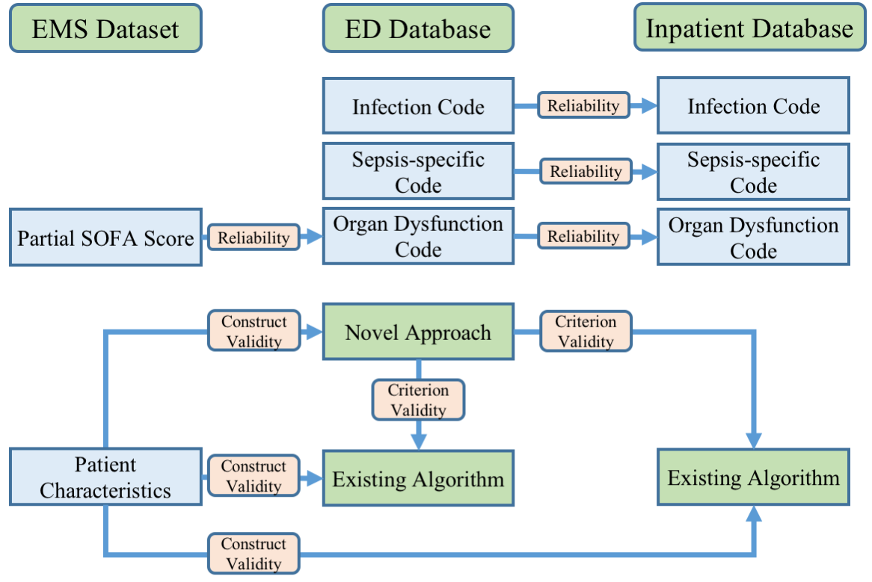

Supplement Figure 2: Flow diagram of patients included in our study cohort

