Supplemental Information

**Field evaluation of a Portable Fine Particle Concentrator (PFPC) for ice nucleating particle measurements**

Ellen Gutea*, Larissa Lacherb,+, Zamin A. Kanjib, Rebecca Kohlc, Joachim Curtiusc, Daniel Weberc, Heinz Bingemerc, Hans-Christian Clemend, Johannes Schneiderd, Martin Gysel-Beer e, Stephen T. Fergusonf and Jonathan P.D. Abbatta

aDepartment of Chemistry, University of Toronto, Toronto, Canada; bInstitute for Atmospheric and Climate Science, ETH Zurich, Zurich; Switzerland; cInstitute for Atmospheric and Environmental Sciences, Goethe-Universität Frankfurt am Main, Frankfurt am Main, Germany; dParticle Chemistry Department, Max Planck Institute for Chemistry, Mainz, Germany; eLaboratory of Atmospheric Chemistry, Paul Scherrer Institute, Villigen, Switzerland; Department of Environmental Health, Harvard T.H. Chan School of Public Health, Boston, MA, USA; +now at Institute for Meteorology and Climate Research – Atmospheric Aerosol Research, KIT, Karlsruhe, Germany

**Contents of this file**

A schematic and dimensions of the concentrator stages are provided in **Figure S1**. **Figure S2** shows results of the OPC side-by-side measurements to ensure agreement between the two instruments used to determine enrichment factors (EFs). INP enrichment factors depending on the calculated cumulative fraction (CF) of the aerosol at the Jungfraujoch research station are shown for particle sizes of 465 nm (**Figure S3**) and 721 nm (**Figure S4**). Number size distributions for cases with CF above and below 0.95 are shown in **Figure S5** **a** and **b**.

A time series of AMS measurements is presented in **Figure S6** and the time periods used to determine such AMS EFs are given in **Table S1**. AMS particle mass size distributions for two cases are shown in **Figure S7** and **Figure S8**. ALABAMA measurement periods are listed in **Table S2** and a cluster analysis is presented in **Figure S9** and discussed in **Text S1**.

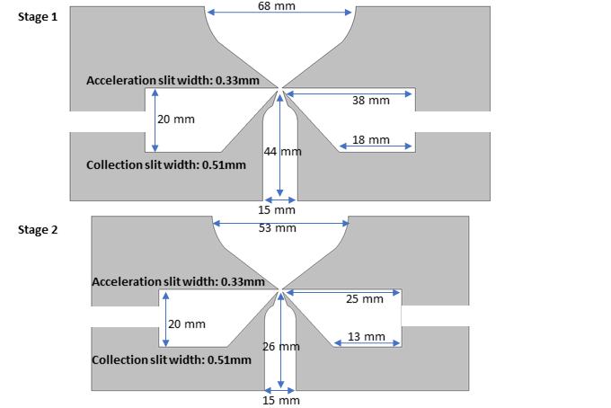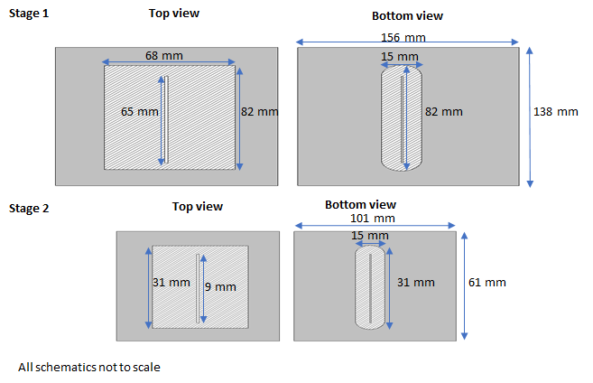

**Figure S1.** PFPC stages side, top and bottom view with dimensions. Schematic is not to scale.

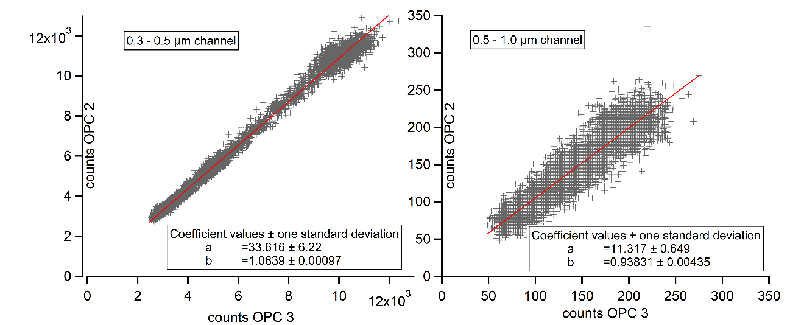

**Figure S2.** OPC side-by-side measurements of ambient particles over 11.2 hours (left) and 10 minutes (right). Shown are the scatter plots for the size channels 0.3 to 0.5 µm and 0.5 to 1.0 µm, indicating that the counters agree to within at least 10%. For particles between 1 and 5 µm, the ratio of the means of the particle concentrations measured during this time period was 1.04, but the temporal correlation between the measurements is poor given the small number of particles counted. Overall, these measurements indicate that the accuracy of the two OPCs is at least at the 10% level, which is within the counting uncertainty.

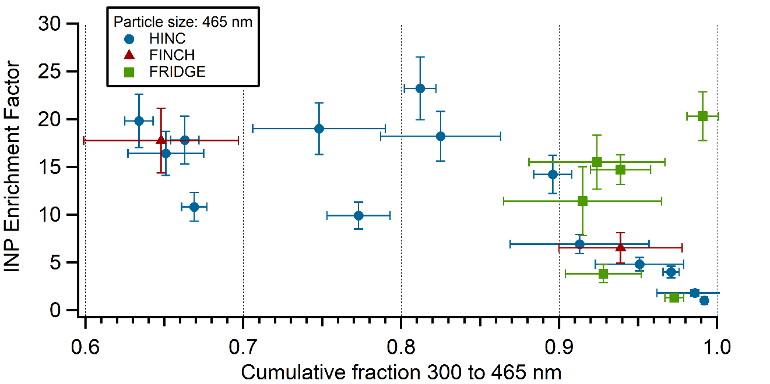

**Figure S3.** INP Enrichment factors determined from measurements with the HINC, FINCH and FRIDGE chambers plotted against the calculated cumulative fraction obtained for particles of 465 nm from OPS data. The uncertainties in the plot are one standard deviation values calculated for the vertical axis from the individual uncertainties of the INP measurements and for the horizontal axis from the individual OPS measurements.

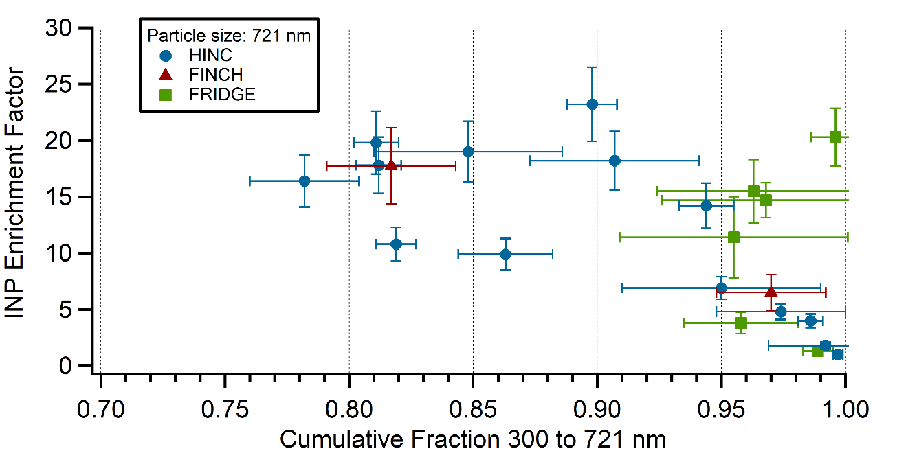

**Figure S4.** INP Enrichment factors determined from measurements with the HINC, FINCH and FRIDGE chambers plotted against the calculated cumulative fraction obtained for particles of 721 nm from OPS data. Uncertainties as in Figure S4.

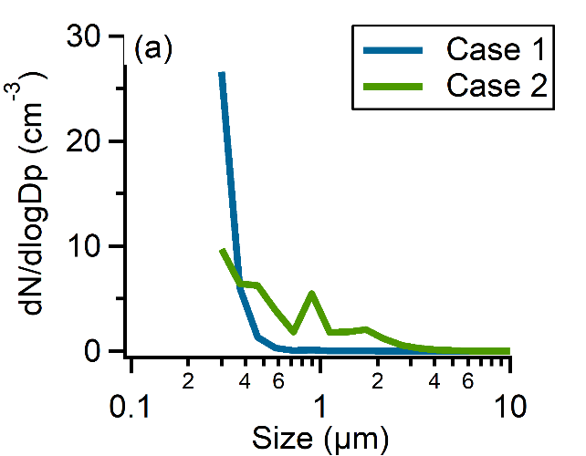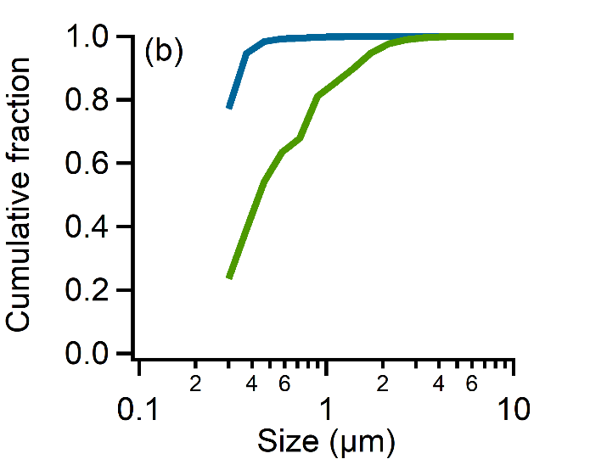

**Figure S5** (a) Ambient particle number size distributions at the high altitude station for a time (Case 1) when the calculated cumulative fraction (CF) for 579 nm particles is above 0.95 (10.02.2017 13:21 to 14:15) and for another time (Case 2) with CF for this particle size below 0.95 (16.02.2017 17:16 to 18:09). The INP HINC enrichment factor for Case 1 with CF > 0.95 was 1 and for Case 2 with CF < 0.95 was 20. (b) Cumulative fractions as a function of particle diameter for both cases calculated from OPS measurements.

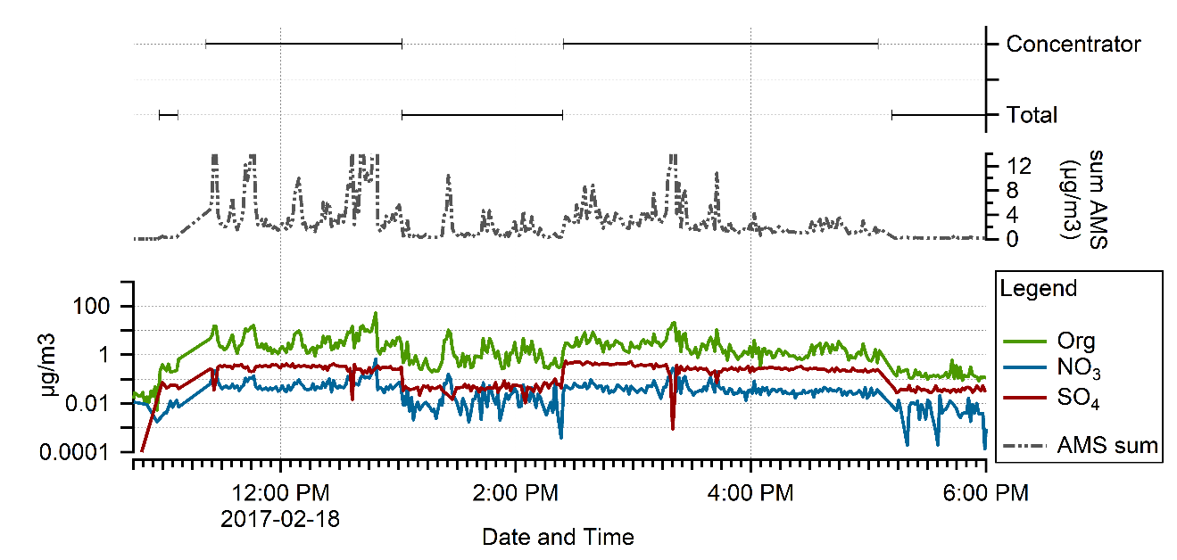

**Figure S6.** Timeseries of AMS measurements. The times selected and the corresponding AMS EFs are presented in the table below. Sum AMS refers to the summed mass concentrations.

**Table S1.** Time periods of AMS measurements on February 18th, 2017 and corresponding calculated EFs.

|  |  |  |  |
| --- | --- | --- | --- |
|  |  | EF #2 | EF #3 |
|  | Time period total inlet | 13:02 – 13:12 | 14:14 – 14:24 |
|  | Time period PFPC | 12:52 – 13:02 | 14:24 – 14:34 |
| Organics |  | 3.7 | 7.0 |
| Sulfate |  | 9.1 | 7.2 |

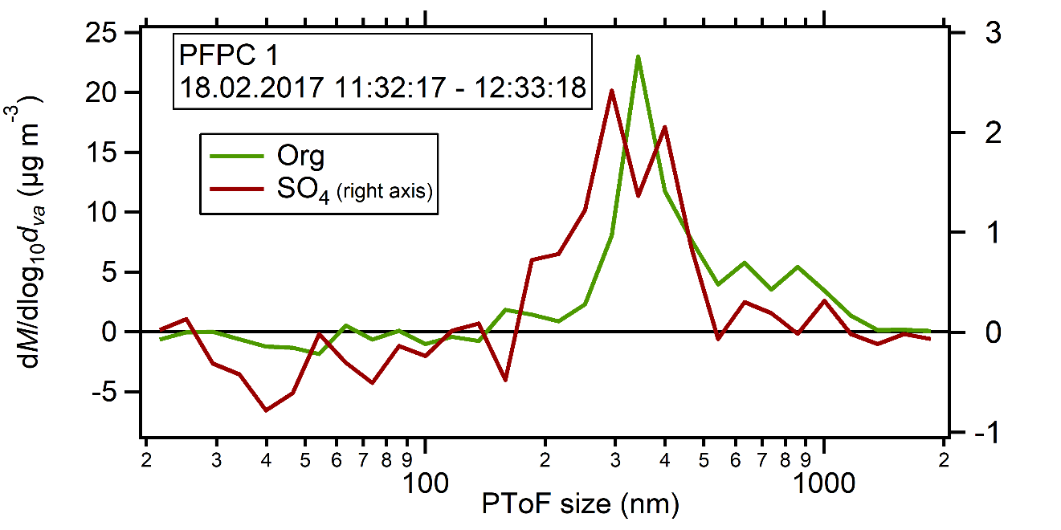

**Figure S7.** AMS mass distribution as a function of size during measurement downstream of the PFPC from 11:22 to 13:02. In general, given the short period of analysis, the uncertainties in the mass measurements at large sizes (greater than roughly 500 nm) are particularly large.

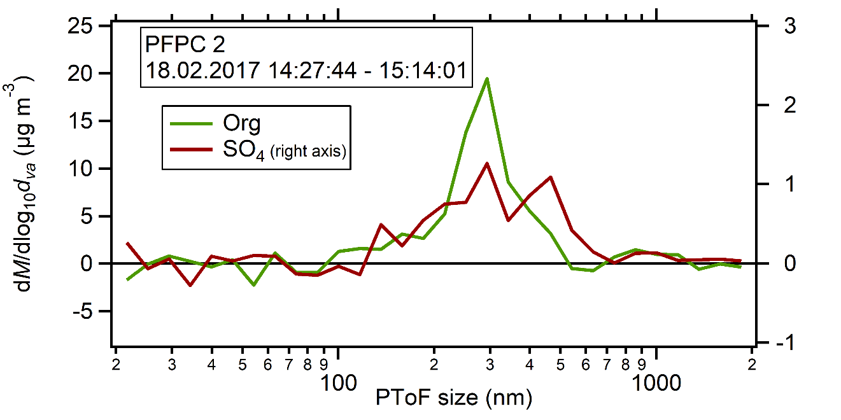

**Figure S8.** AMS mass distribution as a function of size during measurement downstream of the PFPC from 14:24 to 14:34. In general, given the short period of analysis, the uncertainties in the mass measurements at large sizes (greater than roughly 500 nm) are particularly large.

**Table S2.** Time periods of ALABAMA measurements on February 18th, 2017 used for the calculation of the particle-type dependent EFs. Periods without strong local particle emissions were selected. Additionally, the numbers of applied mass spectra are listed next to each measurement period.

|  |  |  |  |  |
| --- | --- | --- | --- | --- |
| EF calculations | | |  |  |
|  | EF #1 | No. spectra | EF #2 | No. spectra |
| Time period PFPC inlet + PFPC | 11:50 – 12:00 LT | 1874 | 14:50 – 15:00 LT | 2105 |
| Time period PFPC inlet only | 13:10 – 13:20 LT | 932 | 14:13 – 14:23 LT | 815 |
| **SIZE DEPENDENT INFORMATION** | | |  |  |
|  |  | | No. spectra |  |
| Median particle diameter of clusters | 10:18 – 11:08 LT | | 4783 |  |
| Fractional size distribution | 10:18 – 11:08 LT | | 4783 |  |



**Figure S9.** Fractional size distribution of particles types (clusters) identified by ALABAMA during a measurement without the PFPC. 20 clusters were prescribed for the analysis algorithm; cluster 20 represents the unassigned particles. The purple line represents the absolute size distribution of all particles analysed by ALABAMA.

**Text S1.** The presented clusters and their abundances were obtained by applying the fuzzy c-means algorithm (e.g. Hinz et al. 1999; Bezdek et al. 1984) to the ALABAMA mass spectra, with 20 random class centers chosen as starting conditions. It is beyond the scope of this paper to discuss the composition of each particle cluster but two clusters, C0 and C12, are discussed below.

For the EF calculation, the cluster fractions during the time period listed in Table S2, related to the total number of detected particles at the same period, were used. The particle detection in ALABAMA takes place before ablation/ionization and was without limitation during times with enhanced particle concentrations when using the PFPC. The median diameter size of the clusters was obtained from an earlier time period on this day (Table S2) with stable particle size distributions. One of the clusters with the smallest particles is Cluster 12 with a median vacuum aerodynamic diameter of 427 nm. The signal intensities of elemental carbon (EC)-related mass-to-charge ratios (m/z) of 12, 24 and 36 dominate the positive averaged mass spectra of Cluster 12 , with lower intensity K signals (m/z 39, 41) and signatures of organic carbon (OC) as m/z 27, 29, 37, 43 (Spencer and Prather, 2006). In the negative mode spectrum, the signal of m/z 26 (CN-) dominates with lower intensity signals at m/z 24 (C2-), 25(C2H-) and 97 (HSO4-). Overall the cluster is dominated by EC and K, with little indication of atmospheric aging. In particular, m/z 43 (C2H3O+) is a commonly used marker for aged organics (Qin et al., 2012), although it may alternatively be identified as C3H7+ or C2H5N+.

For Cluster 0, the median vacuum aerodynamic diameter is 899 nm. The positive averaged mass spectrum is dominated by OC signatures, with additional high signals of nitrogen-related peaks at m/z 18 (NH4+) and 30 (CH4N+ or NO+). In the negative mode, Cluster 0 is dominated by a strong peak at m/z 97 (HSO4-) which might be related to sulfate with possible signatures from organosulfates as m/z 141 and 155 (Froyd et al., 2010). Overall, the cluster is dominated by ammonium sulfate related compounds and OC, with evidence of more aging than the previously discussed Cluster 12 (signal intensity of m/z 43 in Cluster 0 is roughly then times higher to Cluster 12).

**References**

Bezdek, J.C., Ehrlich, R., and Full, W. (1984). FCM: The fuzzy c-means clustering algorithm. *Comput. Geosci.,* 10(2–3):191–203.

Froyd, K.D., Murphy, S.M., Murphy, D.M., de Gouw, J.A., Eddingsaas, N.C., and Wennberg, P.O. (2010). Contribution of isoprene-derived organosulfates to free tropospheric aerosol mass. *Proc. Natl. Acad. Sci.,* 107(50):21360–21365.

Hinz, K.-P., Greweling, M., Drews, F., and Spengler, B. (1999). Data processing in on-line laser mass spectrometry of inorganic, organic, or biological airborne particles. *J. Am. Soc. Mass Spectrom.,* 10(7):648–660.

Qin, X., Pratt, K.A., Shields, L.G., Toner, S.M., and Prather, K.A. (2012). Seasonal comparisons of single-particle chemical mixing state in Riverside, CA. *Atmos. Environ.,* 59:587–596.

Spencer, M.T. and Prather, K.A. (2006). Using ATOFMS to Determine OC/EC Mass Fractions in Particles. *Aerosol Sci. Technol.,* 40(8):585–594.