ELECTRONIC SUPPLEMENTARY INFORMATION
Polycyclic aromatic hydrocarbons and their adducts with solvents from Ag(II)SO₄–based oxidative C–C coupling†,‡
P. J. Leszczyński, ^{a *} T. Jaroń, ª P. J. Malinowski, ª J. Gawraczyński, ^{a,b} Z. Mazej,^{c} W. Grochala ^{a *}

a. Center of New Technologies, University of Warsaw, Żwirki i Wigury 93, 02089 Warsaw Poland.
b. Faculty of Chemistry, University of Warsaw, Pasteur 1, 02093 Warsaw Poland.
c. Department of Inorganic Chemistry and Technology, Jožef Stefan Institute, Jamova cesta 39, 1000 Ljubljana Slovenia
E-mail: piotr.leszczynski@cent.uw.edu.pl, w.grochala@cent.uw.edu.pl

Experimental details

All manipulations of highly reactive AgSO₄ were done in Ar-filled glovebox (MBraun, O₂, H₂O< 1 ppm).
AgSO₄ was obtained according to literature procedures. Commercial 9,9’-bianthrene was purchased from Fluorochem, while 9,9’-biphenantrene was purchased from Sigma Aldrich. All solvents used were from Sigma Aldrich.
IR spectra were measured on Bruker Vertex 80v FTIR spectrometer. MIR spectra were measured with samples in KBr pellets while for FIR range the samples were smeared on HDPE windows.
NMR spectra were recorded on Bruker AVANCE 500 MHz spectrometer. For GC-MS measurements Agilent 7890A & 5975 spectrometer (EI ionization) with standard HP-5MS column and NIST 08 database was used in all cases. Mass spectra were recorded in the range of 10-800 amu.
Raman spectra were recorded on Horiba-Jobin Yvon, T64000 spectrometer, 514 nm excitation line, 200 um confocal aperture, Rayleigh band cutoff via edge filter, monochromated with 1800 diffraction grating.
The crystals were measured on Agilent Supernova X-ray diffratometer with Cu-Kα radiation (microsource). Data collection and reduction was performed with CrysAlisPro software (v. 38.43). Structure solution: SHELXT, refinement against F² in Shelxl-2013, with ShelXle or Olex as GUI software.
Crystal growth:
- pure 9,9'-bianthryl and 9,9'-biphenanthryl: 10 mg of the compound in 2 ml of m-xylene; slow crystallization at RT
- The inclusion compounds were prepared using 10 mg of bianthrene dissolved in ca. 2 ml of the corresponding solvent (benzene, toluene, o/p-xylene)using slow evaporation technique. Only 1:1 adduct of 1 and toluene was obtained by slow cooling of the RT-saturated solution of 1 in C₇H₈ to −30°C.
Hirschfeld surfaces were generated using Crystal Explorer software.

The ¹H, ¹³C and ¹H vs. ¹³C HSQC NMR spectra, and IR spectra for 1 and 2

9,9’-bianthryl (1) NMR spectra: C₂₈H₁₈
¹H 500 MHz, ¹³C 125 MHz, ¹H vs. ¹³C HSQC CDCl₃ 298 K

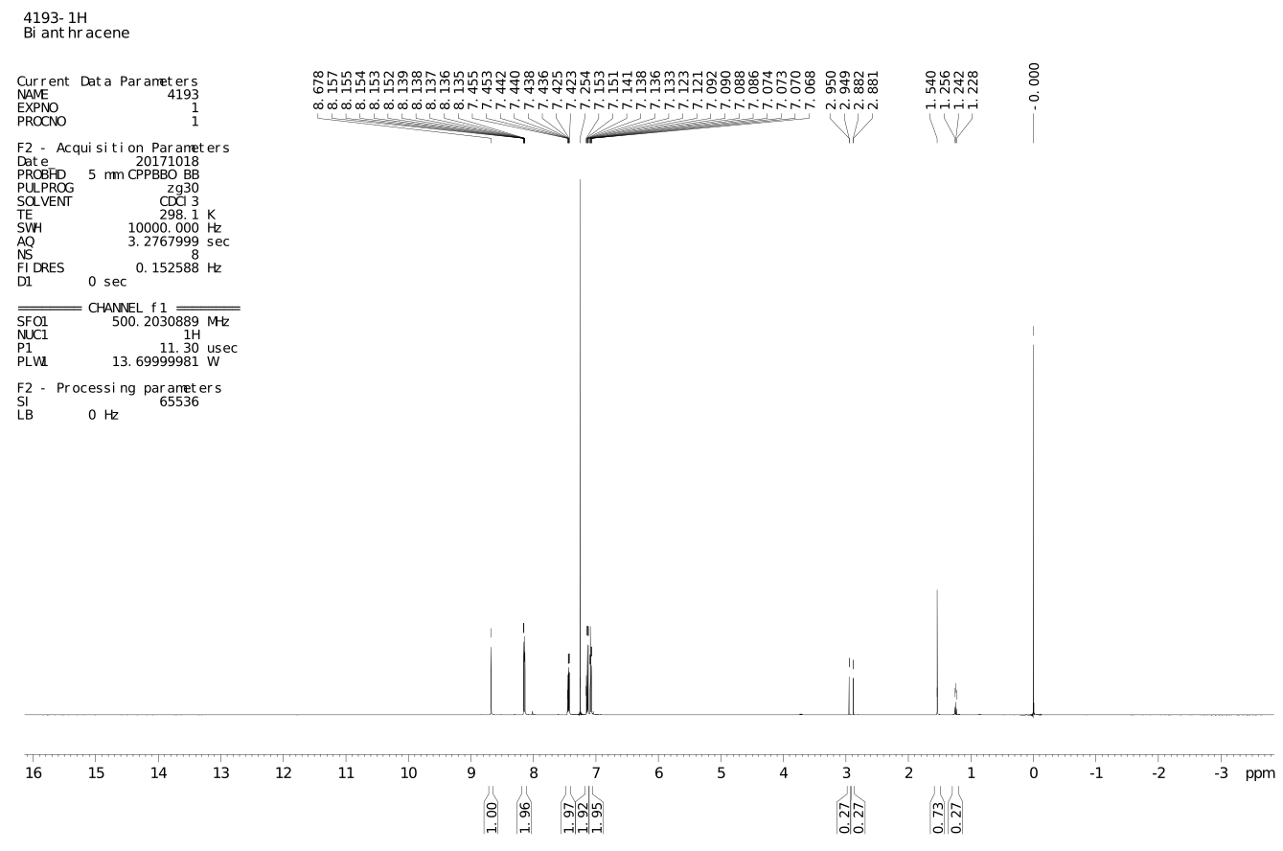

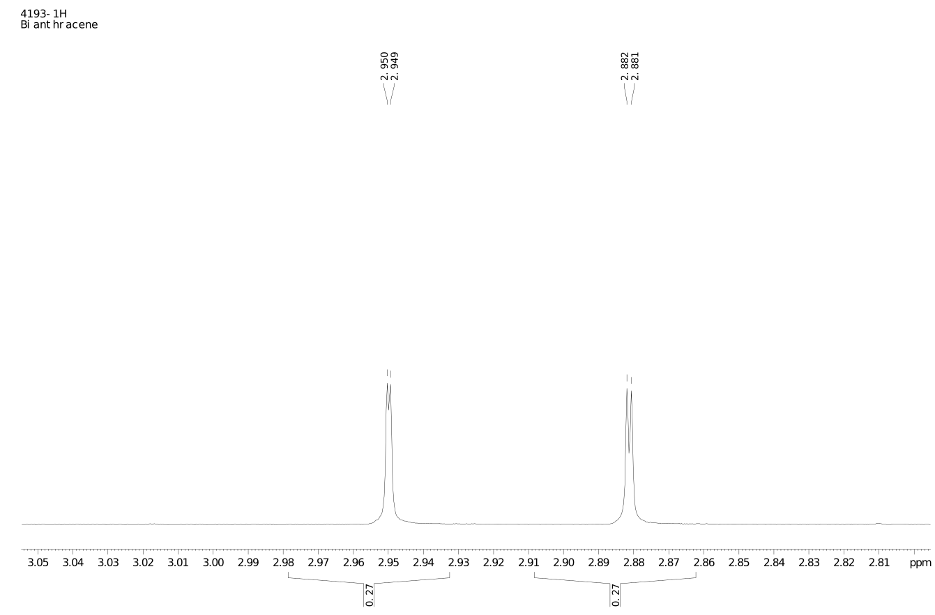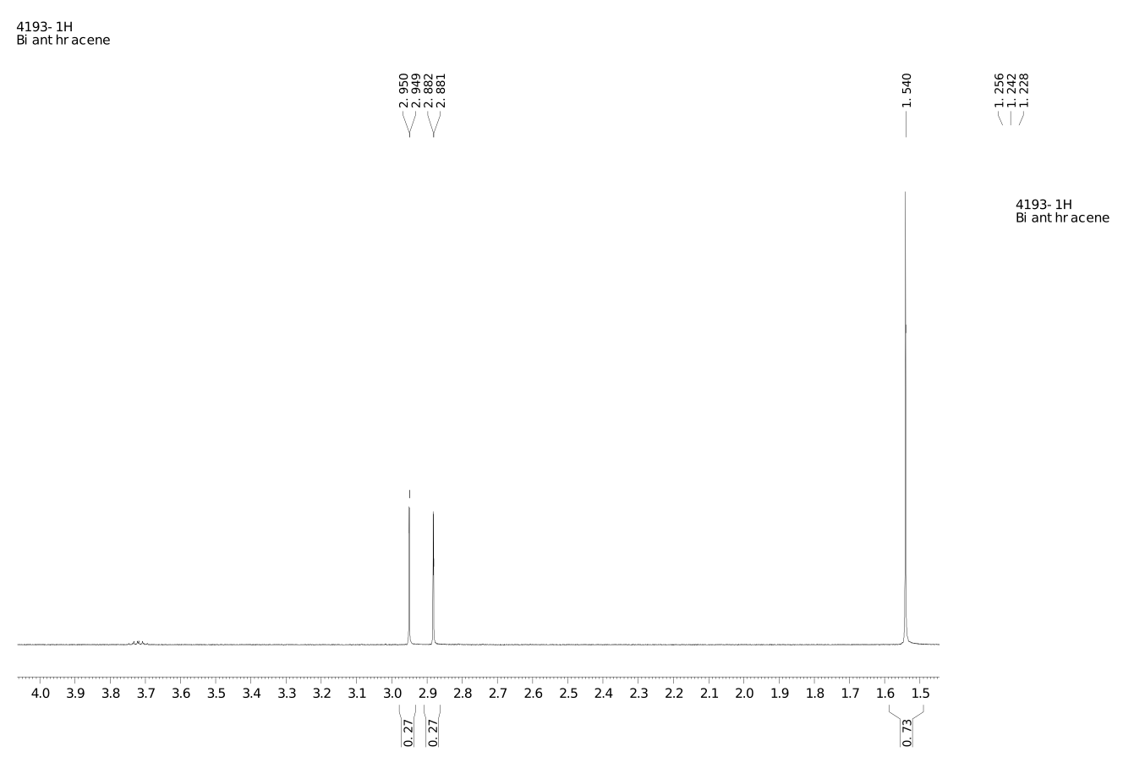

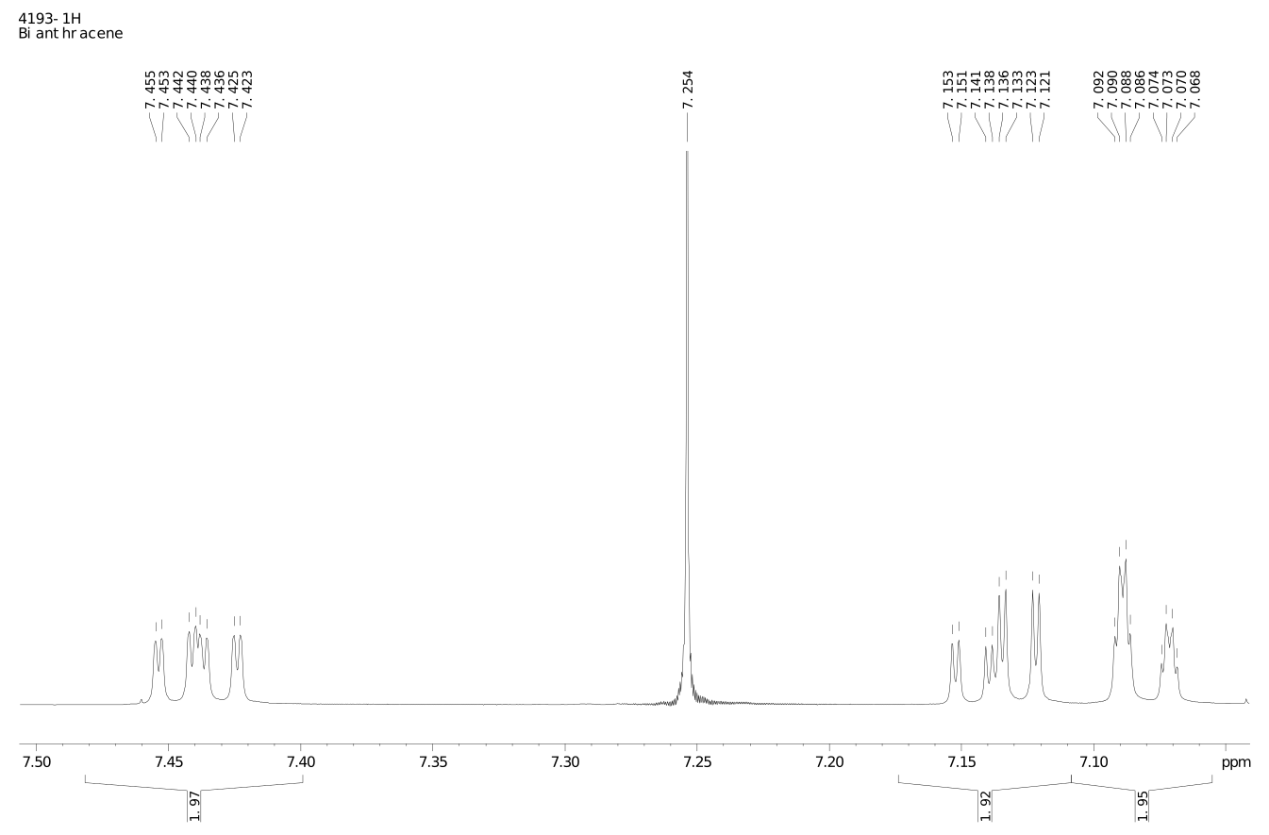
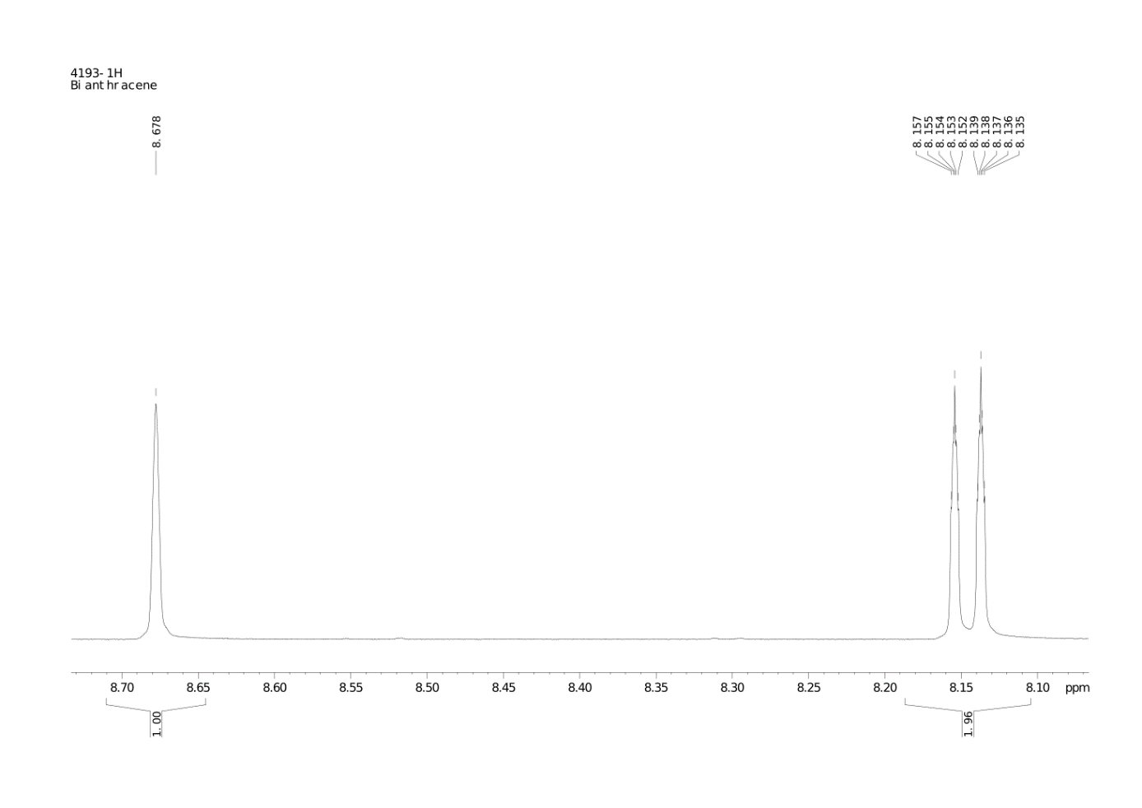
¹H NMR:

7.092-7.068 ppm (4H dq J = 1 Hz)
7.153-7.121 ppm (4H dqd J = 1 Hz)
7.455-7.523 ppp (4H dqd J = 1 Hz)
8.157-8.135 ppm (4H dq J = 0.5 Hz)
8.678 ppm (2H s)

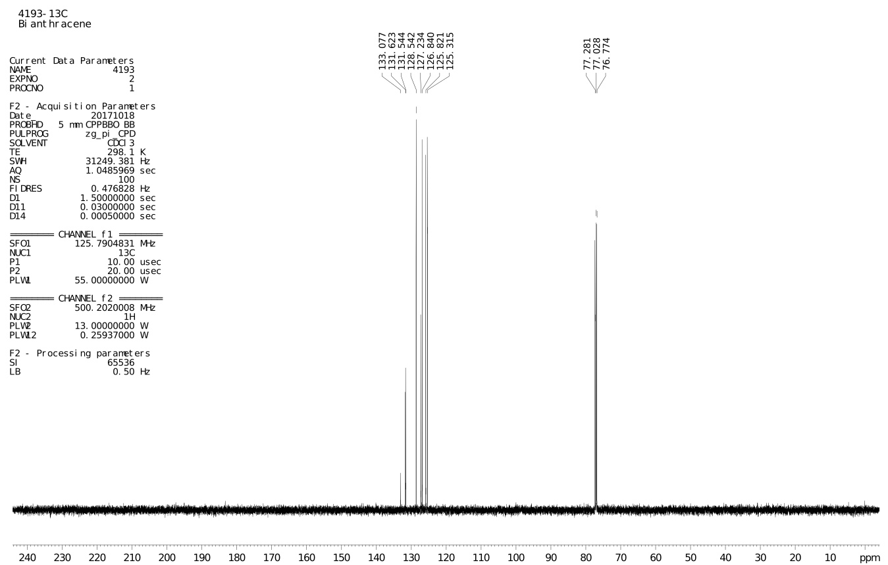
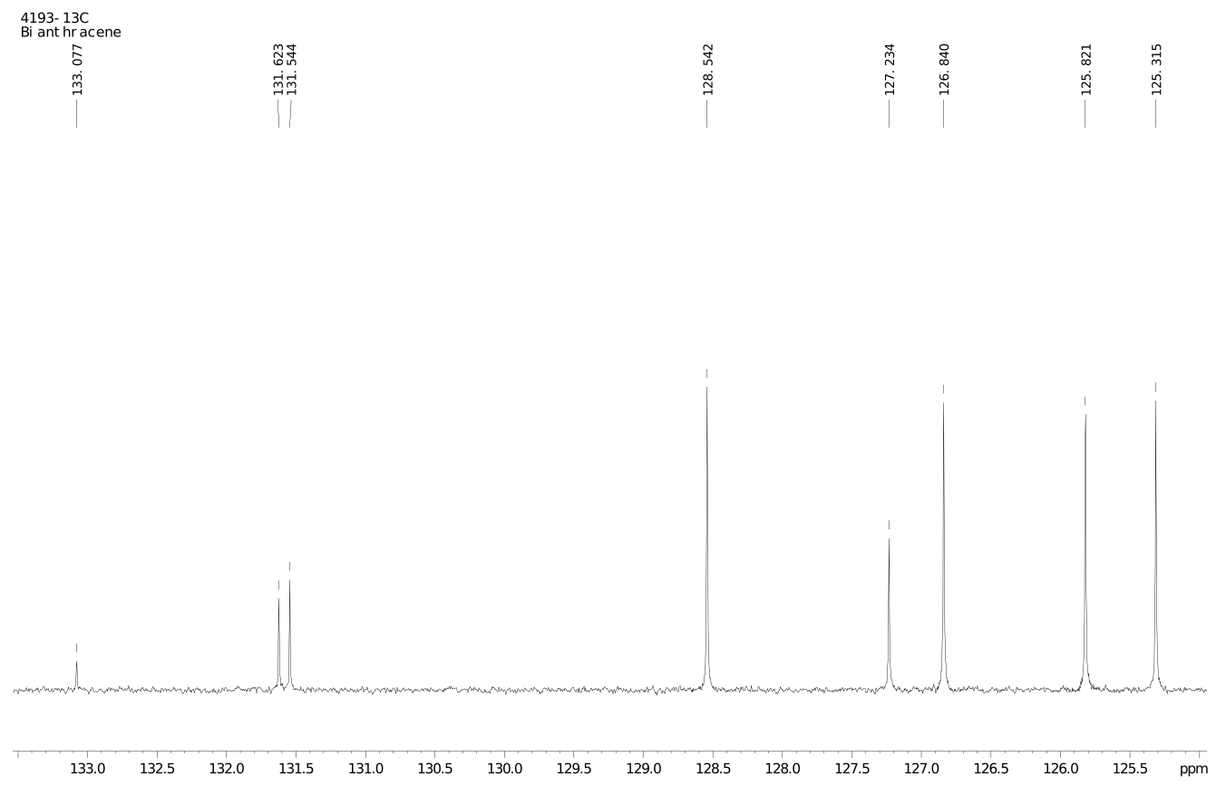

¹³C NMR:

125.315 ppm
125.821 ppm
126.840 ppm
127.234 ppm
128.542 ppm
131.544 ppm
131.623 ppm
133.077 ppm

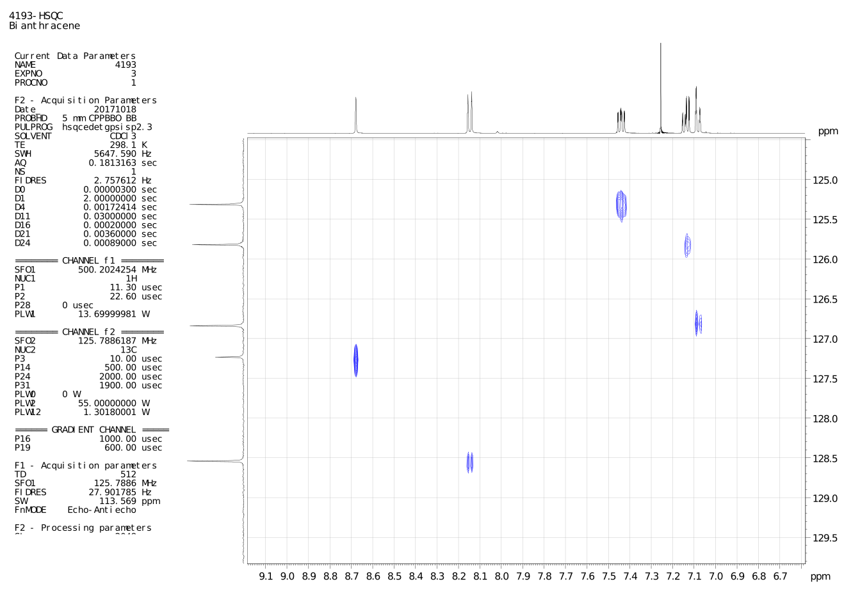

Raman bands [cm⁻¹]: 400, 1262, 1368, 1385, 1403, 1425, 1562, 1624

IR bands [cm⁻¹]: 425, 519, 563, 599, 602, 624, 641, 648, 730, 736, 760, 785, 789, 834, 837, 858, 885, 892, 909, 961, 1011, 1105, 1150, 1160, 1170, 1223, 1256, 1269, 1306, 1318, 1380, 1403, 1442, 1452, 1518, 1555, 1572, 1623, 1673, 1719, 1813, 1919, 1948, 2997, 3035, 3055, 3075
9,9’-biphenanthryl (2) NMR spectra: C₂₈H₁₈
¹H 500 MHz, ¹³C 125 MHz, ¹H vs. ¹³C HSQC CDCl₃ 298 K
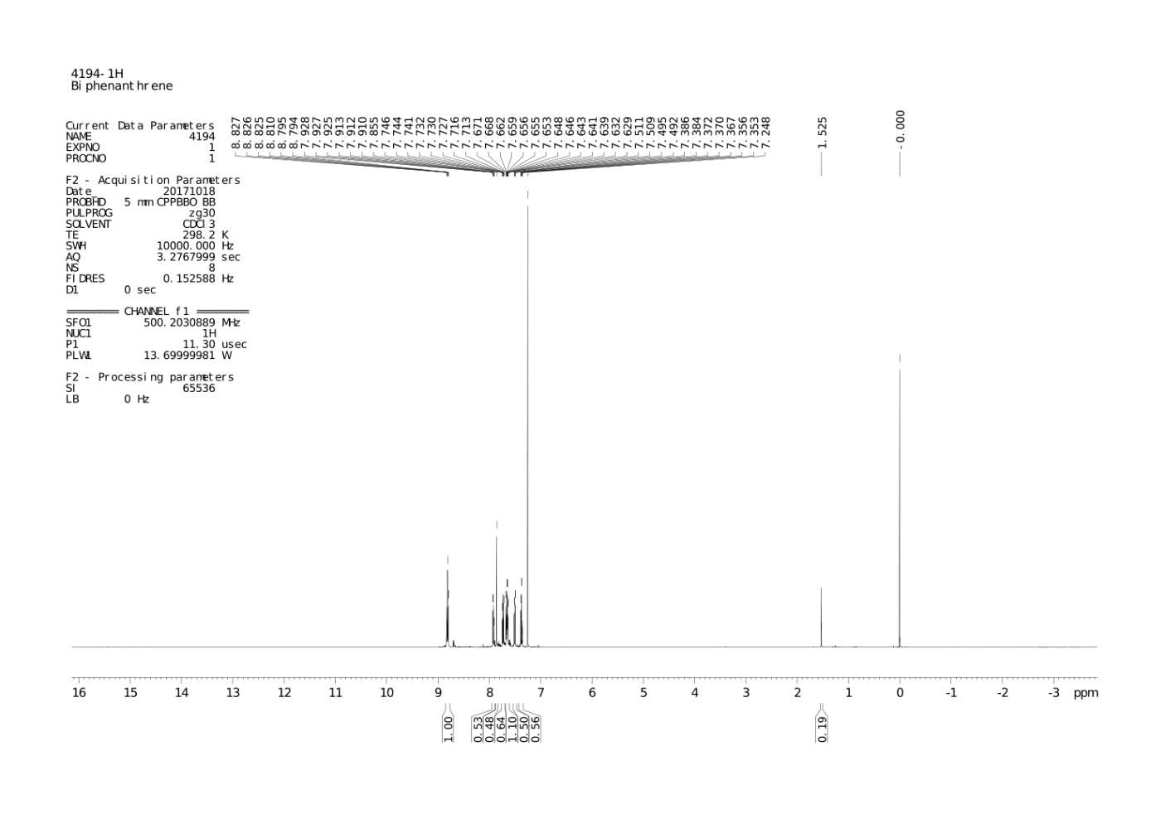
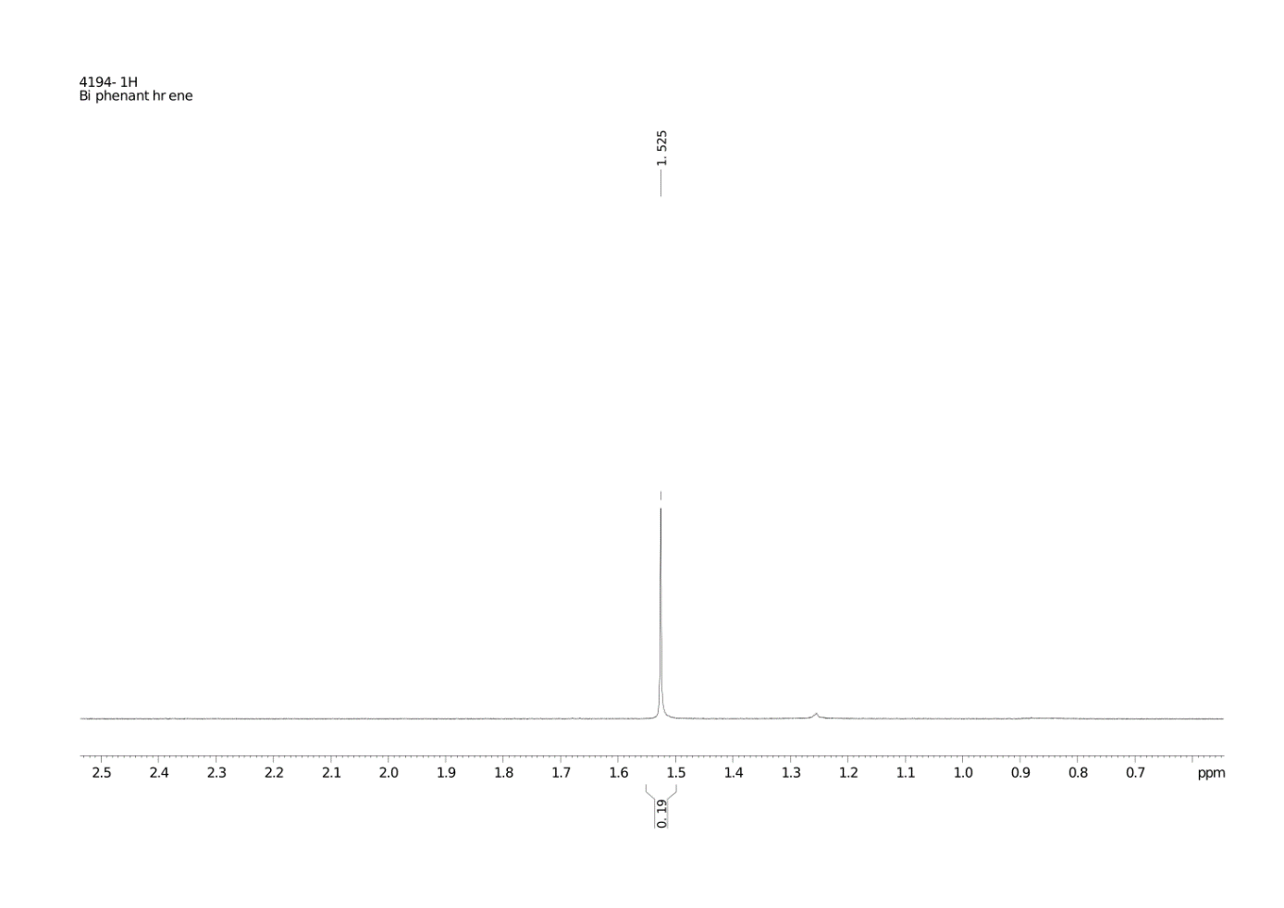
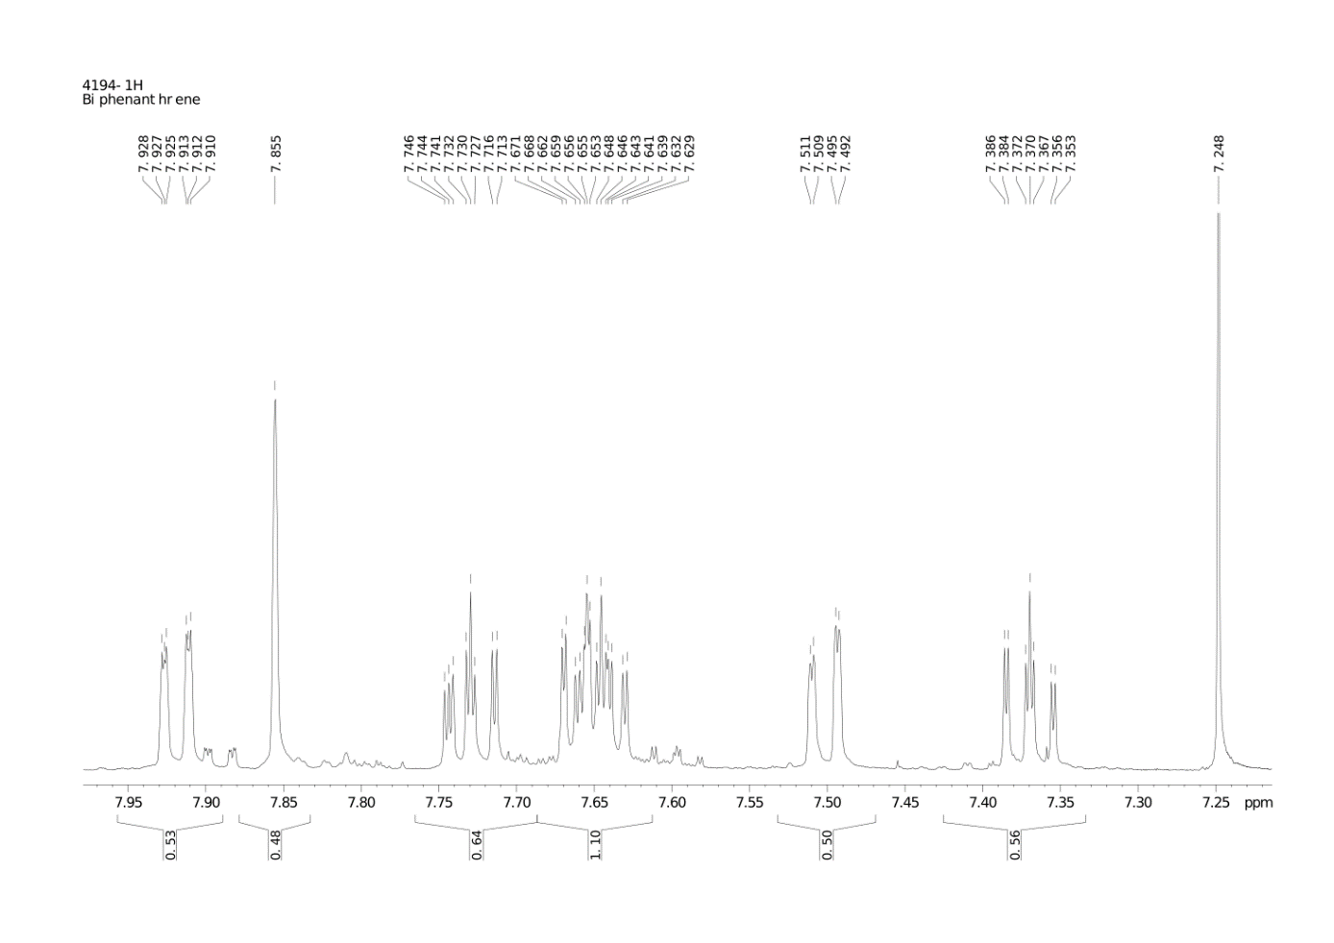
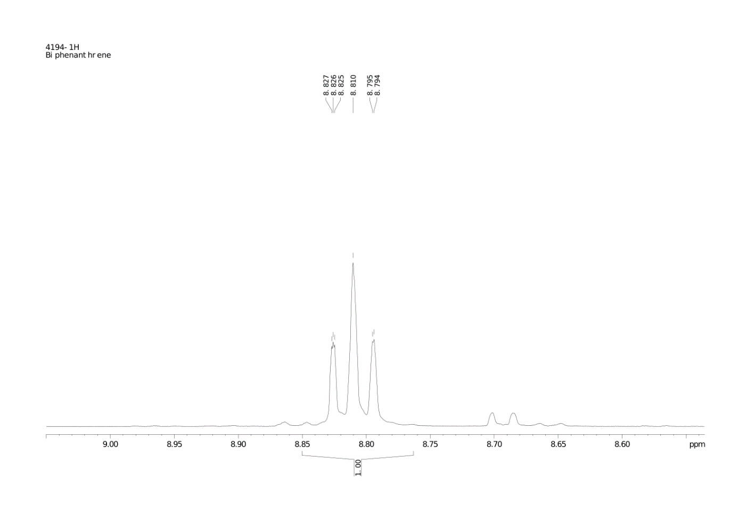
¹H NMR:

7.386-7.353 ppm (2H dtd J = 1 Hz)
7.511-7.492 ppm (2H dd J = 1 Hz)
7.671-7.629 ppm (4H dqqd J = 1Hz)
7.746-7.713 ppm (2H ttd J = 1 Hz)
7.855 ppm (2H s)
7.928-7.910 ppm (2H dt J = 1 Hz)
8.827-8.794 ppm (4H tsd J = 1 Hz)

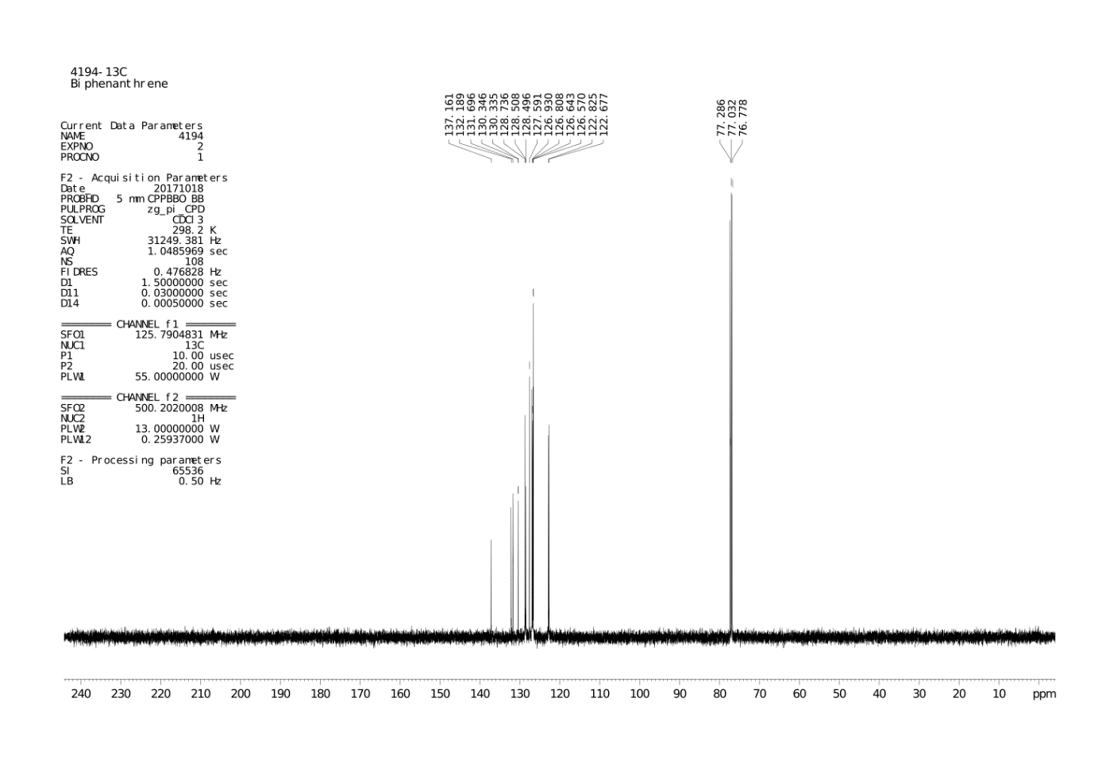
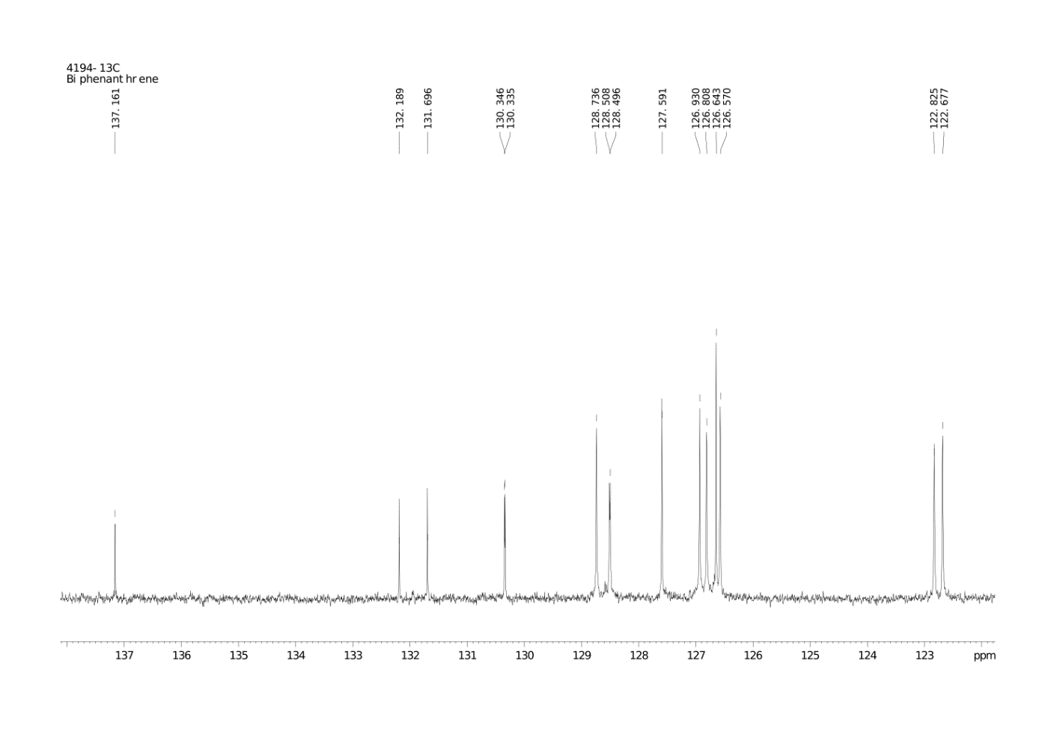
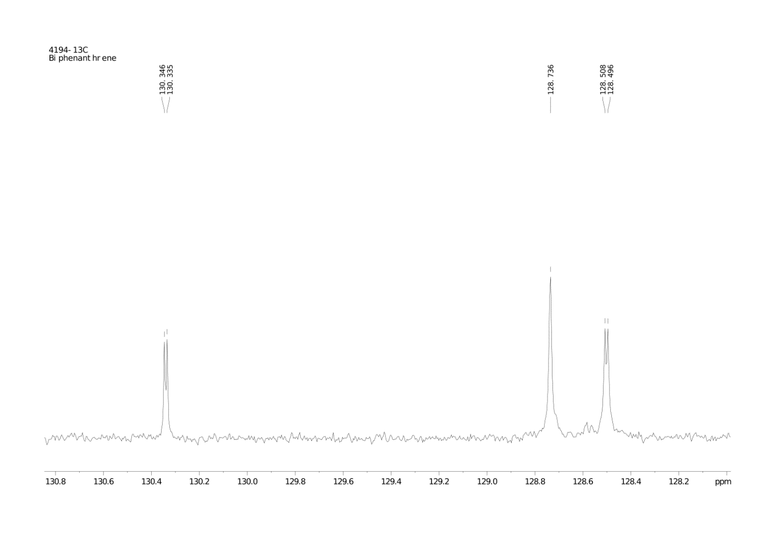
¹³C NMR:

122.677 ppm
122.825 ppm
126.570 ppm
126.643 ppm
126.808 ppm
126.930 ppm
127.591 ppm
128.496 ppm
128.508 ppm
128.736 ppm
130.335 ppm
130.346 ppm
131.696 ppm
132.189 ppm
137.161.ppm

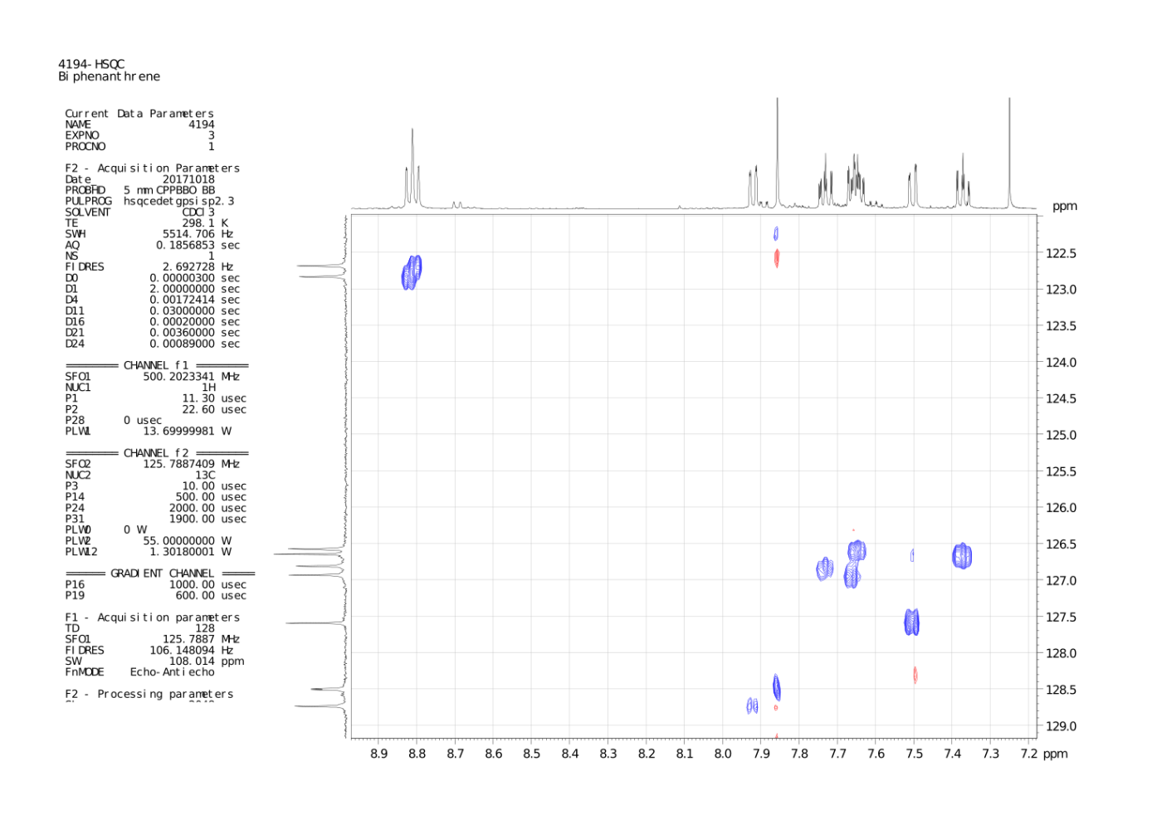

Raman bands [cm⁻¹]: 117, 188, 409, 714, 1036, 1247, 1347, 1382, 1421, 1447, 1459, 1528

IR bands [cm⁻¹]: 408, 421, 426, 503.5, 548, 616.5, 726, 746.5, 766, 777, 789, 810, 832, 853, 866, 884, 896, 915, 942, 949, 976, 1002, 1020, 1039, 1100, 1142, 1155, 1165, 1187, 1206, 1230, 1243, 1263, 1291, 1372, 1381, 1421, 1428, 1440, 1449, 1480, 1493, 1526, 1573, 1592, 1916, 1946, 2930, 2965, 3016, 3029, 3051, 3056, 3072, 3101
TGA-DSC studies

Thermogravimetric (TGA) – calorimetric (DSC) profile of bianthryl-toluene 1:1 adduct at 5 K/min

Toluene is released in two steps, 20–78.5 ºC and 78.5–140 ºC, with half mole of toluene released at each step from one mole of solvate. The total mass loss of ca. 18.9 % nicely corresponds to theoretical value (20.6 %). At 313 ºC bianthryl melts or sublimes (the melting point of 316.6 ºC was reported before [7]), and this is followed by vigorous evaporation of the liquid; at 400 ºC all bianthryl is in the gas phase.

Thermogravimetric (TGA) – calorimetric (DSC) profile of biphenanthryl at 5 K/min

At 157.1 ºC biphenanthryl melts and this is followed by evaporation of the liquid; the boiling point, determined from the maximum of the DSC peak, is 420 ºC.

References

P. Połczyński, T.E. Gilewski, J. Gawraczyński, M. Derzsi, P.J. Leszczyński, W. Gadomski, Z. Mazej, R. Jurczakowski, W. Grochala, Eur. J. Inorg. Chem. 2016, 35, 5401-5404.
Agilent (2014). CrysAlis PRO. Agilent Technologies Ltd, Yarnton, Oxfordshire, England.
G. M. Sheldrick, Acta Cryst. (2015) A71, 3–8.
C. B. Hübschle, G. M. Sheldrick, B. Dittrich, J. Appl. Crystallogr. (2011) 44, 1281–1284.
L.J. Bourhis, O.V. Dolomanov, R.J. Gildea, L.J. Bourhis, O.V. Dolomanov, R.J. Gildea, J.A.K. Howard, H. Puschmann, Acta Cryst. (2015) A71, 59-75.
M. J. Turner, J. J. McKinnon, S. K. Wolff, D. J. Grimwood, P. R. Spackman, D. Jayatilaka and M. A. Spackman, CrystalExplorer17 (2017). University of Western Australia. http://hirshfeldsurface.net. 7 J. B. Kyzioł, J. Zaleski, Acta Cryst. (2007) E63, o1235–o1237.

