Supplemental Appendix A
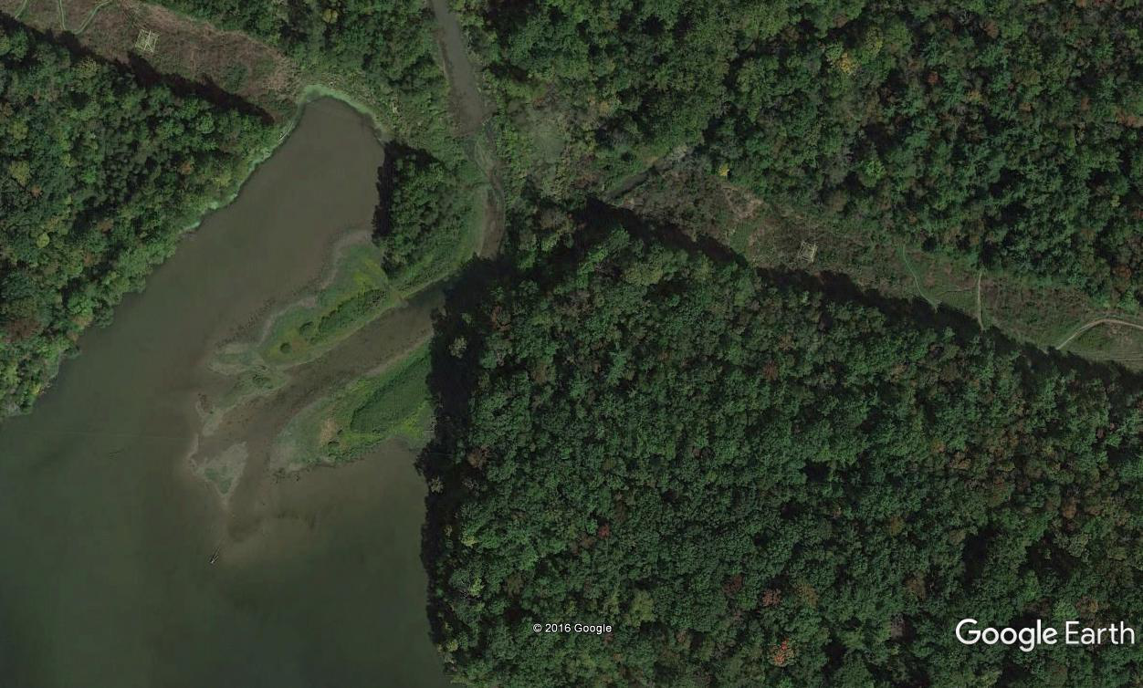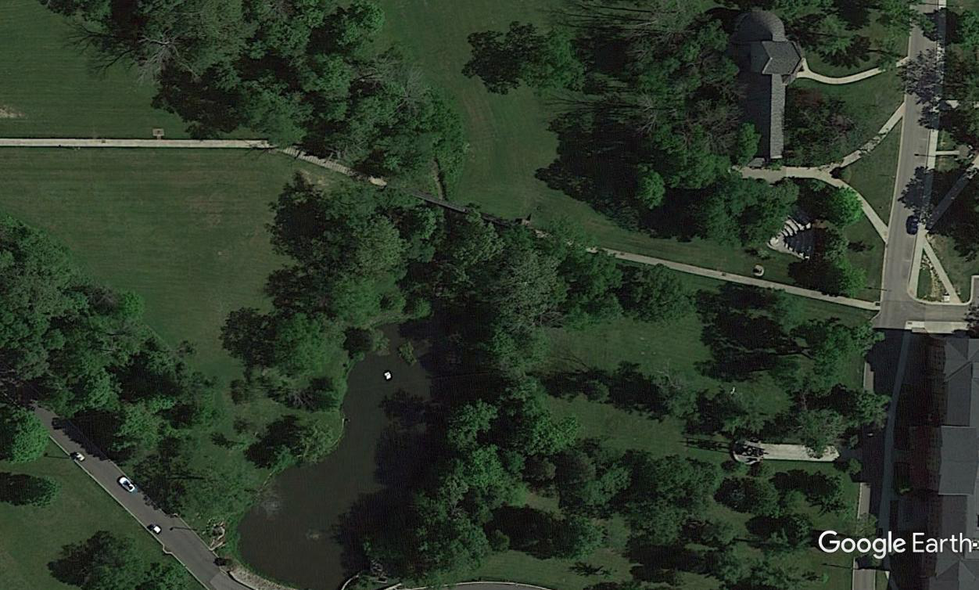
*
**
***
*
**
***
100 m
100 m
Supplemental Figure A1: Examples of sampled habitat locations. Stream (*), Ecotone (**), and Open Water (***) habitats were sampled for adult dragonflies along 100 m transects when available. One of three Acton Lake sites (left) and the Western Pond site (right) are depicted. Imagery from Google Earth Pro (2016). Google, Inc. Mountain View, California.

Supplemental Figure A2: Relative importance of variables explaining dragonfly abundance. Values based on weights of averaged competing models (n=5) and the appearance of canopy cover, habitat type, algal density, density of emergent vegetation, and interaction between canopy and habitat within models.

Supplemental Table A1: Mean Coefficient of Conservatism (CoC) by habitat. Species occurrences during 1 hour (n = 4 samples) of observations along each transect (depicted by “X”) and the associated mean CoC scores used in OIWI analysis. CoC scores extracted from Kutcher and Bried (2013).
Habitat: | Stream |  |  |  | Ecotone |  |  |  | Open |  |  |  | CoC
Site: | L | M | S | W | L | M | S | W | L | M | S | W | -
Anax junius | - | - | - | - | X | X | X | X | - | - | - | - | 5.1
Anax longipes | - | - | - | - | - | - | - | - | X | - | - | - | 8.3
Dromogomphus spoliatus | - | - | - | - | - | - | - | - | - | - | X | - | NA*
Epitheca princeps | - | - | - | - | X | X | X | - | X | X | X | X | 5.8
Erythemis simplicicollis | - | X | X | X | X | X | X | X | X | X | X | X | 5.3
Libellula luctuosa | - | X | X | X | X | X | X | X | X | X | X | X | 4.0
Libellula lydia | - | X | - | X | X | X | X | X | - | X | X | X | 6.0
Libellula pulchella | - | - | - | - | X | - | - | - | X | - | - | - | 4.2
Patchydiplax longipennis | - | - | - | - | X | X | X | X | X | - | - | X | 4.1
Pantala flavescens | - | - | - | - | - | - | - | - | - | X | - | - | 3.1
Perithemis tenera | - | - | - | - | X | X | X | - | X | X | X | X | 3.9
Tramea lacerata | - | - | - | - | X | X | X | - | X | X | - | X | 5.0

* Dromogomphus spoliatus did not receive a CoC score in Kutcher and Bried (2013).

