Supplementary data

Insight into structural features of phenyltetrazole derivatives as ABCG2 inhibitors for the treatment of multidrug resistance in cancer
Bhagwati Bhardwaj¹, Anurag T.K. Baidya¹, S. A. Amin², Nilanjan Adhikari², Tarun Jha^{2,}* and Shovanlal Gayen^{1,}*
¹Laboratory of Drug Design and Discovery, Department of Pharmaceutical Sciences, Dr. HarisinghGour University, Sagar 470003, Madhya Pradesh, India
²Natural Science Laboratory, Department of Pharmaceutical Technology, Division of Medicinal & Pharmaceutical Chemistry, PO Box 17020, Jadavpur University, Kolkata 700032, India

*Tarun Jha tjupharm@yahoo.com Natural Science Laboratory, Division of Medicinal and Pharmaceutical Chemistry, Department of Pharmaceutical Technology, Jadavpur University, P.O. Box 17020, Kolkata 700032, India;
*Shovanlal Gayen shovanlal.gayen@gmail.com Laboratory of Drug Design and Discovery, Department of Pharmaceutical Sciences, Dr. Harisingh Gour University (A Central University), Sagar 470003, Madhya Pradesh, India
Supplementary Fig. 1S Predicted vs Observed pIC₅₀ plot of (A) training set, (B) test set compounds.

Supplementary Fig. 2S Structures of compounds showing importance of descriptor nAtomLC

Supplementary Fig. 3S Structures of compounds showing importance of descriptor minHBint5

Supplementary Fig. 4S Structures of compounds showing importance of descriptor piPC10

Supplementary Fig. 5S Structures of compounds showing importance of descriptor ATSC4i

Supplementary Fig. 6S Structures of compounds showing importance of descriptor ATSC4c
Supplementary Fig. 7S The structures of compounds 03, 04, 05, 19

Supplementary Fig. 8S The structures of compounds 63, 64, 65

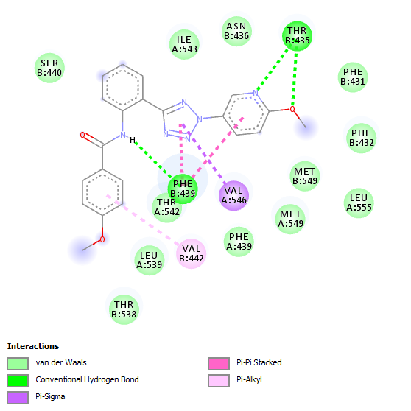
Supplementary Fig. 9S 2D diagram showing binding interactions of compound 64

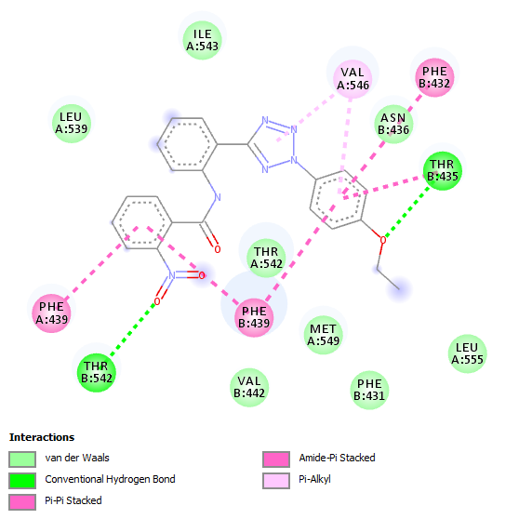
Supplementary Fig. 10S 2D diagram showing importance of –NO₂ group in making H-bond with T435 residue (compound 27)

Supplementary Table 1S. Y-randomization results for training set and test set for the 2D QSAR
 | Test Set |  | Training Set
Model | R | R² | R | R²
Original | 0.925943 | 0.857371 | 0.82565 | 0.681699
Random 1 | 0.416494 | 0.173468 | 0.263293 | 0.069323
Random 2 | 0.269648 | 0.07271 | 0.182641 | 0.033358
Random 3 | 0.345275 | 0.119215 | 0.548226 | 0.300551
Random 4 | 0.730119 | 0.533074 | 0.301087 | 0.090654
Random 5 | 0.786094 | 0.617943 | 0.390734 | 0.152673
Random 6 | 0.721348 | 0.520343 | 0.394003 | 0.155238
Random 7 | 0.652865 | 0.426233 | 0.228911 | 0.0524
Random 8 | 0.468805 | 0.219778 | 0.474681 | 0.225322
Random 9 | 0.705497 | 0.497726 | 0.326127 | 0.106359
Random 10 | 0.186474 | 0.034773 | 0.299583 | 0.08975
Average r : | 0.528262 |  | 0.340929
Average r² : | 0.321526 |  | 0.127563
cR²p | 0.70415 |  | 0.620868

