Supplement Material S1 : METHODS

Subjects: Twenty-eight (11 male and 17 female, age group: 25 – 64 yrs, mean 47.6 ±12.7) with most prominent clinical picture of Usher syndrome (USH) were selected from a patient pool of 3200 showing etiology of deafness and blindness who were enrolled in Deaf-Blind Support Foundation "Con-nection" with follow up period during 2014 to 2016. The ethnicity of the cohort is given in Fig. S1, Supplement Table S1. The age of disease manifestation was between 1 - 18 yrs. Inclusion criteria: (i) hearing loss > 2 degrees or higher (audible sound level is 41 dB and above), (ii) vision of each eye is narrowed by 15 degrees or more. Exclusion criteria: (i) subjects with dementia, psychoneurological diseases, drug addiction, alcoholism, etc.), (ii) participation in other clinical trials, (iii) medical history of eye traumas, barotraumas, serious concussions of the brain with loss of consciousness and craniocerebral traumas, acute disorders of cerebral circulation, (iv), diabetes mellitus, (v) ischemic heart disease of stage 3 or 4, (vi) presence of chronic infectious disease, (vii) patients with malignant tumors and a background of receiving chemo- and / or radiotherapy.

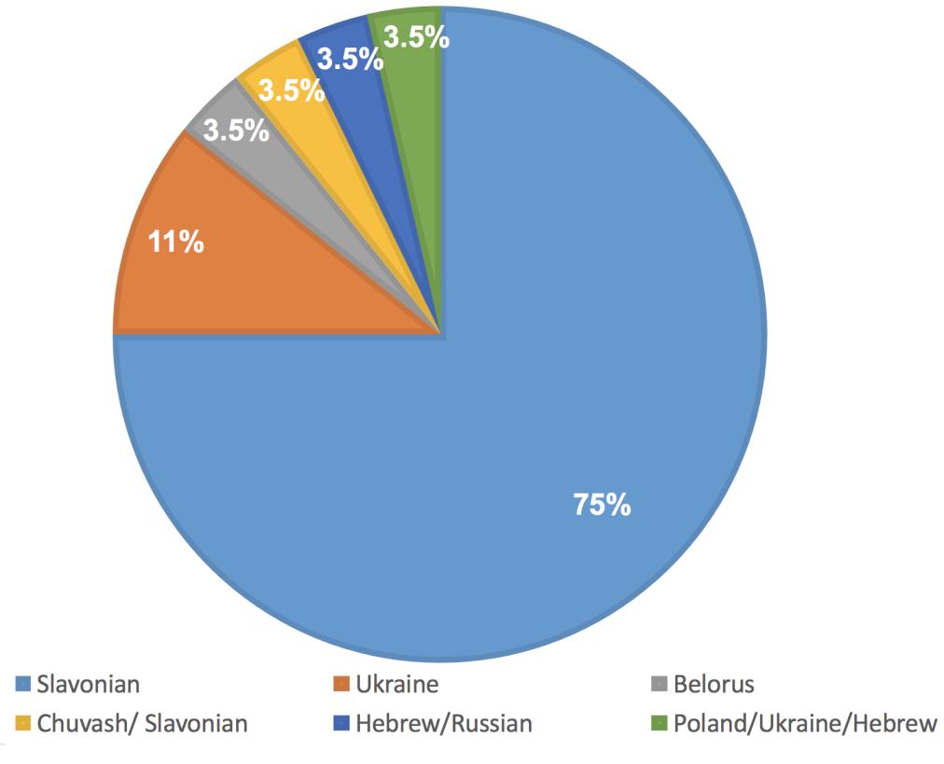

Fig. S1: The ethnicity of the Russian cohort of USH 28 patients.

Ethical considerations: The clinical examinations for USH diagnosis were based on the framework of NCT03319524.¹ The study was conducted according to the rules of Helsinki Declaration for medical research and Russian rules for conducting research in the field of medicine particularly clinical trials. Written inform consent was taken from all the 28 patients enrolled in this study and the study was approved by Independent International Ethical Committee, Moscow, Russia and from Independent interdisciplinary ethics committee on ethical review for clinical studies meeting secretary (12 May 2017).

Clinical examination: Clinical examinations were carried by experienced ophthalmologist and geneticist to confirm clinical picture, anamnesis and to exclude other genetic syndromes by authors respective clinics and hospitals following the NCT03319524 guidelines. Otorhinolaryngology examination included standard procedure for tonal audiometry, Auditory Steady-State Response (ASSR-test), Acoustic impedance measurement, Vestibulometry and posturometry, and Electronystagmography, Ophthalmology examination included visometry and best corrected visual acuity measurement, anterior chamber investigation, refractometry, pneumotonometry, eye fundus examination, OCT (optical coherence tomography), perimetry, visual field measurement, full-field and pattern electroretinogram (ERG), The visual evoked potentials (VEP), and color vision test. Mobility assessment and low vision test was performed by Functional Low-Vision Observer Rated Assessment (FLORA). The clinical examinations of patients 4, 13, 20, 21, 22, and 26 were conducted in other clinics and were not tested as per our complete protocol. However, their clinical diagnoses were USH.

Samples and NGS analysis: Genomic DNA was extracted from 5 ml of peripheral blood using a standard phenol-chloroform protocol containing proteinase K.² The next-generation sequencing (NGS) was performed using an Ion AmpliSeq Inherited Disease Panel (325 gene panel from Life Technologies, USA, #Cat. NO: 4477686) and the Ion AmpliSeq Library Kit 2.0, on the Ion S5 platform, following the protocol of the supplier as described in our previous study.³ AmpliSeq Inherited Disease Panel incorporates primers flanking all the coding exons and splice sites of the genes mutations in which are most commonly found in USH: MYO7A, USH1C, CDH23, PCDH15 and USH2A, as well as of several other genes implicated in genetics behind blindness and/or deafness.

Data analysis and variant annotation: The sequencing results were analyzed as described by. ³ In brief, Ion Torrent Suite software (aligning with genome assembly GRCh37) was used for the data analysis and visual analysis of data, filtering out of the sequencing artifacts, and correction of alignment errors were manually performed using the Integrative Genomics Viewer (IGV) program.⁴ Filtering out of known polymorphisms was done and the functional annotation of variants was performed with the ANNOVAR software.⁵ In addition, extensive literature search was carried out to annotate the detected variants and their clinical significance. The identified variants were deposited in Leiden Open Variation Database (LOVD) Retinal and hearing impairment genetic mutation database (https://grenada.lumc.nl/LOVD2/Usher_montpellier/home.php) Submitter ID: 00035.

Clinical significance of variants: This variant classification for clinical significance was followed as recommended by ACMG/AMP.⁶ Frequency of the variants in controls was considered and bioinformatic analysis of pathogenicity was carried out using PolyPhen 2, SIFT, PROVEAN, MutationTaster.⁷⁻¹⁰ The variants that were not reported in USH in any population were designated as novel variants. The UV is termed for uncertain significance, UV1 for benign, UV2 for likely benign, UV3 for likely pathogenic, and UV4 for pathogenic.

Multiplex ligation dependent probe amplification (MLPA): The MLPA designed by MRC Holland was used to screen for suspected large genomic deletions and CNVs in PCDH15 and USH2A genes in the samples in which presumably homozygous mutations in these genes were detected by NGS and in the samples with incomplete USH genotypes. The SALSA MLPA P292 PCDH15, P361 USH2A mix1, and P362 USH2A mix2 kits were used according to manufacturer’s instructions (http://www.mlpa.com/).

Sanger sequencing: The USH2A:c.7595-2144A>G deep intronic mutation is one of the important pathogenic variations in USH type-2 for both diagnostic and therapy.¹¹⁻¹² As the AmpliSeq Inherited Disease Panel we used does not cover this mutation, we carried out Sanger sequencing to evaluate this mutation in our USH cohort. We used 3500 Genetic Analyzer (Thermo Fisher Scientific) for sequencing with the primers Fw: ACTTGCACTTCAAACCCCCA and Rev: AGCAGCGAATCTACTCAGCC following the method as described by Mikhailenko et al, 2017.¹³

Statistical analysis: Statistical analysis was performed using SAS version 9.4 (SAS Institute, Inc, Cary, NC) and SPSS version 24 (SPSS, Inc, Chicago, IL).^{14, 15} Descriptive statistics included mean and standard deviation. The Kolmogorov-Smirnov, Shapiro-Wilk, Cramerevon-Mises, and Anderson-Darling methods were used for the detection of normal or non-normal data distribution. The degree of correlation between the values of study was evaluated by Pearson correlation coefficient and Spearman correlation coefficient. Due to the small number of patients, the Monte-Carlo method was used for detecting association between mutations. Statistical significance was set at P < 0.05.

REFERENCES
- https://clinicaltrials.gov/ct2/show/NCT03319524
- Psifidi, A, Dovas, CI, and Banos, G. A comparison of six methods for genomic DNA extraction suitable for PCR-based genotyping applications using ovine milk samples. Mol Cell Probes 2010; 24: 93–98 [19900535]
- Zolnikova, IV, Strelnikov, VV, Ivanova, ME et al Stargardt disease-associated mutation spectrum of a Russian Federation cohort. Eur J Med Genet. 2017; 60: 140–147 [27939946]
- Thorvaldsdóttir, H, Robinson, JT, Mesirov, JP et al Integrative Genomics Viewer (IGV): high-performance genomics data visualization and exploration. Brief Bioinform. 2013; 14: 178–192 [22517427]
- Yang, H., and Wang, K. Genomic variant annotation and prioritization with ANNOVAR and wANNOVAR. Nature protocols 2015; 10: 1556 [26379229]
- Richards, S, Aziz, N, Bale, S, Bick, D et al. Standards and guidelines for the interpretation of sequence variants: a joint consensus recommendation of the American College of Medical Genetics and Genomics and the Association for Molecular Pathology. Genet Med. 2015 17(5):405–424.
- Adzhubei, IA, Schmidt, S, Peshkin, L et al A method and server for predicting damaging missense mutations. Nat Methods. 2010; 7: 248–249 [20354512]
- Schwarz, JM, Cooper, DN, Schuelke, M et al. MutationTaster2: mutation prediction for the deep-sequencing age. Nat Methods. 2014; 11: 361–362 [24681721]
- Choi, Y, Sims, GE, Murphy, S et al. Predicting the functional effect of amino acid substitutions and indels. PLoS One. 2012; 7: e46688 [23056405]
- Kumar, P, Henikoff, S, Ng, PC et al. Predicting the effects of coding non-synonymous variants on protein function using the SIFT algorithm. Nat Protoc. 2009; 4: 1073–1081. [19561590]
- Vaché, C, Besnard, T, le Berre, P et al Usher syndrome type 2 caused by activation of an USH2A pseudoexon: implications for diagnosis and therapy. Hum Mutat. 2012; 33: 104–108 [22009552]
- Slijkerman, RW, Vaché, C, Dona, M, et al Antisense Oligonucleotide-based Splice Correction for USH2A-associated Retinal Degeneration Caused by a Frequent Deep-intronic Mutation. Mol Ther Nucleic Acids. 2016; 5: e381 [27802265]
- Mikhailenko, DS, Efremov, GD, Strelnikov, VV et al. Detection of rare mutations by routine analysis of KRAS, NRAS, and BRAF oncogenes. Bull Exp Biol Med. 2017; 162: 375–378. [28091917]
- https://www.sas.com/en_in/software/sas9.html
- http://www-01.ibm.com/support/docview.wss?uid=swg24041224

