Table S1: Optical density and dry weight biomass linear correlation
Strain | Equation | R² | Optical density range at 750 nm
21.99 | $${g L}^{-1}=OD×0.918-0.0288$$ | 0.9961 | 0.118 to 0.930
257.80 | $${g L}^{-1}=OD×0.938-0.0127$$ | 0.9952 | 0.014 to 0.890

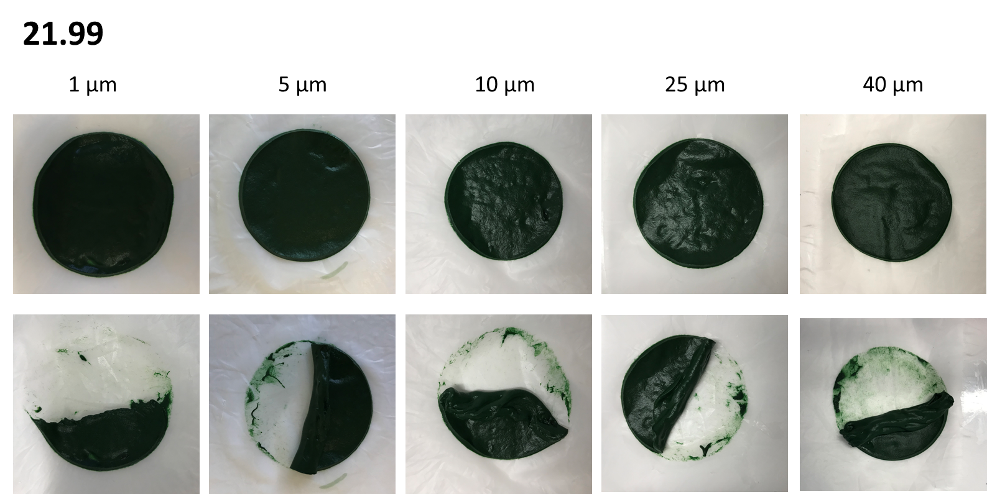
Fig. S1. Harvested biomass on membranes of different pore size after gravity filtration of the helical strain Arthrospira 21.99. Top images, intact formed cake. Bottom images, cake partially removed from membrane using a spatula.

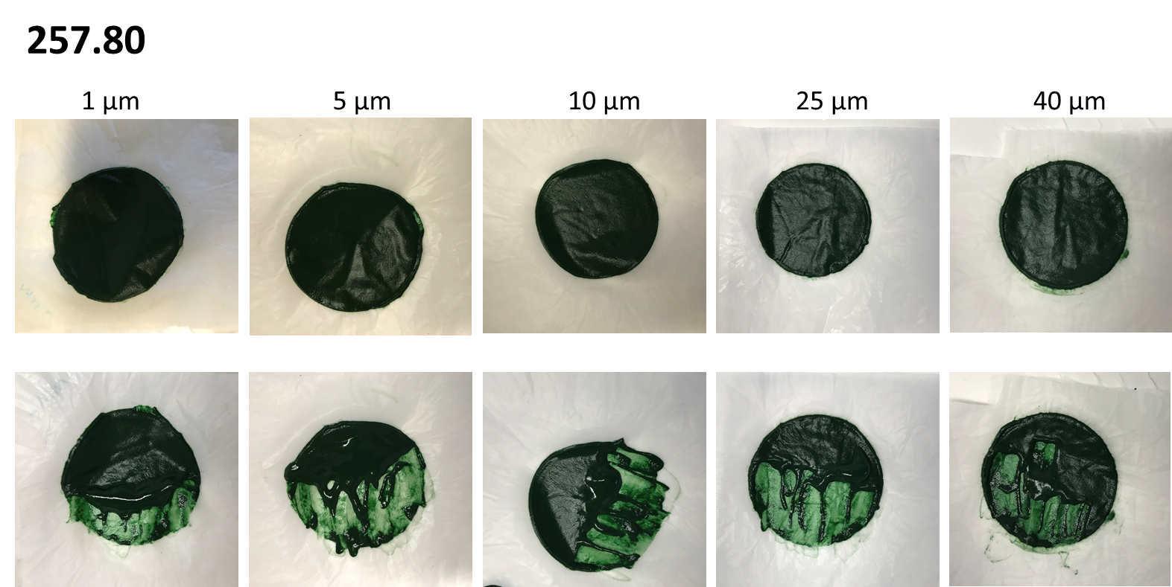

Fig. S2. Harvested biomass on membranes of different pore size after gravity filtration of the straight strain Arthrospira 257.80. Top images, intact formed cake. Bottom images, cake partially removed from membrane using a spatula.

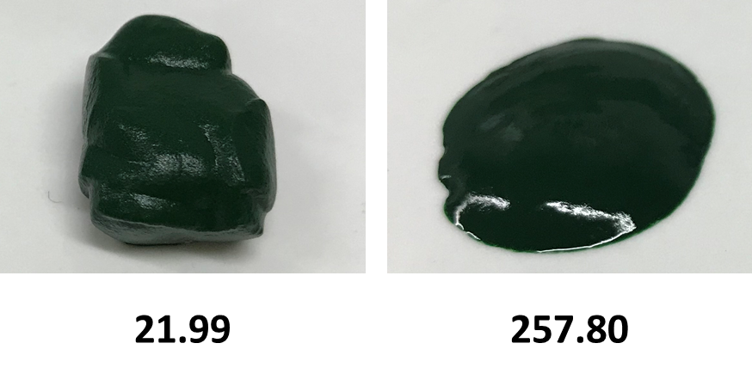
Fig. S3. Harvested biomass from the 10 µm filtration membrane after gravity filtration. Arthrospira 21.99 helical trichomes form a soft but well-shaped loose cake, while Arthrospira 257.80 straight trichomes form an irregular and liquid-texture cake.

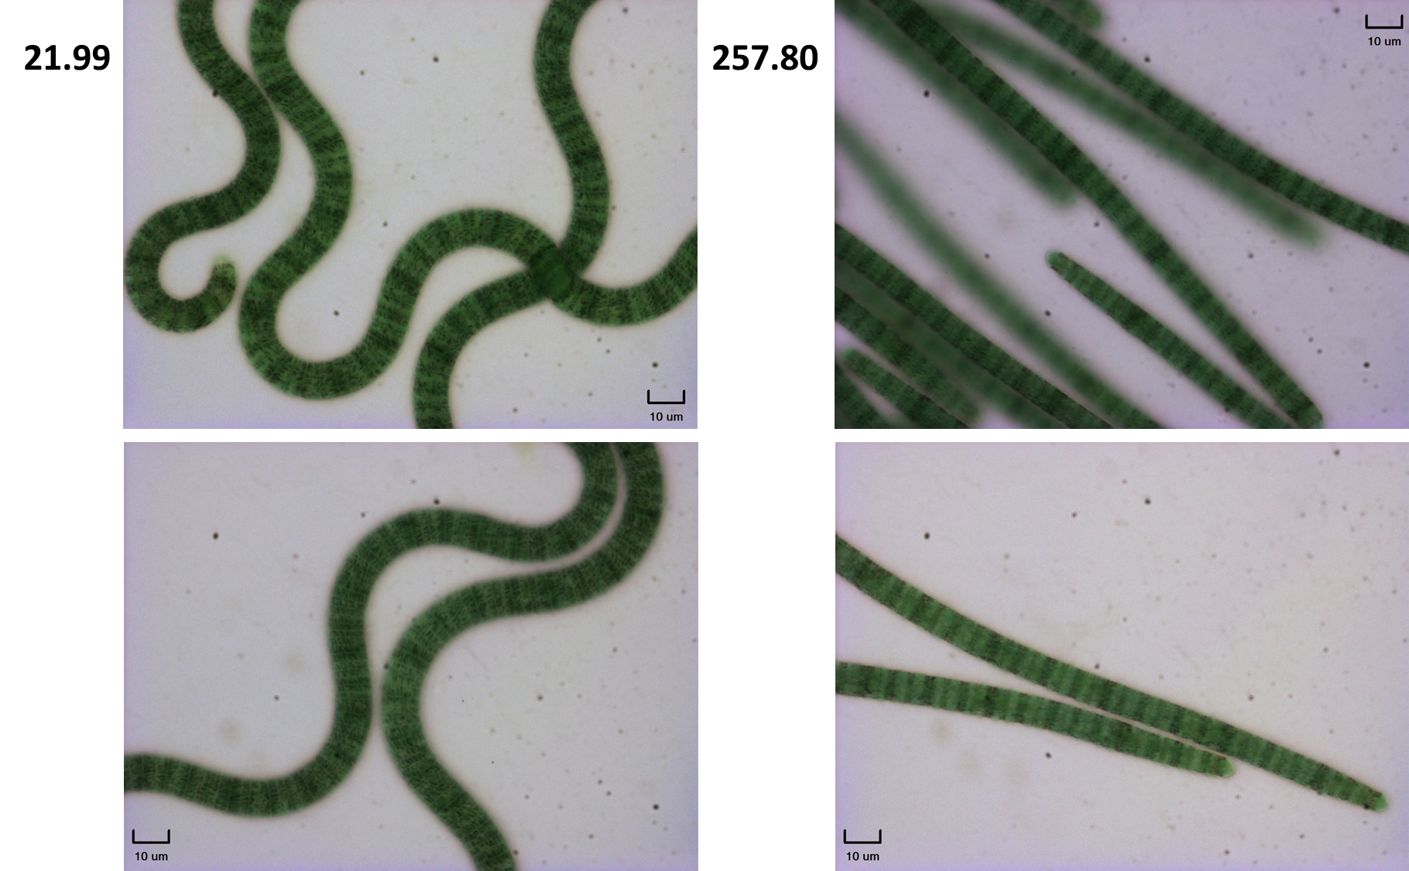
Figure S4: Microscopy images at 40x magnification. Presence of gas vacuoles (dark granulations) in trichomes of the helical strain 21.99 (left column) and in trichomes of the straight strain 257.80 (right column).

