**Supporting Document**

**Figure 1S.** Typical structures of triazines herbicides

**Figure 2S.** Sampling points along Msunduzi River, A- Camps drift, B – College road,

C- Baynespruit and D – Cedara Agricultural College

**Figure 3S.** Chromatogram of 1ppm standard of pesticides mixture

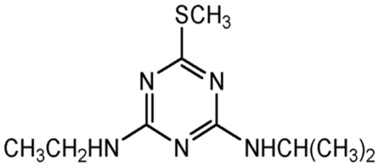 

**Ametryne Atrazine Propazine**

**Fig. 1S**

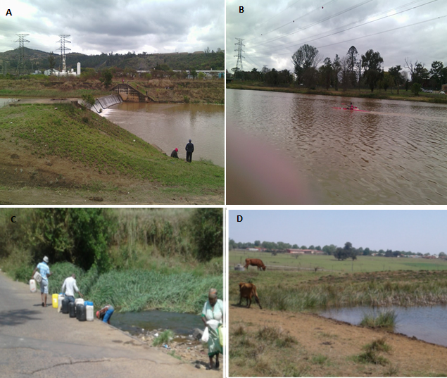

**Fig. 2S**

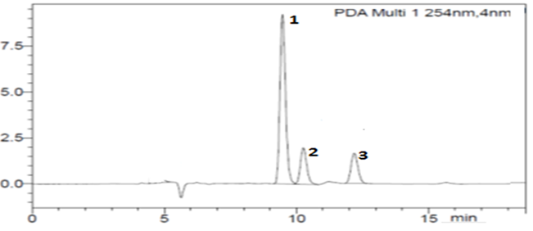

**Fig. 3S**

**Table 1S**: Physical properties of river water samples collected in Pietermaritzburg during the hot and cold season

|  |  |  |  |  |  |  |
| --- | --- | --- | --- | --- | --- | --- |
| **Sampling points along the Msunduzi River** | **Temperature (◦C)** | | **pH** | | **Conductivity (µS/cm)** | |
| **Hot** | **Cold** | **Hot** | **Cold** | **Hot** | **Cold** |
| Camps Drift | 22.2 | 22.9 | 6.81 | 7.98 | 233 | 254 |
| College Road | 22.3 | 22.4 | 7.17 | 8.32 | 237 | 264 |
| Baynespruit | 22.3 | 19.9 | 7.24 | 8.01 | 240 | 223 |
| Bishopstowe | 22.2 | 21.5 | 7.03 | 8.08 | 274 | 326 |

**Table 2S**: Physical properties of dam water samples collected in Cedara dams

|  |  |  |  |
| --- | --- | --- | --- |
| **Samples** | **Temperature (◦C)** | **pH** | **Conductivity (µS/cm)** |
| H3 (1) | 19.3 | 9.30 | 100.3 |
| H3(2) | 19.8 | 8.94 | 77.0 |
| M1 | 19.4 | 8.51 | 91.4 |
| M3 | 19.4 | 9.41 | 93.6 |
| J1 | 20.5 | 9.61 | 130.5 |

**Table 3S:** Physical properties of wastewater samples collected in Durban during the

cold season

|  |  |  |  |  |  |  |  |  |  |  |
| --- | --- | --- | --- | --- | --- | --- | --- | --- | --- | --- |
| **Samples** | **pH** | | **Conductivity (µS/cm)** | | **TDS**  **(mg/L)** | | **DO**  **(mg/L)** | | **Salinity (psu)** | |
| **Inf** | **Eff** | **Inf** | **Eff** | **Inf** | **Eff** | **Inf** | **Eff** | **Inf** | **Eff** |
| Mhlathuzana | 7.66 | 7.73 | 1089 | 813 | 540 | 406 | 0.50 | 3.22 | 0.53 | 0.41 |
| Manzimtoti | 7.59 | 7.54 | 1318 | 1371 | 667 | 688 | 0.81 | 3.54 | 0.66 | 0.68 |
| Northern | 7.56 | 7.22 | 745 | 683 | 384 | 341 | 3.45 | 2.74 | 0.38 | 0.33 |
| Mbilo | 7.78 | 7.57 | 835 | 683 | 398 | 331 | 3.02 | 4.31 | 0.39 | 0.33 |

Inf – influent and eff **–** effluent

**Table 4S:** Physical properties of samples collected in Durban during the hot season

|  |  |  |  |  |  |  |  |  |  |  |
| --- | --- | --- | --- | --- | --- | --- | --- | --- | --- | --- |
| **Samples** | **pH** | | **Conductivity (µS/cm)** | | **TDS**  **(mg/L)** | | **DO**  **(mg/L)** | | **Salinity (psu)** | |
| **Inf** | **Eff** | **Inf** | **Eff** | **Inf** | **Eff** | **Inf** | **Eff** | **Inf** | **Eff** |
| Mhlathuzana | 7.39 | 7.84 | 1062 | 783 | 529 | 361 | 0.38 | 2.66 | 0.53 | 0.37 |
| Manzimtoti | 7.53 | 7.78 | 1290 | 1279 | 636 | 653 | 0.83 | 2.72 | 0.64 | 0.66 |
| Northern | 7.66 | 7.02 | 862 | 692 | 445 | 352 | 0.17 | 0.27 | 0.45 | 0.35 |
| Mbilo | 7.46 | 7.66 | 786 | 754 | 394 | 388 | 0.24 | 2.34 | 0.38 | 0.40 |

**Table 5S:** Physical parameters of sediment samples collected along the Msunduzi River and Cedara

|  |  |  |  |  |  |  |
| --- | --- | --- | --- | --- | --- | --- |
| **Sampling points along the Msunduzi River** | **Temperature (◦C)** | | **pH** | | **Conductivity (µS/cm)** | |
| **Hot** | **Cold** | **Hot** | **Cold** | **Hot** | **Cold** |
| Camps Drift | 23.0 | 23.2 | 6.80 | 6.88 | 208 | 268 |
| College Road | 22.8 | 22.9 | 6.13 | 6.90 | 117 | 116.4 |
| Bishopstowe | 22.9 | 22.6 | 6.32 | 6.67 | 184 | 178.6 |
|  |  |  |  |  |  |  |
| **Sampling points in Cedara dam** |  |  |  |  |  |  |
| H3 (1) | 22.4 | - | 6.40 | - | 101.4 | - |
| H3(2) | 23.2 | - | 7.01 | - | 78.1 | - |
| M1 | 22.4 | - | 7.04 | - | 33.3 | - |
| M3 | 23.6 | - | 6.81 | - | 23.6 | - |
| J1 | 22.5 | - | 5.67 | - | 152.6 | - |

* = no samples were collected