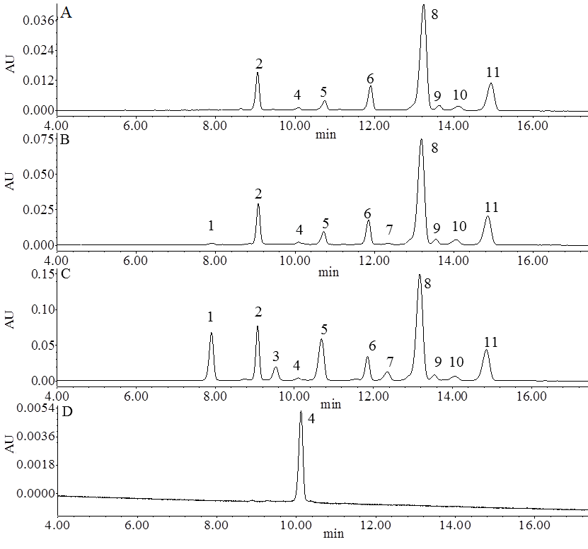

Figure S1. UPLC chromatograms of blueberry juice samples and cyanidin-3-glucoside standard. A: control, no pretreatment; B: hot water bath blanching for 5 min; C: steam blanching for 3 min; D: cyanidin-3-glucoside standard.

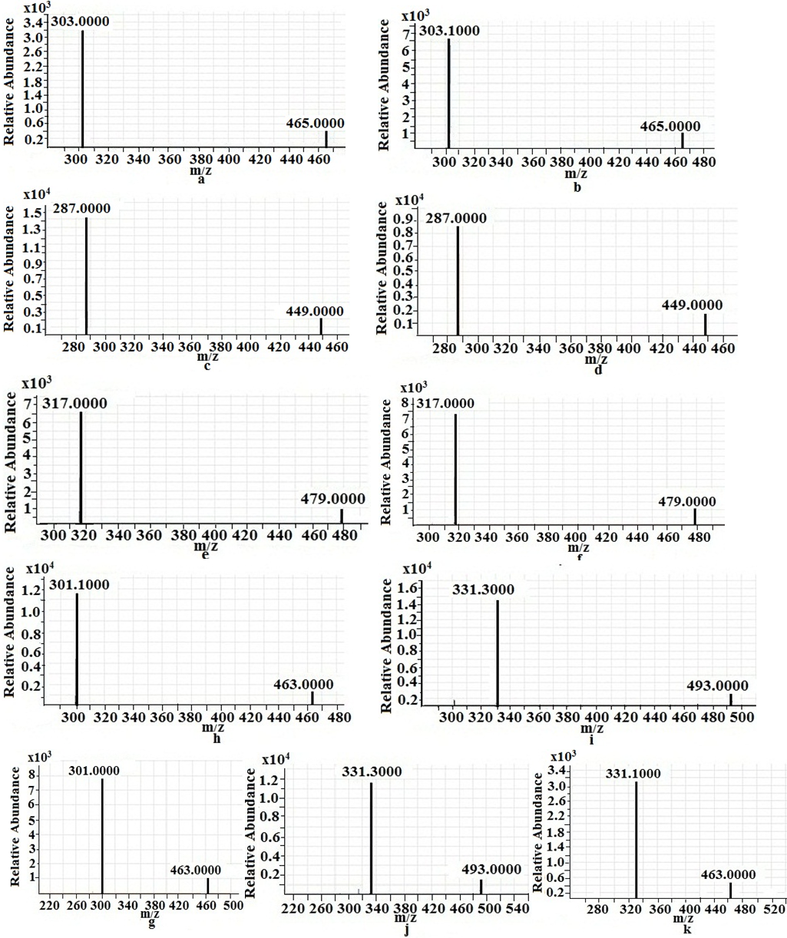

Figure S2. The mass spectrometry information of blueberry juice. a: Delphinidin-3-galactoside; b: Delphinidin-3-glucoside; c: Cyanidin-3-galactoside; d: Cyanidin-3-glucoside; e: Petunidin-3-galactoside; f: Petunidin-3-glucoside; h: Peonidin-3-glucoside; i: Malvidin-3-galactoside; g: Peonidin-3-galactoside; j: Malvidin-3-glucoside; k: Malvidin-3- arabinoside.

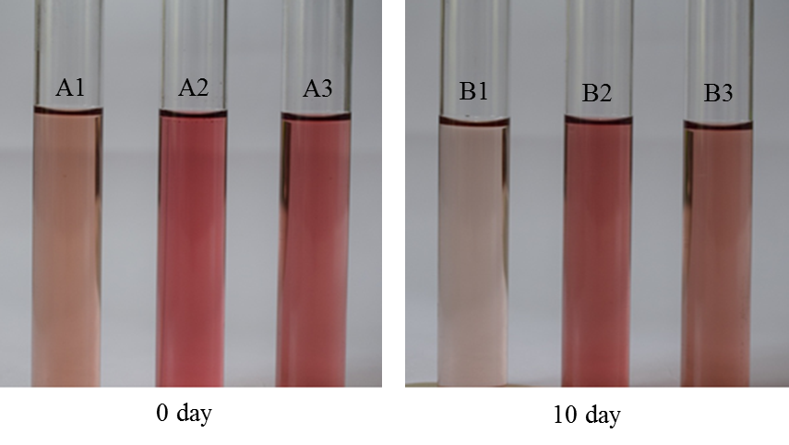
Figure S3. Photographs of stored juice samples diluted 16 times on day 0 (A1: untreated blueberries; A2: steam blanching (3 min) blueberries; A3: hot water bath blanching (5 min) blueberries) and day 10 (B1: untreated blueberries; B2: steam blanching (3 min) blueberries; B3: hot water bath blanching (5 min) blueberries.

