Supplementary Material
Understanding airborne contaminants produced by different fuel packages during training fires

Figures
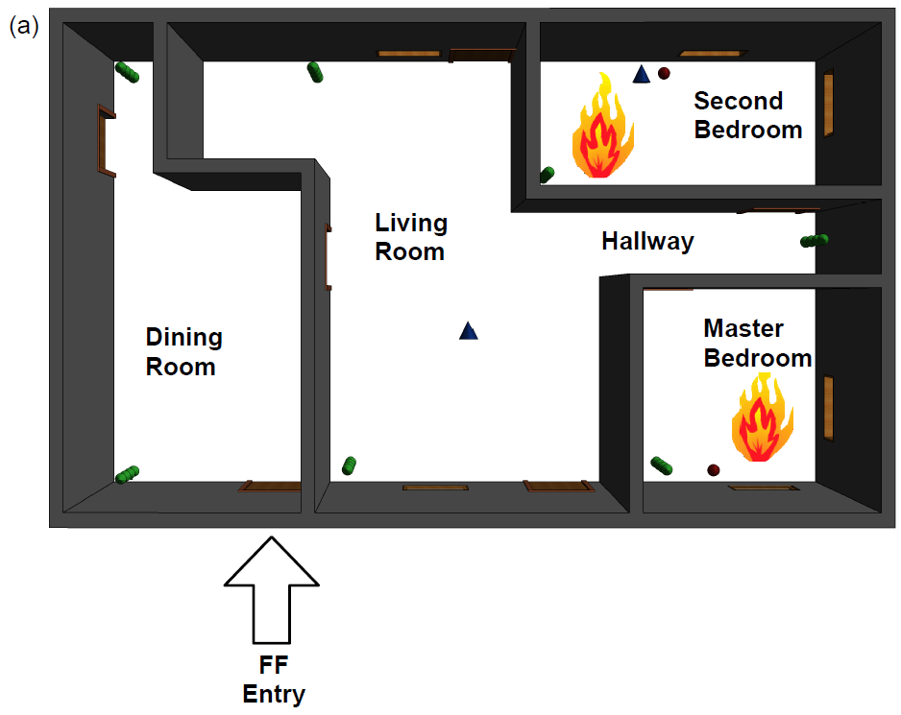
Fig. S1. Pallet and straw /simulated smoke floor plan

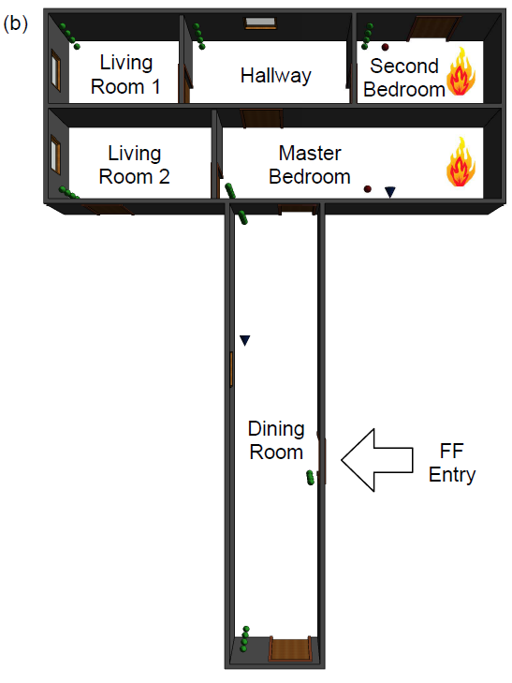
Fig. S2 OSB floor plan

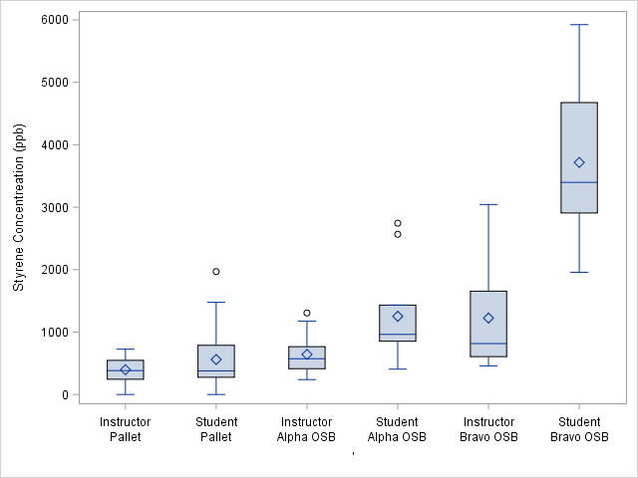
Figure S3. Styrene personal air concentrations measured on instructors and students by fuel type. The box and whiskers provide the minimum, 25th percentile, median, 75th percentile and maximum values. Exposures are significantly below NIOSH STEL (100,000 ppb).

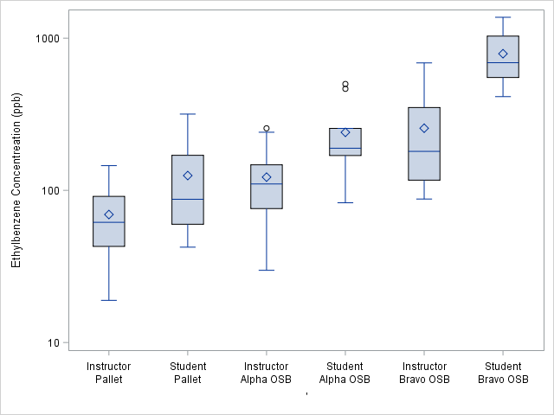
Figure S4. Ethylbenzene personal air concentrations measured on instructors and students by fuel type. The box and whiskers provide the minimum, 25th percentile, median, 75th percentile and maximum values. Exposures are significantly below NIOSH STEL (125,000 ppb).

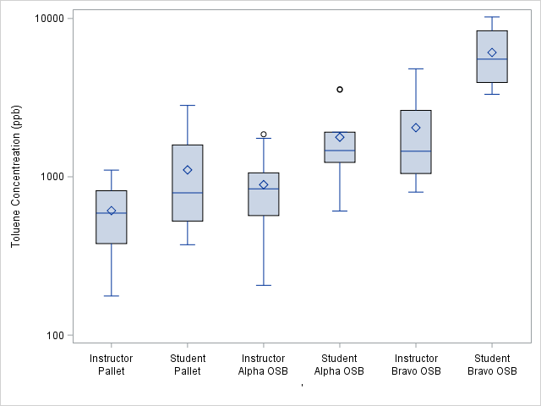
Figure S5. Toluene personal air concentrations measured on instructors and students by fuel type. The box and whiskers provide the minimum, 25th percentile, median, 75th percentile and maximum values. Exposures are significantly below NIOSH STEL (150,000 ppb).

Tables

Table S1. Summary of personal air sampling for firefighters and instructors
Analyte |  | Job assignment | Type of Participant | n | Duration of scenario range (min) | Sampling time during scenario range (min) | Median Sampling time during scenario (min)
HCN | Pallet and straw |  | Instructor | 28 | 26 – 30 | 8 – 30 | 26
 |  |  | Firefighter | 19 | 10 – 12 | 3 – 12 | 10
 | Alpha OSB |  | Instructor | 12 | 25 – 28 | 8 – 28 | 27
 |  |  | Firefighter | 9 | 11 – 13 | 5 – 13 | 9
 | Bravo OSB |  | Instructor | 11 | 25 – 31 | 25 – 31 | 25
 |  |  | Firefighter | 6 | 12 | 12 | 12
Total PAHs | Pallet and straw |  | Instructor | 17 | 26 – 30 | 14 - 30 | 26
 |  |  | Firefighter | 9 | 10 – 12 | 4 – 12 | 10
 | Alpha OSB |  | Instructor | 9 | 25 – 28 | 13 – 28 | 27
 |  |  | Firefighter | 5 | 11 – 13 | 5 – 13 | 10
 | Bravo OSB |  | Instructor | 9 | 25 – 31 | 12 – 30 | 25
 |  |  | Firefighter | 6 | 12 – 14 | 12 – 14 | 12
BTEX | Pallet and straw |  | Instructor | 28 | 26 – 30 | 18 – 30 | 26
 |  |  | Firefighter | 20 | 10 – 12 | 3 – 12 | 10
 | Alpha OSB |  | Instructor | 12 | 25 – 28 | 11 – 28 | 25
 |  |  | Firefighter | 11 | 11 – 13 | 5 – 13 | 10
 | Bravo OSB |  | Instructor | 12 | 25 – 31 | 25 – 33 | 30
 |  |  | Firefighter | 10 | 12 – 14 | 6 – 14 | 12

Table S2: Average personal air concentrations of individual PAHs by percent of total PAHs
 | Pallet and Straw | Bravo OSB | Alpha OSB
Compound  (IARC^{A}) | Percent of total PAHs
Anthracene (3) | 1 | 2 | 2
Acenaphthene (3) | 1 | 1 | 1
Benzo(a)anthracene (2B) | 1 | 1 | 1
Benzo(a)pyrene (1) | 1 | 1 | 1
Benzo(b)fluoranthene (2B) | 1 | 1 | 1
Benzo(g,h,i)perylene (3) | 1 | < 1 | < 1
Benzo(k)fluoranthene (2B) | < 1 | < 1 | < 1
Chrysene (2B) | 1 | 1 | 1
Dibenzo(a,h)anthracene (2A) | 2 | 1 | 1
Fluorene (3) | 6 | 9 | 7
Fluoranthene (3) | 5 | 4 | 5
Indeno(1,2,3-cd)pyrene (2B) | 1 | 1 | < 1
Naphthalene (2B) | 68 | 66 | 66
Phenanthrene (3) | 7 | 8 | 10
Pyrene (3) | 4 | 4 | 4
Total PAHs | 100 | 100 | 100
- IARC classification categories: 1= Carcinogenic to humans, 2A=Probably carcinogenic to humans, 2B=Possibly carcinogenic to humans, 3=Not classifiable as to its carcinogenicity to humans

Table S3. VOCs air concentrations by location and type of fuel package
VOCs | Fuel Type | Location | n | ND (%) | Median | Range
Propene (ppm) | Pallet | Downwind | 4 | 0 | 0.0045 | 0.0029 – 0.013
 |  | Background | 2 | 50 | 0.000457 | < 0.000354 – 0.000560
 |  | Inside Structure | 4 | 0 | 4.10 | 3.70 – 4.60
 | Simulated smoke | Background | 2 | 50 | 0.000677 | < 0.000354 – 0.001
 |  | Inside Structure | 4 | 25 | 0.00091 | < 0.000354 – 0.0037
 | Bravo OSB | Background | 1 | 100 | < 0.000354 | < 0.000354
 |  | Downwind | 2 | 0 | 0.029 | 0.017 – 0.041
 |  | Inside Structure | 2 | 0 | 1.04 | 0.087 – 2.00
 | OSB | Background | 1 | 100 | < 0.000354 | < 0.000354
 |  | Downwind | 2 | 0 | 0.0084 | 0.0075 – 0.0093
 |  | Inside Structure | 2 | 0 | 1.24 | 0.770 – 1.70
Chloromethane (ppm) | Pallet | Downwind | 4 | 0 | 0.00565 | 0.0049 – 0.013
 |  | Background | 2 | 0 | 0.000665 | 0.00061 – 0.00072
 |  | Inside Structure | 4 | 0 | 5.15 | 3.30 – 6.90
 | Simulated smoke | Background | 2 | 0 | 0.000735 | 0.00062 – 0.00085
 |  | Inside Structure | 4 | 0 | 0.000805 | 0.00067 – 0.00093
 | Bravo OSB | Background | 1 | 100 | 0.001 | 0.001
 |  | Downwind | 2 | 0 | 0.00385 | 0.0027 – 0.0050
 |  | Inside Structure | 2 | 0 | 0.887 | 0.074 – 1.70
 | Alpha OSB | Background | 1 | 0 | 0.0007 | 0.0007
 |  | Downwind | 2 | 0 | 0.0054 | 0.0042 – 0.0066
 |  | Inside Structure | 2 | 0 | 0.615 | 0.590 – 0.640
Acetone (ppm) | Pallet | Downwind | 4 | 0 | 0.00875 | 0.0075 – 0.023
 |  | Background | 2 | 0 | 0.00535 | 0.0048 – 0.0059
 |  | Inside Structure | 4 | 0 | 4.55 | 3.60 – 5.50
 | Simulated smoke | Background | 2 | 0 | 0.0207 | 0.0054 – 0.036
 |  | Inside Structure | 4 | 0 | 0.0425 | 0.034 – 0.051
 | Bravo OSB | Background | 1 | 0 | 0.022 | 0.022
 |  | Downwind | 2 | 0 | 0.014 | 0.010 – 0.018
 |  | Inside Structure | 2 | 0 | 0.632 | 0.063 – 1.200
 | Alpha OSB | Background | 1 | 0 | 0.0050 | 0.0050
 |  | Downwind | 2 | 0 | 0.0089 | 0.0078 – 0.010
 |  | Inside Structure | 2 | 0 | 0.775 | 0.720 – 0.830

