Supplemental figures and tables

Table S1. The p-values based on three-way analysis of variance (factors = ± hairy vetch, ± charcoal and two moisture steps) of the inorganic-N data (total inorganic-N, ammonium-N (NH₄⁺-N) and nitrate-N (NO₃⁻-N)) for each sampling day. The significances are shown as * (p < 0.05), *** (p < 0.001).

Source | Df
 |  | Total inorganic-N
 |  | Day 3 | Day 11 | Day 18 | Day 28
Hairy vetch | 1 | *** | *** | *** | ***
Moisture | 1 |  |  |  | **
Charcoal | 1 |  |  |  | *
Hairy vetch * Moisture | 1 |  |  |  | **
Hairy vetch * Charcoal | 1 |  |  |  | *
Moisture * Charcoal | 1
Hairy vetch * Moisture * Charcoal | 1
Residuals | 16
 |  | NH₄⁺-N
 |  | Day 3 | Day 11 | Day 18 | Day 28
Hairy vetch | 1 | *** | *** | *** | ***
Moisture | 1 |  |  |  | *
Charcoal | 1 |  |  | * | *
Hairy vetch * Moisture | 1 |  |  |  | *
Hairy vetch * Charcoal | 1 |  |  | * | *
Moisture * Charcoal | 1
Hairy vetch * Moisture * Charcoal | 1
Residuals | 16
 |  | NO₃⁻-N
 |  | Day 3 | Day 11 | Day 18 | Day 28
Hairy vetch | 1 | *** | *** | ** | ***
Moisture | 1 |  |  |  | **
Charcoal | 1 | *
Hairy vetch * Moisture | 1 |  |  |  | ***
Hairy vetch * Charcoal | 1 | **
Moisture * Charcoal | 1 |  |  |  | *
Hairy vetch * Moisture * Charcoal | 1 | * |  |  | *
Residuals | 16

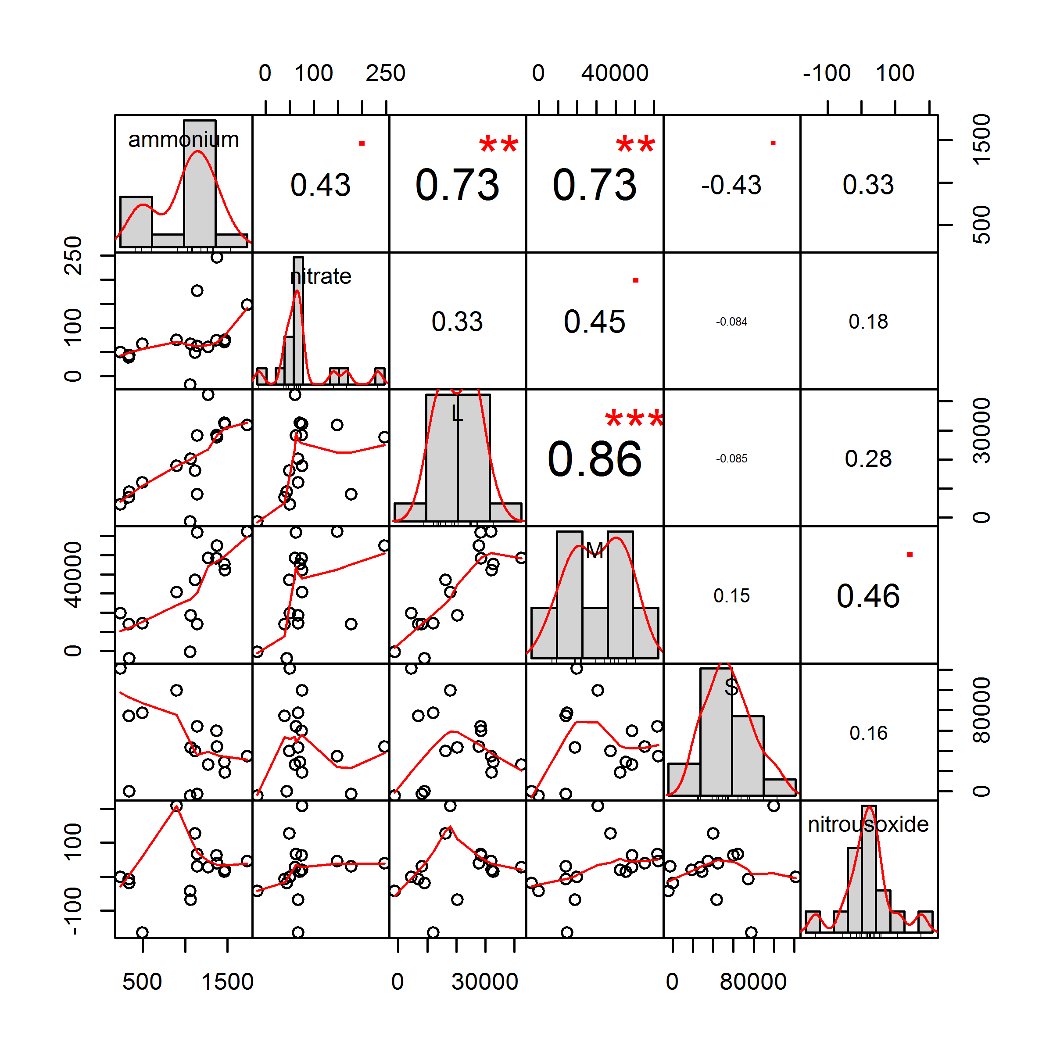
Figure S1. The Pearson’s correlation coefficients among the measured soil properties. Each value is the difference between with and without hairy vetch treatments (with hairy vetch − without hairy vetch). The letter L, M and S express the fraction of the inorganic-N. The significance (p values) is expressed as “.” , “*”, “**” and “***” for p < 0.1, < 0.05, <0.01 and <0.001, respectively.

