Supporting Information

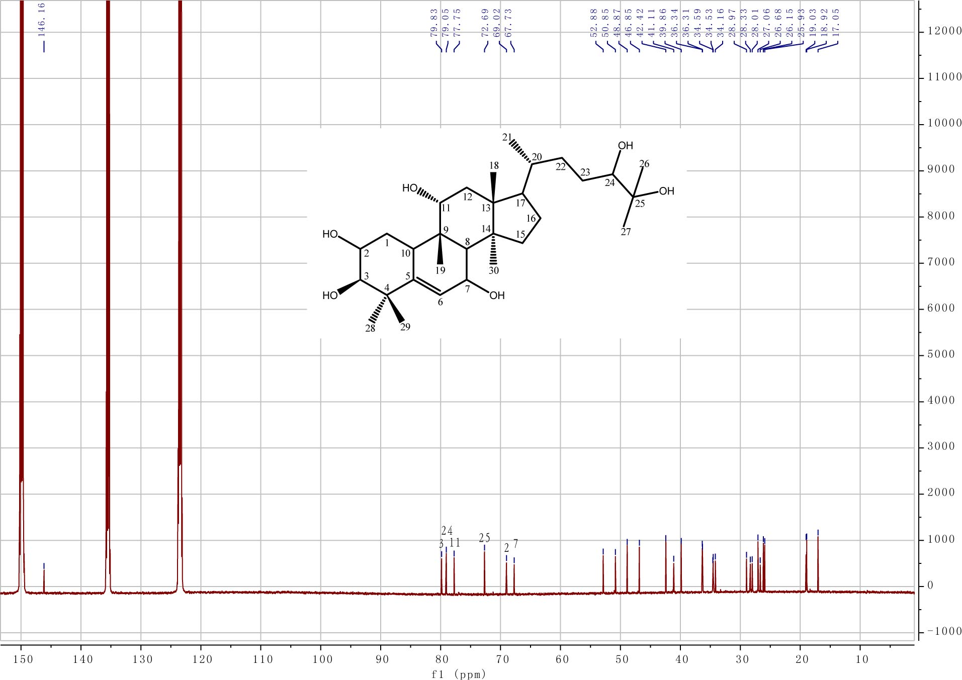
Fig. S1. ¹³C NMR of compound 1.
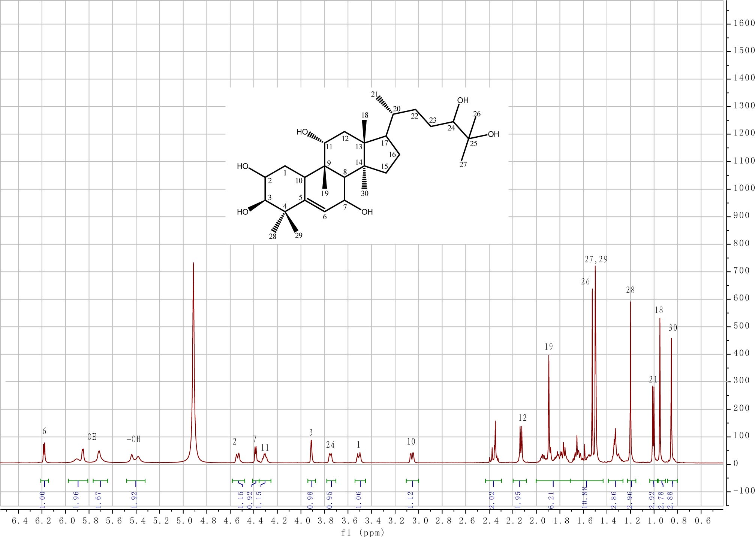
Fig. S2. ¹H NMR of compound 1.
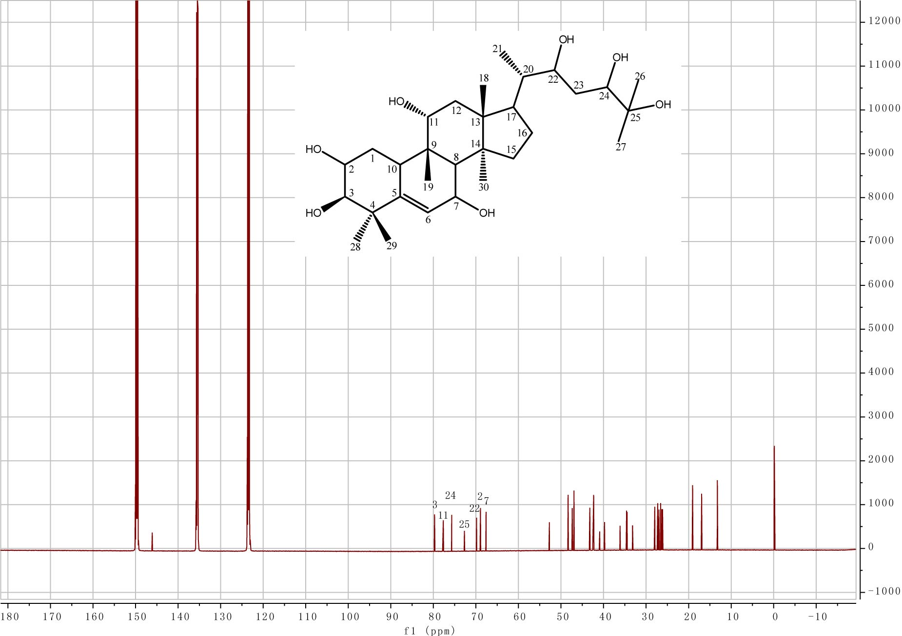
Fig. S3. ¹³C NMR of compound 2.

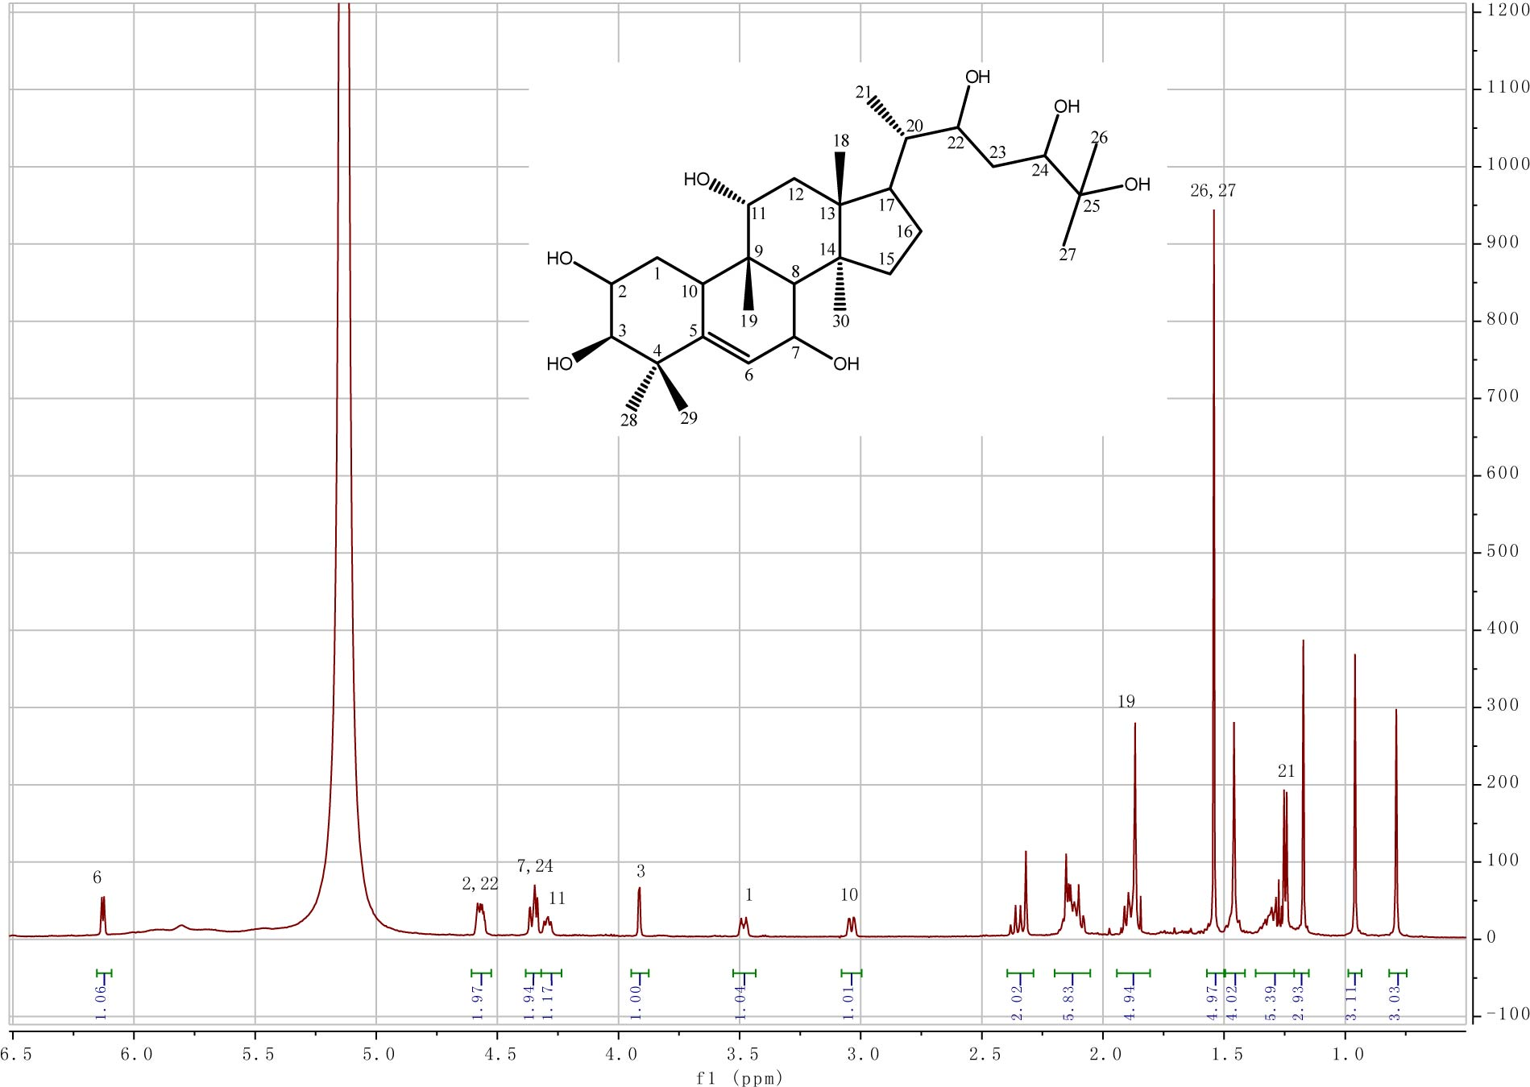

Fig. S4. ¹H NMR of compound 2.
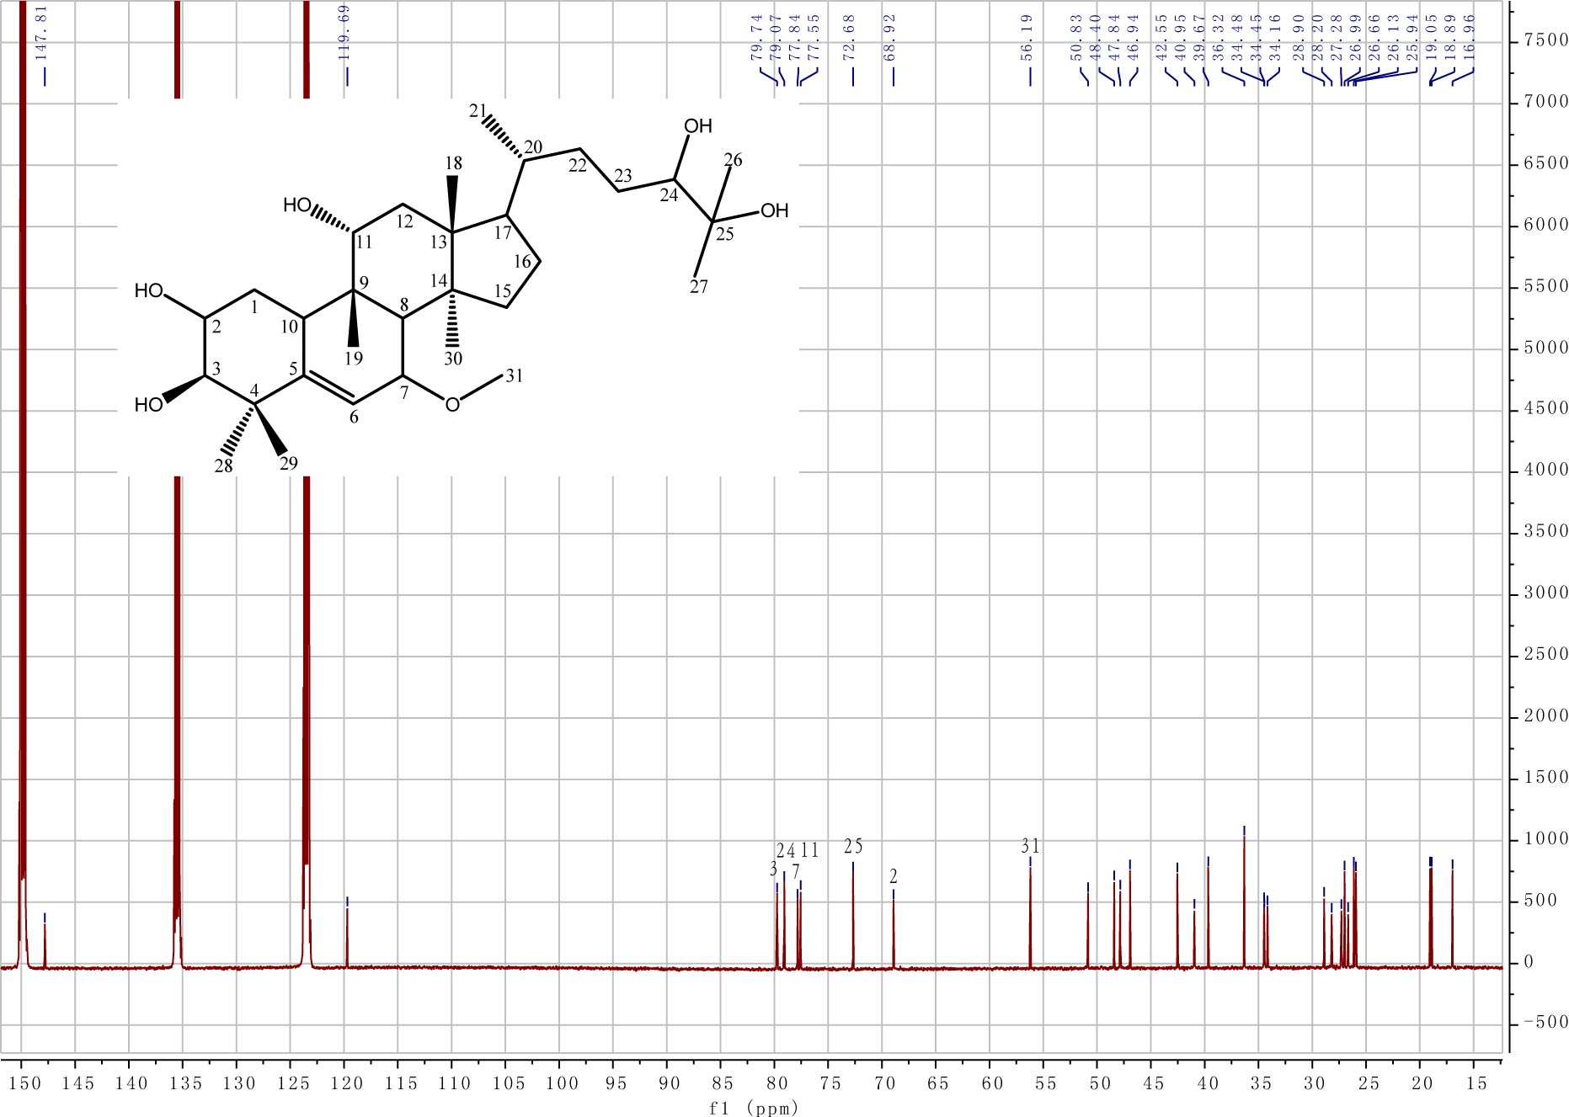
Fig. S5. ¹³C NMR of compound 3.
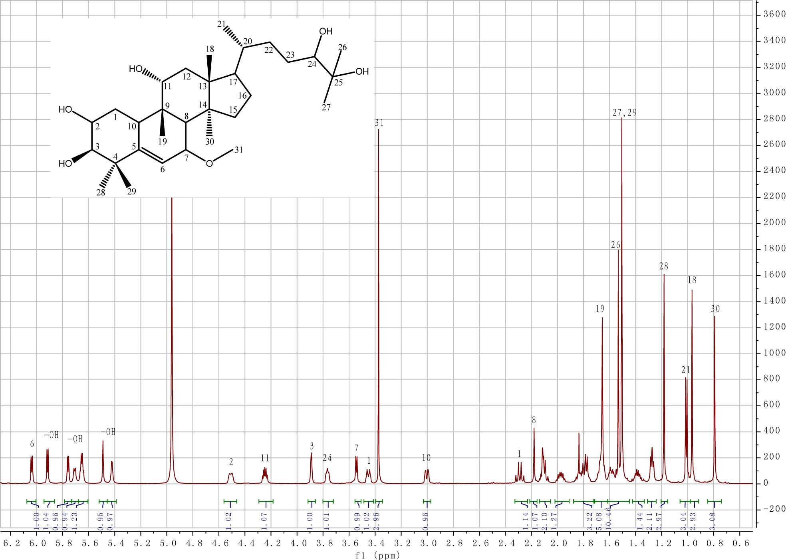
Fig. S6. ¹H NMR of compound 3.

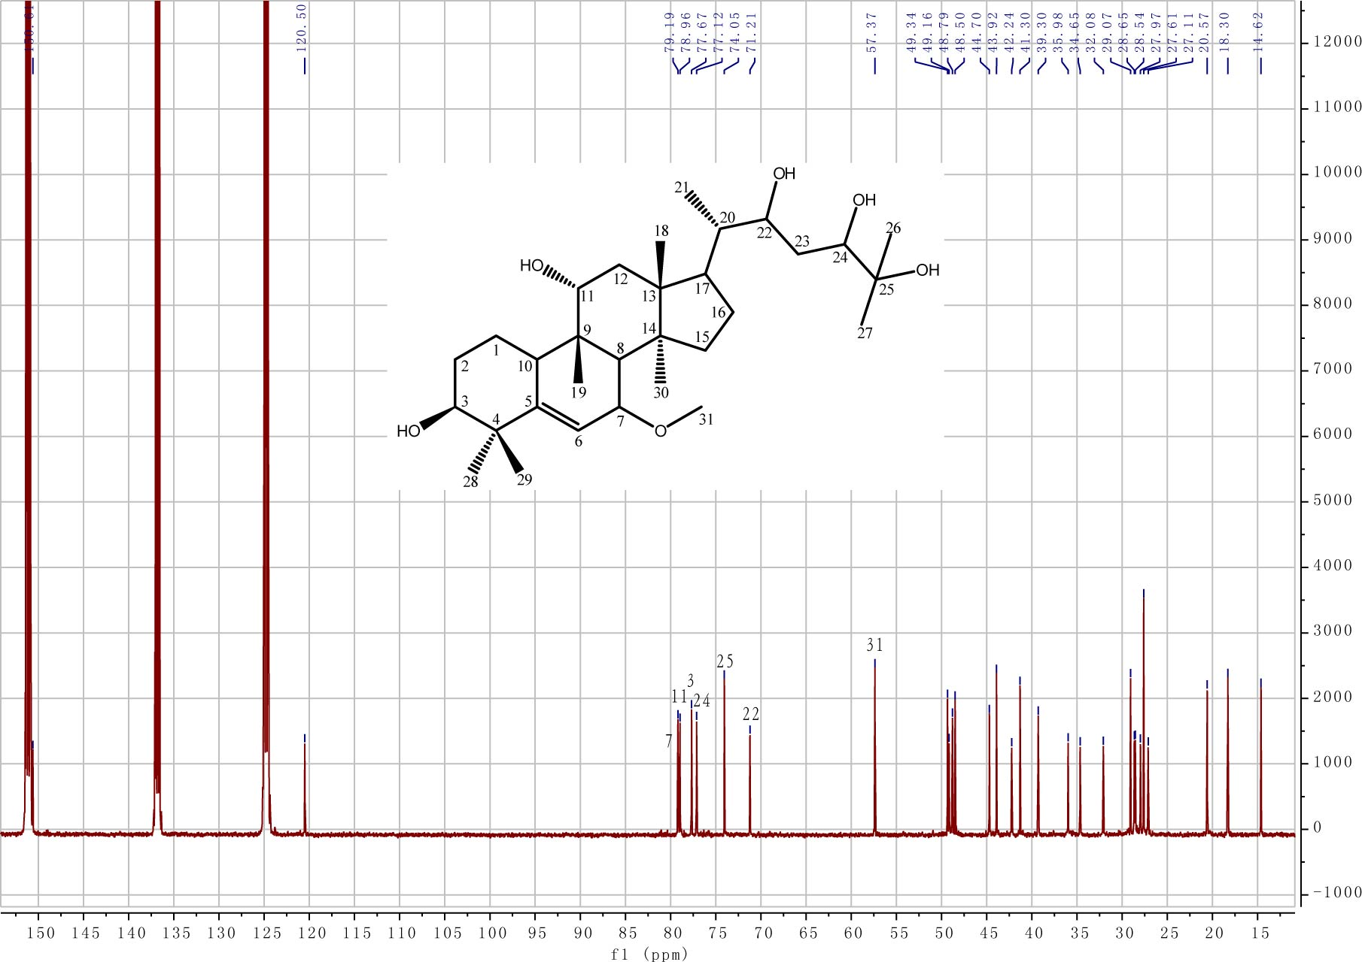
Fig. S7. ¹³C NMR of compound 4.

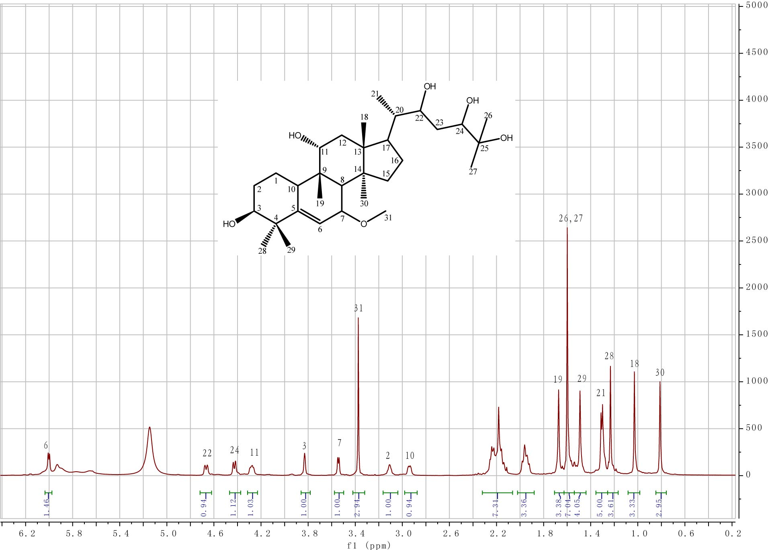
Fig. S8. ¹H NMR of compound 4.

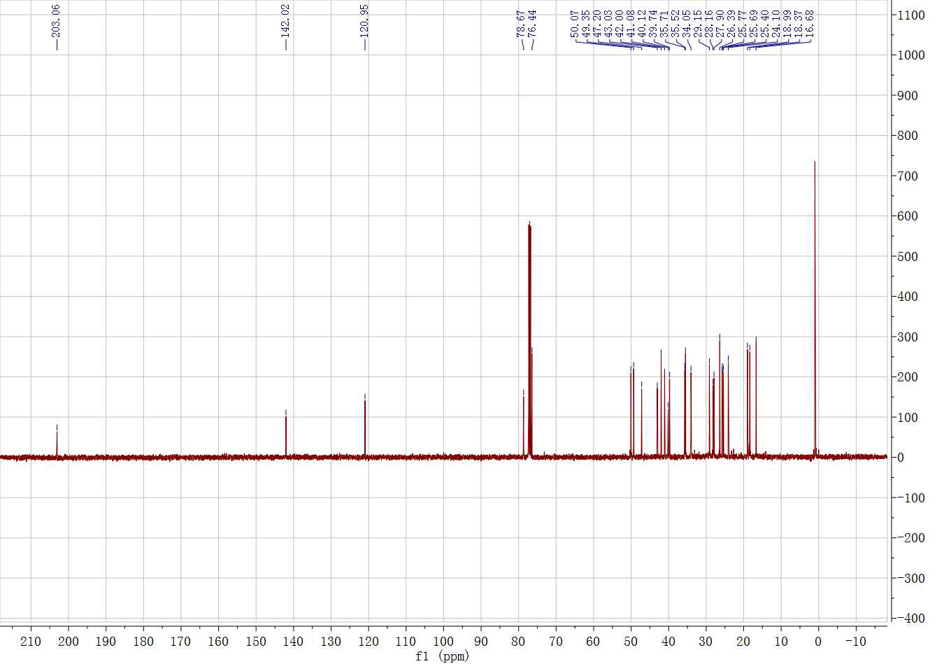
Fig. S9. ¹³C NMR of compound 5.

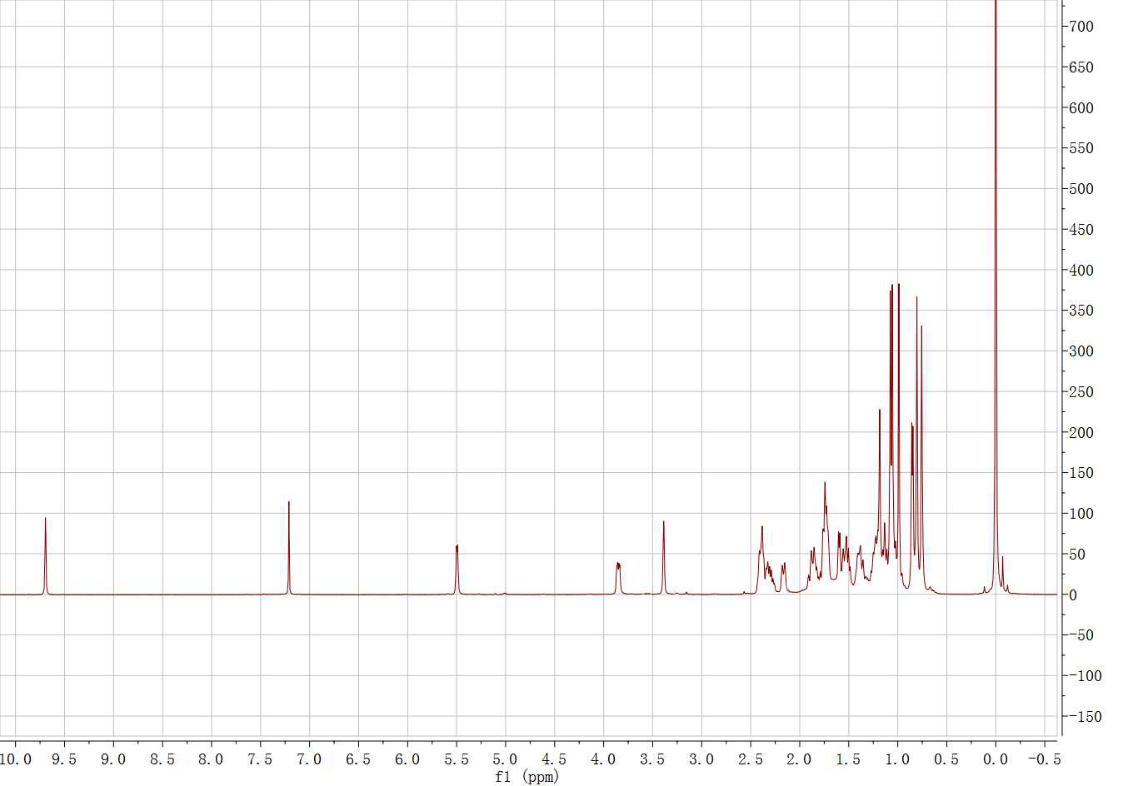
Fig. S10. ¹H NMR of compound 5.

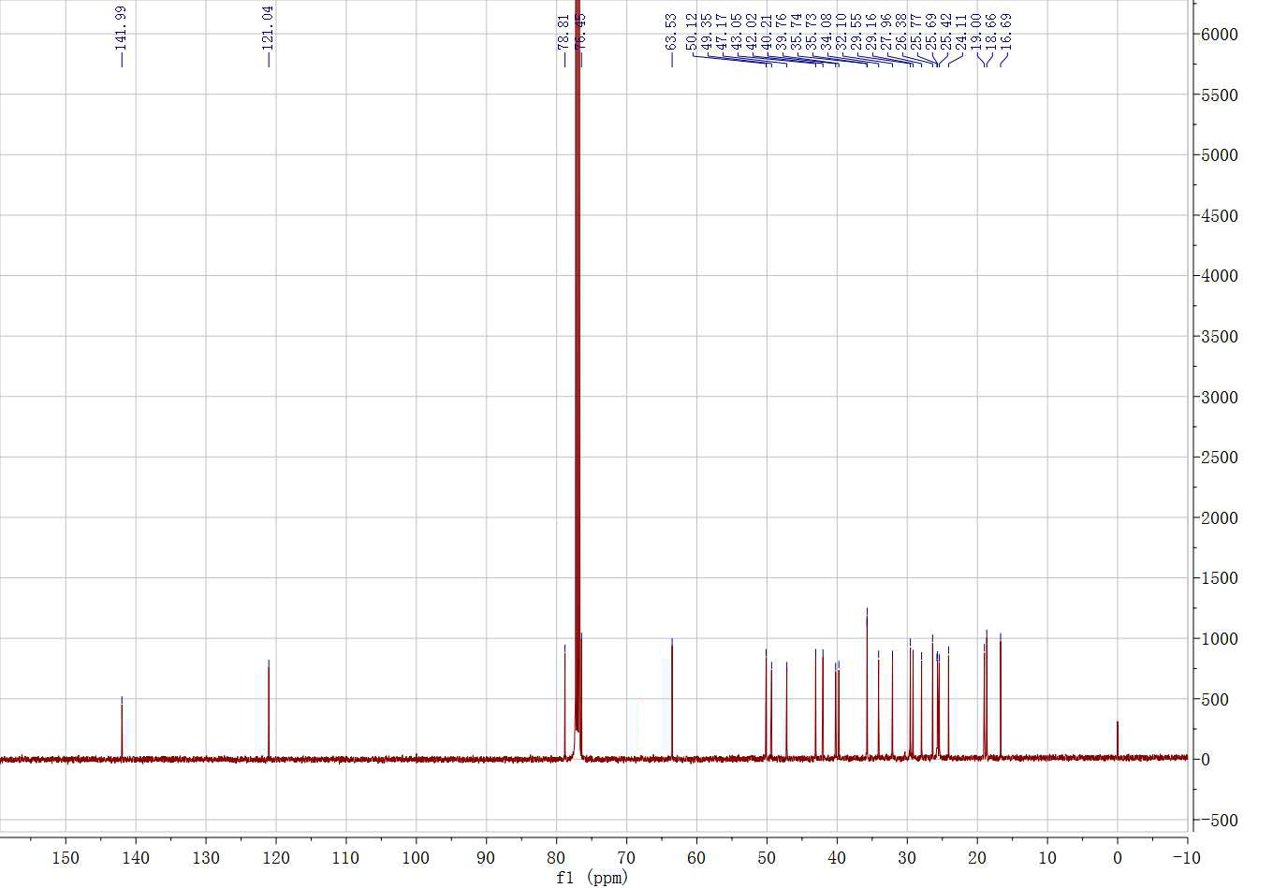
Fig. S11. ¹³C NMR of compound 6.

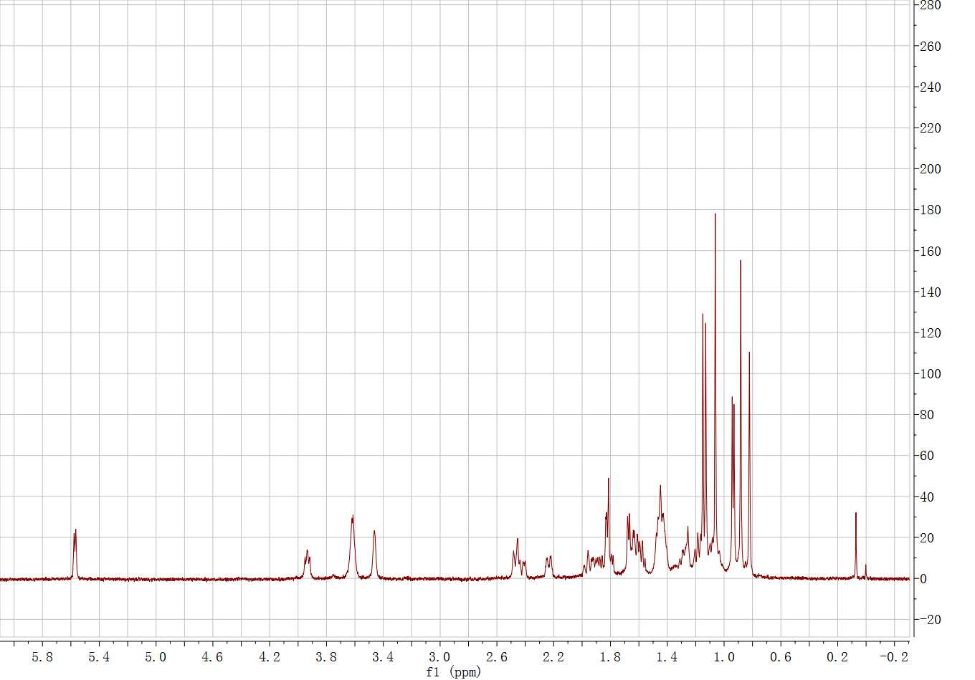

Fig. S12. ¹H NMR of compound 6.

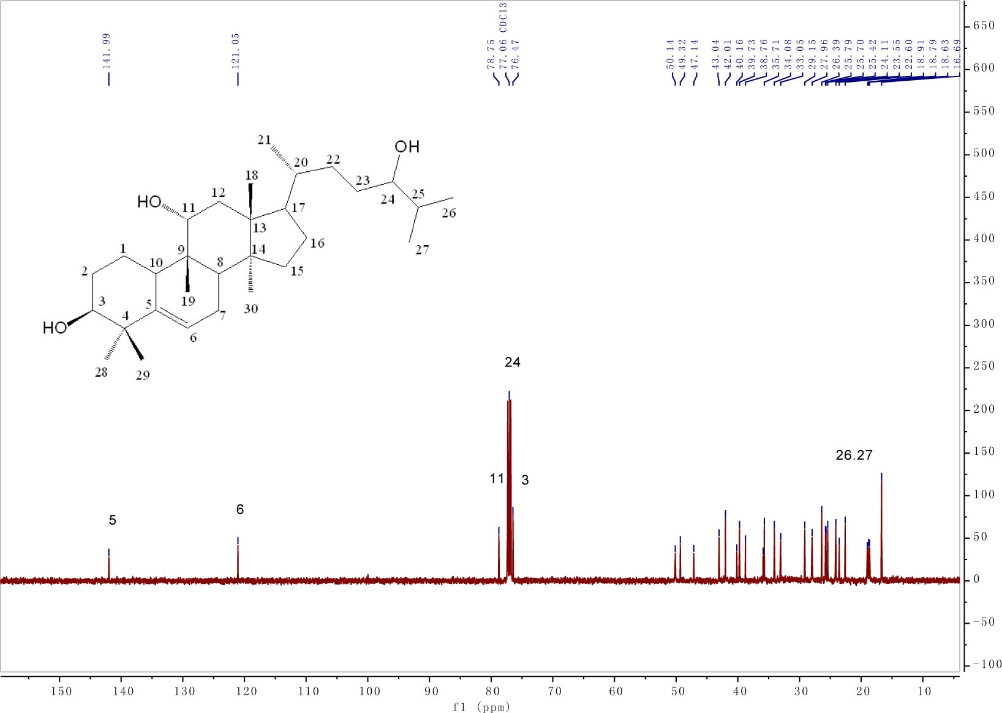
Fig. S25. ¹³C NMR of compound 7.
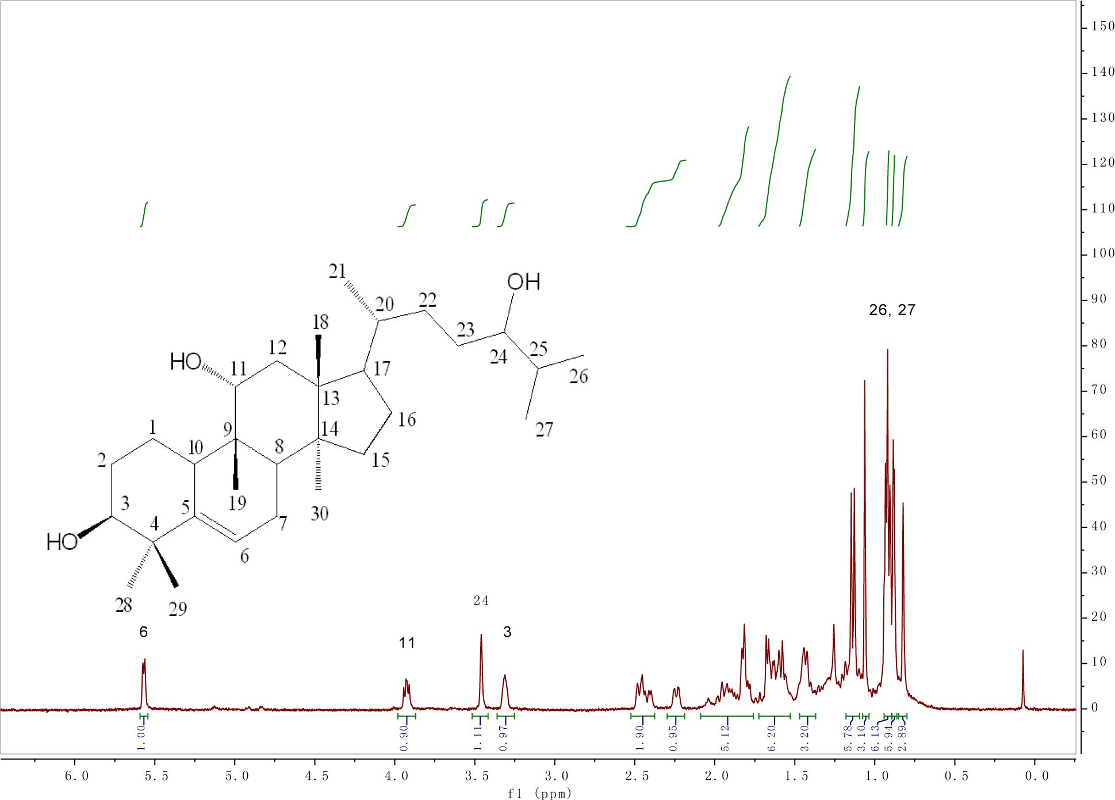
Fig. S26. ¹H NMR of compound 7.
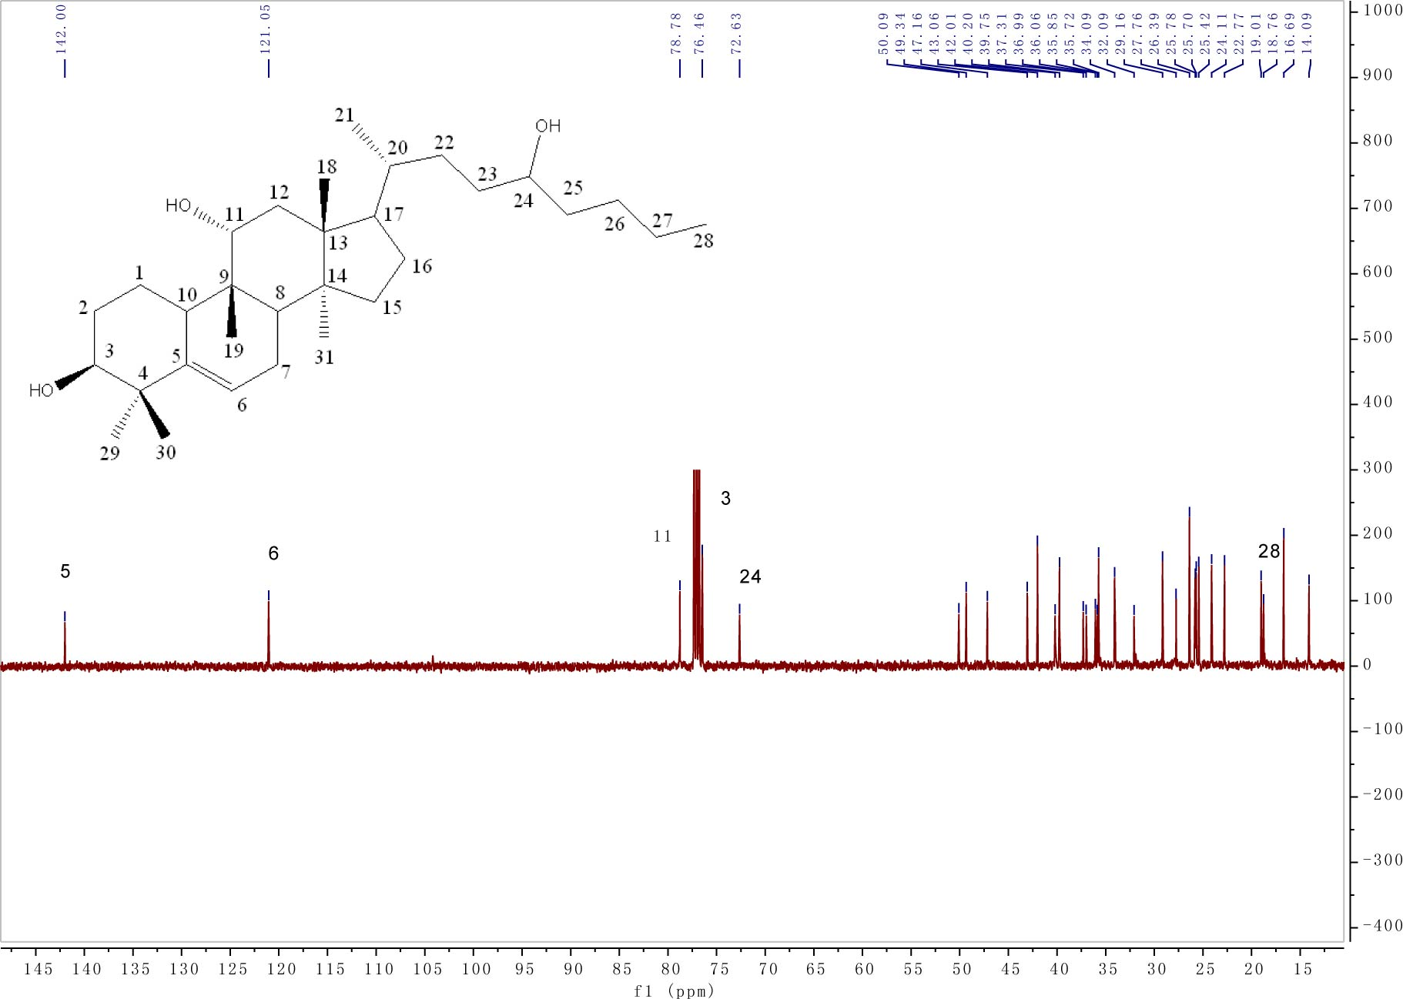
Fig. S27. ¹³C NMR of compound 8.

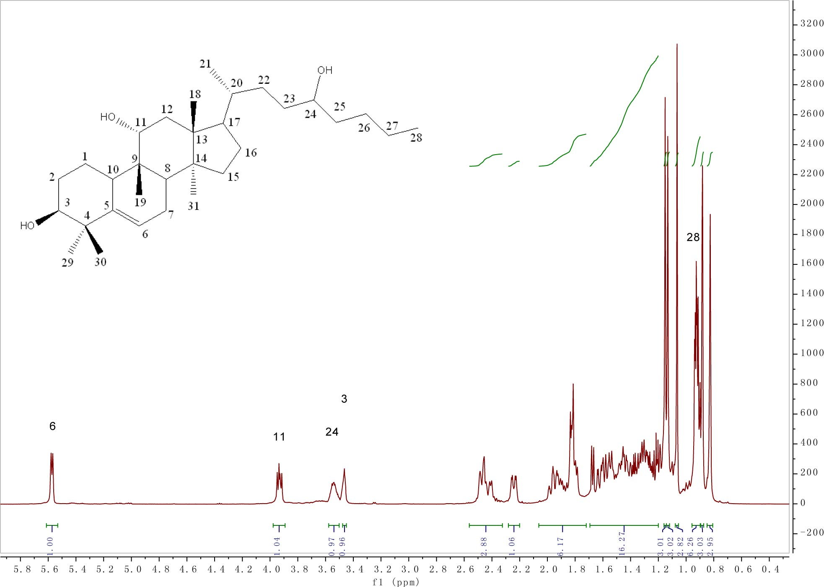
Fig. S28. ¹H NMR of compound 8.
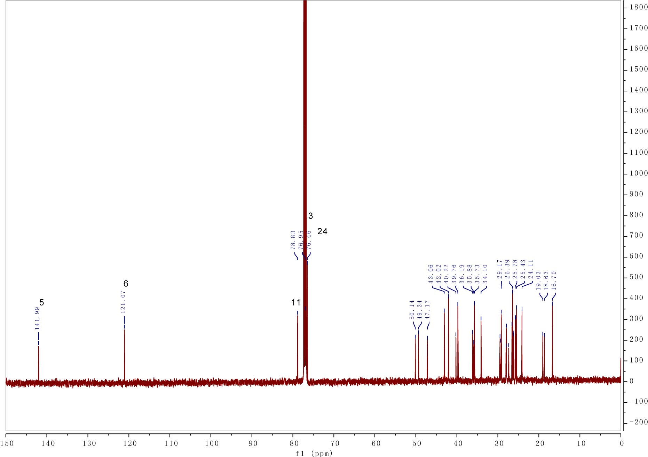
Fig. S29. ¹³C NMR of compound 9.

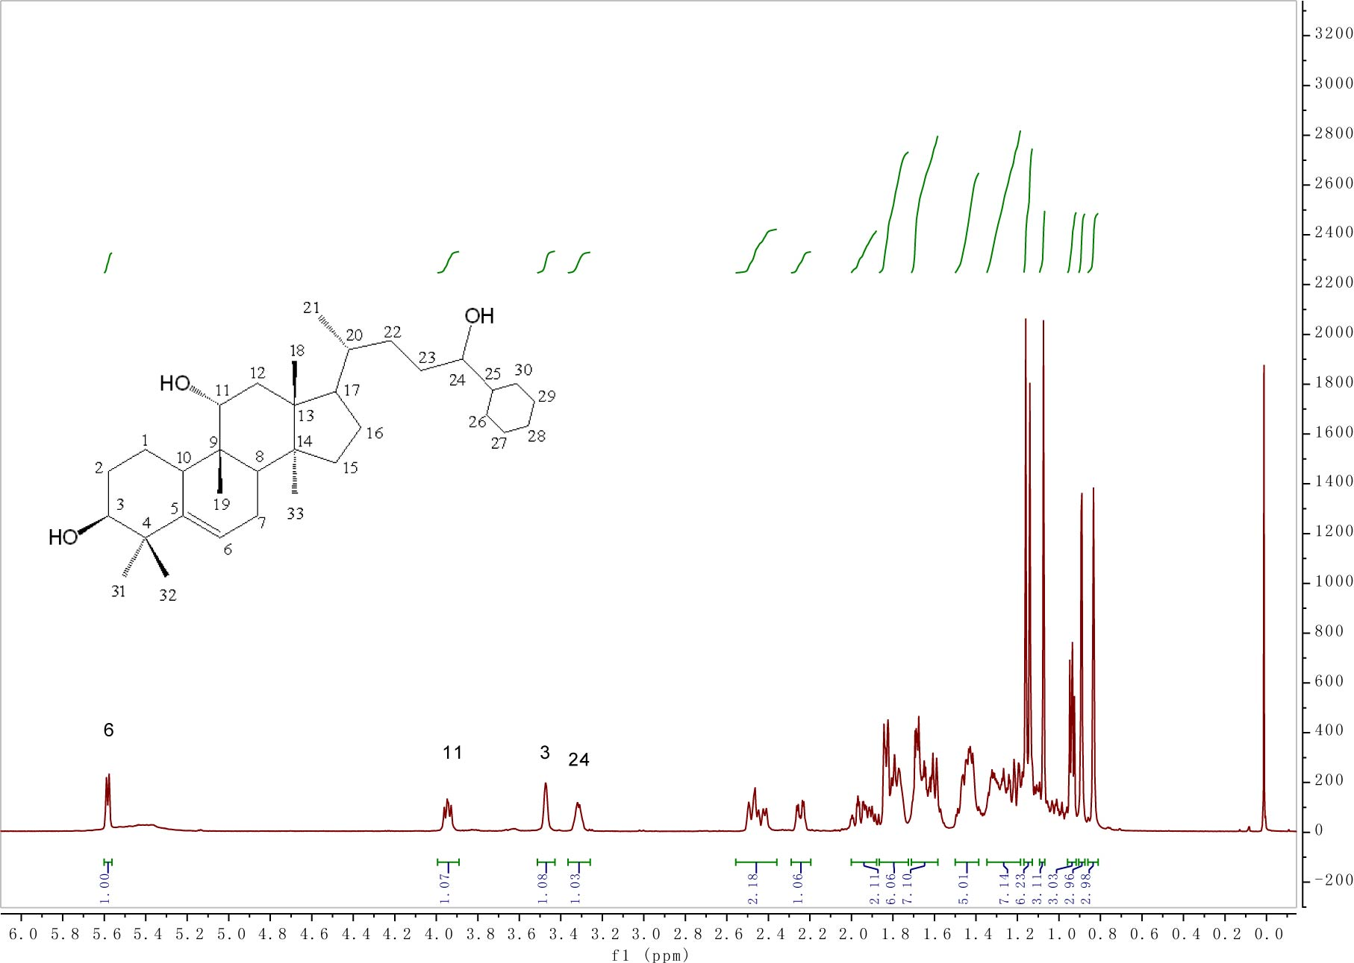
Fig. S30. ¹H NMR of compound 9.
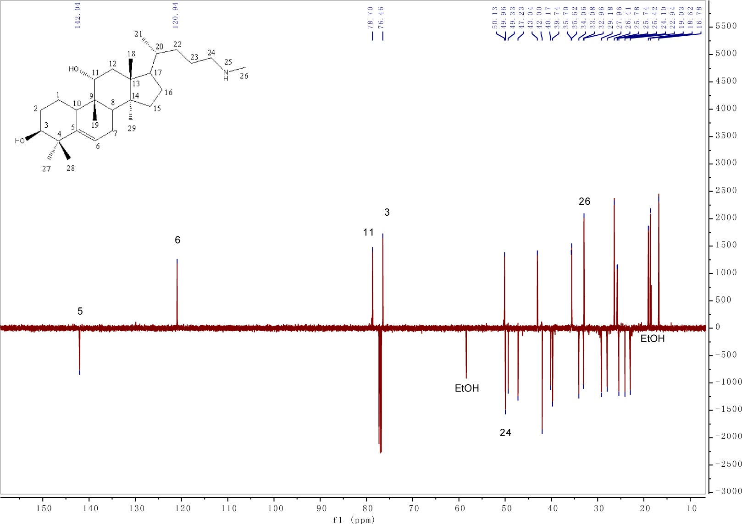
Fig. S17. ¹³C NMR (DEPTQ) of compound 10.

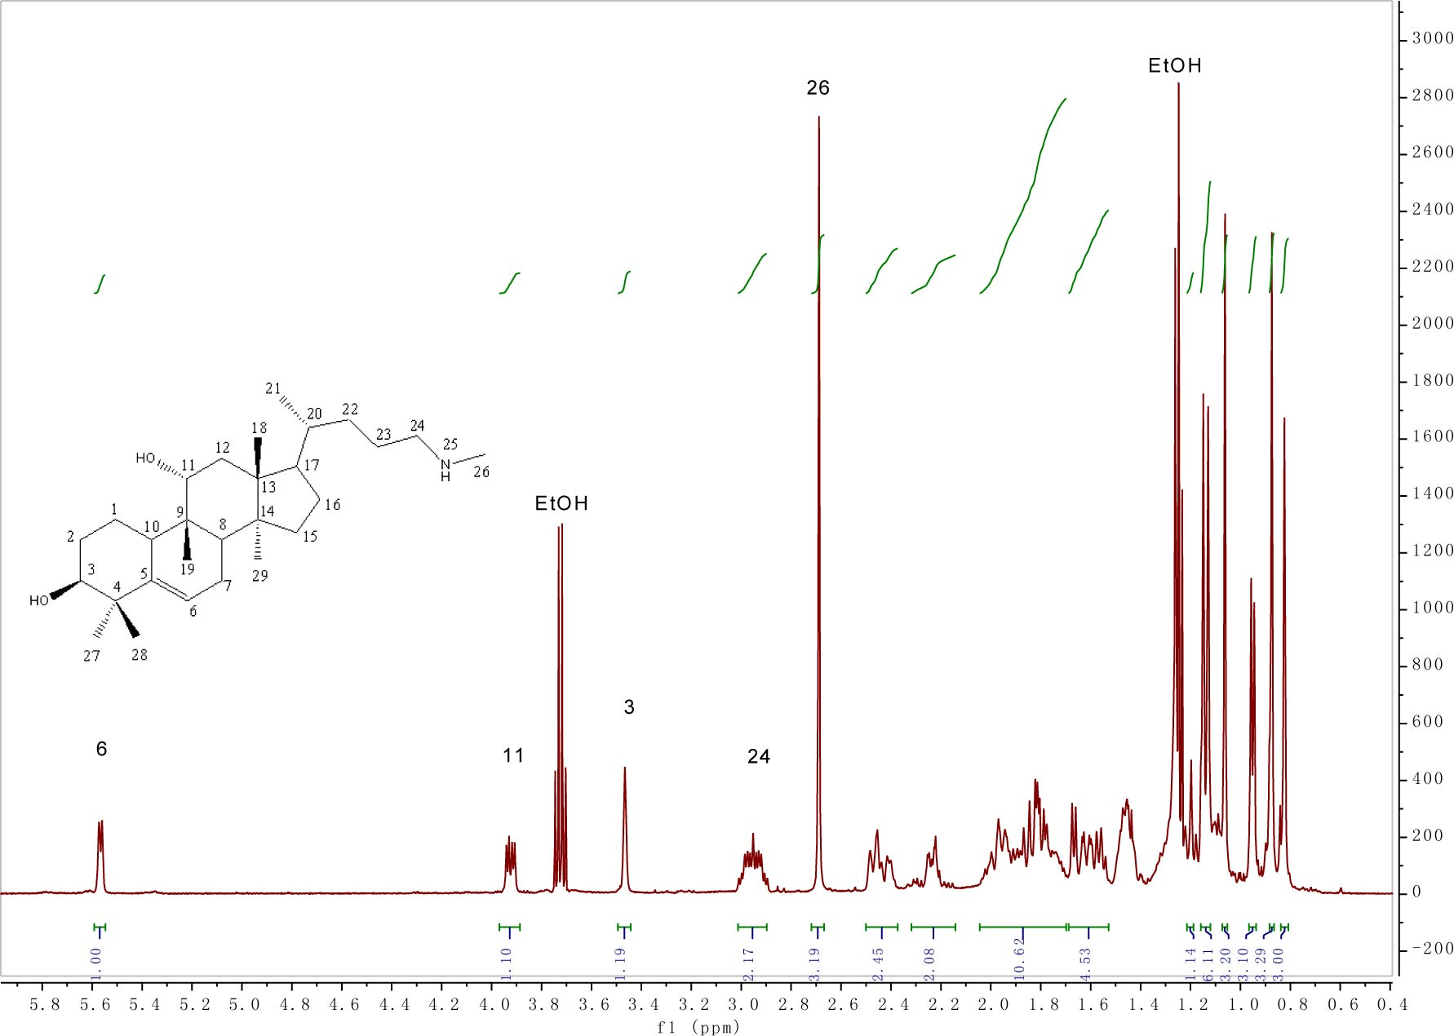
Fig. S18. ¹H NMR of compound 10.
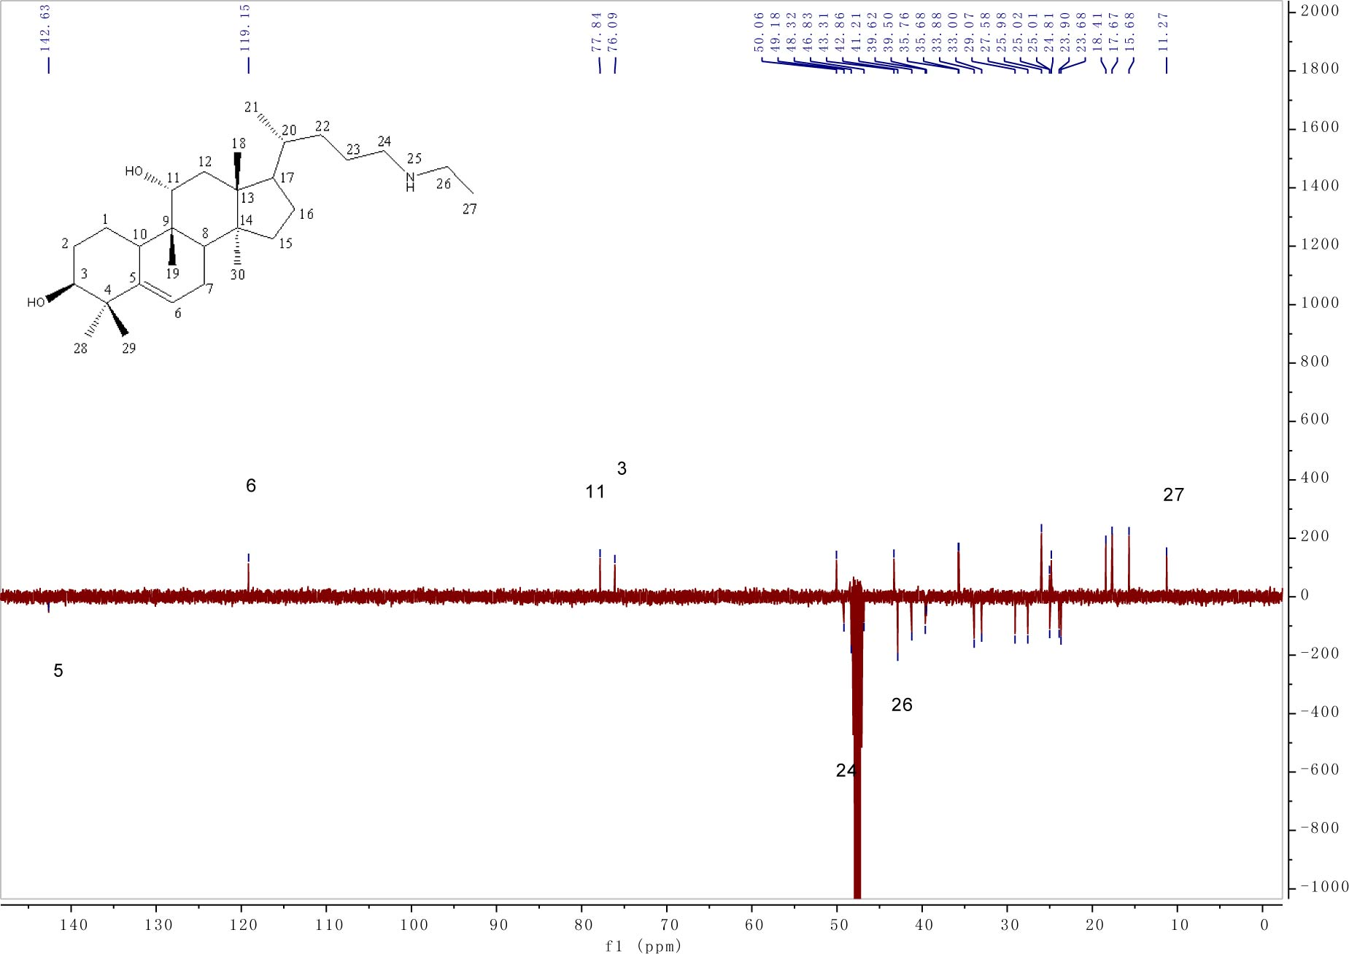
Fig. S19. ¹³C NMR (DEPTQ) of compound 11.

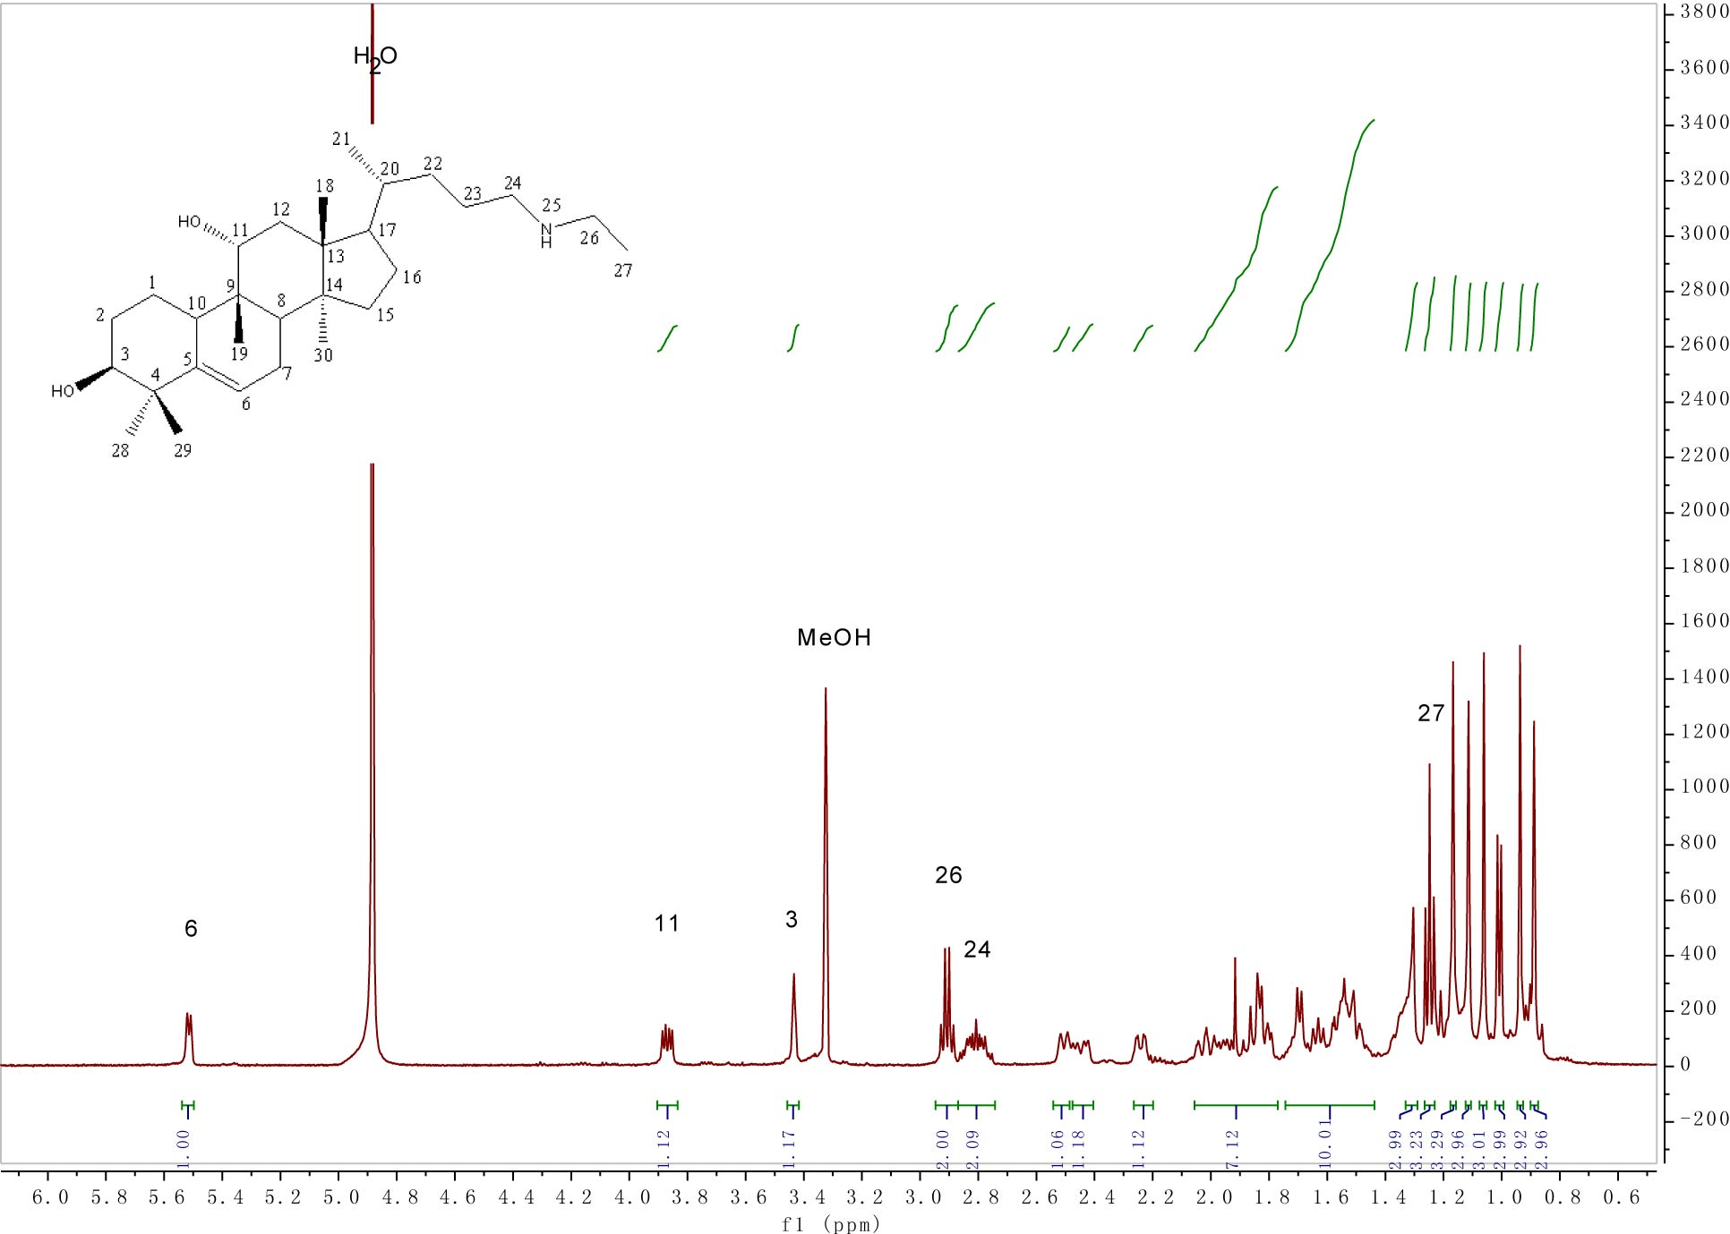

Fig. S20. ¹H NMR of compound 11.
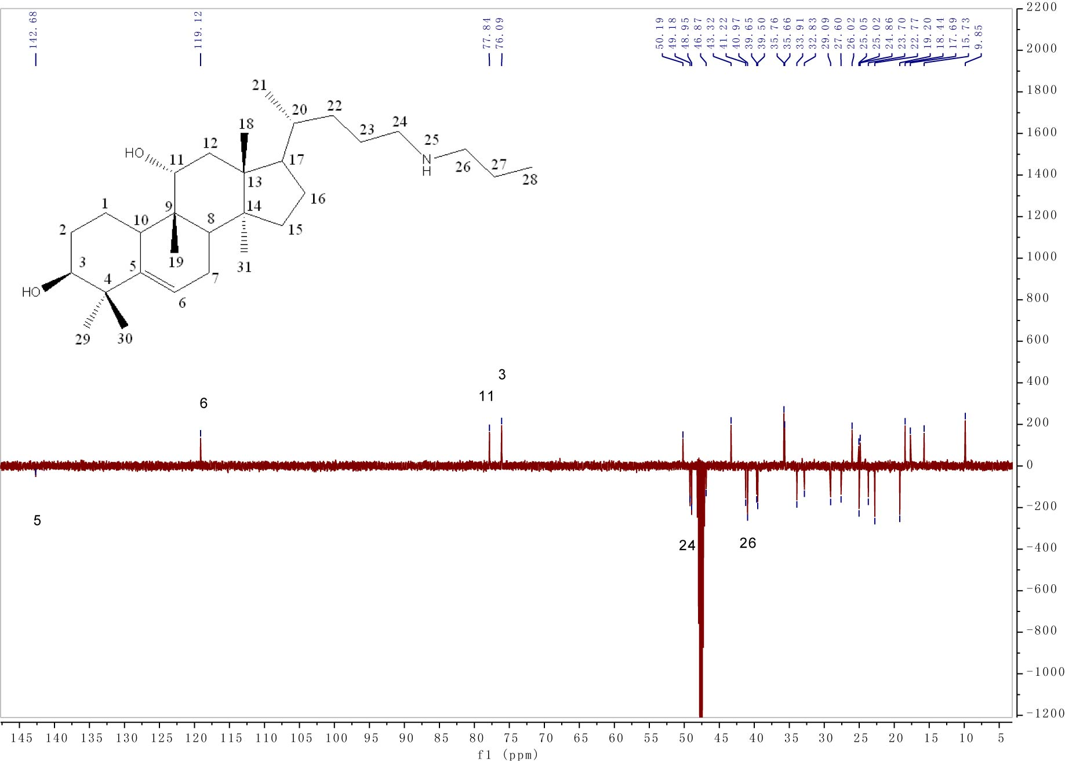
Fig. S21. ¹³C NMR (DEPTQ) of compound 12.

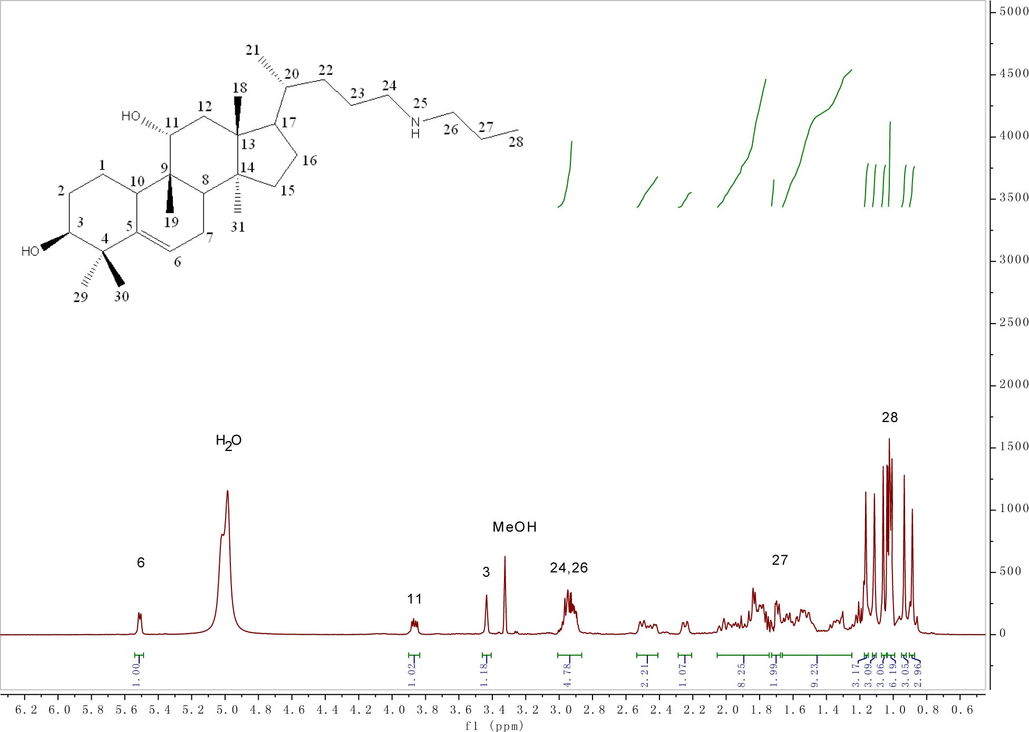
Fig. S22. ¹H NMR of compound 12.
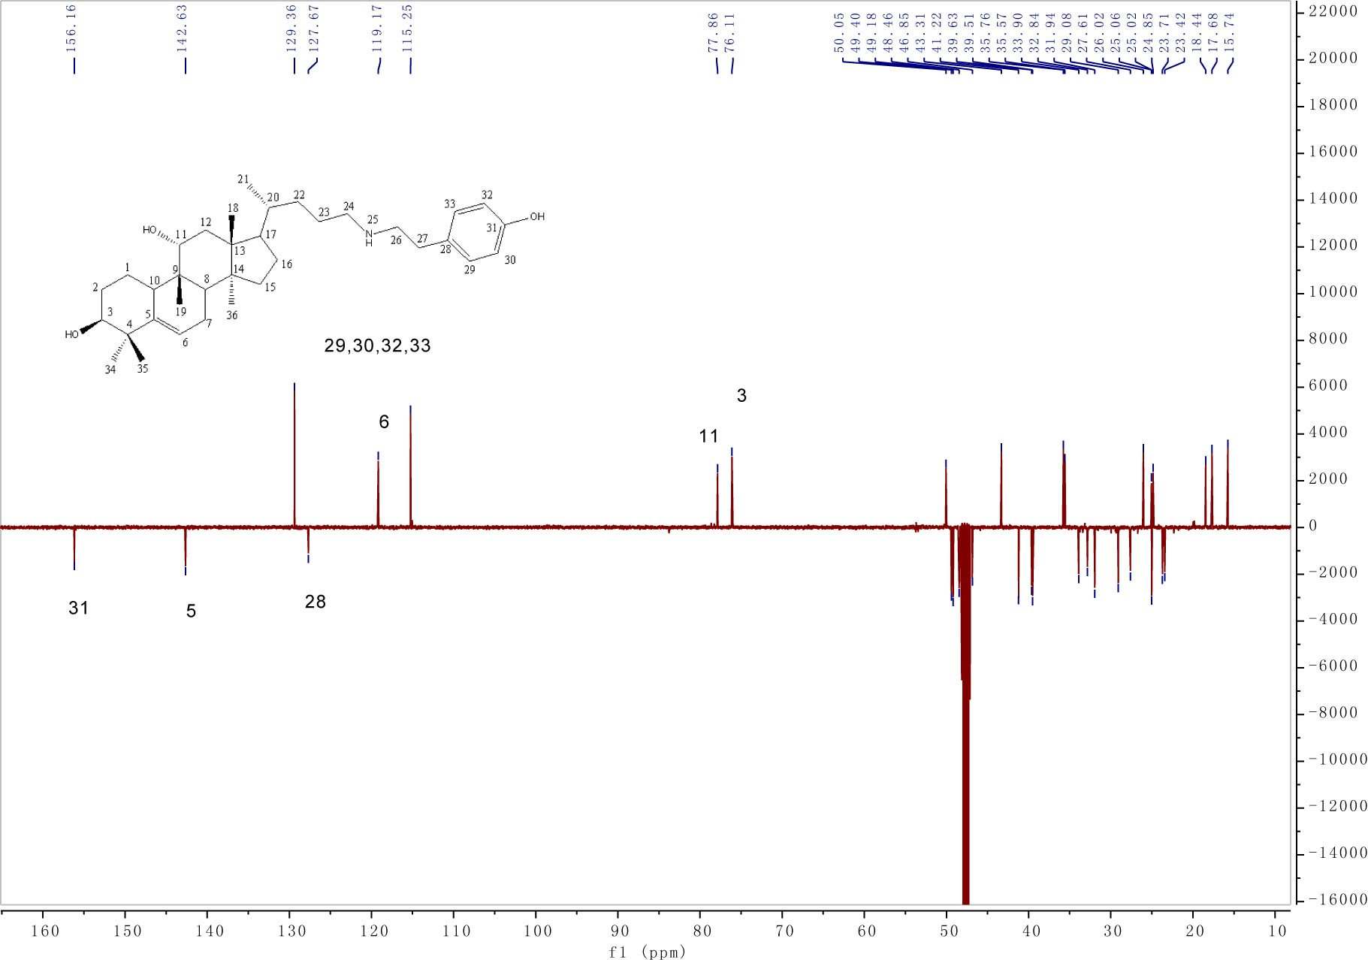
Fig. S23. ¹³C NMR (DEPTQ) of compound 13.
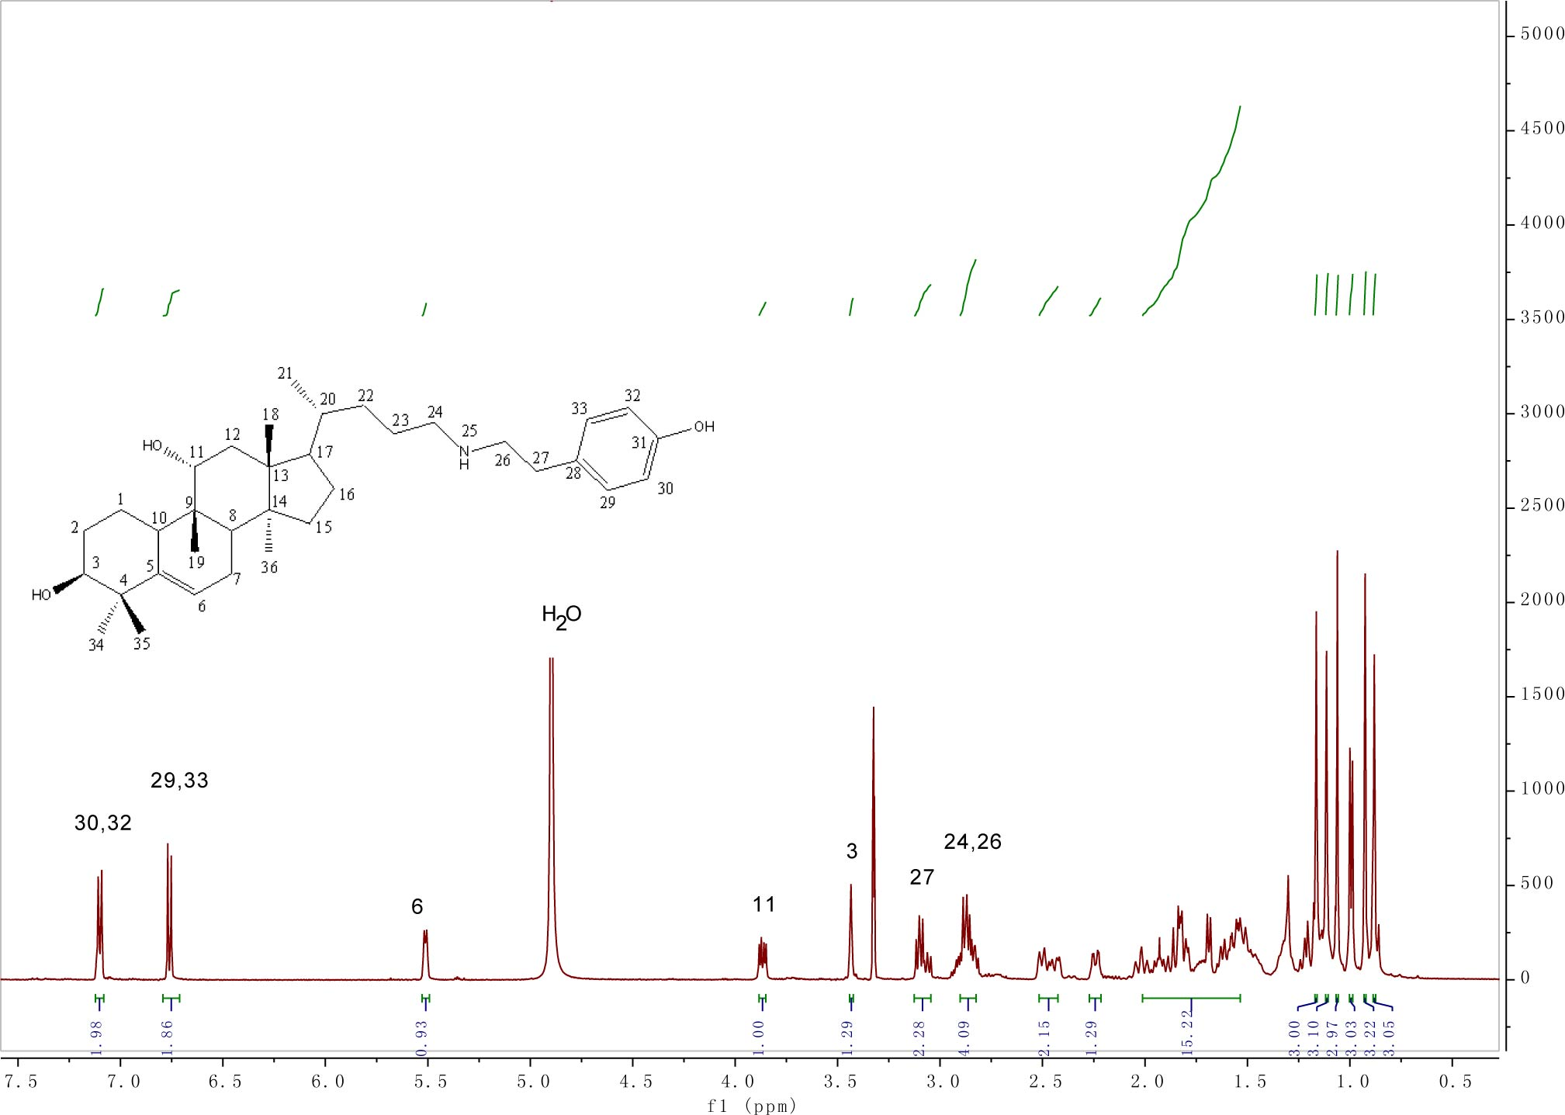
Fig. S24. ¹H NMR of compound 13.

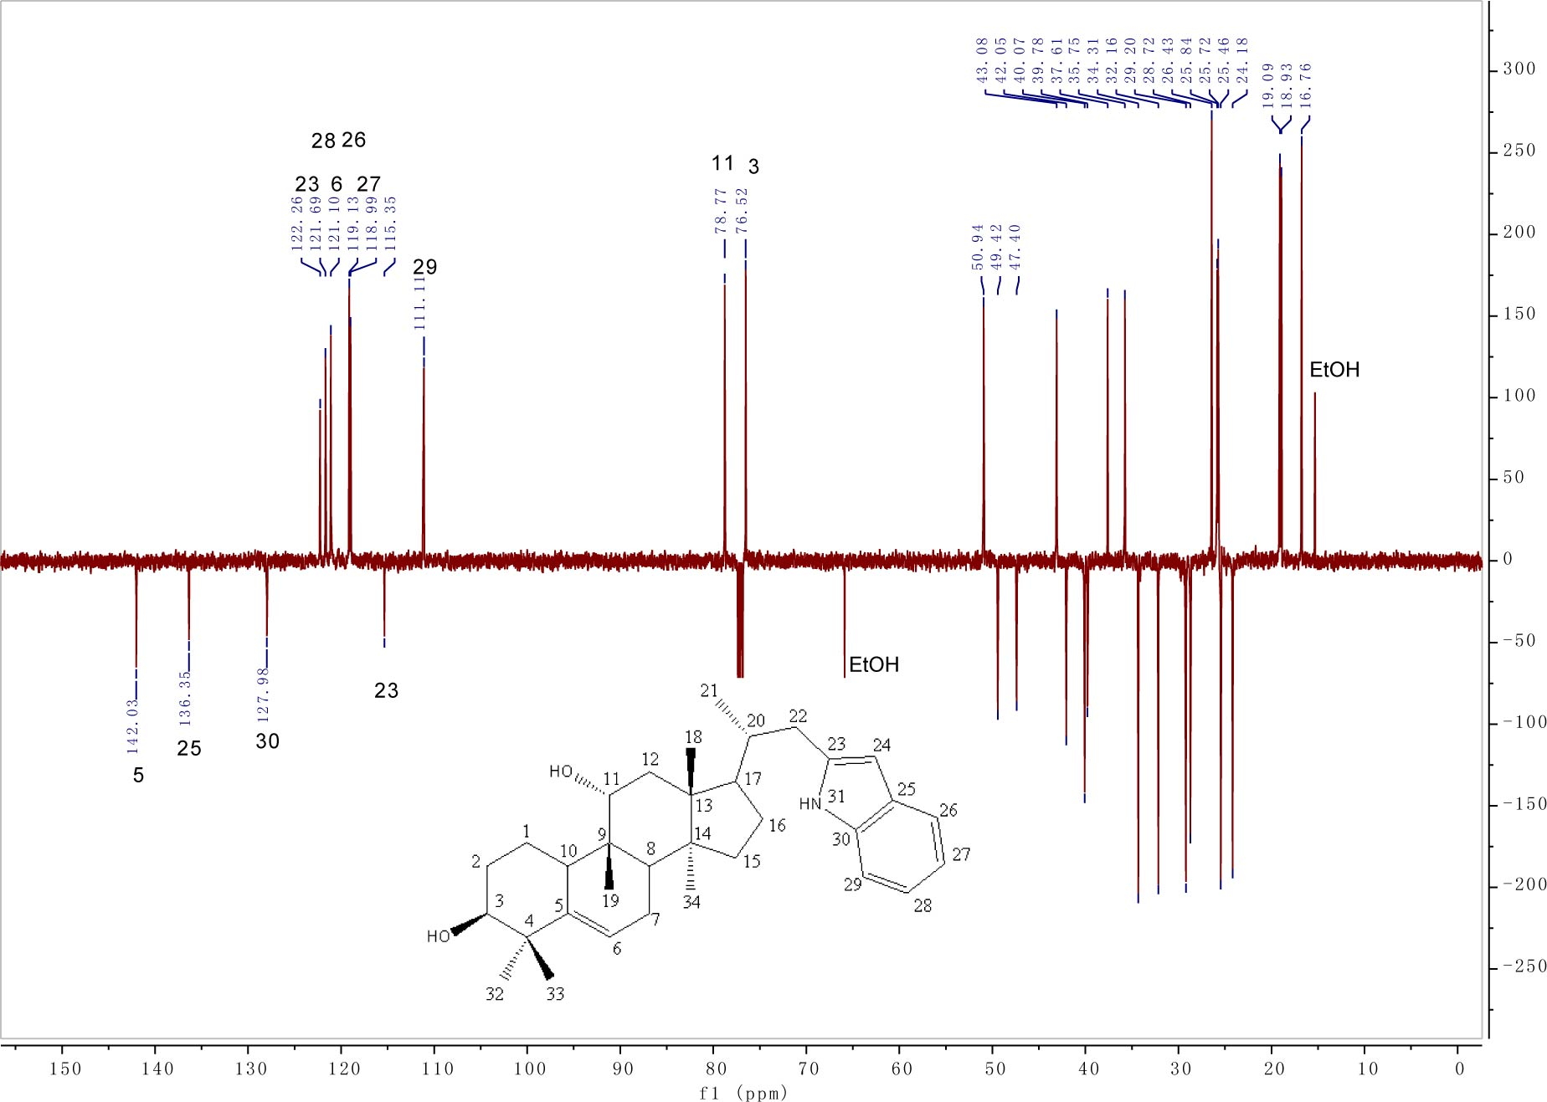
Fig. S31. ¹³C NMR (DEPTQ) of compound 14.

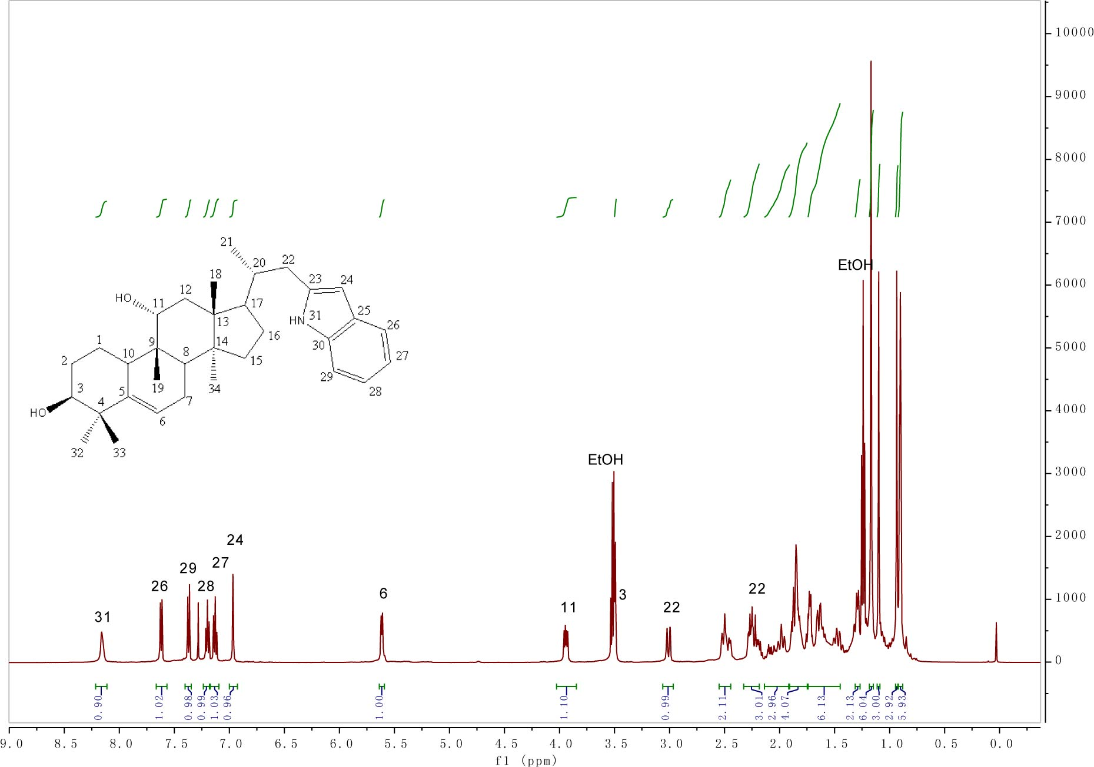

Fig. S32. ¹H NMR of compound 14.

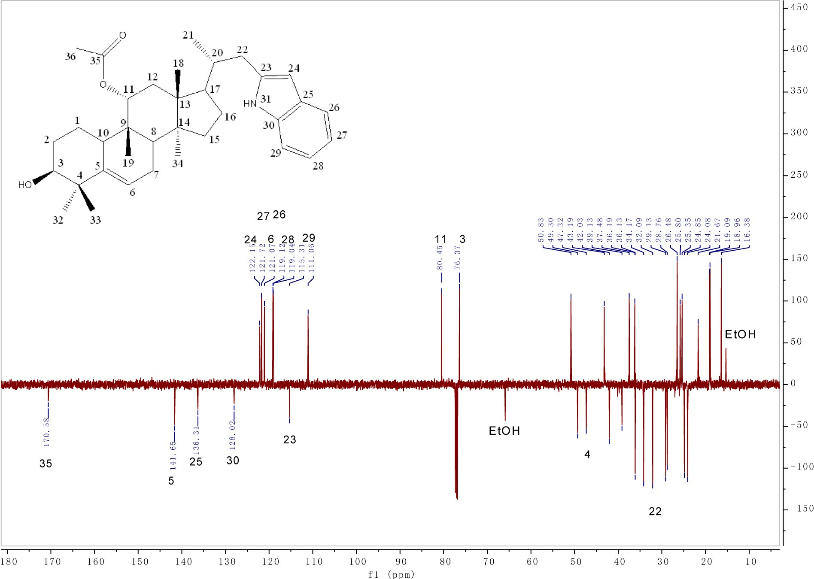
Fig. S33. ¹³C NMR (DEPTQ) of compound 15.

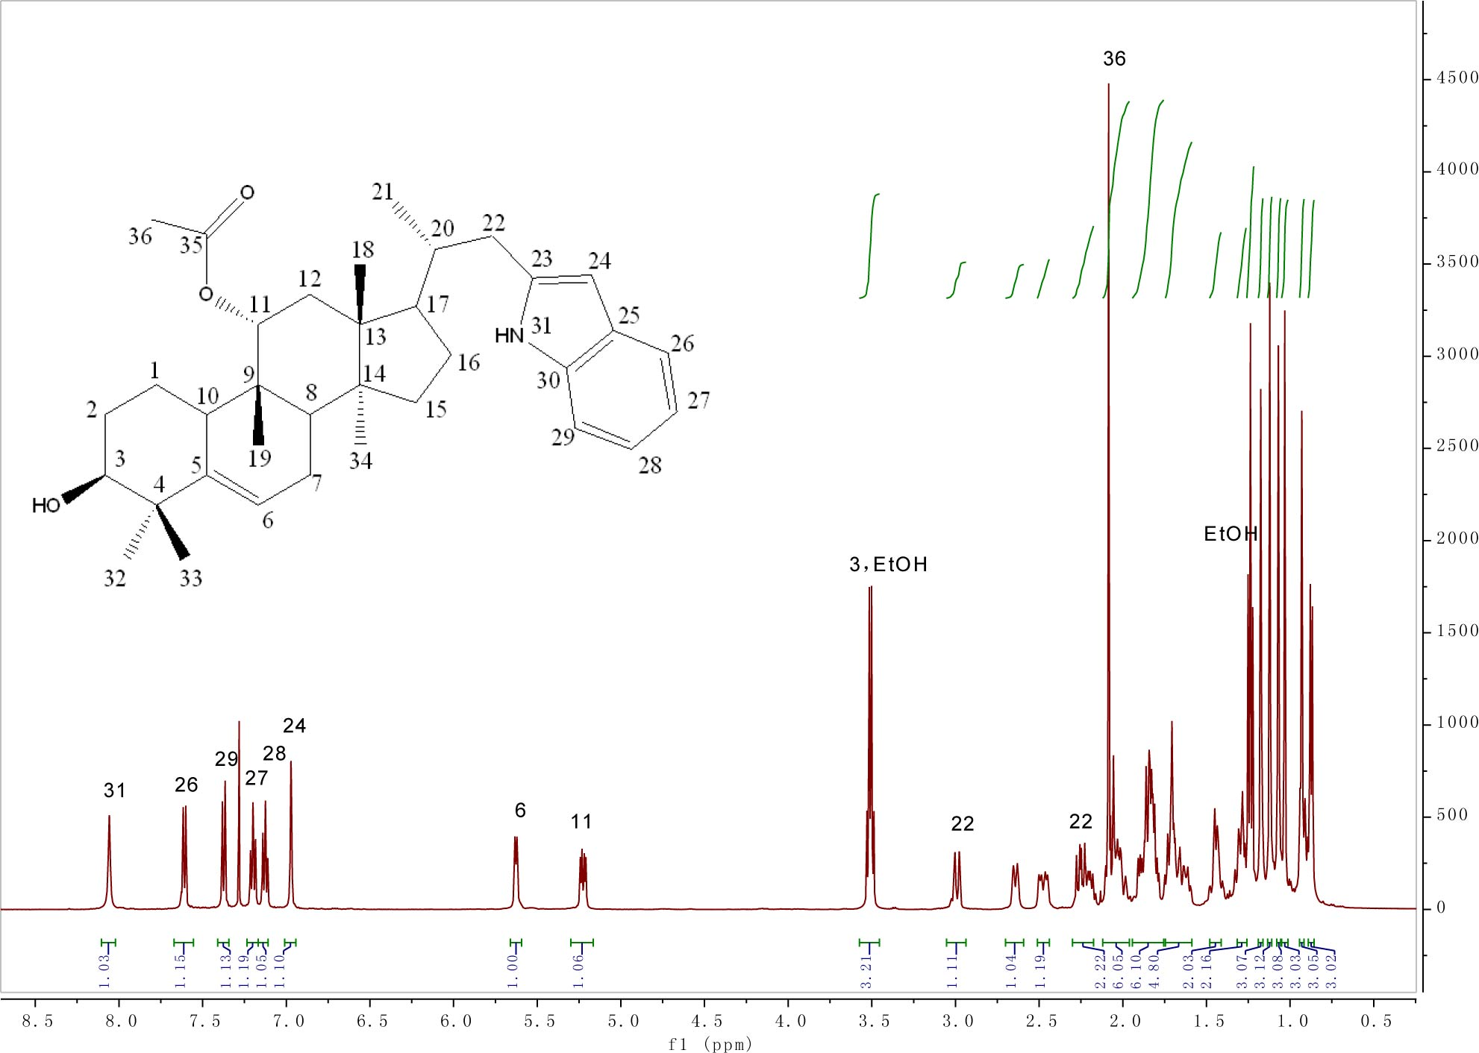

Fig. S34. ¹H NMR of compound 15.

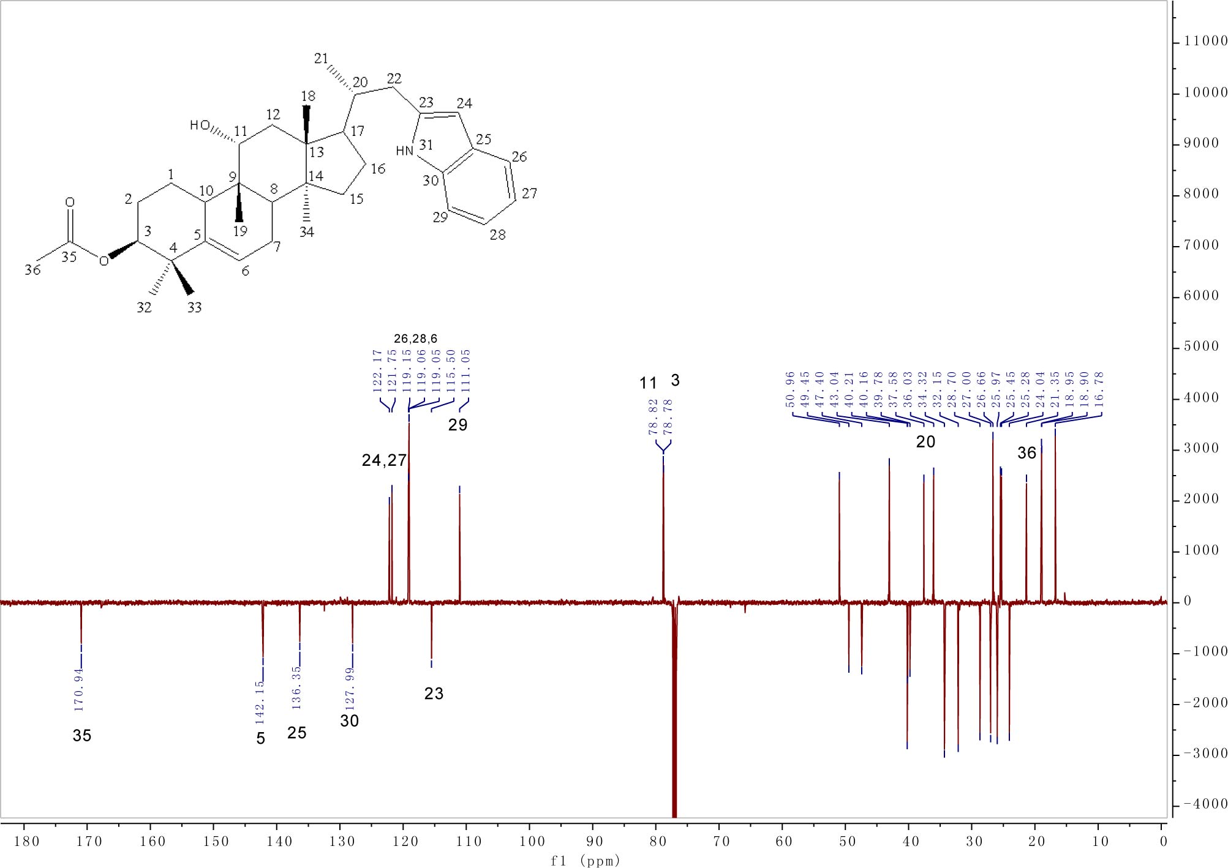
Fig. S35. ¹³C NMR (DEPTQ) of compound 16.

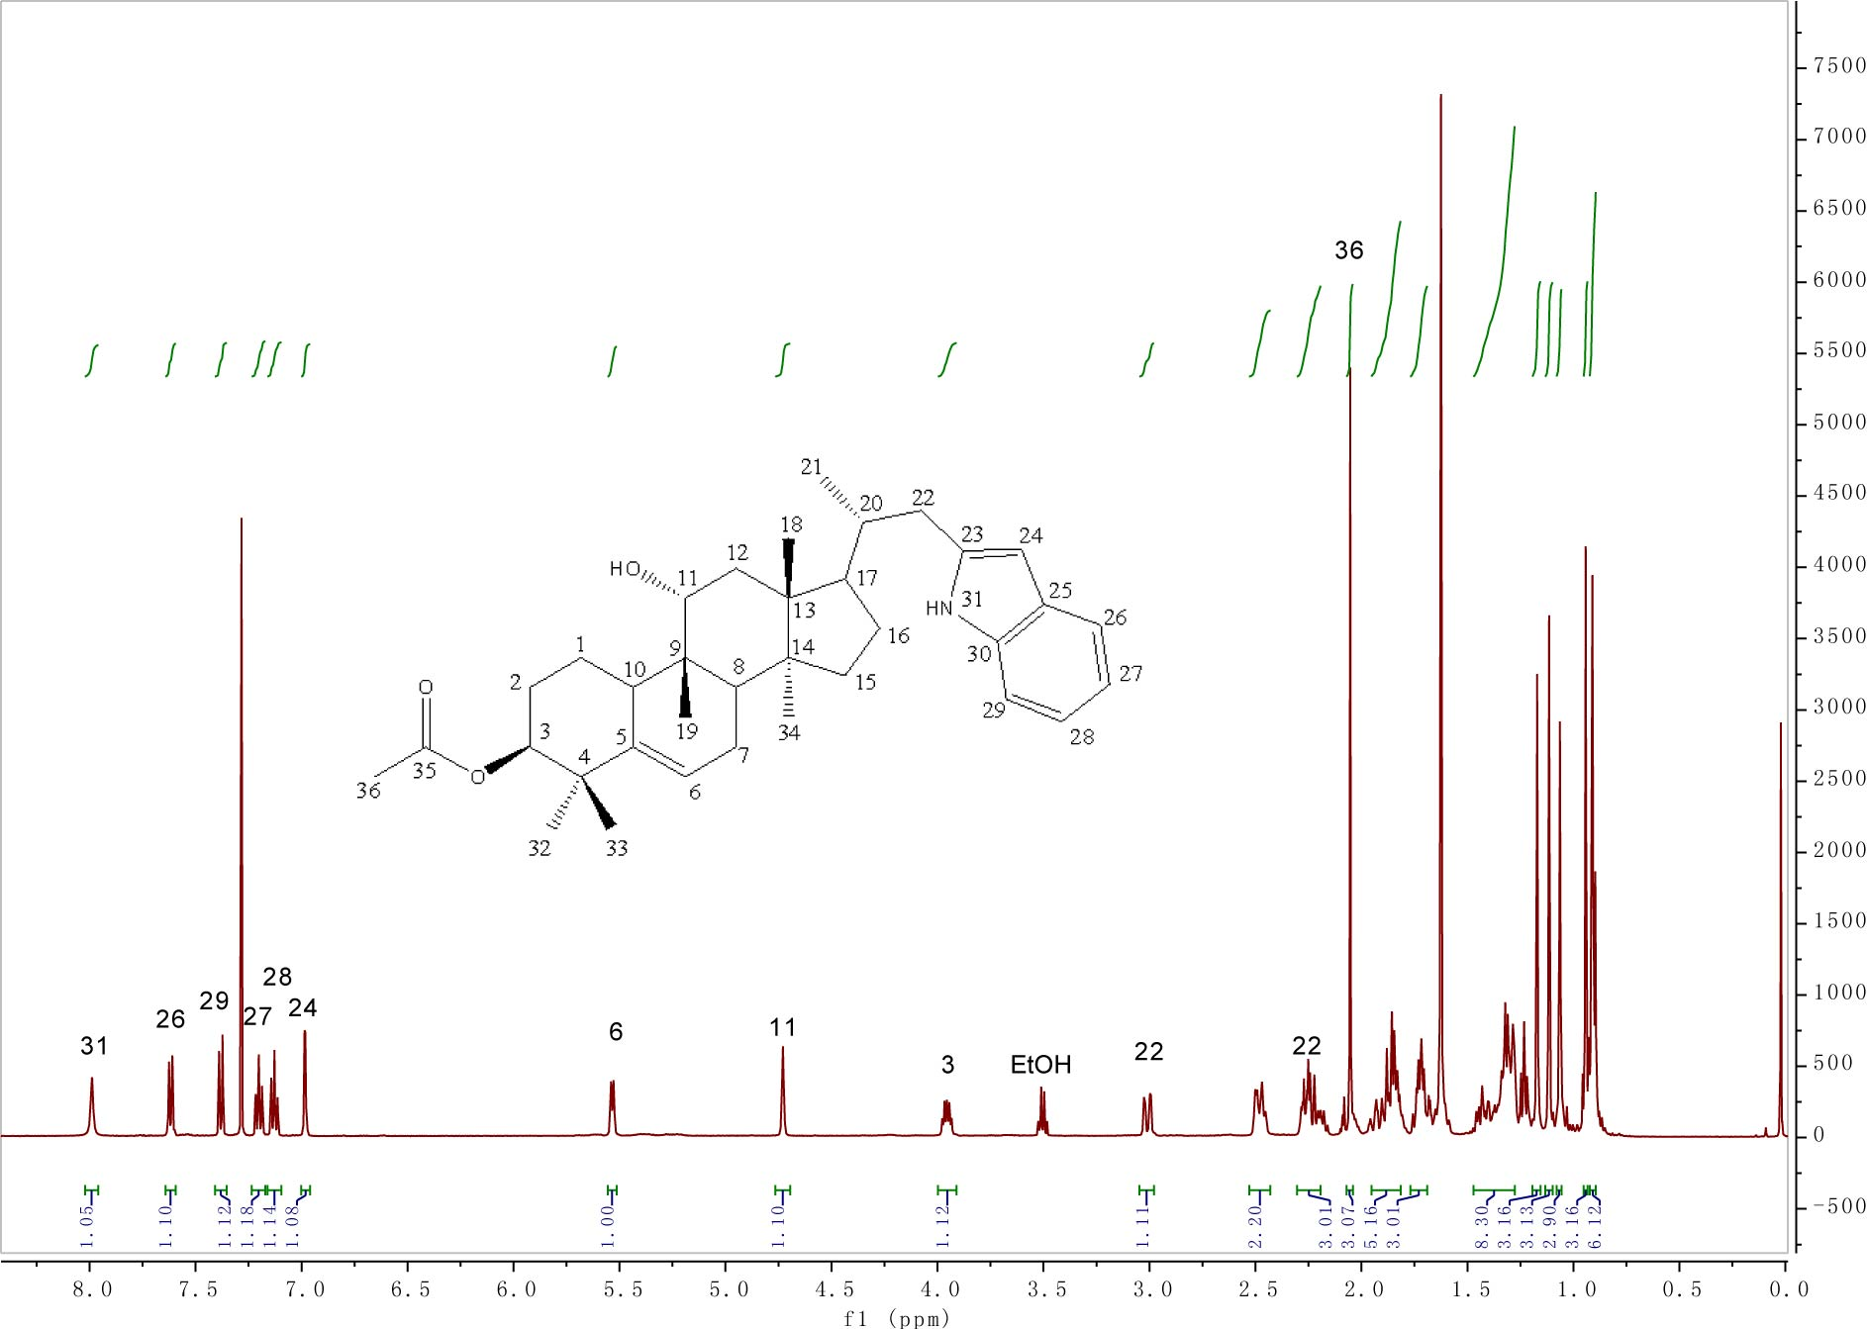

Fig. S36. ¹H NMR of compound 16.
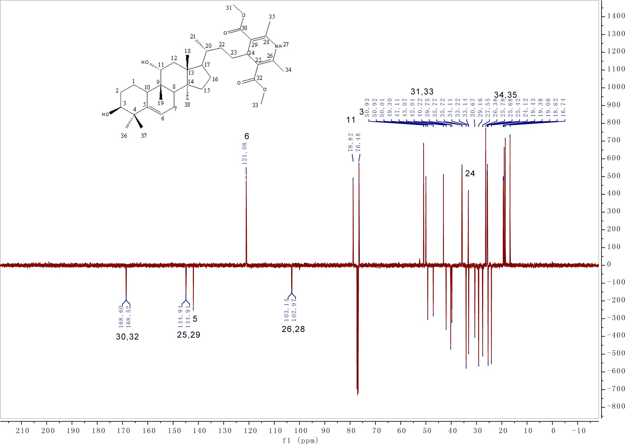
Fig. S37. ¹³C NMR (DEPTQ) of compound 17.

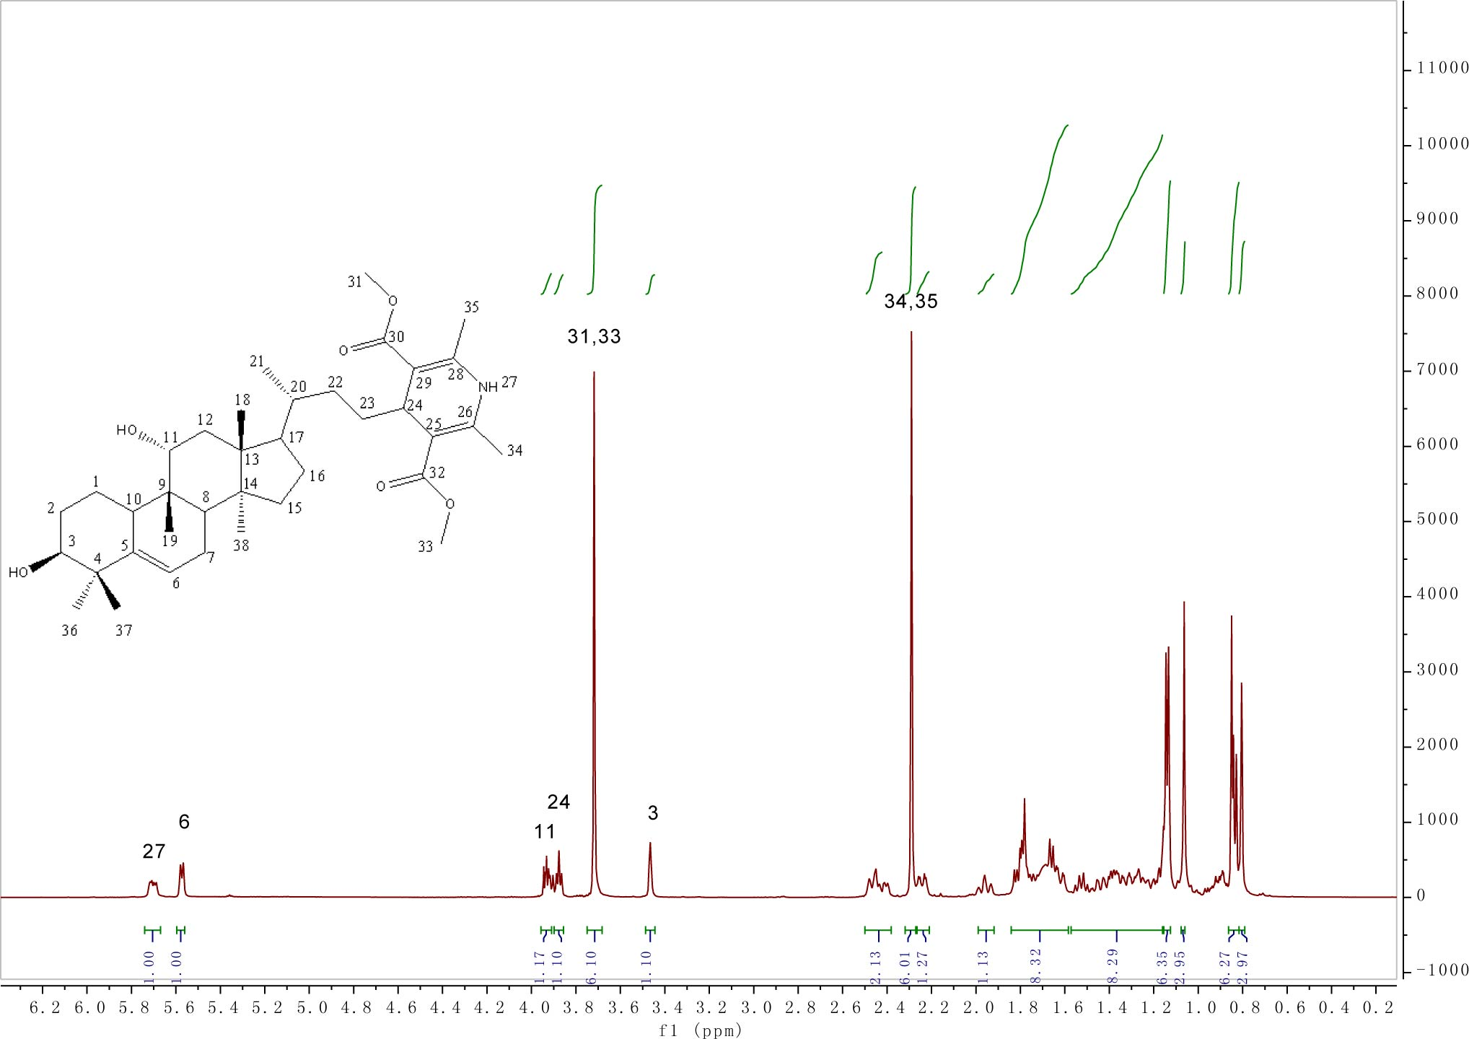

Fig. S38. ¹H NMR of compound 17.

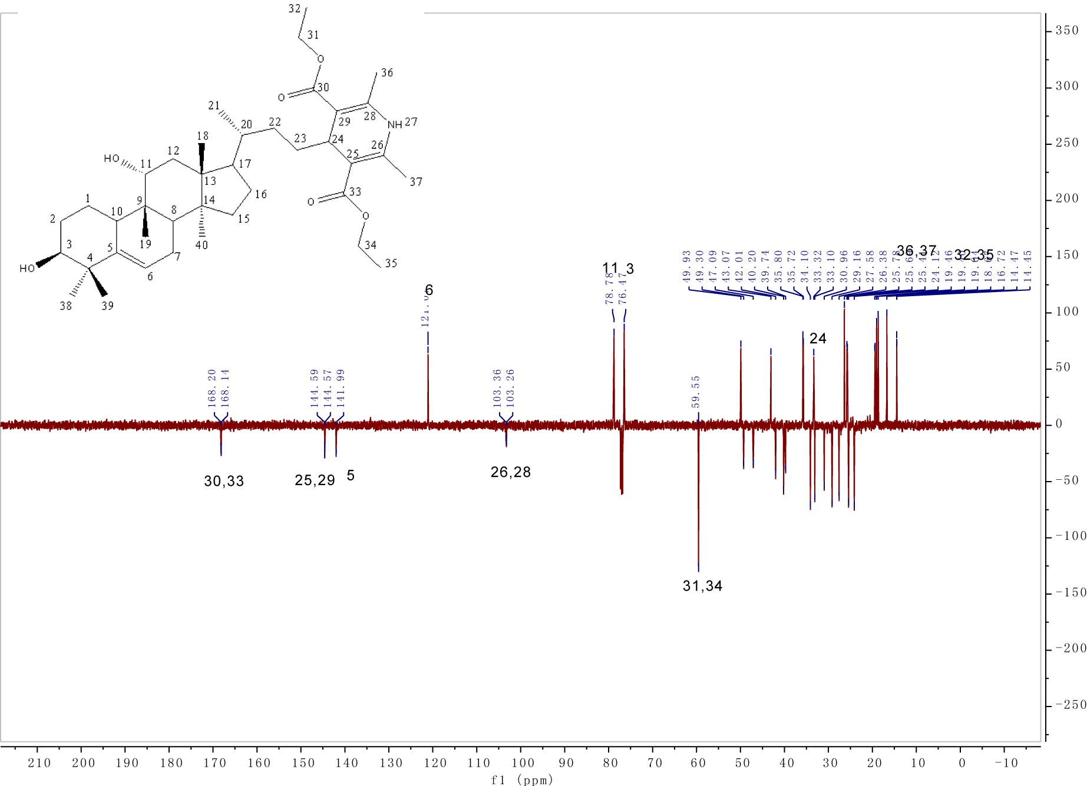
Fig. S30. ¹³C NMR (DEPTQ) of compound 18.

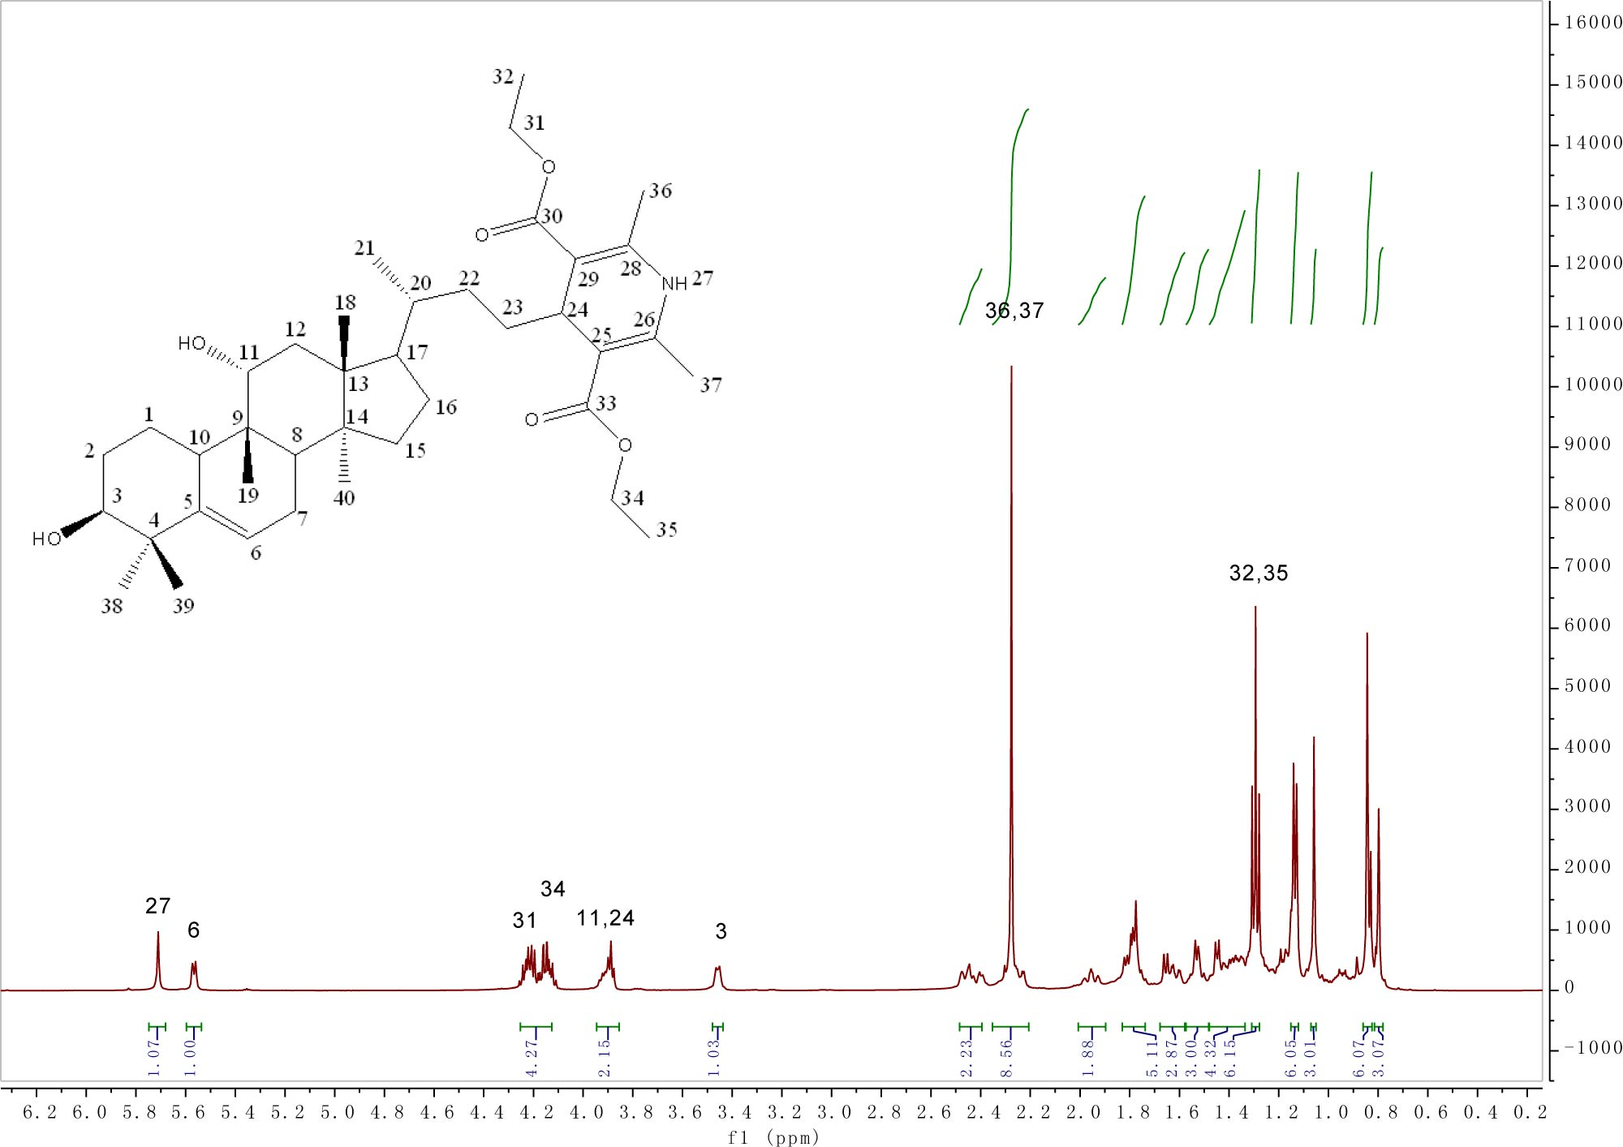

Fig. S40. ¹H NMR of compound 18.
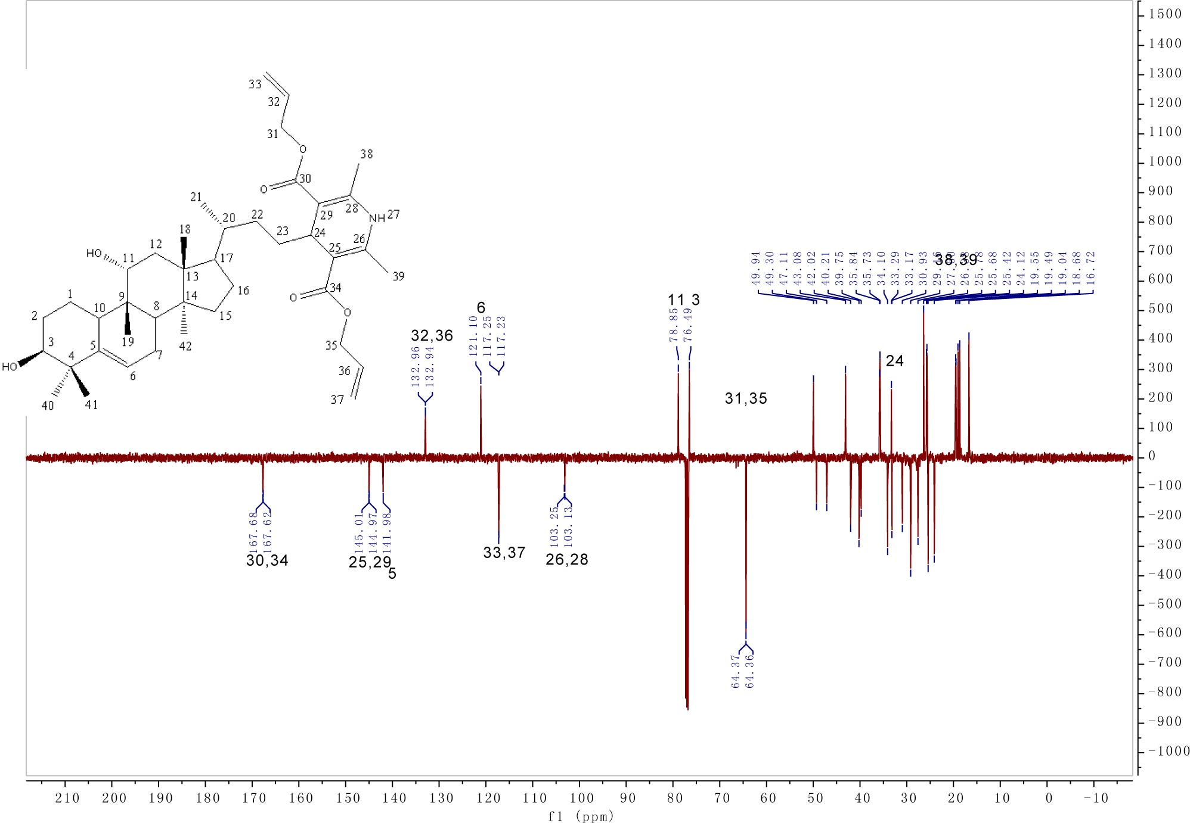
Fig. S41. ¹³C NMR (DEPTQ) of compound 19.

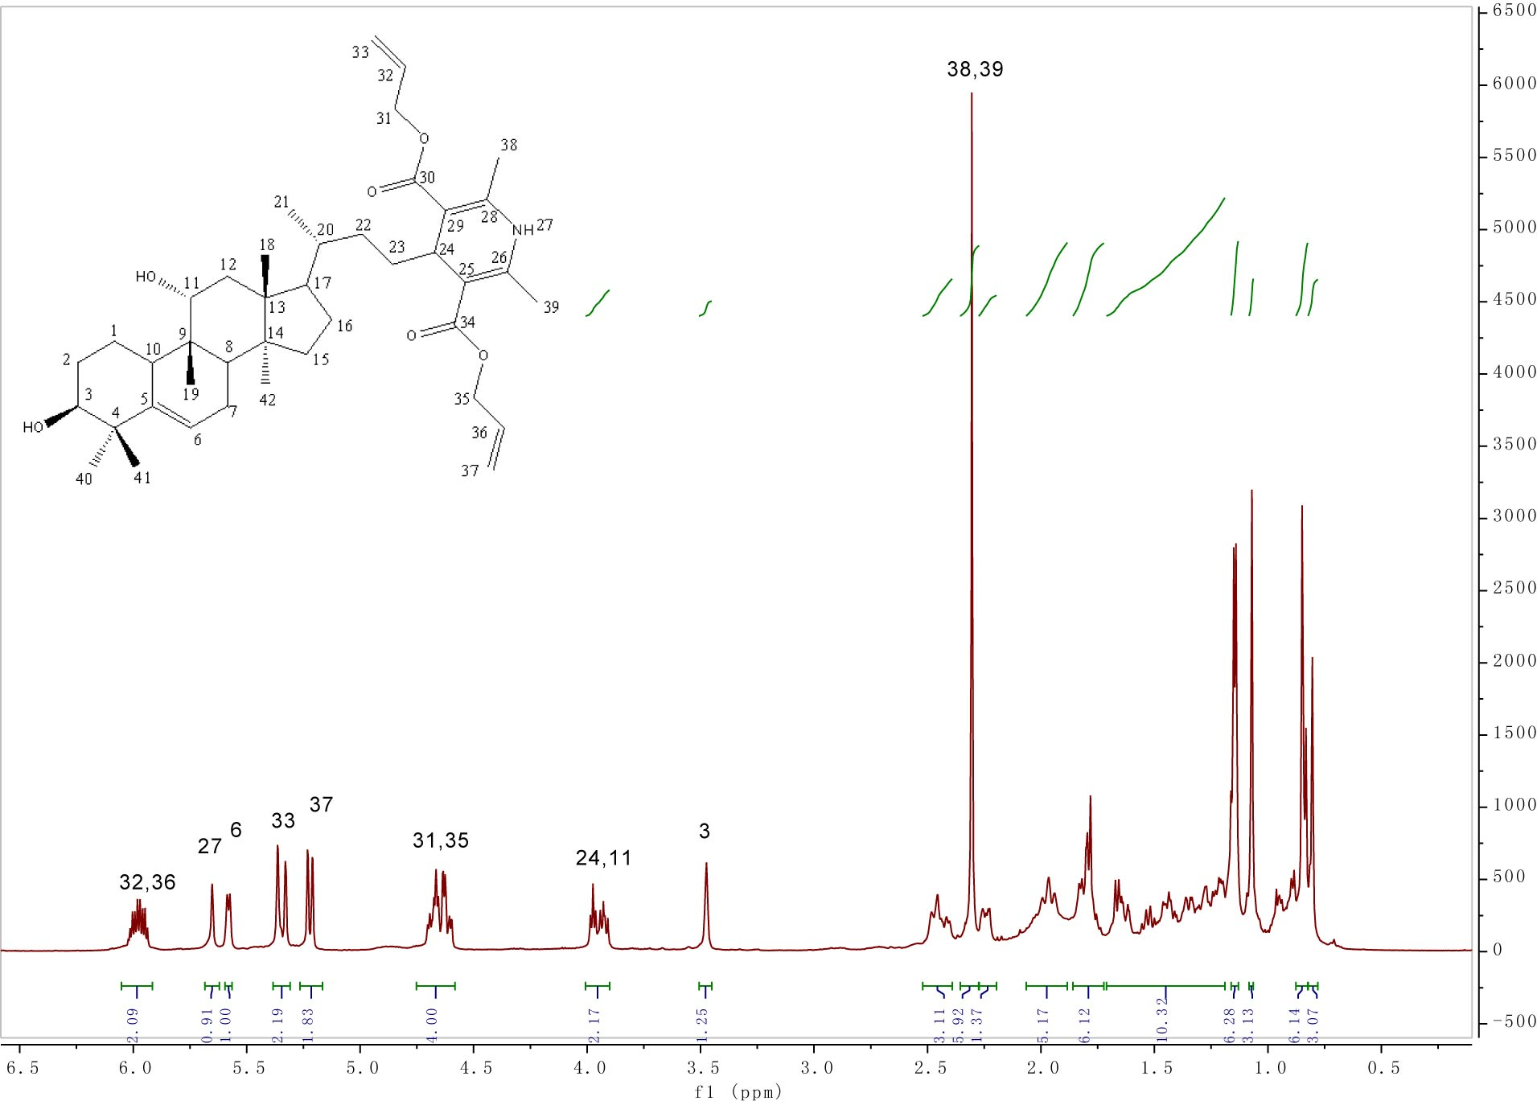
Fig. S42. ¹H NMR of compound 19.
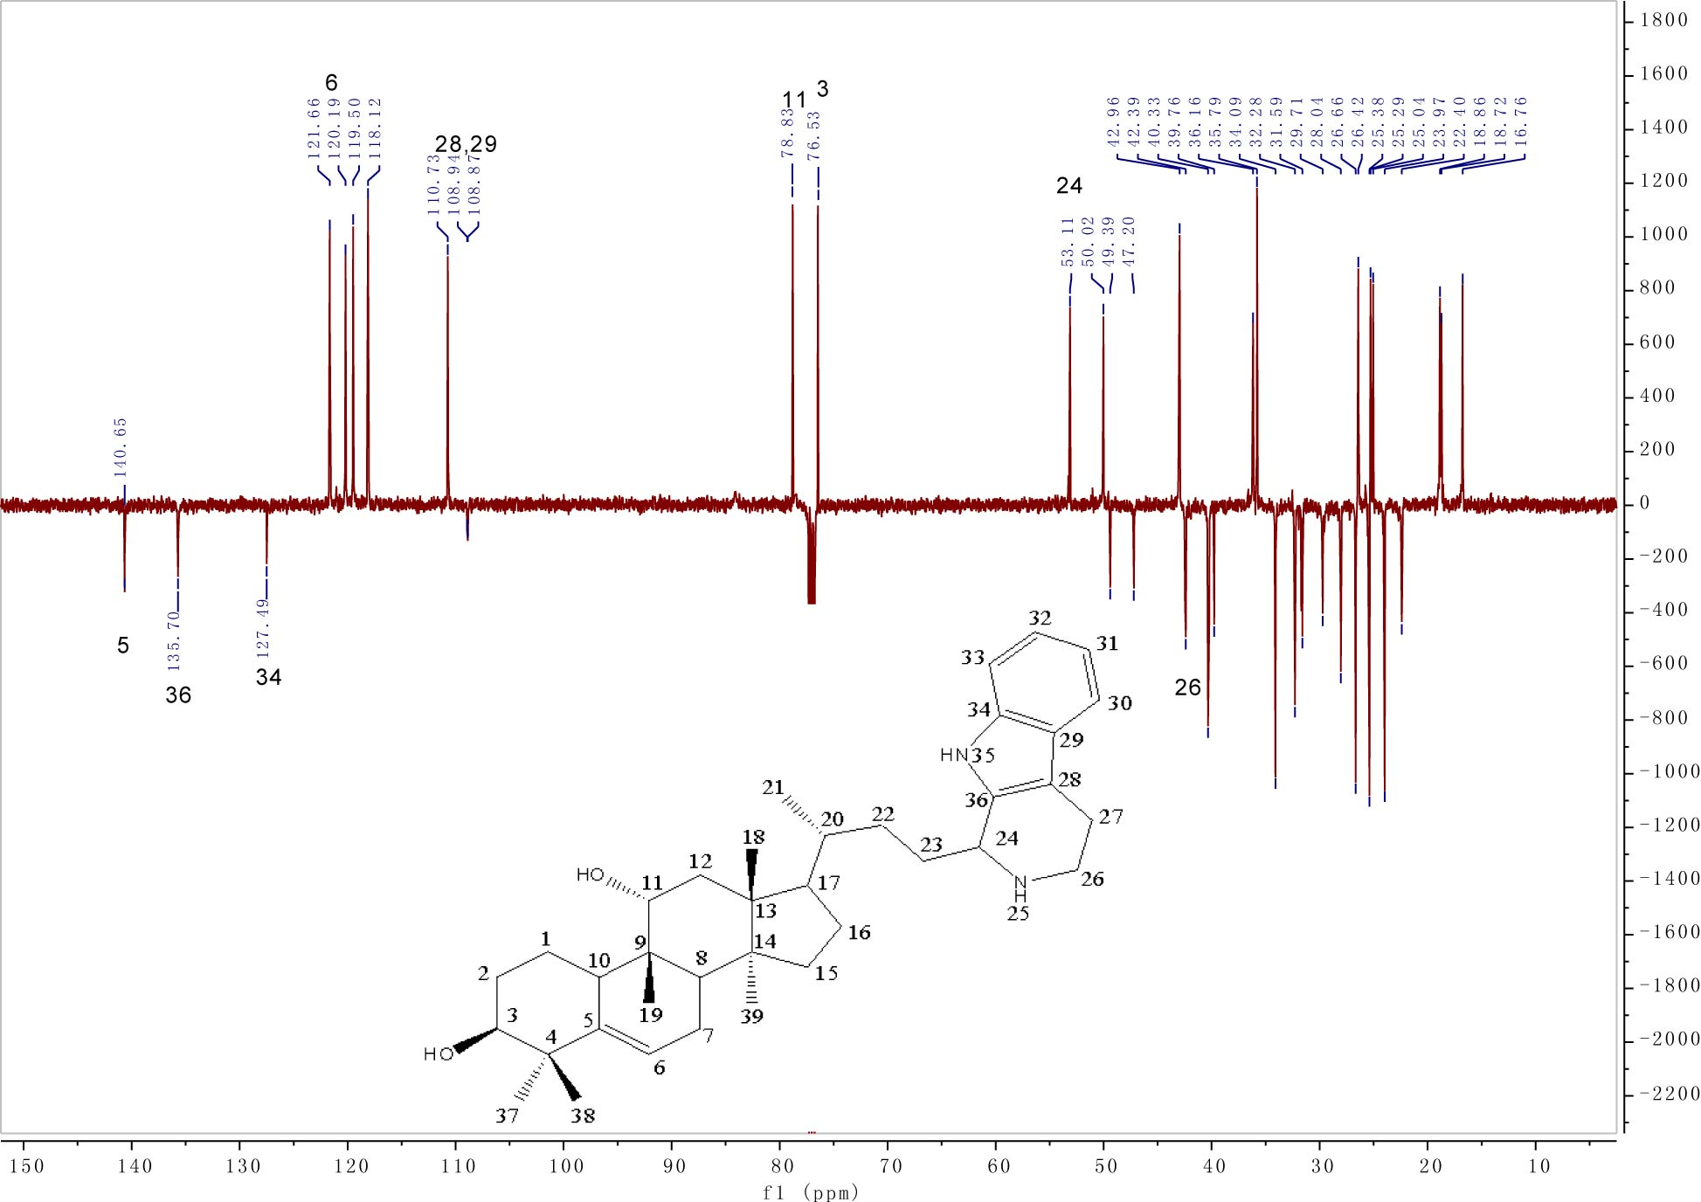
Fig. S43. ¹³C NMR (DEPTQ) of compound 20.
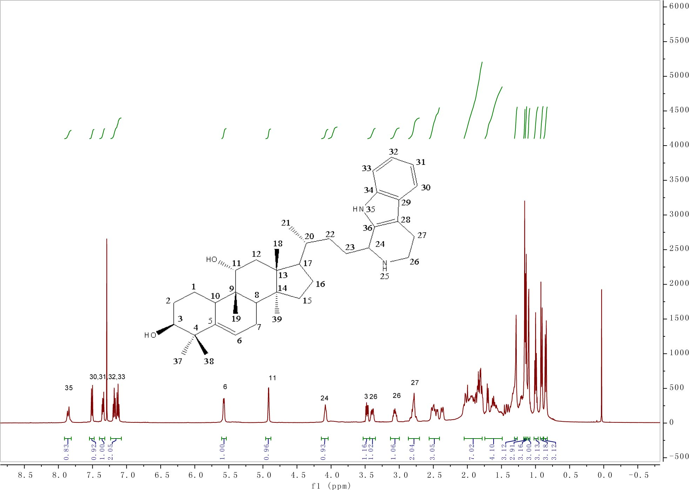
Fig. S44. ¹H NMR of compound 20.
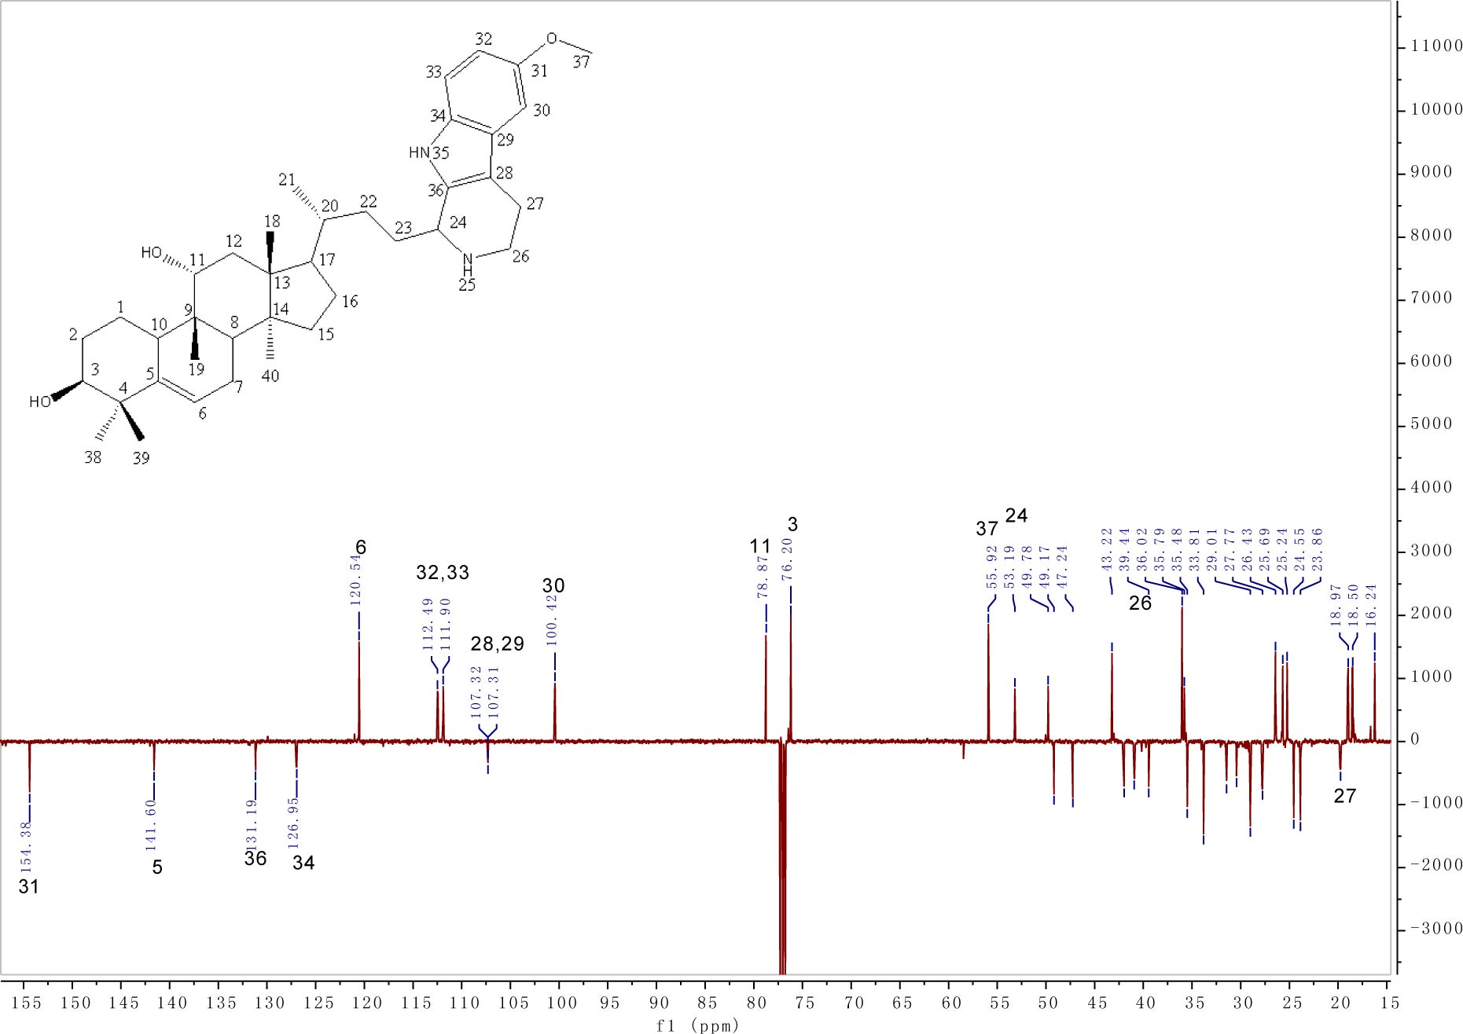
Fig. S45. ¹³C NMR (DEPTQ) of compound 21.

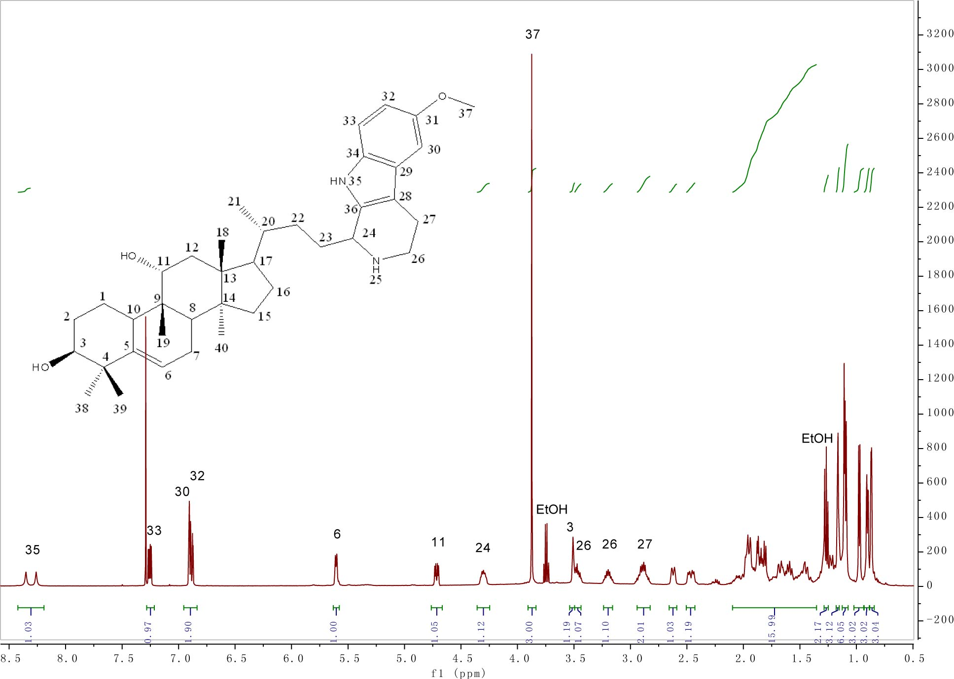
Fig. S46. ¹H NMR of compound 21.
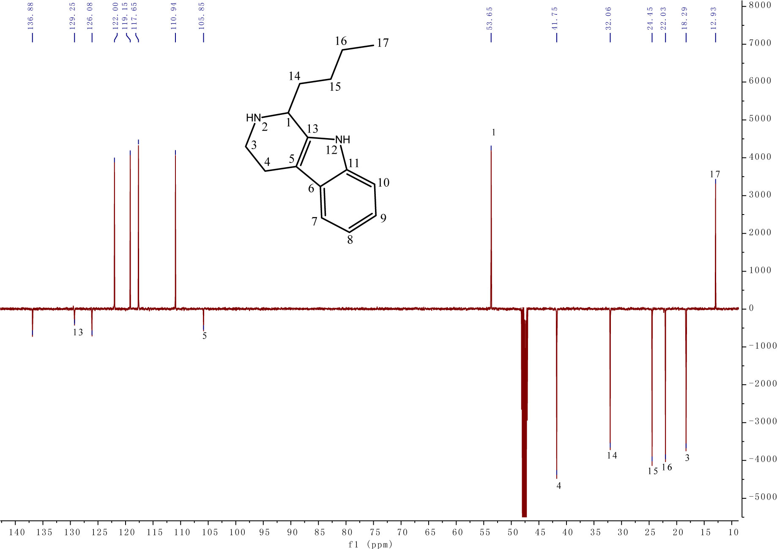
Fig. S47. ¹³C NMR (DEPTQ) of compound 22.

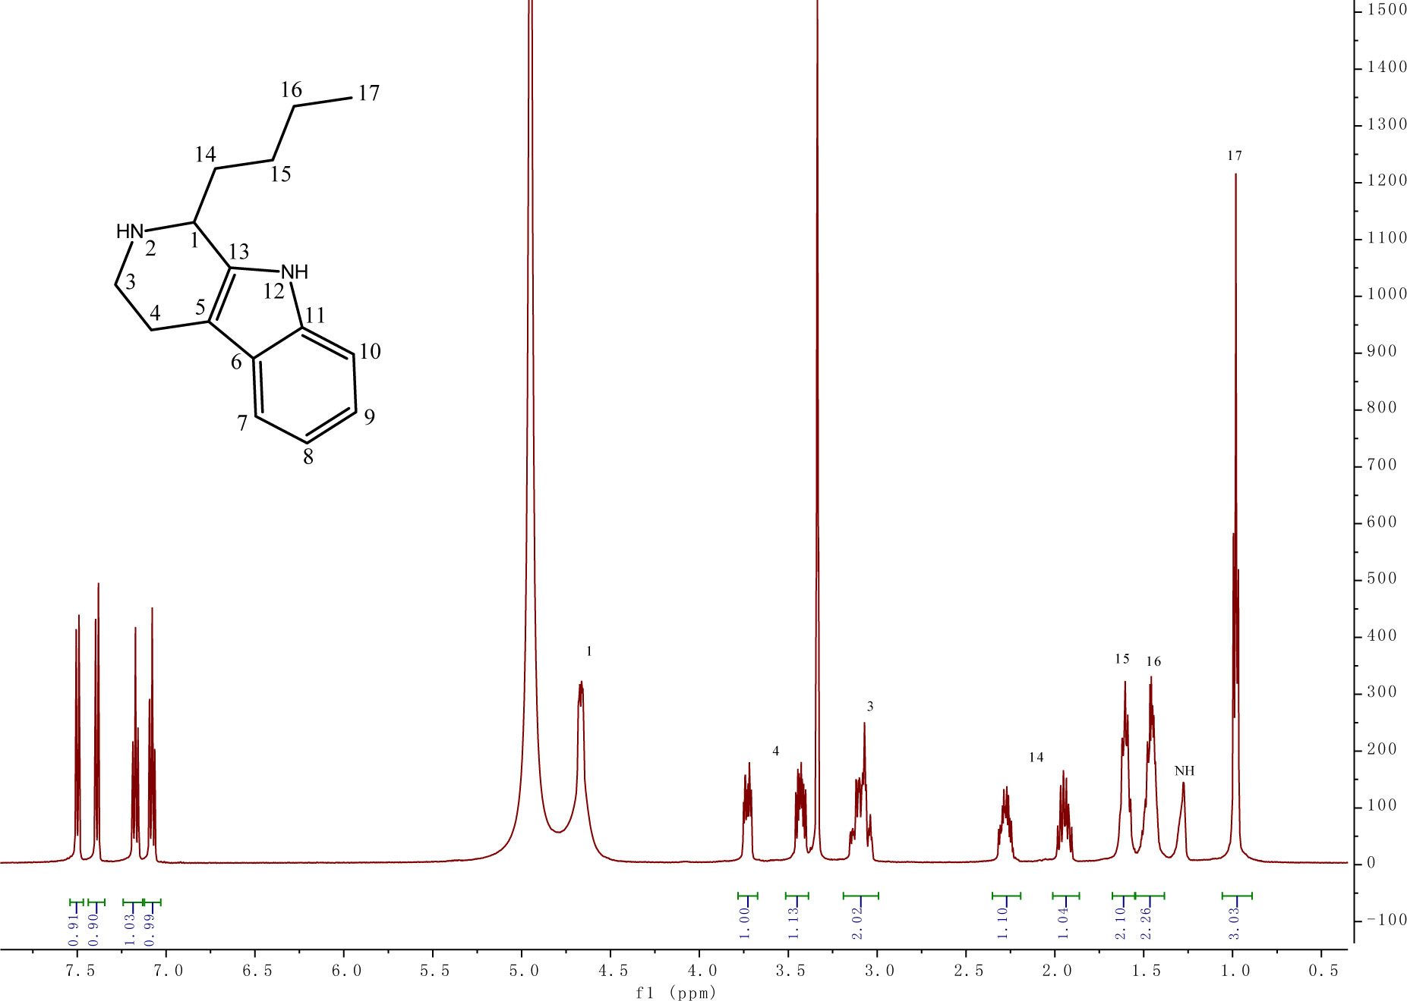
Fig. S48. ¹H NMR of compound 22.

