Supplementary Material
Comparison of forest canopy height profiles in a mountainous region of Taiwan derived from airborne lidar and unmanned aerial vehicle imagery
Chih-Hsin Chungª, Chao-Huan Wangª, Han-Ching Hsieh^{b}, Cho-ying Huang^{c,d,*}
ª Department of Forestry and Natural Resources, National Ilan University, Ilan 26047, Taiwan.
^{b} Taiwan Forestry Research Institute, Taipei 10066, Taiwan
^{c} Department of Geography, National Taiwan University, Taipei 10617, Taiwan
^{d} Research Center for Future Earth, National Taiwan University, Taipei 10617, Taiwan

Corresponding author: Cho-ying Huang (e-mail: choying@ntu.edu.tw)

Address: 1 Sec. 4, Roosevelt Rd., Taipei, Taiwan 10617
Phone: +886-2-3366-3733; Fax: +886-2-2362-2911
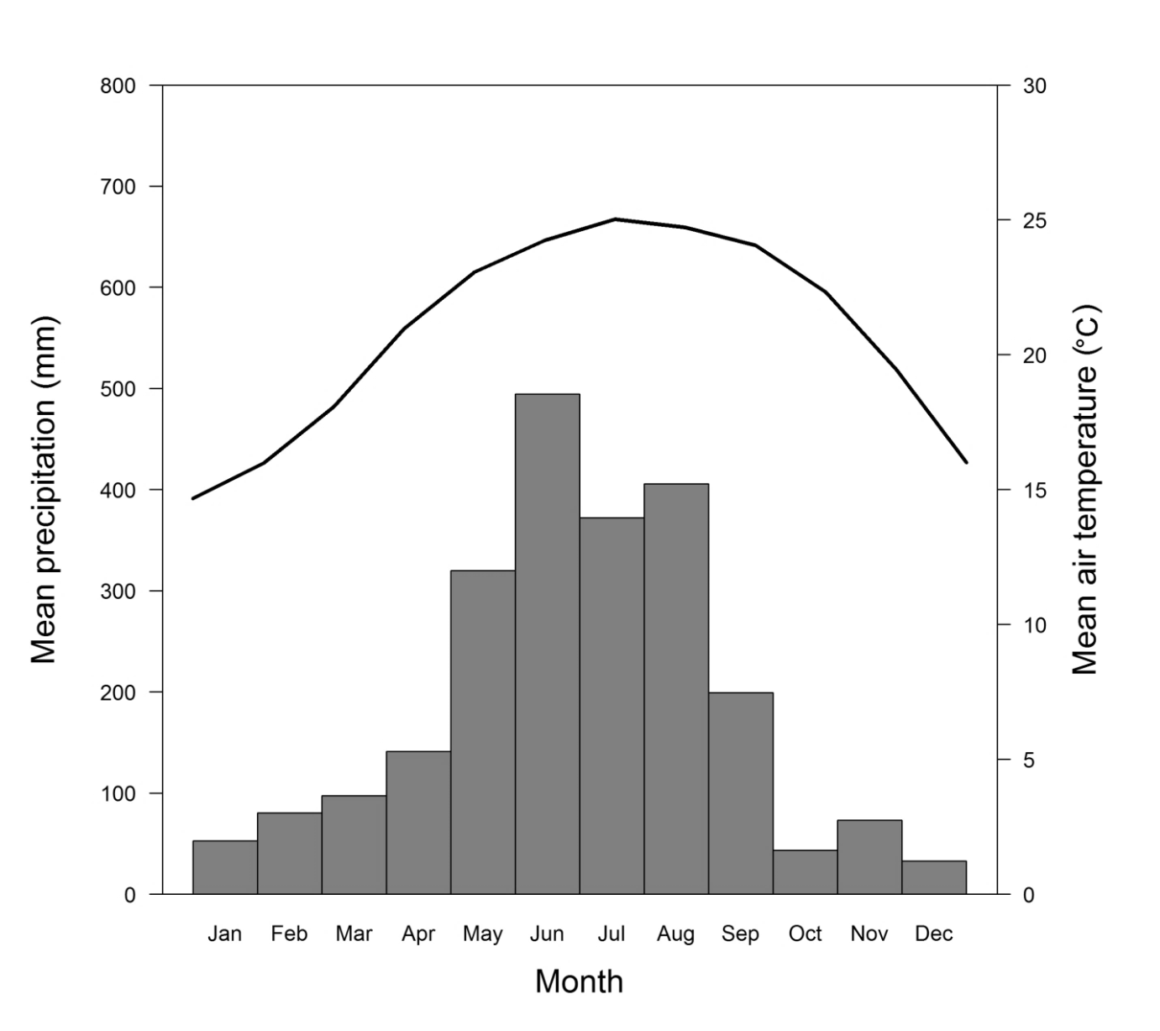
Figure S1. Mean monthly precipitation (the bars, the left y-axis) and air temperature (the line, the secondary y-axis) during the observation period.
Figure S2. The relationships (p > 0.05) between the model residuals of the airborne mean tree height estimations (Fig. 4) and the plot scale mean slope and a Terrain Ruggedness Index, and the standard deviation of elevation.

Figure S3. The Pearson’s correlation coefficient (correlation, r) between the plot scale mean canopy height (MCH, m) derived from lidar (black-colored numbers) or unmanned aerial vehicle imagery (UAV, gray-colored numbers) and the salient structural variables: Tree age (year), stand density (# ha⁻¹), standard deviation of mean tree height (MTH_{sd}, m), Q0 (m) and Q100 (m) for MCH estimation. In addition, correlations among these structural variables are also reported. Numbers without an asterisk indicate statistical insignificance (p > 0.05). Asterisks indicate statistical significance (*, p ≤ 0.05; **, p ≤ 0.01).
Table S1. Tree species inventory of the study site measured from 33 0.05-ha plots (Fig. 1).
Type | Scientific name | Tree numbers(n) |  |  | Percent(%)
 |  | Total | 2011 | 2014 | 2011 | 2014
Conifer species | Cunninghamia lanceolata | 1253 | 631 | 652 | 24.2 | 25.0
 | Calocedrus macrolepis var. formosana | 332 | 151 | 181 | 5.8 | 6.9
 | Araucaria cunninghamii | 60 | 0 | 60 | 0.0 | 2.3
 | Podocarpus nakaii | 4 | 2 | 2 | 0.1 | 0.1
Broadleaf species | Schefflera octophylla | 118 | 52 | 66 | 2.0 | 2.5
 | Michelia compressa | 79 | 20 | 59 | 0.8 | 2.3
 | Cinnamomum kotoense | 31 | 0 | 31 | 0.0 | 1.2
 | Machilus zuihoensis | 44 | 25 | 19 | 1.0 | 0.7
 | Diospyros morrisiana | 96 | 79 | 17 | 3.0 | 0.7
 | Mallotus paniculatus | 34 | 17 | 17 | 0.7 | 0.7
 | Elaeocarpus sylvestris | 39 | 23 | 16 | 0.9 | 0.6
 | Wendlandia formosana | 18 | 4 | 14 | 0.2 | 0.5
 | Bischofia javanica | 14 | 0 | 14 | 0.0 | 0.5
 | Aleurites fordii | 30 | 18 | 12 | 0.7 | 0.5
 | Cyclobalanopsis glauca | 11 | 0 | 11 | 0.0 | 0.4
 | Nothaphoebe konishii | 10 | 0 | 10 | 0.0 | 0.4
 | Phoebe faberi | 12 | 3 | 9 | 0.1 | 0.3
 | Quercus gilva | 9 | 0 | 9 | 0.0 | 0.3
 | Myristi caceylanica | 9 | 0 | 9 | 0.0 | 0.3
 | Sapium discolor | 24 | 17 | 7 | 0.7 | 0.3
 | Engelhardtia roxburghiana | 12 | 5 | 7 | 0.2 | 0.3
 | Mallotus japonicus | 8 | 1 | 7 | 0.0 | 0.3
 | Machilus thunbergii | 30 | 24 | 6 | 0.9 | 0.2
 | Rhus succedanea | 26 | 20 | 6 | 0.8 | 0.2
 | Styrax formosana | 9 | 3 | 6 | 0.1 | 0.2
 | Melicope pteleifolia | 10 | 5 | 5 | 0.2 | 0.2
 | Tricalysia dubia | 10 | 5 | 5 | 0.2 | 0.2
 | Castanopsis cuspidata var. carlesii | 6 | 1 | 5 | 0.0 | 0.2
 | Glochidion acuminatum | 6 | 1 | 5 | 0.0 | 0.2
 | Neolitsea konishii | 5 | 0 | 5 | 0.0 | 0.2
 | Quercus uraiana | 5 | 0 | 5 | 0.0 | 0.2
 | Castanopsis carlesii | 5 | 0 | 5 | 0.0 | 0.2
 | Pasania harlandii | 6 | 2 | 4 | 0.1 | 0.2
 | Castanopsis fargesii | 5 | 1 | 4 | 0.0 | 0.2
 | Elaeocarpus japonicus | 5 | 1 | 4 | 0.0 | 0.2
 | Prunus campanulata | 4 | 0 | 4 | 0.0 | 0.2
 | Zelkova serrata | 4 | 0 | 4 | 0.0 | 0.2
 | Illicium arborescens | 4 | 0 | 4 | 0.0 | 0.2
 | Prunus phaeosticta | 24 | 21 | 3 | 0.8 | 0.1
 | Pasania kawakamii | 13 | 10 | 3 | 0.4 | 0.1
 | Cinnamomum subavenium | 7 | 4 | 3 | 0.2 | 0.1
 | Randia cochinchinensis | 5 | 2 | 3 | 0.1 | 0.1
 | Ilex ficoidea | 4 | 1 | 3 | 0.0 | 0.1
 | Cinnamomum camphora | 4 | 1 | 3 | 0.0 | 0.1
 | Neolitsea aciculata var. variabillima | 4 | 1 | 3 | 0.0 | 0.1
 | Schima superba | 3 | 0 | 3 | 0.0 | 0.1
 | Adinandra formosana | 3 | 0 | 3 | 0.0 | 0.1
 | Antidesma japonicum | 3 | 0 | 3 | 0.0 | 0.1
 | Cryptocarya chinensis | 3 | 0 | 3 | 0.0 | 0.1
 | Toona sinensis | 3 | 0 | 3 | 0.0 | 0.1
 | Pyrenaria shinkoensis | 3 | 0 | 3 | 0.0 | 0.1
 | Machilus zuihoensis var. mushaensis | 3 | 0 | 3 | 0.0 | 0.1
 | Styrax suberifolia | 20 | 18 | 2 | 0.7 | 0.1
 | Camellia oleifera | 19 | 17 | 2 | 0.7 | 0.1
 | Eustigma oblongifolium | 12 | 10 | 2 | 0.4 | 0.1
 | Pasania konishii | 11 | 9 | 2 | 0.3 | 0.1
 | Litsea cubeba | 11 | 9 | 2 | 0.3 | 0.1
 | Cinnamomum osmophloeum | 11 | 9 | 2 | 0.3 | 0.1
 | Acacia confusa | 10 | 8 | 2 | 0.3 | 0.1
 | Syzygium buxifolium | 6 | 4 | 2 | 0.2 | 0.1
 | Crateva adansonii subsp. formosensis | 6 | 4 | 2 | 0.2 | 0.1
 | Archideneron lucidum | 6 | 4 | 2 | 0.2 | 0.1
 | Lagerstoemia subcostata | 4 | 2 | 2 | 0.1 | 0.1
 | Ormosia formosana | 4 | 2 | 2 | 0.1 | 0.1
 | Eucalyptus robusta | 3 | 1 | 2 | 0.0 | 0.1
 | Helicia formosana | 3 | 1 | 2 | 0.0 | 0.1
 | Prunus campanulata | 3 | 1 | 2 | 0.0 | 0.1
 | Castanopsis cuspidata var. carlesii | 3 | 1 | 2 | 0.0 | 0.1
 | Microtropis japonica | 3 | 1 | 2 | 0.0 | 0.1
 | Tetradium glabrifolium | 3 | 1 | 2 | 0.0 | 0.1
 | Corymbia citriodora | 3 | 1 | 2 | 0.0 | 0.1

