Sulfated copper oxide catalyzed one-pot synthesis of
N-fused benzimidazolo/benzothiazolo pyrimidines
Sankaranarayanan Jayashree and Kalegowda Shivashankar*
P.G. Department of Chemistry, Central College Campus, Bangalore University,
Bangalore - 560 001, Karnataka, India.
*Corresponding author: E-mail address: shivashankark@gmail.com (K. Shivashankar)

Synthetic Procedure for various N-fused benzimidazolo/benzthiazolo pyrimidines

Synthetic procedure for the preparation of 2,4-Diphenylbenzo[4,5]imidazo[1,2-a]pyrimidine (4a)
A mixture of benzaldehyde (1 mmol), 2-aminobenzimidazole (1 mmol) and acetonitrile (5 ml) were taken in a sealed tube and warmed for 5 minutes. Phenyl acetylene (1.1 mmol) and sulfated copper oxide (prepared according to literature 62) (10 mol %) were added to the reaction mixture and stirred for another 10 minutes under nitrogen atmosphere at room temperature and the reaction mixture was refluxed at 80⁰ C. Upon completion (3 h) of the reaction, as indicated by TLC, the mixture was washed with ethyl acetate and the catalyst was separated by filtration. The solvent was evaporated under reduced pressure to get the crude product. The crude product was purified by column chromatography on silica gel (ethyl acetate/hexane) and afforded the 2,4-Diphenylbenzo[4,5]imidazo[1,2-a]pyrimidine.

Synthetic procedure for the preparation of 2-(4-Nitrophenyl)-4-phenylbenzo[4,5]imidazo[1,2-a]-pyrimidine (4b)
A mixture of 4-nitrobenzaldehyde (1 mmol), 2-aminobenzimidazole (1 mmol) and acetonitrile (5 ml) were taken in a sealed tube and warmed for 5 minutes. Phenyl acetylene (1.1 mmol) and sulfated copper oxide (prepared according to literature 62) (10 mol %) were added to the reaction mixture and stirred for another 10 minutes under nitrogen atmosphere at room temperature and the reaction mixture was refluxed at 80⁰ C. Upon completion (3 h) of the reaction, as indicated by TLC, the mixture was washed with ethyl acetate and the catalyst was separated by filtration. The solvent was evaporated under reduced pressure to get the crude product. The crude product was purified by column chromatography on silica gel (ethyl acetate/hexane) and afforded the 2-(4-Nitrophenyl)-4-phenylbenzo[4,5]imidazo[1,2-a]-pyrimidine.

Synthetic procedure for the preparation of 4-(4-Phenylbenzo[4,5]imidazo[1,2-a]pyrimidin-2-yl)-benzonitrile (4c)
A mixture of 4-cyanobenzaldehyde (1 mmol), 2-aminobenzimidazole (1 mmol) and acetonitrile (5 ml) were taken in a sealed tube and warmed for 5 minutes. Phenyl acetylene (1.1 mmol) and sulfated copper oxide (prepared according to literature 62) (10 mol %) were added to the reaction mixture and stirred for another 10 minutes under nitrogen atmosphere at room temperature and the reaction mixture was refluxed at 80⁰ C. Upon completion (3 h) of the reaction, as indicated by TLC, the mixture was washed with ethyl acetate and the catalyst was separated by filtration. The solvent was evaporated under reduced pressure to get the crude product. The crude product was purified by column chromatography on silica gel (ethyl acetate/hexane) and afforded 4-(4-Phenylbenzo[4,5]imidazo[1,2-a]pyrimidin-2-yl)-benzonitrile.

Synthetic procedure for the preparation of 2-(4-Bromophenyl)-4-phenylbenzo[4,5]imidazo[1,2-a]-pyrimidine (4d)
A mixture of 4-bromobenzaldehyde (1 mmol), 2-aminobenzimidazole (1 mmol) and acetonitrile (5 ml) were taken in a sealed tube and warmed for 5 minutes. Phenyl acetylene (1.1 mmol) and sulfated copper oxide (prepared according to literature 62) (10 mol %) were added to the reaction mixture and stirred for another 10 minutes under nitrogen atmosphere at room temperature and the reaction mixture was refluxed at 80⁰ C. Upon completion (3 h) of the reaction, as indicated by TLC, the mixture was washed with ethyl acetate and the catalyst was separated by filtration. The solvent was evaporated under reduced pressure to get the crude product. The crude product was purified by column chromatography on silica gel (ethyl acetate/hexane) and afforded 2-(4-Bromophenyl)-4-phenylbenzo[4,5]imidazo[1,2-a]-pyrimidine.

Synthetic procedure for the preparation of 2-(4-Chlorophenyl)-4-phenylbenzo[4,5]imidazo[1,2-a]-pyrimidine (4e)
A mixture of 4-chlorobenzaldehyde (1 mmol), 2-aminobenzimidazole (1 mmol) and acetonitrile (5 ml) were taken in a sealed tube and warmed for 5 minutes. Phenyl acetylene (1.1 mmol) and sulfated copper oxide (prepared according to literature 62) (10 mol %) were added to the reaction mixture and stirred for another 10 minutes under nitrogen atmosphere at room temperature and the reaction mixture was refluxed at 80⁰ C. Upon completion (3 h) of the reaction, as indicated by TLC, the mixture was washed with ethyl acetate and the catalyst was separated by filtration. The solvent was evaporated under reduced pressure to get the crude product. The crude product was purified by column chromatography on silica gel (ethyl acetate/hexane) and afforded 2-(4-Chlorophenyl)-4-phenylbenzo[4,5]imidazo[1,2-a]-pyrimidine.

Synthetic procedure for the preparation of 2-(2-nitrophenyl)-4-phenylbenzo[4,5]imidazo[1,2-a]pyrimidine (4f)
A mixture of 2-nitrobenzaldehyde (1 mmol), 2-aminobenzimidazole (1 mmol) and acetonitrile (5 ml) were taken in a sealed tube and warmed for 5 minutes. Phenyl acetylene (1.1 mmol) and sulfated copper oxide (prepared according to literature 62) (10 mol %) were added to the reaction mixture and stirred for another 10 minutes under nitrogen atmosphere at room temperature and the reaction mixture was refluxed at 80⁰ C. Upon completion (3 h) of the reaction, as indicated by TLC, the mixture was washed with ethyl acetate and the catalyst was separated by filtration. The solvent was evaporated under reduced pressure to get the crude product. The crude product was purified by column chromatography on silica gel (ethyl acetate/hexane) and afforded 2-(2-nitrophenyl)-4-phenylbenzo[4,5]imidazo[1,2-a]pyrimidine.
.
Synthetic procedure for the preparation of 2-(2,6-Dichlorophenyl)-4-phenylbenzo[4,5]imidazo[1,2-a]-pyrimidine (4g)
A mixture of 2,6-dichlorobenzaldehyde (1 mmol), 2-aminobenzimidazole (1 mmol) and acetonitrile (5 ml) were taken in a sealed tube and warmed for 5 minutes. Phenyl acetylene (1.1 mmol) and sulfated copper oxide (prepared according to literature 62) (10 mol %) were added to the reaction mixture and stirred for another 10 minutes under nitrogen atmosphere at room temperature and the reaction mixture was refluxed at 80⁰ C. Upon completion (3 h) of the reaction, as indicated by TLC, the mixture was washed with ethyl acetate and the catalyst was separated by filtration. The solvent was evaporated under reduced pressure to get the crude product. The crude product was purified by column chromatography on silica gel (ethyl acetate/hexane) and afforded 2-(2,6-Dichlorophenyl)-4-phenylbenzo[4,5]imidazo[1,2-a]-pyrimidine.

Synthetic procedure for the preparation of 4-phenyl-2-(p-tolyl)benzo[4,5]imidazo[1,2-a]pyrimidine (4h)
A mixture of 4-methylbenzaldehyde (1 mmol), 2-aminobenzimidazole (1 mmol) and acetonitrile (5 ml) were taken in a sealed tube and warmed for 5 minutes. Phenyl acetylene (1.1 mmol) and sulfated copper oxide (prepared according to literature 62) (10 mol %) were added to the reaction mixture and stirred for another 10 minutes under nitrogen atmosphere at room temperature and the reaction mixture was refluxed at 80⁰ C. Upon completion (3 h) of the reaction, as indicated by TLC, the mixture was washed with ethyl acetate and the catalyst was separated by filtration. The solvent was evaporated under reduced pressure to get the crude product. The crude product was purified by column chromatography on silica gel (ethyl acetate/hexane) and afforded 4-phenyl-2-(p-tolyl)benzo[4,5]imidazo[1,2-a]pyrimidine.

Synthetic procedure for the preparation of 4-phenyl-2-(o-tolyl)benzo[4,5]imidazo[1,2-a]pyrimidine (4i)
A mixture of 2-methylbenzaldehyde (1 mmol), 2-aminobenzimidazole (1 mmol) and acetonitrile (5 ml) were taken in a sealed tube and warmed for 5 minutes. Phenyl acetylene (1.1 mmol) and sulfated copper oxide (prepared according to literature 62) (10 mol %) were added to the reaction mixture and stirred for another 10 minutes under nitrogen atmosphere at room temperature and the reaction mixture was refluxed at 80⁰ C. Upon completion (3 h) of the reaction, as indicated by TLC, the mixture was washed with ethyl acetate and the catalyst was separated by filtration. The solvent was evaporated under reduced pressure to get the crude product. The crude product was purified by column chromatography on silica gel (ethyl acetate/hexane) and afforded 4-phenyl-2-(o-tolyl)benzo[4,5]imidazo[1,2-a]pyrimidine.

Synthetic procedure for the preparation of 4-phenyl-2-(3,4,5-trimethoxyphenyl)benzo[4,5]imidazo[1,2-a]pyrimidine (4j)
A mixture of 3,4,5-methoxybenzaldehyde (1 mmol), 2-aminobenzimidazole (1 mmol) and acetonitrile (5 ml) were taken in a sealed tube and warmed for 5 minutes. Phenyl acetylene (1.1 mmol) and sulfated copper oxide (prepared according to literature 62) (10 mol %) were added to the reaction mixture and stirred for another 10 minutes under nitrogen atmosphere at room temperature and the reaction mixture was refluxed at 80⁰ C. Upon completion (3 h) of the reaction, as indicated by TLC, the mixture was washed with ethyl acetate and the catalyst was separated by filtration. The solvent was evaporated under reduced pressure to get the crude product. The crude product was purified by column chromatography on silica gel (ethyl acetate/hexane) and afforded 4-phenyl-2-(3,4,5-trimethoxyphenyl)benzo[4,5]imidazo[1,2-a]pyrimidine.

Synthetic procedure for the preparation of 2,4-Diphenyl-2H-benzo[4,5]thiazolo[3,2-a]-pyrimidine (5a)
A mixture of benzaldehyde (1 mmol), 2-aminobenzothiazole (1 mmol) and acetonitrile (5 ml) were taken in a sealed tube and warmed for 5 minutes. Phenyl acetylene (1.1 mmol) and sulfated copper oxide (prepared according to literature 62) (10 mol %) were added to the reaction mixture and stirred for another 10 minutes under nitrogen atmosphere at room temperature and the reaction mixture was refluxed at 80⁰ C. Upon completion (3 h) of the reaction, as indicated by TLC, the mixture was washed with ethyl acetate and the catalyst was separated by filtration. The solvent was evaporated under reduced pressure to get the crude product. The crude product was purified by column chromatography on silica gel (ethyl acetate/hexane) and afforded 2,4-Diphenyl-2H-benzo[4,5]thiazolo[3,2-a]-pyrimidine.

Synthetic procedure for the preparation of 2-(4-Nitrophenyl)-4-phenyl-2H-benzo[4,5]thiazolo[3,2-a]-pyrimidine (5b)
A mixture of 4-nitrobenzaldehyde (1 mmol), 2-aminobenzothiazole (1 mmol) and acetonitrile (5 ml) were taken in a sealed tube and warmed for 5 minutes. Phenyl acetylene (1.1 mmol) and sulfated copper oxide (prepared according to literature 62) (10 mol %) were added to the reaction mixture and stirred for another 10 minutes under nitrogen atmosphere at room temperature and the reaction mixture was refluxed at 80⁰ C. Upon completion (3 h) of the reaction, as indicated by TLC, the mixture was washed with ethyl acetate and the catalyst was separated by filtration. The solvent was evaporated under reduced pressure to get the crude product. The crude product was purified by column chromatography on silica gel (ethyl acetate/hexane) and afforded 2-(4-Nitrophenyl)-4-phenyl-2H-benzo[4,5]thiazolo[3,2-a]-pyrimidine.

Synthetic procedure for the preparation of 4-(4-Phenyl)-2H-benzo[4,5]thiazolo[3,2-a]-pyrimidin-2-yl)benzonitrile (5c)
A mixture of 4-cyanobenzaldehyde (1 mmol), 2-aminobenzothiazole (1 mmol) and acetonitrile (5 ml) were taken in a sealed tube and warmed for 5 minutes. Phenyl acetylene (1.1 mmol) and sulfated copper oxide (prepared according to literature 62) (10 mol %) were added to the reaction mixture and stirred for another 10 minutes under nitrogen atmosphere at room temperature and the reaction mixture was refluxed at 80⁰ C. Upon completion (3 h) of the reaction, as indicated by TLC, the mixture was washed with ethyl acetate and the catalyst was separated by filtration. The solvent was evaporated under reduced pressure to get the crude product. The crude product was purified by column chromatography on silica gel (ethyl acetate/hexane) and afforded 4-(4-Phenyl)-2H-benzo[4,5]thiazolo[3,2-a]-pyrimidin-2-yl)benzonitrile.

Synthetic procedure for the preparation of 2-(4-Bromophenyl)-4-phenyl-2H-benzo[4,5]thiazolo[3,2-a]-pyrimidine (5d)
A mixture of 4-bromobenzaldehyde (1 mmol), 2-aminobenzothiazole (1 mmol) and acetonitrile (5 ml) were taken in a sealed tube and warmed for 5 minutes. Phenyl acetylene (1.1 mmol) and sulfated copper oxide (prepared according to literature 62) (10 mol %) were added to the reaction mixture and stirred for another 10 minutes under nitrogen atmosphere at room temperature and the reaction mixture was refluxed at 80⁰ C. Upon completion (3 h) of the reaction, as indicated by TLC, the mixture was washed with ethyl acetate and the catalyst was separated by filtration. The solvent was evaporated under reduced pressure to get the crude product. The crude product was purified by column chromatography on silica gel (ethyl acetate/hexane) and afforded 2-(4-Bromophenyl)-4-phenyl-2H-benzo[4,5]thiazolo[3,2-a]-pyrimidine.

Synthetic procedure for the preparation of 2-(4-Chlorophenyl)-4-phenyl-2H-benzo[4,5]thiazolo[3,2-a]-pyrimidine (5e)
A mixture of 4-chlorobenzaldehyde (1 mmol), 2-aminobenzothiazole (1 mmol) and acetonitrile (5 ml) were taken in a sealed tube and warmed for 5 minutes. Phenyl acetylene (1.1 mmol) and sulfated copper oxide (prepared according to literature 62) (10 mol %) were added to the reaction mixture and stirred for another 10 minutes under nitrogen atmosphere at room temperature and the reaction mixture was refluxed at 80⁰ C. Upon completion (3 h) of the reaction, as indicated by TLC, the mixture was washed with ethyl acetate and the catalyst was separated by filtration. The solvent was evaporated under reduced pressure to get the crude product. The crude product was purified by column chromatography on silica gel (ethyl acetate/hexane) and afforded 2-(4-Chlorophenyl)-4-phenyl-2H-benzo[4,5]thiazolo[3,2-a]-pyrimidine.

Synthetic procedure for the preparation of 2-(2-nitrophenyl)-4-phenyl-2H-benzo[4,5]thiazolo[3,2-a]-pyrimidine (5f)
A mixture of 2-nitrobenzaldehyde (1 mmol), 2-aminobenzothiazole (1 mmol) and acetonitrile (5 ml) were taken in a sealed tube and warmed for 5 minutes. Phenyl acetylene (1.1 mmol) and sulfated copper oxide (prepared according to literature 62) (10 mol %) were added to the reaction mixture and stirred for another 10 minutes under nitrogen atmosphere at room temperature and the reaction mixture was refluxed at 80⁰ C. Upon completion (3 h) of the reaction, as indicated by TLC, the mixture was washed with ethyl acetate and the catalyst was separated by filtration. The solvent was evaporated under reduced pressure to get the crude product. The crude product was purified by column chromatography on silica gel (ethyl acetate/hexane) and afforded 2-(2-nitrophenyl)-4-phenyl-2H-benzo[4,5]thiazolo[3,2-a]-pyrimidine.
.
Synthetic procedure for the preparation of 2-(2,6-dichlorophenyl)-4-phenyl-2H-benzo[4,5]thiazolo[3,2-a]-pyrimidine (5g)
A mixture of 2,6-dichlorobenzaldehyde (1 mmol), 2-aminobenzothiazole (1 mmol) and acetonitrile (5 ml) were taken in a sealed tube and warmed for 5 minutes. Phenyl acetylene (1.1 mmol) and sulfated copper oxide (prepared according to literature 62) (10 mol %) were added to the reaction mixture and stirred for another 10 minutes under nitrogen atmosphere at room temperature and the reaction mixture was refluxed at 80⁰ C. Upon completion (3 h) of the reaction, as indicated by TLC, the mixture was washed with ethyl acetate and the catalyst was separated by filtration. The solvent was evaporated under reduced pressure to get the crude product. The crude product was purified by column chromatography on silica gel (ethyl acetate/hexane) and afforded 2-(2,6-dichlorophenyl)-4-phenyl-2H-benzo[4,5]thiazolo[3,2-a]-pyrimidine.

Synthetic procedure for the preparation of 4-phenyl-2-(p-tolyl)-2H-benzo[4,5]thiazolo[3,2-a]pyrimidine (5h)
A mixture of 4-methylbenzaldehyde (1 mmol), 2-aminobenzothiazole (1 mmol) and acetonitrile (5 ml) were taken in a sealed tube and warmed for 5 minutes. Phenyl acetylene (1.1 mmol) and sulfated copper oxide (prepared according to literature 62) (10 mol %) were added to the reaction mixture and stirred for another 10 minutes under nitrogen atmosphere at room temperature and the reaction mixture was refluxed at 80⁰ C. Upon completion (3 h) of the reaction, as indicated by TLC, the mixture was washed with ethyl acetate and the catalyst was separated by filtration. The solvent was evaporated under reduced pressure to get the crude product. The crude product was purified by column chromatography on silica gel (ethyl acetate/hexane) and afforded 4-phenyl-2-(p-tolyl)-2H-benzo[4,5]thiazolo[3,2-a]pyrimidine.

Synthetic procedure for the preparation of 4-phenyl-2-(o-tolyl)-2H-benzo[4,5]thiazolo[3,2-a]pyrimidine (5i)
A mixture of 2-methylbenzaldehyde (1 mmol), 2-aminobenzothiazole (1 mmol) and acetonitrile (5 ml) were taken in a sealed tube and warmed for 5 minutes. Phenyl acetylene (1.1 mmol) and sulfated copper oxide (prepared according to literature 62) (10 mol %) were added to the reaction mixture and stirred for another 10 minutes under nitrogen atmosphere at room temperature and the reaction mixture was refluxed at 80⁰ C. Upon completion (3 h) of the reaction, as indicated by TLC, the mixture was washed with ethyl acetate and the catalyst was separated by filtration. The solvent was evaporated under reduced pressure to get the crude product. The crude product was purified by column chromatography on silica gel (ethyl acetate/hexane) and afforded 4-phenyl-2-(o-tolyl)-2H-benzo[4,5]thiazolo[3,2-a]pyrimidine.

Synthetic procedure for the preparation of 4-phenyl-2-(3,4,5-trimethoxyphenyl)-2H-benzo[4,5]thiazolo[3,2-a]-pyrimidine (5j)
A mixture of 3,4,5-trimethoxybenzaldehyde (1 mmol), 2-aminobenzothiazole (1 mmol) and acetonitrile (5 ml) were taken in a sealed tube and warmed for 5 minutes. Phenyl acetylene (1.1 mmol) and sulfated copper oxide (prepared according to literature 62) (10 mol %) were added to the reaction mixture and stirred for another 10 minutes under nitrogen atmosphere at room temperature and the reaction mixture was refluxed at 80⁰ C. Upon completion (3 h) of the reaction, as indicated by TLC, the mixture was washed with ethyl acetate and the catalyst was separated by filtration. The solvent was evaporated under reduced pressure to get the crude product. The crude product was purified by column chromatography on silica gel (ethyl acetate/hexane) and afforded 4-phenyl-2-(3,4,5-trimethoxyphenyl)-2H-benzo[4,5]thiazolo[3,2-a]-pyrimidine.
SPECTRAL DETAILS

2,4-Diphenylbenzo[4,5]imidazo[1,2-a]pyrimidine (4a) (Lit. ³¹)
Yellow solid; ¹H NMR (400 MHz, DMSO-d₆): δ 8.27-7.78 (m, 5H, Ar-H), 7.57 (s, 1H, CH), 7.34-6.81 (m, 9H, Ar-H) ppm; ¹³C NMR (100 MHz, DMSO-d₆): δ 162.6, 160.0, 150.1, 142.2, 138.8, 135.2, 133.3, 129.8, 128.8, 127.9, 123.7, 117.1, 113.2, 103.6 ppm; Anal. Calcd for C₂₂H₁₅N₃: C, 82.22; H, 4.70; N, 13.08. Found: C, 82.20; H, 4.67; N, 13.06.

2-(4-Nitrophenyl)-4-phenylbenzo[4,5]imidazo[1,2-a]-pyrimidine (4b) (Lit. ³¹)
Yellow solid; ¹H NMR (400 MHz, DMSO-d₆): δ 8.56-7.73 (m, 8H, Ar-H), 7.56 (s, 1H, CH), 7.34 -6.81 (m, 5H, Ar-H) ppm; ¹³C NMR (100 MHz, DMSO-d₆): δ 162.0, 160.7, 150.6, 147.4, 142.1, 141.5, 139.8, 135.8, 129.7, 128.6, 127.8, 125.4, 124.1, 123.6, 118.3, 113.2, 103.9 ppm; Anal. Calcd for C₂₂H₁₄N₄O₂: C, 72.12; H, 3.85; N, 15.29. Found: C, 72.09; H, 3.83; N, 15.27.

4-(4-Phenylbenzo[4,5]imidazo[1,2-a]pyrimidin-2-yl)-benzonitrile (4c) (Lit. ³¹)
Yellow solid; ¹H NMR (400 MHz, DMSO-d₆): δ 8.22-7.72 (m, 8H, Ar-H), 7.52 (s, 1H, CH), 7.33-6.81 (m, 5H, Ar-H) ppm; ¹³C NMR (100 MHz, DMSO-d₆): δ 162.5, 160.1, 150.1, 142.6, 139.2, 135.9, 132.1, 129.7, 128.0, 127.7, 126.6, 123.5, 119.4, 118.4, 113.7, 112.8, 103.0 ppm; Anal. Calcd for C₂₃H₁₄N₄: C, 79.75; H, 4.07; N, 16.17. Found: C, 79.71; H, 4.03; N, 16.13.

2-(4-Bromophenyl)-4-phenylbenzo[4,5]imidazo[1,2-a]-pyrimidine (4d) (Lit. ³¹)
Yellow solid; ¹H NMR (400 MHz, DMSO-d₆): δ 8.12-7.70 (m, 8H, Ar-H), 7.51 (s, 1H, CH), 7.37-6.89 (m, 5H, Ar-H) ppm; ¹³C NMR (100 MHz, DMSO-d₆): δ 162.4, 160.1, 151.4, 143.6, 139.6, 136.3, 135.8, 132.5, 129.0, 128.8, 127.3, 126.0, 123.6, 122.3, 119.5, 113.4, 104.0 ppm; Anal. Calcd for C₂₂H₁₄BrN₃: C, 66.01; H, 3.53; N, 10.50. Found: C, 65.97; H, 3.51; N, 10.48.

2-(4-Chlorophenyl)-4-phenylbenzo[4,5]imidazo[1,2-a]-pyrimidine (4e) (Lit. ³¹)
Yellow solid; ¹H NMR (400 MHz, DMSO-d₆): δ 8.12-7.72 (m, 8H, Ar-H), 7.54 (s, 1H), 7.35-6.94 (m, 5H, Ar-H) ppm; ¹³C NMR (100 MHz, DMSO-d₆): δ 162.1, 160.5, 151.1, 143.4, 139.4, 134.2, 133.5, 132.7, 130.4, 129.8, 128.1, 127.2, 126.9, 123.8, 120.8, 114.1, 104.2 ppm; Anal. Calcd for C₂₂H₁₄ClN₃: C, 74.26; H, 3.97; N, 11.81. Found: C, 74.24; H, 3.95; N, 11.78.

2-(2-Nitrophenyl)-4-phenylbenzo[4,5]imidazo[1,2-a]pyrimidine (4f) (Lit. ³²)
Yellow solid; ¹H NMR (400 MHz, DMSO-d₆): δ 8.20-7.77 (m, 6H, Ar-H), 7.51 (s, 1H, CH), 7.39-6.95 (m, 7H, Ar-H) ppm; ¹³C NMR (100 MHz, DMSO-d₆): δ 163.3, 161.1, 150.6, 149.9, 143.3, 140.2, 135.1, 133.7, 132.2, 130.8, 129.7, 128.3, 127.6, 123.6, 119.6, 113.9, 105.8 ppm; Anal. Calcd for C₂₂H₁₄N₄O₂: C, 74.26; H, 3.97; N, 11.81. Found: C, 74.24; H, 3.95; N, 11.78.

2-(2,6-Dichlorophenyl)-4-phenylbenzo[4,5]imidazo[1,2-a]-pyrimidine (4g ) (Lit. ³¹)
Yellow solid; ¹H NMR (400 MHz, DMSO-d₆): δ 8.12-7.67 (m, 5H, Ar-H), 7.53 (s, 1H, CH), 7.49-6.93 (m, 7H, Ar-H) ppm; ¹³C NMR (100 MHz, DMSO-d₆): δ 163.1, 161.3, 149.2, 143.7, 140.2, 135.0, 133.4, 131.2, 130.2, 129.4, 128.4, 127.0, 126.7, 123.2, 119.1, 113.5, 105.3 ppm; Anal. Calcd for C₂₂H₁₃Cl₂N₃: C, 67.71; H, 3.36; N, 10.77. Found: C, 67.70; H, 3.33; N, 10.74.

4-Phenyl-2-(p-tolyl)benzo[4,5]imidazo[1,2-a]pyrimidine (4h) (Lit. ³²)
Yellow solid; ¹H NMR (400 MHz, DMSO-d₆): δ 8.27-7.78 (m, 4H, Ar-H), 7.57 (s, 1H, CH), 7.49-6.82 (m, 9H, Ar-H), 2.38 (s, 3H, CH₃) ppm; ¹³C NMR (100 MHz, DMSO-d₆): δ 162.9, 160.0, 150.7, 143.2 139.6, 135.4, 132.1, 131.4, 130.4, 129.9, 128.1, 127.8, 124.6, 123.1, 119.8, 112.1, 105.1, 21.7 ppm; Anal. Calcd for C₂₃H₁₇N₃: C, 82.36; H, 5.11; N, 12.53. Found: 82.34; H, 5.09; N, 12.52.

4-Phenyl-2-(o-tolyl)benzo[4,5]imidazo[1,2-a]pyrimidine (4i)
Yellow solid; ¹H NMR (400 MHz, DMSO-d₆): δ 8.26-7.71 (m, 5H, Ar-H), 7.52 (s, 1H, CH), 7.48-6.94 (m, 8H, Ar-H), 2.35 (s, 3H) ppm; ¹³C NMR (100 MHz, DMSO-d₆): δ 163.3, 161.1, 150.0, 143.7, 140.7, 137.0, 135.0, 131.5, 130.4, 129.4, 128.8, 127.6, 126.2, 123.6, 122.2, 119.0, 117.6, 105.1, 19.2 ppm; Anal. Calcd for C₂₃H₁₇N₃: C, 82.36; H, 5.11; N, 12.53. Found: 82.34; H, 5.10; N, 12.51; HRMS: m/z Calculated: 335.1422, Found: 336.1507 [M + H] ⁺

4-Phenyl-2-(3,4,5-trimethoxyphenyl)benzo[4,5]imidazo[1,2-a]pyrimidine (4j) (Lit. ³²)
Yellow solid; ¹H NMR (400 MHz, DMSO-d₆): δ 8.23-7.77 (m, 4H, Ar-H), 7.53 (s, 1H, CH), 7.37-6.51 (m, 7H, Ar-H), 3.89 (s, 9H, 3-OCH₃) ppm; ¹³C NMR (100 MHz, DMSO-d₆): δ 162.3, 160.5, 153.4, 150.0, 143.5, 140.2, 139.0, 135.5, 129.6, 128.1, 127.0, 126.1, 123.4, 119.0, 113.8, 105.0, 100.1, 61.2, 56.2 ppm; Anal. Calcd for C₂₅H₂₁N₃O₃: C, 72.98; H, 5.14; N, 10.21; O, 11.67. Found: C, 72.96; H, 5.11; N, 10.19; O, 11.66.
2,4-Diphenyl-2H- benzo[4,5]thiazolo[3,2-a]-pyrimidine (5a)
Yellow solid; ¹H NMR (400 MHz, DMSO-d₆): δ 7.94-6.92 (m, 14H, Ar-H), 6.01 (d, 8.1 Hz, 1H), 5.54 (d, J = 7.6 Hz, 1H) ppm; ¹³C NMR (100 MHz, DMSO-d₆): δ 160.7, 145.8, 143.2, 141.8, 134.2, 129.9, 128.6, 127.5, 126.0, 125.9, 124.7, 123.8, 122.0, 121.8, 119.4, 101.8, 60.8 ppm; Anal. Calcd for C₂₂H₁₆N₂S: C, 77.62; H, 4.74; N, 8.23: S, 9.42. Found: C, 77.60; H, 4.72; N, 8.21: S, 9.38; HRMS: m/z Calculated: 340.1034, Found: 341.1119 [M + H] ⁺

2-(4-Nitrophenyl)-4-phenyl-2H-benzo[4,5]thiazolo[3,2-a]-pyrimidine (5b)
Yellow solid; ¹H NMR (400 MHz, DMSO-d₆): δ 8.12-6.91 (m, 13H, Ar-H), 6.02 (d, 8.4 Hz, 1H), 5.53 (d, J = 8.1 Hz, 1H) ppm; ¹³C NMR (100 MHz, DMSO-d₆): δ 161.0, 147.1, 146.8, 145.5, 143.9, 134.3, 130.2, 129.2, 128.2, 127.9, 126.6, 124.4, 123.2, 122.5, 121.9, 119.5, 100.2, 60.0 ppm; Anal. Calcd for C₂₂H₁₅N₃O₂S: C, 68.55; H, 3.92; N, 10.90; S, 8.32; Found: 68.53; H, 3.90; N, 10.87; S, 8.29; HRMS: m/z Calculated: 385.0885, Found: 386.0968 [M + H] ⁺

4-(4-Phenyl)-2H-benzo[4,5]thiazolo[3,2-a]-pyrimidin-2-yl)benzonitrile (5c)
Yellow solid; ¹H NMR (400 MHz, DMSO-d₆): δ 7.93-6.92 (m, 13H, Ar-H), 6.03 (d, 8.1 Hz, 1H), 5.54 (d, J = 8.1 Hz, 1H) ppm; ¹³C NMR (100 MHz, DMSO-d₆): δ 160.7, 146.0, 145.9, 143.1, 134.2, 132.4, 129.5, 128.7, 127.4, 126.1, 125.8, 124.7, 122.1, 121.9, 119.7, 117.8, 110.4, 101.5, 60.7 ppm; Anal. Calcd for C₂₃H₁₅N₃S: C, 75.59; H, 4.14; N, 11.50; S, 8.77; Found: C, 75.56; H, 4.11; N, 11.48; S, 8.75; HRMS: m/z Calculated: 365.0987, Found: 366.1069 [M + H] ⁺

2-(4-Bromophenyl)-4-phenyl-2H-benzo[4,5]thiazolo[3,2-a]-pyrimidine (5d)
Yellow solid; ¹H NMR (400 MHz, DMSO-d₆): δ 7.94-6.91 (m, 13H, Ar-H), 6.04 (d, 8.1 Hz, 1H), 5.53 (d, J = 8.1 Hz, 1H) ppm; ¹³C NMR (100 MHz, DMSO-d₆): δ 160.8, 145.0, 143.1, 141.3, 134.3, 132.6, 131.5, 129.4, 128.8, 127.8, 126.1, 124.7, 122.2, 121.6, 120.0, 119.8, 101.4, 60.8 ppm; Anal. Calcd for C₂₂H₁₅BrN₂S: C, 63.01; H, 3.61; N, 6.68; S, 7.65; Found: C, 62.98; H, 3.59; N, 6.66; S, 7.63; HRMS: m/z Calculated: 418.0139, Found: 419.0221 [M + H] ⁺

2-(4-Chlorophenyl)-4-phenyl-2H-benzo[4,5]thiazolo[3,2-a]-pyrimidine (5e) (Lit. ³¹)
Yellow solid; ¹H NMR (400 MHz, DMSO-d₆): δ 7.95-6.93 (m, 13H, Ar-H), 6.03 (d, 8.1 Hz, 1H), 5.54 (d, J = 8.1 Hz, 1H) ppm; ¹³C NMR (100 MHz, DMSO-d₆): δ 160.7, 145.6, 143.0, 141.2, 135.9, 132.3, 131.6, 130.1, 129.3, 128.4, 127.9, 126.0, 124.2, 122.1, 121.9, 119.6, 101.3, 60.1 ppm; Anal. Calcd for C₂₂H₁₅ClN₂S: C, 70.48; H, 4.03 N, 7.47. Found: C, 70.45; H, 4.01 N, 7.45.
2-(2-Nitrophenyl)-4-phenyl-2H-benzo[4,5]thiazolo[3,2-a]-pyrimidine (5f)
Yellow solid; ¹H NMR (400 MHz, DMSO-d₆): δ 8.13-6.91 (m, 13H, Ar-H), 6.03 (d, 8.1 Hz, 1H), 5.53 (d, J = 8.4 Hz, 1H) ppm; ¹³C NMR (100 MHz, DMSO-d₆): δ 160.2, 145.5, 143.1, 140.6, 136.4, 135.3, 134.2, 129.1, 128.8, 127.2, 126.7, 125.4, 124.8, 123.6, 122.7, 121.2, 119.2, 101.6, 50.9 ppm; Anal. Calcd for C₂₂H₁₅N₃O₂S: C, 68.55; H, 3.92; N, 10.90; S, 8.32; Found: C, 68.53; H, 3.90; N, 10.87; S, 8.30; HRMS: m/z Calculated: 385.0885, Found: 386.0969 [M + H] ⁺

2-(2,6-Dichlorophenyl)-4-phenyl-2H-benzo[4,5]thiazolo[3,2-a]-pyrimidine (5g)
Yellow solid; ¹H NMR (400 MHz, DMSO-d₆): δ 8.14-7.12 (m, 13H, Ar-H), 6.03 (d, 8.1 Hz, 1H), 5.54 (d, J = 8.1 Hz, 1H) ppm; ¹³C NMR (100 MHz, DMSO-d₆): δ 160.7, 145.8, 143.2, 140.2, 136.2, 135.7, 134.1, 129.4, 128.1, 127.4, 126.8, 125.7, 124.4, 123.0, 122.1, 121.9, 120.5, 101.5, 50.0 ppm; Anal. Calcd for C₂₂H₁₄Cl₂N₂S: C, 64.55; H, 3.45; N, 6.84; S, 7.83 Found: C, 64.53; H, 3.42; N, 6.83; S, 7.81; HRMS: m/z Calculated: 408.0255, Found: 409.0338 [M + H] ⁺

4-Phenyl-2-(p-tolyl)-2H-benzo[4,5]thiazolo[3,2-a]pyrimidine (5h)
Yellow solid; ¹H NMR (400 MHz, DMSO-d₆): δ 8.13-7.10 (m, 13H, Ar-H), 6.04 (d, 8.1 Hz, 1H), 5.56 (d, J = 8.1 Hz, 1H), 2.37 (s, 3H, CH₃) ppm; ¹³C NMR (100 MHz, DMSO-d₆): δ 160.7, 145.7, 143.0, 138.7, 136.7, 133.1, 129.3, 128.3, 127.3, 126.7, 125.4, 124.1, 122.4, 121.9, 119.7, 100.6, 61.8, 21.2 ppm; Anal. Calcd for C₂₃H₁₈N₂S: C, 77.93; H, 5.12; N, 7.90; S, 9.05. Found: C, 77.89; H, 5.10; N, 7.89; S, 9.04; HRMS: m/z Calculated: 354.1191, Found: 355.1276 [M + H] ⁺

4-Phenyl-2-(o-tolyl)-2H-benzo[4,5]thiazolo[3,2-a]pyrimidine (5i)
Yellow solid; ¹H NMR (400 MHz, DMSO-d₆): δ 6.91-8.12 (m, 13H, Ar-H), 6.04 (d, 8.1 Hz, 1H), 5.52 (d, J = 8.1 Hz, 1H), 2.35 (s, 3H, CH₃) ppm; ¹³C NMR (100 MHz, DMSO-d₆): δ 160.7, 145.6, 143.4, 138.5, 136.9, 134.1, 131.4, 130.0, 129.8, 128.6, 127.3, 126.3, 125.5, 124.9, 122.8, 121.4, 119.1, 101.8, 60.0, 20.0 ppm; Anal. Calcd for C₂₃H₁₈N₂S: C, 77.93; H, 5.12; N, 7.90; S, 9.05. Found: C, 77.89; H, 5.10; N, 7.89; S, 9.04; HRMS: m/z Calculated: 354.1191, Found: 355.1276 [M + H] ⁺

4-Phenyl-2-(3,4,5-trimethoxyphenyl)-2H-benzo[4,5]thiazolo[3,2-a]-pyrimidine (5j)
Yellow solid; ¹H NMR (400 MHz, DMSO-d₆): δ 8.12-7.12 (m, 9H, Ar-H) 6.52 (s, 2H), 6.03 (d, 8.1 Hz, 1H), 5.54 (d, J = 8.1 Hz, 1H), 3.81 (s, 9H, 3-OCH₃) ppm; ¹³C NMR (100 MHz, DMSO-d₆): δ 160.8, 151.5, 145.2, 143.8, 136.5, 133.8, 129.5, 128.8, 127.5, 126.4, 124.1, 122.3, 121.8, 119.4, 105.5, 100.9, 61.7, 60.8, 55.7 ppm; Anal. Calcd for C₂₅H₂₂N₂O₃S: C, 69.75; H, 5.15; N, 6.51; S, 7.45; Found: C, 69.73; H, 5.12; N, 6.49; S, 7.43; HRMS: m/z Calculated: 430.1351, Found: 431.1436 [M + H] ⁺

Supporting Information:
Contents

¹H NMR and ¹³C NMR spectra of 4a……………….......................................16
¹H NMR and ¹³C NMR spectra of 4b……………….......................................17
¹H NMR and ¹³C NMR spectra of 4c………………...................................... 18
¹H NMR and ¹³C NMR spectra of 4d………………………………………… 19
¹H NMR and ¹³C NMR spectra of 4e……………………………………….....20
¹H NMR and ¹³C NMR spectra of 4f………………………………………... 21
¹H NMR and ¹³C NMR spectra of 4g……………………………………….. 22
¹H NMR and ¹³C NMR spectra of 4h………………………………………... 23
¹H NMR and ¹³C NMR spectra of 4i………………………………………… 24
HRMS spectra of 4i……………………………………………………………...25
¹H NMR ¹³C NMR spectra of 4j………………………………………………. 25-26
¹H NMR and ¹³C NMR spectra of 5a………………………………………… 27-28
HRMS spectra of 5a……………………………………………………………...28
¹H NMR and ¹³C NMR spectra of 5b…………………………………………. 28-29
HRMS spectra of 5b……………………………………………………………...29
¹H NMR and ¹³C NMR spectra of 5c………………………………………… 29-30
HRMS spectra of 5c……………………………………………………………...30
¹H NMR and ¹³C NMR spectra of 5d……………………………………………. 31
HRMS spectra of 5d……………………………………………………………...32
¹H NMR and ¹³C NMR spectra of 5e…………………………………………… 32-33
HRMS spectra of 5e……………………………………………………………...33
¹H NMR and ¹³C NMR spectra of 5f…………………………………………… 34
HRMS spectra of 5f……………………………………………………………...35
¹H NMR and ¹³C NMR spectra of 5g……………………………………………. 35-36
HRMS spectra of 5g……………………………………………………………...36
¹H NMR and ¹³C NMR spectra of 5h…………………………………………….. 37
HRMS spectra of 5h……………………………………………………………...38
¹H NMR and ¹³C NMR spectra of 5i………………………………………………38-39
HRMS spectra of 5i……………………………………………………………...39
¹H NMR and ¹³C NMR spectra of 5j……………………………………………….40
HRMS spectra of 5j……………………………………………………………...40

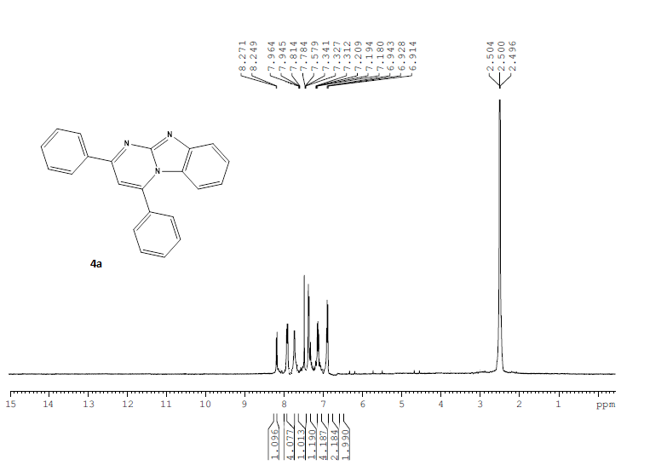
¹H NMR spectra of 4a
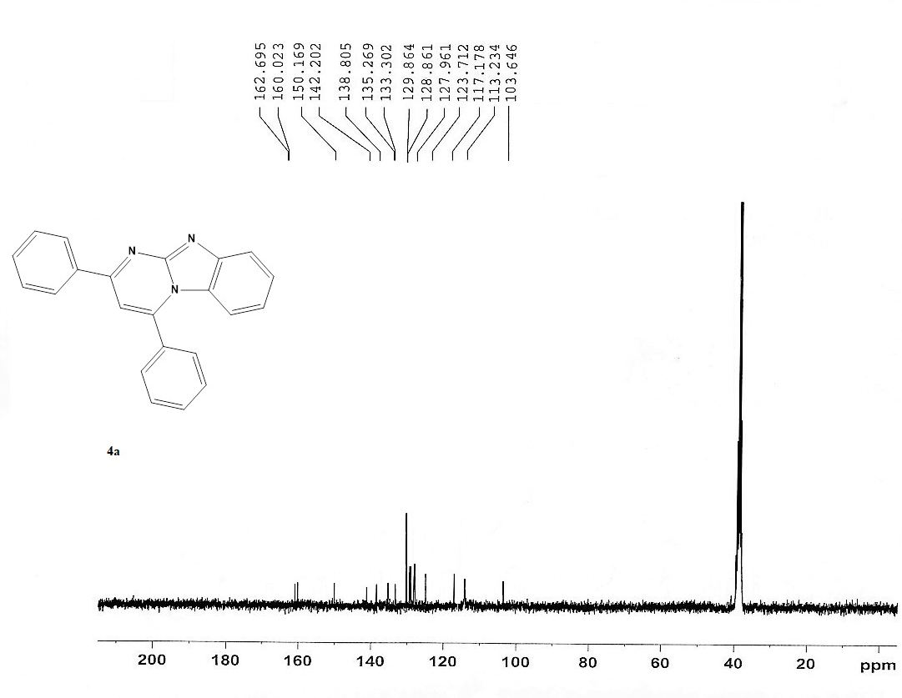

¹³C NMR spectra of 4a

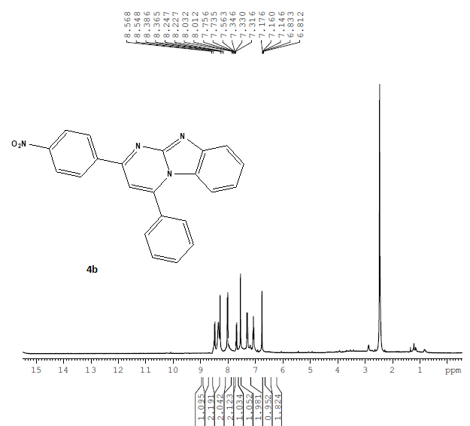
¹H NMR spectra of 4b
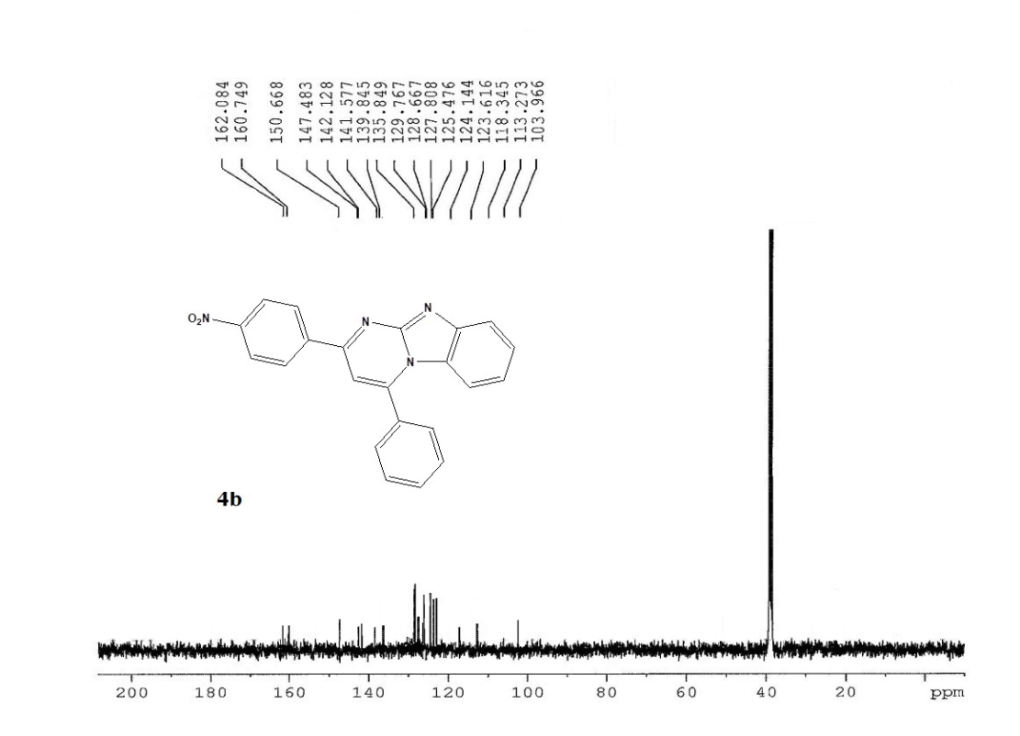
¹³C NMR spectra of 4b

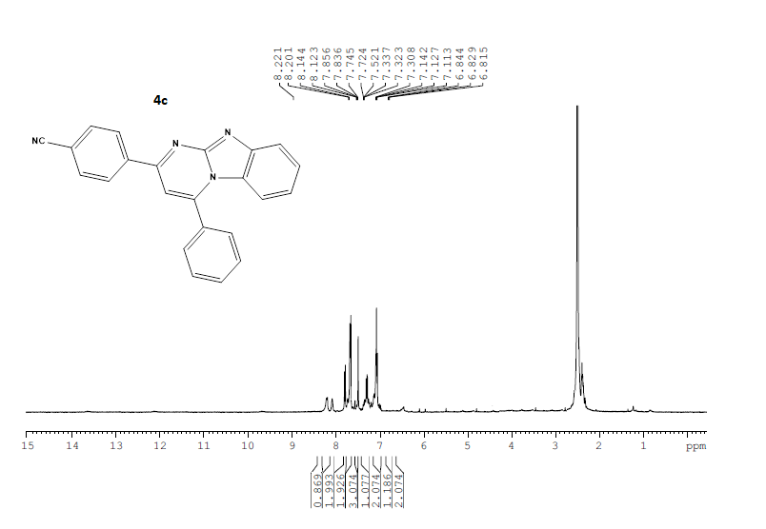
¹H NMR spectra of 4c
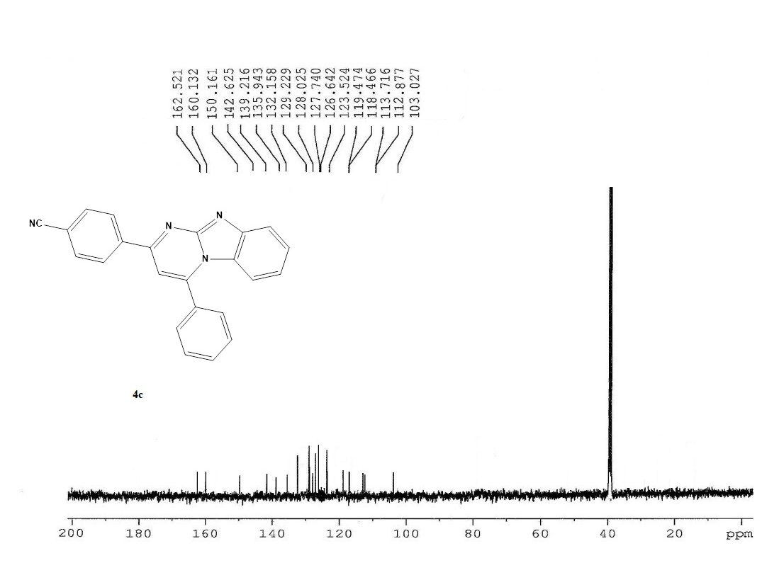
¹³C NMR spectra of 4c

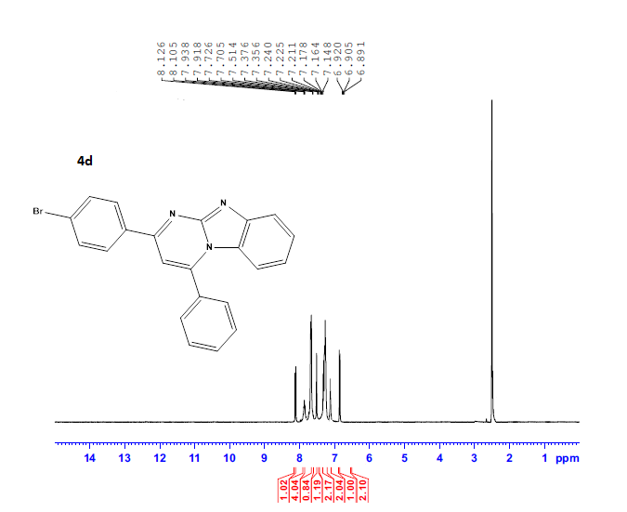
¹H NMR spectra of 4d

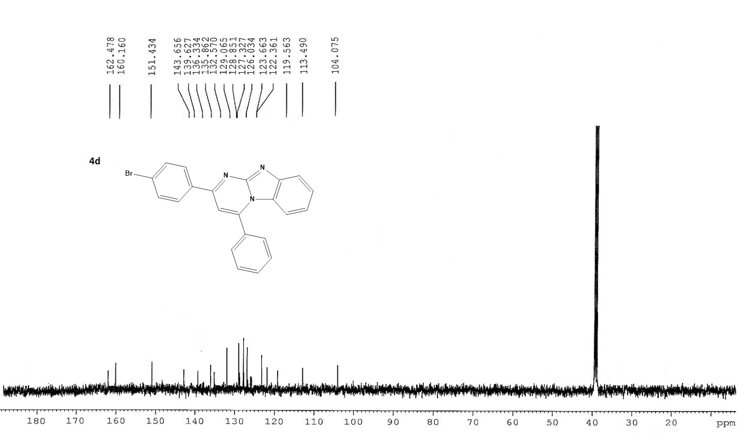
¹³C NMR spectra of 4d

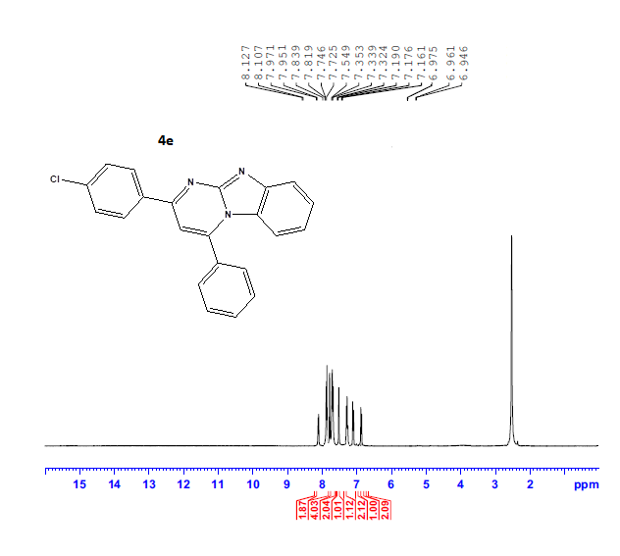

¹H NMR spectra of 4e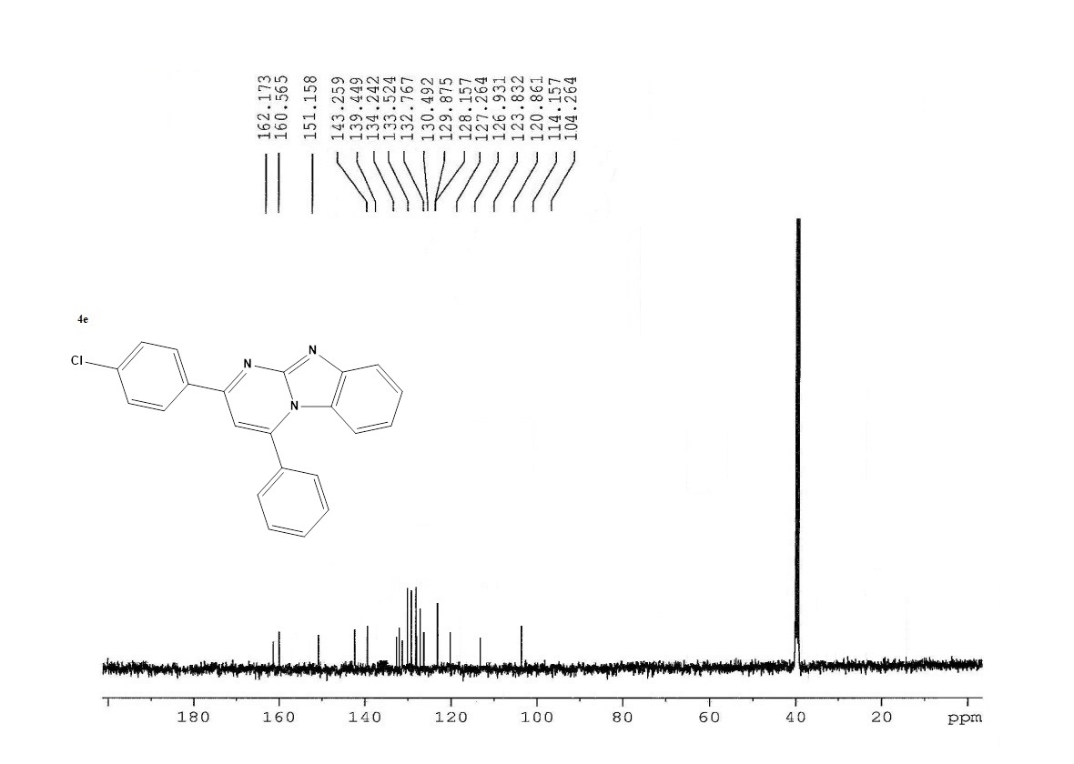
¹³C NMR spectra of 4e
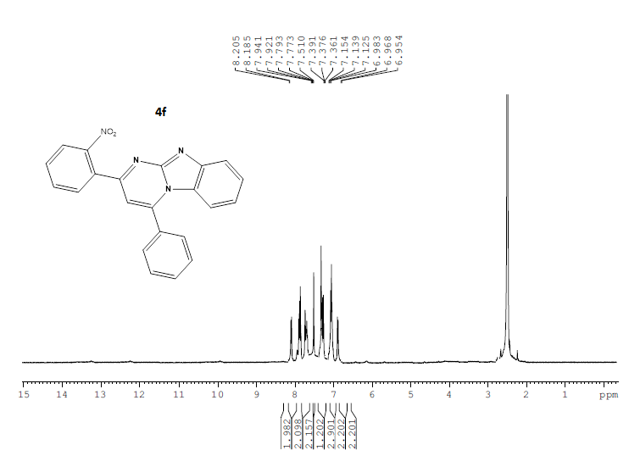
¹H NMR spectra of 4f

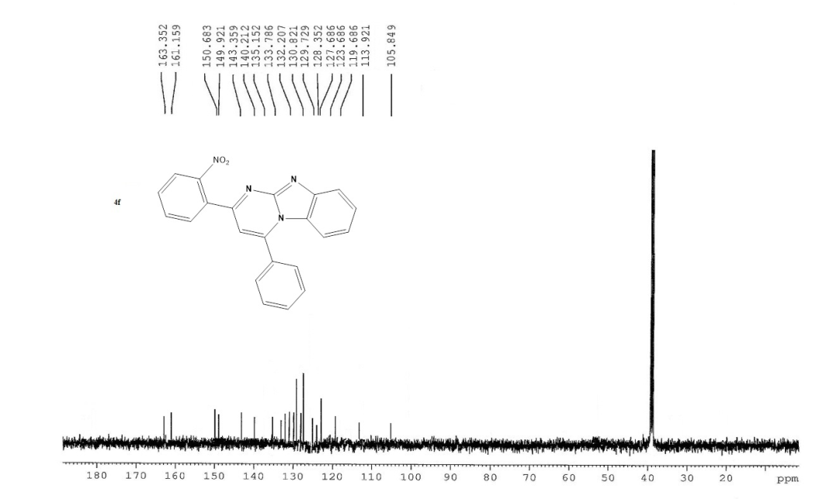
¹³C NMR spectra of 4f

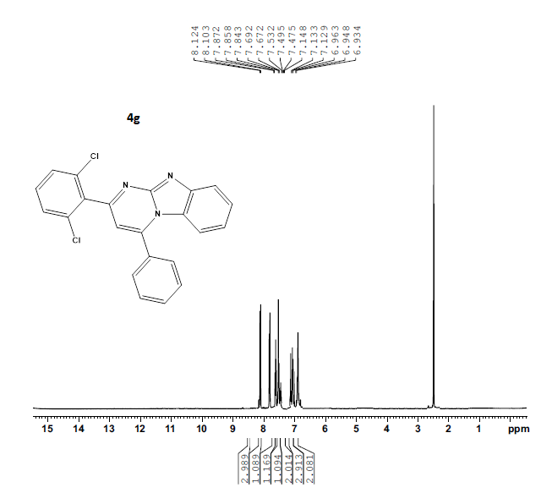
¹H NMR spectra of 4g

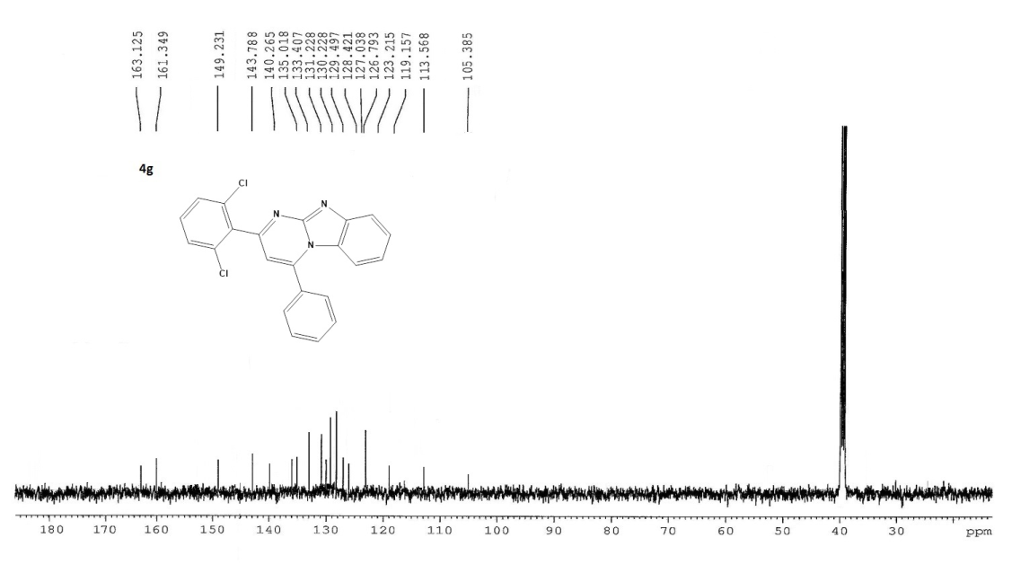
¹³C NMR spectra of 4g

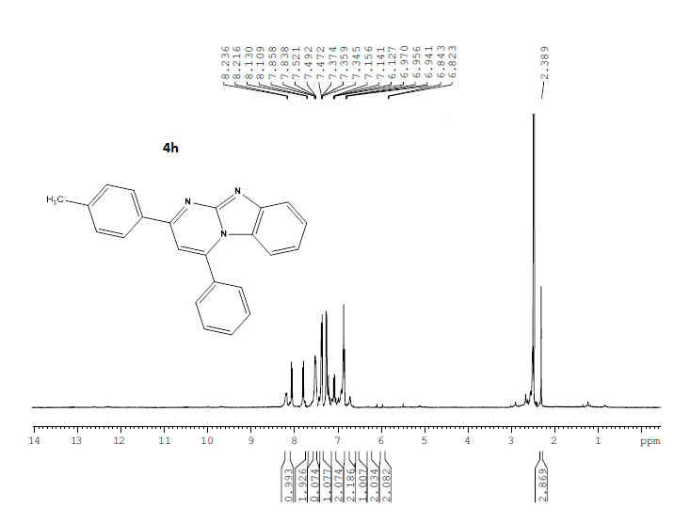
¹H NMR spectra of 4h
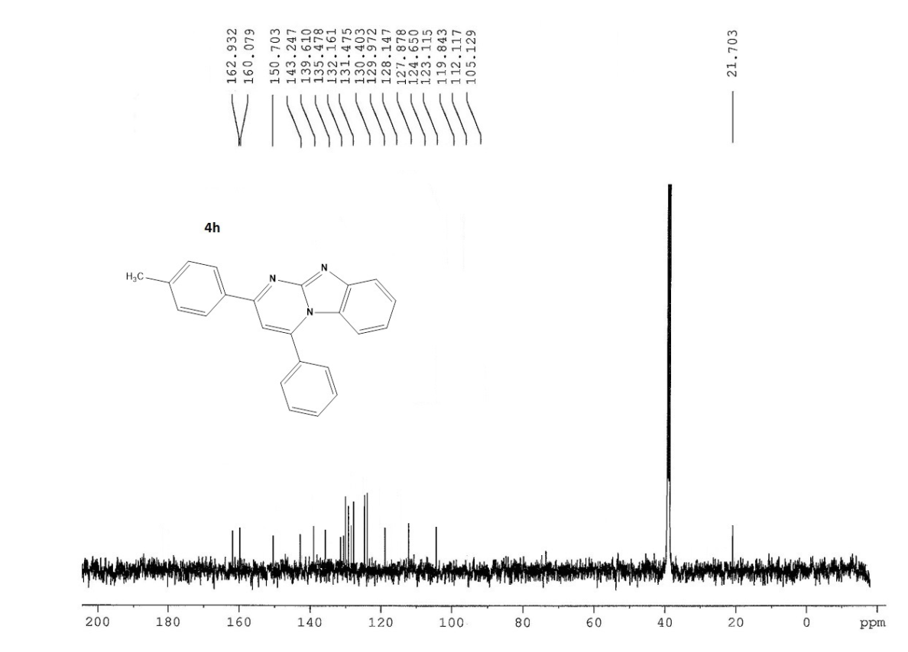
¹³C NMR spectra of 4h

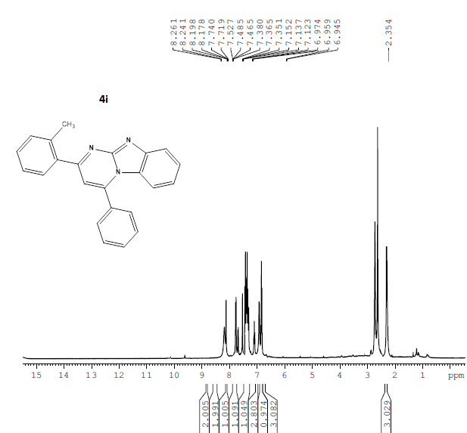
¹H NMR spectra of 4i

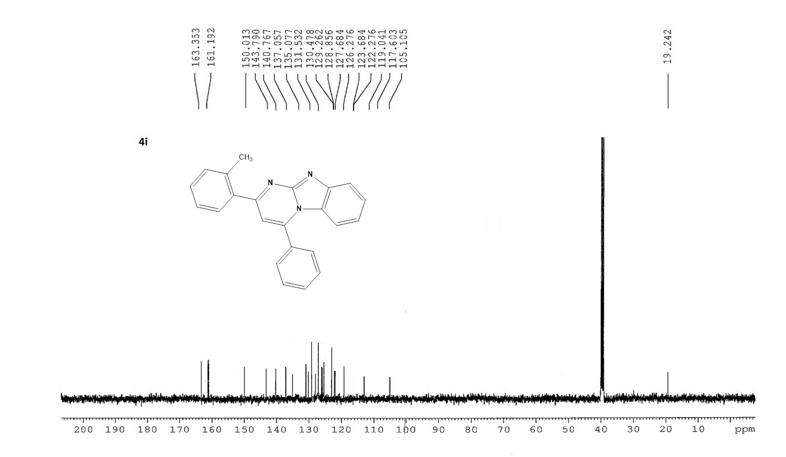
¹³C NMR spectra of 4i

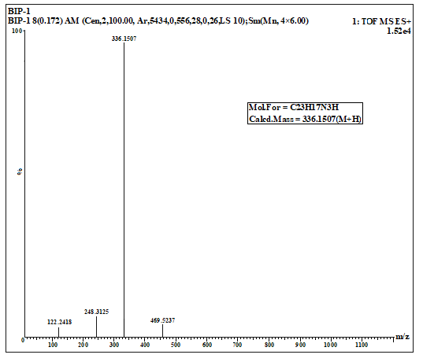
HRMS spectra of 4i

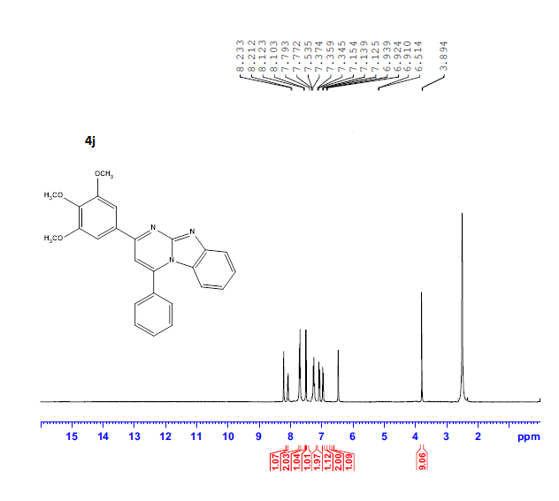
¹H NMR spectra of 4j
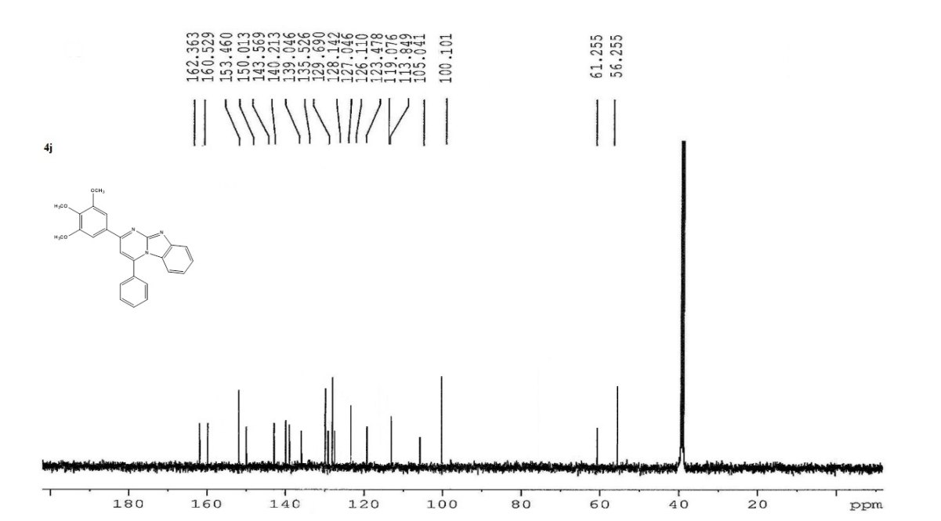
¹³C NMR spectra of 4j

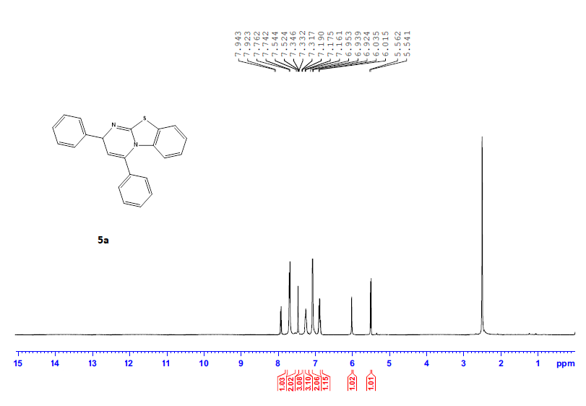
¹H NMR spectra of 5a
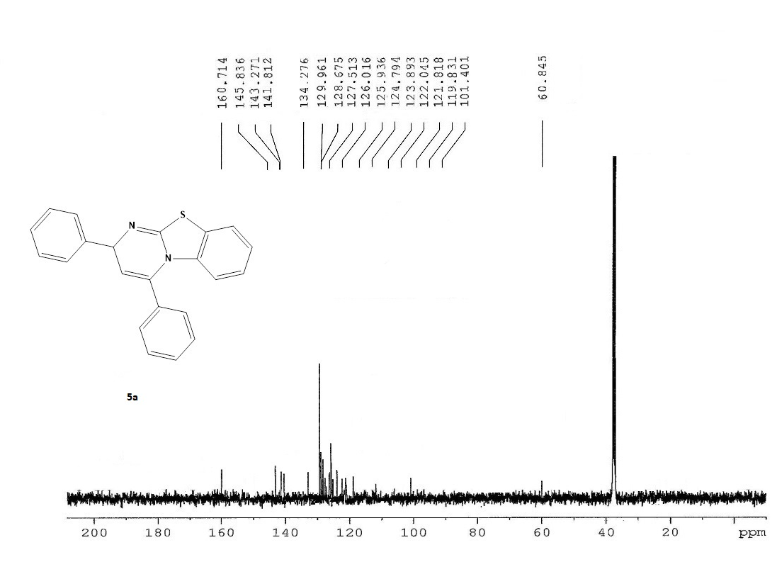
¹³C NMR spectra of 5a

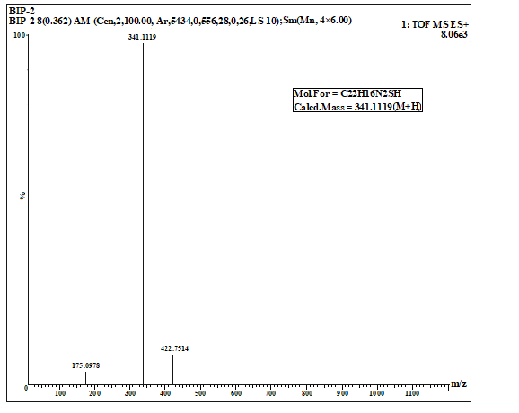
HRMS spectra of 5a

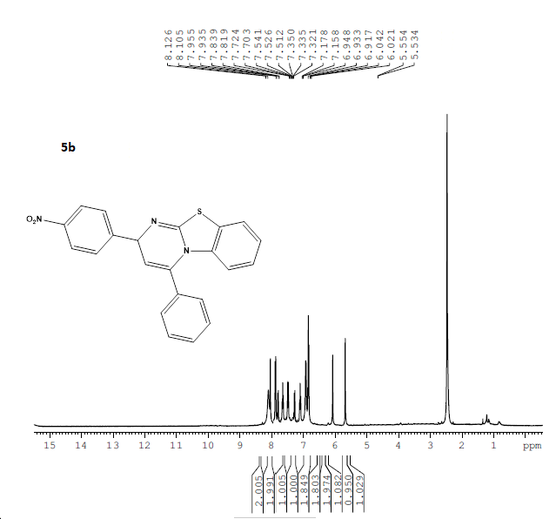
¹H NMR spectra of 5b

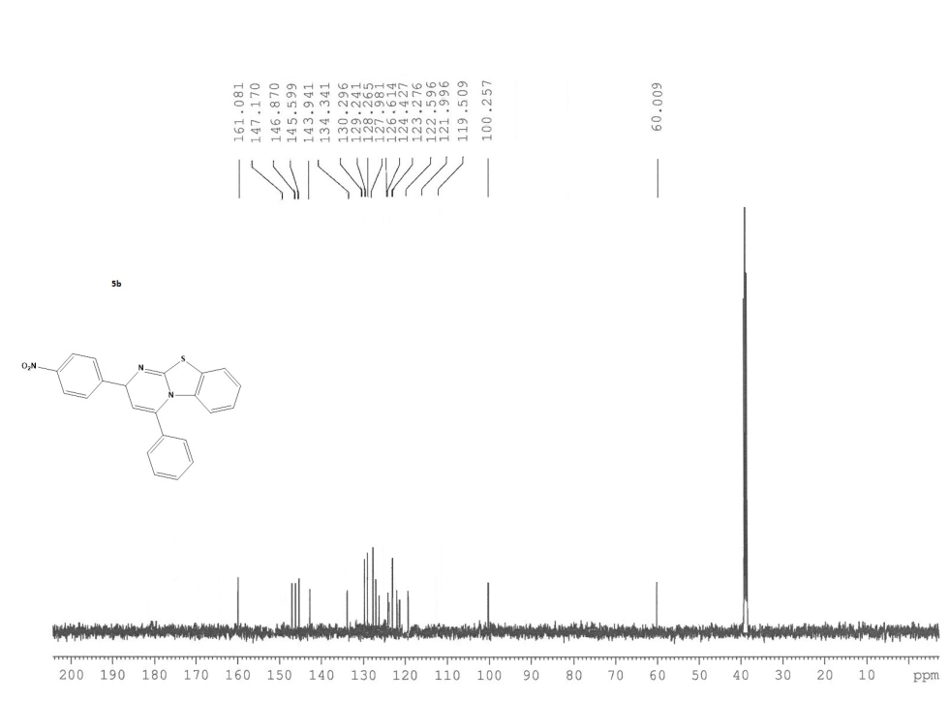
¹³C NMR spectra of 5b
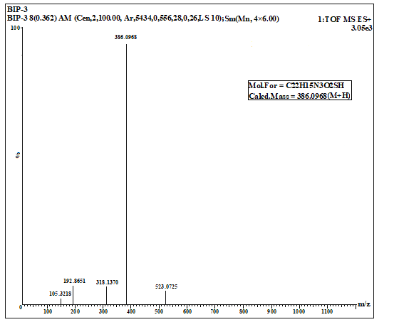
HRMS spectra of 5b

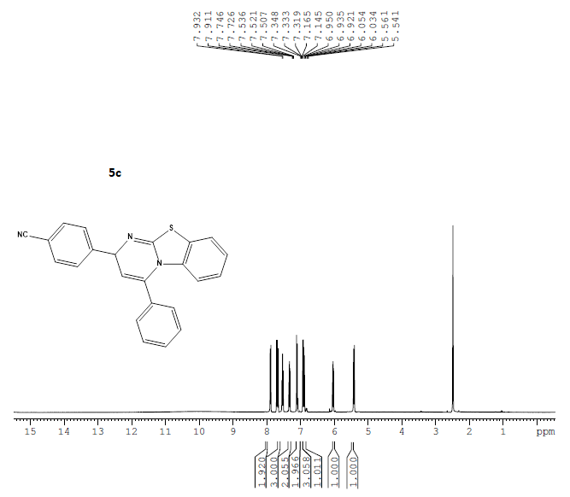
¹H NMR spectra of 5c

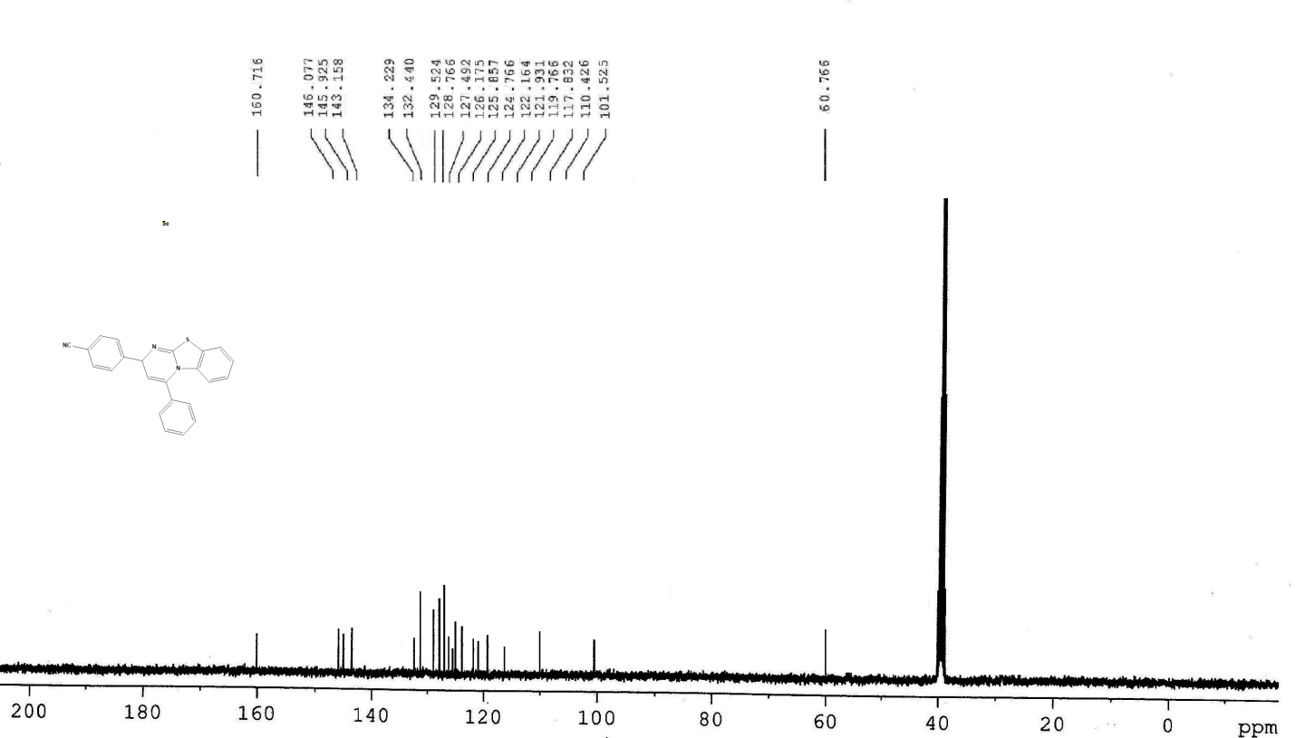
¹³C NMR spectra of 5c
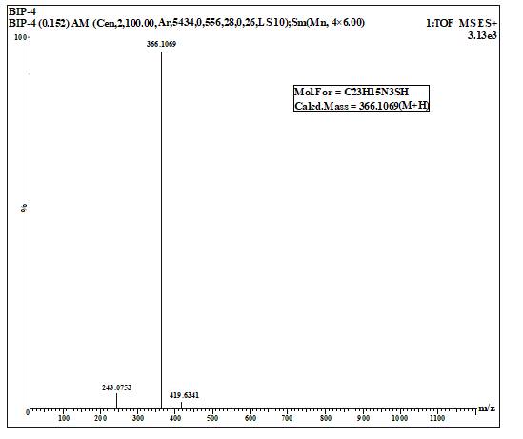
HRMS spectra of 5c

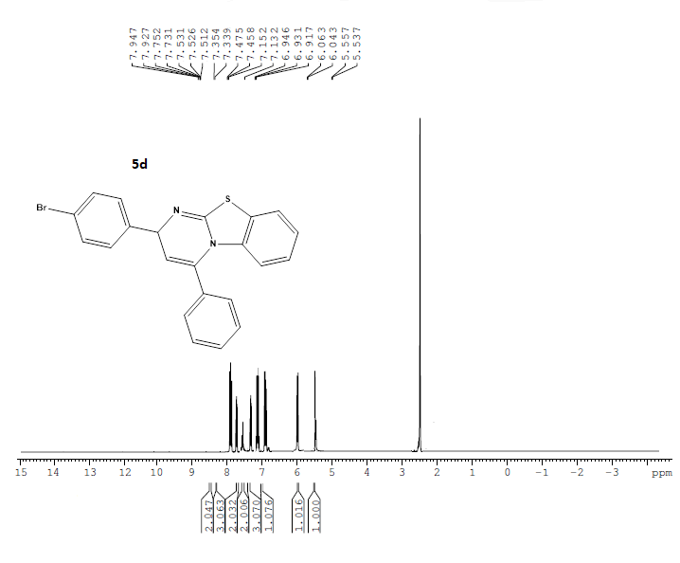
¹H NMR spectra of 5d

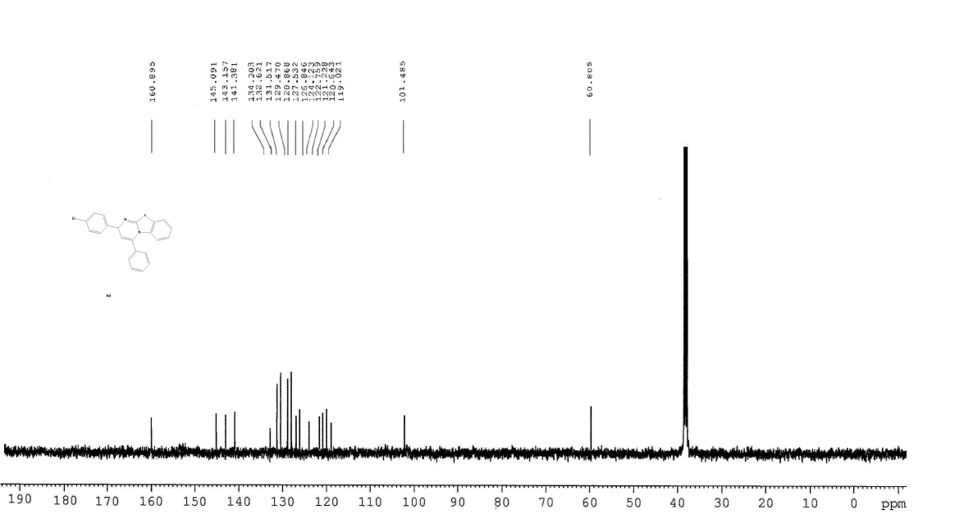
¹³C NMR spectra of 5d

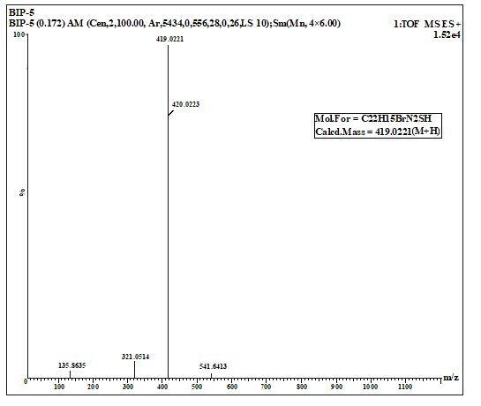
HRMS spectra of 5d

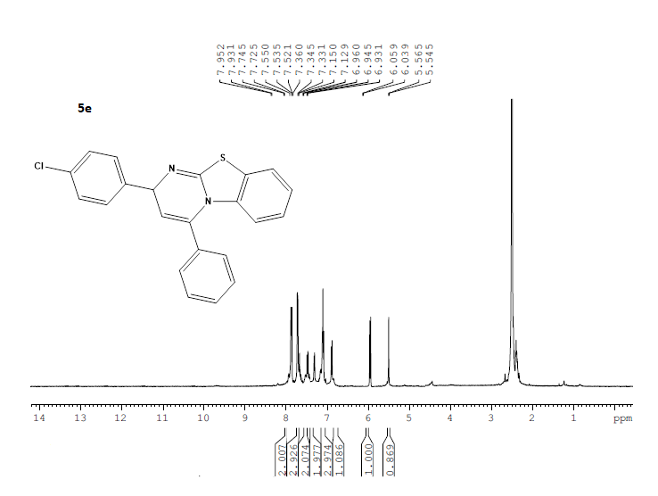
¹H NMR spectra of 5e
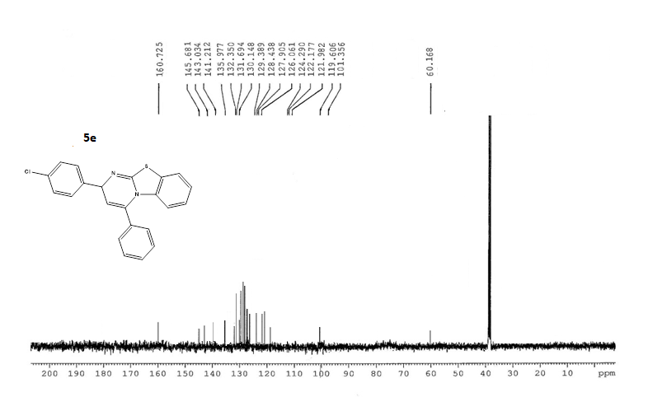
¹³C NMR spectra of 5e

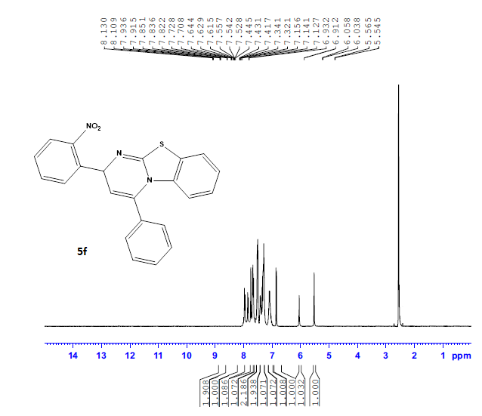
¹H NMR spectra of 5f
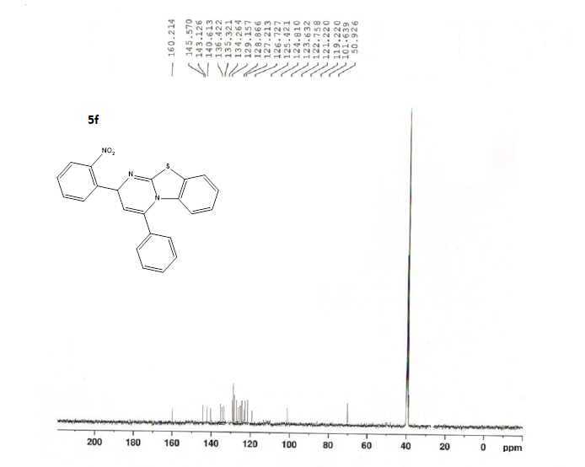
¹³C NMR spectra of 5f

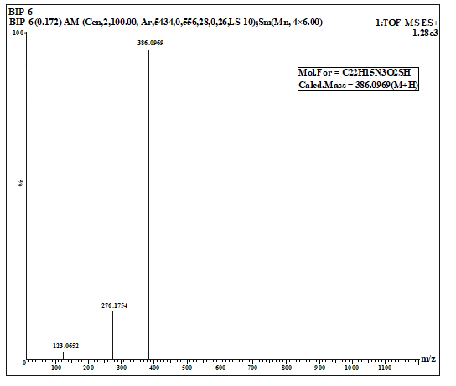
HRMS spectra of 5f

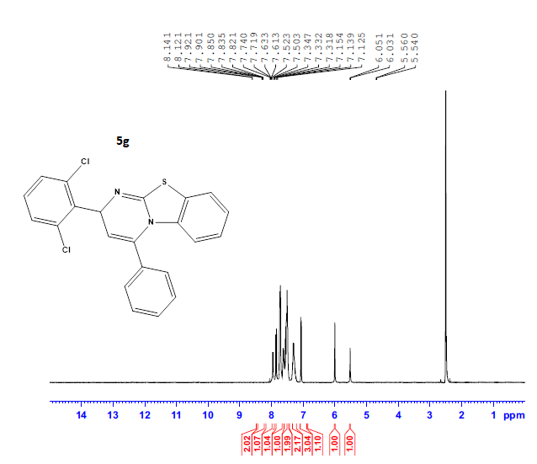
¹H NMR spectra of 5g
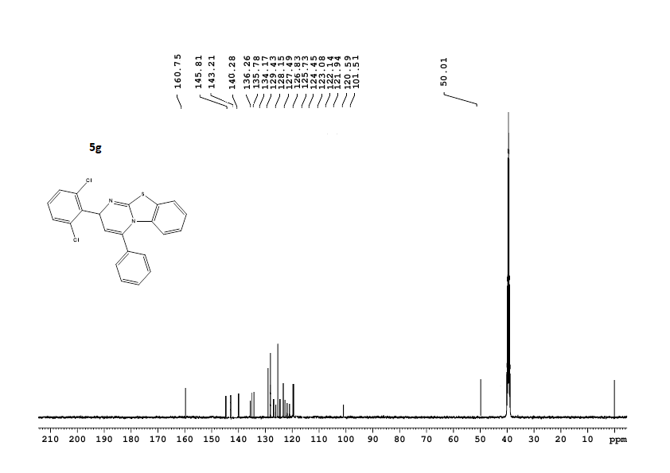
¹³C NMR spectra of 5g
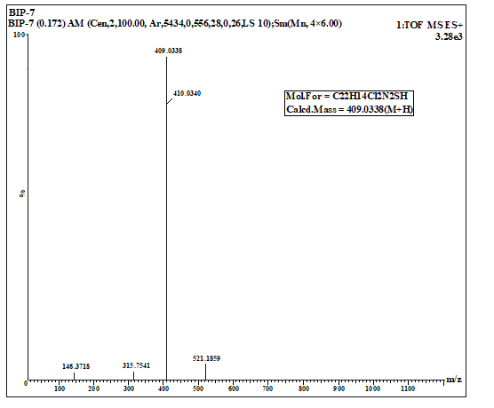
HRMS spectra of 5g

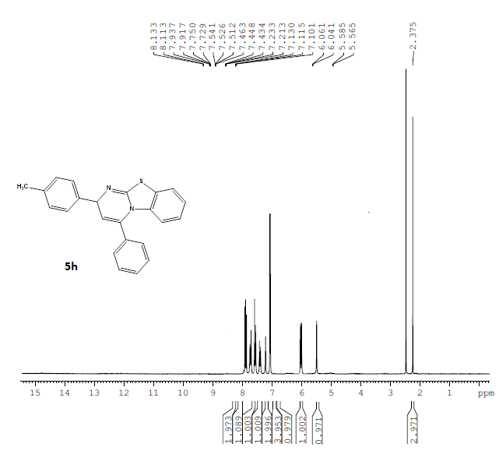
¹H NMR spectra of 5h
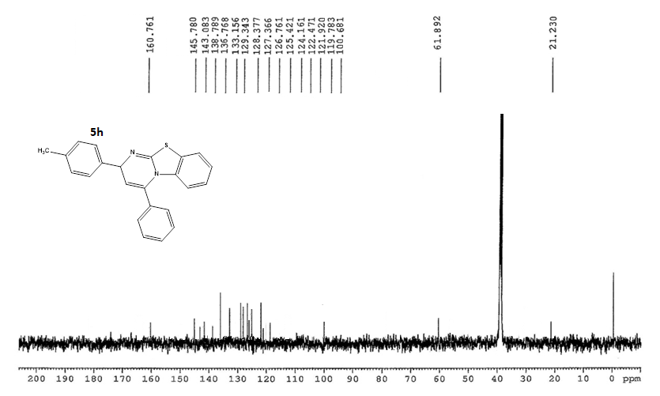
¹³C NMR spectra of 5h

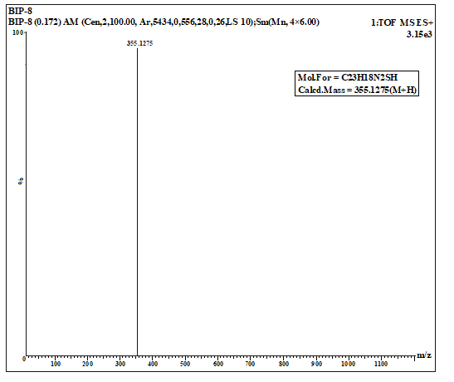
HRMS spectra of 5h

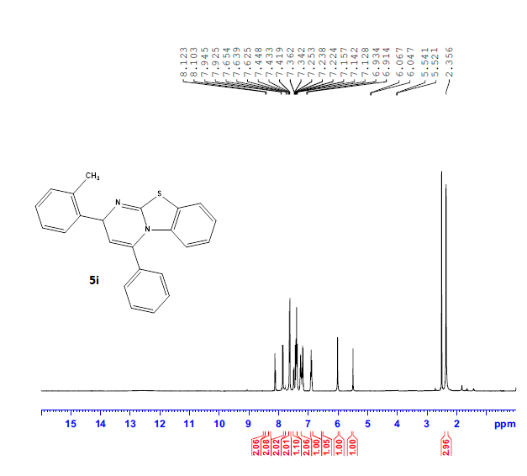
¹H NMR spectra of 5i
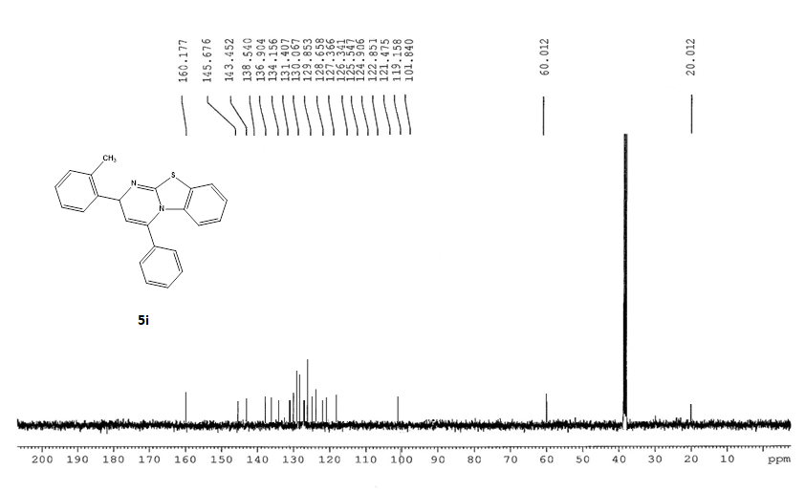
¹³C NMR spectra of 5i
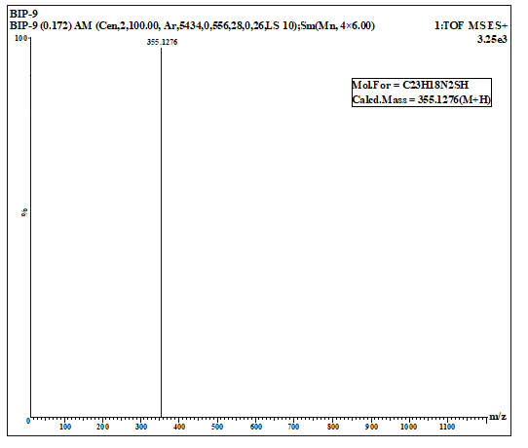
HRMS spectra of 5i

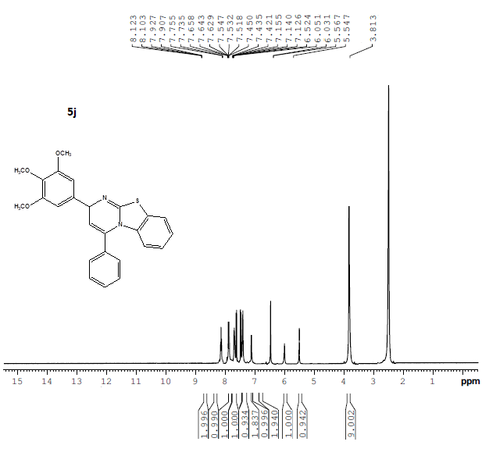
¹H NMR spectra of 5j
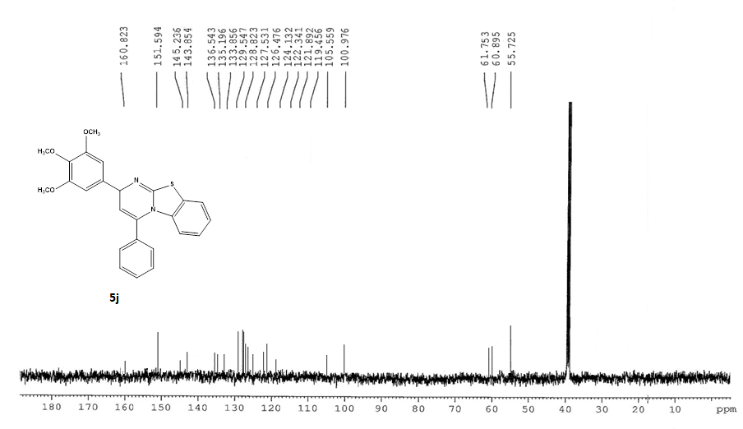
¹³C NMR spectra of 5j

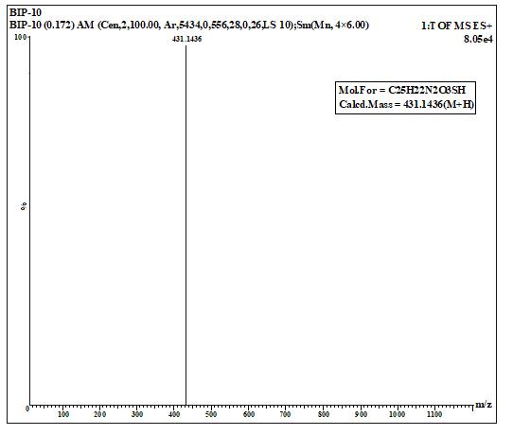
HRMS spectra of 5j

