Appendix

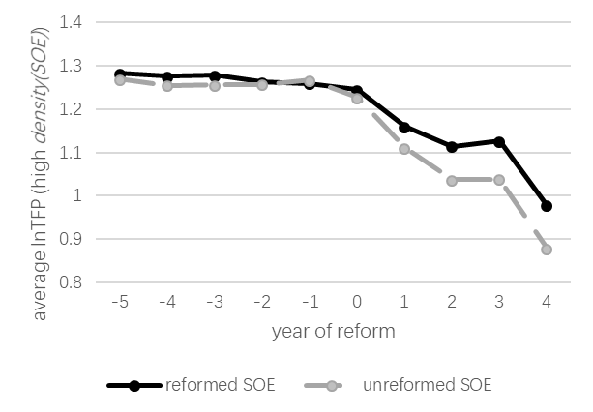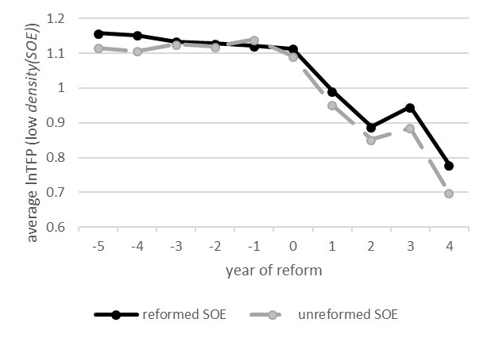
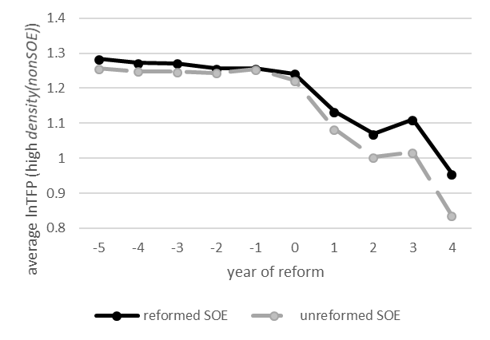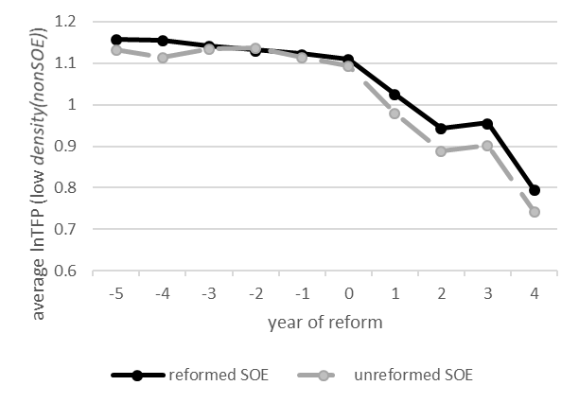
Figure A1 Average TFP of the treatment and control groups with high and low levels of density(SOE)/density(nonSOE)

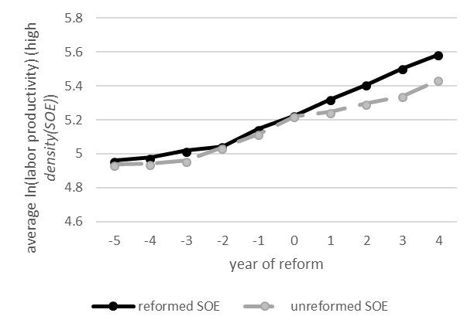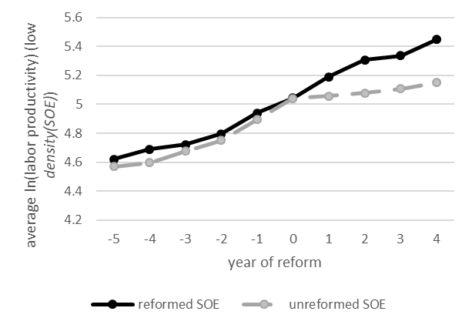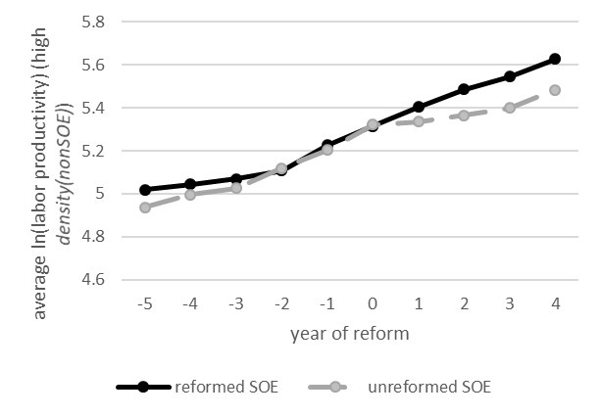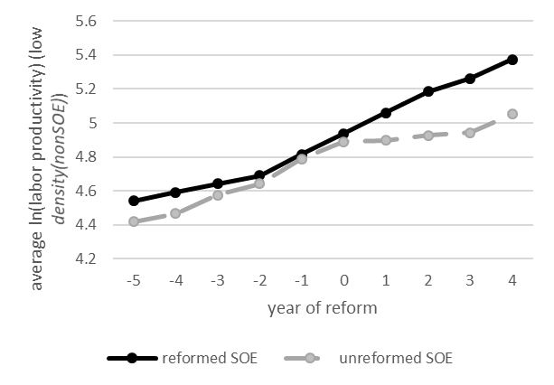
Figure A2 Average labor productivity of the treatment and control groups with high and low levels of density(SOE)/density(nonSOE)

Table A1 Baseline results (TFP)
 | 1 year after | 2 years after | 3 years after | 4 years after
post | 0.140*** | 0.226*** | 0.196*** | 0.384***
 | (0.0149) | (0.0174) | (0.0206) | (0.0249)
Reform | -0.0193 | -0.023 | -0.0333* | -0.031
 | (0.0172) | (0.0180) | (0.0182) | (0.0189)
density(nonSOE) | 0.133*** | 0.283*** | 0.199*** | 0.327***
 | (0.0138) | (0.0145) | (0.0157) | (0.0173)
density(SOE) | -0.0794*** | -0.171*** | -0.128*** | -0.214***
 | (0.0139) | (0.0153) | (0.0173) | (0.0189)
post*Reform | 0.0509** | 0.0510** | 0.0571** | 0.0418
 | (0.0212) | (0.0242) | (0.0277) | (0.0325)
Reform*density(nonSOE) | 0.0482*** | 0.0505*** | 0.0293** | 0.0235
 | (0.0132) | (0.0140) | (0.0144) | (0.0150)
Reform*density(SOE) | -0.0378*** | -0.0400*** | -0.0288** | -0.0225
 | (0.0127) | (0.0135) | (0.0139) | (0.0145)
post*density(nonSOE) | -0.0720*** | -0.176*** | -0.0898*** | -0.202***
 | (0.0115) | (0.0142) | (0.0176) | (0.0219)
post*density(SOE) | 0.0883*** | 0.196*** | 0.132*** | 0.238***
 | (0.0103) | (0.0122) | (0.0145) | (0.0175)
post*Reform*density(nonSOE) | 0.0932*** | 0.103*** | 0.0786*** | 0.0890***
 | (0.0169) | (0.0202) | (0.0242) | (0.0287)
post*Reform*density(SOE) | 0.0540*** | 0.0632*** | 0.0498*** | 0.0278
 | (0.0148) | (0.0168) | (0.0188) | (0.0211)
Constant | 1.308*** | 1.409*** | 1.347*** | 1.409***
 | (0.0294) | (0.0302) | (0.0316) | (0.0331)
Fixed effects | year, industry, region, year-industry, year-region, industry-region
Observations | 73,621 | 63,387 | 54,787 | 49,510
R-squared | 0.465 | 0.477 | 0.461 | 0.486
* p < 0.1, ** p < 0.05, *** p < 0.01, Standard errors in parentheses

Table A2 Baseline results (output)
 | 1 year after | 2 years after | 3 years after | 4 years after
post | 0.142*** | 0.316*** | 0.439*** | 0.604***
 | (0.0409) | (0.0475) | (0.0572) | (0.0679)
Reform | 0.0242 | 0.0486 | 0.0337 | 0.0184
 | (0.0473) | (0.0490) | (0.0506) | (0.0517)
density(nonSOE) | 0.455*** | 0.425*** | 0.394*** | 0.428***
 | (0.0380) | (0.0395) | (0.0436) | (0.0471)
density(SOE) | 0.398*** | 0.402*** | 0.429*** | 0.337***
 | (0.0382) | (0.0417) | (0.0479) | (0.0516)
post*Reform | 0.0644** | 0.0499* | 0.0632** | 0.0364
 | (0.0283) | (0.0260) | (0.0268) | (0.0386)
Reform*density(nonSOE) | -0.0173 | 0.0312 | 0.0416 | 0.00944
 | (0.0362) | (0.0383) | (0.0400) | (0.0410)
Reform*density(SOE) | 0.0334 | 0.00601 | -0.0144 | 0.00764
 | (0.0349) | (0.0369) | (0.0386) | (0.0395)
post*density(nonSOE) | 0.317*** | 0.447*** | 0.458*** | 0.428***
 | (0.0315) | (0.0387) | (0.0487) | (0.0597)
post*density(SOE) | -0.207*** | -0.283*** | -0.292*** | -0.233***
 | (0.0282) | (0.0332) | (0.0403) | (0.0477)
post*Reform*density(nonSOE) | 0.0949** | 0.145*** | 0.144** | 0.181**
 | (0.0464) | (0.0551) | (0.0670) | (0.0784)
post*Reform*density(SOE) | 0.0372 | 0.0599 | 0.0552 | 0.0382
 | (0.0406) | (0.0458) | (0.0523) | (0.0575)
Constant | 11.78*** | 11.73*** | 11.72*** | 11.61***
 | (0.0809) | (0.0824) | (0.0877) | (0.0904)
Fixed effects | year, industry, region, year-industry, year-region, industry-region
Observations | 73,621 | 63,387 | 54,787 | 49,510
R-squared | 0.391 | 0.385 | 0.382 | 0.381
* p < 0.1, ** p < 0.05, *** p < 0.01, Standard errors in parentheses

Table A3 Estimation results for highly and lowly marketized regions (labor productivity)
 | 1 year after |  | 2 years after |  | 3 years after |  | 4 years after
 | Highly marketized regions | Lowly marketized regions | Highly marketized regions | Lowly marketized regions | Highly marketized regions | Lowly marketized regions | Highly marketized regions | Lowly marketized regions
post | 0.0655* | 0.182*** | 0.172*** | 0.344*** | 0.248*** | 0.449*** | 0.372*** | 0.618***
 | (0.0396) | (0.0451) | (0.0468) | (0.0519) | (0.0595) | (0.0606) | (0.0744) | (0.0692)
Reform | 0.133*** | 0.145*** | 0.0936* | 0.155*** | 0.136*** | 0.154*** | 0.125** | 0.178***
 | (0.0471) | (0.0555) | (0.0491) | (0.0577) | (0.0514) | (0.0595) | (0.0522) | (0.0606)
density(nonSOE) | 0.0583 | 0.0112 | 0.0913* | 0.0416 | 0.108* | 0.0319 | 0.127** | 0.0266
 | (0.0470) | (0.0348) | (0.0505) | (0.0360) | (0.0592) | (0.0392) | (0.0623) | (0.0427)
density(SOE) | 0.0705* | 0.137*** | 0.0712 | 0.214*** | 0.0719 | 0.253*** | 0.0625 | 0.212***
 | (0.0406) | (0.0376) | (0.0463) | (0.0402) | (0.0573) | (0.0446) | (0.0633) | (0.0470)
post*Reform | 0.0679** | -0.00931 | 0.0766* | 0.0473 | 0.0837* | 0.0932 | 0.0904 | 0.0278
 | (0.0360) | (0.0655) | (0.0447) | (0.0732) | (0.0493) | (0.0824) | (0.0748) | (0.0919)
Reform*density(nonSOE) | -0.0645 | 0.000216 | 0.0246 | -0.00616 | -0.0135 | 0.0113 | 0.01 | -0.0436
 | (0.0442) | (0.0370) | (0.0477) | (0.0387) | (0.0505) | (0.0406) | (0.0512) | (0.0415)
Reform*density(SOE) | -0.0152 | -0.0909** | -0.0692* | -0.0901** | -0.0624 | -0.110*** | -0.0745* | -0.0693*
 | (0.0375) | (0.0357) | (0.0403) | (0.0375) | (0.0428) | (0.0392) | (0.0435) | (0.0401)
post*density(nonSOE) | 0.108*** | 0.161*** | 0.174*** | 0.259*** | 0.145** | 0.281*** | 0.0407 | 0.334***
 | (0.0374) | (0.0303) | (0.0458) | (0.0369) | (0.0580) | (0.0456) | (0.0713) | (0.0544)
post*density(SOE) | -0.105*** | -0.0859*** | -0.138*** | -0.142*** | -0.113** | -0.168*** | -0.0186 | -0.189***
 | (0.0307) | (0.0271) | (0.0366) | (0.0317) | (0.0457) | (0.0380) | (0.0552) | (0.0441)
post*Reform*density(nonSOE) | 0.128** | 0.0942** | 0.110* | 0.0555 | 0.0949** | 0.0214 | 0.0678 | 0.0131
 | (0.0533) | (0.0470) | (0.0639) | (0.0544) | (0.0413) | (0.0643) | (0.0919) | (0.0731)
post*Reform*density(SOE) | -0.0399 | 0.00621 | -0.0134 | 0.00838 | -0.0101 | -0.0178 | -0.0954 | -0.0215
 | (0.0419) | (0.0417) | (0.0480) | (0.0462) | (0.0565) | (0.0517) | (0.0630) | (0.0561)
Constant | 5.482*** | 5.121*** | 5.513*** | 5.321*** | 5.518*** | 5.376*** | 5.538*** | 5.282***
 | (0.0786) | (0.0879) | (0.0793) | (0.0897) | (0.0886) | (0.0926) | (0.0914) | (0.0948)
Fixed effects | year, industry, region, year-industry, year-region, industry-region
Observations | 37,135 | 36,454 | 31,447 | 31,532 | 26,224 | 27,869 | 23,490 | 25,183
R-squared | 0.429 | 0.458 | 0.410 | 0.457 | 0.390 | 0.458 | 0.390 | 0.466
* p < 0.1, ** p < 0.05, *** p < 0.01, Standard errors in parentheses

Table A4 Estimation results for highly and lowly marketized regions (TFP)
 | 1 year after |  | 2 years after |  | 3 years after |  | 4 years after
 | Highly marketized regions | Lowly marketized regions | Highly marketized regions | Lowly marketized regions | Highly marketized regions | Lowly marketized regions | Highly marketized regions | Lowly marketized regions
post | 0.147*** | 0.0892*** | 0.268*** | 0.0456* | 0.242*** | 0.0496* | 0.374*** | 0.228***
 | (0.0208) | (0.0224) | (0.0253) | (0.0253) | (0.0312) | (0.0298) | (0.0393) | (0.0352)
Reform | -0.0402 | 0.00611 | -0.0455* | 0.00612 | -0.0672** | -0.00975 | -0.0509* | -0.0144
 | (0.0247) | (0.0275) | (0.0266) | (0.0281) | (0.0270) | (0.0292) | (0.0276) | (0.0309)
density(nonSOE) | 0.213*** | 0.0508*** | 0.417*** | 0.128*** | 0.215*** | 0.112*** | 0.351*** | 0.196***
 | (0.0246) | (0.0173) | (0.0274) | (0.0176) | (0.0310) | (0.0192) | (0.0330) | (0.0217)
density(SOE) | -0.138*** | -0.0293 | -0.287*** | -0.0575*** | -0.160*** | -0.0670*** | -0.191*** | -0.190***
 | (0.0213) | (0.0186) | (0.0251) | (0.0196) | (0.0300) | (0.0219) | (0.0335) | (0.0239)
post*Reform | 0.0247 | 0.0417 | 0.0302 | 0.0702** | 0.0867** | 0.0538 | 0.0463 | 0.0661
 | (0.0294) | (0.0325) | (0.0350) | (0.0357) | (0.0416) | (0.0405) | (0.0501) | (0.0468)
Reform*density(nonSOE) | 0.0543** | 0.0239 | 0.0368 | 0.0258 | -0.0108 | 0.0402** | 0.0338 | 0.00612
 | (0.0232) | (0.0184) | (0.0258) | (0.0189) | (0.0265) | (0.0199) | (0.0271) | (0.0211)
Reform*density(SOE) | -0.0531*** | 0.0017 | -0.0367* | 0.00127 | -0.0139 | -0.0234 | -0.0417* | 0.00674
 | (0.0197) | (0.0177) | (0.0218) | (0.0183) | (0.0224) | (0.0193) | (0.0230) | (0.0204)
post*density(nonSOE) | -0.113*** | -0.0173 | -0.240*** | -0.0440** | -0.152*** | 0.0157 | -0.213*** | -0.132***
 | (0.0196) | (0.0150) | (0.0248) | (0.0180) | (0.0304) | (0.0224) | (0.0377) | (0.0277)
post*density(SOE) | 0.137*** | 0.0452*** | 0.281*** | 0.115*** | 0.200*** | 0.0746*** | 0.312*** | 0.202***
 | (0.0161) | (0.0134) | (0.0198) | (0.0155) | (0.0239) | (0.0186) | (0.0292) | (0.0225)
post*Reform*density(nonSOE) | 0.0683** | 0.0428* | 0.123*** | 0.00491 | 0.152*** | 0.0800** | 0.0872* | 0.0592
 | (0.0280) | (0.0233) | (0.0346) | (0.0265) | (0.0410) | (0.0316) | (0.0486) | (0.0372)
post*Reform*density(SOE) | 0.0482** | 0.0136 | 0.0750*** | 0.0098 | 0.111*** | 0.0472* | 0.0443 | 0.0173
 | (0.0220) | (0.0207) | (0.0260) | (0.0225) | (0.0296) | (0.0254) | (0.0333) | (0.0286)
Constant | 1.304*** | 1.272*** | 1.372*** | 1.375*** | 1.290*** | 1.327*** | 1.441*** | 1.255***
 | (0.0412) | (0.0436) | (0.0429) | (0.0438) | (0.0465) | (0.0455) | (0.0483) | (0.0482)
Fixed effects | year, industry, region, year-industry, year-region, industry-region
Observations | 37,135 | 36,454 | 31,447 | 31,532 | 26,224 | 27,869 | 23,490 | 25,183
R-squared | 0.494 | 0.478 | 0.501 | 0.490 | 0.478 | 0.479 | 0.519 | 0.491
* p < 0.1, ** p < 0.05, *** p < 0.01, Standard errors in parentheses

Table A5 Estimation results for highly and lowly marketized regions (Output)
 | 1 year after |  | 2 years after |  | 3 years after |  | 4 years after
 | Highly marketized regions | Lowly marketized regions | Highly marketized regions | Lowly marketized regions | Highly marketized regions | Lowly marketized regions | Highly marketized regions | Lowly marketized regions
post | 0.181*** | 0.124** | 0.354*** | 0.240*** | 0.489*** | 0.387*** | 0.620*** | 0.577***
 | (0.0635) | (0.0543) | (0.0735) | (0.0645) | (0.0858) | (0.0824) | (0.0989) | (0.1040)
Reform | 0.191** | 0.0849 | 0.187** | 0.133** | 0.181** | 0.109 | 0.227*** | 0.126*
 | (0.0781) | (0.0645) | (0.0817) | (0.0677) | (0.0843) | (0.0712) | (0.0865) | (0.0730)
density(nonSOE) | 0.484*** | 0.381*** | 0.454*** | 0.403*** | 0.380*** | 0.433*** | 0.418*** | 0.435***
 | (0.0490) | (0.0644) | (0.0511) | (0.0697) | (0.0555) | (0.0820) | (0.0609) | (0.0871)
density(SOE) | 0.524*** | 0.199*** | 0.561*** | 0.164** | 0.573*** | 0.155* | 0.457*** | 0.0857
 | (0.0529) | (0.0556) | (0.0569) | (0.0639) | (0.0632) | (0.0793) | (0.0671) | (0.0885)
post*Reform | 0.0875*** | 0.142* | 0.0776** | 0.0602 | 0.151* | 0.0482 | 0.174 | -0.0789
 | (0.0321) | (0.0767) | (0.0384) | (0.0892) | (0.0917) | (0.1100) | (0.1310) | (0.1320)
Reform*density(nonSOE) | -0.0989* | -0.0203 | -0.0875 | 0.0847 | -0.0611 | 0.0704 | -0.140** | 0.106
 | (0.0521) | (0.0605) | (0.0548) | (0.0657) | (0.0574) | (0.0699) | (0.0592) | (0.0716)
Reform*density(SOE) | 0.0443 | 0.0367 | 0.0392 | -0.0219 | 0.0119 | -0.0252 | 0.0633 | -0.0414
 | (0.0503) | (0.0514) | (0.0531) | (0.0556) | (0.0556) | (0.0592) | (0.0572) | (0.0609)
post*density(nonSOE) | 0.344*** | 0.230*** | 0.500*** | 0.326*** | 0.528*** | 0.325*** | 0.570*** | 0.186*
 | (0.0426) | (0.0513) | (0.0523) | (0.0632) | (0.0646) | (0.0802) | (0.0777) | (0.0996)
post*density(SOE) | -0.208*** | -0.183*** | -0.310*** | -0.216*** | -0.337*** | -0.185*** | -0.349*** | -0.0196
 | (0.0381) | (0.0421) | (0.0449) | (0.0504) | (0.0537) | (0.0632) | (0.0631) | (0.0771)
post*Reform*density(nonSOE) | 0.145** | 0.151** | 0.144** | 0.109 | 0.151* | 0.135 | 0.189 | 0.146
 | (0.0662) | (0.0730) | (0.0690) | (0.0881) | (0.0911) | (0.1080) | (0.1340) | (0.1280)
post*Reform*density(SOE) | 0.0474 | 0.00363 | 0.0518 | 0.0459 | 0.0015 | 0.0687 | 0.0379 | -0.0049
 | (0.0587) | (0.0575) | (0.0655) | (0.0662) | (0.0732) | (0.0782) | (0.0802) | (0.0881)
Constant | 12.23*** | 11.18*** | 12.25*** | 11.14*** | 12.14*** | 11.15*** | 11.98*** | 11.04***
 | (0.1240) | (0.1080) | (0.1270) | (0.1090) | (0.1310) | (0.1230) | (0.1350) | (0.1280)
Fixed effects | year, industry, region, year-industry, year-region, industry-region
Observations | 37,135 | 36,454 | 31,447 | 31,532 | 26,224 | 27,869 | 23,490 | 25,183
R-squared | 0.458 | 0.393 | 0.451 | 0.373 | 0.452 | 0.352 | 0.450 | 0.345
* p < 0.1, ** p < 0.05, *** p < 0.01, Standard errors in parentheses

Table A6 Estimation results on financial performance (Leverage ratio)
 | 1 year after | 2 years after | 3 years after | 4 years after
post | -0.00406 | -0.0122* | -0.00735 | -0.0169*
 | (0.0058) | (0.0067) | (0.0081) | (0.0095)
Reform | 0.0488*** | 0.0466*** | 0.0457*** | 0.0461***
 | (0.0067) | (0.0069) | (0.0071) | (0.0072)
density(nonSOE) | -0.00832** | -0.00906** | -0.0144** | -0.0116*
 | (0.0034) | (0.0044) | (0.0061) | (0.0066)
density(SOE) | -0.0148*** | -0.00942 | -0.00279 | -0.00687
 | (0.0054) | (0.0059) | (0.0068) | (0.0072)
post*Reform | -0.0125** | -0.0120* | -0.00851 | -0.00673
 | (0.0052) | (0.0063) | (0.0081) | (0.0103)
Reform*density(nonSOE) | 0.0193*** | 0.0159*** | 0.0167*** | 0.0169***
 | (0.0051) | (0.0054) | (0.0056) | (0.0057)
Reform*density(SOE) | 0.0108** | 0.0124** | 0.0112** | 0.0115**
 | (0.0049) | (0.0052) | (0.0054) | (0.0055)
post*density(nonSOE) | -0.00525 | -0.0140** | -0.0115* | -0.0209**
 | (0.0044) | (0.0055) | (0.0069) | (0.0083)
post*density(SOE) | 0.00124 | 0.0037 | 0.00185 | 0.00635
 | (0.0040) | (0.0047) | (0.0057) | (0.0066)
post*Reform*density(nonSOE) | -0.00907** | -0.00948** | -0.0107* | -0.0109
 | (0.0042) | (0.0048) | (0.0054) | (0.0070)
post*Reform*density(SOE) | 0.00944* | 0.00762 | 0.00753 | 0.00442
 | (0.0057) | (0.0065) | (0.0074) | (0.0080)
Constant | 0.440*** | 0.445*** | 0.448*** | 0.445***
 | (0.0114) | (0.0116) | (0.0123) | (0.0126)
Fixed effects | year, industry, region, year-industry, year-region, industry-region
Observations | 73,621 | 63,387 | 54,787 | 49,510
R-squared | 0.266 | 0.258 | 0.257 | 0.256
* p < 0.1, ** p < 0.05, *** p < 0.01, Standard errors in parentheses

Table A7 Estimation results with pseudo treatment year (labor productivity)
 | 1 year after | 2 years after
post | 0.118 | 0.218
 | (0.0386) | (0.0435)
Reform | -0.140*** | -0.151***
 | (0.0476) | (0.0484)
density(nonSOE) | 0.0441 | 0.0201
 | (0.0367) | (0.0374)
density(SOE) | 0.174*** | 0.173***
 | (0.0398) | (0.0408)
post*Reform | 0.0188 | -0.00658
 | (0.0558) | (0.0596)
Reform*density(nonSOE) | 0.0157 | 0.0211
 | (0.0398) | (0.0406)
Reform*density(SOE) | -0.107 | -0.122*
 | (0.0406) | (0.0415)
post*density(nonSOE) | 0.149 | 0.268*
 | (0.0323) | (0.0381)
post*density(SOE) | -0.104*** | -0.203***
 | (0.0306) | (0.0339)
post*Reform*density(nonSOE) | 0.00923 | 0.084
 | (0.0480) | (0.0523)
post*Reform*density(SOE) | 0.0157 | 0.0321
 | (0.0457) | (0.0471)
Constant | 5.340*** | 5.292***
 | (0.0786) | (0.0762)
Fixed effects | year, industry, region, year-industry, year-region, industry-region
Observations | 39,206 | 36,232
R-squared | 0.458 | 0.459
1. * p < 0.1, ** p < 0.05, *** p < 0.01, Standard errors in parentheses
2. The pseudo treatment year is defined as two years before the actual reform year.

Table A8 Estimation results with pseudo treatment year (TFP)
 | 1 year after | 2 years after
post | 0.0404 | 0.0417*
 | (0.0185) | (0.0209)
Reform | 0.0149 | 0.0228
 | (0.0228) | (0.0233)
density(nonSOE) | 0.0514*** | 0.0491***
 | (0.0176) | (0.0180)
density(SOE) | 0.0802*** | 0.0634***
 | (0.0191) | (0.0196)
post*Reform | 0.0119 | 0.0344
 | (0.0268) | (0.0287)
Reform*density(nonSOE) | 0.0122 | 0.0234
 | (0.0191) | (0.0195)
Reform*density(SOE) | 0.00659 | 0.000649
 | (0.0195) | (0.0200)
post*density(nonSOE) | 0.0328** | 0.109***
 | (0.0155) | (0.0183)
post*density(SOE) | 0.00276 | 0.0572*
 | (0.0147) | (0.0163)
post*Reform*density(nonSOE) | 0.0264 | 0.120
 | (0.0230) | (0.0252)
post*Reform*density(SOE) | 0.0252 | 0.0466
 | (0.0219) | (0.0227)
Constant | 1.463*** | 1.431***
 | (0.0377) | (0.0367)
Fixed effects | year, industry, region, year-industry, year-region, industry-region
Observations | 39,206 | 36,232
R-squared | 0.490 | 0.487
1. * p < 0.1, ** p < 0.05, *** p < 0.01, Standard errors in parentheses
2. The pseudo treatment year is defined as two years before the actual reform year.

Table A9 Estimation results with pseudo treatment year (Output)
 | 1 year after | 2 years after
post | 0.0985 | 0.311**
 | (0.0538) | (0.0611)
Reform | 0.0738 | 0.0582
 | (0.0663) | (0.0680)
density(nonSOE) | 0.426*** | 0.326***
 | (0.0511) | (0.0526)
density(SOE) | 0.426*** | 0.354***
 | (0.0554) | (0.0573)
post*Reform | 0.0246 | -0.101
 | (0.0778) | (0.0837)
Reform*density(nonSOE) | 0.0410 | 0.0109
 | (0.0554) | (0.0570)
Reform*density(SOE) | -0.0358 | -0.0158
 | (0.0566) | (0.0582)
post*density(nonSOE) | 0.277 | 0.476***
 | (0.0450) | (0.0535)
post*density(SOE) | -0.177*** | -0.298***
 | (0.0427) | (0.0477)
post*Reform*density(nonSOE) | 0.127 | 0.198
 | (0.0669) | (0.0734)
post*Reform*density(SOE) | 0.0393 | 0.0808
 | (0.0637) | (0.0661)
Constant | 11.71*** | 11.41***
 | (0.110) | (0.107)
Fixed effects | year, industry, region, year-industry, year-region, industry-region
Observations | 39,206 | 36,232
R-squared | 0.449 | 0.443
1. * p < 0.1, ** p < 0.05, *** p < 0.01, Standard errors in parentheses
2. The pseudo treatment year is defined as two years before the actual reform year.

