Supplement - effect of ozonation on molecular structure of tiamulin
A dramatic change in ¹H NMR spectrum was observed after 30 minutes of ozonation of tiamulin solution (5 g L⁻¹) in acetonitrile (Figure 1). Typical absorptions at δ = 5.0-7.0 ppm (vinyl protons), 3.0-3.5 ppm (protons close to the heteroatoms), and 0.8-1.6 ppm (methyl protons) clearly disappears. On the other hand, the broad absorption of carboxylic protons at δ = 12.0 ppm appeared (inset in the bottom spectrum), due to the ozonation of vinyl double bond, which is expected to be primarily attacked.
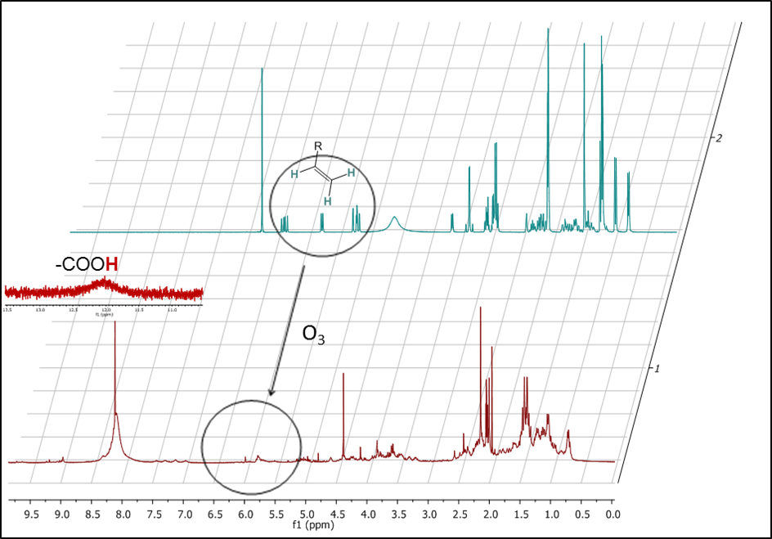
Figure 1. ¹H NMR spectrum of tiamulin solution in acetonitrile before ozonation (top) and after 30 minutes of ozonation (bottom). Typical absorptions for protons of the vinyl group (δ = 5.0 – 7.0 ppm) disappears, and broad absorption of carboxylic protons at δ = 12.0 ppm appeared (inset in the bottom spectrum).

Additional information on ozonation reaction and structural changes in tiamulin molecule were obtained from HPLC-HRMS analysis of reaction mixtures (Figure 2). Namely, tiamulin completely reacted in the batch solution in 30 minutes of ozonation, and HPLC chromatogram did not change noticeably after the next 30 minutes of ozonation. Very similar observations were already noticed in ¹H NMR studies.

To gain additional insight into structural changes during the ozonation process, all HPLC chromatographic peaks were analyzed by HRMS spectrometer, coupled to the HPLC system. From HPLC-HRMS analysis we can conclude that ozone primarily cleavage the vinyl double bond in tiamulin, thus forming the carboxylic group, which appears in all reaction products. In the next step, the oxidation of sulfur atom takes place. Namely, the compound with mass 543.2866 (Figure 2(B)) predominate in the first 30 minutes of ozonation. In the later stages of ozonation, the additional oxidation of tiamulin N-atom takes place (mass 559.2815; Figure 2(C)). Decomposition of the tiamulin skeleton gradually progresses, resulting in increased peaks intensity with lower masses (435.2257 and 320.1988; Figure 2(C)).

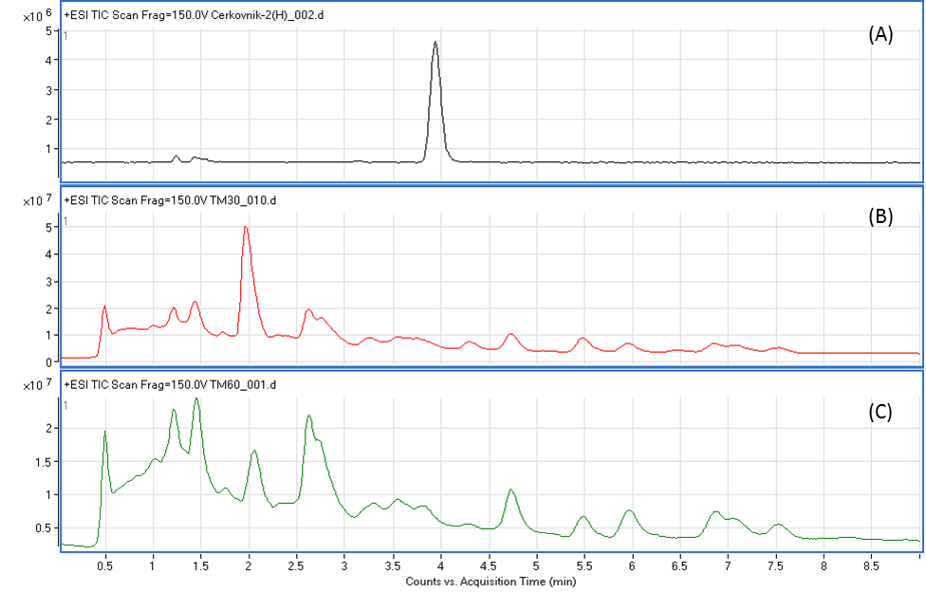
Figure 2. HPLC chromatogram of a batch solution of tiamulin in acetonitrile before ozonation (A), after 30 min of ozonation (B), and after 60 min of ozonation (C).

