Supplemental information for

Retrieval of High Time Resolution Growth Factor Probability Density Function from a Humidity-controlled Fast Integrated Mobility Spectrometer

Yang Wang,^{1,2} Guangjie Zheng,^{1,2} Steven R. Spielman,³ Tamara Pinterich,¹ Susanne Hering,³ and Jian Wang^{1,2 *}

¹Environmental and Climate Sciences Department
Brookhaven National Laboratory
Upton, NY, 11973, USA

²Center for Aerosol Science and Engineering
Department of Energy, Environmental and Chemical Engineering
Washington University in St. Louis
St. Louis, MO, 63130, USA.

³Aerosol Dynamics Inc.
Berkeley, CA, 94710, USA

Revised Manuscript Submitted to:
Aerosol Science and Technology
AST-MS-2019-061.R1
May 29th, 2019

* To whom correspondence should be addressed:
Tel: +1-314-935-3362
E-mail address: jian@wustl.edu
DMA and FIMS transfer functions
The DMA transfer function ($Ω_{DMA}\left(V_{DMA},Z_{p}\right)$) with and without particle diffusion has been solved by Stolzenburg (1988) via considering the particle movement across streamlines bounded by the inlet and outlet of the DMA. When particle diffusion is ignored,
$$Ω_{DMA,nd}\left(V_{DMA},Z_{p}\right)=\frac{1}{2}\frac{1}{Ψ_{2}-Ψ_{1}}\left[\begin{matrix}-\left|Ψ_{4}-Ψ_{2}+Z_{p}ΔΦ\right|+\left|Ψ_{4}-Ψ_{1}+Z_{p}ΔΦ\right| \\ +\left|Ψ_{3}-Ψ_{2}+Z_{p}ΔΦ\right|-\left|Ψ_{3}-Ψ_{1}+Z_{p}ΔΦ\right|\end{matrix}\right]$$ | (S1)
and when particle diffusion is considered,
$$Ω_{DMA}\left(V_{DMA},Z_{p}\right)=\frac{1}{\sqrt{2}}\frac{σ_{Γ,DMA}}{Ψ_{2}-Ψ_{1}}\left[\begin{matrix}-ε\left(\frac{Ψ_{4}-Ψ_{2}+Z_{p}ΔΦ}{\sqrt{2}σ_{Γ,DMA}}\right)+ε\left(\frac{Ψ_{4}-Ψ_{1}+Z_{p}ΔΦ}{\sqrt{2}σ_{Γ,DMA}}\right) \\ +ε\left(\frac{Ψ_{3}-Ψ_{2}+Z_{p}ΔΦ}{\sqrt{2}σ_{Γ,DMA}}\right)-ε\left(\frac{Ψ_{3}-Ψ_{1}+Z_{p}ΔΦ}{\sqrt{2}σ_{Γ,DMA}}\right)\end{matrix}\right]$$ | (S2)
In these expressions, $Ψ_{1}$, $Ψ_{2}$, $Ψ_{3}$, and $Ψ_{4}$ are the stream functions at the boundaries of the DMA inlet and outlet slit. $ΔΦ$ is the difference between the electric flux functions at the DMA outlet and inlet, and $\sqrt{2}σ_{Γ,DMA}$ is a measure of particle diffusion spreading along the particle streamline. $ε(x)$ is a function defined by
$$ε\left(x\right)=\int_{0}^{x}{\operatorname{erf}\left(u\right)du}=xerf\left(x\right)+\frac{1}{\sqrt{π}}e^{-x^{2}}$$ | (S3)
Regarding the FIMS transfer function, by using a similar method to Stolzenburg (1988), the probability density function $P(Z_{p},Ψ_{out})$, which dictates the probability of finding a particle with mobility $Z_{p}$ that exits between streamlines $Ψ_{out}$ and ($Ψ_{out}+dΨ_{out}$), can be solved by (Kulkarni and Wang 2006a)
$$P_{FIMS,nd}\left(Z_{p},Ψ_{out}\right)=\frac{1}{2}\frac{1}{Ψ_{2,in}-Ψ_{1,in}}\left[\begin{matrix}H(Ψ_{out}-Ψ_{1,in}-Z_{p}ΔΦ)- \\ H(Ψ_{out}-Ψ_{2,in}-Z_{p}ΔΦ)\end{matrix}\right]$$ | (S4)
when diffusion is ignored, and
$$P_{FIMS}\left(Z_{p},Ψ_{out}\right)=\frac{1}{2}\frac{1}{Ψ_{2,in}-Ψ_{1,in}}\left[\begin{matrix}erf(\frac{Ψ_{out}-Ψ_{1,in}-Z_{p}ΔΦ}{\sqrt{2}σ_{Γ,FIMS}})- \\ erf(\frac{Ψ_{out}-Ψ_{2,in}-Z_{p}ΔΦ}{\sqrt{2}σ_{Γ,FIMS}})\end{matrix}\right]$$ | (S5)
when diffusion is considered (Kulkarni and Wang 2006a). In Eqs. (A.4) and (A.5), $Ψ_{1,in}$ and $Ψ_{2,in}$ are the stream functions at the lower and upper boundaries of the FIMS inlet, and $σ_{Γ,FIMS}$ is determined by the spreading of particles due to diffusion. Note that Eqs. (A.4) and (A.5) are probability functions that work for point locations at the end of the mobility separator, where the point has a stream function of $Ψ_{out}$. In order to obtain the FIMS bin transfer function, regarding probability functions should be integrated within the FIMS bin, where
$$Ω_{FIMS,i}\left(Z_{p}\right)=\int_{Ψ_{i-\frac{1}{2}}}^{Ψ_{i+\frac{1}{2}}}{P\left(Z_{p},Ψ_{out}\right)dΨ_{out}}$$ | (S6)
The integration limits are $Ψ_{i-\frac{1}{2}}$ and $Ψ_{i+\frac{1}{2}}$, corresponding to the bin boundary sizes of $D_{p,i-\frac{1}{2}}^{*}$ and $D_{p,i+\frac{1}{2}}^{*}$ shown in Section 3.1. Furthermore, due to the limited size of the viewing window of the CCD camera, the transfer function of the $i^{th}$ bin of the FIMS can be solved by
$$Ω_{FIMS,i,nd}\left(Z_{p}\right)=\frac{1}{2}\frac{b_{view}}{b}\frac{1}{Ψ_{in,2}-Ψ_{in,1}}\left[\begin{matrix}-\left|Ψ_{i+\frac{1}{2}}-Ψ_{in,2}+Z_{p}ΔΦ\right|+\left|Ψ_{i+\frac{1}{2}}-Ψ_{in,1}+Z_{p}ΔΦ\right| \\ +\left|Ψ_{i-\frac{1}{2}}-Ψ_{in,2}+Z_{p}ΔΦ\right|-\left|Ψ_{i-\frac{1}{2}}-Ψ_{in,1}+Z_{p}ΔΦ\right|\end{matrix}\right]$$ | (S7)
when particle diffusion is ignored, and
$$Ω_{FIMS,i}\left(Z_{p}\right)=\frac{1}{\sqrt{2}}\frac{b_{view}}{b}\frac{σ_{Γ,FIMS}}{Ψ_{in,2}-Ψ_{in,1}}\left[\begin{matrix}-ε\left(\frac{Ψ_{i+\frac{1}{2}}-Ψ_{in,2}+Z_{p}ΔΦ}{\sqrt{2}σ_{Γ,FIMS}}\right)+ε\left(\frac{Ψ_{i+\frac{1}{2}}-Ψ_{in,1}+Z_{p}ΔΦ}{\sqrt{2}σ_{Γ,FIMS}}\right) \\ +ε\left(\frac{Ψ_{i-\frac{1}{2}}-Ψ_{in,2}+Z_{p}ΔΦ}{\sqrt{2}σ_{Γ,FIMS}}\right)-ε\left(\frac{Ψ_{i-\frac{1}{2}}-Ψ_{in,1}+Z_{p}ΔΦ}{\sqrt{2}σ_{Γ,FIMS}}\right)\end{matrix}\right]$$ | (S8)
when diffusion is considered. $σ_{Γ,DMA}$ and $σ_{Γ,FIMS}$ are dependent on the flow field in the DMA and FIMS, and the spreading of particle movement is different if different flow patterns are assumed. Note that the expressions in Eqs. (A.1-A.2) and Eqs. (A.7-A.8) are almost identical. This is caused by the same mechanism of mobility separation in the DMA and FIMS, where the particle stream functions remain a constant along the trajectory of particles. Furthermore, each FIMS size bin can be regarded as an outlet slit similar to the configuration of the DMA. Hence, same expressions of transfer function can be used in FIMS. But since the flow patterns in the two instruments are different, detailed shapes of the DMA and FIMS transfer functions will vary.

Fig. S1 shows the actual shapes of the DMA (a) and FIMS (b) transfer functions. Owing to the longer residence time, Long DMA causes in considerable diffusion broadening of the transfer function. The shape of the FIMS transfer function, however, is distinct from that of the DMA. Ideal (non-diffusing) FIMS transfer functions possess trapezoidal shapes instead of triangular shapes. This phenomenon can be explained by drawing an analogy between FIMS and DMA, where the FIMS size bin can be considered as a DMA outlet. Triangular-shaped DMA transfer functions are obtained only when the aerosol inlet and outlet flow rate are equal ($Q_{s,DMA}=Q_{a,DMA}$). Because of the parabolic flow pattern in the FIMS and the method for dividing size bins, the aerosol flow rate through each size bin ($Q_{i,FIMS}$) hardly matches exactly with the aerosol inlet flow rate ($Q_{a,FIMS}$). This difference between $Q_{a,FIMS}$ and $Q_{i,FIMS}$ gives a trapezoidal shape of the FIMS transfer function, meaning particles within certain mobility ranges could exit the FIMS size bin with a same probability. In addition, unlike the DMA transfer function, where a non-diffusing transfer function works for all different sizes, the resolution of the non-diffusing FIMS transfer functions becomes lower as particle size becomes larger. This is caused by the higher relative uncertainties in measuring particles with smaller mobilities, where particles with smaller electrical mobilities (i.e., larger sizes, and theoretically can reach to infinitely large) concentrate in the aerosol stream near to the wall. At the same time, at locations near to the wall, the difference between $Q_{a,FIMS}$ and $Q_{i,FIMS}$ becomes the largest as $Q_{a,FIMS}$ approaches zero. This effect results in the similar lengths of the upper and lower bases in the trapezoidal-shaped transfer function, further deteriorating the resolution of the transfer function. To measure particles with larger sizes, the FIMS voltage can be raised accordingly, so that particles with larger inertial endure stronger electrostatic forces and move to the charged side of the parallel plate. Under a same voltage setting, the FIMS can measure particles spanning a factor of around three in particle diameter (a factor of 10 in mobility), which is sufficient to cover the entire range of growth factor for atmospheric aerosols at RH below 90%.

Table S1 Mode parameters of the pre-defined GF-PDFs for testing the data inversion algorithm.
Parameters | $$f_{0,cond,k}$$ | $$G_{cond,k}$$ | $$σ_{cond,k}$$
GF-PDF 1
Mode 1 | 1.00 | 1.40 | 1.15
GF-PDF 2
Mode 1 | 0.45 | 1.10 | 1.05
Mode 2 | 0.55 | 1.30 | 1.05
GF-PDF 3
Mode 1 | 0.50 | 1.05 | 1.10
Mode 2 | 0.42 | 1.40 | 1.05
Mode 3 | 0.38 | 1.70 | 1.10

Table S2 Mode parameters of the multimodal lognormal GF-PDFs calculated for 50 and 165 nm ambient aerosols.
Parameters | $$f_{0,cond,k}$$ | $$G_{cond,k}$$ | $$σ_{cond,k}$$
50 nm
Mode 1 | 0.74 | 1.10 | 1.03
Mode 2 | 0.13 | 1.01 | 1.02
Mode 3 | 0.13 | 1.25 | 1.06
165 nm
Mode 1 | 0.39 | 1.01 | 1.02
Mode 2 | 0.36 | 1.42 | 1.03
Mode 3 | 0.26 | 1.25 | 1.13

Table S3 Mean growth factors of 50 and 165 nm ambient aerosols calculated by the first moment of the inverted GF-PDFs ($GF=\int_{g=0}^{g=∞}{c_{cond,n}\left(g,D_{p1}\right)gdg}$).
$D_{p}$ (nm) | ML GF-PDF |  | PL GF-PDF
 | $$p=2$$ | $$p=3$$ | $$q=10$$ | $$q=20$$
50 | 1.10 | 1.11 | 1.11 | 1.11
165 | 1.23 | 1.24 | 1.27 | 1.23

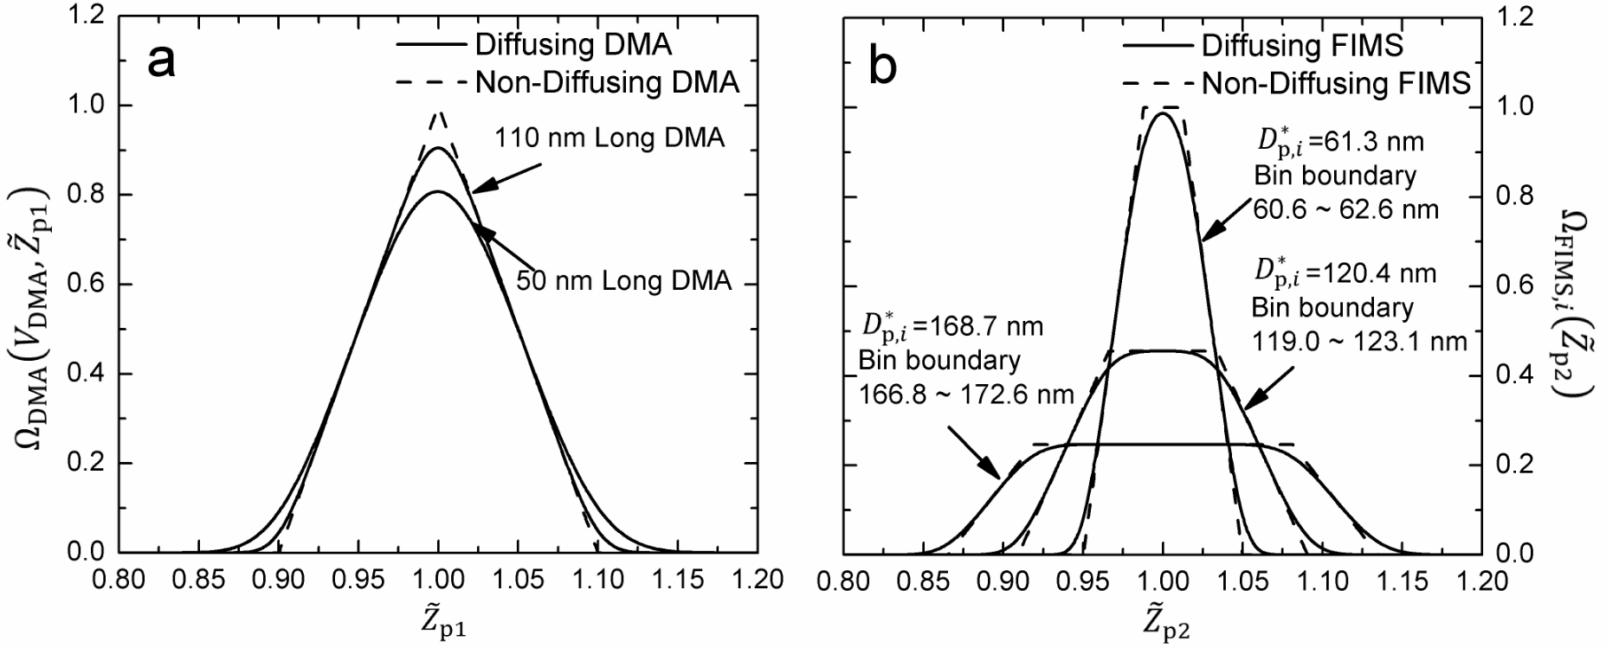
Fig. S1 (a) Normalized Long DMA transfer functions when classifying 50 and 100 nm particles at a sheath flow rate of 3 lpm and an aerosol flow rate of 0.3 lpm with and without particle diffusion; (b) Normalized FIMS transfer functions derived for different size bins with and without particle diffusion.
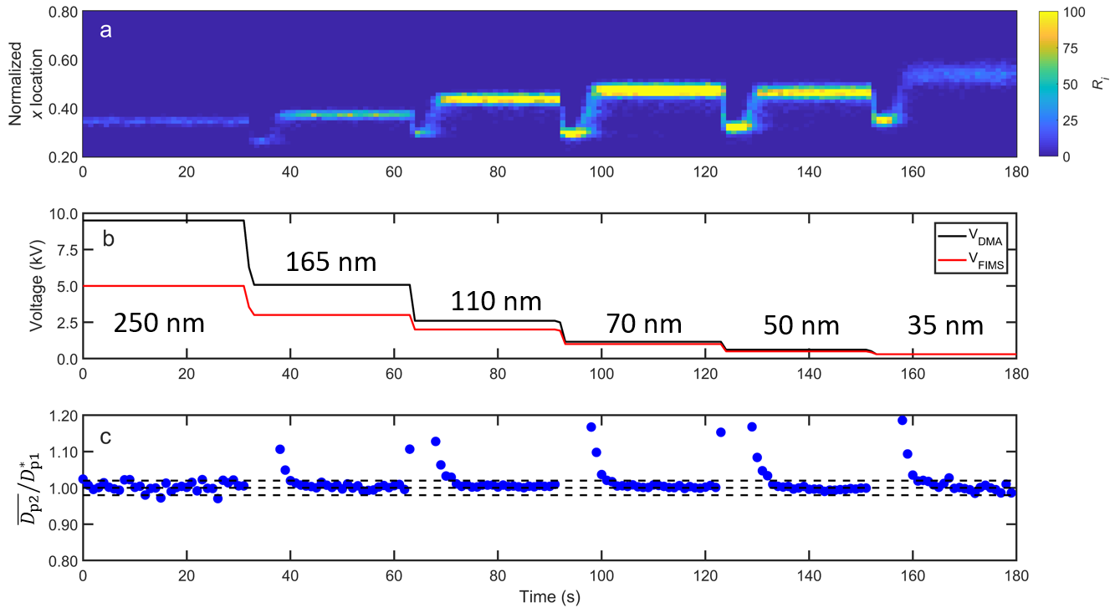
Fig. S2 The settings and response of HFIMS during the test of sizing accuracy. The sample aerosols were atomized (NH₄)₂SO₄ aerosols, and the DMA voltages corresponded to dry particle sizes of 250, 165, 110, 70, 50, and 35 nm. (a): The normalized x-locations ($\tilde{x}$) of particles detected in the viewing window as a function of time. The color of the contour plot shows the number of particles detected in each location bin. (b): The DMA and FIMS voltages as a function of time. (c): The ratios between the mean particle diameter measured by the FIMS to the DMA centroid diameter ($\overline{D_{p2}}/D_{p1}^{*}$) as a function of time. The dashed lines mark the growth factor of 0.98, 1.00 and 1.02.

