Comparison of the toxicity of waters containing initially sulfaquinoxaline after photocatalytic treatment by TiO₂ and polyaniline/TiO₂

Nahid Sandiklyª , Mounir Kassir^{b}, Mouhieddine El Jamal^{c}, Hosni Takache^{d}, Philippe Arnoux^{e}, Samia Mokh^{a f}, Mohammad Al-Iskandaraniª, Thibault Roques-Carmes^{e}

Supporting information S1: Kinetic of adsorption of sulfaquinoxaline (SQX) onto the catalysts

Table S1. Kinetic analysis of the adsorption of SQX onto TiO₂ and PANI/TiO₂ catalysts at various pH. The SQX adsorbed amount is calculated from the difference between the initial pollutant concentration (C_{initial} = 7 mg L⁻¹) and the concentration at time of adsorption tads (C_{tads}) taking into account the volume of the solution (V = 100 mL) and the mass of catalyst (m = 0.1 g): .

Time of adsorption  (tads) | Acidic  pH 4 |  | Neutral  pH 7 |  | Basic  pH 12
 | TiO₂  Γ (mg/g) | PANI/TiO₂  Γ  (mg/g) | TiO₂  Γ  (mg/g) | PANI/TiO₂  Γ  (mg/g) | TiO₂  Γ (mg/g) | PANI/TiO₂  Γ  (mg/g)
tads = 15 min | 1024 | 322 | 0.2 | 2403 | 13 | 1534
tads =30 min | 1168 | 420 | 1 | 2730 | 21 | 1820
tads =45 min | 1192 | 405 | 1.4 | 2733 | 20 | 1811
tads = 60 min | 1163 | 423 | 0.9 | 2732 | 22 | 1819

Supporting information S2: Toxicity tests

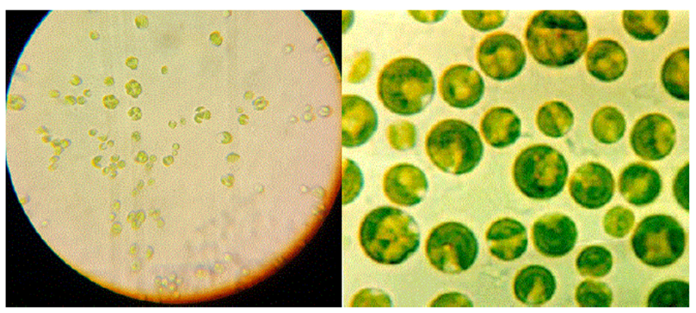
Figure. S1. Microscopic images of the unicellular green algae Chlorella vulgaris.

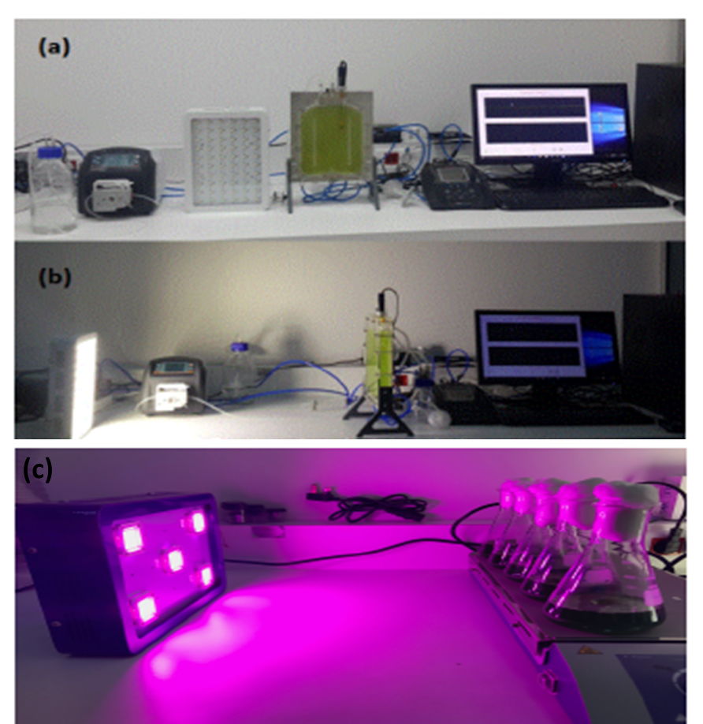

Figure. S2. The experimental setup used for the growth of the unicellular green algae Chlorella vulgaris.

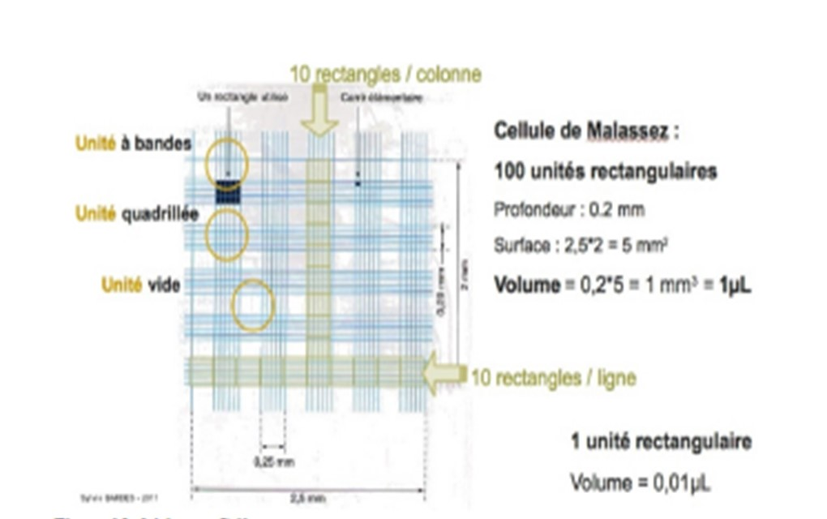

Figure. S3. Schematic representation of the Malassez cell used for cells counting.

Supporting information S3: Measurements of hydroxyl radicals (HO•) by HPF probe

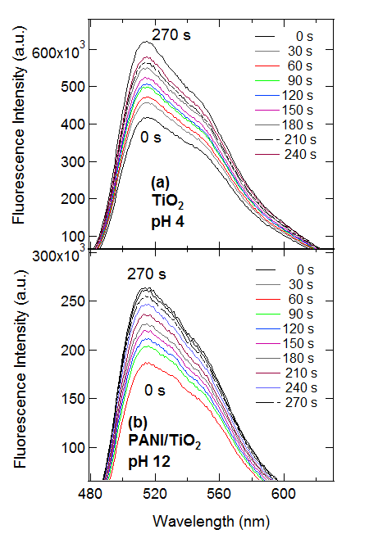

Figure. S4. The temporal evolution of the fluorescence spectra of HPF in the presence of (a) TiO₂ at pH 4, and (b) PANI/TiO₂ at pH 12 excited at 254 nm.

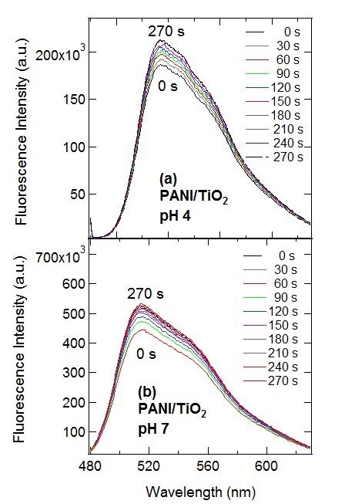

Figure. S5. The temporal evolution of the fluorescence spectra of HPF in the presence of (a) PANI/TiO₂ at pH 4, and (b) PANI/TiO₂ at pH 7 excited at 254 nm.

